Table of Contents

UNITED STATES
SECURITIES AND EXCHANGE COMMISSION

Washington, D.C. 20549

SCHEDULE 14A

Proxy Statement Pursuant to Secton 14(a) of the

Securites Exchange Act of 1934

Filed by the Registrant ☒ Filed by a party other than the Registrant ☐

Check the appropriate box:

- Preliminary Proxy Statement

- Confdental, for Use of the Commission Only (as permited by Rule 14a-6(e)(2))

- Defnitve Proxy Statement

- Defnitve Additonal Materials

- Solicitng Material Under Rule 240.14a-12

ExlService Holdings, Inc.

(Name of Registrant as Specifed In Its Charter)

(Name of Person(s) Filing Proxy Statement, if other than the Registrant)

Payment of Filing Fee (Check the appropriate box):

- No fee required.

- Fee paid previously with preliminary materials.

- Fee computed on table in exhibit required by Item 25(b) per Exchange Act Rules 14a-6(i)(1) and 0-11.

Table of Contents
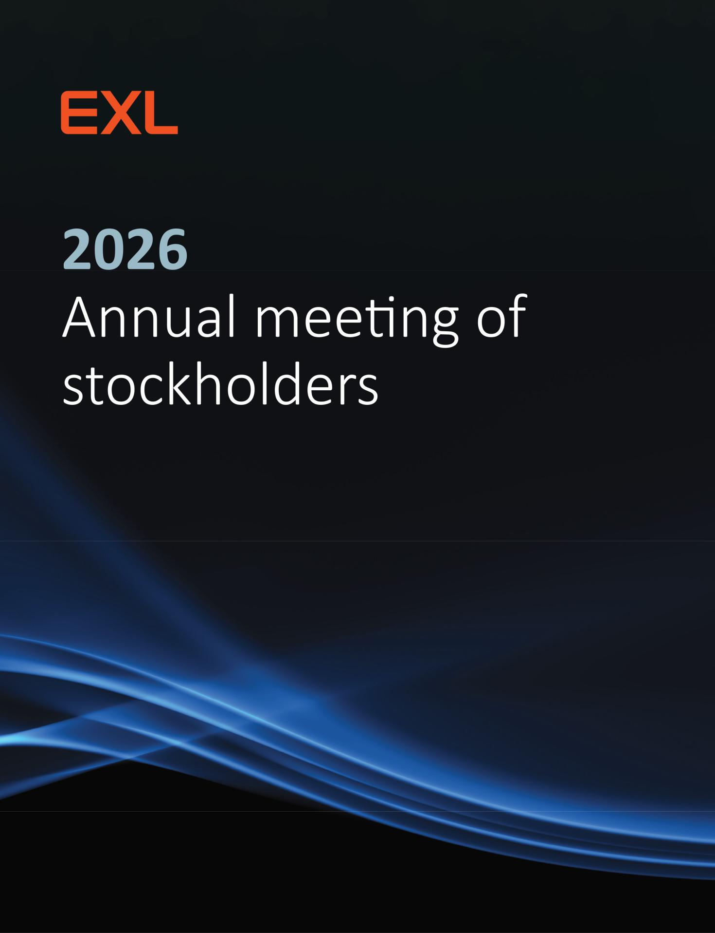

Table of Contents
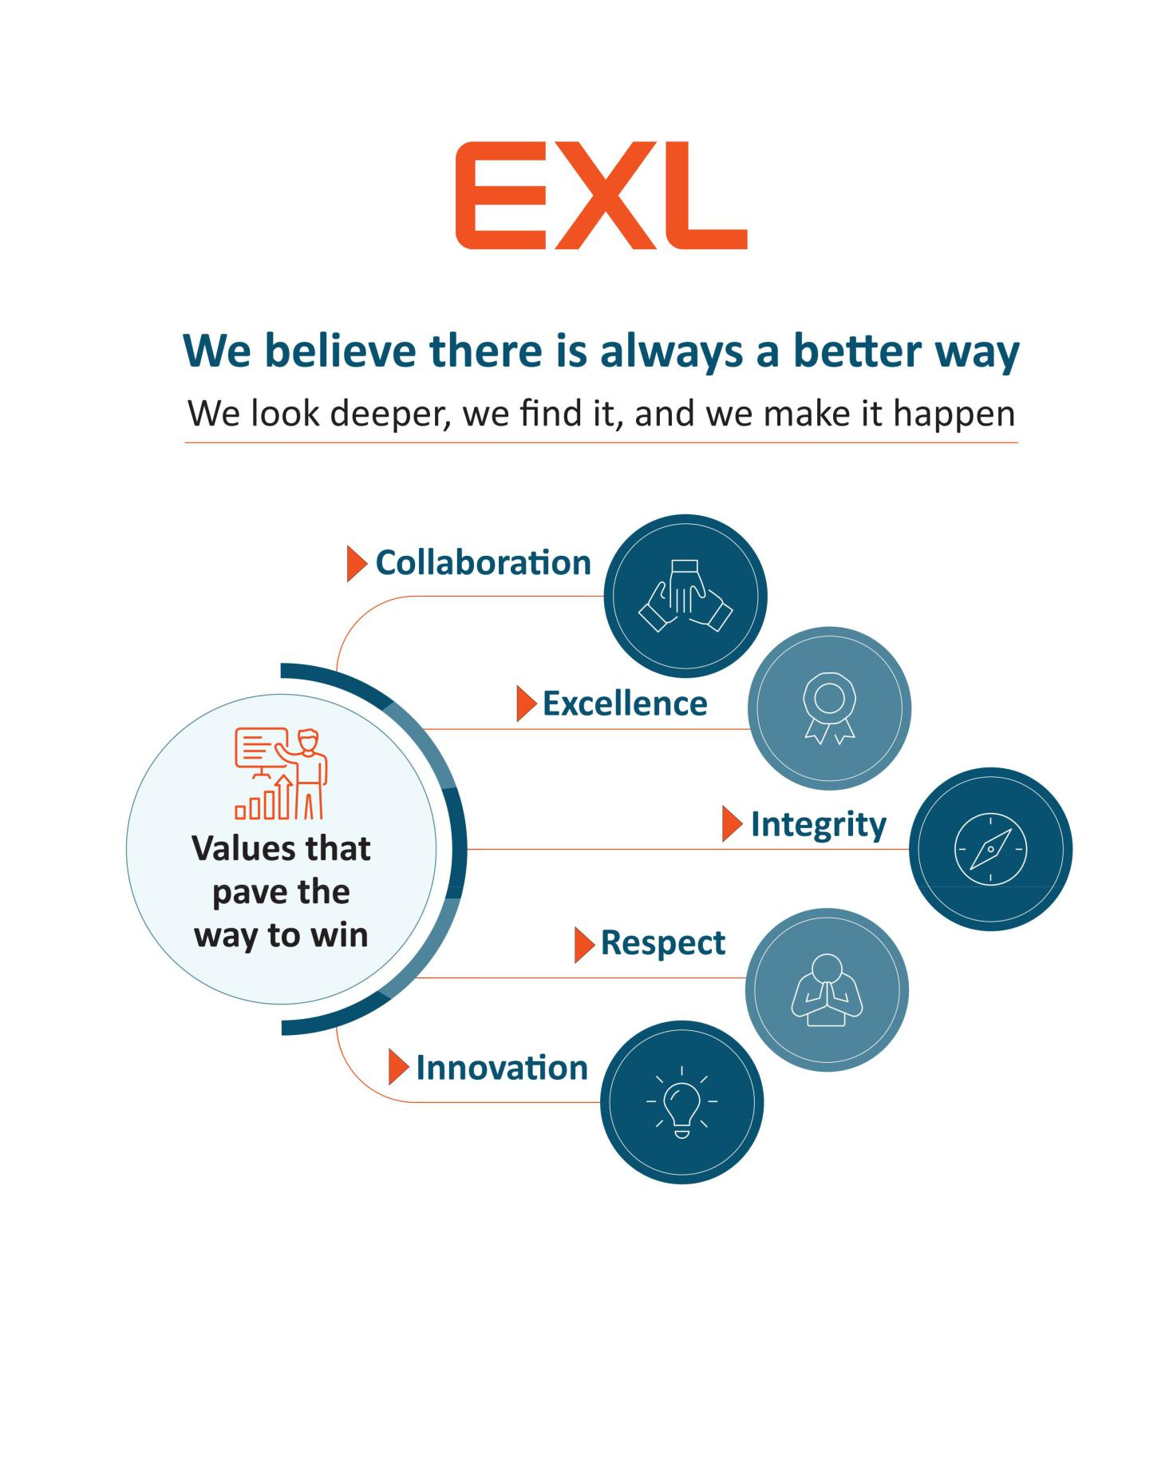

Table of Contents

320 Park Avenue, 29th Floor
New York, NY 10022
(212) 277-7100

Dear Fellow Stockholder,

In 2025, EXL delivered great results driven by focused executon and leading with data and AI to drive measurable results for our clients. We contnued to transform mission critcal workfows by combining deep domain expertse, strong data management, and advanced AI capabilites. Our performance underscores the strength of our strategy and our ability to help clients operatonalize AI at scale through rapid, disciplined innovaton.

We generated total revenues of $2.09 billion in 2025, representng growth of 14% over 2024. Adjusted EPS¹ increased 18% to $1.95, compared to $1.65 in 2024 and $1.43 in 2023. Data and AI-led revenue grew 21% year over year in the fourth quarter and represented 57% of total revenue, refectng the contnued shif in our portolio toward higher value, technology enabled services. More than 75% of our revenues are recurring, providing signifcant visibility and resiliency as we enter 2026. Our strong balance sheet provides us with fexibility to contnue investng in growth while maintaining disciplined capital allocaton.

Rohit Kapoor Vikram Pandit

Chairman and CEO Lead Director

A central focus in 2025 was making AI real for our clients. We launched EXLerate.ai™, our AI platorm for reimagining workfows, and launched EXLdata.ai™, our agentc AI natve data platorm that helps clients move from data to context to AI in a governed and scalable way. We contnued to embed AI into our industry platorms, including by adding AI agents to our LifePRO Digital Suite for insurers to automate complex tasks and accelerate product launches. We also deepened our ecosystem of strategic partners, expanding co-selling and soluton development with AWS, Databricks, Microsof, NVIDIA and Google, and were named a Google Cloud Global Strategic Services partner, as well as AWS’s 2025 AI/ML Market Disruptor of the Year.

Our more than 65,000 colleagues, bringing strong innovaton mindsets, client-frst mentalites, and a bias toward acton, remain at the heart of our success. In 2025 we contnued investng to build an AI-natve workforce, expanding skills in data engineering, generatve and agentc AI, partner technologies and cloud platorms. Our IdeaTank 2.0 innovaton program generated more than 11,000 ideas from over 30,000 employees, strengthening our organizatonal innovaton capability and speed. We are proud that our culture contnues to be recognized externally, including recent distnctons such as Great Place to Work™ certfcaton in India and The Financial Times Best Employers in Asia Pacifc.

We are equally commited to operatng as a responsible corporate citzen. Across our global footprint, tens of thousands of our colleagues support our corporate social responsibility initatves, with a partcular focus on skills development and educaton to help create the next generaton of future-ready talent. Our emphasis on ethics, compliance, data privacy, security and responsible AI underpins the trust our clients place in us and increasingly diferentates EXL as a partner of choice, opening new opportunites to deploy AI at scale in complex, highly regulated environments, which in turn, unlocks more value for our stockholders. We have been recognized for our eforts in these areas, including by Newsweek on its America’s Most Responsible Companies, America’s Greenest Companies and America’s Most Charitable Companies lists, by Barron’s on its 100 Most Sustainable Companies list and by Forbes on its Most Trusted Companies in America list.

On behalf of the board of directors of ExlService Holdings, Inc., we are pleased to invite you to the 2026 Annual Meetng of Stockholders, which will be held on June 16, 2026. We look forward to sharing more about our Company at the Annual Meetng. We encourage you to carefully read the atached 2026 Annual Meetng of Stockholders and Proxy Statement, which contains important informaton about the maters to be voted upon and instructons on how you can vote your shares.

Your vote is important to us. Please vote as soon as possible whether or not you plan to partcipate in the Annual Meetng.

The board of directors and management look forward to your atendance at the Annual Meetng.

Sincerely,
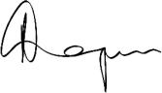
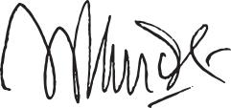

Rohit Kapoor | Vikram Pandit
Chairman and CEO | Lead Director

(1) Adjusted EPS is a non-GAAP fnancial measure. See “Non-GAAP Reconciliaton” later in this proxy statement.

 | EXL 2026 Proxy Statement | /

Table of Contents

Notce of 2026 Annual Meetng of Stockholders

Dear Stockholder:

You are cordially invited to the 2026 Annual Meetng of Stockholders of ExlService Holdings, Inc., a Delaware corporaton (the “Company”), for the purposes of votng on the following maters:

- the electon of seven members of the board of directors of the Company;

- the ratfcaton of the appointment of Deloite & Touche LLP as the independent registered public accountng frm of the Company for fscal year 2026;

- the approval, on a non-binding advisory basis, of the compensaton of the named executve ofcers of the Company; and

- the transacton of such other business as may properly come before the Annual Meetng or any adjournment or postponement thereof.

We will hold our Annual Meetng in virtual format only, via live audio webcast (rather than at any physical locaton) on June 16, 2026 at 9:00 AM, Eastern Time. Our virtual meetng platorm will allow for full partcipaton as if you were atending physically. You or your proxyholder may partcipate, vote, and examine our stockholder list at the Annual Meetng by visitng www.virtualshareholdermeetng.com/EXLS2026 and using your 16-digit control number.

If you are a stockholder of record at the close of business on April 23, 2026, the record date for the Annual Meetng, you are enttled to vote at the Annual Meetng. A list of stockholders as of the record date will be available for examinaton for any purpose germane to the Annual Meetng, during ordinary business hours, at the Company’s executve ofces at 320 Park Avenue, 29th Floor, New York, New York 10022, for a period of 10 days prior to the date of the Annual Meetng. If our corporate headquarters are closed during the 10 days prior to the Annual Meetng, you may send a writen request to the Corporate Secretary at our corporate headquarters, and we will arrange a method for you to inspect the list.

Please note the technical requirements for virtual atendance at the Annual Meetng, as described in the enclosed Proxy Statement beginning on page 115 under the heading “Annual Meetng Q&A.”

Pursuant to rules promulgated by the Securites and Exchange Commission, we are providing access to our proxy materials over the Internet. On or about April 27, 2026, we will mail a Notce of Internet Availability of Proxy Materials (the “Internet Notce”) to each of our stockholders of record and benefcial owners at the close of business on the record date. On the date of mailing of the Internet Notce, all stockholders and benefcial owners will have the ability to access all of the proxy materials on a website referred to in the Internet Notce. These proxy materials will be available free of charge.

Whether or not you expect to atend the Annual Meetng, the Company encourages you to promptly vote and submit your proxy (i) by Internet (by following the instructons provided in the Internet Notce), (ii) by phone (by following the instructons provided in the Internet Notce) or (iii) by requestng that proxy materials be sent to you by mail that will include a proxy card that you can use to vote by completng, signing, datng and returning the proxy card in the prepaid postage envelope provided. Votng by proxy will not deprive you of the right to atend the Annual Meetng or to vote your shares. You can revoke a proxy at any tme before it is exercised by votng at the Annual Meetng, by delivering a subsequent proxy or by notfying the inspector of electons in writng of such revocaton prior to the Annual Meetng. YOUR SHARES CANNOT BE VOTED UNLESS YOU EITHER (I) VOTE BY USING THE INTERNET, (II) VOTE BY PHONE,

- REQUEST PROXY MATERIALS BE SENT TO YOU BY MAIL AND THEN USE THE PROXY CARD PROVIDED BY MAIL TO CAST YOUR VOTE BY COMPLETING, SIGNING AND RETURNING THE PROXY CARD BY MAIL OR (IV) ATTEND THE ANNUAL MEETING AND VOTE.

By Order of the Board of Directors,
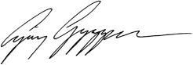

Ajay Ayyappan

Executve Vice President, General Counsel and Corporate Secretary

New York, New York

April 27, 2026

 | EXL 2026 Proxy Statement | /

Table of Contents

2026 Proxy Statement

Table of contents

2026 Proxy Statement summary |  |  |  |  |  |  |  |  |  |  |  |  |  |  |  |  |  |  |  | 1
Our board of directors |  |  |  |  |  |  |  |  |  |  |  |  |  |  |  |  |  |  |  | 12
Corporate governance |  |  |  |  |  |  |  |  |  |  |  |  |  |  |  |  |  |  |  | 21
Sustainability |  |  |  |  |  |  |  |  |  |  |  |  |  |  |  |  |  |  |  | 42
Our Executve Commitee |  |  |  |  |  |  |  |  |  |  |  |  |  |  |  |  |  |  |  | 51
Executve compensaton |  |  |  |  |  |  |  |  |  |  |  |  |  |  |  |  |  |  |  | 54
 | Compensaton Discussion and Analysis |  |  |  |  |  |  |  |  |  |  |  |  |  |  |  |  |  |  | 54
 | Compensaton and Talent Management Commitee Report |  |  |  |  |  |  |  |  |  |  |  |  |  |  |  |  |  |  | 78
 | Summary compensaton table for fscal year 2025 |  |  |  |  |  |  |  |  |  |  |  |  |  |  |  |  |  |  | 79
Stock ownership of directors, executve ofcers and certain benefcial owners |  |  |  |  |  |  |  |  |  |  |  |  |  |  |  |  |  |  |  | 101
Certain relatonships and related person transactons |  |  |  |  |  |  |  |  |  |  |  |  |  |  |  |  |  |  |  | 103
Audit Commitee Report |  |  |  |  |  |  |  |  |  |  |  |  |  |  |  |  |  |  |  | 104
Proposal 1 — Electon of directors |  |  |  |  |  |  |  |  |  |  |  |  |  |  |  |  |  |  |  | 105
Proposal 2 — Ratfcaton of the appointment of independent registered public accountng frm |  |  |  |  |  |  |  |  |  |  |  |  |  |  |  |  |  |  |  | 107
Proposal 3 — Advisory (non-binding) vote to approve executve compensaton |  |  |  |  |  |  |  |  |  |  |  |  |  |  |  |  |  |  |  | 109
Miscellaneous |  |  |  |  |  |  |  |  |  |  |  |  |  |  |  |  |  |  |  | 111
Stockholder proposals and director nominatons for the 2027 Annual Meetng |  |  |  |  |  |  |  |  |  |  |  |  |  |  |  |  |  |  |  | 111
Non-GAAP Reconciliaton |  |  |  |  |  |  |  |  |  |  |  |  |  |  |  |  |  |  |  | 113
Annual Meetng Q&A |  |  |  |  |  |  |  |  |  |  |  |  |  |  |  |  |  |  |  | 115
Other maters |  |  |  |  |  |  |  |  |  |  |  |  |  |  |  |  |  |  |  | 120

 | EXL 2026 Proxy Statement | /

Table of Contents

2026 Proxy Statement summary

Summary

Below is a summary of select components of this Proxy Statement, including informaton regarding this year’s stockholder meetng, nominees for our board of directors, summary of our business, performance highlights and selectve executve compensaton informaton. This summary does not contain all of the informaton that you should consider prior to submitng your proxy, and you should review the entre Proxy Statement and our Annual Report on Form 10-K for the fscal year ended December 31, 2025 (the “2025 Form 10-K”). We refer to the fscal year ended December 31, 2025 as “fscal year 2025,” “fscal 2025,” and “2025.”

Meetng agenda, votng maters and recommendatons*

Votng proposal item | Board vote recommendaton
1. Electon of directors | FOR the electon of each nominee
 | (pg. 105)
Required vote: Afrmatve vote of a majority of votes cast
2. Ratfcaton of appointment of independent | FOR (pg. 107)
registered public accountng frm

Required vote: Afrmatve vote of a majority of shares present in person or represented by proxy and enttled to vote

3. Advisory (non-binding) Say-on-Pay vote to FOR (pg. 109)
approve executve compensaton

Required vote: Afrmatve vote of a majority of shares present in person or represented by proxy and enttled to vote

- Virtual atendance at our Annual Meetng will consttute presence in person for purposes of quorum and votng at the Annual Meetng.

2026 Proxy Statement summary
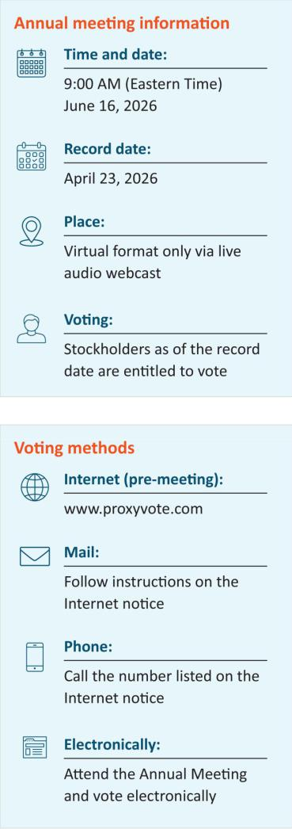

If you are the benefcial owner of shares held in the name of a brokerage, bank, trust or other nominee as a custodian (also referred to as shares held in “street name”), your broker, bank, trustee or nominee will provide you with materials and instructons for votng your shares. See page 116 for additonal details.

EXL 2026 Proxy Statement / 1

Table of Contents

2026 Proxy Statement summary

Our business

We are a global data and artfcial intelligence (“AI”) company that ofers services and solutons to reinvent client business models, drive beter outcomes and unlock growth with speed. EXL harnesses the power of data, AI and deep industry knowledge to transform businesses, including the world’s leading corporatons in industries including insurance, healthcare, banking and fnancial services, media and retail, among others. EXL was founded in 1999 with the core values of innovaton, collaboraton, excellence, integrity and respect. We are headquartered in New York, and have over 65,000 employees as of December 31, 2025, spanning six contnents.

Company’s three-year performance

 |  | Revenue (Year-over-year growth %)
Revenue by segment informaton ($ in millions) | 2023 YOY% |  | 2024 YOY% |  |  | 2025 YOY%
Insurance | $586.4 | 13.7% | $656.4 | 11.9% |  | $710.6 | 8.3%
Healthcare and Life Sciences | 366.4 | 22.0% | 430.7 | 17.5% |  | 532.5 | 23.7%
Banking, Capital Markets and Diversifed Industries | 411.8 | 4.9% | 426.7 | 3.6% |  | 482.4 | 13.0%
Internatonal Growth Markets | 266.1 | 30.8% | 324.6 | 22.0% |  | 362.2 | 11.6%
Consolidated | $1,630.7 | 15.5% | $1,838.4 | 12.7% |  | $2,087.7 | 13.6%

Efectve from the frst quarter of 2025, our reportng segments changed, aligned to our new Industry Market Units (“IMUs”). The revised presentaton is refected on a retrospectve basis in the table above and refected in the 2025 Form 10-K.

2 | / | EXL 2026 Proxy Statement

Table of Contents

2026 Proxy Statement summary
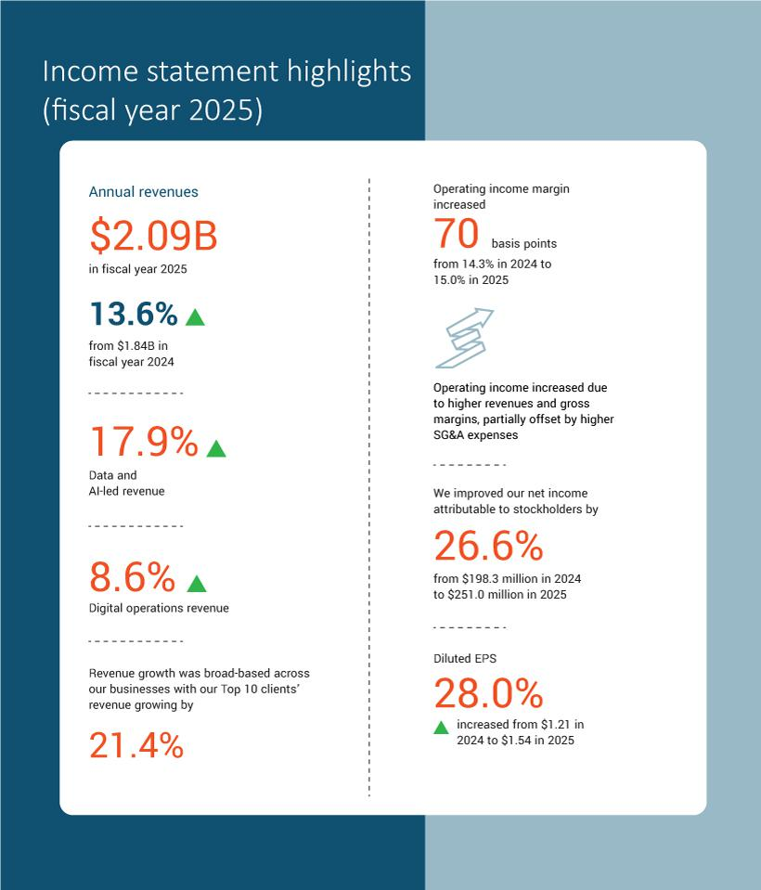

EXL 2026 Proxy Statement / 3

Table of Contents

2026 Proxy Statement summary
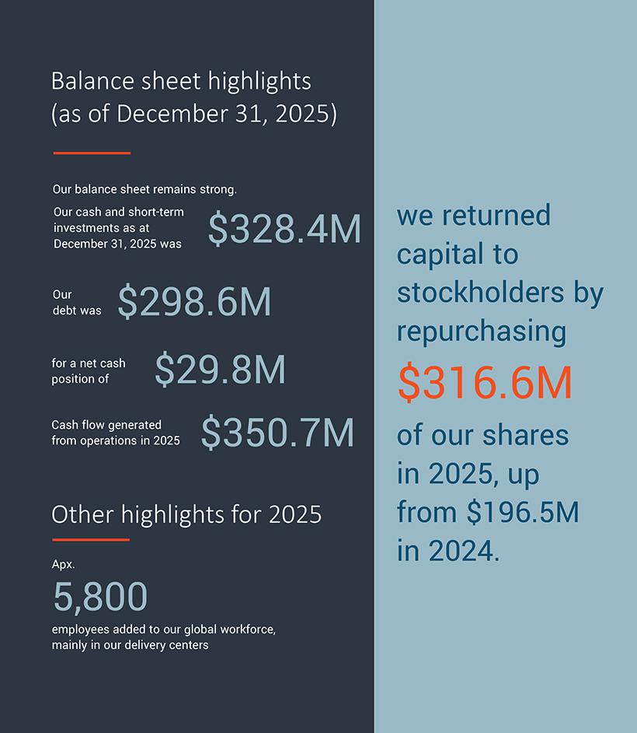

4 | / | EXL 2026 Proxy Statement

Table of Contents

2026 Proxy Statement summary

Total stockholder return

The graphs below compare our 1-year, 3-year and 5-year cumulatve total stockholder return (“TSR”) as of December 31, 2025 with the median TSR for companies included in the Nasdaq Composite index, the S&P MidCap 400 index and our peer group.
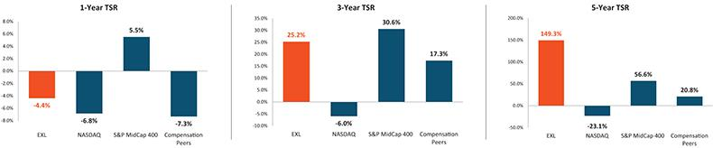

 | EXL 2026 Proxy Statement | / 5

Table of Contents

2026 Proxy Statement summary

Our locatons

Headquartered in New York, we are made up of approximately 65,000 professionals as of December 31, 2025, with more than 50 ofces spanning six contnents.
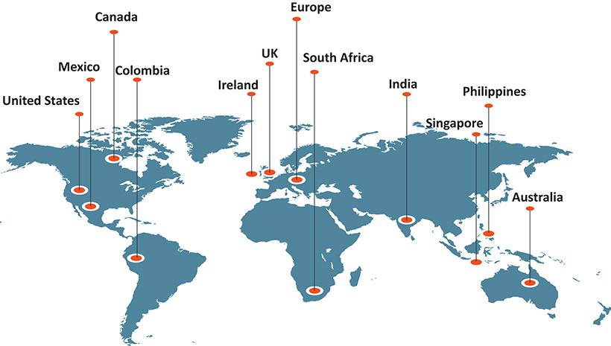

6 | / | EXL 2026 Proxy Statement

Table of Contents

2026 Proxy Statement summary

Corporate governance highlights

The following informaton is based on our board profle immediately following our Annual Meetng (assuming the electon of our seven director nominees) and refects current board practces.
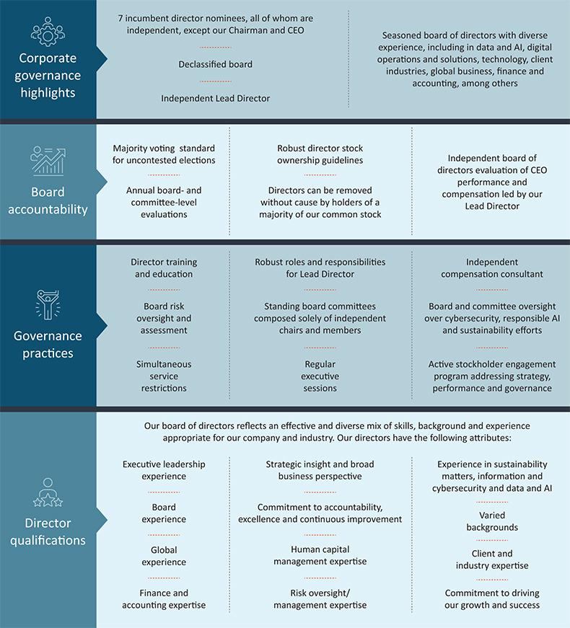

EXL 2026 Proxy Statement / 7

Table of Contents

2026 Proxy Statement summary

Nominees for electon as directors
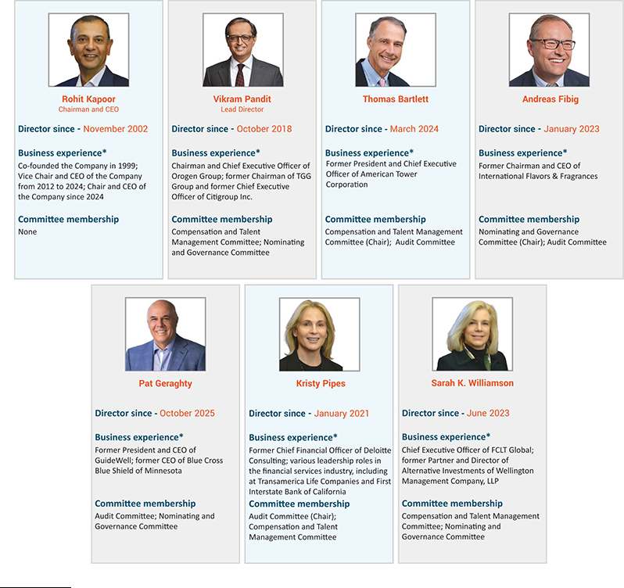

* A complete list of each nominee’s business experience and directorships is listed below beginning on page 14.

8 | / | EXL 2026 Proxy Statement

Table of Contents

2026 Proxy Statement summary

Director nominees - skills matrix

Our director nominees review and indicate whether they are experts in each of the skills and areas of experience listed below. An “expert,” for purpose of the skills set forth in this skill matrix, means an individual who, based on career experience (other than as an EXL director), has developed and contnues to maintain comprehensive knowledge and command over the subject mater, including relevant updates. Defnitons for each of these skills, as well as a descripton for how these are considered for candidates for directors, can be found under “Director qualifcatons” beginning on page 25 of this Proxy Statement.
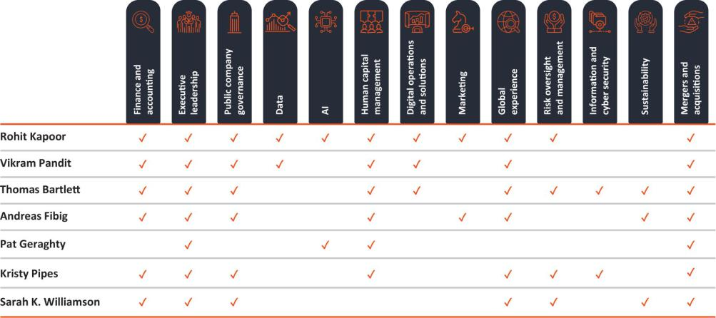

Board statstcs*
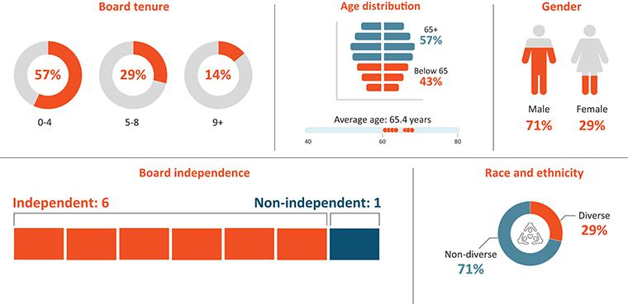

* Following our Annual Meetng, assuming electon of all nominees

 | EXL 2026 Proxy Statement | / 9

Table of Contents

2026 Proxy Statement summary

Sustainability

We pursue sustainability initatves that are aligned with our long-term corporate strategy, which is designed to beneft our stockholders, clients, employees, communites and manage expectatons and commitments across various stakeholder groups. See “Sustainability” beginning on page 42 below for more details on our recent accomplishments in sustainability.
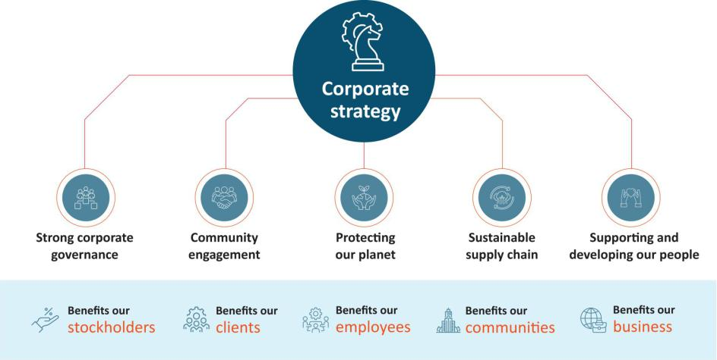

Compensaton Overview

  - Compensaton philosophy: Our executve compensaton philosophy is focused on pay-for-performance.

  - Approximately 96% Say-on-Pay approval of 2024 compensaton: At our 2025 Annual Meetng of Stockholders, our stockholders approved, on a non-binding advisory basis, the compensaton paid to our named executve ofcers for fscal year 2024. Approximately 96% of the votes present in person or by proxy (excluding broker non-votes) voted in favor of fscal year 2024 compensaton.

  - Annual incentve program: Our annual incentve program contnued to use the same formulaic performance criteria for 2025 as it has been using for several years, which includes:

–Company-wide metrics (75%)—Revenue and adjusted operatng proft margin (“AOPM”)

–Individual metrics (25%)—Linked to areas of performance that are specifc to each executve

- In 2025, we achieved 100.3% of our revenue performance target, and 100.04% of our AOPM target, resultng in annual incentve payout calculatons for our named executve ofcers, ranging from 101% of target performance to 106% of target performance.

  - Long-term equity incentve program: We also contnued our equity incentve program, which in 2025 included grantng a balanced mix of tme-vested restricted stock units and performance-based restricted stock units to all of our named executve ofcers. The performance-based restricted stock units were comprised of relatve total stockholder return-linked restricted stock units and revenue-linked restricted stock units.

- This was the third and fnal performance year for the performance-based restricted stock units granted in 2023, which were linked to the Company’s revenue and TSR performance relatve to a peer group. We achieved 101.61% of the revenue target for the revenue-linked restricted stock units, resultng in 116.15% of target funding of those grants. The Company’s TSR performance was at the 64th percentle among its peer group, resultng in 147.17% of the target funding of those grants. In the aggregate, the performance-based restricted stock units granted in 2023 achieved vestng of shares at 134.76% of target performance.

10 | / | EXL 2026 Proxy Statement

Table of Contents

2026 Proxy Statement summary

- Compensaton Policies. Our compensaton program is designed to refect appropriate governance practces aligned with the needs of our business, and includes, among others, the following features: robust clawback policy; robust stock ownership guidelines; limited perquisites; no excise tax gross-ups; and an ant-hedging and ant-pledging policy. See “Executve compensaton program, practces and policies” beginning on page 59 below.

Compensaton mix
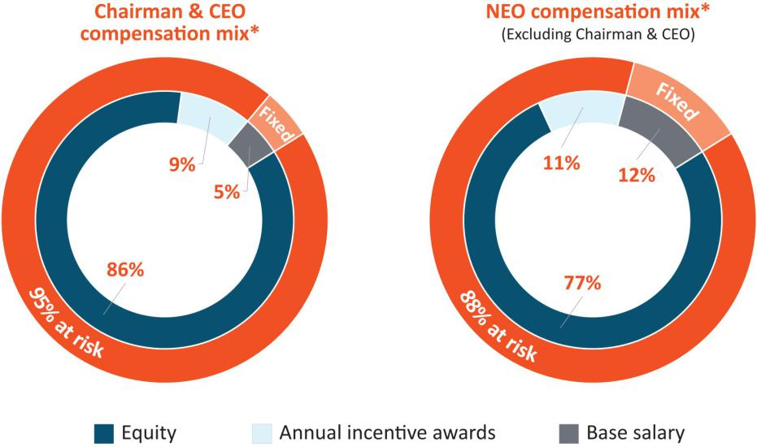

* Percentages displayed are rounded.

See “Executve Compensaton – Compensaton Discussion and Analysis - Executve summary – Pay-for-performance” on page 58 for a descripton of the components that make up each of the compensaton mix elements.

 | EXL 2026 Proxy Statement | / 11

Table of Contents

Our board of directors

Our board of directors

Our board of directors currently consists of eight directors (including our seven director nominees, and one of our directors who currently serves on the board, but will not stand for re-electon) with varied experience, including in data and AI, digital operatons and solutons, client industries, informaton and cybersecurity, human capital management, sustainability, and fnance and accountng, among others.
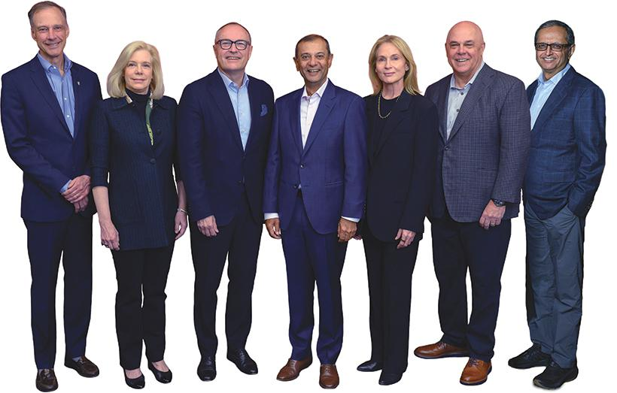

From lef: Thomas Bartlet (Independent Director and Compensaton and Talent Management Commitee Chair), Sarah K. Williamson (Independent Director), Andreas Fibig (Independent Director and Nominatng and Governance Commitee Chair), Rohit Kapoor (Chairman and CEO), Kristy Pipes (Independent Director and Audit Commitee Chair), Pat Geraghty (Independent Director) and Vikram Pandit (Lead Director). Not pictured: Nitn Sahney (Independent Director)*.

* Not standing for re-electon

12 | / | EXL 2026 Proxy Statement

Table of Contents

Our board of directors

Director nominees for electon at the Annual Meetng

Upon the recommendaton of our Nominatng and Governance Commitee, we are pleased to propose seven of our existng directors as nominees for electon as directors at the Annual Meetng.

Our nominees for electon as directors at the Annual Meetng are as follows:
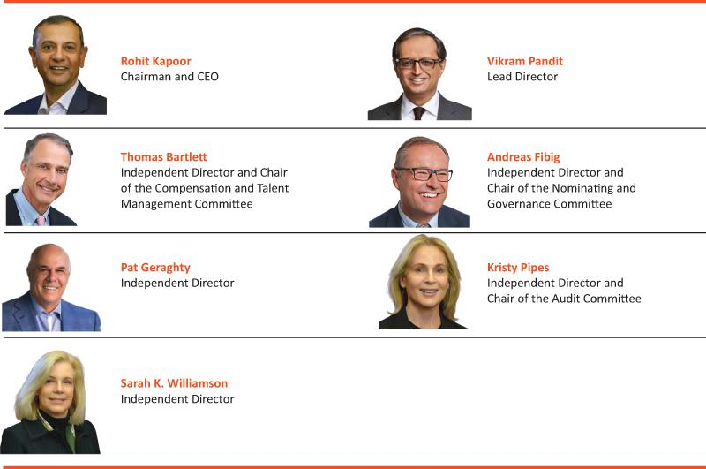

We believe that our director nominees, individually and together as a whole, possess the requisite skills, experience and qualifcatons necessary to maintain an efectve board to serve the best interests of the Company and its stockholders as described below under “Director qualifcatons” beginning on page 25.

The name, age (as of the date of this Proxy Statement), principal occupaton and other informaton, including the specifc experience, qualifcatons, atributes or skills that led to the conclusion that such person should serve as a director of the Company, with respect to each of the nominees, are set forth below. There are no family relatonships among any of our directors or executve ofcers.

 | EXL 2026 Proxy Statement | / 13

Table of Contents

Our board of directors

Nominees for electon at the Annual Meetng – Biographical informaton
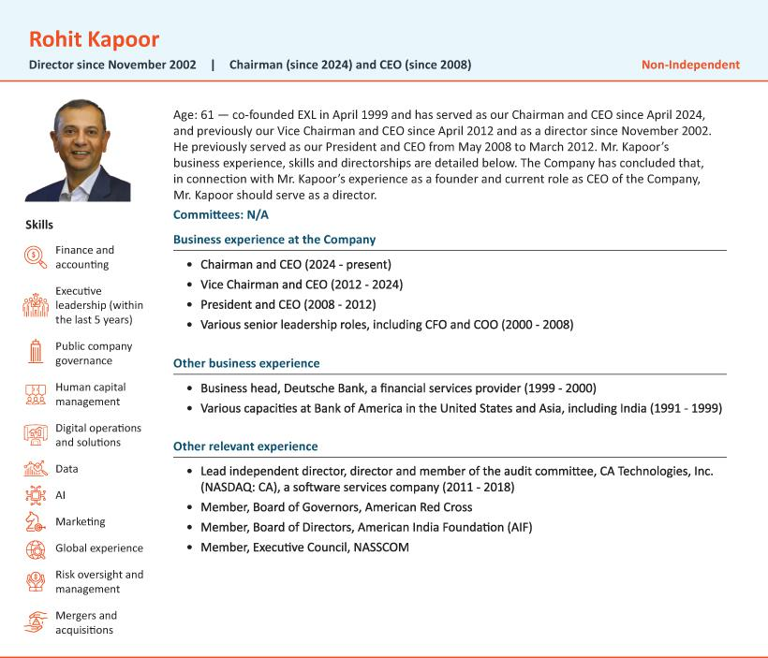

14 | / | EXL 2026 Proxy Statement

Table of Contents

Our board of directors
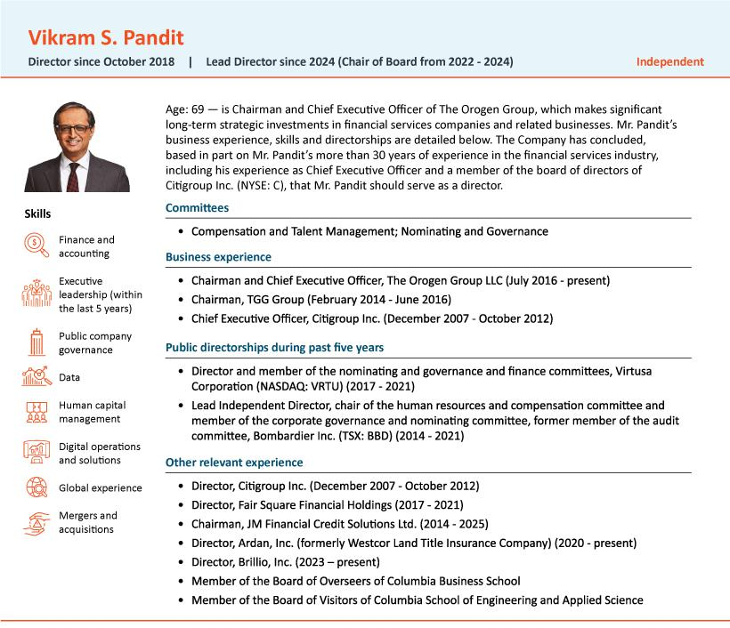

 | EXL 2026 Proxy Statement | / 15

Table of Contents

Our board of directors
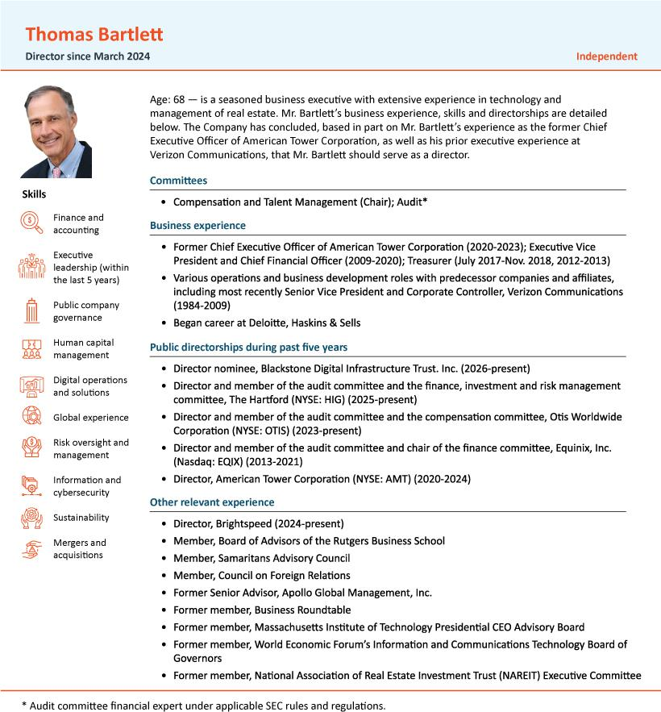

16 | / | EXL 2026 Proxy Statement

Table of Contents

Our board of directors
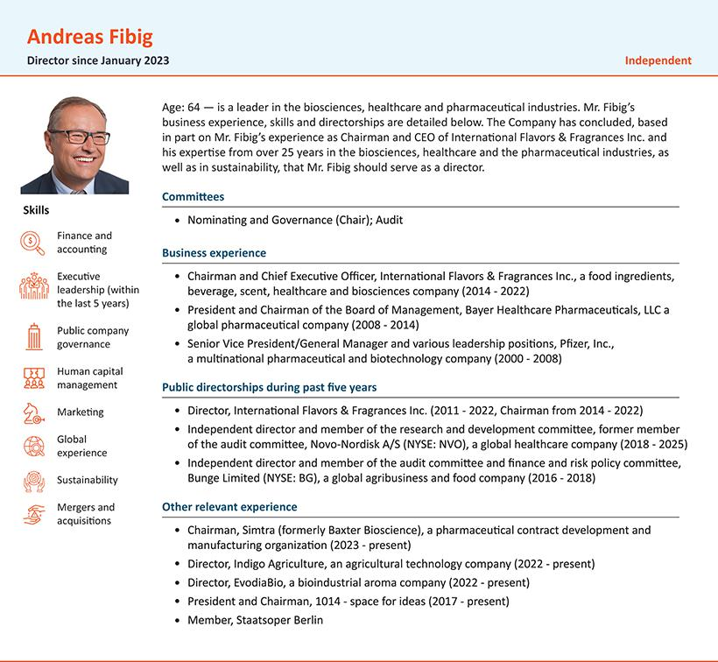

 | EXL 2026 Proxy Statement | / 17

Table of Contents

Our board of directors
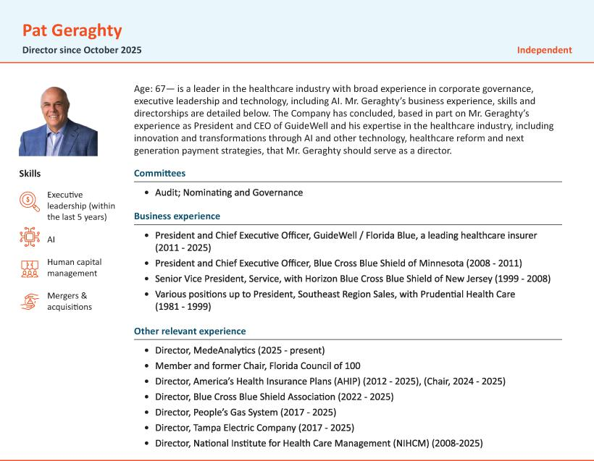

18 | / | EXL 2026 Proxy Statement

Table of Contents

Our board of directors
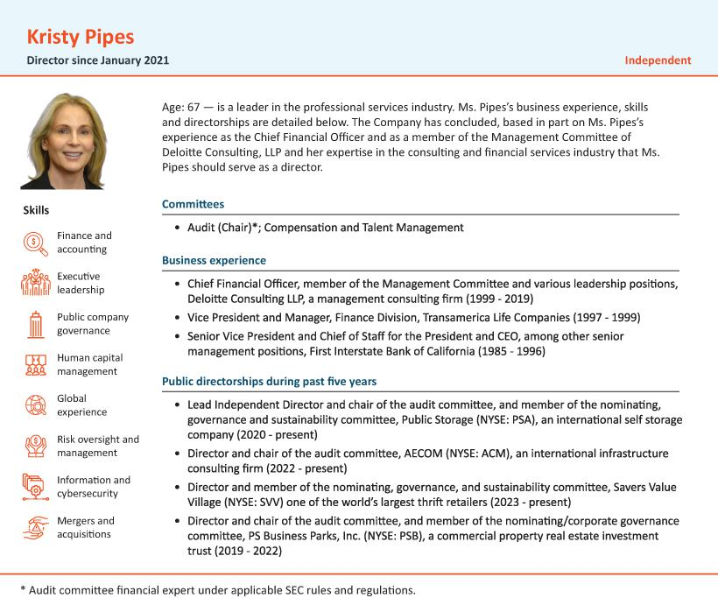

 | EXL 2026 Proxy Statement | / 19

Table of Contents

Our board of directors
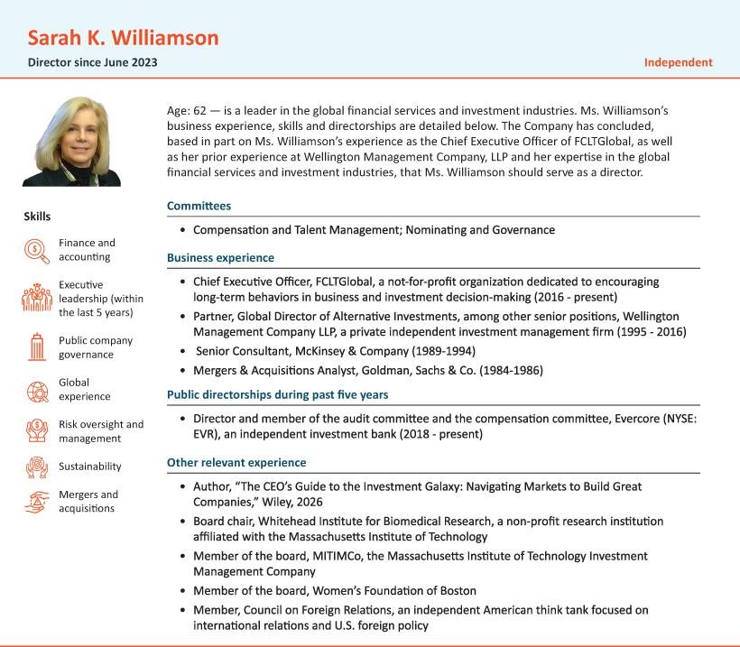

20 | / | EXL 2026 Proxy Statement

Table of Contents

Corporate governance

Corporate governance

Director independence

In determining director independence, the board of directors considered the transactons and relatonships set forth below under “Certain Relatonships and Related Person Transactons—Related Party Transactons.” Based on its review of all applicable relatonships, our board of directors has determined that all of the members on our board of directors, other than Mr. Kapoor, meet the independence requirements of the Nasdaq Stock Market and federal securites laws.

Meetng atendance

We expect our directors to atend all board meetngs and meetngs of commitees on which they serve. We also expect our directors to spend sufcient tme and meet as frequently as necessary to discharge their responsibilites properly. Each director atended at least 75% of the aggregate meetngs of our board of directors and the commitees on which they served during 2025. It is our policy that all of our directors standing for electon should atend our Annual Meetngs of Stockholders absent exceptonal cause.

Incumbent director meetng atendance
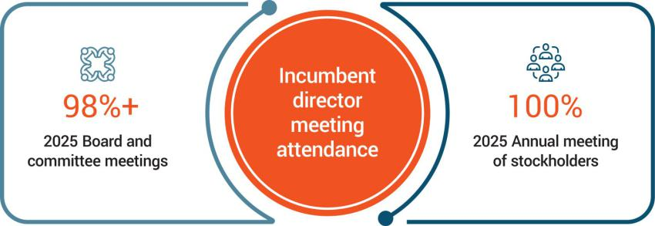

Board and Commitee meetngs in 2025
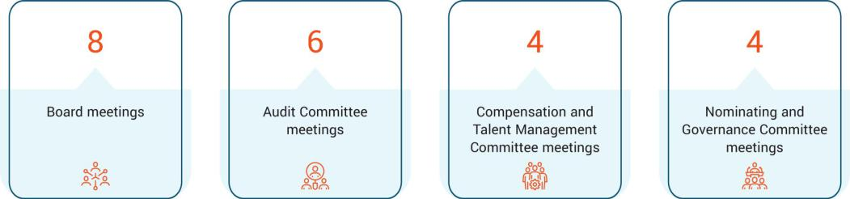

 | EXL 2026 Proxy Statement | / 21

Table of Contents

Corporate governance

Corporate governance framework

Our board is responsible for providing governance and oversight over the efectveness of policy and decision-making with respect to the strategy, operatons and management of EXL, to enhance our long-term fnancial performance and stockholder value.

Our board’s commitment to strong corporate governance is informed by the fve core values of our corporate culture: innovaton, respect, integrity, excellence and collaboraton. Our board seeks to maintain best practces in corporate governance by reviewing our governance policies at least annually and making updates as appropriate. Our board provides oversight over our risk management and strategic planning, as discussed further below.
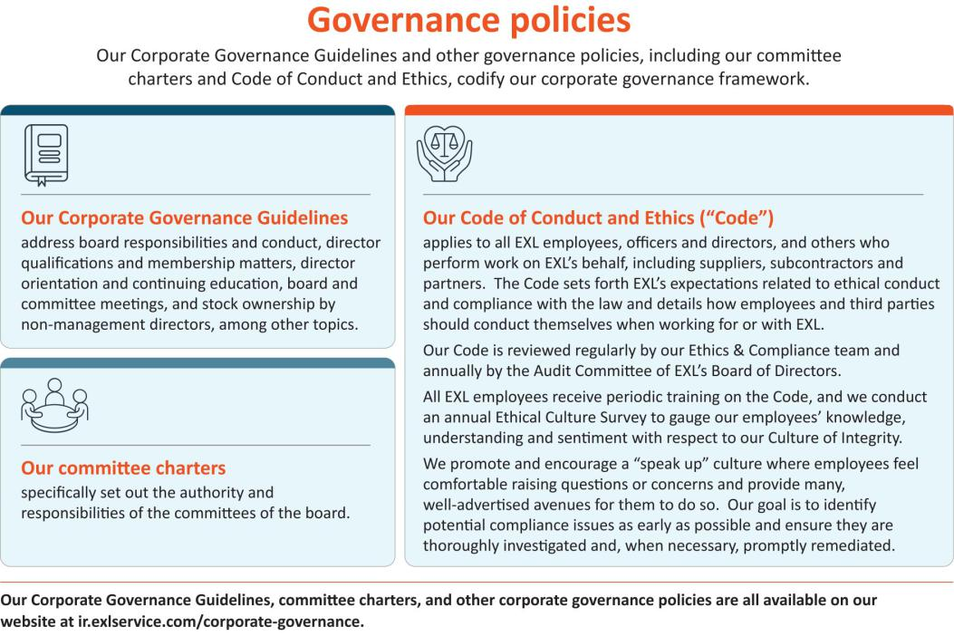

22 | / | EXL 2026 Proxy Statement

Table of Contents

Corporate governance

Beyond the boardroom
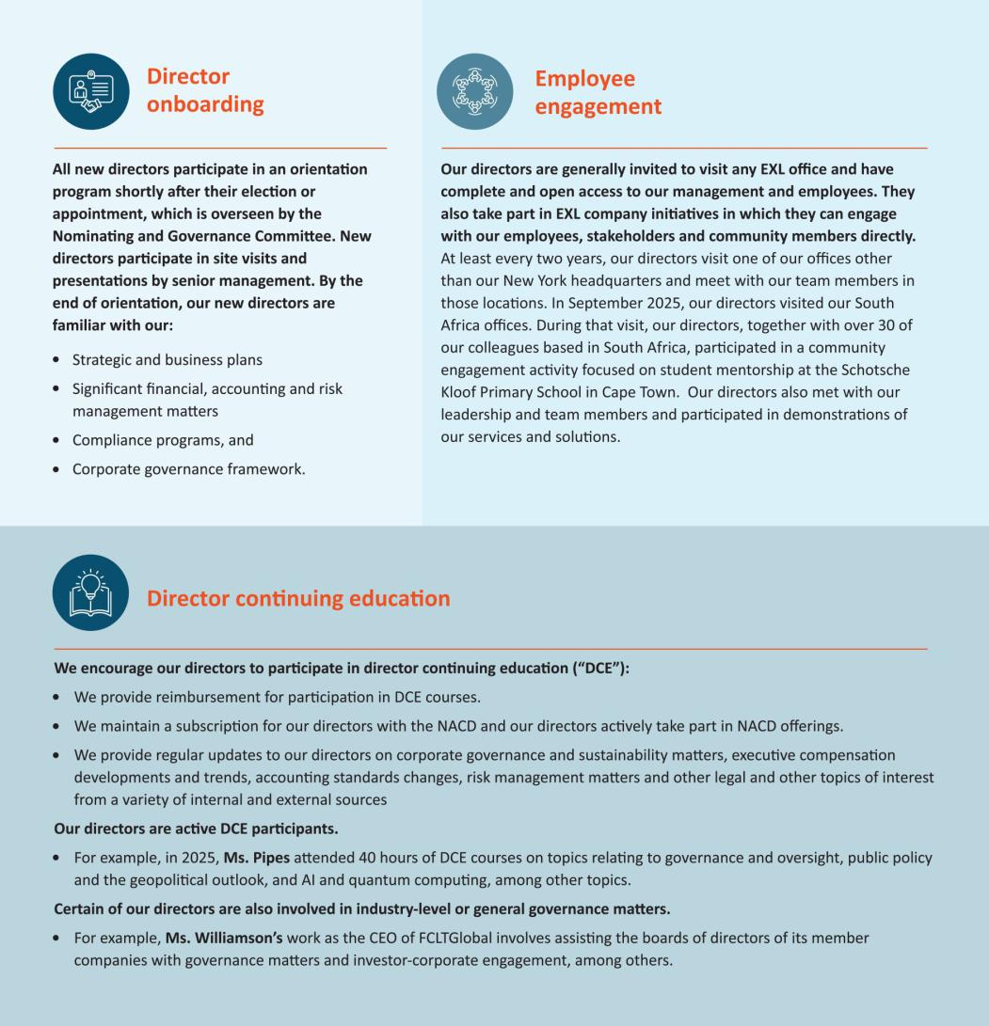

 | EXL 2026 Proxy Statement | / 23

Table of Contents

Corporate governance

Board leadership structure

Our board of directors is currently led by Rohit Kapoor, our Chairman and CEO, and Vikram Pandit, our Lead Director.

Our Chairman and CEO, a non-independent director, was appointed to his current Chairman role in April 2024, at which tme Mr. Pandit, an independent director and our former Chair, was appointed Lead Director. Our Sixth Amended and Restated By-laws (our “By-laws”) and our board policies and practces provide for the following functons and responsibilites, among others, of our Chairman and our Lead Director:
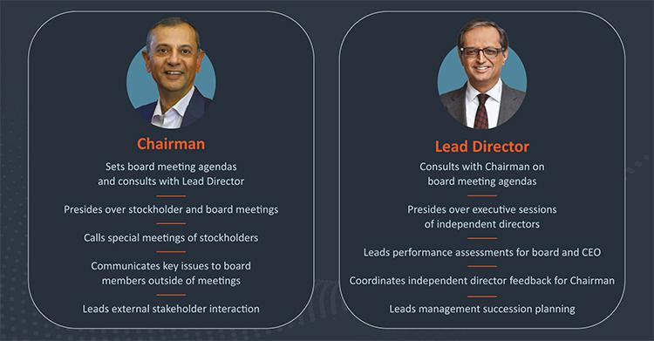

Under our By-laws and Corporate Governance Guidelines, our Chairman generally presides at meetngs of our board of directors and stockholders and may call special meetngs of the board and stockholders. In the Chairman’s absence, our Lead Director presides at board meetngs (and, if both are absent, another director as determined by the board). Our Lead Director has signifcant board leadership responsibilites, including supportng director nominatons and independence consideratons, overseeing director orientaton and contnuing educaton and representng the independent directors in communicatons with stockholders and other stakeholders. The independent directors meet at least quarterly in executve session without management present, and our Lead Director, or in the Lead Director’s absence another independent director, presides at those sessions.


The board of directors does not have a permanent policy or practce regarding the combinaton of the Chairman and CEO role. At present, the board believes that consolidatng the Chairman and CEO positons allows our CEO to contribute his experience and perspectve regarding management and leadership of the Company towards the goals of improved corporate governance and greater management accountability. This structure also provides greater informaton fow between our management team and directors. At the same tme, the delineaton of responsibilites between our Lead Director and our Chairman and CEO, which provides our Lead Director with signifcant leadership dutes, enables the Company to beneft from the ability to integrate the collectve leadership and corporate governance experience of our Lead Director and our Chairman and CEO, while retaining the ability to facilitate the functoning of the board of directors independently of our management and to focus on our commitment to corporate governance.

For the foregoing reasons, our board of directors has determined that its leadership structure is appropriate and in the best interests of our stockholders at this tme.

24 | / | EXL 2026 Proxy Statement

Table of Contents

Corporate governance

Director qualifcatons, refreshment and evaluatons

Director qualifcatons

The board of directors considers it paramount to achieving excellence in corporate governance to assemble a board of directors that, taken together, has the breadth of skills, qualifcatons, experience and atributes appropriate for functoning as the board of our Company and working productvely with management. The Nominatng and Governance Commitee of the board is responsible for recommending nominees who are qualifed and bring a broad set of skills and qualifcatons to oversee the Company efectvely.
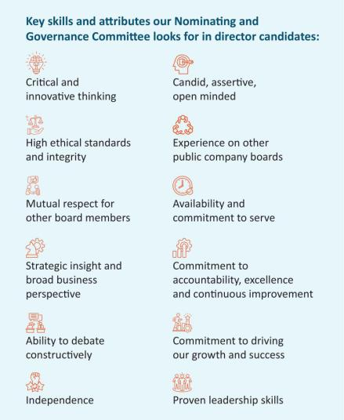

The Nominatng and Governance Commitee has not formally established any

minimum qualifcatons for director candidates, but pursuant to our Corporate Governance Guidelines, our board seeks independent directors from varied professional and personal backgrounds who combine a broad spectrum of experience and expertse with a reputaton for integrity. The board believes that its directors should possess a range of backgrounds, skills and experiences and endeavors to consider such criteria in the context of the needs of the board. The Nominatng and Governance Commitee assesses each director candidate on this basis. The Nominatng and Governance Commitee considers several factors in selectng director candidates, including, among others: ethical standards and integrity; independence; professional and personal backgrounds; skills and experience; other public company directorships; fnancial literacy and expertse; communicaton skills; and ability and willingness to comply with Company policies and procedures.

In light of our business, the primary areas of experience, qualifcatons and atributes typically sought and put forward by the Nominatng and Governance Commitee in director candidates include, but are not limited to, the following:


Executve leadership

Experience holding signifcant leadership positons, including as a CEO or head of a signifcant business, to help us drive business strategy, growth and performance.



Finance and accountng
Expertse in fnance, accountng or fnancial reportng processes, to help drive fnancial performance.



Global companies
Experience working outside of the United States or with multnatonal companies, to help facilitate our global expansion.

 | EXL 2026 Proxy Statement | / 25

Table of Contents

Corporate governance


Board experience

Understanding of public company board of director and fduciary dutes, to help provide perspectve on corporate governance best practces and related maters.



Data and AI

Experience with data analytcs, digital operatons and solutons, artfcial intelligence and machine learning, and other key technologies that are central to our business.



Client and industry knowledge

Experience with our key client industries, including insurance, healthcare, banking and fnancial services, fnance/accountng, and our other capabilites, to help deepen our knowledge of our key industry vertcals and markets in which we do business.



Risk oversight/management
Experience assessing and overseeing the overall risk profle of multnatonal public companies.



Human capital management

Experience in management and development of human capital, including management of a large workforce, diversity and inclusion, talent development, workplace health and safety, compensaton and other human capital issues.



Varied backgrounds
We seek directors with varied professional and personal backgrounds and perspectves to provide a range of viewpoints.



Experience in sustainability maters
Experience in managing sustainability maters, incorporatng them into business and strategy and associated risks.



Informaton and cybersecurity
Experience in informaton and cybersecurity maters, best practces and associated risks.



Mergers and acquisitons
Experience in mergers and acquisitons as a component of business development and strategy.



Marketng
Experience in marketng and branding of multnatonal companies.

26 | / | EXL 2026 Proxy Statement

Table of Contents

Corporate governance

Refreshment

Our Nominatng and Governance Commitee considers the size and compositon of our board (and its commitees) on a contnual basis with an aim toward creatng a balanced board with extensive experience and insttutonal knowledge, and fresh perspectve and insight.

Consideratons include whether the compositon of the board of directors (and its commitees) includes sufcient experience and skill sets, as appropriate for our immediate and long-term strategic needs. These consideratons are also informed by discussions with our investors through stockholder engagement.

Our Nominatng and Governance Commitee also considers the length of tenure of the directors as a whole. Following the Annual Meetng (assuming the electon of all nominees), we will have the following balance of tenures:
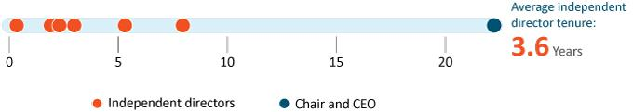

 | EXL 2026 Proxy Statement | / 27

Table of Contents

Corporate governance

Board refreshment process
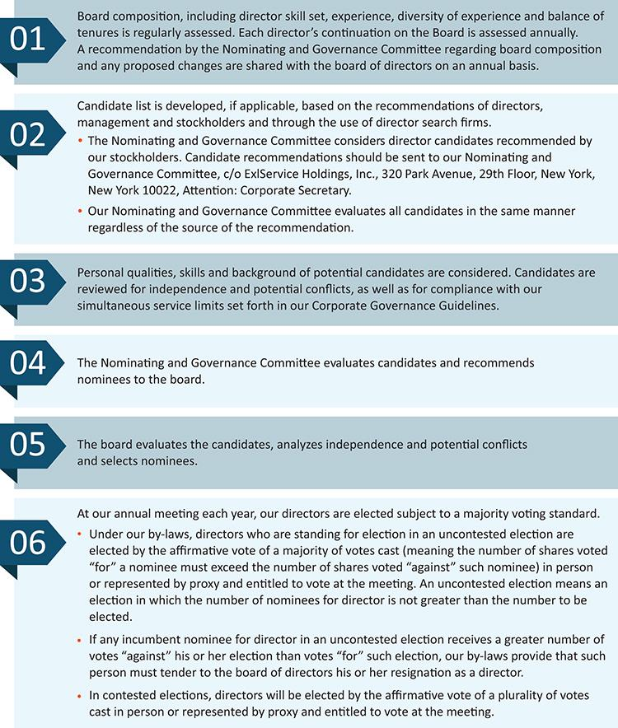

28 | / | EXL 2026 Proxy Statement

Table of Contents

Corporate governance

Commitee rotaton

We rotate commitee and commitee chair assignments based on the current compositon of the board. Recent rotatons are as follows:
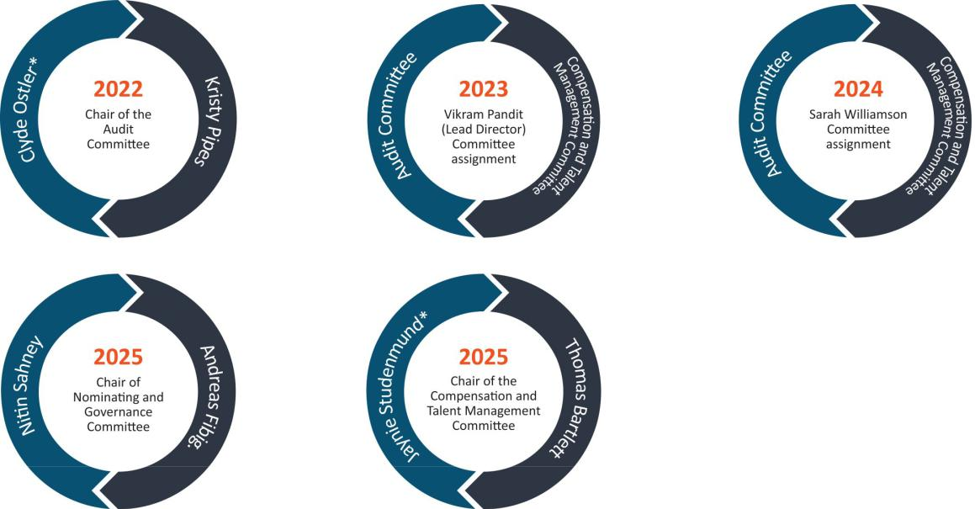

* Former director

 | EXL 2026 Proxy Statement | / 29

Table of Contents

Corporate governance

Board evaluatons

We consider the contnued efectveness of the board and its commitees as critcal to our long-term success and stockholder value. The board is commited to a rigorous evaluaton of its performance and the performance of its commitees and each director on an annual basis through the following process:
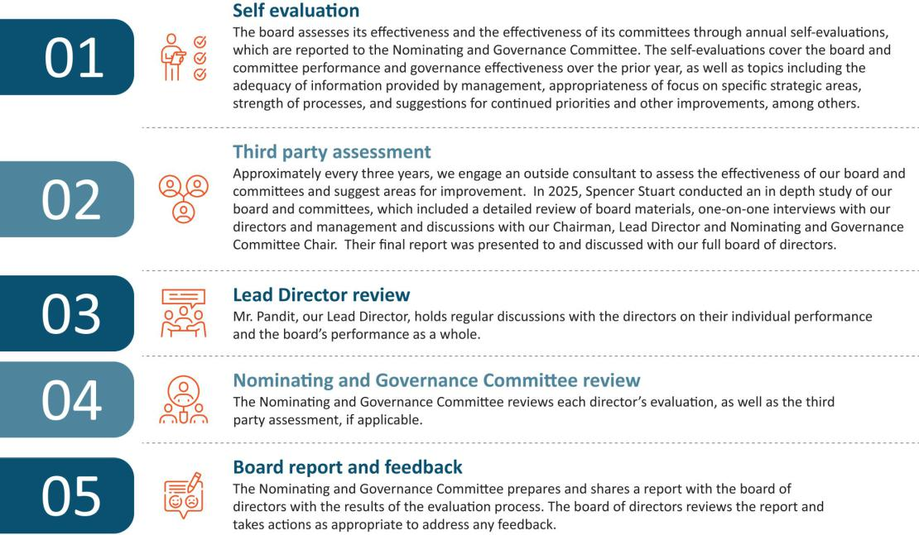

30 | / | EXL 2026 Proxy Statement

Table of Contents

Corporate governance

Succession planning

Our board of directors, guided by our Lead Director, is responsible for developing and annually reassessing succession plans for our CEO and other key executve ofcers of the Company, and preparing contngency plans for interim CEO succession in the event of an unexpected occurrence for board review. In additon, our Compensaton and Talent Management Commitee is responsible for ensuring appropriate compensaton strategies and design to align with the retenton and recruitment of our key executve ofcers. We actvely plan for the succession of our executve ofcers (including those who are retring or departng from the Company) and regularly consider our strong pipeline of internal and external candidates. As part of this process, in April 2024, Vikas Bhalla and Vivek Jetley, were each promoted to President of EXL in additon to their business head roles and became responsible for broader Company-wide responsibilites. In additon, in 2025 we re-aligned several leaders within the Company to enhance collaboraton between groups and accelerate innovaton in areas such as data modernizaton and artfcial intelligence. These new roles are refected below under “Our Executve Ofcers.”

We generally consider succession planning and associated executve compensaton maters on the following schedule:
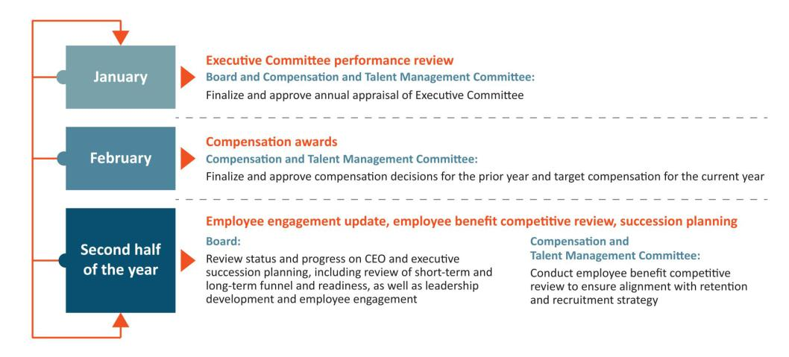

 | EXL 2026 Proxy Statement | / 31

Table of Contents

Corporate governance

Commitees

Our board of directors has three standing commitees: the Audit Commitee, the Compensaton and Talent Management Commitee and the Nominatng and Governance Commitee. As discussed above, our board of directors has determined that each member of the Audit, Compensaton and Talent Management and Nominatng and Governance Commitees meets the independence and experience requirements of the Nasdaq Stock Market and federal securites laws. Copies of our commitee charters can be found on the Investor Relatons page of our website at: htps://ir.exlservice.com/corporate-governance. Informaton on our website referred to in this Proxy Statement does not consttute a part of this Proxy Statement.

The following table sets forth the current chairs and members of each standing commitee of the board of directors. As an executve director, Mr. Kapoor, our Chairman and CEO, does not serve on any board commitee.
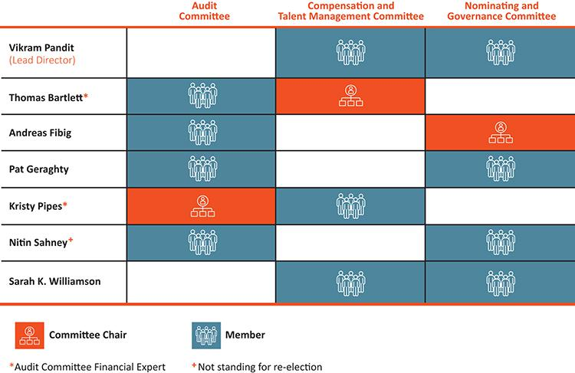

32 | / | EXL 2026 Proxy Statement

Table of Contents

Corporate governance

Audit Commitee

Our Audit Commitee assists our board of directors in its oversight of our accountng and fnancial reportng processes, including the integrity of the fnancial statements and other fnancial informaton provided by us to our stockholders, the public, stock exchanges and others; our compliance with legal and regulatory requirements; our independent registered public accountng frm’s qualifcatons and independence; the audit of our fnancial statements; the performance of our internal audit functon and independent registered public accountng frm; the Company’s cybersecurity program and cyber strategy-related risks; business contnuity and disaster recovery planning; our compliance program, including our Code of Conduct and Ethics and the processes used to disseminate it to our employees and monitor their compliance with its requirements; corporate insurance; and sustainability-related disclosures, processes and controls. Its risk oversight is discussed below beginning on page 36. The commitee’s charter permits the commitee to form and delegate authority to subcommitees when appropriate, provided that the subcommitees are composed entrely of directors who satsfy the applicable independence requirements under federal securites laws and Nasdaq Stock Market rules.
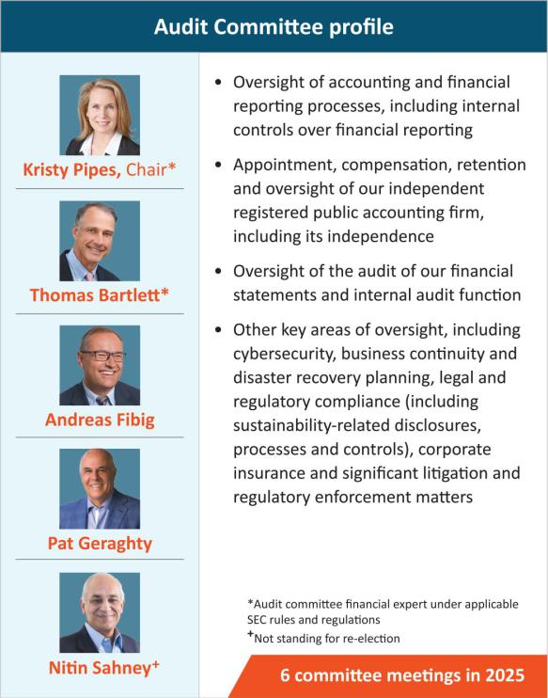

Our Audit Commitee has direct responsibility for the appointment, compensaton, retenton (including terminaton) and oversight of our independent registered public accountng frm, and our independent registered public accountng frm reports directly to our Audit Commitee. It also reviews and approves specifed related-party transactons that are required to be disclosed under applicable securites disclosure rules, or as required by the rules of the Nasdaq Stock Market. The Audit Commitee was established in accordance with Secton 3(a)(58)(A) of the Securites Exchange Act of 1934 (the “Exchange Act”). Our Audit Commitee annually reviews and assesses the adequacy of its charter and its own performance.

The members of our Audit Commitee are appointed by our board of directors. All members of the commitee must also be recommended by our Nominatng and Governance Commitee.

 | EXL 2026 Proxy Statement | / 33

Table of Contents

Corporate governance

Compensaton and Talent Management Commitee

Our Compensaton and Talent Management Commitee reviews and recommends policies relatng to compensaton and benefts of our directors, ofcers and employees and is responsible for approving the compensaton of our Chairman and CEO and other executve ofcers, as well as overseeing our employee benefts policies, programs and administraton. The commitee reviews, evaluates and makes recommendatons to our board of directors with respect to our incentve compensaton plans and equity-based plans and administers the issuance of awards under our equity incentve plans. It also provides oversight with respect to human capital management maters, including talent and leadership engagement, development and training. The commitee’s charter permits the commitee to form and delegate authority to subcommitees when appropriate, provided that the subcommitees are composed entrely of directors who satsfy the applicable independence requirements of the Nasdaq Stock Market rules.
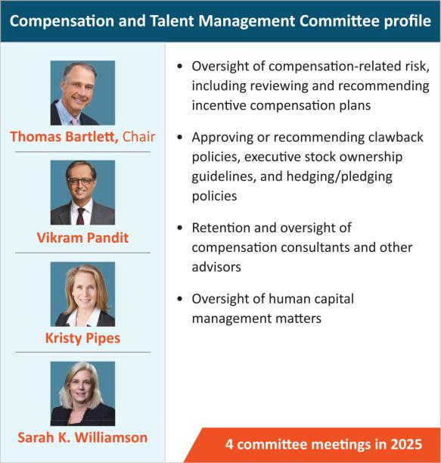

The Compensaton and Talent Management Commitee charter also permits the commitee to retain advisors, consultants or other professionals to assist the commitee to evaluate director, Chairman and CEO or other senior executve compensaton and to carry out its dutes. For 2025 and contnuing into 2026, our Compensaton and Talent Management Commitee retained the services of Farient Advisors LLC (“Farient”), a qualifed and independent compensaton consultant, to aid the commitee in performing its review of executve compensaton including executve compensaton benchmarking and peer group analysis. Our Compensaton and Talent Management Commitee annually reviews and assesses the adequacy of its charter and its own performance. Additonal informaton regarding our Compensaton and Talent Management Commitee’s processes and procedures for considering executve compensaton are addressed in the Compensaton Discussion and Analysis below.

The members of our Compensaton and Talent Management Commitee are appointed by our board of directors. All new members of the commitee must be recommended by our Nominatng and Governance Commitee. During 2025, none of our executve ofcers served as a member of the board of directors or compensaton commitee (or similar) of any entty that has one or more executve ofcers who serve on our board of directors or Compensaton and Talent Management Commitee.

34 | / | EXL 2026 Proxy Statement

Table of Contents

Corporate governance

Nominatng and Governance Commitee

Our Nominatng and Governance Commitee is primarily responsible for:
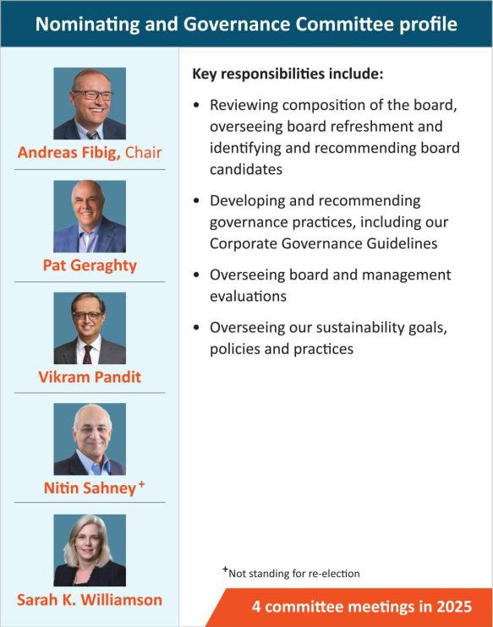
- identfying and recommending candidates for electon to our board of directors using selecton criteria approved by our board of directors, reviewing compositon of the board and commitee membership and overseeing board refreshment and reviewing and recommending to our board of directors non-employee director compensaton and benefts maters, (ii) developing and recommending to our board of directors Corporate Governance Guidelines, including independence standards, and other board procedures or corporate governance policies, as well as any changes to such guidelines, procedures or policies or to any of our organizatonal documents; (iii) overseeing our board of director, board commitee, individual director and management evaluatons and our director educaton program, and (iv) overseeing our sustainability-related goals, policies and practces. The commitee’s charter permits the commitee to form and delegate authority to subcommitees when appropriate, provided that the subcommitees are composed entrely of directors who satsfy the applicable independence requirements of the Nasdaq Stock Market rules.

Our Nominatng and Governance Commitee reviews writen and oral informaton provided by and about candidates and considers any additonal criteria it feels are appropriate to ensure that all director nominees possess appropriate skills and experience to serve as a member of our board of directors.

It also oversees our director onboarding and training program, which provides new directors with training regarding the Company’s policies and procedures and specifc requirements that may be needed based on the director’s commitee memberships.

In additon, the Nominatng and Governance Commitee oversees and reviews the Company’s sustainability goals, policies and programs and the Company’s corporate governance policies and practces regularly. It is responsible for reviewing and assessing the adequacy of our organizatonal documents and recommending any changes and annually reviewing and assessing the adequacy of its charter and its own performance. The members of our Nominatng and Governance Commitee are appointed by our board of directors.

 | EXL 2026 Proxy Statement | / 35

Table of Contents

Corporate governance

Board and commitee oversight of risk management
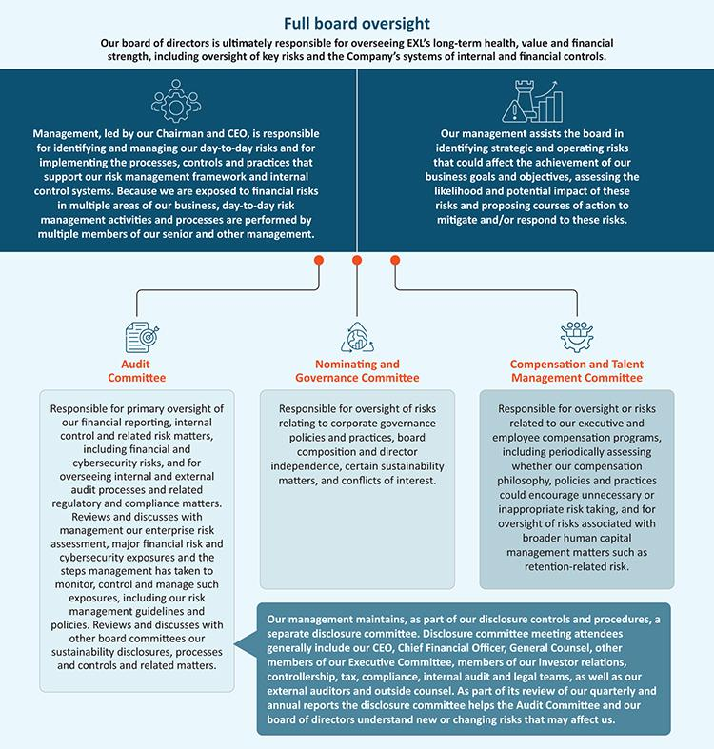

36 | / | EXL 2026 Proxy Statement

Table of Contents

Corporate governance

Cybersecurity risk management

Given the nature of our business, EXL is highly focused on maintaining a robust and comprehensive program that identfes and manages a broad range of informaton security, cybersecurity and data privacy, referred to collectvely herein as “cybersecurity,” risks on behalf of our clients and their customers, as well as our employees, contractors and any relevant third partes.

Our board’s Audit Commitee has primary oversight over cybersecurity and receives briefngs from management throughout the year, typically on a quarterly basis, regarding our security risk management, including cybersecurity-related risks, vulnerabilites, policies, practces, and strategic initatves. This also includes oversight of data governance and privacy practces. At least once a year, our board receives a report from management on our cybersecurity posture, our readiness and our capability to reduce the risk of, detect and respond to a cyber-atack.

Day-to-day management over cybersecurity is managed by our cross-functonal cybersecurity apex body, the Management Security, Contnuity and Privacy Forum, which is comprised of representatves from our management, business unit heads, and enterprise functons, such as legal, human resources, fnance, growth and strategy, compliance, technology and informaton security. Our AI Governance Commitee, which is further described below, provides management-level oversight and directon as specifcally relates to secure AI practces and risk management.

Our cybersecurity team consists of qualifed technical cybersecurity professionals, business contnuity specialists and atorneys. We regularly conduct cybersecurity and other risk assessments and compliance audits both internally and through third party auditors that we independently engage or that we engage in connecton with our certfcaton to certain internatonal standards. We also regularly assess and deploy technical safeguards and conduct vulnerability assessment and penetraton testng of our technology environment independently and through third partes. We use the outcome of these assessments to align our cybersecurity program and technical safeguards with the evolving cybersecurity threat landscape and adjust and augment our security controls environment as required. We also periodically engage third-party experts to review and assess our cybersecurity governance and management, including as may relate to our use of suppliers and third party partners.

 | EXL 2026 Proxy Statement | / 37

Table of Contents

Corporate governance

In 2025, our board and senior management completed cybersecurity tabletop exercises to further our preparedness in the event of a need to address a variety of cybersecurity threat scenarios.
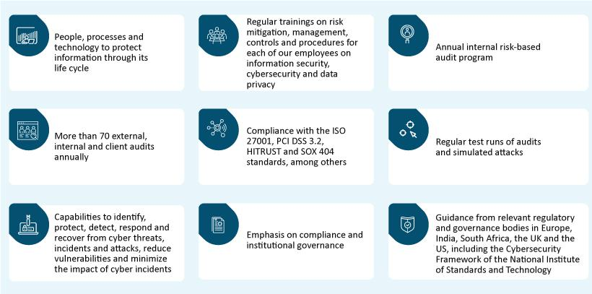

For more details on our cybersecurity program, see “Sustainability – Cybersecurity at EXL” on page 49.

38 | / | EXL 2026 Proxy Statement

Table of Contents

Corporate governance

Sustainability risk management

Our board reviews and receives regular reports on sustainability risks, including those relatng to sustainability disclosures, employee safety, environmental-related eforts, human capital management maters, and corporate governance trends and best practces. We also receive third-party limited assurance of the informaton contained in our annual Sustainability Report from a Big 4 accountng frm afliate. Each of our board commitees oversees sustainability-related risks related to maters within their purview:
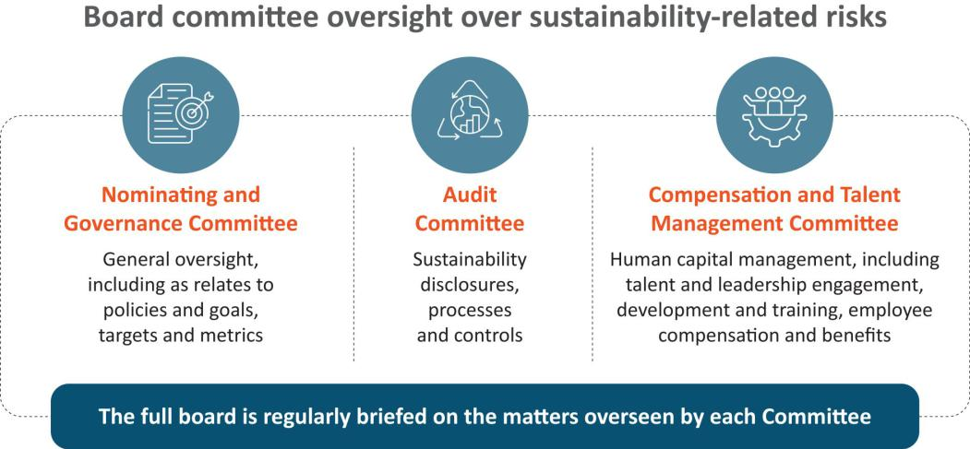

We maintain a cross functonal management-level sustainability steering commitee (“Sustainability Steering Commitee”), which is responsible for setng our sustainability strategy and risk management, updatng our management and board on sustainability-related developments, including applicable regulatory changes, overseeing our internal and external disclosures on sustainability maters, and providing implementaton support across our Company. The Sustainability Steering Commitee works in close coordinaton with the board, advising and assistng in the board’s oversight of sustainability risks and other maters. For more details on our sustainability-related eforts, see “Sustainability” on page 42.

Artfcial intelligence risk management

We have a centralized, cross-functonal management-level AI Governance Commitee, which oversees the use of AI models by EXL, and is jointly led by our General Counsel and Chief Informaton Ofcer and supported by our corporate compliance team, and digital, analytcs and applicable business leads. The AI Governance Commitee is guided by our global AI Governance Policy.

Our board and our Audit Commitee are briefed from tme to tme by management and third-party frms on AI-related risks and opportunites, including in-depth discussions regarding current AI deployments with our customers. For more details on the use of responsible AI, see “Responsible artfcial intelligence” on page 49.

 | EXL 2026 Proxy Statement | / 39

Table of Contents

Corporate governance

Stockholder engagement

In 2025 and early 2026, we contnued our formal governance-focused stockholder outreach program. Given our frequent engagement and the maturity of our stockholder outreach program, a number of our stockholders with which we engaged in prior years elected to defer meetng again to a future year. For the meetngs we conducted with our stockholders in 2025 and early 2026, EXL was represented by our management and members of our legal and investor relatons teams. We discussed the topics listed below.

~64% | Outreach to stockholders by
~64% | shares outstanding during
~64% | 2025-2026 season
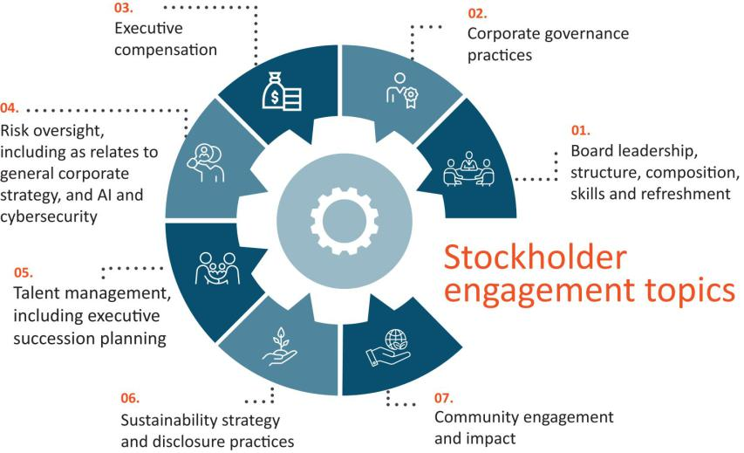

EXL also regularly interacts and shares informaton with our stockholders through our quarterly earnings calls, investor meetngs, SEC flings and publicatons on our website, among others. The feedback received from our stockholders is shared with and reviewed by our board, which is used to inform and focus our decisions relatng to our governance and sustainability practces and to improve our disclosures.

40 | / | EXL 2026 Proxy Statement

Table of Contents

Corporate governance

Communicatons with the board

Stockholders interested in contactng our board of directors, Lead Director or the directors who meet in executve session are invited to do so by writng to:

Board of Directors of ExlService Holdings, Inc.

c/o Corporate Secretary

ExlService Holdings, Inc.

320 Park Avenue, 29th Floor

New York, New York 10022

All other stockholder communicatons addressed to our board of directors will be referred to our Chairman and CEO and our Lead Director and tracked by our Corporate Secretary. Stockholder communicatons specifcally addressed to a partcular director will be referred to that director.

Complaints and concerns relatng to our accountng, internal accountng controls or auditng maters should be communicated to our Audit Commitee, which consists solely of non-employee directors. Any such communicaton may be anonymous and may be reported to our Audit Commitee through our General Counsel by writng to:

Audit Commitee of the Board of Directors

ExlService Holdings, Inc.

320 Park Avenue, 29th Floor

New York, New York 10022

Atn: General Counsel

All such concerns will be reviewed under Audit Commitee directon and oversight by our General Counsel, our Head of Internal Audit or such other persons as our Audit Commitee determines to be appropriate. Confdentality will be maintained to the fullest extent possible, consistent with the need to conduct an adequate review. Prompt and appropriate correctve acton will be taken when and as warranted in the judgment of our Audit Commitee. We prepare periodic summary reports of all such communicatons for our Audit Commitee.

 | EXL 2026 Proxy Statement | / 41

Table of Contents

Sustainability

Sustainability
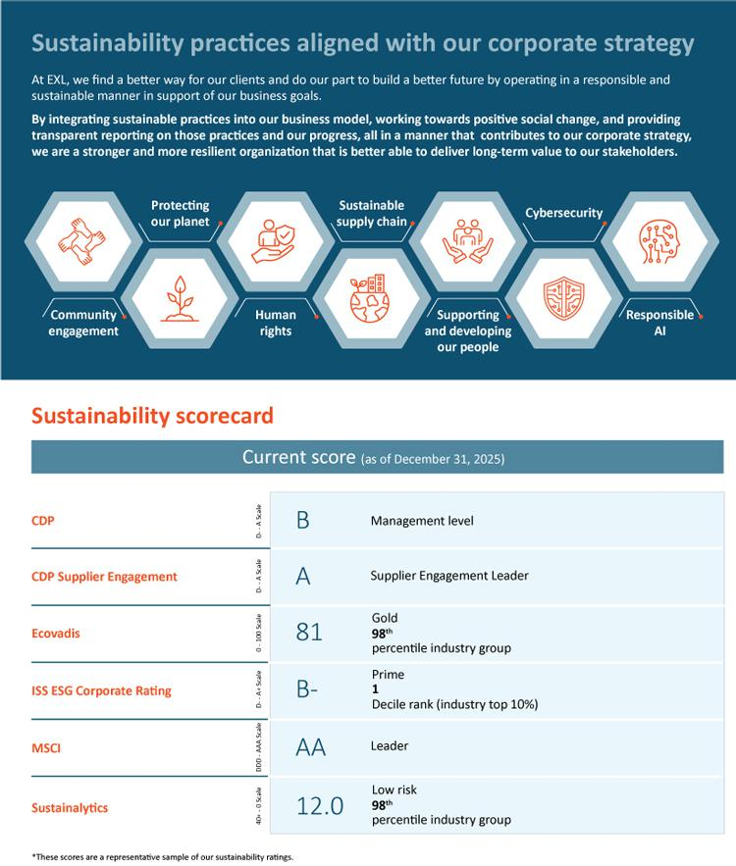

42 | / | EXL 2026 Proxy Statement

Table of Contents

Sustainability

Community engagement
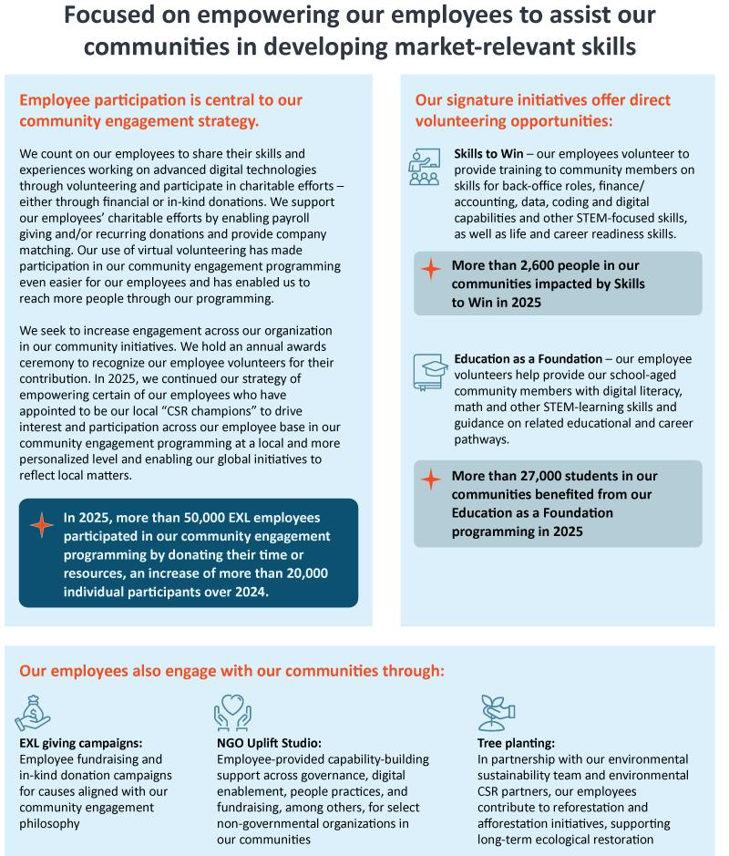

EXL 2026 Proxy Statement / 43

Table of Contents

Sustainability

Environmental sustainability; Sustainable supply chain
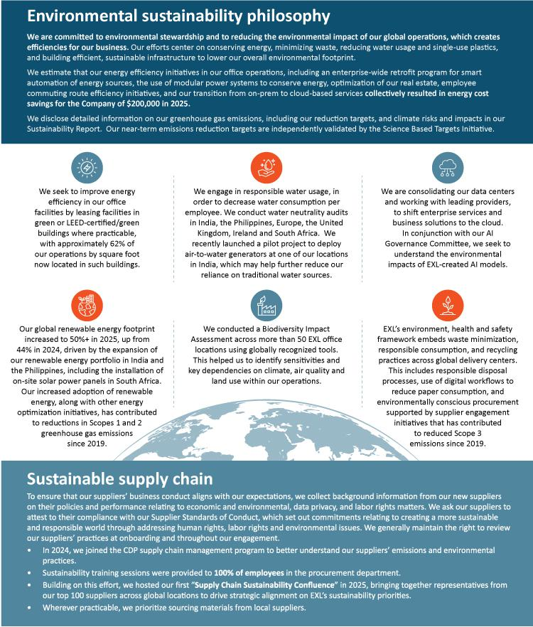

44 | / | EXL 2026 Proxy Statement

Table of Contents

Sustainability

Supportng and developing our people

At EXL, our people are our greatest asset and a key diferentator in delivering data and AI-driven solutons that fuel long-term strategic growth. We invest in fostering a high-performance, people-frst culture that prioritzes contnuous learning, personalized development, and robust upskilling — partcularly in data and AI capabilites — to ensure our workforce remains future-ready and highly engaged. This commitment to employee advancement is refected in our workplace culture grounded in collaboraton, innovaton, and respect. We provide our employees access to democratzed talent development programs, as well as employee resource groups, mentorship and professional networking opportunites to reinforce engagement, cultvate varied perspectves, and align with our core values, all of which help EXL atract, develop, and retain top talent empowered to meet evolving client needs. On an annual basis, our Compensaton and Talent Management Commitee reviews a comprehensive human capital strategic review prepared by management, followed by a full board review.

Our workplace culture

We believe that diversity of perspectve and experience is fundamental to our ability to innovate and deliver on our global strategy. EXL’s inclusive workplace culture is anchored in a governance framework with strategic directon and executon supported by a global, cross-functonal mix of senior leaders. We assess our current gaps, develop awareness, and advance capabilites to manage unconscious bias. At EXL, we build culture and competencies to improve diversity and inclusivity. Our organizaton builds awareness at all levels, generates visibility, and encourages a culture of diverse views through sustained communicaton and employee resource groups. We are making the necessary interventons to ensure that our talent decisions and outcomes are free from bias and based on merit, efort and performance. EXL’s Diversity and Inclusion Council is an apex body that has been created to ensure that our D&I program achieves its mult-pronged objectves

Talent recruitment, development and retenton


Talent-frst mindset for our

multfaceted talent needs

We view talent as a key compettve advantage. Our talent acquisiton strategy is a core pillar of our growth and capability agenda, designed to atract high-caliber professionals with cutng-edge skills in data, AI, digital transformaton, and domain expertse. Our integrated talent management framework prioritzes proactve identfcaton of critcal roles and skills, market mapping, and a structured recruitment approach that leverages advanced online platorms, AI-enabled screening to enhance candidate experience and ft.

Integrated talent management

framework

We maintain an integrated talent management framework, employing actve collaboraton between our recruitment, capability development and human resource functons. We use data, technology, including an AI-driven infrastructure, and business insights to help us create a global talent network and stay ahead of the dynamic talent economy, while building a future-ready workforce.

Our senior leadership team and board play a critcal role in defning our talent priorites to align with
Actve role for senior leadership
our strategic vision for each of our business units, as well as with our clients’ priorites.

Contnuous employee

development

At EXL, capability development is a cornerstone of our talent strategy, designed to equip employees with the skills and expertse needed to succeed in a rapidly evolving digital, data, and AI landscape. From and afer onboarding, we promote large-scale upskilling and reskilling opportunites, while fostering an environment that supports individual skill building and career advancement through a democratzed learning ecosystem.

 | EXL 2026 Proxy Statement | / 45

Table of Contents

Sustainability

Our capability development framework

Our capability development framework is focused on addressing roles critcal to strategy, upskilling our employees with appropriate skillsets for Company-wide critcal roles and create a future-ready workforce with data, AI and domain skills. Our digital learning ecosystem enables self-directed learning with AI-curated content, personalized learning pathways, hands-on practce labs, and collaboratve forums that help individuals build digital, domain, and leadership capabilites aligned with both current roles and future opportunites.

We complement this with structured domain and technical academies, as well as targeted programs in topics such as generatve AI and customer experience to deepen specialized expertse, and training in partnership with various industry organizatons, insttutes, business schools and consultng frms.
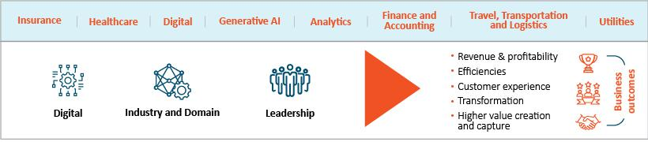

2025 Training by the numbers
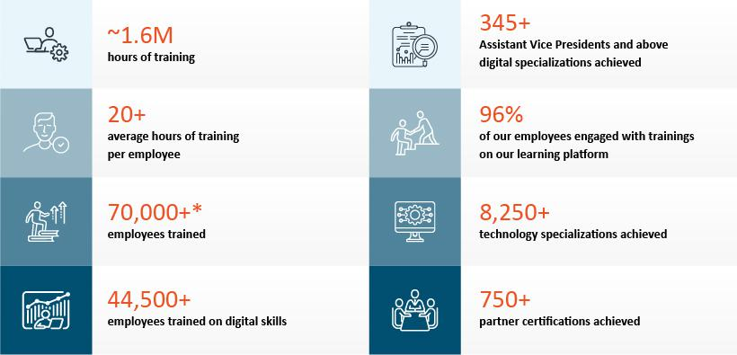

*Includes current and former employees

46 | / | EXL 2026 Proxy Statement

Table of Contents

Sustainability

Employee engagement and communicaton

We believe that each message we share with our 65,000+ employees is an opportunity to connect these colleagues across the globe with a unifed sense of purpose and encourage them to drive our culture and innovaton. Our employee engagement and internal communicatons strategy is centered on building a workforce that is connected, informed and future-ready through a narratve that is consistent, compelling, and relatable.

We strengthen alignment across EXL through clear, theme-based communicaton linked to business priorites, to make informaton accessible, engaging, and consistent. By spotlightng innovaton, employee experiences, and learning pathways, we reinforce a sense of pride and enable contnuous upskilling and AI-adopton across teams. Cross-functonal collaboraton is a cornerstone of our approach, ensuring consistent messaging and integrated campaigns that power enterprise-wide initatves.
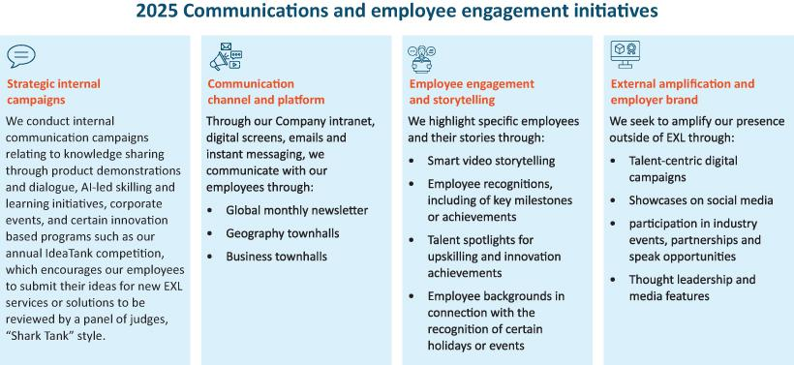

 | EXL 2026 Proxy Statement | / 47

Table of Contents

Sustainability

Benefts
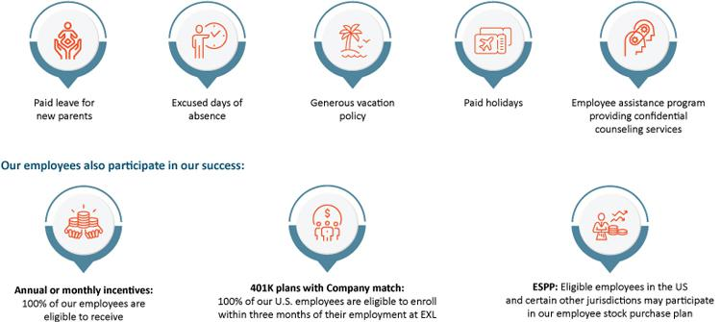

Employee health, safety and wellbeing

The health, safety and wellbeing of our employees are fundamental to our operatons and aligned with our commitment to conduct our business in a responsible and safe manner. We maintain a comprehensive Environment, Health and Safety (EHS) Management System certfed to ISO 45001:2018, which provides a structured framework to manage risks and promote workplace safety across our global operatons. We have achieved a Five Star Ratng from the Britsh Safety Council for best practces in occupatonal health and safety across our United Kingdom, India, Philippines, Europe and South Africa centers, and we contnue to operate in alignment with the guidelines of the Five Star audit framework. Training on health and safety is delivered periodically to employees, suppliers and partners, and in 2025 an updated mandatory health and safety e-learning module was launched for all employees. We conduct annual risk assessments with the objectve of identfying and minimizing workplace hazards. We have established both Company-wide and worksite-specifc safety objectves that are integrated into our EHS Management System to ensure consistent applicaton of safety practces.

Where practcable, EHS consideratons are integrated into business actvites with a focus on conductng operatons in an environmentally responsible manner while safeguarding the health and safety of employees, contractors, customers, visitors and the communites in which we operate.

48 | / | EXL 2026 Proxy Statement

Table of Contents

Sustainability

In additon to safety practces, we ofer a range of initatves to support overall employee wellbeing, including:
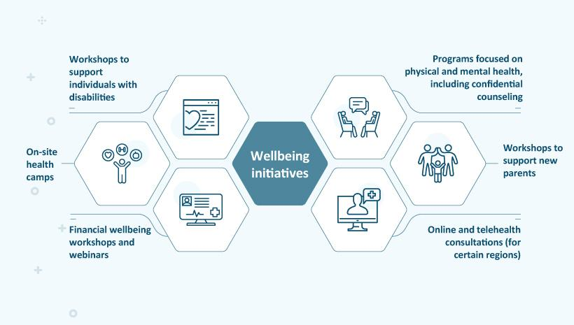

Cybersecurity at EXL

We are commited to protectng the confdentality, integrity, availability and privacy of the informaton assets of our clients and their customers, as well as our employees, and our vendors, that are shared with us and for which we are responsible. We maintain a comprehensive cybersecurity and data privacy program, based on defned policies processes and practces to safeguard the security, confdentality, integrity, availability and protecton of this informaton that we aim to contnually strengthen in order to mitgate material vulnerabilites and the impact of cyber incidents and comply with applicable data privacy laws and regulatons.

For more informaton on our cybersecurity risk management, please see “Cybersecurity risk management” on page 37. For more informaton on our informaton security and data privacy procedures, please refer to the 2025 Form 10-K, Item 1C.

Responsible artfcial intelligence

We seek to ensure that our use of AI in our business and operatons is ethical, trustworthy and responsible. Our approach to the development and applicaton of AI is grounded in the principles of fairness, security, reliability, transparency, accountability, sustainability and privacy. A strong responsible AI framework contributes to measurable business outcomes. It enables the scalable deployment of AI solutons while reducing regulatory, operatonal, reputatonal and litgaton risk. Our framework helps to build trust and accelerate client adopton.

 | EXL 2026 Proxy Statement | / 49

Table of Contents

Sustainability

Oversight over our use of AI models is provided by our centralized, cross-functonal AI Governance Commitee, which is jointly led by our General Counsel and Chief Informaton Ofcer and includes representatves from our corporate compliance team and digital and applicable business leads. Pursuant to our AI Governance Policy, new deployment of AI created by EXL is assessed against our trustworthy AI principles to promote consistent risk management, efcient model life cycle oversight and sustained business value.

Our AI Governance Policy also establishes guidelines on regulatory compliance, data privacy and security, best practces for front-end and back-end development and human oversight, helping ensure that AI-enabled solutons deliver measurable outcomes for clients while preserving trust and resilience. Our management of these risks is reported to the board and the Audit Commitee from tme to tme. See “Artfcial intelligence risk management” on page 39. We also emphasize training our workforce in AI and responsible AI practces to enhance adopton, executon quality and long-term value creaton. See “2025 Training by the numbers” on page 46.

Human rights

Our Human Rights Policy details our commitment to human rights and our zero tolerance for workplace harassment and discriminaton and preventng forced labor and trafcking and other abuses.

Sustainability maters and pay-for-performance at EXL

Contnued focus on sustainability initatves aligned with business strategy and return on investment is a factor in determining our CEO’s total compensaton. For more informaton, see “Detailed review of compensaton components – Annual incentves – Determinaton of individual performance measure achievement” on page 69.

Sustainability oversight

For more informaton on our oversight of sustainability and sustainability-related maters and risks, see “Sustainability risk management” on page 39.

Learn more about sustainability maters at EXL

Please visit www.exlservice.com/about/sustainability to learn more about our eforts toward sustainability, the impacts we are making on our communites and the environment and how this contributes to our business strategy. Informaton on our website referred to in this Proxy Statement does not consttute a part of this Proxy Statement.

50 | / | EXL 2026 Proxy Statement

Table of Contents

Our Executve Commitee

Our Executve Commitee
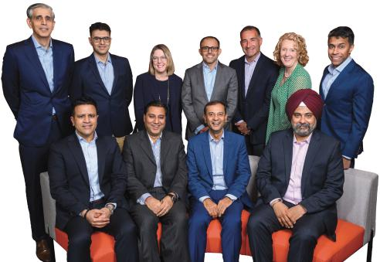

From back lef: Vivek Jetley, President and Head of Insurance, Healthcare and Life Sciences; Vikas Bhalla, President and Head of AI Services and Operatons; Anita Mahon, Executve Vice President, Chief Strategy & M&A Ofcer*; Narasimha Kini, Executve Vice President, Banking & Capital Markets and Diversifed Industries; Maurizio Nicolelli, Executve Vice President and Chief Financial Ofcer; Pamela Harrison, Executve Vice President and Chief Human Resources Ofcer; Ajay Ayyappan, Executve Vice President, General Counsel and Corporate Secretary

From front lef: Andy Logani, Executve Vice President and Chief Digital and AI Ofcer; Vishal Chhibbar, Executve Vice President, Internatonal Growth Markets and Chief Growth Ofcer; Rohit Kapoor, Chairman and CEO; Baljinder Singh, Executve Vice President, Global Chief Informaton Ofcer, and Head of Enterprise Digital Transformaton

*Ms. Mahon served on our Executve Commitee through April 1, 2025.

 | EXL 2026 Proxy Statement | / 51

Table of Contents

Our Executve Commitee

Executve Commitee biographies

The following are biographies for each of the members of our Executve Commitee. Of the members of our Executve Commitee, Rohit Kapoor, Ajay Ayyappan, Vikas Bhalla, Vishal Chhibbar, Pamela Harrison, Vivek Jetley, Narasimha Kini and Maurizio Nicolelli are considered executve ofcers.


Rohit Kapoor (age 61) | Chairman and CEO

See “Our board of directors” above for Mr. Kapoor’s biography.


Ajay Ayyappan (age 48) | Executve Vice President, General Counsel and Corporate Secretary

Mr. Ayyappan has served as our Executve Vice President, General Counsel and Corporate Secretary since February 2023. He previously served as our Senior Vice President, General Counsel and Corporate Secretary (December 2018 to February 2023), our Vice President, Actng General Counsel and Corporate Secretary (August 2018 to December 2018), our Vice President, Deputy General Counsel and Assistant Secretary (April 2014 to August 2018) and our Vice President and Assistant General Counsel (March 2007 to March 2014). Prior to joining us, Mr. Ayyappan was a corporate associate at the law frm, Morgan, Lewis & Bockius LLP.


Vikas Bhalla (age 54) | President and Head of AI Services and Operatons

Mr. Bhalla has served as our President and Head of AI Services and Operatons Strategic Growth Unit since 2025. Previously, he served as President and Business Head, Insurance since April 2024 and, prior to that, as our Executve Vice President and Business
 | Head, Insurance since January 2014 and as our Head of Outsourcing since November 2009. He previously served as Vice President,
 | Operatons of EXL India (June 2006 to October 2009), as Vice President, Migratons, Quality and Process Excellence of EXL India (April
 | 2002 to June 2006) and as Director, Quality Initatves of EXL India (May 2001 to March 2002). From May 1998 to May 2001,
 | Mr. Bhalla served in various capacites at General Electric, including as the Quality Leader and E-Business Leader for GE Plastcs India.
 | Mr. Bhalla is based in India.
 | Vishal Chhibbar (age 58) | Executve Vice President, Internatonal Growth Markets and Chief Growth Ofcer
 | Mr. Chhibbar has served as our Executve Vice President, Internatonal Growth Markets and Chief Growth Ofcer since 2025.
 | Previously, he served as our Chief Growth and Strategy Ofcer since July 2023. Mr. Chhibbar was EXL’s chief fnancial ofcer from
 | 2009 – 2019, and also previously served as the head of Finance and Accountng at EXL. Between 2019 and his return to EXL, Mr.
 | Chhibbar served as chief fnancial ofcer at Brillio and president and chief fnancial ofcer of EPIQ. Mr. Chhibbar has also served in
 | various fnancial leadership roles across companies such as GE Capital, American Express Bank and Xerox.
52 / | EXL 2026 Proxy Statement


Table of Contents

Our Executve Commitee


Pamela Harrison (age 61) | Executve Vice President and Chief Human Resources Ofcer

Ms. Harrison has served as our Executve Vice President and Chief Human Resources Ofcer since June 2023. She previously served as executve vice president of human resources at Genworth Financial, and as a director of human resources of business transformaton at Latham & Watkins LLP.


Vivek Jetley (age 51) | President and Head of Insurance, Healthcare and Life Sciences

Mr. Jetley has served as our President and Head of Insurance, Healthcare and Life Sciences since 2025. Previously, he served as President and Business Head, Analytcs since April 2024 and previously as our Executve Vice President and Business Head, Analytcs since January 2020. He previously served in various leadership roles with us, including heading enterprise strategy and setng up a strategic deal team. Mr. Jetley has been with EXL since 2006. Prior to joining us, Mr. Jetley was a Partner at Inducts.


Narasimha Kini (age 57) | Executve Vice President, Banking & Capital Markets and Diversifed Industries

Mr. Kini has served as our Executve Vice President, Banking & Capital Markets and Diversifed Industries since 2025. Previously, he served as our Executve Vice President and Business Head, Emerging Business since October 2021. He previously served in several leadership roles with us, including in our strategic initatves and fnance and accountng services. Mr. Kini has been with EXL since 2001. Prior to joining us, Mr. Kini was a Finance Leader at Willis Faber.


Anand “Andy” Logani (age 49) | Executve Vice President and Chief Digital and AI Ofcer

Mr. Logani has served as our Executve Vice President and Chief Digital and AI Ofcer since 2025. Previously, he served as our Executve Vice President and Chief Digital Ofcer since January 2024. Since joining EXL in 2001, he has served in various leadership positons with us, including as Chief Digital Ofcer and as our Global Head of Life & Annuity Insurance business. Prior to joining us, Mr. Logani was a member of the strategic sales team at Kuehne & Nagel.


Maurizio Nicolelli (age 57) | Executve Vice President and Chief Financial Ofcer

Mr. Nicolelli has served as our Executve Vice President and Chief Financial Ofcer since February 2020. Prior to joining the Company, Mr. Nicolelli served as Senior Vice President and Chief Financial Ofcer of Casa Systems beginning in 2019. He previously served 23 years at FactSet Research Systems, where he was Senior Vice President, Principal and Chief Financial Ofcer from 2009 to 2018.


Baljinder Singh (age 53) | Executve Vice President, Global Chief Informaton Ofcer, and Head of Enterprise Digital Transformaton

Mr. Singh has served as our Executve Vice President and Global Chief Informaton Ofcer since January 2024. Mr. Singh has been with EXL for more than 24 years, joining us as part of the founding leadership team. He has held several leadership roles at EXL across technology, transformaton, digital solutons, platorms development, and informaton security. He is based in India.

 | EXL 2026 Proxy Statement | / 53

Table of Contents

Executve compensaton

Executve compensaton

Compensaton Discussion and Analysis

Table of Contents

Named executve ofcers |  |  |  |  |  |  |  |  |  |  |  |  |  |  |  |  |  |  |  |  |  |  |  |  |  |  |  |  |  |  |  |  |  |  | 55
Executve summary |  |  |  |  |  |  |  |  |  |  |  |  |  |  |  |  |  |  |  |  |  |  |  |  |  |  |  |  |  |  |  |  |  |  | 55
 | Select 2025 fnancial and business highlights |  |  |  |  |  |  |  |  |  |  |  |  |  |  |  |  |  |  |  |  |  |  |  |  |  |  |  |  |  |  |  |  |  | 55
 | Awards and recognitons |  |  |  |  |  |  |  |  |  |  |  |  |  |  |  |  |  |  |  |  |  |  |  |  |  |  |  |  |  |  |  |  |  | 56
 | Clients and operatons |  |  |  |  |  |  |  |  |  |  |  |  |  |  |  |  |  |  |  |  |  |  |  |  |  |  |  |  |  |  |  |  |  | 57
 | Summary of key compensaton consideratons & decisions in 2025 |  |  |  |  |  |  |  |  |  |  |  |  |  |  |  |  |  |  |  |  |  |  |  |  |  |  |  |  |  |  |  |  |  | 57
 | Pay-for-performance |  |  |  |  |  |  |  |  |  |  |  |  |  |  |  |  |  |  |  |  |  |  |  |  |  |  |  |  |  |  |  |  |  | 58
Executve compensaton program, practces and policies |  |  |  |  |  |  |  |  |  |  |  |  |  |  |  |  |  |  |  |  |  |  |  |  |  |  |  |  |  |  |  |  |  |  | 59
Overview of compensaton policies and philosophies |  |  |  |  |  |  |  |  |  |  |  |  |  |  |  |  |  |  |  |  |  |  |  |  |  |  |  |  |  |  |  |  |  |  | 61
Compensaton process: roles and responsibilites |  |  |  |  |  |  |  |  |  |  |  |  |  |  |  |  |  |  |  |  |  |  |  |  |  |  |  |  |  |  |  |  |  |  | 62
Components of executve compensaton for 2025 |  |  |  |  |  |  |  |  |  |  |  |  |  |  |  |  |  |  |  |  |  |  |  |  |  |  |  |  |  |  |  |  |  |  | 65
Detailed review of compensaton components |  |  |  |  |  |  |  |  |  |  |  |  |  |  |  |  |  |  |  |  |  |  |  |  |  |  |  |  |  |  |  |  |  |  | 66
 | Base salary |  |  |  |  |  |  |  |  |  |  |  |  |  |  |  |  |  |  |  |  |  |  |  |  |  |  |  |  |  |  |  |  |  | 66
 | Annual cash incentve program |  |  |  |  |  |  |  |  |  |  |  |  |  |  |  |  |  |  |  |  |  |  |  |  |  |  |  |  |  |  |  |  |  | 66
 | Long-term equity incentves |  |  |  |  |  |  |  |  |  |  |  |  |  |  |  |  |  |  |  |  |  |  |  |  |  |  |  |  |  |  |  |  |  | 70
2025 Annual Restricted Stock Unit Awards |  |  |  |  |  |  |  |  |  |  |  |  |  |  |  |  |  |  |  |  |  |  |  |  |  |  |  |  |  |  |  |  |  |  | 71
Payout of awards granted in prior fscal years |  |  |  |  |  |  |  |  |  |  |  |  |  |  |  |  |  |  |  |  |  |  |  |  |  |  |  |  |  |  |  |  |  |  | 73
Benefts and perquisites |  |  |  |  |  |  |  |  |  |  |  |  |  |  |  |  |  |  |  |  |  |  |  |  |  |  |  |  |  |  |  |  |  |  | 74
Clawback Policy |  |  |  |  |  |  |  |  |  |  |  |  |  |  |  |  |  |  |  |  |  |  |  |  |  |  |  |  |  |  |  |  |  |  | 75
Stock Ownership Policy |  |  |  |  |  |  |  |  |  |  |  |  |  |  |  |  |  |  |  |  |  |  |  |  |  |  |  |  |  |  |  |  |  |  | 75
Compensaton Risk assessment |  |  |  |  |  |  |  |  |  |  |  |  |  |  |  |  |  |  |  |  |  |  |  |  |  |  |  |  |  |  |  |  |  |  | 76
Securites Trading Policy |  |  |  |  |  |  |  |  |  |  |  |  |  |  |  |  |  |  |  |  |  |  |  |  |  |  |  |  |  |  |  |  |  |  | 76
Severance and change-in-control benefts |  |  |  |  |  |  |  |  |  |  |  |  |  |  |  |  |  |  |  |  |  |  |  |  |  |  |  |  |  |  |  |  |  |  | 76
Timing of equity awards |  |  |  |  |  |  |  |  |  |  |  |  |  |  |  |  |  |  |  |  |  |  |  |  |  |  |  |  |  |  |  |  |  |  | 76
Compensaton and Talent Management Commitee Report |  |  |  |  |  |  |  |  |  |  |  |  |  |  |  |  |  |  |  |  |  |  |  |  |  |  |  |  |  |  |  |  |  |  | 78
Summary compensaton table for fscal year 2025 |  |  |  |  |  |  |  |  |  |  |  |  |  |  |  |  |  |  |  |  |  |  |  |  |  |  |  |  |  |  |  |  |  |  | 79
Grants of plan-based awards table for fscal year 2025 |  |  |  |  |  |  |  |  |  |  |  |  |  |  |  |  |  |  |  |  |  |  |  |  |  |  |  |  |  |  |  |  |  |  | 81
NEO Employment agreements |  |  |  |  |  |  |  |  |  |  |  |  |  |  |  |  |  |  |  |  |  |  |  |  |  |  |  |  |  |  |  |  |  |  | 81
Outstanding equity awards at fscal 2025 year-end |  |  |  |  |  |  |  |  |  |  |  |  |  |  |  |  |  |  |  |  |  |  |  |  |  |  |  |  |  |  |  |  |  |  | 83
Opton exercises and stock vested during fscal year 2025 |  |  |  |  |  |  |  |  |  |  |  |  |  |  |  |  |  |  |  |  |  |  |  |  |  |  |  |  |  |  |  |  |  |  | 85
Pension benefts for fscal year 2025 |  |  |  |  |  |  |  |  |  |  |  |  |  |  |  |  |  |  |  |  |  |  |  |  |  |  |  |  |  |  |  |  |  |  | 85
Potental payments upon terminaton or change in control at fscal 2025 year-end |  |  |  |  |  |  |  |  |  |  |  |  |  |  |  |  |  |  |  |  |  |  |  |  |  |  |  |  |  |  |  |  |  |  | 86
Certain defned terms |  |  |  |  |  |  |  |  |  |  |  |  |  |  |  |  |  |  |  |  |  |  |  |  |  |  |  |  |  |  |  |  |  |  | 93
CEO pay rato |  |  |  |  |  |  |  |  |  |  |  |  |  |  |  |  |  |  |  |  |  |  |  |  |  |  |  |  |  |  |  |  |  |  | 95
Director compensaton for fscal year 2025 |  |  |  |  |  |  |  |  |  |  |  |  |  |  |  |  |  |  |  |  |  |  |  |  |  |  |  |  |  |  |  |  |  |  | 99

54 | / | EXL 2026 Proxy Statement

Table of Contents

Executve compensaton

Named Executve Ofcers

As determined in accordance with SEC rules, our named executve ofcers (“NEOs”) for 2025 are:

Rohit Kapoor, our Chairman and CEO

Maurizio Nicolelli, our Executve Vice President and CFO

Vikas Bhalla, our President and Head of AI Services and Operatons

Vivek Jetley, our President and Head of Insurance, Healthcare and Life Sciences

Narasimha Kini, our Executve Vice President, Banking & Capital Markets and Diversifed Industries

Executve summary

Select 2025 fnancial and business highlights

- Our annual revenues increased by 13.6%, from $1.84 billion in fscal year 2024 to $2.09 billion in fscal year 2025. Data and AI-led revenue and Digital Operatons revenue increased by 17.9% and 8.6%, respectvely.

- We improved our net income atributable to stockholders by 26.6% from $198.3 million in fscal year 2024 to $251.0 million in fscal year 2025.

- Our diluted EPS increased from $1.21 in fscal year 2024 to $1.54 in fscal year 2025, an increase of 28%.

- We added approximately 5,800 employees to our global workforce, mainly in our delivery centers.

- In 2025, we returned capital to stockholders by repurchasing $316.6 million of shares. During fscal year 2025, on July 29, 2025, we entered into a 2025 ASR Agreement with Citbank to repurchase shares of our common stock for an aggregate purchase

 | EXL 2026 Proxy Statement | / 55

Table of Contents

Executve compensaton

price of $125.0 million, as part of our 2024 Repurchase Program. On December 15, 2025, we privately repurchased shares from Orogen Echo LLC for an aggregate purchase price of $63.3 million, which is separate from the 2024 Repurchase program.

- As of December 31, 2025, our 1-year TSR was (4.4%), our 3-year TSR was 25.2% and our 5-year TSR was 149.3%. We outperformed our comparator groups in 5-year TSR, refectng our long-term growth expectatons and performance.

Awards and recognitons
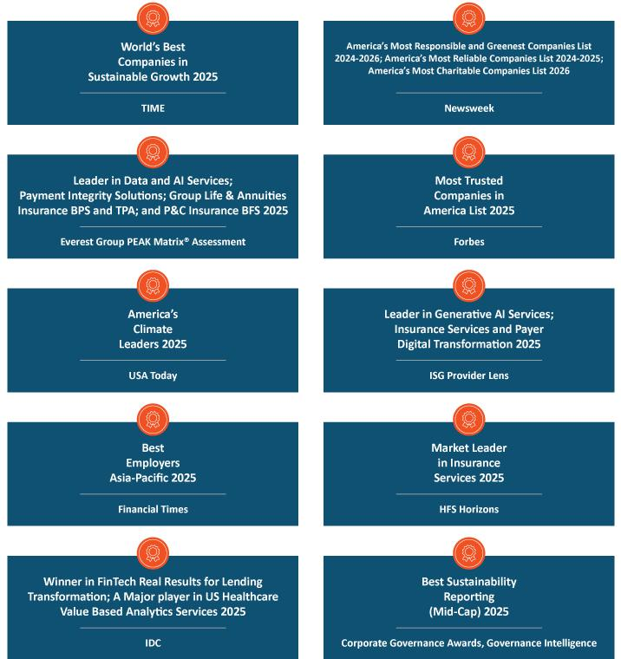

56 | / | EXL 2026 Proxy Statement

Table of Contents

Executve compensaton

Clients and operatons

- In 2025, we won 65 new clients, adding to the 69 new clients we won in 2024.

- In 2025, we unveiled EXLdata.ai™, a frst-of-its-kind agentc AI-natve suite of data solutons to solve enterprises’ biggest challenges in making data ready for AI.

- We secured a Great Place to Work® Certfcaton™ in India and the Philippines for 2025.

- We were named a World Economic Forum (WEF) 2025 MINDS (Meaningful, Intelligent, Novel, Deployable Solutons) Winner for Code Harbor™, an AI-powered platorm modernizaton soluton. The award is part of the WEF AI Governance Alliance to identfy AI applicatons that are delivering real impact at scale.

Summary of key compensaton consideratons & decisions in 2025

The following highlights the Compensaton and Talent Management Commitee’s key consideratons and compensaton decisions in 2025.

Items | Consideratons and decisions
Stockholder Input | At our 2025 Annual Meetng, approximately 96% of our stockholders approved, on a non-binding basis (excluding broker non-votes),
 | of our compensaton of our NEOs, indicatng to us that our stockholders support our executve compensaton program. In 2025, we
 | contnued to engage with our stockholders about our executve compensaton program, as described on page 40.
Base Salaries | All of our contnuing named executve ofcers received a base salary increase, consistent with Company performance and growth and
 | applicable benchmarking practces.
Annual Incentves | Our annual incentves contnued to be based on achievement of Company goals (revenue and AOPM) and personal performance
 | goals. Our contnuing named executve ofcers, other than the CEO, each received an increase to their target annual incentve
 | opportunity, a change which was refectve of the Company’s growth, peer benchmarking, and, for Messrs. Bhalla and Jetley,
 | promotons in April 2024 from executve vice president to president. In 2025, we delivered 100.3% of our revenue performance target
 | and 100.04% of our AOPM target, resultng in annual incentve payouts, ranging from 101% to 106% of target performance for our
 | named executve ofcers.
Equity Incentves | Consistent with prior years, we granted tme-based and performance-based restricted stock units to our NEOs. Performance-based
 | restricted stock units are linked to the achievement of cumulatve revenue and relatve TSR.
 | The tme-based restricted stock units vest 25% per year over four years based on contnued employment and the performance-based
 | restricted stock units clif vest at the end of a three-year performance period based on our achievement of the performance metrics.
 | At the Company’s 2025 Annual Meetng, our stockholders approved the ExlService Holdings, Inc. 2025 Omnibus Incentve Plan as a
 | successor to the ExlService Holdings, Inc. 2018 Omnibus Incentve Plan.
 | EXL 2026 Proxy Statement / 57

Table of Contents

Executve compensaton

Pay-for-performance

Our executve compensaton philosophy is focused on pay-for-performance. In this regard, we link a signifcant porton of each NEO’s total compensaton to the achievement of specifed performance goals. This variable compensaton is “at-risk” and rewards performance and contributons to both short- and long-term fnancial performance.

As illustrated by the following graphs, the majority of the compensaton that may be earned by our NEOs is ted to the achievement of fnancial performance metrics (annual incentve awards and PRSUs) or fuctuates with the underlying value of our common stock (PRSUs and RSUs).
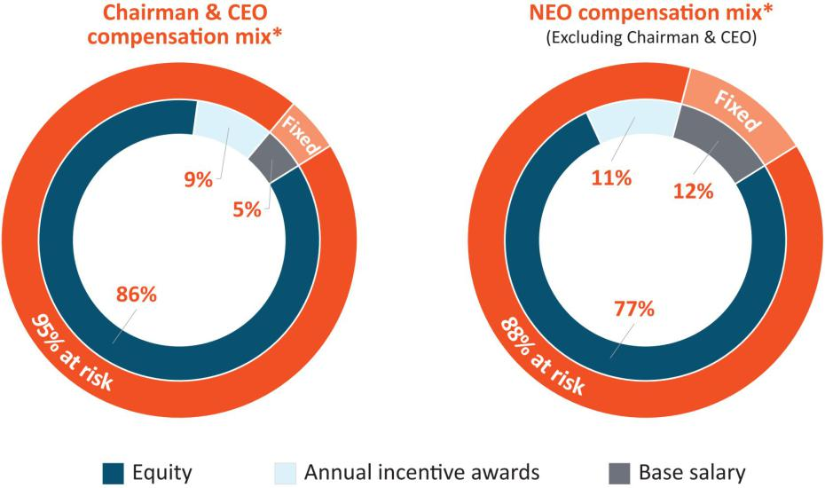

* Percentages displayed are rounded.

The graphs above refect the following informaton included in the Summary Compensaton Table on page 79. “Equity” refects the informaton in the “Stock Awards” column, “Annual incentve awards” refects the informaton in the “Non-Equity Incentve Plan Compensaton” column, and “Base salary” refects the informaton in the “Salary” column. Items in the “Change in Pension Value and Nonqualifed Deferred Compensaton” and “All Other Compensaton” columns of the Summary Compensaton Table on page 79 are not refected in the above graphs.

58 | / | EXL 2026 Proxy Statement

Table of Contents

Executve compensaton

Executve compensaton program, practces and policies

Our compensaton programs, practces and policies are reviewed and re-evaluated regularly and are subject to change from tme to tme in line with market best practces, including alignment of pay with performance. Our executve compensaton philosophy is refectve of our core values, focused on pay-for-performance and designed to refect appropriate governance practces aligned with the needs of our business. Listed below are some of the Company’s more signifcant practces and policies that were in efect during fscal year 2025, which are intended to drive performance and to align our executves’ interests with those of our stockholders.

What we do |  | What we don’t do
 | Align our executve pay with performance: We link a signifcant porton |  | No opton repricing: We prohibit opton repricing without stockholder
 | of each NEO’s total compensaton to the achievement of specifc |  | approval.
 | performance goals.
 | Variable compensaton is “at-risk” and rewards performance and
 | contributons to both short- and long-term fnancial performance.
 | Use appropriate peer groups when establishing compensaton: We |  | No opton backdatng or discountng: We prohibit opton backdatng
 | establish a peer group to help us review market practces and design a |  | and discountng.
 | compettve compensaton program. The criteria for peer group selecton
 | include annual revenues, similarity in business model and strategic
 | focus, scope of operatons, potental mobility of talent and industry
 | alignment.
 | We set compensaton for our executve ofcers at levels that we believe
 | are appropriate relatve to the compensaton paid to similarly situated
 | executve ofcers of our peers, giving consideraton to market and other
 | factors.
 | Ensure equity compensaton best practces: We design annual long- |  | No excessive overhang or diluton: We do not have excessive overhang
 | term equity incentves to encourage our executves to maintain a long- |  | or diluton from equity grants.
 | term view of stockholder value creaton and to encourage retenton. Our
 | standard annual equity awards are granted in part on the basis of the
 | executve’s performance in the prior year and are subject to tme or
 | performance-based vestng conditons. A signifcant porton of such
 | awards only pay out according to the achievement of Company
 | performance goals covering a 3-year period.
 | We hold dividends accrued under our equity awards, if any, untl the
 | recipient vests in the underlying shares or units.
 |  |  | EXL 2026 Proxy Statement / 59

Table of Contents

Executve compensaton

What we do |  | What we don’t do
 | Maintain an independent Compensaton and Talent Management |  | Perquisites: We do not provide our named executve ofcers with
 | Commitee and compensaton consultant: Compensaton decisions for |  | signifcant perquisites or personal benefts. We believe the limited
 | our NEOs are approved by a Compensaton and Talent Management |  | perquisites we ofer are reasonable and consistent with market trends. In
 | Commitee composed of non-employee independent directors. |  | additon, we consider the perquisites and personal benefts that we ofer
 | Our Compensaton and Talent Management Commitee is advised by an |  | to our executves in India to be customary benefts which allow us to
 |  |  | remain compettve for top talent.
 | independent compensaton consultant who reports directly to the |  | remain compettve for top talent.
 | Compensaton and Talent Management Commitee and provides no
 | other services to the Company or management.
 | Mitgate risks: The mix and design of our compensaton programs |  | No tax gross-ups: We do not provide gross-ups to any of our named
 | serves to mitgate operatonal, fnancial, legal, regulatory, strategic and |  | executve ofcers for any excise taxes imposed with respect to
 | reputatonal risks. |  | Secton 280G (change-in-control payments) or Secton 409A (nonqualifed
 |  |  | deferred compensaton) of the U.S. Internal Revenue Code of 1986, as
 |  |  | amended (which we refer to as the “Code”).
 | Maintain a clawback policy: Our clawback policy, which covers both |  | No hedging: We maintain a policy in which the following persons are
 | performance-based and tme-based awards, mandates recoupment of |  | prohibited from engaging in hedging transactons involving our shares
 | erroneously awarded incentve based compensaton in the event of a |  | and other securites: our directors and their secretaries and other
 | fnancial restatement and allows for recoupment of compensaton in |  | assistants; our executve ofcers and their secretaries and other
 | the event of an executve’s misconduct. |  | assistants; our employees in the accountng, fnance and legal
 |  |  | departments; the members and permanent invitees of our operatng and
 |  |  | executve commitees; and all of our vice president level 2 and 3 ofcers
 |  |  | (whom we refer to collectvely as “Reportng Persons”). For this purpose,
 |  |  | “hedging” refers to any strategy to ofset or reduce the risk of price
 |  |  | fuctuatons in our shares or other securites or to protect, in whole or in
 |  |  | part, against declines in the value of our shares or other securites. This
 |  |  | prohibiton thus applies to all transactons in derivatve securites based
 |  |  | on our stock such as other securites, including puts, calls, swaps and
 |  |  | collar arrangements.
 | Maintain a robust stock ownership policy: We maintain a robust stock |  | No pledging: Under our policy mentoned above, Reportng Persons (as
 | ownership policy that we amended in 2025 to require each covered |  | defned above) are only permited to pledge shares of our stock that
 | executve at an Executve Vice President level to maintain aggregate |  | exceed those required to be owned under our stock ownership policy
 | stock ownership equal to at least three tmes his or her base salary, |  | described above.
 | while Presidents are required to maintain ownership equal to at least
 | four tmes their base salaries, and our CEO is required to maintain
 | ownership equal to at least six tmes his base salary. See page 75 for a
 | discussion of that policy.
 | We maintain a similar stock ownership policy for our non-employee
 | directors, requiring them to maintain aggregate stock ownership equal
 | to at least fve tmes their annual cash retainer. See page 100 for a
 | discussion of that policy.
 | As of December 15, 2025, all covered executves and directors were in
 | compliance with the applicable stock ownership policy.
60 / EXL 2026 Proxy Statement

Table of Contents

Executve compensaton

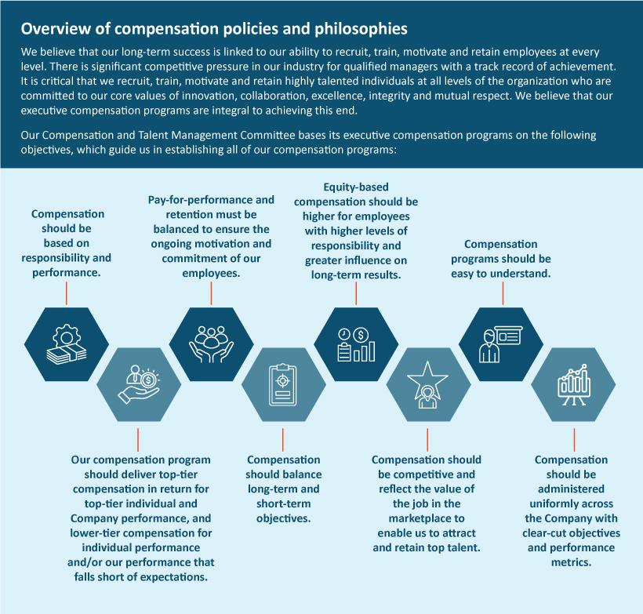

 | EXL 2026 Proxy Statement | / 61

Table of Contents

Executve compensaton

Compensaton process: roles and responsibilites

Our Compensaton and Talent Management Commitee has established a number of processes to assist it in ensuring that our executve compensaton programs are achieving their objectves. Our Compensaton and Talent Management Commitee, our management and our independent compensaton consultant are each engaged in these processes, as described in greater detail below.

Company | Establishment of performance measures
performance – | At the beginning of each year, or the end of the prior year, our Compensaton and Talent Management Commitee establishes the Company-
Compensaton and | wide and relevant business line performance measures on which our named executve ofcers’ annual cash incentve awards and equity
Talent Management | incentve awards are largely based. These measures refect targets that are intended to encourage stretch performance.
Commitee | Assessment of Company performance
 | At the end of the applicable performance period, the Compensaton and Talent Management Commitee reviews and certfes our
 | performance achievement in relaton to the pre-established targets and considers the appropriateness of adjustments to the performance
 | criteria and calculatons of performance achievement to determine payouts for cash and equity incentve awards.
Individual | The evaluaton of an individual’s performance determines a porton of the payouts under our annual incentve program and infuences any
performance – | changes in base salary for each of our named executve ofcers.
board of directors,
Compensaton | Assessment of CEO performance
and Talent | For Mr. Kapoor, our board of directors reviews and provides feedback on a self-evaluaton prepared by Mr. Kapoor. Once all directors have
Management | given feedback on Mr. Kapoor’s performance, our Lead Director and Chair of the Compensaton and Talent Management Commitee lead a
Commitee, and | comprehensive discussion of the full board of directors on Mr. Kapoor’s performance, leadership accomplishments and overall competence to
CEO | evaluate the achievement of established objectves.
 | Assessment of performance for all other NEOs and executve ofcers
 | For all other NEOs and executve ofcers, Mr. Kapoor makes a performance assessment and compensaton recommendaton to our
 | Compensaton and Talent Management Commitee. He bases the performance assessments on our executve ofcers’ self-evaluatons and his
 | performance assessments of each of them.
 | Our board of directors reviews the performance assessments with Mr. Kapoor and evaluates the achievement of established objectves by
 | each executve ofcer and his or her business line, if applicable, and his or her contributon to the Company’s performance, leadership
 | accomplishments and overall performance.
Other maters | Our Compensaton and Talent Management Commitee periodically reviews related maters such as succession planning and management,
relevant to | evaluaton of management performance, changes in the scope of managerial responsibilites, and consideraton of the business environment,
compensaton | and considers such maters in making compensaton decisions. The Commitee also considers an executve ofcer’s job responsibilites,
decisions – | performance, qualifcatons and skills in determining individual compensaton levels.
Compensaton and
Talent Management
Commitee
62 / EXL 2026 Proxy Statement

Table of Contents

 |  |  |  | Executve compensaton
Independent | For 2025, the Compensaton and Talent Management Commitee again retained the services of Farient Advisors, a qualifed and
compensaton | independent compensaton consultant, to aid the Compensaton and Talent Management Commitee in performing its dutes. The
consultant | Compensaton and Talent Management Commitee’s compensaton consultant assists in:
 | • | reviewing our executve pay philosophy,
 | • | collectng and evaluatng external market data regarding executve compensaton and performance,
 | • | selectng peer group companies,
 | • | reviewing the Proxy Statement,
 | • | advising the Compensaton and Talent Management Commitee on developing trends and best practces in executve
 |  | compensaton and compensaton governance, and
 | • | advising the Compensaton and Talent Management Commitee on incentve plan design that aligns with our strategy.
 | In additon, Farient advises our Nominatng and Governance Commitee regarding director compensaton from tme to tme. Other than
 | performing these consultng services, Farient does not provide other services to us or our executve ofcers. We have afrmatvely
 | determined that no confict of interest has arisen in connecton with the work of Farient as compensaton consultant for the Compensaton
 | and Talent Management Commitee.
Peer market data | We review peer compensaton data on an annual basis to set compensaton for each following year. At the tme compensaton decisions
Compensaton and | were made for our senior executve ofcers in 2025, our Compensaton and Talent Management Commitee reviewed publicly available
Compensaton and | compensaton data. In partnership with our independent compensaton consultant, we have established a list of criteria to assess the
Talent Management
Talent Management | relevance of diferent companies to be included in our compensaton peer group. The criteria by which we select our peers includes
Commitee and | companies that are in similar industries, have similar business models (operatng in similar markets, requiring similar executve talent skills
independent | and subject to similar market forces), and are within a revenue range of around half our revenues to three tmes our revenues.
compensaton
consultants | The following chart shows the peer group companies that we used to make 2025 compensaton decisions, as well as the respectve
 | industries and 2025 revenues of each:
 |  |  |  | 2025
 |  |  |  | Revenue
 | Company |  | Industry | ($MM, USD)
 | EPAM Systems, Inc. |  | IT Consultng and Other Services | $5,457
 | Genpact Limited |  | Data Processing and Outsourced Services | $5,080
 | Verisk Analytcs, Inc. |  | Research and Consultng Services | $3,073
 | TTEC Holdings, Inc. |  | Data Processing and Outsourced Services | $2,137
 | ExlService Holdings, Inc. |  | Data Processing and Outsourced Services | $2,088
 | Fair Isaac Corporaton |  | Applicaton Sofware | $1,991
 | Teradata Corporaton |  | Systems Sofware | $1,663
 | UiPath Inc. |  | Systems Sofware | $1,430
 | WNS (Holdings) Limited |  | Data Processing and Outsourced Services | $1,315
 | Guidewire Sofware, Inc. |  | Applicaton Sofware | $1,202
 | Dun & Bradstreet |  | Research and Consultng Services | n/a
 | Informatca Inc. |  | Applicaton Sofware | n/a
 | Perfcient, Inc. |  | IT Consultng and Other Services | n/a
 | Thoughtworks Holding, Inc. |  | IT Consultng and Other Services | n/a

EXL 2026 Proxy Statement / 63

Table of Contents

Executve compensaton

In June of 2025, we updated the peer group companies that we used to make 2026 pay decisions as follows: TTEC Holdings was removed due to poor fnancials and Thoughtworks and Perfcient were removed due to their acquisiton in 2024 and replaced with SS&C Technologies, Snowfake and Veeva Systems which provide sofware products and cloud-based platorms. In additon, each of Dun & Bradstreet, Informatca, and WNS will be removed in future years as they have been acquired.

We use a separate peer group for measuring performance under our PRSUs, as described under “Compensaton—2025 Annual Restricted Stock Unit Awards.”

The Compensaton and Talent Management Commitee reviews compensaton informaton provided by Farient and other third-party data that highlights industry-based market compensaton trends to evaluate each executve’s fxed and variable compensaton when considering any changes to executve compensaton.

The Compensaton and Talent Management Commitee uses this informaton to obtain a general understanding of current market practces and as a data point to design a compettve executve compensaton program that is aligned with the Company’s fundamental business objectves and strategy.

64 | / | EXL 2026 Proxy Statement

Table of Contents

Executve compensaton

Components of executve compensaton for 2025

For 2025, the compensaton of executve ofcers consisted of the following fve primary components:

Compensaton component | Descripton | Objectves
Base salary | Fixed compensaton that is reviewed annually and is | Provide a base level of compensaton that
 | based on performance, experience, responsibilites, | corresponds to the job functon performed.
 | skill set and market value. | Atract, retain, reward and motvate qualifed and
 |  | experienced executves.
Annual incentves | “At-risk” compensaton earned based on | Incentvize executves to achieve annual goals that
 | performance measured against pre-established | ultmately contribute to long-term Company growth
 | annual goals. | and stockholder return.
 | 75% of each NEO’s award is ted to Company-wide
 | performance with the remaining 25% to the
 | achievement of individualized goals.
Long-term incentves | “At-risk” compensaton in the form of equity awards | Align executve interests with those of stockholders.
 | whose value fuctuates according to stockholder | Reward contnuous service with the Company.
 | value. | Reward contnuous service with the Company.
 | RSU Awards: | Incentvize executves to achieve goals that drive
 | RSU Awards: | Company performance over the long-term.
 | - 40% of the award vests based on contnued
 | service.
 | - 60% vests based on achievement of revenue
 | and relatve total stockholder return goals.
Other benefts | Broad-based benefts provided to employees (e.g., | Provide a total compensaton package that is
 | health and group insurance), a retrement savings | compettve with the marketplace and addresses
 | plan and other personal benefts as appropriate or | unique needs, especially for overseas executves.
 | required by local law.
Severance and change | Protect executves during a potentally tumultuous | Allow executves to focus on generatng stockholder
in control protectons | corporate transacton. | value during a change in control transacton.
 | Provide post-employment compensaton upon other | Provide market-compettve post-employment
 | involuntary terminatons. | compensaton recognizing executves likely require
 |  | more tme to fnd subsequent employment.
 |  | EXL 2026 Proxy Statement / 65

Table of Contents

Executve compensaton

Detailed review of compensaton components

Base salary

We provide our named executve ofcers fxed cash compensaton commensurate with their performance, experience, responsibilites, skill set and market value. This atracts and retains an appropriate caliber of talent for these positons and provides a base wage that is not subject to our performance. In setng base salaries for 2025, our Compensaton and Talent Management Commitee considered:

Individual performance | The degree to which the executve met and exceeded expectatons.
Market data | Market data to test reasonableness of compensaton.
Overall compensaton mix | Senior executves should have a greater porton of their compensaton ted to increasing stockholder value.

Upon completng its review, the Compensaton and Talent Management Commitee determined it was appropriate to increase base salaries for each of our NEOs based on applicable market data and overall Company performance and growth. The fxed compensaton amount for Mr. Bhalla covers not only base salary, but also amounts available as a travel allowance, an automobile allowance, a housing allowance, and a cash supplementary allowance, consistent with compensaton practces in India.

 |  |  | Percentage
 | 2024 Base salary / | 2025 Base salary / | change to
Name | annual fxed | annual fxed | annual fxed
Name | compensaton ($/INR) | compensaton ($/INR) | compensaton (%)
Rohit Kapoor | 840,000 | 900,000 | 7%
Maurizio Nicolelli | 540,000 | 567,000 | 5%
Vikas Bhalla (1) | INR 33,000,000(2) | INR 36,000,000(3) | 9%
Vivek Jetley | 550,000 | 575,000 | 4.5%
Narasimha Kini | _{N/A}(4) | 500,000 | —

- For Mr. Bhalla, total annual fxed compensaton is determined and paid in Indian rupees (INR).

- Equivalent to $385,446 converted at 85.615 INR to 1 USD, which was the exchange rate on December 31, 2024.

- Equivalent to $400,579 converted at 89.87 INR to 1 USD, which was the exchange rate on December 31, 2025.

- Mr. Kini’s 2024 base salary is not included in the table above because he was not an NEO in 2024.

Annual cash incentve program

We have established an annual cash incentve program, which is generally maintained under our stockholder-approved omnibus incentve plan, in order to align our executve ofcers’ goals with our performance targets for the current year and to encourage meaningful contributons to our future fnancial performance. Our Compensaton and Talent Management Commitee approved the same framework for our annual incentve program in early 2025 for awards payable in respect of 2025 performance as we have used in prior years. Under the program, annual incentve award target amounts, expressed as a percentage of base salary or annual fxed compensaton, are established for partcipants at the beginning of each year. Funding of potental annual incentve award payouts for

66 | / | EXL 2026 Proxy Statement

Table of Contents

Executve compensaton

the year are determined by our fnancial results for the year relatve to predetermined performance measures and our assessment of each named executve ofcer’s performance relatve to his or her predetermined individual performance goals. If our performance falls short of target, our aggregate funding of the annual incentve pool declines. If we do not achieve a minimum threshold for the established fnancial performance objectves, then the annual incentve pool is not funded for that partcular objectve. The Compensaton and Talent Management Commitee has the discreton under the applicable omnibus incentve plan to adjust an award payout from the amount yielded by the formula at the end of the performance period for reasons including, but not limited to, the efect of changes in laws or regulatory rules, acquisitons or divesttures, reorganizaton or restructuring, extraordinary accountng items, foreign exchange gains or losses, and/or any specifc unusual or non-recurring events. The Compensaton and Talent Management Commitee did not apply any such discretonary adjustments for the 2025 annual incentve awards.

Our Compensaton and Talent Management Commitee considered the following when establishing the awards for 2025:

Annual incentve award targets

Annual incentve award targets were established based on job responsibilites and comparable market data. Our objectve was to set targets such that total annual cash compensaton was within the broad middle range of market data and a substantal porton of that compensaton was linked to our performance. Our Compensaton and Talent Management Commitee established the following annual incentve award targets (expressed as a percentage of base salary or annual fxed compensaton) as well as maximum targets for each named executve ofcer for 2025. Each of our contnuing named executve ofcers other than the CEO received an increase in his annual incentve award target and maximum for 2025, which was a refecton of market data inputs, and, for Messrs. Bhalla and Jetley, a refecton of their respectve promotons from executve vice president to president in April 2024, and Company growth.

Name | Annual incentve award target(1) | Annual incentve award maximum
Rohit Kapoor | 150% of base salary | 300% of base salary
Maurizio Nicolelli | 80% of base salary | 160% of base salary
Vikas Bhalla | 90% of annual fxed compensaton | 180% of annual fxed compensaton
Vivek Jetley | 90% of base salary | 180% of base salary
Narasimha Kini | 80% of base salary | 160% of base salary

(1) Annual incentve award target is a percentage of base salary for U.S.-based employees and annual fxed compensaton for Mr. Bhalla, who is based in India.

Performance measures

Our executves were eligible to earn annual incentves with 75% of the award based on their achievement of Company-wide performance metrics and the remaining 25% of the award based on individual performance. Consistent with prior years, the Company-wide porton of the 2025 annual incentve program was based 50% on the Company’s revenue goal and 50% on the Company’s adjusted operatng proft margin (AOPM) for all eligible employees, including our named executve ofcers. Individual

 | EXL 2026 Proxy Statement | / 67

Table of Contents

Executve compensaton

performance goals are unique to each of our executve positons within the organizaton. The Compensaton and Talent Management Commitee believes achievement of these performance metrics will drive our business and, in turn, lead to increased stockholder value.

Determinaton of fnancial performance achievement

For 2025, our Compensaton and Talent Management Commitee established a revenue target of $2.085 billion (which was 14% higher than our actual revenue for the prior year and 13% higher than our prior year’s target performance) and an AOPM target of $405.9 million (which was 15% higher than our actual AOPM for the prior year and 14% higher than our prior year’s target performance). As shown below, the porton of annual incentve award payments that were subject to these fnancial performance measures could have ranged from zero to 200% of the target depending on the achievement of the performance goals.

Performance targets: revenue ($2.085 billion); and AOPM ($405.9 million)

% of performance achieved compared to target goal | % of target porton funded*
Above 110% | 200%
At 100% | 100%
At 90% | 10%
Less than 90% | 0%

*Linear interpolaton for performance between discrete points.

Based on our performance during the 2025 fscal year, we achieved revenue performance of $2.09 billion, which was equal to 100.3% of our revenue performance target (resultng in funding of 102.6% based on the chart above), and AOPM performance of approximately $406.1 million, which was equal to 100.04% of our AOPM target (resultng in funding of 100.4% based on the chart above), which together yielded a weighted funding of 101.5% for the Company-wide performance metric. For purposes of achievement of fnancial performance targets, revenue and AOPM are measured using the estmates and assumptons (partcularly, currency exchange rates) at the tme the targets are established.

68 | / | EXL 2026 Proxy Statement

Table of Contents

Executve compensaton

Determinaton of individual performance measure achievement

Our named executve ofcers earn 25% of their annual incentve awards based on the achievement of individual performance measures designed to balance the named executve ofcers’ eforts between the achievement of near-term objectves that improve specifc processes or performance metrics and long-term objectves that increase the Company’s value, economic impact, and sustained stockholder returns. For more informaton on the process for determining individual performance measure achievement, please see “Compensaton process: roles and responsibilites” on page 62. Below is a summary of each named executve ofcer’s individual performance measures, as well as a summary of each named executve ofcer’s achievements in light of the designated performance measures applicable to each such executve’s role during 2025:

Named Executve
Ofcer |  | 2025 Individual performance measure |  | 2025 Individual performance achievement
Rohit Kapoor | • | Increase percentage of revenue that is | • | Led 14% revenue growth and 18% adjusted EPS⁽¹⁾ growth
 |  | data & AI-led | • | Increased data & AI-led revenue to 55% of all revenue
 | • | Improve AOPM | • | Won $1.7B in new deals
 | • | Positon EXL as a data and AI leader | • | Improved AOPM% by 10 bps to 19.5%
 | • | Develop robust partnerships | • | Added 9 patents. Built capabilites like EXLerate.ai™ and EXLdata.ai™.
 | • | Be a preferred employer for colleagues |  | Developed 50+ AI agents and 5 enterprise AI solutons. Elevated EXL’s
 |  | working on and with AI |  | positon as a global thought leader in Data and AI
 | • | Contnued focus on sustainability | • | Grew partner-led revenue, increased partner funding and increased
 |  |  |  | partner-led wins
 |  |  | • | Contnued focus on talent upskilling, expanded leadership and data & AI
 |  |  |  | capabilites. 70%+ of EXL colleagues’ data & AI trained with 6K+ Deep
 |  |  |  | data, AI & tech specializatons; Became Great Place To Work® Certfed™
 |  |  |  | in India 2025, and other industry awards
 |  |  | • | Contnued to advance sustainability-related initatves aligned with
 |  |  |  | business strategy and focus on ROI and received industry
 |  |  |  | recognitons. Reached record CSR volunteer partcipaton and expanded
 |  |  |  | renewable energy footprint.
Maurizio Nicolelli | • | Drive proftable growth agenda | • | Drove full year EPS growth rate at 18%, outperforming revenue growth
 |  | emphasizing EPS growth |  | rate of 14%
 | • | Drive long term tax strategy | • | Implemented long-term tax strategy improving efectve tax rate to 22%
 | • | Improve Return on Invested Capital (RoIC) |  | with pathway to future benefts
 | • | Expand the investor base | • | Improved one-year RoIC to 20.2% from 17.5%
 |  |  | • | Expanded our overall investor base and existng investor positons. Three
 |  |  |  | new investors joined our top 20 investors.
Vikas Bhalla | • | Deliver proftable growth in 2025 and drive | • | Achieved revenue and AOPM targets for domain capabilites while
 |  | data and AI in operatons |  | increasing AI embedding in operatons
 | • | Focus on strong executon and service | • | Strengthened our frst line compliance functon and cross-line
 |  | delivery |  | compliance alignment. Standardized risk practces across businesses.
 |  |  | • | Transformed delivery by embedding analytcs teams in operatons clients,
 |  |  |  | building COEs, and ofering AI solutons with a healthy pipeline for future
 |  |  |  | growth
 |  |  |  | EXL 2026 Proxy Statement / 69

Table of Contents

Executve compensaton

Named Executve
Ofcer |  | 2025 Individual performance measure |  | 2025 Individual performance achievement
Vivek Jetley | • | Drive revenue and proftability for | • | Grew Insurance revenue by 8% and grew Healthcare & Life Sciences
 |  | Insurance and Healthcare & Life Sciences |  | revenue by 24% with improved proftability of 70 bps
 |  | IMUs | • | Executed EXL Ventures Lab IdeaTank 2.0 actvity enterprise-wide,
 | • | Drive culture of innovaton and executon |  | generatng 11,000+ ideas, over fve tmes the number of ideas generated
 |  |  |  | in 2024, with fnalists moving from concept to Company adopton
 |  |  | • | Drove innovaton and executon through the Global Leadership Council
Narasimha Kini | • | Drive revenue and proftability for | • | Grew Banking & Capital Markets revenue by 19% and grew Diversifed
 |  | Banking & Capital Markets and Diversifed |  | Industries revenue by 7% with improved proftability of 10 bps
 |  | Industries IMUs | • | Scaled revenue via increased penetraton in client accounts across
 | • | Drive cross-sell across EXL |  | industries

- Adjusted EPS is a non-GAAP fnancial measure. See “Non-GAAP Reconciliaton” beginning on page 113 for more details, as well as a reconciliaton of the non-GAAP measures used herein.

The table below shows the 2025 annual incentve awards paid to our named executve ofcers (paid in March 2026):

 | Overall percentage | 2025 Actual annual
 | atainment of | incentve awarded
Name | target bonus | ($)(1)
Rohit Kapoor | 106% | 1,410,750
Maurizio Nicolelli | 101% | 453,384
Vikas Bhalla | 105% | 370,380
Vivek Jetley | 105% | 536,987
Narasimha Kini | 101% | 401,567

- The exchange rate used for the bonus conversion from Indian rupees to U.S. dollars for Mr. Bhalla was 89.87 INR to 1 USD, which was the exchange rate on December 31, 2025.

Long-term equity incentves

The Compensaton and Talent Management Commitee believes long-term equity awards provide employees with the incentve to stay with us for longer periods of tme, which in turn provides greater stability as we grow. These incentves foster the long-term perspectve necessary for contnued success in our business because the value of the awards is directly linked to long-term performance of our stock price, thereby ensuring that our executve ofcers are properly focused on stockholder value.

The Compensaton and Talent Management Commitee elects to grant Time-Vested and Performance-Vested restricted stock unit awards (“RSUs”) because these awards ofer executves the opportunity to receive shares of our common stock on or shortly following vestng. Such awards serve both to reward and retain executves: value is linked to the price of our stock, the executve

70 | / | EXL 2026 Proxy Statement

Table of Contents

Executve compensaton

must generally remain employed by the Company through the applicable vestng dates to receive shares and the Performance- Vested awards require achievement of certain performance goals. For these reasons, restricted stock unit awards provide a signifcant degree of alignment between the interests of our executves and stockholders.

The Compensaton and Talent Management Commitee also believes that the mix between Time-Vested RSUs and Performance-Vested RSUs provides an appropriate balance between incentvizing our executves to contnue their employment with the Company and ensuring they are focused on generatng long-term fnancial performance and sustained stockholder value.

Equity compensaton

2025 Annual Restricted Stock Unit Awards

Under our equity compensaton program, our named executve ofcers received restricted stock units under the ExlService Holdings, Inc. 2025 Omnibus Incentve Plan (“2025 Plan”). 40% of the restricted stock units vest based on contnued employment over four years, and 60% percent of the restricted stock units may be earned based on our relatve TSR and revenue performance during a three-year performance period beginning on January 1, 2025 and concluding on December 31, 2027, as shown below.

40% | + | 36% | + | 24% | = | Total
Time-Vested |  | Relatve TSR-linked |  | Revenue-linked |  | Long-Term
RSUs |  | PRSUs |  | PRSUs |  | Incentve Award

Our Compensaton and Talent Management Commitee selected relatve TSR and revenue as the performance measures for the PRSUs because revenue is a key driver of stockholder value, thus aligning stockholder and executve interests, and relatve TSR incorporates a comparatve component that measures our stock performance against industry peers. In additon, both the relatve TSR and revenue performance measures encourage a focus on our strategic goals of long-term fnancial performance and market share growth.

 | EXL 2026 Proxy Statement | / 71

Table of Contents

Executve compensaton

The table below shows the target dollar value of Time-Vested RSUs and Performance-Vested RSUs our Compensaton and Talent Management Commitee awarded our named executve ofcers in 2025. In general, the Compensaton and Talent Management Commitee believes that the size of the award granted to an executve ofcer should increase based on the executve ofcer’s level of responsibility within the Company. The number of shares subject to each NEO’s Time-Vested RSU and Performance-Vested RSU (assuming a “target” level of performance) was determined by dividing the NEO’s target dollar value by the average stock closing price for the preceding month. Therefore, it difers from the grant date fair value of the awards, as shown in the Summary Compensaton Table for fscal year 2025, which is calculated based on the assumptons described in note 1 to that table.

 |  | Target | Target | Total Target
 | Target | Revenue-Linked | Relatve TSR-Linked | Total Target
Name | Time-Vested RSUs ($) | PRSUs ($) | PRSUs ($) | Equity ($)
Rohit Kapoor | 4,600,000 | 2,760,000 | 4,140,000 | 11,500,000
Maurizio Nicolelli | 800,000 | 480,000 | 720,000 | 2,000,000
Vikas Bhalla | 1,300,000 | 780,000 | 1,170,000 | 3,250,000
Vivek Jetley | 1,300,000 | 780,000 | 1,170,000 | 3,250,000
Narasimha Kini | 800,000 | 480,000 | 720,000 | 2,000,000

- The “Time-Vested RSUs” will vest in increments of 25% on each of the frst four anniversaries of the grant date, generally subject to contnuous service with the Company through the applicable vestng date.

–The Compensaton and Talent Management Commitee believes these Time-Vested RSUs provide an important role in promotng retenton of our executve ofcers.

- The “Performance-Vested” porton of the 2025 RSUs (“PRSUs”) vest based on performance measures as follows:

–Revenue-Linked PRSUs: 40% of these PRSUs will clif-vest on December 31 of the third fscal year in the performance period, subject to achievement of threshold Company revenues against an aggregate revenue target over the grant’s three-year performance period of January 1, 2025 to December 31, 2027, and generally, contnuous employment through December 31, 2027. The ultmate amount of Revenue-Linked PRSUs that a recipient earns may be up to 200% of the target award of Revenue-Linked PRSUs. To the extent the Company’s revenue falls in between the outlined achievement levels, the percentage of Revenue-Linked PRSUs earned will be determined based on straight line interpolaton between these points. The chart below sets forth the revenue achievement levels and the corresponding funding percentage:

Revenue achievement levels | Percentage of Revenue-Linked PRSUs earned
110% or more | 200%
At 100% | 100%
90% | 25%

–Relatve TSR-Linked PRSUs: The remaining 60% of the PRSUs will clif-vest on December 31 of the third fscal year in the performance period, based on the achievement of a threshold level of the Company’s total stockholder return performance relatve to a performance peer group over the grant’s three-year performance period of January 1, 2025 to

72 | / | EXL 2026 Proxy Statement

Table of Contents

Executve compensaton

December 31, 2027, and generally, contnuous employment through December 31, 2027. The Company’s TSR for the TSR performance period will be computed and then compared to the TSR of the companies in the “performance peer group,” which is comprised of the public companies traded on either the NYSE or Nasdaq stock markets in our 8-digit Global Industry Classifcaton Standard sub-industry group. In the Compensaton and Talent Management Commitee’s view, this comparator set is more appropriate than the Company’s 2025 compensaton peer group for this purpose as it provides a more robust comparison of our performance to the marketplace by the inclusion of more companies and eliminaton of size as a selecton criterion, which is more relevant for compensaton benchmarking than a performance comparison. For the Relatve TSR-Linked PRSUs granted in 2025, the Company included a negatve TSR cap. Under the negatve TSR cap, if the Company’s total stockholder return is negatve over the course of the three-year performance period, no named executve ofcer may receive greater than 100% funding of the TSR-Linked PRSUs, even if the Company’s performance as compared to the performance peer group exceeds the 50th percentle.

The percentage of Relatve TSR-Linked PRSUs earned will be determined based on straight-line interpolaton to the extent the

Company’s TSR falls in between the 20th and 80th percentles, as per the chart below:

TSR peer group percentle | Percentage of Relatve TSR-Linked PRSUs earned
80.0 or more | 200%
50.0 | 100%
21.0 | 3.33%
20.0 or less | 0%

The Compensaton and Talent Management Commitee believes the PRSUs focus our executves on key drivers of our Company’s business that will ultmately lead to creaton of additonal stockholder value.

Payout of awards granted in prior fscal years

This was the third and fnal performance year for the 2023 performance-based restricted stock units. Our cumulatve three-year revenue target was approximately $5.409 billion. We achieved approximately $5.496 billion for the three-year period, which was 101.61% of the revenue target for the revenue-linked PRSUs, resultng in the executves earning 116.15% of the 2023 revenue-linked PRSUs. The Company’s TSR performance was at the 64th percentle among its peer group, resultng in the executves earning 147.17% of the 2023 relatve TSR-Linked PRSUs pursuant to the terms of the original grant.

 | Threshold
 | (25% for Revenue |  | Maximum
Performance Metric | and 3.33% for TSR) | Target (100%) | (200%) | Actual Performance
Revenue | 90% | 100% | 110% | 101.615%
TSR(1) | 21st | 50th | 80th or > | 64th percentle
 | percentle | percentle | percentle

2023-2025 PRSU Final Payout Percentage: 134.76%

- As noted above, the TSR peer group for this performance metric is comprised of the public companies traded on either the NYSE or Nasdaq stock markets in our 8-digit Global Industry Classifcaton Standard sub-industry group.

 | EXL 2026 Proxy Statement | / 73

Table of Contents

Executve compensaton

Approval of the ExlService Holdings, Inc. 2025 Omnibus Incentve Plan (“2025 Plan”)

At the Company’s 2025 Annual Meetng, our stockholders voted to approve the 2025 Plan to replace the 2018 Omnibus Incentve Plan (the “Prior Plan”), which enables the Company to make equity and cash awards to employees, directors, consultants and advisors of the Company and its afliates. Similar to the Prior Plan, the 2025 Plan provides a means through which we and our afliates may atract capable candidates to enter and remain in our employ or service and to provide a means whereby our employees, directors and consultants can acquire and maintain ownership of our common stock, or be paid incentve compensaton measured by reference to the value of our common stock, thereby strengthening their commitment to the welfare of the Company and its afliates and promotng an identty of interest between them and our stockholders.

Benefts and perquisites

We ofer employee benefts coverage in order to:

- provide our global workforce with a reasonable level of fnancial support in the event of illness or injury; and

- provide market-compettve benefts that enhance productvity and job satsfacton through programs that focus on work/life balance.

The benefts available for all U.S. employees include customary medical and dental coverage, disability insurance, life insurance and a 401(k) plan. A number of our U.S. employees, including our U.S.-based named executve ofcers, partcipate in these plans. The cost of employee benefts is partally borne by our employees, including our named executve ofcers. Mr. Bhalla, who is located in India, is eligible to partcipate in the Company’s pension beneft, health and welfare and fringe beneft plans otherwise available to executve employees in India.

We generally do not provide our named executve ofcers with signifcant perquisites or personal benefts. Our CEO is provided a limited number of perquisites which we believe are reasonable and consistent with market trends, and which are intended to be part of a compettve overall compensaton program. In additon, we consider the perquisites and personal benefts that we ofer to our executves in India to be customary benefts which allow us to remain compettve for top talent. We also may provide limited perquisites to executve ofcers upon hire, such as relocaton costs and legal fees.

See the “All Other Compensaton” column in the Summary compensaton table for fscal year 2025 on page 79 for a list of all the perquisites received in 2025 by our named executve ofcers.

74 | / | EXL 2026 Proxy Statement

Table of Contents

Executve compensaton

Clawback Policy

Under our current clawback policy, in the event a restatement of our fnancial statements is required, incentve-based compensaton ted to a fnancial reportng measure that was “received” under applicable Nasdaq rules by covered executve ofcers in the three prior completed fscal years will be recalculated (if applicable) based on the updated fnancial statements. Incentve compensaton deemed to have been erroneously received as a result of the restatement will be subject to recoupment. The method of recoupment will be determined by the board or a commitee of the board.

In additon, our clawback policy contains an additonal recoupment trigger in the event of executve ofcer misconduct. If the board or a commitee of the board determines that an executve violated material Company policies, misstated fnancial or other material informaton about the Company, commited fraud or misconduct, breached a restrictve covenant or other agreement with the Company, engaged in other conduct that is detrimental to the business or reputaton of the Company, or was identfed by the Department of Justce as having engaged in wrongdoing (including through supervisory actvity), the board or a commitee of the board may in its sole discreton recoup compensaton (including tme-based equity awards) from that executve ofcer. Amounts recoupable under the misconduct trigger may include compensaton that would not otherwise be subject to recoupment under the Nasdaq listng standards.

Stock Ownership Policy

Our executve stock ownership policy, requires our executves to maintain stock ownership as a multple of base salary as follows:

Executve | Ownership requirement
CEO | 6x base salary
Presidents | 4x base salary
Other members of our Executve | 3x base salary
Commitee (including Mr. Nicolelli and Mr. Kini)

Under the policy, stock ownership refers to common stock owned outright and vested restricted stock units; this includes any stock owned by, or held in trust for the beneft of, the executve’s spouse and children, provided they share the same household as the executve. Unearned performance-based restricted stock units and unexercised optons (including in-the-money optons) do not count toward the ownership policy.

New executves generally have fve years to meet the ownership requirement, whereas existng executves generally have three years to meet any increased ownership requirements as a result of base salary increases. During the applicable phase-in period, executves generally must retain at least 50% of shares delivered (net of tax) following the vestng of an equity award untl the ownership requirement is met. If the ownership requirement is not met at the end of the phase-in period, executves generally may not sell any shares (other than to satsfy taxes) untl the ownership requirement is met.

All covered executves were in compliance with the executve stock ownership policy as of the December 15, 2025 measurement date.

 | EXL 2026 Proxy Statement | / 75

Table of Contents

Executve compensaton

Securites Trading Policy

The Company has adopted an insider trading policy that governs the purchase, sale, and/or other transactons of our securites by our directors, ofcers and employees. A copy of our insider trading policy was fled as Exhibit 19.1 to the 2025 Form 10-K. In additon, with regard to the Company’s trading in its own securites, it is the Company’s policy to comply with the federal securites laws and the applicable exchange listng requirements.

Compensaton risk assessment

Our Compensaton and Talent Management Commitee has taken into account its discussions with management and Farient regarding our compensaton practces and has concluded that any risks arising from our compensaton policies and practces are not reasonably likely to have a material adverse efect on the Company. This conclusion was based on the features of our compensaton programs, practces and policies set forth under “Executve compensaton program, practces and policies” on page 59.

Severance and change-in-control benefts

Each named executve ofcer is party to an employment agreement that sets forth the terms of his or her employment, including compensaton, which was negotated through arms’-length contract negotatons. Under these employment agreements or leters, we are obligated to pay severance or other enhanced benefts upon terminaton of their employment under certain circumstances. A discussion of the severance and other enhanced benefts provided to our named executve ofcers is provided under “Potental payments upon terminaton or change in control at fscal 2025 year-end” beginning on page 86.

We provide change-in-control severance protecton for some of our executve ofcers, including our named executve ofcers. Our Compensaton and Talent Management Commitee believes that such protecton preserves employee morale and productvity and encourages retenton in the face of the disruptve impact of an actual or rumored change in control. In additon, for executve ofcers, the program is intended to align executve ofcers’ and stockholders’ interests by enabling executve ofcers to consider corporate transactons that are in the best interests of our stockholders and other consttuents without undue concern over whether the transactons may jeopardize the executve ofcers’ own employment.

Senior executve ofcers, including our named executve ofcers, have enhanced levels of benefts based on their job level, seniority and probable loss of employment afer a change in control. We also consider it likely that it will take more tme for senior executve ofcers to fnd new employment.

Timing of equity awards

While we have in the past granted stock optons in certain years, we do not currently have a practce or policy regarding stock opton grant tming, because stock optons are not part of our typical long-term incentve program. We did not grant stock optons in 2025. Our current long-term incentve program is comprised of tme-vested restricted stock units and performance-based restricted stock units. We generally grant annual equity awards to our named executve ofcers and other eligible employees at the Compensaton and Talent Management Commitee’s regularly scheduled meetng in February of each year or shortly

76 | / | EXL 2026 Proxy Statement

Table of Contents

Executve compensaton

thereafer. This meetng is scheduled far in advance. In 2025, we approved the grant of annual equity awards to our executve ofcers in February, consistent with our general practce, but the efectveness of the grants was contngent upon stockholder approval of our 2025 Plan at our 2025 Annual Meetng. Outside of our annual equity award cycle, we grant equity awards at other tmes throughout the year, such as to new employee hires, to employees receiving promotons, for retentve purposes, or in other relevant circumstances. Separate from our long-term incentve program, we maintain the ExlService Holdings, Inc. 2022 Employee Stock Purchase Plan, which allows eligible employees to receive an opton to automatcally purchase the Company’s shares of common stock through payroll deductons at a discount on the last day of the applicable ofering period.

 | EXL 2026 Proxy Statement | / 77

Table of Contents

Executve compensaton

Compensaton and Talent Management Commitee Report

The Compensaton and Talent Management Commitee of the board of directors of ExlService Holdings, Inc. has reviewed and discussed the Compensaton Discussion and Analysis with our management and, based on such review and discussion, has recommended to the board of directors of ExlService Holdings, Inc. that the Compensaton Discussion and Analysis be included in our Annual Report on Form 10-K for the fscal year ended December 31, 2025, and our Proxy Statement relatng to the Annual Meetng.

Compensaton and Talent Management Commitee

Mr. Thomas Bartlet (Chair)

Mr. Vikram Pandit

Ms. Kristy Pipes

Ms. Sarah K. Williamson

78 | / | EXL 2026 Proxy Statement

Table of Contents

Executve compensaton

Summary compensaton table for fscal year 2025

The following table sets forth informaton for compensaton earned in fscal years 2023, 2024 and 2025 by our named executve ofcers:

 |  |  |  |  |  |  |  | Change in
 |  |  |  |  |  |  |  | pension value
 |  |  |  |  |  |  |  | and
 |  |  |  |  |  |  | Non-equity | nonqualifed
 |  |  |  |  |  |  | incentve | deferred
 |  |  |  |  | Stock | Opton | plan | compensaton | All other
Name and |  |  | Salary | Bonus | awards | awards | compensaton | earnings | compensaton |  | Total
principal positon |  | Year | ($) | ($) | ($)⁽¹⁾ | ($) | ($)⁽²⁾ | ($)⁽³⁾ | ($) |  | ($)
Rohit Kapoor | 2025 |  | 885,205 | — | 13,811,888 | — | 1,410,750 | — | 93,918 | (4) | 16,201,761
Chairman & CEO | 2024 |  | 821,284 | — | 11,847,065 | — | 1,440,000 | — | 58,647 |  | 14,166,996
 | 2023 |  | 815,000 | — | 9,982,605 | — | 1,514,253 | — | 34,148 |  | 12,346,006
Maurizio Nicolelli | 2025 |  | 560,342 | — | 2,402,095 | — | 453,384 | — | 17,335 | (5) | 3,433,156
Executve Vice |  | 2024 | 517,541 | — | 1,979,695 | — | 394,215 | — | 11,106 |  | 2,902,557
President and CFO |  | 2023 | 510,000 | — | 1,570,763 | 1,615,392 | 459,441 | — | 10,947 |  | 4,166,543
Vikas Bhalla | 2025 |  | 368,796(6) | — | 3,903,181 | — | 370,380 | 20,222 | 22,447 | (7) | 4,685,025
President and | 2024 |  | 320,342 | — | 3,394,217 | — | 269,216 | 29,540 | 18,644 |  | 4,031,959
Head of AI Services |  |  |  |  |  |  |  |  |  |  | 4,031,959
and Operatons | 2023 |  | 300,188 | — | 1,681,606 | 3,230,785 | 320,917 | 5,642 | 18,383 |  | 5,557,521
Vivek Jetley | 2025 |  | 568,836 | — | 3,903,181 | — | 536,987 | — | 15,337 | (8) | 5,024,340
President and |  | 2024 | 512,568 | — | 3,394,217 | — | 323,153 | — | 11,106 |  | 4,241,045
Head of Insurance, |  | 2023 | 500,000 | — | 1,681,606 | 3,230,785 | 422,307 | — | 10,404 |  | 5,845,102
Healthcare and Life |  |  |  |  |  |  |  |  |  |  | 5,845,102
Sciences
Narasimha Kini | 2025 |  | 496,301 | — | 2,402,095 | — | 401,567 | — | 30,284 | (9) | 3,330,248
Executve Vice President, | 2024 |  | — | — | — | — | — | — | — |  | —
Banking & Capital Markets and | 2023 |  | — | — | — | — | — | — | — |  | —
Diversifed Industries

- Amounts refect the total grant date fair value of awards (RSUs and revenue-based PRSUs) and Monte Carlo value of awards (TSR-based PRSUs) recognized for fnancial statement reportng purposes for the fscal years ended December 31, 2023, 2024 and 2025, in accordance with FASB ASC Topic 718 (disregarding any forfeiture assumptons). Assumptons used in the calculaton of these amounts are included for 2025 in footnotes 2 and 23 to the audited fnancial statements for the fscal year ended December 31, 2025, included in our Annual Report on Form 10-K fled with the Securites and Exchange Commission on February 24, 2026; for 2024 in footnotes 2 and 23 to the audited fnancial statements for the fscal year ended December 31, 2024, included in our Annual Report on Form 10-K fled with the Securites and Exchange Commission on February 25, 2025; and for 2023, in footnotes 2 and 23 to the audited fnancial statements for the fscal year ended December 31, 2023, included in our Annual Report on Form 10-K fled with the Securites and Exchange Commission on February 29, 2024. With respect to performance-based stock awards granted in 2025 (Revenue-Linked PRSUs and TSR-Linked PRSUs), the table below sets forth the value atributable to such units based on target achievement, the probable outcome of such performance measures; this value is included in the “Stock awards” column. Performance-based restricted stock units granted in 2025 may pay out up to 200% of the target award, which would have amounted to the grant date fair values listed as the maximum total grant date fair value for each named executve ofcer in the table below.

Name | Total grant date fair value ($) | Maximum total grant date fair value ($)
Rohit Kapoor | 9,141,126 | 18,282,252
Maurizio Nicolelli | 1,589,780 | 3,179,560
Vikas Bhalla | 2,583,241 | 5,166,482
Vivek Jetley | 2,583,241 | 5,166,482
Narasimha Kini | 1,589,780 | 3,179,560

EXL 2026 Proxy Statement / 79

Table of Contents

Executve compensaton

- Refects the annual cash incentve awards earned in respect of 2025 and paid in 2026. For details on our annual incentve program, see “Compensaton Discussion and Analysis—Annual Cash Incentve Program” beginning on page 66.

- Refects the present value of accruals under the Gratuity Plan for Indian employees. Informaton regarding our Gratuity Plan (including the assumptons used to calculate these amounts) may be found under “Pension benefts for fscal year 2025” beginning on page 85.

- Amount for Mr. Rohit Kapoor includes the travel allowance ($38,055) provided for under his employment agreement, to be used for once-a-year business class airfare for himself and his family between the United States and India, contributon to our 401 (k) plan ($10,500), personal tax and estate planning expenses ($30,000), Company-paid supplemental long-term disability ($6,108), and cyber-based security services ($9,254). In additon, certain travel expenses for Mr. Kapoor’s spouse to accompany him on business trips were provided at no incremental cost to the Company.

- Amount for Mr. Maurizio Nicolelli includes contributon to our 401 (k) plan ($10,500) and Company-paid supplemental long-term disability ($6,835).
- Mr. Vikas Bhalla’s compensaton is paid in Indian rupees. The amounts set forth for him in this table have been converted from Indian rupees, where applicable, at a rate of 89.87 (for

2025), 85.615 (for 2024), and 83.208 (for 2023) Indian rupees to $1.00 USD, the Indian rupee to U.S. dollar exchange rate in efect as of the last day of the applicable fscal year. The amount set forth in the “Salary” column for Mr. Bhalla for 2025 includes the following elements of his total direct compensaton: $137,282 of base salary, $151,438 of a cash supplementary allowance, $68,641 of housing allowance (which Mr. Bhalla elected to receive instead in cash) and $11,436 of travel allowance (which Mr. Bhalla elected to receive instead in cash).

- Amount for Mr. Bhalla includes contributons to the Employees’ Provident Fund Scheme (a statutorily required defned contributon program for Indian employees) ($16,474), costs associated with use of an automobile and driver in India ($361), home internet and telephone charges ($803) and tax assistance ($4,810).
- Amount for Mr. Vivek Jetley includes contributons to our 401(k) plan ($10,500) and Company paid supplemental long-term disability ($4,837).

- Amount for Mr. Narasimha Kini includes contributons to our 401(k) plan ($10,500), fnancial and tax planning ($13,387), domestc travel for himself ($180) and Company supplemental long-term disability ($6,217).

80 | / | EXL 2026 Proxy Statement

Table of Contents

Executve compensaton

Grants of plan-based awards table for fscal year 2025

The following table sets forth informaton concerning grants of stock and opton awards and non-equity incentve plan awards granted to our named executve ofcers during fscal year 2025:

 |  |  |  |  | Estmated future payouts under |  |  | Estmated future payouts
 |  |  |  |  | non-equity incentve plan awards⁽¹⁾ |  |  | under equity incentve plan awards |  |  |  |  | All other
Name |  |  |  |  |  |  |  |  |  |  |  |  | opton
Name |  |  |  |  |  |  |  |  |  |  |  | All other | awards: | Exercise
 |  |  |  |  |  |  |  |  |  |  |  | stock awards: | number of | or base | Grant Date Fair
 |  |  |  |  |  |  |  |  |  |  |  | number of | securites | price of | Value of Stock
 |  |  |  |  |  |  |  |  |  |  |  | shares of | underlying | the | and Opton
 |  | Grant | Approval |  | Threshold | Target | Maximum | Threshold | Target | Maximum |  | stock or units⁽³⁾ | opton | opton | Awards⁽⁴⁾
 |  | Date | Date⁽²⁾ |  | ($) | ($) | ($) | (#) | (#) | (#) |  | (#) | (#) | awards | ($)
 |  |  |  |  | — | 1,327,808 | 2,655,616
Rohit | 6/17/2025 |  | 2/20/2025 |  |  |  |  |  |  |  |  | 96,944 |  |  | 4,670,762
Kapoor | 6/17/2025 |  | 2/20/2025 |  |  |  |  | 14,542 | 58,167(5) | 116,334 |  |  |  |  | 2,802,486
 | 6/17/2025 |  | 2/20/2025 |  |  |  |  | 2,905 | 87,249(6) | 174,498 |  |  |  |  | 6,338,640
 |  |  |  |  | — | 448,274 | 896,548
Maurizio | 6/17/2025 |  | 2/20/2025 |  |  |  |  |  |  |  |  | 16,860 |  |  | 812,315
Nicolelli |  | 6/17/2025 | 2/20/2025 |  |  |  |  | 2,529 | 10,116(5) | 20,232 |  |  |  |  | 487,389
 |  | 6/17/2025 | 2/20/2025 |  |  |  |  | 505 | 15,174(6) | 30,348 |  |  |  |  | 1,102,391
 |  |  |  |  | — | 353,113 | 706,226
Vikas | 6/17/2025 |  | 2/20/2025 |  |  |  |  |  |  |  |  | 27,396 |  |  | 1,319,939
Bhalla | 6/17/2025 |  | 2/20/2025 |  |  |  |  | 4,110 | 16,438(5) | 32,876 |  |  |  |  | 791,983
 | 6/17/2025 |  | 2/20/2025 |  |  |  |  | 821 | 24,656(6) | 49,312 |  |  |  |  | 1,791,258
 |  |  |  |  | — | 511,952 | 1,023,904
Vivek | 6/17/2025 |  | 2/20/2025 |  |  |  |  |  |  |  |  | 27,396 |  |  | 1,319,939
Jetley |  | 6/17/2025 | 2/20/2025 |  |  |  |  | 4,110 | 16,438(5) | 32,876 |  |  |  |  | 791,983
 |  | 6/17/2025 | 2/20/2025 |  |  |  |  | 821 | 24,656(6) | 49,312 |  |  |  |  | 1,791,258
 |  |  |  |  | — | 397,041 | 794,082
Narasimha | 6/17/2025 |  | 2/20/2025 |  |  |  |  |  |  |  |  | 16,860 |  |  | 812,315
Kini | 6/17/2025 |  | 2/20/2025 |  |  |  |  | 2,529 | 10,116(5) | 20,232 |  |  |  |  | 487,389
 | 6/17/2025 |  | 2/20/2025 |  |  |  |  | 505 | 15,174(6) | 30,348 |  |  |  |  | 1,102,391

- These amounts refect the target and maximum cash incentve bonuses set for 2025. There is no threshold amount reported for the cash incentve bonus as the individual performance measure (25% of the total bonus) does not have a threshold performance below which no payment will be made. However, the Company performance metric (75% of the total bonus) does have a threshold. For details of our annual incentve bonus program, see “Compensaton Discussion and Analysis—Annual Cash Incentve Program” beginning on page 66.

- Equity awards granted to the named executve ofcers in 2025 were approved on February 20, 2025 (the “Approval Date”) under the 2025 Plan, contngent upon stockholder approval of the 2025 Plan. The grant date for these awards is June 17, 2025, the date that the 2025 Plan was approved by stockholders.
- Represents annual awards of restricted stock units granted under the 2025 Plan, subject to ratable vestng on the frst four anniversaries of the Approval Date.

- Amounts in this column refect the total grant date fair value at target performance of Revenue-Linked PRSUs and Monte Carlo value of TSR-Linked PRSUs recognized for fnancial statement reportng purposes, in accordance with FASB ASC Topic 718 (disregarding any forfeiture assumptons).
- Represents annual PRSU—Revenue-Linked PRSUs granted under the 2025 Plan, which will clif vest, subject to performance, on December 31, 2027.
- Represents annual PRSU—TSR-Linked awards granted under the 2025 Plan, which will clif vest, subject to performance, on December 31, 2027.

NEO Employment agreements

We maintain employment agreements with each of the NEOs. Each agreement, as amended from tme to tme, generally provides for base salary, target bonus opportunity, eligibility to receive equity-based awards, partcipaton in our beneft plans, severance, and in certain cases, specifed additonal benefts.

 | EXL 2026 Proxy Statement | / 81

Table of Contents

Executve compensaton

Salary

Mr. Kapoor’s employment agreement provides a minimum base salary of $750,000, which may not be decreased unless a Company-wide decrease in pay is implemented. The base salaries that were in efect for our NEOs during the 2025 fscal year are described on page 66 above.

Target Bonus Opportunites

Target bonus opportunity as a percentage of base salary, as specifed in the NEO employment agreements, is as follows: Mr. Kapoor, 150% (with a maximum of 310% set forth in his employment agreement, and subject to any other annual cap set by the Compensaton and Talent Management Commitee, as described further above), Messrs. Bhalla, Jetley, Nicolelli and Kini: 75% (which, as described further above, has been increased from tme to tme by the Compensaton and Talent Management Commitee).

Equity Awards

The NEOs are generally eligible to receive annual equity awards in the discreton of the Compensaton and Talent Management Commitee. Mr. Kapoor’s employment agreement provides that in determining his annual equity award, the Compensaton and Talent Management Commitee will consider, among other factors, an aggregate “baseline” value equal to $4,925,000, Company and individual performance, shareholder input on executve compensaton, and market data.

India-Specifc Compensaton Arrangement

Mr. Bhalla’s annual fxed compensaton includes base salary, as well as amounts available as a travel allowance, a housing allowance, an automobile/driver allowance, contributons to the Employees’ Provident Fund scheme, a medical allowance, a cash supplementary allowance and statutory gratuity.

Additonal Benefts for CEO

Mr. Kapoor’s employment agreement specifes certain benefts to which he is enttled, including: (1) certain club memberships in the United States and India, (2) home ofce supplies, (3) term life insurance policy (with a face value of $500,000), (4) once-a-year business class airfare between the United States and India for the executve and his family, (5) personal tax and estate planning expenses, (6) car allowance for an automobile in the United States,

- expenses associated with maintaining an automobile in India (including cost of a driver), (8) personal security for the executve and his family while in India, and (9) a per diem allowance for certain trips. In additon, his employment agreement enttles him to certain other benefts in the event he is relocated to India, but which are not applicable currently as he maintains a U.S. residency.

Severance

The NEO employment agreements include severance, terminaton and/or non-competton provisions, which are described below under “Potental payments upon terminaton or change in control at fscal 2025 year-end” beginning on page 86.

82 | / | EXL 2026 Proxy Statement

Table of Contents

Executve compensaton

Outstanding equity awards at fscal 2025 year-end

 |  |  | Opton Awards |  |  |  |  | Stock Awards
 |  |  |  |  |  |  | Market |  | Equity incentve
 |  |  |  |  |  | Number | value of | Equity incentve plan | plan awards:
 |  |  | Number of |  |  | of shares | shares | awards: | Market or payout
 |  |  | shares |  |  | or units | or units | Number of | value of
 |  | Number of shares | underlying the |  |  | of stock | of stock | unearned shares, | unearned
 |  | underlying the | unexercised | Opton |  | that | that | units or other rights | shares, units or
 |  | unexercised | Stock Optons | Exercise | Opton | have not | have not | that have not | other rights that
 |  | Stock Optons | (#) | Price | Expiraton | vested | vested | vested | have not vested
Name | Grant Date | (#) Exercisable⁽¹⁾ | Unexercisable⁽¹⁾ | ($) | Date | (#) | ($)⁽²⁾ | _{(#)}(3)(4) | ($)⁽²⁾
Rohit | 2/16/2022 |  |  |  |  | 31,455(5) | 1,334,950
Kapoor | 2/15/2023 |  |  |  |  | 52,240(5) | 2,217,066
 | 2/28/2024 |  |  |  |  | 100,575(5) | 4,268,403
 | 6/17/2025 |  |  |  |  | 96,944(6) | 4,114,303
 | 2/28/2024 |  |  |  |  |  |  | 160,920 | 6,829,445
 | 2/28/2024 |  |  |  |  |  |  | 241,380 | 10,244,167
 | 6/17/2025 |  |  |  |  |  |  | 116,334 | 4,937,215
 | 6/17/2025 |  |  |  |  |  |  | 174,498 | 7,405,695
Maurizio | 2/16/2022 |  |  |  |  | 4,855(5) | 206,046
Nicolelli | 2/15/2023 |  |  |  |  | 8,220(5) | 348,857
 | 2/27/2024 |  |  |  |  | 16,761(5) | 711,337
 | 6/17/2025 |  |  |  |  | 16,860(6) | 715,538
 | 6/21/2023 | 67,160 | 67,165 | 30.15 | 6/21/2033
 | 2/27/2024 |  |  |  |  |  |  | 26,818 | 1,138,156
 | 2/27/2024 |  |  |  |  |  |  | 40,226 | 1,707,191
 | 6/17/2025 |  |  |  |  |  |  | 20,232 | 858,646
 | 6/17/2025 |  |  |  |  |  |  | 30,348 | 1,287,969
Vikas | 2/16/2022 |  |  |  |  | 5,435(5) | 230,661
Bhalla | 2/15/2023 |  |  |  |  | 8,800(5) | 373,472
 | 2/27/2024 |  |  |  |  | 28,737(5) | 1,219,598
 | 6/17/2025 |  |  |  |  | 27,396(6) | 1,162,686
 | 6/21/2023 | 134,325 | 134,325 | 30.15 | 6/21/2033
 | 2/27/2024 |  |  |  |  |  |  | 45,980 | 1,951,391
 | 2/27/2024 |  |  |  |  |  |  | 68,968 | 2,927,002
 | 6/17/2025 |  |  |  |  |  |  | 32,876 | 1,395,257
 | 6/17/2025 |  |  |  |  |  |  | 49,312 | 2,092,801

 | EXL 2026 Proxy Statement | / 83

Table of Contents

Executve compensaton
 |  |  | Opton Awards |  |  |  |  | Stock Awards
 |  |  |  |  |  |  | Market |  | Equity incentve
 |  |  |  |  |  | Number | value of | Equity incentve plan | plan awards:
 |  |  | Number of |  |  | of shares | shares | awards: | Market or payout
 |  |  | shares |  |  | or units | or units | Number of | value of
 |  | Number of shares | underlying the |  |  | of stock | of stock | unearned shares, | unearned
 |  | underlying the | unexercised | Opton |  | that | that | units or other rights | shares, units or
 |  | unexercised | Stock Optons | Exercise | Opton | have not | have not | that have not | other rights that
 |  | Stock Optons | (#) | Price | Expiraton | vested | vested | vested | have not vested
Name | Grant Date | (#) Exercisable⁽¹⁾ | Unexercisable⁽¹⁾ | ($) | Date | (#) | ($)⁽²⁾ | _{(#)}(3)(4) | ($)⁽²⁾
Vivek | 2/16/2022 |  |  |  |  | 5,050(5) | 214,322
Jetley | 2/15/2023 |  |  |  |  | 8,800(5) | 373,472
 | 2/27/2024 |  |  |  |  | 28,737(5) | 1,219,598
 | 6/17/2025 |  |  |  |  | 27,396(6) | 1,162,686
 | 6/21/2023 | 134,325 | 134,325 | 30.15 | 6/21/2033
 | 2/27/2024 |  |  |  |  |  |  | 45,980 | 1,951,391
 | 2/27/2024 |  |  |  |  |  |  | 68,968 | 2,927,002
 | 6/17/2025 |  |  |  |  |  |  | 32,876 | 1,395,257
 | 6/17/2025 |  |  |  |  |  |  | 49,312 | 2,092,801
Narasimha | 2/16/2022 |  |  |  |  | 3,300(5) | 140,052
Kini | 2/15/2023 |  |  |  |  | 6,460(5) | 274,162
 | 2/27/2024 |  |  |  |  | 16,761(5) | 711,337
 | 6/17/2025 |  |  |  |  | 16,860(6) | 715,538
 | 6/21/2023 | 67,160 | 67,165 | 30.15 | 6/21/2033
 | 2/27/2024 |  |  |  |  |  |  | 26,818 | 1,138,156
 | 2/27/2024 |  |  |  |  |  |  | 40,226 | 1,707,191
 | 6/17/2025 |  |  |  |  |  |  | 20,232 | 858,646
 | 6/17/2025 |  |  |  |  |  |  | 30,348 | 1,287,969

- The stock opton awards in this table became or will become vested and exercisable as to 25% of the underlying grant on each of the frst four anniversaries of the grant date, generally subject to contnued employment through each applicable vestng date.

- The price used in determining the market values set forth in this table is $42.44, which was the closing price of our stock on December 31, 2025.

- The performance-based restricted stock unit awards in this table vest and convert to shares, subject to performance, at the end of a three-year performance period, generally subject to contnued employment through such date. The vestng date for awards granted in 2024 is December 31, 2026 and for awards granted in 2025 is December 31, 2027.

- Amounts shown in this column for the 2024 and 2025 PRSUs refect maximum performance.

- The restricted stock units granted in each of 2022, 2023 and 2024 vest as to 25% of the underlying grant on each of the frst four anniversaries of the grant date.

- The restricted stock unit grants made on June 17, 2025 vest on each on the frst four anniversaries of the grant approval date (February 20, 2025).

84 | / | EXL 2026 Proxy Statement

Table of Contents

Executve compensaton

Opton exercises and stock vested during fscal year 2025

The following table provides additonal informaton about the value realized by our named executve ofcers on opton award exercises and stock award vestng during fscal year 2025.

Opton awards Stock awards

 | Number of shares | Value realized on | Number of shares
 | acquired on | exercise | acquired on
Name | exercise | ($) | vestng(1)

Value realized on vestng(1) ($)

Rohit Kapoor | — | — | 346,548 | 15,838,278
Maurizio Nicolelli | — | — | 70,359 | 3,241,186
Vikas Bhalla | — | — | 78,091 | 3,606,613
Vivek Jetley | — | — | 75,976 | 3,498,896
Narasimha Kini | — | — | 55,483 | 2,541,760

- For PRSUs, the number of shares acquired on vestng is based on the achievement of the applicable performance metrics. For both RSUs and PRSUs, the value realized on vestng is calculated based on the closing price of the stock on the last trading day immediately preceding the vestng date.

Pension benefts for fscal year 2025

The following table discloses the present value of accumulated pension benefts payable to Mr. Bhalla.

 |  |  | Number of | Present value | Payments during
 |  |  | years credited | of accumulated | last fscal year
Name |  | Plan name | service (#)(1) | beneft ($)(2) | ($)
Vikas Bhalla |  | Gratuity Plan for Indian Employees | 25 | 168,513 | —

- Consists of the number of years of service credited as of December 31, 2025 for the purpose of determining beneft service under the Gratuity Plan. Credited service is determined based on the completed years of contnuous employment (rounded to the nearest whole number of years) with the Company since the executve’s date of hire.

- Liabilites with regard to the Gratuity Plan are determined by actuarial valuaton using the projected unit credit method. Under this method, we determine our liability based upon the discounted value of salary increases untl the date of separaton arising from retrement, death, resignaton or other terminaton of services. Critcal assumptons used in measuring the plan expense and projected liability under the projected unit credit method include the discount rate, expected return on assets and the expected increase in the compensaton rates. Details regarding the assumptons used in the calculaton of these amounts are included in footnote 20 to the audited fnancial statements for the fscal year ended December 31, 2025 included in our Annual Report on Form 10-K fled with the Securites and Exchange Commission on February 24, 2026.

We are required to provide all Indian employees with benefts under the Gratuity Plan, a statutory, defned beneft pension plan in India. Distributons from the Gratuity Plan are made in a single lump sum following retrement from the Company. An executve’s beneft under the Gratuity Plan is determined at any tme as follows: the product of (i) the executve’s annual basic salary (determined based on the executve’s most recent monthly basic salary divided by 26, multplied by 15), and (ii) the executve’s completed years of contnuous service with the Company. An executve has a vested and non-forfeitable right to payment of his accrued Gratuity Plan beneft only afer fve years of service. The present value of Mr. Bhalla’s accumulated benefts has been determined based on his monthly basic salary rate in efect on December 31, 2025, which was approximately $11,684.

 | EXL 2026 Proxy Statement | / 85

Table of Contents

Executve compensaton

Potental payments upon terminaton or change in control at fscal 2025 year-end

The following tables summarize the amounts payable to each named executve ofcer upon a change in control or terminaton of his employment with us on December 31, 2025. In calculatng potental payments for purposes of this disclosure, we have quantfed our equity-based payments using the closing stock price on December 31, 2025, which was $42.44. Some of the capitalized terms used in the employment agreements for our named executve ofcers are defned in the secton enttled “Certain defned terms” on page 93.

Rohit Kapoor

Severance on Terminaton Without “Cause,” “Good Reason,” or “Retrement”

If Mr. Kapoor’s employment were terminated by us without “cause” or by him for “good reason” (in each case, as described below), he would be enttled to cash severance consistng of: (1) contnuaton of his base salary for 24 months; (2) his actual bonus, if any, earned for the year of terminaton, determined as if he had been employed for the full year of terminaton, paid ratably over the remaining base salary contnuaton period; (3) 18 month contnuaton of life insurance coverage; and (4) only with respect to terminaton by us without cause, 18 months of post-terminaton COBRA payments or reimbursements, as applicable; provided, however, that the life insurance and COBRA benefts described in this sentence will terminate if Mr. Kapoor is eligible to receive comparable benefts from a subsequent employer prior to the conclusion of the 18 month post-terminaton period. If Mr. Kapoor’s employment terminated as a result of his retrement (described below), he would be enttled only to items (3) and (4) from the prior sentence.

Mr. Kapoor will not receive any enhanced cash severance benefts in the event that he is terminated without “cause” or for “good reason” in connecton with a “Change in Control” (as defned in Mr. Kapoor’s employment agreement); however, rather than salary contnuaton being paid in installments, he will receive his cash payment equal to 24 months of base salary in a lump sum.

Severance on Death or Disability

If Mr. Kapoor’s employment terminates due to his death or disability, he (or his estate) will be enttled to a prorated porton of his projected bonus amount for the year of terminaton.

Treatment of Equity

On a qualifying event described below, Mr. Kapoor’s outstanding equity awards will vest as follows:

Time-Vested RSUs:

- Terminaton without cause or for good reason (not in connecton with a change in control): If Mr. Kapoor is terminated without cause or for good reason, Mr. Kapoor’s Time-Vested RSUs will remain outstanding and eligible to vest for a period of 27 months following the terminaton date; any Time-Vested RSUs that do not vest in this period will be forfeited.

86 | / | EXL 2026 Proxy Statement

Table of Contents

Executve compensaton

- Change in control: If a change in control occurs prior to the end of the four-year vestng period, any porton of Mr. Kapoor’s Time-Vested RSUs that would have vested within the 12 months following the change in control will vest.

- Terminaton without cause or resignaton for good reason in connecton with a change in control: All of Mr. Kapoor’s outstanding Time-Vested RSUs will become fully vested on terminaton if, within 12 months following or in specifc contemplaton of a change in control, he is terminated without cause or, within 12 months following a change in control, resigns for good reason.

- Death: If Mr. Kapoor dies before the end of the four-year vestng period, all of his outstanding Time-Vested RSUs will become fully vested.

- Retrement: If Mr. Kapoor retres at age 60 or older, his unvested Time-Vested RSUs will remain outstanding and eligible to vest for a period of 27 months following his retrement. Mr. Kapoor would be eligible for retrement treatment of his outstanding equity awards based on his current age.

Revenue-Linked PRSUs:

- Terminaton without cause or for good reason (not in connecton with a change in control): If Mr. Kapoor is terminated without cause or for good reason, Mr. Kapoor’s Revenue-Linked PRSUs will remain outstanding and eligible to vest, subject to actual performance, for a period of 27 months following the terminaton date; any Revenue-Linked PRSUs that do not vest in this period will be forfeited.

- Change in control: If a change in control occurs prior to the end of the performance period, 100% of Mr. Kapoor’s Revenue-Linked PRSUs will be deemed earned and converted to Time-Vested RSUs. They will retroactvely be deemed subject to a three-year ratable vestng schedule, with each deemed vestng date occurring on the last day of each calendar year within the performance period. Any such RSUs that are deemed to have vested on a date prior to the change in control, as well as any RSUs that are deemed scheduled to vest within the next 12 months, will vest upon the change in control. Any remaining RSUs will be subject to tme-based vestng through the last day of the original three-year performance period.

- Terminaton in connecton with a change in control: All of Mr. Kapoor’s outstanding Revenue-Linked PRSUs (which converted to Time-Vested RSUs on the change in control, in accordance with the explanaton provided above) will become fully vested if

(i) following or in specifc contemplaton of a change in control, Mr. Kapoor is terminated without cause, or (ii) within 12 months following a change in control, he resigns for good reason.

- Death: If Mr. Kapoor dies prior to the end of the performance period, he will generally become vested in the target number of Revenue-Linked PRSUs.

- Retrement: If Mr. Kapoor retres at age 60 or older, his unvested Revenue-Linked PRSUs will remain outstanding and eligible to vest for a period of 27 months following his retrement. Mr. Kapoor would be eligible for retrement treatment of his outstanding equity awards based on his current age.

 | EXL 2026 Proxy Statement | / 87

Table of Contents

Executve compensaton

Relatve TSR-Linked PRSUs:

- Terminaton without cause or for good reason (not in connecton with a change in control): If Mr. Kapoor is terminated without cause or for good reason, Mr. Kapoor’s Relatve TSR-Linked PRSUs will remain outstanding and eligible to vest, subject to actual performance, for a period of 27 months following the terminaton date; any Relatve TSR-Linked PRSUs that do not vest in this period will be forfeited.

- Change in control:

  - If a change in control occurs on or prior to the frst anniversary of the grant date, 100% of Mr. Kapoor’s Relatve TSR-Linked PRSUs will be deemed earned, and he will not be eligible to receive more Relatve TSR-Linked PRSUs.

  - If a change in control occurs afer the frst anniversary of the grant date, the performance period will be deemed to end on the date of the change in control and the Compensaton and Talent Management Commitee will determine the number of earned Relatve TSR-Linked PRSUs based on actual performance as of the change in control.

  - In either scenario, the Relatve TSR-Linked PRSUs that are deemed earned will convert to Time-Vested RSUs. They will retroactvely be deemed subject to a three-year ratable vestng schedule, with each deemed vestng date occurring on the last day of each calendar year within the performance period. Any such RSUs that are deemed to have vested on a prior date, as well as any RSUs that are deemed scheduled to vest within the next 12 months, will vest upon the change in control. Any remaining RSUs will be subject to tme-based vestng through the last day of the original three-year performance period.

- Terminaton without cause or resignaton for good reason in connecton with a change in control: All of Mr. Kapoor’s outstanding, earned TSR-Linked PRSUs (which converted to Time-Vested RSUS on the change in control, in accordance with the explanaton provided above) will become fully vested if (i) following, or in specifc contemplaton of a change in control,

Mr. Kapoor is terminated without cause or (ii) within 12 months following a change in control, he resigns for good reason.

- Death. If Mr. Kapoor dies prior to the end of the performance period, he will generally become vested in the target number of TSR-Linked PRSUs.

- Retrement: If Mr. Kapoor retres at age 60 or older, his unvested TSR-Linked PRSUs will remain outstanding and eligible to vest for a period of 27 months following his retrement. Mr. Kapoor would be eligible for retrement treatment of his outstanding equity awards based on his current age.

Mr. Kapoor’s severance payments and terminaton-related equity acceleraton are subject to his executon of a waiver and release of claims against us. Mr. Kapoor is subject to perpetual confdentality and non-disparagement restrictons as well as non-competton and non-solicitaton restrictons during his employment and for one year thereafer.

88 | / | EXL 2026 Proxy Statement

Table of Contents

Executve compensaton

Code Secton 280G

Mr. Kapoor’s employment agreement also contains a “modifed cut-back” provision such that any payments that consttute “excess parachute payments” under Secton 280G of the Code will be reduced to an amount that does not trigger the applicable excise taxes, to the extent such reduced amount is larger than the amount Mr. Kapoor would have received on a present value net-afer-tax basis (including excise taxes) absent such a reducton.

 |  |  |  |  |  | Terminaton
 |  |  |  |  |  | without cause or for
 |  |  |  |  |  | good reason
 |  |  |  |  |  | following change
 |  |  |  |  |  | in control or
 |  |  |  |  |  | terminaton
 |  |  |  |  |  | without cause in
 |  |  |  | Terminaton for |  | specifc
 | Death prior to a | Death afer a |  | good reason or | Change in | contemplaton of
Payments upon | change in control | change in control | Disability | without cause⁽¹⁾ | control | change in control
Terminaton | ($) | ($) | ($) | ($) | ($) | ($) | Retrement
Base salary payout | — | — | — | 1,800,000 | — | 1,800,000 | —
Bonus payout | 1,410,750 | 1,410,750 | 1,410,750 | 1,410,750 | — | 1,410,750 | 1,410,750
Life insurance | — | — | — | 1,134 | — | 1,134
Health insurance | — | — | — | 51,830 | — | 51,830 | 51,830
Time-based restricted stock units | 11,934,722 | 11,934,722 | — | 10,906,146 | 4,894,860 | 11,934,722 | 10,906,146
Performance-based restricted stock units | 14,708,261 | 19,123,850 | — | 14,708,261 | 17,066,904 | 19,123,850 | 14,708,261

- As described above, upon his terminaton for good reason or without cause, Mr. Kapoor is treated as having contnued his employment for 27 additonal months for purposes of his annual equity awards. The informaton in this table was calculated assuming target performance over the additonal 27-month period, however, the actual payment would depend upon the Company’s actual performance following Mr. Kapoor’s terminaton.

All Other NEOs

EXL may terminate an NEO’s employment at any tme with 30 days’ notce, and an NEO may terminate his employment at any tme with 90 days’ notce. If the NEO is terminated by EXL without “cause” (other than due to death or disability), or resigns for “good reason”, the NEO will receive a cash severance payment equal to twelve months’ of then-current base salary, with 25% payable on the frst payroll date at least 10 days following terminaton and the remainder payable in nine equal monthly installments commencing on the third month following the terminaton date.

On a qualifying event described below, the NEOs’ outstanding equity awards will vest as follows:

- Time-Vested RSUs:

  - Change in control: If a change in control occurs prior to the end of the four-year vestng period, any porton of the NEO’s Time-Vested RSUs that would have vested within the 12 months following the change in control will accelerate and vest.

 | EXL 2026 Proxy Statement | / 89

Table of Contents

Executve compensaton

  - Terminaton without cause or resignaton for good reason in connecton with a change in control: All of the NEO’s outstanding Time-Vested RSUs will become fully vested if, following or in specifc contemplaton of a change in control, the NEO is terminated without cause or, following a change in control, resigns for good reason.

  - Death: If the NEO dies before the end of the four-year vestng period, all of the NEO’s outstanding Time-Vested RSUs will become fully vested.

  - Retrement: If the NEO retres at age 60 or older with at least 10 years of service and the applicable award has been outstanding for at least 6 months, the NEO will become vested in all unvested RSUs that would have vested within the next 12 months absent the NEO’s retrement. If the NEO retres at age 60 or older with at least 5 years of service but less than 10 years, the number of Time-Vested RSUs that the NEO will become vested in will be calculated as described in the preceding sentence and then (i) for awards granted prior to 2023, reduced by 50%, and (ii) for awards granted in 2023 and thereafer, reduced by a pro rata percentage to refect the NEO’s total years of service to the Company (5 years = 50% reducton, 6 years = 40%, 7 years = 30%, 8 years = 20%, 9 years = 10%). As of December 31, 2025, no non-CEO NEOs are eligible for retrement treatment in respect of their outstanding equity awards.

- Revenue-Linked PRSUs:

  - Change in control: If a change in control occurs prior to the end of the performance period, 100% of the NEO’s Revenue-Linked PRSUs will be deemed earned and converted to Time-Vested RSUs. They will retroactvely be deemed subject to a three-year ratable vestng schedule, with each deemed vestng date occurring on the last day of each calendar year within the performance period. Any such RSUs that are deemed to have vested on date prior to the change in control, as well as any RSUs that are deemed scheduled to vest within the next 12 months, will vest upon the change in control. Any remaining RSUs will be subject to tme-based vestng through the last day of the original three-year performance period.

  - Terminaton in connecton with a change in control: All of the NEO’s outstanding Revenue-Linked PRSUs (which converted to Time-Vested RSUs on the change in control, in accordance with the explanaton provided above) will become fully vested if

(i) following or in specifc contemplaton of a change in control, the NEO is terminated without cause or, following a change in control, resigns for good reason or (ii) if the NEO dies following a change in control.

  - Death: If the NEO dies prior to the end of the performance period and no change in control has occurred, the NEO will become vested in a pro rata porton of the target number of Revenue-Linked PRSUs.

  - Retrement: If the NEO retres at age 60 or older with at least 10 years of service and the applicable award has been outstanding for at least 6 months, the award will remain outstanding through the end of the applicable performance period and vest pro-rata, based on actual performance at the end of such period. If the NEO retres at 60 years old or older with at least 5 years and fewer than 10 years of service and the applicable award has been outstanding for at least 6 months, the award will be calculated as described in the preceding sentence and then reduced by a pro rata percentage to refect the NEO’s total years of service to the Company (5 years = 50%

90 | / | EXL 2026 Proxy Statement

Table of Contents

Executve compensaton

reducton, 6 years = 40%, 7 years = 30%, 8 years = 20%, 9 years = 10%). As of December 31, 2025, no non-CEO NEOs are eligible for retrement treatment in respect of their outstanding equity awards.

- Relatve TSR-Linked PRSUs:

  - Change in control:

    - If a change in control occurs on or prior to the frst anniversary of the grant date, 100% of the NEO’s Relatve TSR-Linked PRSUs will be deemed earned , and the NEO will not be eligible to receive more Relatve TSR-Linked PRSUs.

    - If a change in control occurs afer the frst anniversary of the grant date, the performance period will be deemed to end on the date of the change in control and the Compensaton and Talent Management Commitee will determine the number of earned Relatve TSR-Linked PRSUs based on actual performance as of the change in control.

    - In either scenario, the Relatve TSR-Linked PRSUs that are deemed earned will convert to Time-Vested RSUs. They will retroactvely be deemed subject to a three-year ratable vestng schedule, with each deemed vestng date occurring on the last day of each calendar year within the three-year performance period. Any RSUs that are deemed to have vested on a prior date, as well as any RSUs that are deemed scheduled to vest within the next 12 months, will vest upon the change in control. Any remaining RSUs will be subject to tme-based vestng through the last day of the original three-year performance period.

  - Terminaton without cause or resignaton for good reason in connecton with a change in control: All of the NEO’s outstanding, earned TSR-Linked PRSUs (which converted to Time-Vested RSUS on the change in control, in accordance with the explanaton provided above) will become fully vested if (i) following or in specifc contemplaton of a change in control, the NEO is terminated without cause or, following a change in control, resigns for good reason or (ii) if the NEO dies following a change in control.

  - Death. If the NEO dies prior to the end of the performance period and no change in control has occurred, the NEO will become vested in a pro rata porton of the target number of Relatve TSR-Linked PRSUs.

  - Retrement: Relatve TSR-Linked PRSUS receive the same treatment as described above for the Revenue-Linked PRSUs.

- Optons:

  - Change in control: If a change in control occurs prior to the end of the four-year vestng period, any porton of the NEO’s optons that would have vested within the 12 months following the change in control will accelerate and vest.

  - Terminaton without cause or resignaton for good reason in connecton with a change in control: All of the NEO’s outstanding optons will become fully vested if, following or in specifc contemplaton of a change in control, the NEO is terminated without cause or, following a change in control, the NEO resigns employment for good reason.

 | EXL 2026 Proxy Statement | / 91

Table of Contents

Executve compensaton

- Death: If the NEO dies before the end of the four-year vestng period, all outstanding optons will become fully vested.

- Retrement: If the NEO retres at age 60 or older with at least 10 years of service and the applicable award has been outstanding for at least 6 months, the NEO will become vested in all unvested optons that would have vested within the next 12 months if the NEO had not retred. If the NEO retres at 60 years old or older with at least 5 years of service but less than 10, the number of vested optons will be calculated as described in the preceding sentence and then reduced by a pro rata percentage to refect the NEO’s total years of service to the Company (5 years = 50% reducton, 6 years = 40%, 7 years = 30%, 8 years = 20%, 9 years = 10%). As of December 31, 2025, no non-CEO NEOs are eligible for retrement treatment in respect of their outstanding, unvested opton awards.

- Exercise: Generally, vested optons are exercisable untl the earlier of: (1) 90 days following terminaton and (2) the date preceding the tenth anniversary of the opton grant date.

Each NEO’s severance payments and terminaton-related equity acceleraton are generally subject to the NEO’s executon of a waiver and release of claims against us. The NEOs are subject to confdentality restrictons at all tmes, as well as non-competton and non-solicitaton restrictons for one year following terminaton of employment.

Indicatve Payouts for All Non-CEO NEOs

 |  |  |  |  |  | Terminaton
 |  |  |  |  |  | without cause or
 |  |  |  |  |  | for good reason
 |  |  |  |  |  | following change
 |  |  |  |  |  | in control or
 |  |  |  |  |  | terminaton
 |  |  |  |  |  | without cause in
 |  |  |  | Terminaton for |  | specifc
 | Payments | Death prior to a | Death afer a | good reason or | Change in | contemplaton of
 | upon | change in control | change in control | without cause | control | change in control | Retrement
 | terminaton | ($) | ($) | ($) | ($) | ($) | ($)
Maurizio Nicolelli | Base salary payout | — | — | 567,000 | — | 567,000 | —
 | Time- based restricted stock units | 1,981,778 | 1,981,778 | — | 796,471 | 1,981,778 | —
 | Performance-based restricted stock units | 1,306,230 | 3,231,840 | — | 2,874,106 | 3,231,840 | —
 | Optons | 825,458 | 825,458 | — | 412,714 | 825,458 | —
Vikas Bhalla | Base salary payout | — | — | 400,579 | — | 400,579 | —
 | Time-based restricted stock units | 2,986,418 | 2,986,418 | — | 1,114,602 | 2,986,418 | —
 | Performance-based restricted stock units | 2,207,497 | 5,444,865 | — | 4,863,580 | 5,444,865 | —
 | Optons | 1,650,854 | 1,650,854 | — | 825,427 | 1,650,854 | —
 | Government-required payouts | 168,513 | 168,513 | 168,513 | — | 168,513 | —

92 | / | EXL 2026 Proxy Statement

Table of Contents

 |  |  |  |  |  | Executve compensaton
 |  |  |  |  |  | Terminaton
 |  |  |  |  |  | without cause or
 |  |  |  |  |  | for good reason
 |  |  |  |  |  | following change
 |  |  |  |  |  | in control or
 |  |  |  |  |  | terminaton
 |  |  |  |  |  | without cause in
 |  |  |  | Terminaton for |  | specifc
 | Payments | Death prior to a | Death afer a | good reason or | Change in | contemplaton of
 | upon | change in control | change in control | without cause | control | change in control | Retrement
 | terminaton | ($) | ($) | ($) | ($) | ($) | ($)
Vivek Jetley | Base salary payout | — | — | 575,000 | — | 575,000 | —
 | Time-based restricted stock units | 2,970,079 | 2,970,079 | — | 1,098,262 | 2,970,079 | —
 | Performance-based restricted stock units | 2,207,497 | 5,444,865 | — | 4,863,580 | 5,444,865 | —
 | Optons | 1,650,854 | 1,650,854 | — | 825,427 | 1,650,854 | —
Narasimha Kini | Base salary payout | — | — | 500,000 | — | 500,000 | —
 | Time-based restricted stock units | 1,841,090 | 1,841,090 | — | 693,130 | 1,841,090 | —
 | Performance-based restricted stock units | 1,306,230 | 3,231,840 | — | 2,874,106 | 3,231,840 | —
 | Optons | 825,458 | 825,458 | — | 412,714 | 825,458 | —

Certain defned terms

Defniton of cause

The following defniton of “cause” generally applies to all named executve ofcers unless stated otherwise. “Cause” will occur if: (i) there is a fnal non-appealable convicton of, or pleading of no contest to, (1) a crime of moral turpitude which causes serious economic injury or serious injury to our reputaton or (2) a felony; (ii) the executve engages in fraud, embezzlement, gross negligence, self-dealing, dishonesty or other gross and willful misconduct which causes serious and demonstrable injury to us; (iii) the executve materially violates any of our material policies (for Mr. Kapoor, which is not remedied within 15 days of receipt of notce from the Company specifying the breach in reasonable detail); (iv) the executve willfully and contnually fails to substantally perform his or her dutes (other than for reason of physical or mental incapacity) which contnues beyond 15 days afer we notfy the executve in writng of the need to substantally improve performance, provided that a failure to achieve performance objectves will not by itself consttute cause and no act or failure to act shall be considered “willful” unless done or failed to be done by the executve in bad faith and without a reasonable belief that his or her acton or omission was in our best interest; (v) the executve fails to reasonably cooperate in a governmental investgaton involving the Company; (vi) the executve materially, knowingly and intentonally fails to comply with applicable laws with respect to the executon of the Company’s business operatons (subject to a presumpton of good faith if the executve is following advice of counsel); (vii) the executve fails to follow his or her supervisor’s (or, for Mr. Kapoor, our board of directors’) lawful instructons and does not remedy the failure for 15 days afer we give him or her writen notce; (viii) the executve’s use of alcohol or drugs materially interferes with the performance of his or her dutes; (ix) for Mr. Kapoor only, he fails to take reasonable steps to end certain afliatons specifed in his

 | EXL 2026 Proxy Statement | / 93

Table of Contents

Executve compensaton

employment agreement within six months afer a request by our board of directors; or (x) for Mr. Kapoor only, he materially breaches any material term of his employment agreement which is not remedied within 15 days of receipt of notce from the Company specifying the breach in reasonable detail.

Defniton of good reason

For Mr. Kapoor, “good reason” generally means: (i) his dutes or responsibilites are substantally reduced, he is required to report to anyone other than our board of directors, or his ttle as our ofcer is adversely changed; however, if following a change in control, his new ttle and authority are similar to his old ttle and authority, then any change in the executve’s ttle will not consttute a signifcant reducton in his dutes and authorites, it being understood that “good reason” shall be deemed to exist if Mr. Kapoor is no longer the chief executve ofcer of the Company or any entty that acquires the Company;

- his base salary is reduced, or his target annual bonus opportunity is reduced below 100% of his base salary; (iii) the ofce or locaton where he is based in the metropolitan New York City area is moved more than 30 miles, and the new locaton is more than 30 miles from his primary residence in the metropolitan New York City area; or (iv) we breach any material term of his employment agreement. If Mr. Kapoor plans to terminate his employment for good reason, he must notfy us within 45 days following the date the executve frst becomes aware of the circumstances giving rise to good reason and must allow us 30 days to remedy the problem.

The following defniton of “good reason” applies to Mr. Nicolelli, Bhalla, Jetley and Kini unless stated otherwise. “Good reason” means, without the executve’s prior writen consent: (i) the executve’s dutes or responsibilites are substantally reduced, or he or she is required to report to anyone other than our board of directors, or our CEO; (ii) the executve’s ttle as our ofcer is adversely changed; however, if following a change in control (as defned in the applicable omnibus incentve plan), his or her new ttle and authority are similar to the old ttle and authority, then any change in the executve’s ttle will not consttute a signifcant reducton in his or her dutes and authorites; (iii) there is a change in the ofce or locaton where the executve is based of more than 50 miles (100 kilometers for Mr. Bhalla); or (iv) we breach any material term of the executve’s employment agreement. If the executve plans to terminate his or her employment for good reason, he or she must provide us with a notce of terminaton within 30 days following the date the executve frst becomes aware of the circumstances giving rise to good reason and must allow us 30 days to remedy the problem.

Defniton of change in control

A “change in control” (as generally defned in Mr. Kapoor’s employment agreement and our omnibus incentve plans, as applicable) generally means any of the following events: (i) subject to certain exceptons, any person, entty or group becomes a benefcial owner of more than 50% of either (1) the combined votng power of our then-outstanding votng securites enttled to vote in the electon of directors or (2) our outstanding shares of common stock (taking into account as outstanding all rights to acquire common stock through optons, warrants, conversion of convertble stock or debt, and the like); (ii) a majority of the members of our board of directors changes from those in ofce as of the date of Mr. Kapoor’s employment agreement (August 3, 2020) or the efectve date of the applicable omnibus incentve plan (as applicable), except that the electon of any new director whose electon or nominaton was approved by at least two-thirds of our incumbent directors will not be regarded towards a change in the majority for these purposes;

- our dissoluton or liquidaton; (iv) the sale, transfer or other dispositon of all or substantally all of our business or our assets; or (v) consummaton of a reorganizaton, recapitalizaton, merger, consolidaton or

94 | / | EXL 2026 Proxy Statement

Table of Contents

Executve compensaton

similar transacton with another entty which requires the approval of our stockholders; however, any such transacton will not be a change in control if afer the transacton (1) more than 50% of the total votng power of the resultng entty or its ultmate parent is represented by what were our outstanding votng securites before the transacton in substantally the same proporton among holders; (2) no person or group is or becomes the benefcial owner of more than 50% of the total votng power of the outstanding votng securites eligible to elect members of the board of directors of the parent or surviving company; and (3) at least a majority of the members of our board of directors of the parent or surviving company following the transacton were our board members when our board frst approved the transacton.

Defniton of disability

“Disability” generally means the NEO’s incapacity, due to mental, physical or emotonal injury or illness, such that the NEO is substantally unable to perform his or her dutes hereunder for a period of six (6) consecutve months (or 180 days for Mr. Kapoor).

CEO pay rato

In accordance with SEC rules and the Dodd-Frank Wall Street Reform and Consumer Protecton Act, presented below is an estmate of the rato of our CEO’s annual total compensaton to our median employee’s annual total compensaton (our “Pay Rato”). Due to the size and complexity of our organizaton, which as of December 31, 2025, was made up of approximately 65,000 professionals throughout the world, with delivery centers in over 13 countries, our Pay Rato is based on the reasonable assumptons and estmates described below.

We selected the median employee used for Pay Rato in 2025 by looking at our entre full-tme and part-tme employee populaton (excluding our CEO) as of December 31, 2025, but excluding leased employees and independent contractors. Each employee’s “total pay” was calculated using the sum of his or her fxed pay / base salary and variable pay (including any performance bonus, sales commission, and retenton or signing bonus). We also annualized total pay for all full-tme and part-tme employees that were employed for less than the full fscal year 2025.

For all employees located in jurisdictons other than the United States, a cost-of-living adjustment was made to align their compensaton with the higher cost-of-living standards in the United States, the jurisdicton in which our CEO resides. We converted all amounts paid in a foreign currency to U.S. dollars using the exchange rate as of December 31, 2025 for each jurisdicton in which we have employees. Finally, we identfed the median employee and calculated his annual total compensaton and the CEO’s annual total compensaton in the manner required by Item 402(u) of Regulaton S-K, to determine the pay rato shown in the table below.

Pay Rato – all employees (with COLA)(1)

Chief Executve Ofcer’s annual total compensaton | $ | 16,201,761
Median employee’s annual total compensaton | $ | 12,542
Rato of Chief Executve Ofcer’s annual total compensaton to median employee’s annual total compensaton |  | 1,292:1

- 2025 Mercer Combined Index. Our median employee, identfed without performing a cost-of-living adjustment, is based in India and had an annual total compensaton of $6,589, resultng in a pay rato of 2,459:1.

 | EXL 2026 Proxy Statement | / 95

Table of Contents

Executve compensaton

Approximately 95.5% of our employees are located outside of the United States, primarily in India and the Philippines, where the cost of living is lower than in the United States, as is employee compensaton. As is common with many global companies, our compensaton programs are market based, and as such they may difer for employees based on the country where an employee works. Accordingly, we believe that it is important to show our pay-rato calculated in a similar manner as described above using the median U.S.-based employee to provide a commensurable view of our pay practces.

Pay Rato – United States employees

Chief Executve Ofcer’s annual total compensaton | $ | 16,201,761
Median employee’s annual total compensaton | $ | 108,229
Rato of Chief Executve Ofcer’s annual total compensaton to median employee’s annual total compensaton |  | 150:1
96 / EXL 2026 Proxy Statement

Table of Contents

Executve compensaton

Pay versus performance

Our executve compensaton philosophy is focused on pay-for-performance. In this regard, we link a signifcant porton of each NEO’s total compensaton to the achievement of specifed performance goals. This variable compensaton is “at-risk” and rewards performance and contributons to both short- and long-term fnancial performance.

In accordance with SEC rules and the Dodd-Frank Wall Street Reform and Consumer Protecton Act, the following table shows the past four fscal years’ total compensaton for our named executve ofcers as set forth in the Summary Compensaton Table, the “compensaton actually paid” to our named executve ofcers (as determined under SEC rules), our total shareholder return (TSR), the TSR of our peer group over the same period, our net income, and our revenue, which we have selected as our Company Selected Measure because of its role as a component of both our annual and long-term incentve compensaton program.

2025 Pay versus performance table

 |  |  | Avg. Summary
 | Summary | Compensaton | Compensaton Table | Avg. compensaton |  |  |  | Company Selected Measure:
 | Compensaton Table | actually paid to | total for other | actually paid to
 |  |  |  |  |  |  |  | Revenue
 | total for CEO⁽¹⁾ | _{CEO}(1)(3) | NEOs⁽²⁾ | other NEOs⁽²⁾⁽³⁾ | TSR⁽⁴⁾ | Peer group TSR⁽⁴⁾ | Net income | Revenue
Year | ($) | ($) | ($) | ($) | ($) | ($) | ($ in millions) | ($ in millions)
2025 | 16,201,761 | 14,000,427 | 4,118,193 | 3,227,304 | 249 | 172 | 251 | 2,087.7
2024 | 14,166,996 | 28,702,408 | 3,540,320 | 7,968,804 | 261 | 140 | 198.3 | 1,838.4
2023 | 12,346,006 | 8,676,507 | 4,831,740 | 1,838,204 | 181 | 130 | 184.6 | 1,630.7
2022 | 11,010,906 | 16,069,419 | 2,697,045 | 4,081,949 | 199 | 77 | 143 | 1,412
2021 | 10,033,589 | 19,117,355 | 3,445,143 | 5,740,391 | 170 | 128 | 115 | 1,122

- The CEO for each of 2025, 2024, 2023, 2022, and 2021 was Rohit Kapoor.

- The other named executve ofcers for each applicable year are as follows:

  - 2025: Maurizio Nicolelli, Vikas Bhalla, Vivek Jetley and Narasimha Kini

  - 2024: Maurizio Nicolelli, Vikas Bhalla, Vivek Jetley and Vishal Chhibbar

  - 2023: Maurizio Nicolelli, Vikas Bhalla, Vivek Jetley and Anita Mahon

  - 2022: Maurizio Nicolelli, Vikas Bhalla, Vivek Jetley, and Ankor Rai

  - 2021: Maurizio Nicolelli, Vikas Bhalla, Vivek Jetley, and Samuel Meckey

- SEC rules require certain adjustments be made to the Summary Compensaton Table totals to determine “compensaton actually paid” as reported in the Pay versus Performance Table. “Compensaton actually paid” does not represent cash and/or equity value transferred to, or actually earned or realized by, the applicable named executve ofcer without restricton, but rather is a valuaton calculated under applicable SEC rules. In general, “compensaton actually paid” is calculated as Summary Compensaton Table total compensaton adjusted to (a) include the increased value (or loss) of any pension beneft atributed to the past fscal year, including on account of any amendments adopted during such year; and (b) include the fair market value of equity awards as of December 31, 2025, or, if earlier, the vestng date (rather than the grant date) and factor in dividends and interest accrued with respect to such awards. In additon, for purposes of the equity award adjustments shown below, no equity awards were cancelled due to failure to meet vestng conditons, no equity awards were granted and vested in the same year, and there are no dividends or interest accrued to report. The following table details the applicable adjustments:

 |  |  |  |  |  |  |  | Add change in
 |  |  |  |  |  |  | Add change in | value of
 |  |  |  |  |  | Add year-end value | value of unvested | equity awards
 |  | Summary | Deduct change |  |  | of unvested equity | equity awards | granted in prior | Total
 |  | Compensaton | in pension | Add pension | Deduct equity | awards granted in | granted in prior | years which | Compensaton
 |  | Table total | value | service cost | awards | year | years | vested in year | Actually Paid
Year | Executve(s) | ($) | ($) | ($) | ($) | ($) | ($) | ($) | ($)
2025 | CEO | 16,201,761 | 0 | 0 | (13,811,888) | 12,210,585 | (1,246,787) | 646,756 | 14,000,427
 | Other NEOs | 4,118,193 | (5,055) | 5,055 | (3,152,638) | 2,787,133 | (611,127) | 85,743 | 3,227,304

- TSR is determined based on the value of an inital fxed investment of $100. The peer group TSR represents TSR of the peer group, consistng of the Nasdaq 100 Technology Sector Index, which was used in our Form 10-K performance graph pursuant to Regulaton S-K Item 201(e)(1)(ii), but incorrectly labeled as the S&P 500 Informaton Technology

 | EXL 2026 Proxy Statement | / 97

Table of Contents

Executve compensaton

Index. As of December 31, 2025, the peer group was changed to the Nasdaq 100 Technology Sector Index and the earlier peer group, which comprised two companies: Genpact Limited and WNS (Holdings) Limited was removed, because WNS (Holdings) Limited delisted on October 17, 2025. As a result of such delistng, providing a comparison of the Company’s TSR against the prior peer group is not meaningful.

Relatonship between “compensaton actually paid” and performance measures

The following comparisons describe the relatonships between the amounts included in the pay versus performance table above for 2021 - 2025, including

- the relatonship between our TSR and our peer group TSR, and (ii) the relatonship between compensaton actually paid to our CEO and other NEOs and revenue (our Company-Selected Measure), TSR and net income:
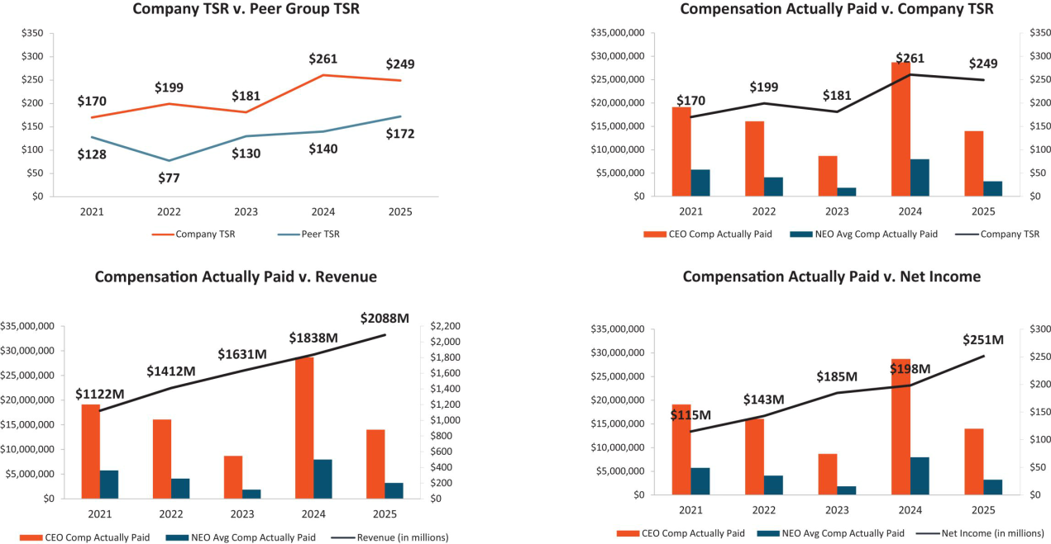

2025 Performance measures

As noted above, our Compensaton and Talent Management Commitee believes in a holistc evaluaton of our executves’ and our Company’s performance and uses a mix of performance measures throughout our annual and long-term incentve programs to align executve pay with stockholder value creaton. As required by SEC rules, in 2025, the fnancial performance measures identfed as the most important and used by us to link compensaton actually paid for our named executve ofcers are listed below.


Revenue

Adjusted Operatng Proft Margin

Relatve TSR

98 | / | EXL 2026 Proxy Statement

Table of Contents

Executve compensaton

Director compensaton for fscal year 2025

The following table sets forth informaton for compensaton earned in fscal year 2025 by our non-executve directors who served during fscal year 2025:

 |  | Fees earned or |  | All Other
 |  | paid in cash | Stock awards | compensaton | Total
Name(1) |  | ($) | _{($)}(2)(3) | ($) | ($)
Thomas Bartlet |  | 108,750 | 239,387 |  | 348,137
Andreas Fibig |  | 111,250 | 239,387 |  | 350,637
Pat Geraghty(4) |  | 25,000 | 152,504 |  | 177,504
Vikram Pandit |  | 100,000 | 343,437 |  | 443,437
Kristy Pipes |  | 117,500 | 239,387 |  | 356,887
Nitn Sahney |  | 103,750(5) | 239,387 |  | 343,137
Jaynie Studenmund(6) |  | 58,750 | — | 2,000 | 60,750
Sarah K. Williamson |  | 100,000(5) | 239,387 |  | 339,387

- Mr. Kapoor’s compensaton during 2025 was based solely on his role as CEO, as disclosed in the “Summary compensaton table for fscal year 2025” beginning on page 79 and discussed in “Compensaton Discussion and Analysis” beginning on page 54. He does not receive any additonal compensaton for his services as a director.

- Amounts refect the aggregate grant date fair value of stock awards recognized for fnancial statement reportng purposes for the fscal year ended December 31, 2025, in accordance with FASB ASC Topic 718 (disregarding any forfeiture assumptons). All of the grants were made on June 17, 2025 except for Mr. Geraghty’s grant which was made on October 15, 2025. Assumptons used in the calculaton of these amounts are included in footnotes 2 and 23 to our audited fnancial statements for the fscal year ended December 31, 2025 included in the 2025 Form 10-K.

- The outstanding equity awards, comprised entrely of unvested restricted stock units, held by each of our non-employee directors on December 31, 2025 are as follows: for
Ms. Studenmund: 0; for each of Mr. Bartlet, Mr. Fibig, Ms. Pipes, Mr. Sahney, and Ms. Williamson: 4,981; for Mr. Pandit: 7,146; and for Mr. Geraghty: 3,760.

- Mr. Geraghty was elected to the Board on October 15, 2025. The values for his annual retainer fee and stock award each represent a pro-rated porton of the 2025 annual retainer fee and the annual equity award in respect of his service from October 15, 2025 through the Company’s 2026 annual meetng of stockholders.
- Mr. Sahney and Ms. Williamson each elected to receive their cash retainers in the form of tme-based restricted stock units.

- Ms. Studenmund resigned from the board, efectve as of the 2025 Annual Meetng. The amount included in this table in respect of her cash fees refects a pro-rated amount for the period during 2025 that she served as a director. Ms. Studenmund did not receive any stock awards in respect of her 2025 service. The “All Other Compensaton” column includes $2,000 Ms. Studenmund earned for consultng fees in 2025 afer retring from the board.

In 2025, non-executve directors were eligible to receive an annual retainer fee in the amount of $100,000 in cash and $230,000 in equity, granted in the form of tme-based restricted stock units. This represents an increase from the 2024 non-executve director compensaton of an $85,000 annual retainer fee and $215,000 in equity. The increases in non-executve director compensaton were put into place following a compettve assessment of Director pay of companies similar to EXL in size and scope completed by Farient. Upon discussions of market positoning and workload, the directors felt an increase was appropriate. The number of shares subject to each director’s tme-based restricted stock unit award was determined by dividing the dollar value noted above by the average stock closing price for the preceding month. Therefore, the value difers from the grant date fair value of the awards, as shown in the “Director compensaton for fscal year 2025” table, which is calculated based on the assumptons described in note 2 to that table.

 | EXL 2026 Proxy Statement | / 99

Table of Contents

Executve compensaton

As the non-executve Board Chair and then the Lead Director during 2025, Mr. Pandit was eligible to receive an additonal $100,000 in restricted stock units, with the number of units calculated based on the method described above. We believe that maintaining the same compensaton for Mr. Pandit in his Lead Director role is appropriate given the breadth of his scope of responsibilites, which remain substantvely aligned with the responsibilites he performed in his former role as Board Chair. See “Board leadership structure” on page 24. New non-executve directors who join our board of directors during a calendar quarter are eligible to receive the full cash fee for such calendar quarter and a pro-rated equity grant. The chairs of our Audit Commitee and Compensaton and Talent Management Commitee were eligible to receive an additonal annual fee of $17,500 in cash, and the chair of our Nominatng and Governance Commitee was eligible to receive an additonal annual fee of $15,000 in cash. These commitee chair fees were pro-rated for 2025 for Messrs. Bartlet, Fibig and Sahney based on the respectve tme they served in such positons during 2025. Directors may elect to receive their cash retainer fee in the form of tme-based restricted stock units, which vest 50% on the date of the Annual Meetng and 50% on the last day of the calendar year (or an earlier change in control). The grants will generally setle at the same tme as our annual equity awards, as described below.

There are no additonal fees payable for atendance at our board or commitee meetngs (whether in person, telephonic or otherwise). We make quarterly cash payments in respect of the director fees to our directors. Directors who hold restricted stock units do not receive the underlying shares of common stock untl the units have vested and are setled. The restricted stock units granted to directors generally vest upon the earliest of (i) the frst anniversary of the date of grant, (ii) the date on which the director’s term on the board expires if the director is not subsequently elected to a new term and (iii) a change in control. The restricted stock units issued to each of our non-employee directors will generally setle on the earliest of (i) the director’s death, (ii) a change in control, or (iii) 180 days following the end of the director’s term on our board of directors. However, in lieu of setlement 180 days following the director’s term, a director may elect in advance that the units be setled on an alternate delivery date following the director’s service on the board, or if the director has satsfed our stock ownership guidelines, upon the vestng date of the award.

We maintain a non-employee director stock ownership policy that requires directors to maintain stock ownership of at least fve tmes their respectve annual cash retainers (countng common stock, vested restricted stock units and unvested tme-based restricted stock units). New directors have fve years from their appointment date to atain the required stock ownership levels, whereas existng directors generally have three years to meet any increased ownership requirements as a result of annual cash retainer increases.

Common stock is counted toward the ownership requirement if it is owned by or for the beneft of the director, the director’s spouse or the director’s children sharing the same household. During the applicable phase-in period, directors generally must retain at least 50% of shares delivered following the vestng of an equity award untl the ownership requirement is met. If the ownership requirement is not met at the end of the phase-in period, directors generally may not sell any shares untl the ownership requirement is met other than to satsfy tax obligatons arising with respect to equity awards.

As of December 15, 2025, all applicable directors were either in compliance with this policy or in the phase-in period.

100 | / | EXL 2026 Proxy Statement

Table of Contents

Stock ownership of directors, executve ofcers and certain benefcial owners

Stock ownership of directors, executve ofcers and certain benefcial owners

Unless otherwise indicated, the table below sets forth informaton with respect to the benefcial ownership of our common stock by:

- each of our directors and each of our named executve ofcers individually;

- each person who is known to be the benefcial owner of more than 5% of our common stock; and

- all of our current directors and current executve ofcers (i.e., not just named executve ofcers) as a group.

The amounts and percentages of common stock benefcially owned below are as of March 25, 2026 (the “Determinaton Date”) and are reported on the basis of the regulatons of the SEC governing the determinaton of benefcial ownership of securites. Under these rules, a person is deemed to be a benefcial owner of a security if that person has or shares votng power, which includes the power to vote or to direct the votng of such security, or investment power, which includes the power to dispose of or to direct the dispositon of such security. A person is also deemed to be a benefcial owner of any securites of which that person has a right to acquire benefcial ownership within 60 days of the Determinaton Date. Under these rules, more than one person may be deemed to be a benefcial owner of the same securites. Except as otherwise indicated below, each of the persons named in the table has sole votng and investment power with respect to the securites benefcially owned by such person as set forth opposite such person’s name.

 |  |  |  | Vested but
 | Name and address(1) | Shares | %(2) | unsetled RSUs(3) | Total
 | Named Executve Ofcers
 | Rohit Kapoor | 3,914,904(4) | 2.56% | — | 3,914,904
 | Maurizio Nicolelli | 321,529(5) | * | — | 321,529
 | Vikas Bhalla | 299,620(6) | * | — | 299,620
 | Vivek Jetley | 560,499(7) | * | — | 560,499
 | Narasimha Kini | 278,908(8) | * | — | 278,908
 | Directors
 | Thomas Bartlet | — | — | 9,033 | 9,033
 | Andreas Fibig | 3,000 | — | 15,575 | 18,575
 | Pat Geraghty | — | — | 0 | 0
 | Vikram S. Pandit | 0 | — | 65,939 | 65,939
 | Kristy Pipes | 0 | — | 30,510 | 30,510
 | Nitn Sahney | 0 | — | 83,822 | 83,822
 | Sarah K. Williamson | 0 | — | 18,067 | 18,067
 | All current directors and executve ofcers as a group (15 people)⁽⁹⁾ | 5,629,189⁽¹⁰⁾ | 3.66% | 222,946 | 5,852,135
 |  |  |  | EXL 2026 Proxy Statement | / 101

Table of Contents

Stock ownership of directors, executve ofcers and certain benefcial owners

 | Benefcial ownership
Name and address(1) | Shares | %(2)
5% Benefcial owners
Blackrock Inc.⁽¹¹⁾ | 15,437,315 | 10.09
The Vanguard Group, Inc.⁽¹²⁾ | 14,851,966 | 9.70
FMR LLC⁽¹³⁾ | 14,331,972 | 9.36
*Less than 1%.

- Unless otherwise noted, the business address of each benefcial owner is c/o ExlService Holdings, Inc., 320 Park Avenue, 29th Floor, New York, New York 10022.

- Based on 153,052,838 shares outstanding as of the Determinaton Date.

- For non-management directors, this column includes restricted stock units (previously granted for service on the board) that have vested but are unsetled. Because vested restricted stock units generally setle 180 days following the director’s term of service (see “Director compensaton for fscal year 2025” for additonal details on setlement), the units are not treated as benefcially owned under SEC rules because the holder does not have the right to acquire the underlying stock within 60 days of the Determinaton Date. However, we separately present these amounts because restricted stock units that are vested but unsetled provide a meaningful alignment with the Company’s stockholders, and they count towards our stock ownership policy for non-employee directors, which requires directors to maintain stock ownership of at least fve tmes their respectve annual retainers.

- The amount includes: (a) 885,670 shares of our common stock owned indirectly by Mr. Kapoor through a family trust created in 2016 under a 2005 grantor-retained annuity trust, for which

Mr. Kapoor’s spouse and Mr. Kapoor’s brother are the co-trustees and share dispositve and votng control over the shares in the trust, (b) 201,095 shares of our common stock owned indirectly by Mr. Kapoor through a family trust created in 2016 under a 2013 grantor retained annuity trust, for which Mr. Kapoor’s spouse and Mr. Kapoor’s brother are the co-trustees and share dispositve and votng control over the shares in the trust, (c) 420,000 shares of our common stock owned indirectly by Mr. Kapoor through a spousal lifetme access trust, for which Mr. Kapoor’s spouse and

Mr. Kapoor’s brother are the co-trustees and share dispositve and votng control over the shares in the trust, (d) 420,000 shares of our common stock owned indirectly by Mr. Kapoor through a spousal lifetme access trust for Mr. Kapoor’s spouse, for which Mr. Kapoor and Mr. Kapoor’s brother are the co-trustees and share dispositve and votng control over the shares in the trust, and

- 665,925 shares of our common stock owned indirectly by Mr. Kapoor through a family trust created in 2016 for which Mr. Kapoor is the investment advisor to Commonwealth Trust Company, the trustee.

(5) This amount consists of 67,160 shares of our common stock of which Mr. Nicolelli has the right to acquire benefcial ownership within 60 days of the Determinaton Date pursuant to currently vested and exercisable stock optons.

(6) This amount consists of 134,325 shares of our common stock of which Mr. Bhalla has the right to acquire benefcial ownership within 60 days of the Determinaton Date pursuant to currently vested and exercisable stock optons.

(7) This amount consists of 134,325 shares of our common stock of which Mr. Jetley has the right to acquire benefcial ownership within 60 days of the Determinaton Date pursuant to currently vested and exercisable stock optons.

(8) This amount consists of 67,160 shares of our common stock of which Mr. Kini has the right to acquire benefcial ownership within 60 days of the Determinaton Date pursuant to currently vested and exercisable stock optons.

(9) Includes seven current non-employee directors and our eight current executve ofcers as of the Determinaton Date.

(10) This amount consists of 178,935 shares of our common stock of which our executve ofcers, other than our named executve ofcers, have the right to acquire benefcial ownership within 60 days of the Determinaton Date pursuant to currently vested and exercisable stock optons.

(11) Based on the Schedule 13G/A fled on July 17, 2025, Blackrock, Inc. had sole votng power with respect to 14,991,298 shares and sole dispositve power with respect to 15,437,315 shares. The business address of Blackrock, Inc. is 55 East 52nd Street, New York, New York 10022.

(12) Based on the Schedule 13G/A fled on July 29, 2025, The Vanguard Group, Inc. had shared votng power with respect to 84,470 shares, sole dispositve power with respect to 14,569,047 shares and shared dispositve power with respect to 282,919 shares. The business address of The Vanguard Group, Inc. is 100 Vanguard Boulevard, Malvern, PA 19355. Subsequent to the Determinaton Date, The Vanguard Group reported that due to an internal realignment it no longer has, or is deemed to have, benefcial ownership over our securites benefcially owned by various Vanguard subsidiaries and/or business divisions. The Vanguard Group also reported that certain subsidiaries or business divisions that formerly had, or were deemed to have, benefcial ownership with The Vanguard Group, will report benefcial ownership separately (on a disaggregated basis).

(13) Based on the Schedule 13G/A fled on February 5, 2026, FMR LLC had sole votng power with respect to 12,283,088 shares and sole dispositve power with respect to 14,331,972 shares. The business address of FMR LLC is 245 Summer Street, Boston, Massachusets 02210.

102 | / | EXL 2026 Proxy Statement

Table of Contents

Certain relatonships and related person transactons

Certain relatonships and related person transactons

Review and approval of related party transactons

We review all relatonships and transactons involving the Company and our directors, director nominees, executve ofcers, 5% stockholders and each of their immediate family members that may involve a direct or indirect material interest by such persons. Our Code of Conduct and Ethics instructs our directors, ofcers and employees to report the facts and circumstances of any such transacton or potental transacton to our General Counsel or our Audit Commitee. Our board of directors has adopted a policy regarding the review of potental related party transactons. Under this policy, our General Counsel will review the facts and circumstances of any covered transacton. If our General Counsel determines that the transacton involves a related party transacton and the amount involved does not equal or exceed $120,000, our General Counsel will approve or disapprove the transacton. If our General Counsel determines that the transacton involves a related party transacton and the amount involved equals or exceeds $120,000, our General Counsel will refer the transacton to our Audit Commitee for consideraton. In reviewing, approving or ratfying a related party

Factors used in assessing related party transactons


- The nature of the related party transacton

- The related party’s interest in the transacton

- The material terms of the transacton, including the amount involved and type of transacton

- The benefts to us of the proposed transacton

- The availability of other sources for comparable products or services

- Whether the proposed transacton is on terms comparable to terms available to an unrelated third party or employees generally

- Whether the transacton would impair the judgment of a director or executve ofcer to act in our best interest

transacton, our General Counsel (for transactons below $120,000) or the Audit Commitee or its Chair (for transactons exceeding $120,000) considers factors as they consider appropriate, including but not limited to the factors in the box to the right.

Related party transactons

As required under SEC rules, transactons since the beginning of our last fscal year, or any currently proposed transacton, in which we are a partcipant and which involve amounts exceeding $120,000, and in which any related person had or will have a direct or indirect material interest are disclosed in our Proxy Statement. In additon to the procedures set forth above, each year we require our executve ofcers, directors and director nominees to submit a routne questonnaire seeking confrmaton of, among other things, any transactons with the Company in which such person, or their family members, may have an interest. Other than as set forth below, there were no such related person transactons since January 1, 2025.

The Company entered into a Stock Purchase Agreement, dated as of December 15, 2025, with Orogen Echo LLC (“Orogen”), an afliate of The Orogen Group LLC, pursuant to which the Company privately repurchased 1,551,970 shares of the Company’s common stock from Orogen for an aggregate purchase price of $63.4 million based on a purchase price per share of $40.834, which was the volume weighted average price over the 5 days prior to setlement. The terms of the contract with Orogen were, in the Company’s opinion, no less favorable than the Company would have been able to negotate with an unrelated party, and the transacton was approved by the Audit Commitee. Afer considering the facts and circumstances regarding the relatonship, our board of directors has determined that the stock repurchase from Orogen did not and does not impair Mr. Pandit’s independence under applicable Nasdaq standards and federal securites laws.

 | EXL 2026 Proxy Statement | / 103

Table of Contents

Audit Commitee Report

Audit Commitee Report

The Audit Commitee of the board of directors of ExlService Holdings, Inc. assists our board of directors in fulflling its oversight responsibilites with respect to the following:

- our accountng and fnancial reportng processes, including the integrity of the fnancial statements and other fnancial informaton provided by us to our stockholders, the public, stock exchanges and others;

- our compliance with legal and regulatory requirements;

- our registered independent public accountng frm’s qualifcatons and independence;

- the audit of our fnancial statements; and

- the performance of our internal audit functon and independent registered public accountng frm.

In connecton with these responsibilites, the Audit Commitee met with management and Deloite & Touche LLP to review and discuss the December 31, 2025 audited consolidated fnancial statements. The Audit Commitee also discussed with Deloite & Touche LLP the maters required to be discussed by the applicable requirements of the Public Company Accountng Oversight Board and the SEC. The Audit Commitee also received writen disclosures and the leter from Deloite & Touche LLP required by Rule 3526 of the Public Company Accountng Oversight Board (Communicatons with Audit Commitees Concerning Independence), and the Audit Commitee discussed with Deloite & Touche LLP the frm’s independence.

Based on the review and discussions referred to above, the Audit Commitee approved the inclusion of the audited fnancial statements in the Company’s Annual Report on Form 10-K for the fscal year ended December 31, 2025.

Audit Commitee

Ms. Kristy Pipes (Chair)

Mr. Thomas Bartlet

Mr. Andreas Fibig

Mr. Pat Geraghty

Mr. Nitn Sahney

104 | / | EXL 2026 Proxy Statement

Table of Contents

Proposal 1 — Electon of directors

Proposal 1 — Electon of directors

The nominees

Our Nominatng and Governance Commitee has nominated, and our board of directors has designated, Mr. Kapoor, Mr. Pandit, Mr. Bartlet, Mr. Fibig,

Mr. Geraghty, Ms. Pipes and Ms. Williamson to stand for electon as directors at the Annual Meetng. Mr. Geraghty was appointed in October 2025 and was identfed and recommended to the Nominatng and Governance Commitee by a third-party search frm. Mr. Sahney will not be standing for re-electon at the Annual Meetng.

Term of ofce

If elected, each of the director nominees will serve a term of one year on our board of directors, untl our 2027 Annual Meetng of Stockholders or untl their respectve successors are duly elected and qualifed in accordance with our By-laws.

Votng instructons and substtutes

The proxies given to the proxy holders will be voted or not voted as directed and, if no directon is given, will be voted FOR these seven nominees. Our board of directors knows of no reason why any of these nominees should be unable or unwilling to serve. However, if for any reason any nominee should be unable or unwilling to stand for electon, the shares represented by proxies will be voted for the electon of any substtute nominee designated by our board of directors to fll the vacancy.

General informaton about nominees

The age as of the date of this Proxy Statement, tenure on our board of directors and commitee membership, if any, of each nominee appears below. Informaton regarding the business experience during at least the last fve years and directorships of other publicly owned corporatons of each nominee can be found above under “Our board of directors.” Other informaton required with respect to any solicitaton of proxies in connecton with the electon of directors is found elsewhere in this Proxy Statement.

 | EXL 2026 Proxy Statement | / 105

Table of Contents

Proposal 1 — Electon of directors
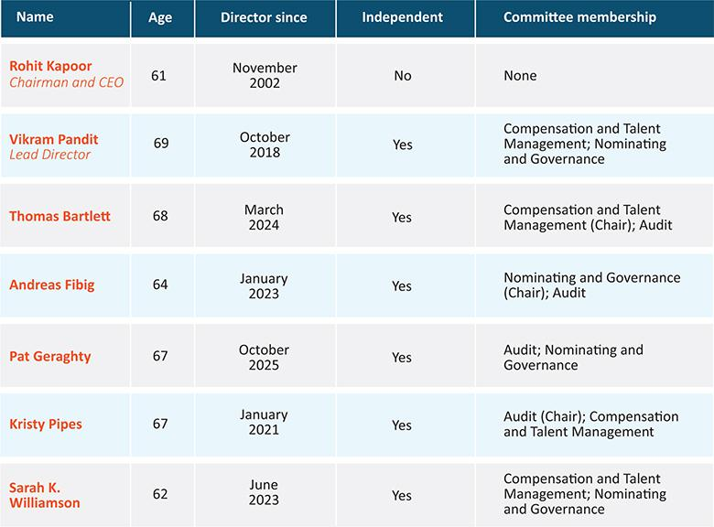

Required vote

The afrmatve vote of a majority of votes cast (meaning the number of shares voted “for” a nominee must exceed the number of shares voted “against” such nominee) at the Annual Meetng will elect the seven nominees as directors for a term of one year. If any nominee for director receives a greater number of votes “against” his or her electon than votes “for” such electon, our By-laws provide that such person will tender to the board of directors his or her resignaton as a director. Unless marked to the contrary, proxies received will be voted “FOR” the nominees.

 |  | Our board recommends that you vote
 |  | FOR | the electon of Mr. Kapoor, Mr. Pandit, Mr. Bartlet, Mr. Fibig, Mr. Geraghty, Ms. Pipes and
 |  | FOR | Ms. Williamson as directors of the Company
106 /
106 / | EXL 2026 Proxy Statement

Table of Contents

Proposal 2 — Ratfcaton of the appointment of independent registered public accountng frm

Proposal 2 — Ratfcaton of the appointment of independent registered public accountng frm

Our Audit Commitee has appointed Deloite & Touche LLP (“Deloite”) as the independent registered public accountng frm to audit the Company’s and its subsidiaries’ books, records and accounts for fscal year 2026. Our board of directors has endorsed this appointment. Ratfcaton of the appointment of Deloite by our stockholders is not required by law. However, as a mater of good corporate practce, such appointment is being submited to our stockholders for ratfcaton at the Annual Meetng. If our stockholders do not ratfy the appointment, our board of directors and our Audit Commitee will reconsider whether or not to retain Deloite, but may nonetheless retain Deloite. Even if the appointment is ratfed, the Audit Commitee in its discreton may change such appointment at any tme during the year if it determines that such change would be in the best interests of the Company and our stockholders.

In retaining Deloite as the Company’s independent registered public accountng frm, the Audit Commitee considered whether the provision of non-audit services by Deloite was compatble with maintaining Deloite’s independence and concluded that it was. Representatves of Deloite are expected to be present at the Annual Meetng. They will have an opportunity to make a statement, if they desire to do so, and will be available to respond to appropriate questons. Deloite has served as our independent registered public accountng frm since February 28, 2018.

Audit and non-audit fees

The following is a summary of the fees billed or expected to be billed to us by the Company’s independent registered public accountng frm for professional services rendered in each of the last two fscal years:

 | Fiscal | Fiscal
Fee category | 2025 | 2024
 |  | (in thousands)
Audit fees | $2,122 | $1,955
Audit-related fees | — | —
Tax fees | 14 | 25
All other fees | 189 | 237
Total fees | $2,325 | $2,217

Audit fees:

Consist of fees billed or expected to be billed for professional services rendered for the audit of our consolidated fnancial statements, including (i) the audit of efectveness of internal control over fnancial reportng, (ii) review of our consolidated fnancial statements included in our quarterly reports, and

- services that are normally provided by our independent registered public accountants including services in connecton with statutory or regulatory flings or engagements for those fscal years.

 | EXL 2026 Proxy Statement | / 107

Table of Contents

Proposal 2 — Ratfcaton of the appointment of independent registered public accountng frm

Audit-related fees:

Consist of fees billed for assurance and related services that are reasonably related to the performance of the audit or review of our consolidated fnancial statements and are not reported under “Audit Fees.”

Tax fees:

Consist primarily of fees billed or expected to be billed for other tax fling and advisory projects.

All other fees:

Consist of fees billed or expected to be billed for other permissible work performed by our independent registered public accountng frm not reported under the categories above and primarily include permissible advisory services related to a project to upgrade our informaton systems.

Our Audit Commitee pre-approves and is responsible for the engagement of all auditng services provided by our independent registered public accountants and all non-auditng services to be provided by such accountants to the extent permited under Secton 10A of the Exchange Act, including all fees and other terms of engagement. Our Audit Commitee may delegate the authority to pre-approve audit and permited non-audit services between meetngs of our Audit Commitee to a designated member of our Audit Commitee, provided that the decisions made by such member are presented to our full Audit Commitee for ratfcaton at its next scheduled meetng.

All of the fees paid to Deloite in fscal year 2025 were pre-approved by the Audit Commitee.

Required vote

The ratfcaton of the appointment of Deloite as our independent registered public accountng frm requires the afrmatve vote of a majority of shares present in person or represented by proxy and enttled to vote at the Annual Meetng. Unless marked to the contrary, proxies received will be voted “FOR” ratfcaton of the appointment.


Our board recommends that you vote:

 |  | FOR | the ratfcaton of the appointment of Deloite as our independent registered public
 |  | FOR | accountng frm
108 / EXL 2026 Proxy Statement

Table of Contents

Proposal 3 — Advisory (non-binding) vote to approve executve compensaton

Proposal 3 — Advisory (non-binding) vote to approve executve compensaton

Proposal 3 is a vote, on a non-binding advisory basis, to approve the compensaton of our executve ofcers as described in this Proxy Statement. Although the vote is advisory and is not binding on the board of directors, our Compensaton and Talent Management Commitee will take into account the outcome of the vote when considering future executve compensaton decisions. We refer to this vote as the “say-on-pay” vote.

At the 2023 Annual Meetng of Stockholders, our stockholders voted on a proposal relatng to the frequency of the “say-on-pay” vote. We recommended, and our stockholders approved on a non-binding advisory basis, an annual say-on-pay vote. Accordingly, we include the say-on-pay vote each year as a regular part of each Annual Meetng of Stockholders. The next vote on the frequency of the “say-on-pay” vote will be held at the 2029 Annual Meetng of Stockholders.

- Our board of directors is commited to corporate governance best practces and recognizes the signifcant interest of stockholders in executve compensaton maters.

- Our board of directors believes that our current executve compensaton program directly links executve compensaton to our performance and aligns the interests of our executve ofcers with those of our stockholders. For example, the bulk of our annual incentve awards is earned based on achievement of two core fnancial metrics: revenue and AOPM. As we discuss in greater detail in our Compensaton Discussion and Analysis, these fnancial metrics focus our named executve ofcers on top-line revenues and botom-line earnings that are likely to make meaningful contributons to our future fnancial performance. We believe rewarding our executves with incentve pay based on achievement of these fnancial metrics closely aligns management with the interests of our stockholders.

In additon, our philosophy places more emphasis on variable elements of compensaton (such as annual incentves and equity-based compensaton) than fxed remuneraton.

Our stockholders have the opportunity to vote for, against or abstain from votng on the following resoluton:

“Resolved, that the stockholders approve on an advisory basis the compensaton of our named executve ofcers, as disclosed pursuant to the compensaton disclosure rules of the SEC (which disclosure shall include the Compensaton Discussion and Analysis, the compensaton tables and any related material disclosed in this Proxy Statement).”

The above-referenced disclosures related to the compensaton of our named executve ofcers appear beginning at page 54 of this Proxy Statement.

 | EXL 2026 Proxy Statement | / 109

Table of Contents

Proposal 3 — Advisory (non-binding) vote to approve executve compensaton

Required vote

The approval, on an advisory (non-binding) basis, of the compensaton of our named executve ofcers requires the afrmatve vote of a majority of shares present in person or represented by proxy and enttled to vote at the Annual Meetng. Unless marked to the contrary, proxies received will be voted “FOR” the approval of the compensaton of our named executve ofcers.


Our board recommends that you vote:

the approval, on an advisory (non-binding) basis, of the compensaton of our named _{FOR} executve ofcers as disclosed pursuant to the compensaton disclosure rules of the SEC

(including the Compensaton Discussion and Analysis, the compensaton tables and any related material disclosed in this Proxy Statement)

110 | / | EXL 2026 Proxy Statement

Table of Contents

Miscellaneous

Miscellaneous

Stockholder proposals and director nominatons for the 2027 Annual Meetng

Stockholder proposals intended to be included in our proxy materials for the 2027 Annual Meetng of Stockholders (“2027 Annual Meetng”) must be received by the deadline calculated in accordance with SEC Rule 14a-8, which is 120 days before the anniversary of the date of this year’s Proxy Statement. This year’s deadline is December 28, 2026. Such proposals must include the informaton required by SEC rules and should be sent in writng by courier or certfed mail to the Corporate Secretary of the Company at 320 Park Avenue, 29th Floor, New York, New York 10022. Stockholder proposals that are sent to any other person or locaton or by any other means may not be received in a tmely manner and thus may be ineligible for inclusion. Any stockholder proposal submited outside the Rule 14a-8 process will be deemed “untmely” for purposes of Rule 14a-4(c) if received afer March 13, 2027 (45 days before the anniversary of the date on which we frst mailed our proxy materials for the Annual Meetng). In that case, we may exercise discretonary authority to vote on such proposal using proxies solicited by the Board.

Stockholders who intend to submit proposals at the 2027 Annual Meetng but whose proposals are not included in the proxy materials for the meetng, and stockholders who intend to submit nominatons for directors at the 2027 Annual Meetng, are required to notfy the Corporate Secretary of the Company (at the address above) of their proposal or nominatons not less than 90 days, nor more than 120 days, before the anniversary of this year’s Annual Meetng of Stockholders, in accordance with our By-laws. Such notces of proposals for the 2027 Annual Meetng must be delivered between February 16, 2027 and March 18, 2027. Special notce provisions apply under the By-laws if the date of the 2027 Annual Meetng is more than 30 days before or 70 days afer the anniversary date of this year’s Annual Meetng of Stockholders.

Any notce of proposed business or nominaton, whether or not included in our Proxy Statement, must include the informaton required under our By-laws, including Secton 2.11.4, in order for the mater to be eligible for consideraton at the 2027 Annual Meetng. In additon, to comply with the universal proxy rules, stockholders who intend to solicit proxies in support of director nominees other than the Company’s nominees must provide notce that sets forth the informaton required by Rule 14a-19 under the Exchange Act no later than 60 days before the anniversary of this year’s Annual Meetng of Stockholders, or April 17, 2027. If this deadline falls on a weekend or holiday, we will accept tmely notce on the next business day. Special deadlines apply if the date of the 2027 Annual Meetng is more than 30 days from the anniversary date of this year’s Annual Meetng of Stockholders.

The presiding ofcer of the 2027 Annual Meetng may refuse to acknowledge any mater or nominaton not made in compliance with the procedures in our By-laws. Our By-laws can be found on our website and the current SEC rules for submitng stockholder proposals can be obtained from the SEC at: Division of Corporaton Finance, 100 F. Street, N.E., Washington, DC 20549, or through the SEC’s Internet website at www.sec.gov.

Delivery of documents to stockholders sharing an address

If you are the benefcial owner, but not the record holder, of shares of our common stock, your broker, bank, trust or other nominee may only deliver one copy of this Proxy Statement and the 2025 Form 10-K, which serves as our Annual Report to Stockholders under Regulaton 14A (the “2025 Annual Report”), to multple stockholders who share an address unless that

 | EXL 2026 Proxy Statement | / 111

Table of Contents

Miscellaneous

nominee has received contrary instructons from one or more of the stockholders. We will deliver promptly, upon writen or oral request, a separate copy of this Proxy Statement and the 2025 Annual Report to a stockholder at a shared address to which a single copy of the documents was delivered. A stockholder who wishes to receive a separate copy of the Proxy Statement and annual report, now or in the future, should submit this request to our investor relatons department through the Investor Relatons page of our website at htps://ir.exlservice.com/. Benefcial owners sharing an address who are receiving multple copies of proxy materials and annual reports and who wish to receive a single copy of such materials in the future will need to contact their broker, bank, trust or other nominee to request that only a single copy of each document be mailed to all stockholders at the shared address in the future.

Electronic access to Proxy Statement and Annual Report

This proxy statement and our 2025 Annual Report may be viewed on our website at www.exlservice.com and at www.proxyvote.com by following the instructons provided in the Internet Notce. If you are a stockholder of record, you can elect to access future annual reports and proxy statements electronically by marking the appropriate box on your proxy form. If you choose this opton, you will receive a proxy form in mid-May listng the website locatons and your choice will remain in efect untl you notfy us by mail that you wish to resume mail delivery of these documents. If you hold your common stock through a bank, broker or another holder of record, refer to the informaton provided by that entty for instructons on how to elect this opton.

Delinquent Secton 16(a) reports

Secton 16(a) of the Exchange Act requires our directors, executve ofcers and holders of more than 10% of the Company’s common stock to fle reports with the SEC regarding their ownership and changes in ownership of our securites. Based upon our examinaton of the copies of Forms 3, 4, and 5, and amendments thereto fled electronically with the SEC and the writen representatons of our reportng persons, we believe that all reports were fled on a tmely basis during fscal 2025.

Forward-looking statements

This Proxy Statement contains forward-looking statements within the meaning of the United States Private Securites Litgaton Reform Act of 1995. You should not place undue reliance on these statements because they are subject to numerous uncertaintes and factors relatng to our operatons and business environment, all of which are difcult to predict and many of which are beyond our control. These statements ofen include words such as “may,” “will,” “should,” “believe,” “expect,” “antcipate,” “intend,” “plan,” “estmate” or similar expressions. These statements are based on assumptons that we have made in light of our experience in the industry as well as our perceptons of historical trends, current conditons, expected future developments and other factors we believe are appropriate under the circumstances. As you read and consider this Proxy Statement, you should understand that these statements are not guarantees of performance or results. They involve known and unknown risks, uncertaintes and assumptons. Although we believe that these forward-looking statements are based on reasonable assumptons, you should be aware that many factors could afect our actual fnancial results or results of operatons and could cause actual results to difer materially from those in the forward-looking statements. For a more detailed discussion of these factors, see the informaton under “Risk Factors” and “Management’s Discussion and Analysis of Financial Conditon and Results of Operatons” in the 2025 Form 10-K.

112 | / | EXL 2026 Proxy Statement

Table of Contents

Non-GAAP Reconciliaton

Non-GAAP Reconciliaton

The Company reports its fnancial results in accordance with U.S. generally accepted accountng principles (“GAAP”). However, certain non-GAAP measures have been provided in this Proxy Statement.

These non-GAAP fnancial measures are not based on any comprehensive set of accountng rules or principles, should not be considered a substtute for, or superior to, fnancial measures calculated in accordance with GAAP, and may be diferent from non-GAAP fnancial measures used by other companies. Accordingly, the fnancial results calculated in accordance with GAAP and reconciliatons from those fnancial statements should be carefully evaluated.

The Company believes that non-GAAP fnancial measures – present additonal useful comparisons between current results and results in prior operatng periods, providing investors with a supplemental view of the underlying trends of the Company’s business. The Company also uses

these non-GAAP fnancial measures in making fnancial, operatng, planning and compensaton decisions and in evaluatng the Company’s performance.

Non-GAAP measures/ inputs for Proxy Statement 2025

Descripton of Adjusted Financial Measures to GAAP Measures

Our adjusted net income and adjusted diluted EPS refers to net income as per GAAP, adjusted for non-cash expenses like stock-based compensaton expense and amortzaton of acquisiton-related intangible assets and certain non-recurring expenses/(benefts) that the management believe can provide useful supplemental informaton for investors analyzing period-to-period comparisons of the Company’s results and comparisons of the Company’s results with the results of other companies. Our adjusted net income and adjusted diluted EPS also excludes the efects of income tax on such adjustments, as applicable.

 | EXL 2026 Proxy Statement | / 113

Table of Contents

Non-GAAP Reconciliaton

The following table shows the reconciliaton of non-GAAP fnancial measures for the year ended December 31, 2025 and 2024:

Reconciliaton of Adjusted Net Income and Adjusted Diluted Earnings Per Share (Amounts in thousands, except per share data)

 |  |  |  | Year ended
 |  |  |  | December 31,
 |  |  |  | 2025 |  |  | 2024
Net income (GAAP) |  | $ |  | 251,019 | $ |  | 198,297
add: Stock-based compensaton expense |  |  |  | 79,469 |  |  | 72,658
add: Amortzaton of acquisiton-related intangibles |  |  |  | 13,140 |  |  | 13,630
add: Restructuring and litgaton setlement costs (a) |  |  |  | — |  |  | 6,174
add/(subtract): Changes in fair value of contngent consideraton |  |  |  | 2,300 |  |  | (589)
add: Other tax expenses (b) |  |  |  | 267 |  |  | 3,817
subtract: Acquisiton-related adjustments |  |  |  | (945) |  |  | —
subtract: Tax impact on stock-based compensaton expense (c) |  |  |  | (24,997) |  |  | (17,576)
subtract: Tax impact on amortzaton of acquisiton-related intangibles |  |  |  | (3,313) |  |  | (3,318)
subtract: Tax impact on restructuring and litgaton setlement costs |  |  |  | — |  |  | (1,540)
add: Tax impact on changes in fair value of contngent consideraton |  |  |  | — |  |  | 146
Adjusted net income (Non-GAAP) |  | $ |  | 316,940 | $ |  | 271,699
Adjusted diluted earnings per share (Non-GAAP) |  | $ |  | 1.95 | $ |  | 1.65

- To exclude efects of employee severance costs and outplacement support costs of $4,762 and litgaton setlement costs and associated legal fees of $1,412 during the year ended December 31, 2024.

- To exclude tax expenses related to certain deferred tax assets and liabilites.

- Tax impact includes $15,930 and $9,714 for the year ended December 31, 2025 and 2024, respectvely, related to discrete beneft recognized in income tax expense in accordance with ASU

No. 2016-09, Compensaton—Stock Compensaton.

114 | / | EXL 2026 Proxy Statement

Table of Contents

Annual Meetng Q&A

Annual Meetng Q&A

Who is providing this Proxy Statement?

This Proxy Statement is being furnished to you in connecton with the solicitaton by the board of directors of ExlService Holdings, Inc., a Delaware corporaton (“us,” “we,” “our” or the “Company”), of proxies to be used at our 2026 Annual Meetng of Stockholders (the “Annual Meetng”) to be held in virtual format only via live audio webcast at the website www.virtualshareholdermeetng.com/EXLS2026 on June 16, 2026 at 9:00 AM, Eastern Time, and any adjournments or postponements thereof.

How are the proxy materials being made available?

In accordance with rules and regulatons adopted by the Securites and Exchange Commission (the “SEC”), instead of mailing a printed copy of our proxy materials to each stockholder of record, the Company furnishes proxy materials via the Internet. If you received a Notce of Internet Availability of Proxy Materials (the “Internet Notce”) by mail, you will not receive a printed copy of our proxy materials other than as described herein. Instead, the Internet Notce will instruct you as to how you may access and review all of the important informaton contained in the proxy materials. The Internet Notce also instructs you as to how you may submit your proxy over the Internet or by phone. If you received an Internet Notce by mail and would like to receive a printed copy of our proxy materials, you should follow the instructons for requestng proxy materials included in the Internet Notce.

Our Notce of Annual Meetng, Proxy Statement and form of proxy card are each available at www.proxyvote.com. You may access these materials and provide your proxy by following the instructons provided in the Internet Notce.

When will the internet notce be sent?

We antcipate the Internet Notce will be sent to stockholders on or about April 27, 2026. This Proxy Statement and the form of proxy relatng to the Annual Meetng will be made available via the Internet to stockholders on or prior to the date that the Internet Notce is frst sent.

Who can vote?

Only stockholders who own shares of our common stock at the close of business on April 23, 2026, the record date for the Annual Meetng, can vote at the Annual Meetng. As of the close of business on April 23, 2026, the record date, we had 152,796,131 shares of common stock outstanding and enttled to vote. Each holder of common stock is enttled to one vote for each share held as of the record date for the Annual Meetng.

Is cumulatve votng applicable in the electon of directors?

There is no cumulatve votng in the electon of directors.

 | EXL 2026 Proxy Statement | / 115

Table of Contents

Annual Meetng Q&A

How do I vote my shares?

If your shares are registered directly in your name with Computershare Trust Company, N.A., our transfer agent (which means you are a “stockholder of record”), you can vote your proxy by (i) Internet, (ii) by phone or (iii) by requestng that proxy materials be sent to you by mail that will include a proxy card that you can use to vote by completng, signing, datng and returning the proxy card in the prepaid postage envelope provided. Please refer to the specifc instructons set forth in the Internet Notce.

If you are the benefcial owner of shares held in the name of a brokerage, bank, trust or other nominee as a custodian (also referred to as shares held in “street name”), your broker, bank, trustee or nominee will provide you with materials and instructons for votng your shares. In additon to votng by mail, a number of banks and brokerage frms partcipate in a program provided through Broadridge Financial Solutons, Inc. (“Broadridge”) that ofers telephone and Internet votng optons. Votes submited by telephone or by using the Internet through Broadridge’s program must be received by 11:59 p.m. Eastern Time, on June 15, 2026.

You also have the right to vote electronically at the Annual Meetng if you decide to atend. Our board of directors recommends that you vote by Internet, phone or mail even if you choose to atend the Annual Meetng. If you are a “stockholder of record,” you may vote your shares electronically at the Annual Meetng. If you hold your shares in “street name,” you must obtain a proxy from your broker, bank, trustee or nominee giving you the right to vote the shares electronically at the Annual Meetng or your vote at the Annual Meetng will not be counted.

You will not be able to vote your shares unless you use one of the methods described above to designate a proxy or you vote electronically at the Annual Meetng.

Can I revoke my proxy?

You can revoke your proxy at any tme before it is exercised in any of the following ways:

- by votng at the Annual Meetng;
- by submitng writen notce of revocaton to the inspector of electons prior to the Annual Meetng; or
- by submitng another properly executed proxy of a later date to the inspector of electons prior to the Annual Meetng.

How is a quorum established at the Annual Meetng?

A quorum, which is a majority of the issued and outstanding shares of our common stock as of the record date of April 23, 2026, must be present, in person or by proxy, to conduct business at the Annual Meetng. A quorum is calculated based on the number of shares represented by the stockholders atending the Annual Meetng in person and by their proxy holders. If you indicate an abstenton as your votng preference for all maters to be acted upon at the Annual Meetng, your shares will be counted toward a quorum but they will not be voted on any mater. Virtual atendance at our Annual Meetng consttutes presence in person for purposes of quorum at the Annual Meetng.

116 | / | EXL 2026 Proxy Statement

Table of Contents

Annual Meetng Q&A

What is a “broker non-vote”?

If you are the benefcial owner of shares held in “street name” by a broker, then your broker, as the record holder of the shares, must vote those shares in accordance with your instructons. If you fail to provide instructons to your broker, under the New York Stock Exchange rules (which apply to brokers even though our shares are listed on the Nasdaq Stock Market), your broker will not be authorized to vote your shares on “non-routne” proposals as described below. As a result, a “broker non-vote” occurs. However, without your instructons, your broker has discretonary authority to vote your shares with respect to “routne” proposals only.

How many votes are needed to approve each proposal and what is the efect of abstentons and/or broker non-votes?

If you submit your proxy, but do not mark your votng preference, the proxy holders will vote your shares (i) FOR the electon of all seven nominees for director (or any substtute designated by the Board as described above), (ii) FOR the ratfcaton of the appointment of our independent registered public accountng frm, (iii) FOR the approval on an advisory (non-binding) basis of the compensaton of our named executve ofcers, and (iv) as described below, in the judgment of the proxy holder on any other maters properly presented at the Annual Meetng.

The chart below summarizes, for each proposal described in this Proxy Statement, the board’s votng recommendaton, the votng approval standard, and the efect of abstentons and broker non-votes. Virtual atendance at our Annual Meetng will consttute presence “in person” for purposes of votng at the Annual Meetng.

 |  | Votng approval |  |  | Efect of
 | Board votng | Votng approval | Efect of | Routne or | broker non-
Proposal | recommendaton | standard | abstentons⁽¹⁾ | non-routne | vote⁽²⁾
1: Electon of directors | FOR the electon | Afrmatve vote of | No | Non-routne | No
 | of each nominee | a majority of votes | efect |  | efect
 |  | cast(3)
2: The ratfcaton of the appointment of our independent | FOR | Majority of shares | Vote | Routne | N/A
registered public accountng frm |  | present and enttled | against(4)
 |  | to vote
3: The advisory (non-binding) approval of the compensaton of our | FOR | Majority of shares | Vote | Non-routne | No
named executve ofcers |  | present and | against(4) |  | efect
 |  | enttled to vote

- If you wish to abstain from votng on a proposal, you must indicate, or mark ABSTAIN, while votng. If a proxy is submited with no directon given, the proxies given to the proxy holders will be voted in accordance with the board recommendatons.

- As discussed above under “What is a broker non-vote?,” brokers will not be enttled to vote on “non-routne” proposals unless benefcial owners provide votng instructons.

- Under our By-Laws, directors who are standing for electon at the Annual Meetng will be elected by the afrmatve vote of a majority of votes cast (meaning the number of shares voted “for” a nominee must exceed the number of shares voted “against” such nominee) by stockholders in person or represented by proxy and enttled to vote at the Annual Meetng. If any incumbent nominee for director receives a greater number of votes “against” his or her electon than votes “for” such electon, our By-laws provide that such person will tender to the board of directors his or her resignaton as a director. You may cast your vote in favor of electng all of the nominees as directors, against one or more nominees, or abstain from votng your shares.

- Under the General Corporaton Law of the State of Delaware, shares that abstain consttute shares that are present and enttled to vote and, accordingly, have the practcal efect of being voted “against” these proposals requiring a majority of shares present and enttled to vote or those based on total shares outstanding.

 | EXL 2026 Proxy Statement | / 117

Table of Contents

Annual Meetng Q&A

Are there other maters to be acted upon at the meetng?

Our board of directors presently is not aware of any maters, other than those specifcally stated in the Notce of Annual Meetng, which are to be presented for acton at the Annual Meetng. If any mater other than those described in this Proxy Statement is presented at the Annual Meetng on which a vote may properly be taken, the shares represented by proxies will be voted in accordance with the judgment of the person or persons votng those shares.

What about adjournments and postponements?

Any acton on the items of business described above may be considered at the Annual Meetng at the tme and on the date specifed above or at any tme and date to which the Annual Meetng is properly adjourned or postponed.

Who pays for solicitaton of proxies?

We will pay the cost of printng and mailing proxy materials and postng them on the Internet. Upon request, we will reimburse brokers, dealers, banks and trustees, or their nominees, for reasonable expenses incurred by them in forwarding proxy materials to benefcial owners of shares of our common stock.

How can I atend the Annual Meetng and why is the Company holding the Annual Meetng in a virtual only format?

As we have done in recent years, we will hold a virtual Annual Meetng rather than a meetng at any physical locaton. We believe that holding a meetng in a virtual format provides an opportunity for broader stockholder partcipaton.

To atend and partcipate in the Virtual Annual Meetng, stockholders will need to access the live audio webcast of the meetng. To do so, stockholders of record will need to visit www.virtualshareholdermeetng.com/EXLS2026 and use their 16-digit Control Numbers provided in the Internet Notce to log in to this website, and benefcial owners of shares held in street name will need to follow the instructons provided by the broker, bank or other nominee that holds their shares. We encourage stockholders to log in to this website and access the webcast before the Annual Meetng’s start tme. Further instructons on how to atend, partcipate in and vote at the Annual Meetng, including how to demonstrate your ownership of our stock as of the record date, are available at www.virtualshareholdermeetng.com/EXLS2026. Please note you will only be able to atend, partcipate and vote in the meetng using this website. All references to atending the Annual Meetng “in person” in this Proxy Statement shall mean atending the live webcast at the Annual Meetng.

How do I submit questons at the Annual Meetng?

We are commited to ensuring that our stockholders will be aforded the same rights and opportunites to partcipate in a virtual Annual Meetng as they would at a meetng held at a physical locaton. You will be able to submit questons during our Annual

118 | / | EXL 2026 Proxy Statement

Table of Contents

Annual Meetng Q&A

Meetng by visitng www.virtualshareholdermeetng.com/EXLS2026. We will try to answer as many stockholder-submited questons as tme permits that comply with the meetng rules of conduct as determined by the chair of the meetng. However, we reserve the right to edit profanity or other inappropriate language, or to exclude questons that are not pertnent to meetng maters or that are otherwise inappropriate. If we receive substantally similar questons, we will group such questons together and provide a single response to avoid repetton.

Will the Annual Meetng be recorded?

A recording of the Annual Meetng will be available online at www.virtualshareholdermeetng.com/EXLS2026 for approximately 12 months following the meetng date.

What if I have technical difcultes or trouble accessing the virtual Annual Meetng?

We will have technicians ready to assist you with any technical difcultes you may have while accessing the live webcast of the Annual Meetng. A technical support phone number will be posted on www.virtualshareholdermeetng.com/EXLS2026 that you may call if you experience technical difcultes during the check-in process or during the Annual Meetng.

What if I have further questons?

If you have any further questons about votng your shares or atending the Annual Meetng, please call our Investor Relatons Department at (212) 277-7100 or email at ir@exlservice.com.

Important

Please promptly vote and submit your proxy before the Annual Meetng by (i) Internet (by following the instructons provided in the Internet Notce), (ii) by phone (by following the instructons provided in the Internet Notce) or (iii) by requestng that proxy materials be sent to you by mail that will include a proxy card that you can use to vote by completng, signing, datng and returning the proxy card in the prepaid postage envelope provided. This will not limit your right to atend or vote at the Annual Meetng.

 | EXL 2026 Proxy Statement | / 119

Table of Contents

Other maters

Other maters

Our board of directors does not know of any other business that will be presented at the Annual Meetng. If any other business is properly brought before the Annual Meetng, your proxy holders will vote on it as they think best unless you direct them otherwise in your proxy instructons.

Whether or not you intend to be present at the Annual Meetng, we urge you to submit your signed proxy promptly.

By Order of the Board of Directors,

Ajay Ayyappan

Executve Vice President, General Counsel and Corporate Secretary

New York, New York

April 27, 2026

We will furnish without charge to each person whose proxy is being solicited, upon the writen request of any such person, a copy of the 2025 Form 10-K, as fled with the SEC, as well as copies of exhibits to the 2025 Form 10-K, but for copies of exhibits will charge a reasonable fee per page to any requestng stockholder. Stockholders may make such request in writng to ExlService Holdings, Inc., 320 Park Avenue, 29th Floor, New York, New York 10022, Atenton: Investor Relatons. The request must include a representaton by the stockholder that as of April 23, 2026, the stockholder was enttled to vote at the Annual Meetng.

120 | / | EXL 2026 Proxy Statement

Table of Contents


Table of Contents
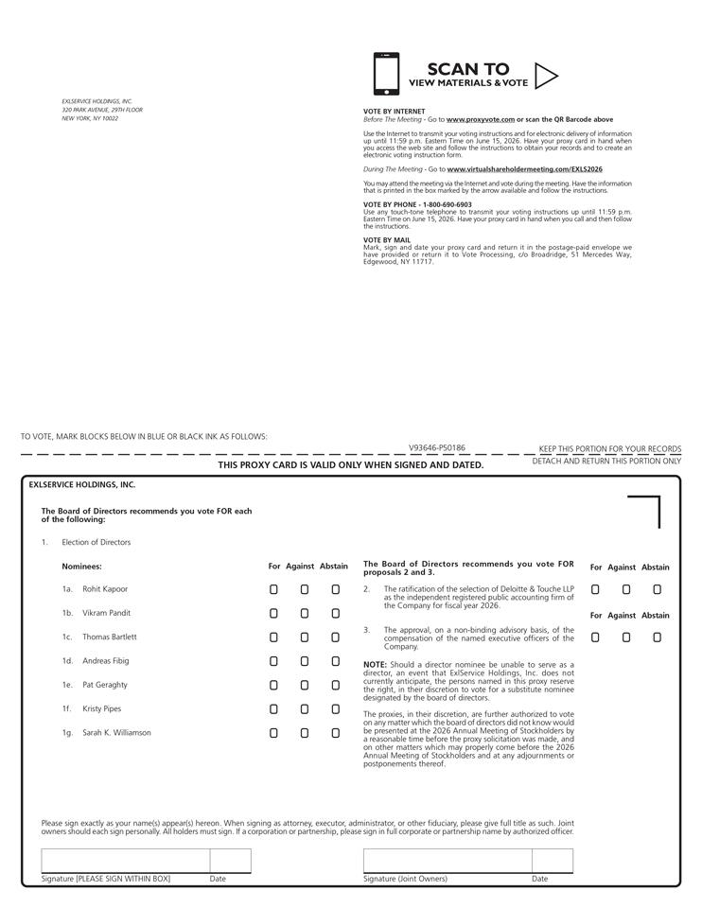

Table of Contents


