UNITED STATES

SECURITIES AND EXCHANGE COMMISSION

Washington, D.C. 20549

SCHEDULE 14A

(Rule 14a-101)

INFORMATION REQUIRED IN PROXY STATEMENT

SCHEDULE 14A INFORMATION

Proxy Statement Pursuant to Section 14(a) of the Securities Exchange Act of 1934 (Amendment No.

)

Filed by the Registrant ☒

Filed by a Party other than the Registrant ☐

Check the appropriate box:

- Preliminary Proxy Statement

- Confidential, for Use of the Commission Only (as permitted by Rule 14a-6(e)(2))

- Definitive Proxy Statement

- Definitive Additional Materials

- Soliciting Material Pursuant to §240.14a-12

ExlService Holdings, Inc.

(Name of Registrant as Specified in its Charter)

N/A

(Name of Person(s) Filing Proxy Statement, if Other Than the Registrant)

PAYMENT OF FILING FEE (Check the appropriate box):

- No fee required.

  - Fee computed on table below per Exchange Act Rules 14a-6(i)(1) and 0-11.

    - Title of each class of securities to which transaction applies:

    - Aggregate number of securities to which transaction applies:

    - Per unit price or other underlying value of transaction computed pursuant to Exchange Act Rule 0-11 (set forth the amount on which the filing fee is calculated and state how it was determined):

    - Proposed maximum aggregate value of transaction:

    - Total fee paid:

- Fee paid previously with preliminary materials.

- Check box if any part of the fee is offset as provided by Exchange Act Rule 0-11(a)(2) and identify the filing for which the offsetting fee was paid previously. Identify the previous filing by registration statement number, or the Form or Schedule and the date of its filing.
  - Amount Previously Paid:

  - Form, Schedule or Registration Statement No.:

  - Filing Party:

  - Date Filed:

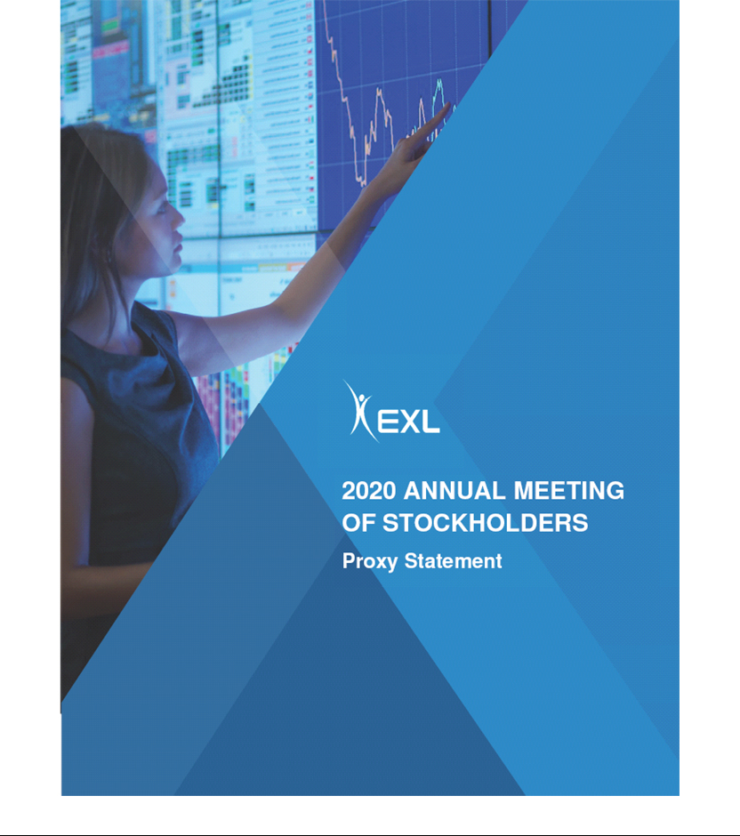



320 Park Avenue, 29th Floor
New York, NY 10022
(212) 277-7100

April 24, 2020

Dear Stockholder:

As we all confront the unprecedented challenges stemming from the COVID-19 pandemic, it can be difficult to keep focused on the path ahead. EXL is bringing to bear the full strength of our people around the globe to do just that. Our first priority is to ensure the health and safety of our employees, their families and the communities in which they work. We are also taking every action practical to help our clients with their needs and to assist with their business continuity during this time, including through remote working and enabling virtual work environments. We intend to provide critical support in resolving the challenges faced by our clients during the COVID-19 pandemic.

As we look back on 2019, we thank you for your continued support. We have a strong sense of pride and achievement. We crossed the $1 billion revenue mark on an annualized basis in 2019 – with revenue growth of over 12%. Not only have we reached this landmark revenue run rate in only 20 years of our existence, but we are well positioned to keep up our growth momentum in the future. Our strategy of continuously adding value for our clients – the world’s leading companies – by incorporating advanced digital technologies, machine learning and analytics capabilities in all of our offerings – positions each of our business lines for market leadership and ongoing strong growth. We are now participating in new markets, new verticals and in larger, more complex deals.

Our focus on looking deeper and adapting to technology changes has enabled us to deliver superior returns and create tremendous value for our stockholders since our IPO in 2006. Today, we are a trusted Strategic Digital Transformation partner for our clients. We employ our industry domain expertise and technology to help our clients generate value by enabling them to apply digital technologies and analytics to transform their business models, better understand and use their data assets, and efficiently run their operations. Our emphasis on analytics has been key to our growth in the last four years, comprising 36% of revenue, up from 19% in 2015.

As a global company, we have always felt that it is our obligation to our stockholders, employees and the communities in which we operate to emphasize corporate social responsibility in our business. We are committed to maintaining a diverse group of directors with a strong mix of qualifications to best enable our board to guide our business, manage our risks and oversee our growth and development as a Company.

Our people are our primary assets. Our achievements over the past 20 years are, and going forward will continue to be, a result of the imagination, dedication and effort that each of our employees bring every day to EXL. One of EXL’s defining characteristics is our active learning culture, which is realized through our capability learning academies that

enhance our employees’ domain expertise and digital skills. In 2019, 99+% of our employees were trained in “Digital Intelligence” and EXL’s proprietary “Digital EXLerator” framework for delivering digital transformation to our clients. We emphasize the importance of talent and leadership development within our ranks by training our future team leaders. We believe that embracing diversity of thought best allows us to deliver exceptional results for our clients and aim to foster, both through policies and practice, an inclusive work environment. We are committed to hiring a diverse workforce and to improving diversity in our senior leadership, and include diversity and inclusion among the guiding principles in our talent acquisition, training and retention practices.

We and our employees are also committed to volunteerism, giving and social change – in 2019 we took part in a number of initiatives focused on education and assisting our community members in market-relevant skill development. And we have doubled down on our commitment to sustainability and workplace safety, undertaking a Company-wide review of emissions and water and paper usage so that we can make sure that we meet key reduction objectives, continuing to provide trainings to all of employees on health and safety, and to receive industry certifications and other recognitions for these efforts. In order to increase our transparency to our stockholders on our efforts relating to sustainability, human capital management and corporate social responsibility, this year’s Proxy Statement includes dedicated sections to these topics, and we plan to improve our disclosure on these efforts on our website throughout the year.

As we look toward the future, we plan to continue responding to the market’s increased focus on digital and data by increasing our investments in those areas to create next generation revenue and profit streams.

On behalf of the board of directors of ExlService Holdings, Inc., we are pleased to invite you to the 2020 Annual Meeting of Stockholders, which will be held on June 15, 2020. We look forward to sharing more about our Company at the Annual Meeting. Due to concerns regarding the current public health crisis related to the COVID-19 pandemic and the health and wellbeing of our stockholders, employees and directors, we will hold our Annual Meeting in virtual format only via live audio webcast instead of holding the meeting in New York or at any physical location. We encourage you to read carefully the attached 2020 Annual Meeting of Stockholders and Proxy Statement, which contain important information about the matters to be voted upon and instructions on how you can vote your shares.

Your vote is important to us. Please vote as soon as possible whether or not you plan to participate in the Annual Meeting. The board of directors and management look forward to seeing you at the Annual Meeting. Sincerely,
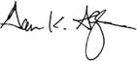
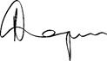

Garen K. Staglin | Rohit Kapoor
Chairman | Vice Chairman and CEO

NOTICE OF 2020 ANNUAL MEETING OF STOCKHOLDERS

Dear Stockholder:

You are cordially invited to the 2020 Annual Meeting of Stockholders of ExlService Holdings, Inc., a Delaware corporation (the “Company”). The Annual Meeting will be held in virtual format only via live audio webcast at the website www.virtualshareholdermeeting.com/EXLS2020 (rather than at any physical location) on June 15, 2020 at 8:30 AM, Eastern Time, for the purposes of voting on the following matters:

- the election of six members of the board of directors of the Company;

- the ratification of the appointment of Deloitte & Touche LLP as the independent registered public accounting firm of the Company for fiscal year 2020;

- the approval, on a non-binding advisory basis, of the compensation of the named executive officers of the Company; and

- the transaction of such other business as may properly come before the Annual Meeting or any adjournment or postponement thereof.

Due to concerns regarding the current public health crisis related to the novel coronavirus, or COVID-19, and the health and wellbeing of our stockholders, employees and directors, we will hold our Annual Meeting in virtual format only via live audio webcast (the “Virtual Annual Meeting”) instead of holding the meeting in New York or at any physical location. You or your proxyholder may participate, vote, and examine our stockholder list at the Virtual Annual Meeting by visiting www.virtualshareholdermeeting.com/EXLS2020 and using your 16-digit control number.

If you are a stockholder of record at the close of business on April 17, 2020, the record date for the Annual Meeting, you are entitled to vote at the Annual Meeting. A list of stockholders as of the record date will be available for examination for any purpose germane to the Annual

Meeting, during ordinary business hours, at the Company’s executive offices at 320 Park Avenue, 29th Floor, New York, New York 10022, for a period of 10 days prior to the date of the Annual Meeting and at the Annual Meeting itself. If, due to COVID-19, our corporate headquarters are closed during the ten days prior to the Annual Meeting, you may send a written request to the Corporate Secretary at our corporate headquarters, and we will arrange a method for you to inspect the list. The list of stockholders will also be available during the Annual Meeting at www.virtualshareholdermeeting.com/EXLS2020.

Please note the technical requirements for virtual attendance at the Annual Meeting, as described in the enclosed Proxy Statement beginning on page 11 under the heading "Annual Meeting Q&A."

Pursuant to rules promulgated by the Securities and Exchange Commission, we are providing access to our proxy materials over the Internet. On or about April 24, 2020, we will mail a Notice of Internet Availability of Proxy Materials (the “Internet Notice”) to each of our stockholders of record and beneficial owners at the close of business on the record date. On the date of mailing of the Internet Notice, all stockholders and beneficial owners will have the ability to access all of the proxy materials on a website referred to in the Internet Notice. These proxy materials will be available free of charge.

Whether or not you expect to attend the Annual Meeting, the Company encourages you to promptly vote and submit your proxy by (i) Internet (by following the instructions provided in the Internet Notice), (ii) by phone (by following the instructions provided in the Internet Notice) or (iii) by requesting that proxy materials be sent to you by mail that will include a proxy card that you can use to vote by completing, signing, dating and returning the proxy card in the prepaid postage envelope provided. Voting by proxy will not deprive you of the right to attend the Annual Meeting or to vote your shares. You can revoke a proxy at any time before it is exercised by voting electronically at the Annual Meeting, by delivering a subsequent proxy or by notifying the inspector of elections in writing of such revocation prior to the Annual Meeting. YOUR SHARES CANNOT BE VOTED UNLESS YOU EITHER (I) VOTE BY USING THE INTERNET, (II) VOTE BY PHONE, (III)

REQUEST PROXY MATERIALS BE SENT TO YOU BY MAIL AND THEN USE THE PROXY CARD PROVIDED BY MAIL TO CAST YOUR VOTE BY COMPLETING, SIGNING AND RETURNING THE PROXY CARD BY MAIL OR (IV) ATTEND THE ANNUAL MEETING AND VOTE ELECTRONICALLY.

By Order of the Board of Directors


Ajay Ayyappan
Senior Vice President,

General Counsel and Corporate Secretary

New York, New York
April 24, 2020

TABLE OF CONTENTS

2020 PROXY STATEMENT SUMMARY | Page
2020 PROXY STATEMENT SUMMARY | 1
ANNUAL MEETING Q&A | 11
OUR BOARD OF DIRECTORS | 15
CORPORATE GOVERNANCE | 28
CORPORATE SOCIAL RESPONSIBILITY | 35
SUSTAINABILITY AND WORKPLACE HEALTH AND SAFETY | 36
HUMAN CAPITAL MANAGEMENT | 37
OUR EXECUTIVE OFFICERS | 40
EXECUTIVE COMPENSATION | 42
Compensation, Discussion and Analysis | 42
Compensation Committee Report | 61
Summary Compensation Table | 62
STOCK OWNERSHIP OF DIRECTORS, EXECUTIVE OFFICERS AND CERTAIN BENEFICIAL OWNERS | 82
CERTAIN RELATIONSHIPS AND RELATED PERSON TRANSACTIONS | 85
AUDIT COMMITTEE REPORT | 86
PROPOSAL 1 — ELECTION OF DIRECTORS | 87
PROPOSAL 2 — RATIFICATION OF THE APPOINTMENT OF INDEPENDENT REGISTERED PUBLIC ACCOUNTING FIRM | 89
PROPOSAL 3 — ADVISORY (NON-BINDING) VOTE ON EXECUTIVE COMPENSATION | 92
STOCKHOLDER PROPOSALS AND DIRECTOR NOMINATIONS FOR THE 2021 ANNUAL MEETING | 94
MISCELLANEOUS | 95
OTHER MATTERS | 96


2020 PROXY STATEMENT SUMMARY

Summary

Below is a summary of selected key components of this proxy statement, including information regarding this year’s stockholder meeting, nominees for our board of directors, summary of our business, performance highlights and selective executive compensation information. This summary does not contain all of the information that you should consider prior to submitting your proxy, and you should review the entire proxy statement and our Annual Report on Form 10-K for the fiscal year ended December 31, 2019 (the “2019 Form 10-K”). We refer to the fiscal year ended December 31, 2019 as “fiscal year 2019,” “fiscal 2019,” and “2019.”

Annual Meeting Information

Time and Date:

8:30 AM (Eastern Time)
June 15, 2020

Record Date:

April 17, 2020

Place:

Virtual format only via live audio webcast www.virtualshareholdermeeting.com/EXLS2020

Voting:

Stockholders as of the Record Date are entitled to vote

Voting Methods



If you are the beneficial owner of shares held in the name of a brokerage, bank, trust or other nominee as a custodian (also referred to as shares held in “street name”), your broker, bank, trustee or nominee will provide you with materials and instructions for voting your shares. See page 11 for additional details.

EXLSERVICE.COM ⁄ 1

Meeting Agenda, Voting Matters and Recommendations


Proposal | Board Vote | Required Vote | Page
Proposal | Recommendation | Required Vote | Number
1. Election of directors | FOR the election of each | Affirmative vote of a majority of shares present in | 87
1. Election of directors | nominee | person* or represented by proxy and entitled to vote | 87
2. Ratification of appointment of | FOR | Affirmative vote of a majority of shares present in
independent registered public | FOR | Affirmative vote of a majority of shares present in | 89
independent registered public | FOR | person* or represented by proxy and entitled to vote | 89
accounting firm |  | person* or represented by proxy and entitled to vote
3. Advisory (non-binding) vote on | FOR | Affirmative vote of a majority of shares present in | 92
executive compensation | FOR | person* or represented by proxy and entitled to vote | 92

* Virtual attendance at our Annual Meeting constitutes presence in person for purposes of quorum and voting at the Annual Meeting.

Our Business

We are a leading operations management and analytics company that helps our clients build and grow sustainable businesses. By orchestrating our domain expertise, data, analytics and digital technology, we look deeper to design and manage agile, client-centric operating models to improve global operations, drive profitability, enhance client satisfaction, increase data-driven insights, and manage risk and compliance. We serve clients in multiple industries, including insurance, healthcare, banking and financial services, utilities, travel, transportation and logistics, media and retail, among others. Headquartered in New York, as of March 31, 2020 we had more than 32,700 professionals in locations throughout the United States, the United Kingdom, Europe, India, the Philippines, Colombia, Australia and South Africa.

 |  | Company 3 Year Performance
 | Revenue and Segment Information ($ in millions)
 |  | Revenue (Year-over-year growth %)
 | 2017 YOY% |  | 2018 YOY% |  | 2019 YOY%
Insurance Segment | $234.8 | 13.8% | $258.1 | 9.9% | $294.2 | 14.0%
Healthcare Segment | 77.0 | 12.2% | 84.4 | 9.6% | 90.6 | 7.3%
Travel, Transportation and Logistics | 71.0 | 2.3% | 70.2 | -1.0% | 68.0 | -3.2%
Segment
Finance and Accounting Segment | 86.5 | 9.0% | 97.9 | 13.2% | 106.6 | 8.8%
All Other | 83.1 | -13.9% | 87.2 | 4.8% | 74.6 | -14.3%
Analytics Segment | 209.9 | 26.7% | 285.3 | 35.9% | 357.3 | 25.3%
Consolidated | $762.3 | 11.1% | $883.1 | 15.8% | $991.3 | 12.3%

EXLSERVICE.COM ⁄ 2

We improved our annual revenues from $883.1 million in fiscal year 2018 to $991.3 million in fiscal year 2019, and improved our net income attributable to stockholders by 19% to $67.7 million. We also achieved numerous other successes, including substantial completion of the wind down of the operations of our Health Integrated business. For more information regarding these and other business highlights, please see pages 43 to 44 below and the 2019 Form 10-K.

The graphs below compare our 1-year, 3-year and 5-year total stockholder return (“TSR”) with that of the companies comprising Nasdaq, S&P 500 and our peer group.
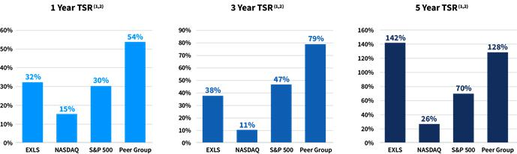

- Cumulative growth rate as of December 31, 2019.

- Peer group TSR data excludes Convergys Corporation, which was acquired in October 2018, and DST Systems, which was acquired in April 2018.

EXLSERVICE.COM ⁄ 3

Our Purpose and Core Values


EXLSERVICE.COM ⁄ 4

Corporate Governance Highlights

Based on current board profile and practices
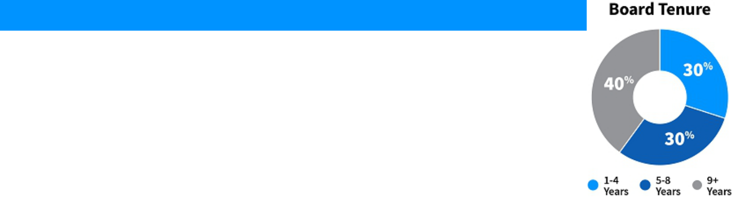

Board of Directors Composition

- Ten directors, all of whom are independent, except for our Vice Chairman and CEO

- Independent board chairman

- Seasoned board of directors, with diverse experience, including in human capital management, insurance, healthcare, utilities, banking and financial services, finance/accounting, global business and technology

- Diversity in age, gender and other important characteristics

- Declassified board (subject to phase-out as described below)


Board Accountability

- Majority voting standard for uncontested elections

- Annual board- and committee-level evaluations

- Regularly-held executive session of non-management directors

- Robust executive and director equity ownership guidelines

- Independent board of directors evaluation of CEO performance and compensation


Governance Practices

- Regular executive sessions

- Standing board committees composed solely of independent chairs and members

- Equity ownership guidelines

- Independent compensation consultants

- Board risk oversight and assessment

- Board committee oversight over sustainability efforts

- Director training and education

- Simultaneous service restrictions

EXLSERVICE.COM ⁄ 5

Director Qualifications
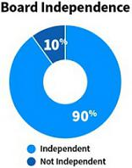

Our board of directors reflects an effective and diverse mix of skills and experience appropriate for our
Company and industry. Our directors have the following attributes:

- Executive Leadership

- Board Experience

- Finance and Accounting

- Client and Industry Expertise

- Global Experience

- Risk Oversight/Management

- Human Capital Management


Nominees for Election as Directors

Name | Director
Name | Since
Rohit Kapoor | November 2002

Experience*

Co-founder of EXL Inc. in April 1999; Vice Chairman and CEO of the Company since April 2012

Committee

Membership

None

 |  |  | Nominating and Governance Committee
David B. Kelso | June | Financial advisor for Kelso Advisory Services; former Senior Advisor for | (Chair);
David B. Kelso | June | Inductis, Inc.; former director and member of audit and finance &
David B. Kelso | 2006
 | 2006 | investment committees for Assurant, Inc. | Audit Committee

Anne Minto March

2013

Som Mittal December 2013

Clyde Ostler December 2007

Jaynie Studenmund September 2018

Qualified lawyer and member of Law Society of Scotland; former executive of Centrica plc, Shell UK and Smiths Group plc; current non-executive director for Tate and Lyle and former non-executive director of Shire plc

Former Chairman and President of NASSCOM; current director for Sheela Foam Ltd. and former director for Axis Bank, Ltd.

Former executive for Wells Fargo, whose roles included Group Executive Vice President, Chief Financial Officer and Chief Auditor; Director for McClatchy Company

Former Chief Operating Officer of Overture Services, Inc.; current director for Pacific Premier Bancorp, CoreLogic, Inc. and Western Asset Management, and former director for Pinnacle Entertainment, Inc. and Lifelock

Compensation Committee (Chair); Nominating and Governance Committee

Compensation Committee; Nominating and Governance Committee

Audit Committee (Chair); Compensation Committee

Audit Committee; Compensation Committee

*A complete list of each nominee’s business experience and directorships is listed below beginning on page 18

EXLSERVICE.COM ⁄ 6

Corporate Social Responsibility, Sustainability and Human Capital Management
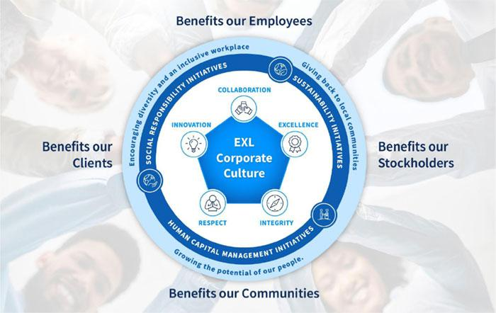

Our corporate culture is rooted in our five core values. In line with our culture, we are committed to corporate social responsibility, sustainability and human capital management initiatives that are key to our long-term strategy and benefit our communities, clients, employees and stockholders.

2019 Compensation Highlights


Named Executive Officers

Name | Title
Rohit Kapoor | Vice Chairman and CEO
Vishal Chhibbar | Former Executive Vice President and CFO
Pavan Bagai | President and Chief Operating Officer and Interim CFO
Nalin Miglani | Executive Vice President and Chief Human Resources Officer
Vikas Bhalla | Executive Vice President and Business Head, Insurance
Samuel Meckey | Executive Vice President and Business Head, Healthcare
 | EXLSERVICE.COM ⁄ 7



2019 Standard Annual Compensation

Compensation | Rohit | Vishal | Pavan | Nalin | Vikas | Samuel
Component | Kapoor | Chhibbar⁽²⁾ | Bagai | Miglani | Bhalla | Meckey
Salary | $720,000 | $427,808 | $311,554 | $450,000 | $263,809 | $425,000
Non-Equity Incentive Plan
Compensation | 1,304,453 | 0 | 323,814 | 411,735 | 285,636 | 364,320
Equity Awards | 4,121,410 | 1,010,024 | 1,557,454 | 880,294 | 973,685 | 765,547
Other Compensation⁽¹⁾ | 49,354 | 11,289 | 54,023 | 9,444 | 45,554 | 9,444
Total | $6,195,217 | $1,449,121 | $2,246,845 | $1,751,473 | $1,568,683 | $1,564,311

- For each named executive officer, this category includes, if applicable, his perquisites and personal benefits, changes in pension value, Company-paid life insurance premiums and Company contributions to our 401(k) plan. A detailed discussion of the compensation components for each named executive officer for fiscal year 2019 is provided in the “Summary Compensation Table for Fiscal Year 2019” beginning on page [62].

- Mr. Chhibbar’s last working day at the Company was December 13, 2019.

On an annual basis, we submit to our stockholders a vote to approve, on a non-binding advisory basis, the compensation of our named executive officers as described in this proxy statement. We refer to this vote as “say-on-pay”. Please refer to our Compensation Discussion and Analysis, beginning on page 42 for a complete description of our 2018 compensation program.

EXLSERVICE.COM ⁄ 8

Below are a few highlights of our executive compensation:

- Compensation Philosophy: Our executive compensation philosophy is focused on pay-for-performance and is designed to reflect appropriate governance practices aligned with the needs of our business, and includes, among others, the following features: clawback policy; stock ownership policy; no excessive perquisites; no tax gross-ups; and an anti-hedging and anti-pledging policy. See “Executive Compensation Program, Practices and Policies” beginning on page 46 below.

- 97% Say-on-Pay Approval of 2018 Compensation: At our 2019 Annual Meeting of Stockholders, our stockholders approved, on a non-binding advisory basis, the compensation paid to our named executive officers for fiscal year 2018. Approximately 97% of the votes present in person or by proxy voted in favor of fiscal year 2018 compensation.

- Annual Bonus Program Based Upon Financial Performance Criteria: Our Compensation Committee approved the continued use of our annual bonus program, which was based upon the following performance criteria:

  - Company Wide Metrics – Adjusted earnings per share (“EPS”) and revenue
  - Business Line Metrics – Revenue and Business Operating Income (BOI)
  - Individual Metrics – Linked to areas of performance that are specific to each executive

- Long-Term Equity Incentive Program: We also continued our equity incentive program, which includes granting a mix of time-vested restricted stock units and performance-based restricted stock units. The performance-based restricted stock units were comprised of:

  - Relative total stockholder return-linked restricted stock units, and
  - Revenue-linked restricted stock units.

- 2019 Performance: We delivered the following revenue and Adjusted EPS (as described below) performance in 2019.

  - Annual Incentive Program: As measured under our annual incentive plan, we delivered 104.1% of our Adjusted EPS target and 99.2% of our revenue performance target resulting in annual incentive payouts to our named executive officers, ranging from 114% of target performance to 124% of target performance.
  - Equity Incentive Program: This was the third and final performance year for the 2017 performance-based restricted stock units. We achieved 102.61% of the revenue target for the revenue-linked restricted stock units resulting in 126.14% of target funding of those grants. The Company’s TSR performance was at the 51.2 percentile amongst its peer group, resulting in the executives earning 104.07% of the 2017 relative TSR-linked restricted stock units pursuant to the terms of the original grant resulting in vesting of shares at 115.11% of target performance.

EXLSERVICE.COM ⁄ 9

Compensation Mix

Vice Chairman & CEO | NEO Compensation Mix
Compensation Mix | (Excluding Vice Chairman & CEO)
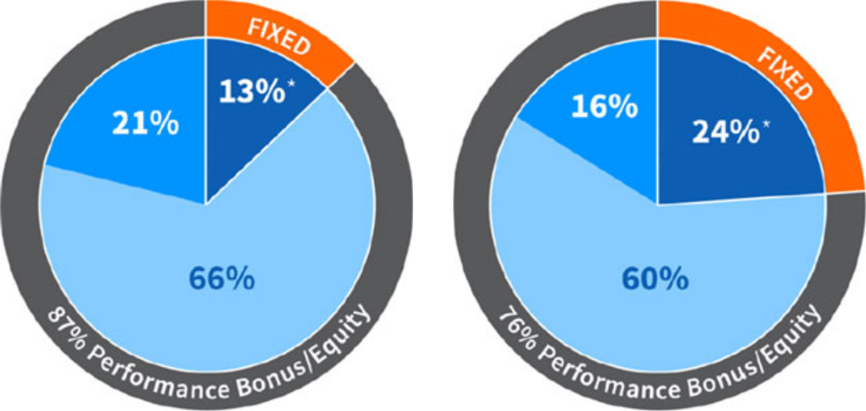

● Base Salary

● Annual

Performance

● Equity (RUSs & PRSUs)

*Base Salary also includes 1% of other compensation

EXLSERVICE.COM ⁄ 10

ANNUAL MEETING Q&A

Who Is Providing this Proxy Statement?

This Proxy Statement is being furnished to you in connection with the solicitation by the board of directors of ExlService Holdings, Inc., a Delaware corporation (“us,” “we,” “our” or the “Company”), of proxies to be used at our 2020 Annual Meeting of Stockholders (the “Annual Meeting”) to be held in virtual format only via live audio webcast at the website www.virtualshareholdermeeting.com/EXLS2020, at 8:30 AM, Eastern Time, and any adjournments or postponements thereof.

How Are the Proxy Materials Being Made Available?

In accordance with rules and regulations adopted by the Securities and Exchange Commission (the “SEC”), instead of mailing a printed copy of our proxy materials to each stockholder of record, the Company furnishes proxy materials via the Internet. If you received a Notice of Internet Availability of Proxy Materials (the “Internet Notice”) by mail, you will not receive a printed copy of our proxy materials other than as described herein. Instead, the Internet Notice will instruct you as to how you may access and review all of the important information contained in the proxy materials. The Internet Notice also instructs you as to how you may submit your proxy over the Internet or by phone. If you received an Internet Notice by mail and would like to receive a printed copy of our proxy materials, you should follow the instructions for requesting proxy materials included in the Internet Notice.

Our Notice of Annual Meeting, proxy statement and form of proxy card are each available at www.proxyvote.com. You may access these materials and provide your proxy by following the instructions provided in the Internet Notice.

When Will the Internet Notice Be Sent?

We anticipate the Internet Notice will be sent to stockholders on or about April 24, 2020. This proxy statement and the form of proxy relating to the Annual Meeting will be made available via the Internet to stockholders on or prior to the date that the Internet Notice is first sent.

Who Can Vote?

Only stockholders who own shares of our common stock at the close of business on April 17, 2020, the record date for the Annual Meeting, can vote at the Annual Meeting. As of the close of business on April 17, 2020, the record date, we had 34,316,121 shares of common stock outstanding and entitled to vote. Each holder of common stock is entitled to one vote for each share held as of the record date for the Annual Meeting.

Is Cumulative Voting Applicable in the Election of Directors?

There is no cumulative voting in the election of directors.

How Do I Vote My Shares?

If your shares are registered directly in your name with Computershare Trust Company, N.A., our transfer agent (which means you are a “stockholder of record”), you can vote your proxy by (i) Internet, (ii) by phone or (iii) by requesting that proxy materials be sent to you by mail that will include a proxy card that you can use to vote by completing, signing, dating and returning the proxy card in the prepaid postage envelope provided. Please refer to the specific instructions set forth in the Internet Notice.

EXLSERVICE.COM ⁄ 11

If you are the beneficial owner of shares held in the name of a brokerage, bank, trust or other nominee as a custodian (also referred to as shares held in “street name”), your broker, bank, trustee or nominee will provide you with materials and instructions for voting your shares. In addition to voting by mail, a number of banks and brokerage firms participate in a program provided through Broadridge Financial Solutions, Inc. (“Broadridge”) that offers telephone and Internet voting options. Votes submitted by telephone or by using the Internet through Broadridge’s program must be received by 11:59 p.m. Eastern Time, on June 14, 2020.

You also have the right to vote electronically at the Annual Meeting if you decide to attend. Our board of directors recommends that you vote by Internet, phone or mail as it is not practical for most stockholders to attend the Annual Meeting. If you are a “stockholder of record,” you may vote your shares electronically at the Annual Meeting. If you hold your shares in “street name,” you must obtain a proxy from your broker, bank, trustee or nominee giving you the right to vote the shares electronically at the Annual Meeting or your vote at the Annual Meeting will not be counted.

You will not be able to vote your shares unless you use one of the methods described above to designate a proxy or you vote electronically at the Annual Meeting.

Can I Revoke My Proxy?

You can revoke your proxy at any time before it is exercised in any of the following ways:

- by voting electronically at the Annual Meeting;

- by submitting written notice of revocation to the inspector of elections prior to the Annual Meeting; or

- by submitting another properly executed proxy of a later date to the inspector of elections prior to the Annual Meeting.

How Is a Quorum Established at the Annual Meeting?

A quorum, which is a majority of the issued and outstanding shares of our common stock as of the record date of April 17, 2020, must be present, in person or by proxy, to conduct business at the Annual Meeting. A quorum is calculated based on the number of shares represented by the stockholders attending the Annual Meeting in person and by their proxy holders. If you indicate an abstention as your voting preference for all matters to be acted upon at the Annual Meeting, your shares will be counted toward a quorum but they will not be voted on any matter. Virtual attendance at our Annual Meeting constitutes presence in person for purposes of quorum at the Annual Meeting.

What Is a “Broker Non-Vote”?

If you are the beneficial owner of shares held in “street name” by a broker, then your broker, as the record holder of the shares, must vote those shares in accordance with your instructions. If you fail to provide instructions to your broker, under the New York Stock Exchange rules (which apply to brokers even though our shares are listed on the NASDAQ Stock Market), your broker will not be authorized to vote your shares on “non-routine” proposals, which include, at the Annual Meeting, the election of directors and approval on an advisory (non-binding) basis of the compensation of our named executive officers. As a result, a “broker non-vote” occurs. However, without your instructions, your broker has discretionary authority to vote your shares with respect to “routine” proposals only, which include, at the Annual Meeting, the ratification of the appointment of our independent registered public accounting firm.

EXLSERVICE.COM ⁄ 12

How Many Votes Are Needed to Approve Each Proposal and What Is the Effect of Abstentions and/or Broker Non-Votes?

Proposal 1: Election of Directors

Under our Fifth Amended and Restated By-Laws (our “by-laws”), directors who are standing for election at the Annual Meeting will be elected by the affirmative vote of a majority of votes cast (meaning the number of shares voted “for” a nominee must exceed the number of shares voted “against” such nominee) by stockholders in person or represented by proxy and entitled to vote at the Annual Meeting. If any incumbent nominee for director receives a greater number of votes “against” his or her election than votes “for” such election, our by-laws provide that such person will tender to the board of directors his or her resignation as a director. You may cast your vote in favor of electing all of the nominees as directors, against one or more nominees, or abstain from voting your shares. For purposes of the vote on Proposal 1, abstentions and broker non-votes will have no effect on the results of the vote. Virtual attendance at our Annual Meeting constitutes presence in person for purposes of voting at the Annual Meeting.

Other Proposals

The ratification of the appointment of our independent registered public accounting firm, the advisory (non-binding) approval of the compensation of our named executive officers and each other item to be acted upon at the Annual Meeting will require the affirmative vote of a majority of shares present in person or represented by proxy and entitled to vote at the Annual Meeting. You may cast your vote in favor of or against these proposals or you may abstain from voting your shares. For purposes of the vote on Proposal 2 (ratification of the appointment of our independent registered public accounting firm), Proposal 3 (advisory (non-binding) vote on executive compensation), and such other items properly presented and to be acted upon at the Annual Meeting, abstentions will have the effect of a vote against these proposals. Broker non-votes will have the effect of a vote against Proposal 3, but because Proposal 2 is a “routine” proposal where brokers have discretionary authority to vote in the absence of instruction, there will be no broker non-votes.

If you submit your proxy, but do not mark your voting preference, the proxy holders will vote your shares (i) FOR the election of all six nominees for director, (ii) FOR the ratification of the appointment of our independent registered public accounting firm, (iii) FOR the approval on an advisory (non-binding) basis of the compensation of our named executive officers, and (iv) as described below, in the judgment of the proxy holder on any other matters properly presented at the Annual Meeting.

Are There Other Matters to Be Acted Upon at the Meeting?

Our board of directors presently is not aware of any matters, other than those specifically stated in the Notice of Annual Meeting, which are to be presented for action at the Annual Meeting. If any matter other than those described in this proxy statement is presented at the Annual Meeting on which a vote may properly be taken, the shares represented by proxies will be voted in accordance with the judgment of the person or persons voting those shares.

What About Adjournments and Postponements?

Any action on the items of business described above may be considered at the Annual Meeting at the time and on the date specified above or at any time and date to which the Annual Meeting is properly adjourned or postponed.

Who Pays For Solicitation of Proxies?

We will pay the cost of printing and mailing proxy materials and posting them on the Internet. Upon request, we will reimburse brokers, dealers, banks and trustees, or their nominees, for reasonable expenses incurred by them in forwarding proxy materials to beneficial owners of shares of our common stock.

EXLSERVICE.COM ⁄ 13

How Can I Attend the Annual Meeting and why is the Company holding the Annual Meeting in a Virtual-Only Format?

We have monitored the coronavirus/COVID-19 situation closely and have determined that holding an in-person annual meeting could pose a risk to the health and safety of our stockholders, employees, and directors, and will instead hold a Virtual Annual Meeting rather than a meeting in New York or at any physical location.

To attend and participate in the Virtual Annual Meeting, stockholders will need to access the live audio webcast of the meeting. To do so, stockholders of record will need to visit www.virtualshareholdermeeting.com/EXLS2020 and use their 16-digit Control Number provided in the Internet Notice to log in to this website, and beneficial owners of shares held in street name will need to follow the instructions provided by the broker, bank or other nominee that holds their shares. We encourage stockholders to log in to this website and access the webcast before the Virtual Annual Meeting’s start time. Further instructions on how to attend, participate in and vote at the Virtual Annual Meeting, including how to demonstrate your ownership of our stock as of the record date, are available at www.virtualshareholdermeeting.com/EXLS2020. Please note you will only be able to attend, participate and vote in the meeting using this website.

How Do I Submit Questions at the Annual Meeting?

We are committed to ensuring that our stockholders will be afforded the same rights and opportunities to participate in our Virtual Annual Meeting as they would at a meeting held at a physical location. You will be able to submit questions during the Annual Meeting by visiting www.virtualshareholdermeeting.com/EXLS2020. We will try to answer as many stockholder-submitted questions as time permits that comply with the meeting rules of conduct as determined by the chairman of the meeting. However, we reserve the right to edit profanity or other inappropriate language, or to exclude questions that are not pertinent to meeting matters or that are otherwise inappropriate. If we receive substantially similar questions, we will group such questions together and provide a single response to avoid repetition.

Will the Annual Meeting be Recorded?

A recording of the Annual Meeting will be available online at http://ir.exlservice.com for approximately 12 months following the meeting date.

What if I Have Technical Difficulties or Trouble Accessing the Annual Meeting?

We will have technicians ready to assist you with any technical difficulties you may have accessing the live webcast of the Annual Meeting. A technical support phone number will be posted on www.virtualshareholdermeeting.com/EXLS2020 that you may call if you experience technical difficulties during the check-in process or during the Annual Meeting.

What If I Have Further Questions?

If you have any further questions about voting your shares or attending the Annual Meeting, please call our Investor Relations Department at (212) 624-5913.

Important

Please promptly vote and submit your proxy by (i) Internet (by following the instructions provided in the Internet Notice), (ii) by phone (by following the instructions provided in the Internet Notice) or (iii) by requesting that proxy materials be sent to you by mail that will include a proxy card that you can use to vote by completing, signing, dating and returning the proxy card in the prepaid postage envelope provided. This will not limit your right to attend or vote at the Annual Meeting.

EXLSERVICE.COM ⁄ 14

OUR BOARD OF DIRECTORS

Our board of directors, which currently consists of ten directors, historically was divided into three classes. Beginning at the annual meeting of stockholders held in 2019, each director is elected to serve a one-year term at each year’s annual meeting of stockholders.* The current composition of our board of directors is as follows:

Director Nominees

Former Class I and Class II — Term expires 2020

Rohit Kapoor


Som Mittal


Vice Chairman and CEO and Director

Independent Director

David Kelso


Clyde Ostler


Independent Director and Chair of the Nominating and Governance Committee

Independent Director and Chair of the Audit Committee

Anne Minto


Jaynie Studenmund


Independent Director and Chair of the Compensation Committee

Independent Director

Class III — Term expires 2021

Deborah Kerr


Nitin Sahney


Independent Director

Independent Director

Vikram Pandit**


Garen Staglin


Independent Director

Independent Director and
Chair of the Board

- As approved by the Company’s stockholders at the 2019 Annual Meeting of Stockholders, the board of directors began to be declassified over a three-year phase-out period. All director nominees whose terms expire at the Annual Meeting, including the former Class I directors elected at the 2019 Annual Meeting of Stockholders and the former Class II directors, will be, if elected by our stockholders, elected to hold office for a term of one year, or until their

EXLSERVICE.COM ⁄ 15

successors are duly elected and qualified in accordance with our by-laws. At the 2021 Annual Meeting of Stockholders, all director nominees elected by our stockholders will be elected to hold office for a term of one year, or until their successors are duly elected and qualified in accordance with our by-laws, and the classification of the Board of Directors will terminate in its entirety.

**Mr. Pandit was appointed to the board as a Class III director under the terms of an Investment Agreement as described on page 85 below.

2020 Director Nominees


Former Class I and Class II

Rohit Kapoor | Som Mittal
Vice Chairman and CEO and Director | Independent Director
David Kelso | Clyde Ostler
Independent Director and Chair of the Nominating | Independent Director and
and Governance Committee | Chair of the Audit Committee
Anne Minto | Jaynie Studenmund
Independent Director and | Independent Director
Chair of the Compensation Committee

Upon the recommendation of our Nominating and Governance Committee, we are pleased to propose six of our existing directors, who were formerly our Class I and Class II directors, as nominees for election as directors at the Annual Meeting.

We believe that our director nominees and continuing directors, individually and together as a whole, possess the requisite skills, experience and qualifications necessary to maintain an effective board to serve the best interests of the Company and its stockholders.

Director Qualifications

The board of directors considers it paramount to achieving excellence in corporate governance to assemble a board of directors that, taken together, has the skills, qualifications, experience and attributes appropriate for functioning as the board of directors of our Company and working productively with management. The Nominating and Governance Committee of the Board is responsible for recommending nominees that are qualified and that bring a diverse set of skills and qualifications to oversee the Company effectively.

The Nominating and Governance Committee has not formally established any minimum qualifications for director candidates. However, in light of our business, the primary areas of experience, qualifications and attributes typically sought by the Nominating and Governance Committee in director candidates include, but are not limited to, the following:

Key Skills and Attributes

We Look for in Board Nominees

  - Strategic sense

  - Critical and innovative thinking

  - High ethical standards and integrity

  - Mutual respect for other Board members

  - Ability to debate constructively

  - Candid, assertive, open minded

- Availability and commitment to serve

EXLSERVICE.COM ⁄ 16

Executive Leadership

Experience holding significant leadership positions, including as a CEO or head of a significant business, to help us drive business strategy, growth and performance.


Finance and Accounting

Experience with finance, accounting or financial reporting processes, to help drive financial performance.


Global Experience

Experience working outside of the United States or with multinational companies, to help facilitate our global expansion.


Board Experience

Understanding of public company board of director and fiduciary duties, to help provide perspective on corporate governance best practices and related matters.

Client and Industry Expertise


Experience with our key client industries, including insurance, healthcare, banking and financial services, finance/accounting, and our other capabilities, to help deepen our knowledge of our key industry verticals and markets in which we do business.


Risk Oversight / Management

Experience assessing and overseeing the overall risk profile of multinational public companies.


Human Capital Management

Experience in management and development of human capital, including management of a large workforce, diversity and inclusion, talent development, workplace health and safety, compensation and other human capital issues.

In addition to satisfying these general qualifications considered by the Nominating and Governance Committee in connection with a director nomination, Vikram S. Pandit was appointed to the Board on October 4, 2018 as a Class III director pursuant to the terms of an Investment Agreement, dated as of October 1, 2018 (the “Investment Agreement”), between the Company and Orogen Echo LLC, an affiliate of The Orogen Group LLC (the “Purchaser”). The Investment Agreement was entered into in connection with our issuance to the Purchaser of $150,000,000 in aggregate principal amount of 3.50% Convertible Senior Notes due October 1, 2024 (the “notes”). For so long as the Purchaser has the right to nominate a director to the Board under the Investment Agreement, we have, subject to the terms of the Investment Agreement, agreed to include such person in our list of nominees for election to our board of directors at each of our annual meetings of stockholders at which directors are to be elected, and to use our reasonable best efforts to cause the election of such person to our board of directors. The Purchaser’s right to nominate a director will terminate if Purchaser and its affiliates beneficially own less than 50% of the number of shares of our common stock deemed beneficially owned by the Purchaser and its affiliates immediately following the issuance of the notes (which, for purposes of the Investment Agreement, includes shares of our common stock issuable upon conversion of the notes).

EXLSERVICE.COM ⁄ 17

Board of Directors

The names, ages and principal occupations (which have continued for at least the past five years unless otherwise indicated) and other information, including the specific experience, qualifications, attributes or skills that led to the conclusion that such person should serve as a director of the Company, with respect to each of the nominees and continuing directors are set forth below. There are no family relationships among any of our directors or executive officers.

Nominees for Election at the Annual Meeting

Rohit Kapoor Independent: NO
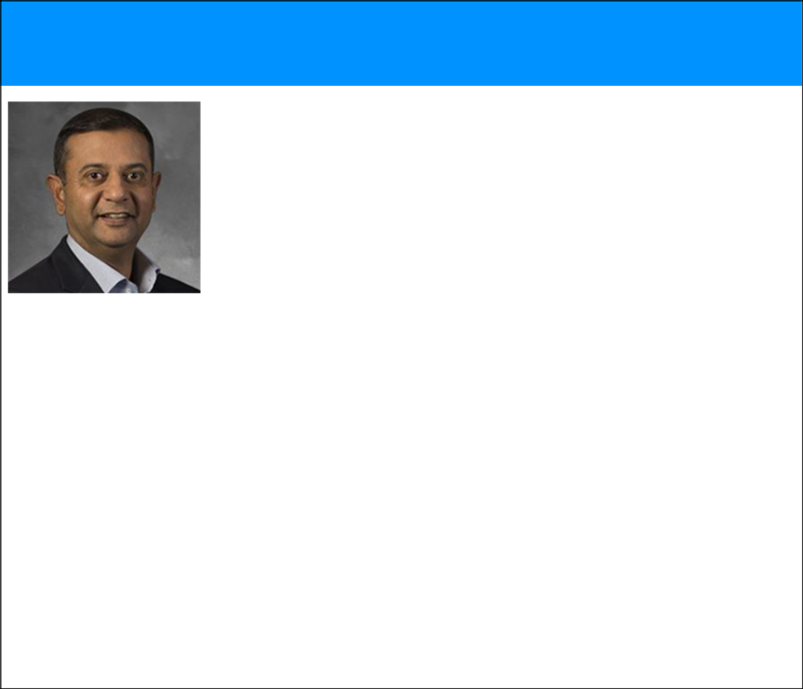

Director since November 2002 Vice Chairman and CEO since April 2012

Committees: N/A

Age: 55— co-founded EXL Inc. in April 1999 and has served as our Vice Chairman and CEO since April 2012 and as a director since November 2002. He previously served as our President and CEO from May 2008 to March 2012. Mr. Kapoor’s business experience and directorships are detailed below. The Company has concluded that, in connection with Mr. Kapoor’s experience as a founder and current role as CEO of the Company, Mr. Kapoor should serve as a director.

Business Experience at the Company

- Vice Chairman and CEO (2012 – present)

- President and CEO (2008 – 2012)

- Various senior leadership roles, including CFO and COO (2000 – 2008)

Other Business Experience

- Business head, Deutsche Bank, a financial services provider (1999-2000)

- Various capacities at Bank of America in the United States and Asia, including India (1991-1999)

Public Directorships During Past Five Years

- Director and member of the audit committee, CA Technologies, Inc., a software services company (NASDAQ: CA) (2002 – 2018)

Other Relevant Experience

- Chairman, National Association of Software and Services Companies (“NASSCOM”) BPM Council.

- Member, Board of Directors, America India Foundation (AIF)

EXLSERVICE.COM ⁄ 18

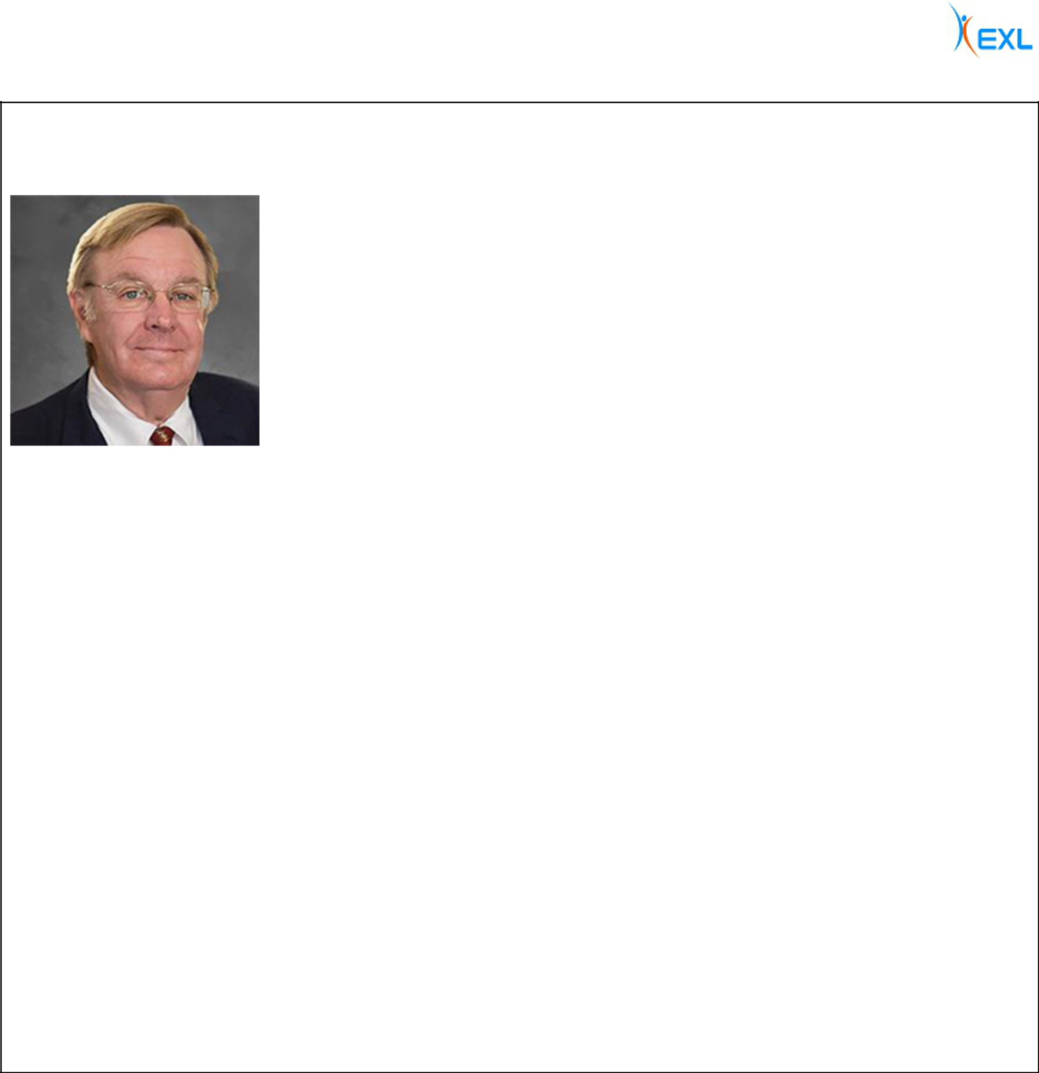

David B. Kelso | Independent: YES
Director since July 2006
 | Age: 67—is a financial advisor for Kelso Advisory Services, a company he started in 2003. Mr.
 | Kelso’s business experience and directorships are detailed below. The Company has concluded,
 | based in part on Mr. Kelso’s business experience with Inductis, his management and operating
 | experience at major public companies, his expertise in finance, strategy and investments, and his
 | board and committee service at other global companies, that Mr. Kelso should serve as a director.

Committees:

- Audit*, Nominating and Governance (Chair)

Business Experience

- Financial Advisor, Kelso Advisory Services (2003 – present)

- Senior Advisor, Inductis, Inc., a strategy and analytics company, until its acquisition by the Company (June 2004 – June 2006)

- Chairman, Aetna Life Insurance Co., Executive Vice President, Strategy and Finance and member of the Office of the Chairman for Aetna, Inc., a managed healthcare company (2001 – 2003)

- Executive Vice President, Chief Financial Officer and Managing Director, Chubb Corporation, a property and casualty insurer (1996-2001)

Public Directorships During Past Five Years

- Director and member of audit committee and finance & investment committee, Assurant, Inc., a global provider of risk management products and services (NYSE: AIZ) (2007 – 2015)

Other Directorships

- Lead independent director and chair of the audit, nominating and valuation committees, Sound Shore Fund, an equity mutual fund (2006 – present)

- Director, Aspen Holdings Limited, a property and casualty reinsurance company (2005 – 2011)

Other Relevant Experience

- Board of Trustees, Darden School Foundation of the University of Virginia Darden School of Business *Audit committee financial expert under applicable SEC rules and regulations.

EXLSERVICE.COM ⁄ 19

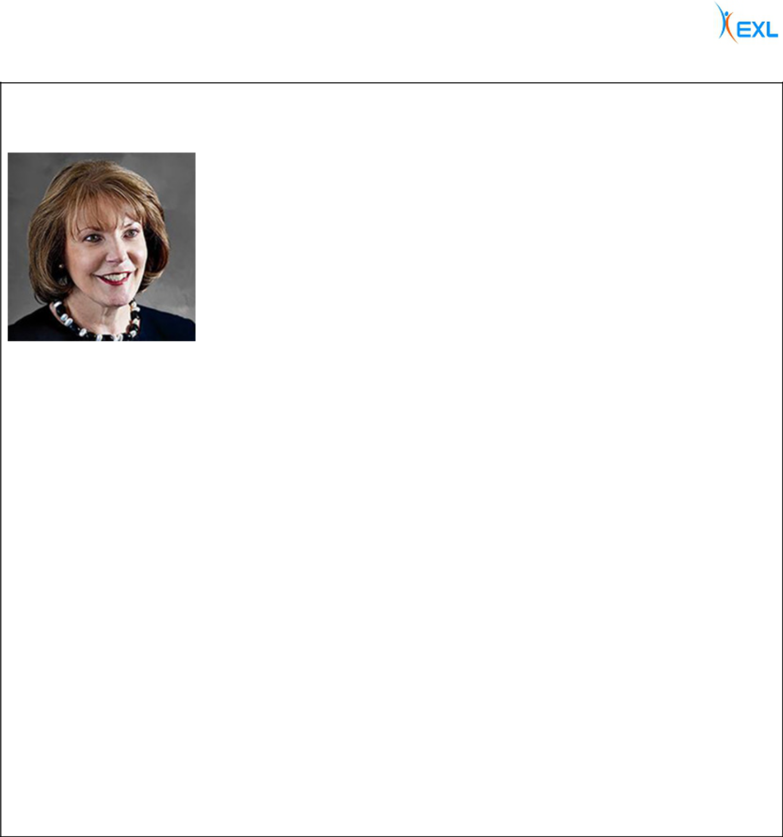

Anne E. Minto | Independent: YES
Director since March 2013
 | Age: 66—is a qualified lawyer and member of the Law Society of Scotland. Ms. Minto’s business
 | experience and directorships are detailed below. The Company has concluded, based in part on Ms.
 | Minto’s extensive experience as a member of international company boards and management in the
 | human resources field, together with her knowledge and experience of the European business and
 | regulatory environment, that Ms. Minto should serve as a director.

Committees:

- Compensation (Chair), Nominating and Governance

Business Experience

- Lawyer and member of Law Society of Scotland

- Former Group Director, Human Resources and member of the executive committee, Centrica plc, an energy and services company (2002 – 2011)

- Prior senior management roles at Shell UK and Smiths Group plc

Public Directorships During Past Five Years

- Director, chairman of the remuneration committee and member of the audit and nomination committees, Tate & Lyle plc, a global provider of specialty food products (LSE: TATE) (2012 – present)

- Director, chairman of the remuneration committee and member of the nomination and governance committee, Shire plc, a global biopharmaceutical company (NASDAQ: SHPG, LSE: SHP) (2010 – 2019)

Other Relevant Experience

- Non-executive director, Court of the University of Aberdeen

- Chairman, University Policy and Resources Committee and University of Aberdeen Development Trust

- Fellow, Chartered Institute of Personnel & Development and the City and Guilds of London Institute

- Fellow, Chartered Institute of Management

- Former Deputy Director-General of the Engineering Employer’s Federation

EXLSERVICE.COM ⁄ 20

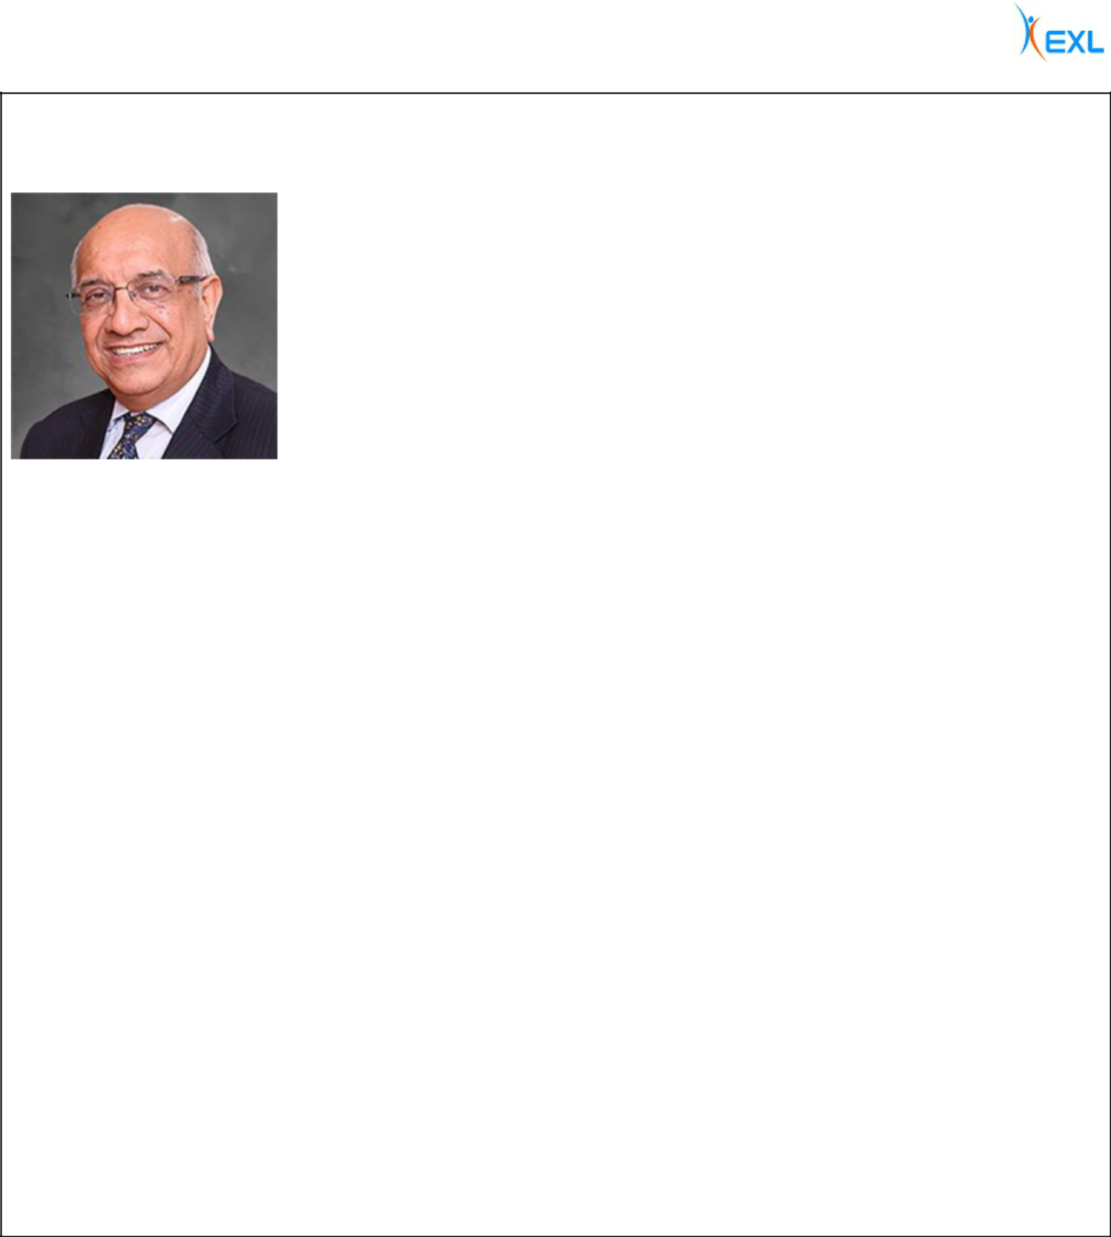
Som Mittal | Independent: YES
Director since December 2013
 | Age: 68—has held various corporate leadership roles in the IT industry since 1989 and has
 | extensive experience in the engineering and automotive sectors. His business experience and
 | directorships are detailed below. The Company has concluded, based in part on Mr. Mittal’s
 | business experience as President of NASSCOM and his knowledge of the global outsourcing
 | industry, that Mr. Mittal should serve as a director.

Committees:

- Compensation, Nominating and Governance

Business Experience

- Chairman and President, NASSCOM, a trade body for the IT and business process management industries in India (2008 – 2014)

- Prior leadership roles at Wipro, Digital, Compaq and HP

- Prior executive roles at Larsen and Tourbo, Escorts and Denso

Public Directorships During Past Five Years

- Director and member of audit and risk management committee, Cyient Ltd., an engineering design services company (NSE:CYIENT) (2014 – present)

- Director and chairman of nomination and remuneration committee, Sheela Foam Ltd., a manufacturing company (NSE: SFL) (2016 – present)

- Director and chairman of customer service committee and IT strategy committee, member of nomination and remuneration committee and other committees, Axis Bank, Ltd., a financial services company (NSE:Axis) (2011 – 2019)

Other Directorships

- Director, Tata SIA Airlines, Ltd., an Indian airline joint venture between TATA and Singapore Airlines with Indian and international operations (2015 – present)

- Non Executive Independent Director and Chairman, Vodafone India Services India Pvt Ltd., an Indian shared services company that is wholly owned, operated and controlled by Vodafone Group Plc (“Vodafone”) and provides information technology and networks services, among others, to Vodafone (2020 – present)

Other Relevant Experience

- Prior member, Board of Governors, Indian Institute of Corporate Affairs

- Prior Committee Member, Indian Prime Minister’s National e-Governance Program

- Member/trustee of educational institutions and non-governmental organizations

EXLSERVICE.COM ⁄ 21

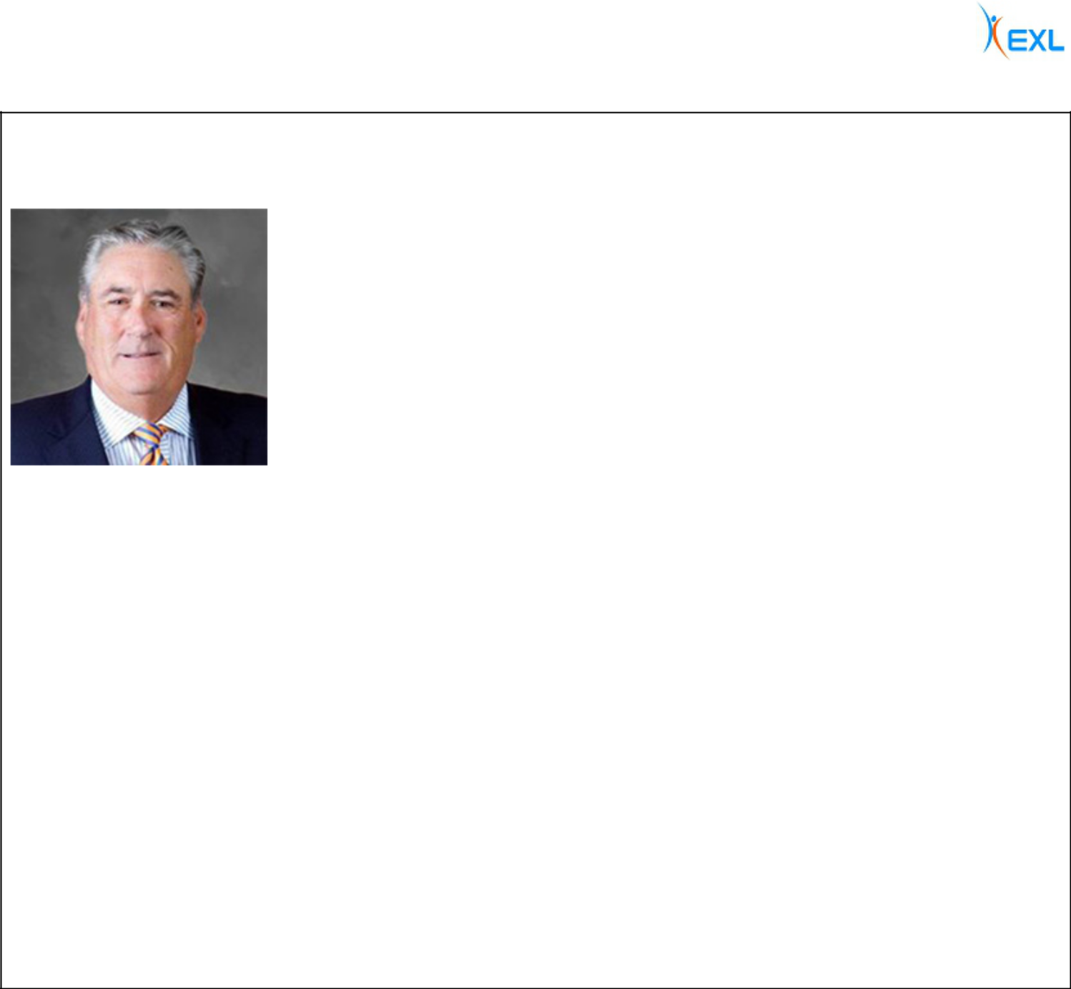

Clyde W. Ostler | Independent: YES
Director since December 2007
 | Age: 73—is a retired executive of Wells Fargo and during his 40-year tenure held numerous senior
 | leadership positions within that organization. The Company has concluded, based in part on Mr.
 | Ostler’s business experience through his positions at Wells Fargo & Company, that Mr. Ostler
 | should serve as a director.

Committees:

- Audit (Chair)*, Compensation

Business Experience

- Leadership positions within Wells Fargo including: Group Executive Vice President, Wells Fargo & Co., Vice Chairman, Wells Fargo Bank California NA, President, Wells Fargo Family Wealth, Vice Chairman in the Office of the President, Chief Financial Officer, Chief Auditor, Head of Retail Branch Banking, Head of Information Technology, Head of Institutional and Personal Investments and Head of Internet Services

- Served on the Senior Management Committee of Wells Fargo for over 25 years

Public Directorships During Past Five Years

- Director, member of the audit committee and compensation committee, McClatchy Company, a media company (NYSE: MNI) (2013 – present)

Other Directorships

- Advisory Director Emeritus, FTV Capital, a private global investment company

Other Relevant Experience

- Director’s Advisory Council, Scripps Institution of Oceanography *Audit committee financial expert under applicable SEC rules and regulations.

EXLSERVICE.COM ⁄ 22



Jaynie M. Studenmund | Independent: YES
Director since September 2018

Age: 65—is a seasoned executive with significant experience as a top line executive leading financial services and digital companies. She also has extensive experience as a public company director. Ms. Studenmund’s business experience and directorships are detailed below. The Company has concluded, based in part on Ms. Studenmund’s extensive public company board experience, together with her knowledge and experience in the digital, financial services, health care and consumer business sectors, that Ms. Studenmund should serve as a director.

Committees:

- Audit*, Compensation

Business Experience

- Chief Operating Officer, Overture Services, a pioneer in paid search and search engine marketing (2001-2004)

- President & Chief Operating Officer, PayMyBills, the leading consumer bill payment and presentment company (1999 – 2001)

- Previously for over two decades served as Executive Vice President and Head of Consumer Businesses for three of the nation’s largest banks, which today form the backbone of Chase and Wells Fargo’s retail franchises in California.

Public Directorships During Past Five Years

- Director and member of the compensation committee and risk management committee, Pacific Premier Bancorp (Nasdaq: PPBI) (2019 – present)

- Director and member of the compensation committee and nomination and governance committee, CoreLogic, Inc. (NYSE: CLGX) (2012 – present)

- Director and member of the contracts committee, audit committee and nomination and governance committee, Western Asset Management (2004 – present), a major fixed income fund, and director of affiliated funds for Western Asset Management

- Director, compensation committee chair and member of the compliance committee, Pinnacle Entertainment (Nasdaq: PNK) until its acquisition in 2018 (2012 – 2018)

- Director, compensation committee chair and member of the audit committee, Lifelock (Nasdaq: LOCK) until its acquisition in 2017 (2015-2017)

Other Relevant Experience

- Board Leadership Fellow, National Association of Corporate Directors

- Life trustee and board chair, Huntington Hospital

*Audit committee financial expert under applicable SEC rules and regulations.

EXLSERVICE.COM ⁄ 23

Class III Directors (Terms Expiring in 2021)


Deborah Kerr | Independent: YES
Director since January 2015
 | Age: 48—is a proven technology leader in the software industry with more than 25 years of diverse
 | management experience. Ms. Kerr’s business experience and directorships are detailed below. The
 | Company has concluded, based in part on Ms. Kerr’s experience in the technology, digital,
 | marketing, operations and software and services industries, and her general management
 | experience, that Ms. Kerr should serve as a director.

Committees:

- Compensation, Nominating and Governance

Business Experience

- Managing Director, Warburg Pincus, a private equity firm (2019 – present) and previously Senior Advisor (2017-2019)

- Executive Vice President and Chief Product and Technology Officer, Sabre Corporation (NASDAQ: SABR), a global technology company (2013 – 2017)

- Executive Vice President, Chief Product and Technology Officer, Fair Isaac Corporation (FICO), an analytics software company (2009 – 2012)

- Prior senior leadership roles with Hewlett Packard, Peregrine Systems and NASA’s Jet Propulsion Laboratory

Public Directorships During Past Five Years

- Director and member of the audit committee, International Airlines Group (BMAD: IAG, LSE: IAG) (2018 – present)

- Director and member of the audit committee, NetApp (NASDAQ: NTAP), a hybrid cloud and data services company (2017 – present)

- Director and member of the human resources, compensation and benefits committee, Chico’s FAS, Inc., a specialty retailer of women’s apparel (NYSE: CHS) (2017 – present)

- Director, D+H Corporation (TSX: DH), a provider of technology solutions and products to the financial industry (2013 – 2017)

Other Directorships

- Director and chair of the audit committee, defi Solutions, Inc. (2019 – present)

- Director and chair of the technology committee, Mitchell International Inc., a provider of technology solutions and services to the property and casualty industry (2010 – 2013)

EXLSERVICE.COM ⁄ 24

Vikram S. Pandit Independent: YES
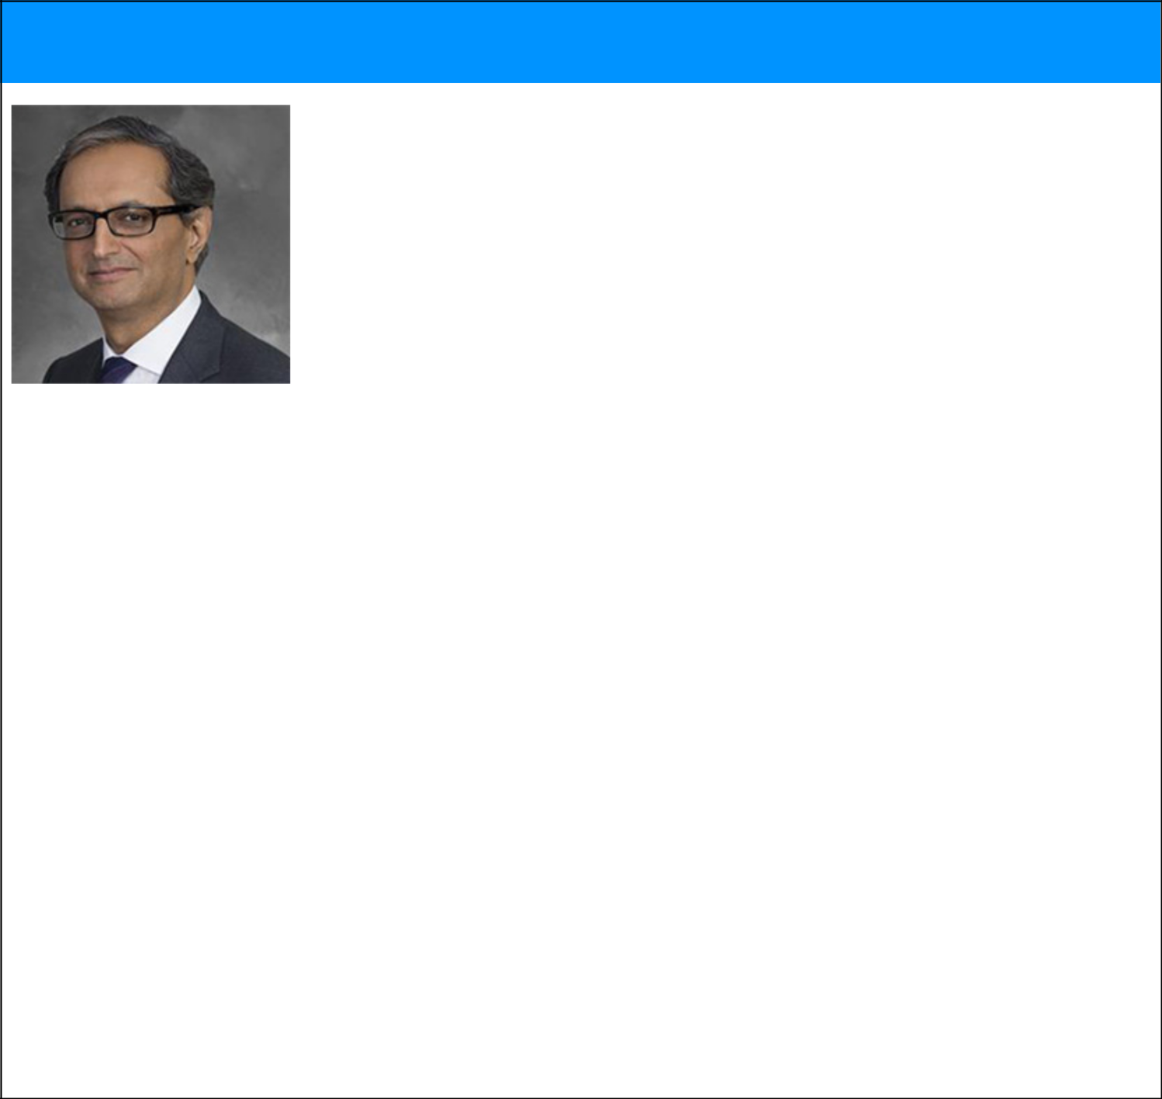

Director since October 2018

Age: 63—is Chairman and Chief Executive Officer of the Orogen Group, which makes significant long-term strategic investments in financial services companies and related businesses. Mr. Pandit’s business experience and directorships are detailed below. Mr. Pandit was appointed to the Board pursuant to the terms of an Investment Agreement, dated as of October 1, 2018, between the Company and Orogen Echo LLC, an affiliate of The Orogen Group LLC. The Company has concluded, based in part on Mr. Pandit’s more than 30 years of experience in the financial services industry, including his experience as Chief Executive Officer and a member of the board of directors of Citigroup Inc. (NYSE: C), that Mr. Pandit should serve as a director.

Committees:

- Audit

Business Experience

- Chairman and Chief Executive Officer, The Orogen Group (July 2016 – present)

- Chairman, TGG Group (February 2014 – June 2016)

- Chief Executive Officer, Citigroup Inc. (December 2007 – October 2012)

Public Directorships During Past Five Years

- Director and member of the nominating and governance and finance committees, Virtusa Corporation (NASDAQ: VRTU) (2017 – present)

- Director, chair of the human resources and compensation committee and member of the corporate governance and nominating and audit committees, Bombardier Inc. (TSX: BBD) (2014 – present)

Other Relevant Experience

- Director, Citigroup Inc. (December 2007 – October 2012)

- Chairman, Fair Square Financial Holdings (2017 – present)

- Chairman, JM Financial Credit Solutions Ltd. (2014 – present)

- Member of the Board of Overseers of Columbia Business School

- Member of the Board of Visitors of Columbia School of Engineering

- Member of the Board of Trustees of Columbia Business School until 2016

EXLSERVICE.COM ⁄ 25

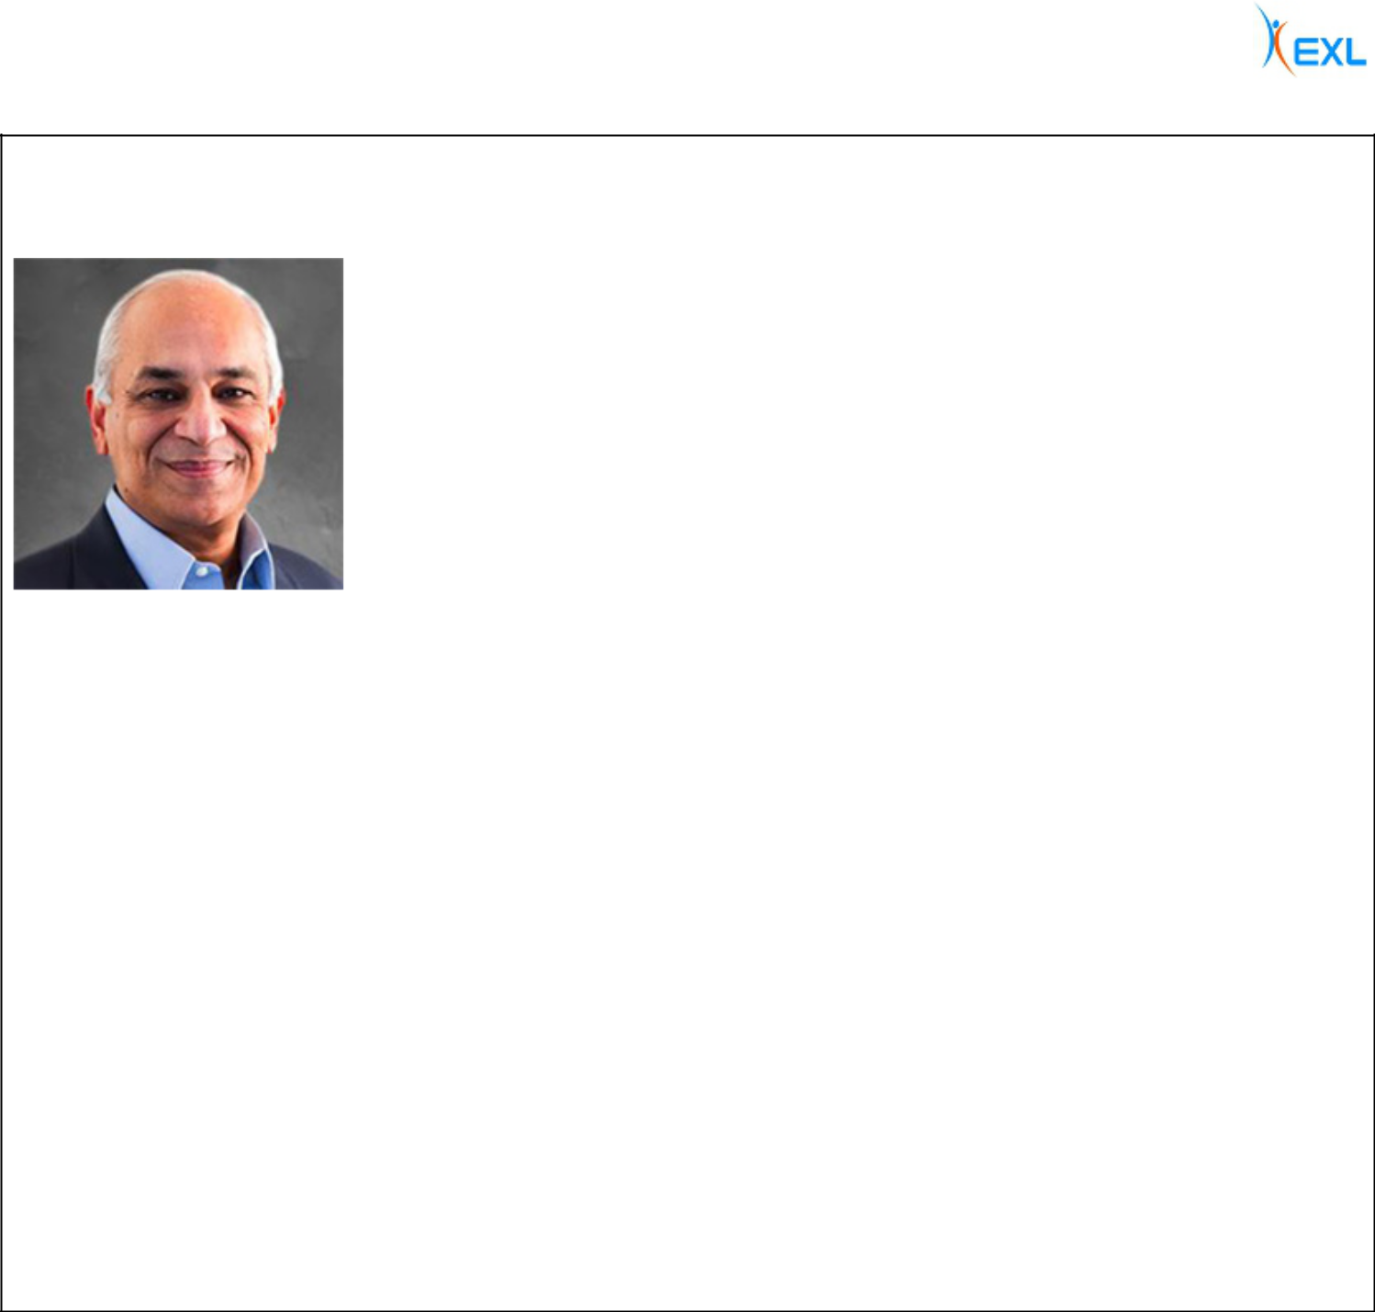

Nitin Sahney | Independent: YES
Director since January 2016
 | Age: 57—is a leader in the healthcare industry with over 25 years of experience across all areas of
 | healthcare. Mr. Sahney’s business experience and directorships are detailed below. The Company
 | has concluded, based in part on Mr. Sahney’s experience as CEO of Omnicare, Inc. and his
 | expertise in the healthcare industry garnered from more than two decades of experience, that Mr.
 | Sahney should serve as a director.

Committees:

- Audit, Compensation

Business Experience

- Founder, Member-Manager and Chief Executive Officer, Pharmacord, LLC, a company that helps biopharma manufacturers address product access hurdles (2016 – present)

- Operating Advisor, Clayton Dubilier & Rice Funds, a private equity firm (2016 – 2017)

- President and CEO (2014 – 2015) and President and COO (2012 – 2014) of Omnicare Inc., a former New York Stock Exchange-listed Fortune 500 company in the long-term care and specialty care industries

- Manager of a healthcare investment fund (2008 – 2010)

- Founder and CEO of RxCrossroads, a specialty pharmaceutical company (2001 – 2007)

- Prior leadership positions with Cardinal Healthcare, a global healthcare services and products company

Public Directorships During Past Five Years

- Director, Option Care Health, Inc. (NASDAQ: OPCH) (2019 – present)

Other Relevant Experience

- Member of the Board of Trustees, University of Louisville (2017 – 2019)

EXLSERVICE.COM ⁄ 26

Garen K. Staglin Independent: YES


Director since June 2005

Chairman of the Board since February 2014

Age: 75—has over 45 years of experience in the financial services and technology industries. Mr. Staglin’s business experience and directorships are detailed below. The Company has concluded, based in part on Mr. Staglin’s experience in the financial services and technology industries and his past experience as a member of public company boards of directors, that Mr. Staglin should serve as a director.

Committees:

- Compensation, Nominating and Governance

Business Experience

- Chief Executive Officer of eONE Global LP, an emerging payments company (2001– 2004)

- Chief Executive Officer of Safelite Auto Glass, a provider of glass claim solutions (1993 – 1999)

Public Directorships During Past Five Years

- Director, chairman of the compensation and member of the governance committee, SVB Financial Group (NASDAQ:SIVB), a financial services provider (2011 – present)

Other Directorships

- Senior Advisor and Advisory Director, FTV Capital, a private global investment company (2004 – present)

- Vice Chairman, Profit Velocity Solutions, a manufacturing analytics firm (2007 – present)

- Chairman, Nvoicepay, an electronic payment service provider (2010 – 2019)

- Advisory Director, Specialized Bicycle, a manufacturer of cycling equipment (1995 –2014)

- Other directorships completed prior to 2014 include: Bottomline Technologies, a provider of payment and invoice automation software and services (2007 – 2012); Solera Holdings, a public automotive insurance software service provider (2005 – 2011); First Data Corporation, a payments solutions provider (1992 –2003); and Global Document Solutions, a private document processing outsourcing company (2005 –2010).

Other Relevant Experience

- Co-Founder and Co-Chairman, One Mind (1995 – present)

- Founder and Co-Chairman, Healthy Brains Financing Initiative (2019 – present)

- Member of the Stewardship Board, World Economic Forum (2019 – present)

- Founder and President, BringChange2Mind (2009 – 2014)

- Co-Chairman, UCLA Centennial Capital Campaign (2014 – 2019)

EXLSERVICE.COM ⁄ 27

CORPORATE GOVERNANCE

Director Independence

In determining director independence, the board of directors considered the transactions and relationships set forth below under “Certain Relationships and Related Person Transactions—Related Party Transactions.” Based on its review of all applicable relationships, our board of directors has determined that all of the members on our board of directors, other than Mr. Kapoor, meet the independence requirements of the Nasdaq Stock Market and federal securities laws.

Meeting Attendance

We expect our directors to attend all board of directors meetings and meetings of committees on which they serve. We also expect our directors to spend sufficient time and meet as frequently as necessary to discharge their responsibilities properly. Each director attended at least 75% of the aggregate meetings of our board of directors and the committees on which they served during 2019. It is our policy that all of our directors should attend our Annual Meetings of Stockholders absent exceptional cause, and all of our then-incumbent directors attended the 2019 Annual Meeting of Stockholders

2019 Meetings

Board — 5
Audit — 7
Compensation — 5
Nominating and
Governance — 5
22 Board and Committee Meetings in 2019

Board Leadership Structure

Our board of directors is currently led by Garen K. Staglin, our Chairman, and Rohit Kapoor, our Vice Chairman and CEO.

Our by-laws provide that our Chairman or, in the absence of our Chairman, our Lead Director (if there is a Lead Director serving at such time), or in the absence of both our Chairman and Lead Director, our CEO, calls meetings of our board of directors to order and acts as the chairman for those board meetings. In the absence of our Chairman, our Lead Director (if there is a Lead Director serving at such time), and our CEO, a majority of our directors present may elect as chairman of the meeting any director present. Independent directors meet at least quarterly in executive session without any management directors or members of the Company’s management present. The Lead Director or, in the absence of the Lead Director, a director chosen by the directors meeting in executive session, presides at all executive sessions.

Independent Chairman

Garen K. Staglin

Vice Chairman and CEO

Rohit Kapoor

Consolidating the Vice Chairman and CEO positions allows our CEO to contribute his experience and perspective regarding management and leadership of the Company towards the goals of improved corporate governance and greater management accountability. In addition, the presence of our Chairman ensures that the board can retain sufficient delineation of responsibilities, such that our Chairman and our Vice Chairman and CEO may each successfully and effectively perform and discharge their respective duties and, as a corollary, enhance our prospects for success. As a result, the Company will benefit from the ability to integrate the collective leadership and corporate governance experience of our Chairman and our Vice Chairman and CEO, while retaining the ability to facilitate the functioning of the board of directors independently of our management and to focus on our commitment to corporate governance.

For the foregoing reasons, our board of directors has determined that its leadership structure is appropriate and in the best interests of our stockholders at this time.

EXLSERVICE.COM ⁄ 28

Majority Voting in Director Elections

Under our by-laws, directors who are standing for election in an uncontested election are elected by the affirmative vote of a majority of votes cast (meaning the number of shares voted “for” a nominee must exceed the number of shares voted “against” such nominee) in person or represented by proxy and entitled to vote at the meeting. If any incumbent nominee for director in an uncontested election receives a greater number of votes “against” his or her election than votes “for” such election, our by-laws provide that such person must tender to the board of directors his or her resignation as a director. (In contested elections, directors will be elected by the affirmative vote of a plurality of votes cast in person or represented by proxy and entitled to vote at the Annual Meeting.) An uncontested election means an election in which the number of nominees for director is not greater than the number to be elected.

Committees

Our board of directors currently has three standing committees: the Audit Committee, the Nominating and Governance Committee and the Compensation Committee. As discussed above, our board of directors has determined that each member of the Audit, Nominating and Governance and Compensation Committees meets the independence and experience requirements of the Nasdaq Stock Market and federal securities laws. Copies of our committee charters can be found on the Investor Relations page of our website at: https://ir.exlservice.com/corporate-governance. Information on our website referred to in this proxy statement does not constitute a part of this proxy statement.

The following table sets forth the current chairs and members of each standing committee of the board of directors. Committee Composition
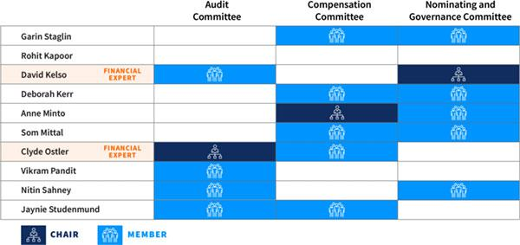

EXLSERVICE.COM ⁄ 29

Audit Committee

Our Audit Committee oversees and assists our board of directors in fulfilling its oversight responsibilities with respect to our accounting and financial reporting processes, including the integrity of the financial statements and other financial information provided by us to our stockholders, the public, stock exchanges and others; our compliance with legal and regulatory requirements; our independent registered public accounting firm’s qualifications and independence; the audit of our financial statements; the performance of our internal audit function and independent registered public accounting firm; and the Company’s cyber security program and cyber strategy-related risks. Our Audit Committee’s risk oversight is discussed below on beginning on page 32.

Our Audit Committee has direct responsibility for the appointment, compensation, retention (including termination) and oversight of our independent registered public accounting firm, and our independent registered public accounting firm reports directly to our Audit Committee. Our Audit Committee also reviews and approves specified related-party transactions as required by the rules of the Nasdaq Stock Market, and oversees the Company’s cyber security program and cyber strategy-related risks. The Audit Committee was established in accordance with Section 3(a)(58)(A) of the Securities Exchange Act of 1934 (the “Exchange Act”). Our Audit Committee annually reviews and assesses the adequacy of the Audit Committee charter and its own performance.

AUDIT COMMITTEE PROFILE
Clyde Ostler, Chair*
David Kelso* | Nitin Sahney
Vikram Pandit | Jaynie Studenmund*


- Accounting and financial reporting processes

- Our independent registered public accounting firm’s appointment and independence

- The audit of our financial statements and internal audit function

- Other key areas including cybersecurity, litigation, compliance and regulatory enforcement matters

- Risk oversight

*Audit committee financial expert under applicable SEC rules and regulations

7 Committee Meetings in 2019

The members of our Audit Committee are appointed by our board of directors. All members of our Audit Committee must also be recommended by our Nominating and Governance Committee.

Nominating and Governance Committee

Our Nominating and Governance Committee is responsible for: (i) identifying and recommending candidates for election to our board of directors using selection criteria approved by our board of directors, (ii) developing and recommending to our board of directors Corporate Governance Guidelines that are applicable to us, and (iii) overseeing our board of director and management evaluations.

Our Nominating and Governance Committee has a policy, reflected in its charter, of considering director candidates recommended by our stockholders. Candidate recommendations should be sent to our Nominating and Governance Committee, c/o ExlService Holdings, Inc.,

320 Park Avenue, 29th Floor, New York, New York 10022, Attention: Corporate Secretary. Our Nominating and Governance Committee evaluates all candidates in the same manner regardless of the source of the recommendation. Our Nominating and Governance Committee, in making its selection of director candidates, considers the appropriate skills and personal characteristics required in the light of the then-current makeup of our board of directors and in the context of our perceived needs at the time. The Nominating and Governance Committee considers a number of factors in selecting director candidates, including, among others:

EXLSERVICE.COM ⁄ 30

ethical standards and integrity; independence; diversity of professional and personal backgrounds; skills and experience; other public company directorships; and financial literacy and expertise; communication skills; and ability and willingness to comply with Company policies and procedures.

Our Nominating and Governance Committee reviews written and oral information provided by and about candidates and considers any additional criteria it feels is appropriate to ensure that all director nominees possess appropriate skills and experience to serve as a member of our board of directors.

Although our Nominating and Governance Committee does not have a formal policy with regard to diversity of board members, pursuant to our Corporate Governance Guidelines, our board of directors seeks members from diverse professional and personal backgrounds who combine a broad spectrum of experience and expertise with a reputation for integrity. This assessment includes an individual’s independence, as well as consideration of diversity, age, skills and experience in the context of the needs of the board of directors. Our Nominating and Governance Committee reviews and makes recommendations regarding the composition of our board of directors in order to ensure that the board has an appropriate breadth of expertise and its membership consists of persons with sufficiently diverse and independent skill sets and backgrounds.

NOMINATING AND GOVERNANCE COMMITTEE PROFILE


David Kelso, Chair
Deborah Kerr | Nitin Sahney
Anne Minto | Garen Staglin
Som Mittal

- Identifying and recommending board candidates

- Developing and recommending governance practices, including our Corporate Governance Guidelines

- Overseeing board and management evaluations

5 Committee Meetings in 2019

The Nominating and Governance Committee is responsible for developing and annually reassessing succession plans for our CEO and other key executive officers of the Company. The Nominating and Governance Committee also prepares contingency plans for interim CEO succession in the event of an unexpected occurrence.

The Nominating and Governance Committee also oversees our director onboarding and training program, which provides new directors with training regarding the Company’s policies and procedures and specific requirements that may be needed based on the director’s committee memberships.

In addition, the Nominating and Governance Committee reviews the Company’s corporate social responsibility goals, policies and programs twice annually and the Company’s corporate governance policies and practices regularly. Our Nominating and Governance Committee annually reviews and assesses the adequacy of the Nominating and Governance Committee charter and its own performance. The members of our Nominating and Governance Committee are appointed by our board of directors.

EXLSERVICE.COM ⁄ 31

Compensation Committee

Our Compensation Committee reviews and recommends policies relating to compensation and benefits of our directors, officers and employees and is responsible for approving the compensation of our Vice Chairman and CEO and other executive officers. Our Compensation Committee also reviews, evaluates and makes recommendations to our board of directors with respect to our incentive compensation plans and equity-based plans and administers the issuance of awards under our equity incentive plans. Our Compensation Committee charter permits the committee to form and delegate authority to subcommittees when appropriate, provided that the subcommittees are composed entirely of directors who satisfy the applicable independence requirements of the Nasdaq Stock Market. Any such subcommittee must have a published committee charter.

COMPENSATION COMMITTEE PROFILE


Anne Minto, Chair
Deborah Kerr | Garen Staglin
Som Mittal | Jaynie Studenmund
Clyde Ostler

- Reviewing and recommending compensation and benefits of directors, officers and employees

- Overall compensation risk management, including recommending incentive compensation plans

- Retention of advisors or other compensation consultants

5 Committee Meetings in 2019

Our Compensation Committee charter also permits the committee to retain advisors, consultants or other professionals to assist the Compensation Committee to evaluate director, Vice Chairman and CEO or other senior executive compensation and to carry out its duties. For 2019, our Compensation Committee retained the services of Frederick W. Cook & Co., Inc. (“FW Cook”), a qualified and independent compensation consultant, to aid the Compensation Committee in performing its review of executive compensation including executive compensation benchmarking and peer group analysis. Our Compensation Committee annually reviews and assesses the adequacy of the Compensation Committee charter and its own performance. Additional information regarding our Compensation Committee’s processes and procedures for considering executive compensation are addressed in the Compensation Discussion and Analysis below.

The members of our Compensation Committee are appointed by our board of directors. All new members of our Compensation Committee must be recommended by our Nominating and Governance Committee.

Board Self-Assessment

Our Nominating and Governance Committee provides annual reports to our board of directors on the directors’ self-assessment of the performance of our board of directors, and on our CEO’s performance in respect of certain goals and objectives set by our Nominating and Governance Committee. In 2019, we engaged the National Association of Corporate Directors (the “NACD”) to assist in this process by providing a third party assessment of our board of directors and our committees.

Risk Oversight

Our board of directors provides risk oversight. Our management assists the board in identifying strategic and operating risks that could affect the achievement of our business goals and objectives, assessing the likelihood and potential impact of these risks and proposing courses of action to mitigate and/or respond to these risks. These risks are reviewed and discussed periodically with the full board of directors as part of the business and operating review.

Our management is responsible for management of our day-to-day risks, and, because we are exposed to financial risks in multiple areas of our business, day-to-day risk management activities and processes are performed by multiple

EXLSERVICE.COM ⁄ 32

members of our senior and other management. Our board of directors primarily relies on the Audit Committee for oversight of our risk management and cyber security risk. The Audit Committee regularly reviews and discusses with management our major financial risk and cyber security exposures and the steps management has taken to monitor, control and manage such exposures, including our risk assessment and risk management guidelines and policies. In addition, our management maintains, as part of our disclosure controls and procedures, a separate disclosure committee that, as part of its review of our quarterly and annual reports, helps facilitate understanding by the Audit Committee and our full board of directors of new or changing risks affecting us.

Once a year, the full board receives a report from management on the Company’s readiness and capability to prevent, detect and respond to a cyber-attack.

In addition, we maintain Risk Appetite Guidelines that describe certain categories of risk and qualitative and quantitative thresholds considered by the Company to be consistent with its strategic objectives. These guidelines are designed to serve as a reference in assessing and implementing strategy, and to be actionable by management such that they are meaningful from an operational perspective.

Compensation Committee Interlocks and Insider Participation

Ms. Kerr, Ms. Minto, Mr. Mittal, Mr. Ostler, Mr. Staglin and Ms.
Studenmund are the members of our Compensation Committee.

Key Risk Oversight Framework

- Board provides risk oversight

- Management is responsible for day-to-day risks

- Audit Committee oversees risk management and cyber security risks

- Compensation Committee oversees risks relating to the Company’s executive compensation plans

- Nominating and Governance Committee manages risk associated with independence of directors and potential conflicts of interest

- We have implemented Risk Appetite Guidelines with qualitative and quantitative thresholds

During 2019, none of our executive officers served as a member of the board of directors or compensation committee of any entity that has one or more executive officers who serve on our board of directors or Compensation Committee.

Other Directorships

Our board of directors maintains a practice whereby our directors disclose any offers to be a director of any other organization, which are then evaluated by the board of directors for potential business and other conflicts. Our directors are subject to a simultaneous service limits that apply to other public company directorships, and, for members of our Audit Committee, service on other public company audit committees. See our Corporate Governance Guidelines on our website at https://ir.exlservice.com/corporate-governance for more information.

Code of Conduct and Ethics; Corporate Governance Guidelines

We believe that our core values, which translate into high ethical standards and strong corporate governance, are essential to our long-term success, continued growth and building the trust of our employees, clients, communities and investors. We have adopted a Code of Conduct and Ethics and a set of Corporate Governance Guidelines, which can each be found on our website at https://ir.exlservice.com/corporate-governance.

Our Code of Conduct and Ethics is applicable to our directors, officers and employees and details how they should conduct themselves when dealing with fellow employees, clients, suppliers, competitors and the general public. Our Code of Conduct and Ethics is reviewed annually by the Audit Committee. We encourage our employees to speak up

EXLSERVICE.COM ⁄ 33

and raise concerns promptly about any situation that they believe may violate our Code of Conduct and Ethics or the law and we are committed to responding promptly to any concerns.

Our Corporate Governance Guidelines assist our board of directors in the exercise of its responsibilities and reflect the commitment of our board of directors to monitor the effectiveness of policy and decision-making, both at the board and senior management levels, and to enhance stockholder value over the long term.

Communications with the Board

Stockholders interested in contacting our board of directors, our Chairman or any individual director are invited to do so by writing to:

Board of Directors of ExlService Holdings, Inc.

c/o Corporate Secretary
ExlService Holdings, Inc.
320 Park Avenue, 29th Floor

New York, New York 10022

All other stockholder communications addressed to our board of directors will be referred to our Chairman and tracked by our Corporate Secretary. Stockholder communications specifically addressed to a particular director will be referred to that director.

Complaints and concerns relating to our accounting, internal accounting controls or auditing matters should be communicated to our Audit Committee, which consists solely of non-employee directors. Any such communication may be anonymous and may be reported to our Audit Committee through our General Counsel by writing to:

Audit Committee of the Board of Directors

ExlService Holdings, Inc.
320 Park Avenue, 29th Floor
New York, New York 10022

Attn: General Counsel

All such concerns will be reviewed under Audit Committee direction and oversight by our General Counsel, our Head of Internal Audit or such other persons as our Audit Committee determines to be appropriate. Confidentiality will be maintained to the fullest extent possible, consistent with the need to conduct an adequate review. Prompt and appropriate corrective action will be taken when and as warranted in the judgment of our Audit Committee. We prepare periodic summary reports of all such communications for our Audit Committee.

EXLSERVICE.COM ⁄ 34

CORPORATE SOCIAL RESPONSIBILITY

We seek to find meaningful ways to help the communities in which we operate. We are committed to positive social change through volunteerism, giving and active engagement at the institutional- and individual employee-levels to help promote these goals.

Charitable and Community Initiatives

EXL is focused on education and assisting community members to develop market-relevant skills.

Highlights of these initiatives include:

- Skills to Win Initiative – for over five years, we have focused on bridging the gaps between market demands and the skills that some of our community members have. This initiative includes employability skills for back-office roles, finance and accounting trainings, data and analytics and digital capabilities, all coupled with life and workplace skills. In 2019, we brought this program to over 2,000 people in the United States, the Philippines, India and South Africa

- Career counseling and communications skills courses

- Supporting STEM education programs in New York City – through a partnership with buildOn we coached fifteen New York City students in data and analytics

We support our employees’ charitable efforts by enabling payroll giving, recognizing social impact through individual, geography and business unit awards, organizing social responsibility events in each region in which we operate and creating “volunteer weeks” that our employees can use for volunteer efforts

We partner with non-profits and our clients to support corporate social responsibility initiatives, in education and skills, global health and disaster relief

Our Engagement Levels
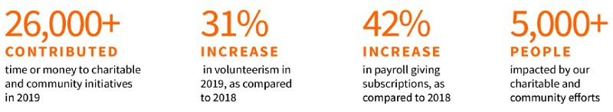

Awards


EXLSERVICE.COM ⁄ 35

SUSTAINABILITY AND WORKPLACE HEALTH AND SAFETY

We are committed to responsible corporate citizenship through sustainable business activities and robust health and safety initiatives for our employees, contractors, clients, visitors and the communities in which we operate.

Objectives
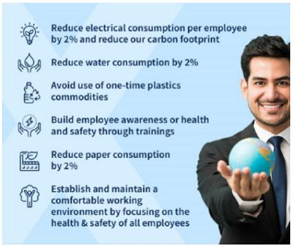

Our leadership is dedicated to continuous improvement of our systems and our approach to sustainability and health and safety.

We have established objectives for our Company and individual worksites, which are integrated into our Environment, Health and Safety Management System and engage third party experts to assess our direct and indirect emissions and paper and water consumption.

We regularly assess our progress.

Certifications and Awards

All of our delivery centers in India and the Philippines are ISO 14001:2015 certified, meeting international standards for effective environmental management systems.

31 of our delivery centers worldwide are OSHAS 18001:2007 certified, meeting international standards for effective occupational health and safety management systems.

Five of our delivery centers in India are ISO 50001:2011 certified, meeting international standards for systemic approaches aimed at energy management and performance.

In 2019, we won the following awards and recognitions for our commitment to sustainability and workplace health and safety:

SAFETY EXCELLENCE | EHS EXCELLENCE | HEALTHY WORKPALCE | INDUSTRY SECTOR
AWARD FOR | AWARD | AWARDS | SAFETY AWARD
WOMEN’S SAFETY | 2019 | 2019 | (IT/ITES)
International Institute | 3 Star Rating, | Silver Level | International Institute
of Safety & Security | CII-South Region | Recognition Award, | of Safety & Security
Management (IISM) | India | Arogya | Management (IISM)
Global Conclave |  |  | Global Conclave
 |  |  | EXLSERVICE.COM ⁄ 36

HUMAN CAPITAL MANAGEMENT

Our people are our primary assets. The world we work and live in is full of diversity and powered by innovation. We believe success in such a world will come through an environment that embraces diversity of thought. In line with our core values, one of our principal priorities is promoting the talent of our employees while creating an inclusive work environment to permit us to leverage our employees’ diversity and to deliver exceptional results for our clients.

Our People

EXL is made up of more than 32,700 professionals (as of March 31, 2020) in locations throughout the United States, the United Kingdom, Europe, India, the Philippines, Colombia, Australia and South Africa.
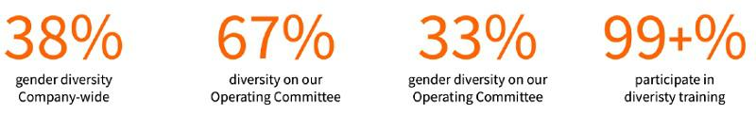

Diversity & Inclusion

Our Diversity and Inclusion Council consists of a global, diverse mix of leaders, provides inputs to the design of our diversity and inclusion program to bring in diverse perspectives, collaborates with external partners for customization inputs, conducts periodic reviews of the progress of our program and provides execution leadership for specific diversity initiatives.

We seek to improve diversity and inclusion through offering a blend of in-person workshops, virtual sessions, and e-learning programs.

We are committed to hiring a diverse workforce and to improving diversity in our senior leadership, and include diversity and inclusion among the guiding principles in our talent acquisition, training and retention practices.

We have several Company-wide initiatives aimed at promoting diversity, inclusion and leadership opportunities for our diverse employees:

- Managing Unconscious Bias Training, a Company-wide, mandatory training for all employees to bring awareness to and address unconscious bias in the workplace to create a more inclusive workplace

- Employee Resource Groups, focus groups of select employee-communities aimed at supporting diverse groups and interests within the Company

- Springboard, a program for leadership development for women at the mid- to senior-level, providing a platform to develop key leadership traits through real life experiential learning and help them build an effective leadership brand

- “Super Mom,” a program to improve retention and engagement of new mothers through employee-friendly parental leave policies, flexible / reduced working hours for pre- and post-maternity, reorientation after long leave, extended leave, nursing stations and employee care, among others

EXLSERVICE.COM ⁄ 37

- WE (Women at EXL), a platform with initiatives such as Employee Resource Groups, Mentoring program (WE NURTURE), Inner circles, Women back to work, Series of web chats and face to face talks. WE has been designed to enable women at EXL to advance their careers and achieve professional growth through discussion, collaboration, networking, training, development and mentorship opportunities

We are committed to building a strong network of diverse suppliers through our U.S. supplier diversity program, which provides opportunities to small businesses and minority, veteran disability, LGBT and women-owned businesses.

Talent Recruitment, Development and Retention

We view talent as a differentiator for our Company’s competitive advantage and, under the leadership of our board of directors and senior executives, are committed to a talent-first mindset.

We maintain an integrated talent management framework, employing active collaboration between our recruitment, capability development and human resource functions.

Our senior leadership team and board of directors play a critical role in defining our talent priorities to align with our strategic vision for each of our business units, as well as with our clients’ priorities.

We focus on recruiting the right talent and continuously developing our employees through our rigorous promotion standards, client and industry-specific training and competitive compensation packages that include incentive-based compensation.

We have institutionalized a comprehensive set of practices, processes and programs to create an active learning culture and to build market-relevant talent within our Company in four stages:

- Prejoining: Assessments, development on online learning platforms

- Onboarding: Company orientation, trainings and informal team meetings

- Job Readiness: Education on client processes, tools and technologies, communication effectiveness and cultural sensitivity

- Ongoing Development: Continue formal learning activities, on the job, supervisor feedback and coaching, regular talent reviews and talent inventory succession, leadership training to identify and develop new leaders

Our capability development framework is focused on developing our employees’ digital and domain expertise and leadership. We do this through our learning academies, and through partnerships with industry organizations, institutes, business schools and consulting firms.

EXLSERVICE.COM ⁄ 38

Academies
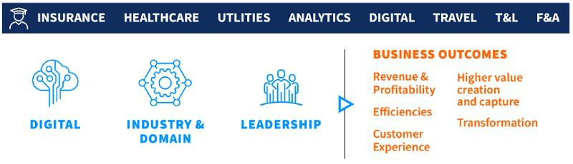

2019 Trainings:

- 99+% of employees trained in “Digital Intelligence” and EXL’s proprietary “Digital EXLerator” framework for delivering digital transformation to our clients

- 99+% of employees trained in diversity and inclusion – managing unconscious bias

- 250+ employees trained in intelligent automation

- 2100+ employees trained on various analytics tools and technologies

- 655 employees trained on digital methodologies

- 450 team leaders were trained in our new leaders training

- 550 team leaders were trained in operations management

- 1,030 employee certified in the insurance, healthcare, travel, transport and logistics and finance and accounting

We have an active employee relations function to ensure that we regularly communicate with and understand our employees, and are able to swiftly respond to specific needs and concerns as they arise.

EXLSERVICE.COM ⁄ 39

Our Executive Officers

Rohit Kapoor (age 55)

Vice Chairman and CEO
See section entitled “Our Board of Directors” above.

Ajay Ayyappan (age 42)

Senior Vice President, General Counsel and Corporate Secretary

Mr. Ayyappan has served as our Senior Vice President, General Counsel and Corporate Secretary since December 2018 and our Vice President, Acting General Counsel and Corporate Secretary since August 2018. He previously served as Vice President, Deputy General Counsel and Assistant Secretary from April 2014 to August 2018 and Vice President and Assistant General Counsel from March 2007 to March 2014. Prior to joining us, Mr. Ayyappan was a corporate associate at the law firm of Morgan, Lewis & Bockius LLP.

Pavan Bagai (age 58)

President and Chief Operating Officer

Mr. Bagai has served as our President and Chief Operating Officer since April 2012, as our Chief Operating Officer from May 2008 to March 2012 and as Vice President, Head of Outsourcing Services of EXL India from June 2006 until April 2008. In addition, he served as our interim Chief Financial Officer from December 2019 through February 2020. He previously served as Vice President, Research and Analytics of EXL India from December 2004 to May 2006, as Vice President, Operations of EXL India from November 2003 to November 2004 and as Vice President, Strategic Businesses of EXL India from July 2002 to November 2003. Prior to joining us, Mr. Bagai served in various capacities in several business areas across markets in Europe and Asia, including India, at Bank of America beginning in 1985.

Vikas Bhalla (age 48)

Executive Vice President and Business Head, Insurance

Mr. Bhalla has served as our Executive Vice President and Business Head, Insurance since January 2014 and as our Head of Outsourcing since November 2009. He previously served as Vice President, Operations of EXL India from June 2006 to October 2009 and as Vice President, Migrations, Quality and Process Excellence of EXL India from April 2002 to June 2006 and as Director, Quality Initiatives of EXL India from May 2001 to March 2002. From May 1998 to May 2001, Mr. Bhalla served in various capacities at General Electric, including as the Quality Leader and E-Business Leader for GE Plastics India.

Vivek Jetley (age 45)

Executive Vice President and Business Head, Analytics

Mr. Jetley began serving as our Executive Vice President and Business Head, Analytics in January 2020. He previously served in various leadership roles with us, including heading enterprise strategy and setting up a strategic deal team. Mr. Jetley has been with EXL since 2006. Prior to joining us, Mr. Jetley was a Partner at Inductis.

EXLSERVICE.COM ⁄ 40

Anita Mahon (age 51)

Executive Vice President and Chief Growth Officer

Ms. Mahon began serving as our Executive Vice President and Chief Growth Officer in March 2020. Prior to joining us, Ms. Mahon served as Vice President, Data, Strategy & Portfolio Officer at IBM Watson Health, a business unit focused on developing cognitive and data-driven technologies to advance health. Ms. Mahon joined IBM in 2016 through its acquisition of Truven Health Analytics, a healthcare information and analytics business, where she served as Chief Strategy Officer. Prior to Truven, she held other leadership roles that placed her at the intersection of strategy, technology and analytics.

Samuel Meckey (age 49)

Executive Vice President and Business Head, Healthcare

Mr. Meckey has served as an Executive Vice President since November 2018 and as Business Head, Healthcare beginning in 2019. Prior to joining us, Mr. Meckey served as President of UnitedHealth Group’s Optum Global Solutions and before that has held various executive roles at UnitedHealth Group, where he was employed from May 2004 to June 2018. Prior to joining UnitedHealth Group, Mr. Meckey was an officer and naval aviator in the United States Navy from May 1992 to August 2002.

Nalin Miglani (age 59)

Executive Vice President and Chief Human Resource Officer

Mr. Miglani has served as our Executive Vice President, Chief Human Resource Officer since December 2014. Mr. Miglani is responsible for the global human resources function at the Company. Prior to joining the Company, he was the Chief HR and Corporate Development Officer for Nutreco, based in Amsterdam, Netherlands, from March 2013 to November 2014. Mr. Miglani also served as the Chief HR and Communications Officer for Tata Global Beverages Company, London, UK, from June 2008 to February 2013. In addition, Mr. Miglani held various global and regional HR leadership roles around the world during his career at The Coca-Cola Company and British American Tobacco.

Maurizio Nicolelli (age 51)

Executive Vice President and Chief Financial Officer

Mr. Nicolelli was appointed as Executive Vice President and Chief Financial Officer of the Company in January 2020. Prior to joining the Company, Mr. Nicolelli served as Senior Vice President and Chief Financial Officer of Casa Systems beginning in 2019. He previously served 23 years at FactSet Research Systems, where he was Senior Vice President, Principal and Chief Financial Officer from 2009 to 2018.

EXLSERVICE.COM ⁄ 41

EXECUTIVE COMPENSATION

Compensation Discussion and Analysis

Table of Contents

Named Executive Officers | 43
Executive Summary | 43
Select 2019 Financial and Business Highlights | 43
Total Stockholder Return | 44
Awards and Industry Recognition | 44
Clients and Operations | 44
Summary of Key Compensation Considerations & Decisions in 2019 | 44
Pay-for-Performance | 45
Executive Compensation Program, Practices and Policies | 46
Overview of Compensation Policies and Philosophies | 48
Our Compensation Committee’s Processes | 49
Assessment of Company Performance | 49
Assessment of Individual Performance | 49
Review of Peer Company Market Data | 49
Total Compensation Review | 50
Role of the Compensation Committee’s Independent Compensation Consultant | 50
Components of Executive Compensation for 2019 | 51
Detailed Review of Compensation Components | 52
Base Salary | 52
Incentive Bonus | 53
Long-Term Equity Incentives | 56
Fiscal Year 2019 Awards | 57
Payout of Awards Granted in Prior Fiscal Years | 59
Benefits and Perquisites | 59
Risk and Compensation Policies | 59
Severance and Change-in-Control Benefits | 59
2020 Compensation | 60
Deductibility Cap on Executive Compensation | 60
Compensation Committee Report | 61
EXLSERVICE.COM ⁄ | 42

Named Executive Officers

As determined in accordance with SEC rules, our named executive officers (“NEOs”) for 2019 are:

- Rohit Kapoor, our Vice Chairman and CEO

- Vishal Chhibbar, our former Executive Vice President and CFO

- Pavan Bagai, our President, Chief Operating Officer and interim CFO

- Nalin Miglani, our Executive Vice President and Chief Human Resources Officer

- Vikas Bhalla, our Executive Vice President and Business Head, Insurance

- Samuel Meckey, our Executive Vice President and Business Head, Healthcare

Executive Summary

Select 2019 Financial and Business Highlights

- Improved our annual revenues from $883.1 million in fiscal year 2018 to $991.3 million in fiscal year 2019 on a reported currency basis (an increase of over 12%)

- Improved net income attributable to stockholders by 19% to $67.7 million

- Substantially completed the wind down of the operations of our Health Integrated business on December 31, 2019

- Added approximately 2,600 employees to our global work force, mainly in our delivery centers

- Added our fourth Digital Lab in London to complement our labs in Manila, Philippines, Noida and Bangalore, India, and our Digital Experience Center in the United States

- Won 28 new clients and received numerous awards and industry recognitions in our primary segments of Insurance, Healthcare and Analytics

EXLSERVICE.COM ⁄ 43

Total Stockholder Return

The following graphs compare our 1-year, 3-year and 5-year total stockholder return (“TSR”) with that of the companies comprising Nasdaq, S&P 500 and our peer group. As shown in the table, our 1-Year TSR outperformed all but one of our market benchmarks while our 5-year TSR outperformed all of our market benchmarks.
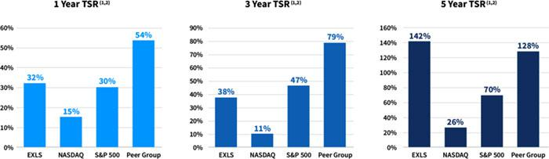

- Cumulative growth rate as of December 31, 2019.

- Peer group TSR data excludes Convergys Corporation, which was acquired in October 2018, and DST Systems, which was acquired in April 2018.

Awards and Industry Recognition

- Our people are our primary assets, and they continue to be recognized across the industry.

- As in prior years, we continued to receive numerous industry recognitions and awards, including being recognized as a Leader in the ISG Provider Lens for Insurance BPO Digital Services – U.S. 2019 for Property & Casualty Insurance Services, Life & Annuity Digital Services and Life & Annuity TPA Services and recognized as a Leader in the Everest Group Clinical and Care Management BPS Services PEAK Matrix™ Assessment 2019.

Clients and Operations

- In 2019 we won 28 new clients adding to the 50 new clients we won in 2018.

- In the past year, revenue from our top 30 clients grew by 14.6%.

Summary of Key Compensation Considerations & Decisions in 2019

The following highlights the Compensation Committee’s key considerations and compensation decisions in 2019 and with respect to performance for 2019 for our NEOs.

EXLSERVICE.COM ⁄ 44

Items | Considerations and Decisions
Say on Pay Approval | 97% of our stockholders approved, on a non-binding basis
 | (excluding broker non-votes), of our compensation of our NEOs.
Base Salaries | We held base salaries constant in 2019.
Annual Bonuses | We based our annual bonuses on achievement of company goals
 | (Adjusted EPS & revenue), business unit goals (total revenues &
 | business operating income) and personal performance goals.
 | In 2019, we delivered 104.1% of our Adjusted EPS target and 99.2%
 | of our revenue performance target resulting in annual incentive
 | payouts to our NEOs, ranging from 114% of target performance to
 | 124% of target performance.
Equity Incentives | We continued to grant a mix of time-based and performance-based
 | restricted stock units (revenue- & TSR-linked performance goals).
 | This was the third and final performance year for the 2017
 | performance-based restricted stock units. We achieved 102.61% of
 | the revenue target for the revenue-linked restricted stock units
 | resulting in 126.14% of target funding of those grants. The
 | Company’s TSR performance was at the 51.2 percentile amongst its
 | peer group, resulting in the executives earning 104.07% of the 2017
 | relative TSR-linked restricted stock units pursuant to the terms of the
 | original grant resulting in vesting of shares at 115.11% of target
 | performance.
Pay-for-Performance
Our executive compensation philosophy is focused on pay-for-
performance. In this regard, we link a significant portion of each
NEO’s total compensation to the achievement of specified
performance goals. This variable compensation is “at-risk” and
rewards performance and contributions to both short- and long-term
financial performance.
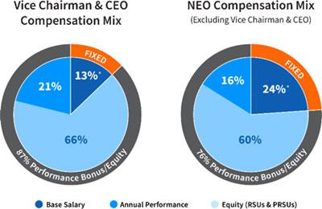

As illustrated by the following charts, the majority of compensation that may be earned by our named executive officers is tied to the achievement of financial performance metrics (annual performance bonuses and PRSUs) or fluctuates with the underlying value of our common stock (RSUs).

EXLSERVICE.COM ⁄ 45

Executive Compensation Program, Practices and Policies

Our compensation programs, practices and policies are reviewed and re-evaluated periodically and are subject to change from time to time. Our executive compensation philosophy is aligned with our core values, focused on pay-for-performance and designed to reflect appropriate governance practices aligned with the needs of our business. Listed below are some of the Company’s more significant practices and policies that were in effect during fiscal year 2019, which were adopted to drive performance and to align our executives’ interests with those of our stockholders.

What We Do | What We Don’t Do
✓ Align our Executive Pay with Performance: We link a significant | û No Option Repricing: We prohibit option repricing without
portion of each NEO’s total compensation to the achievement of | stockholder approval.
specific performance goals, as described below.
Variable compensation is “at-risk” and rewards performance and
contributions to both short- and long-term financial performance.
✓ Use Appropriate Peer Groups When Establishing | û No Option Backdating or Discounting: We prohibit option
Compensation: We established a peer group to help us review | backdating and discounting.
market practices and design a competitive compensation program.
The criteria for peer group selection include similar market
capitalization, scope of operations, potential mobility of talent and
industry alignment.
We set compensation of our executive officers at levels that we
believe are appropriate relative to the compensation paid to similarly
situated officers of our peers, giving consideration to market and
other factors.
✓ Ensure Equity Compensation Best Practices: We design equity | û No Excessive Overhang or Dilution: We do not have
incentives to encourage our executives to maintain a long-term view | excessive overhang or dilution from equity grants.
of stockholder value creation, to encourage retention and to ensure a
significant portion of the award is performance-based.
We hold dividends accrued under our equity awards, if any, until the
recipient vests in the underlying shares or units.
✓ Maintain an Independent Compensation Committee: | û No Excessive Perquisites: We provide our named executive
Compensation decisions for our NEOs are approved by a | officers with only limited perquisites and personal benefits that
Compensation Committee composed of non-employee independent | serve an important business purpose in addition to the regular
directors. | benefits offered to all employees.
Our Compensation Committee is advised by an independent | We consider the perquisites and personal benefits that we offer to
consultant who reports directly to the Compensation Committee and | our executives in India to be customary benefits which allow us to
provides no other services to the Company or management. | remain competitive for top talent.
 | EXLSERVICE.COM ⁄ 46

What We Do | What We Don’t Do
✓ Mitigate Risks: The mix and design of our compensation | û No Tax Gross-Ups: We do not provide “gross-ups” to any of our
programs serves to mitigate operational, financial, legal, regulatory, | named executive officers, including gross-ups for any excise taxes
strategic and reputational risks. | imposed with respect to Section 280G (change-in-control
 | payments) or Section 409A (nonqualified deferred compensation)
 | of the U.S. Internal Revenue Code of 1986, as amended (which
 | we refer to as the “Code”).
✓ Maintain a Clawback Policy: We maintain a compensation | û No Hedging: We maintain a policy in which the following
recovery policy that allows the Company to recover compensation | persons are prohibited from engaging in hedging transactions
(including cash and/or equity awards) previously paid to one or more | involving our shares and other securities: our directors and their
officers in the event of a financial restatement caused by | secretaries and other assistants; our executive officers and their
noncompliance with reporting requirements that impacts the | secretaries and other assistants; our employees in the accounting,
applicable performance metric if, in the opinion of our Board or | finance and legal departments; the members and permanent
Compensation Committee, the identified executive’s misconduct was | invitees of our operating and executive committees; and all of our
a material factor causing the restatement. | vice president level 2 and 3 officers (whom we refer to collectively
 | as “Reporting Persons”). For this purpose, “hedging” refers to any
 | strategy to offset or reduce the risk of price fluctuations in our
 | shares or other securities or to protect, in whole or in part, against
 | declines in the value of our shares or other securities. This
 | prohibition thus applies to all transactions in derivative securities
 | based on our stock such as other securities, including puts, calls,
 | swaps and collar arrangements.
✓ Maintain a Robust Stock Ownership Policy: We maintain a | û No Pledging: Under our policy mentioned above, Reporting
stock ownership policy that requires our CEO to maintain stock | Persons (as defined above) are only permitted to pledge shares of
ownership equal to at least six times his base salary and that | our stock that exceed those required to be owned under our Stock
requires the other members of our executive committee to maintain | Ownership Policy described above.
stock ownership of at least two times their respective base salaries.
Covered executives have five years from December 2014 (or their
hire date, if later) to attain the required stock ownership levels.
We maintain a similar stock ownership policy for our non-employee
directors that requires directors to maintain stock ownership of at
least five times their respective annual retainers.
As of December 31, 2019, all covered executives and directors were
in compliance with the stock ownership policy.
 | EXLSERVICE.COM ⁄ 47

Overview of Compensation Policies and Philosophies

We believe that the long-term success of companies that provide outsourcing, transformation and analytics services globally is linked to their ability to recruit, train, motivate and retain employees at every level. There is significant competitive pressure in our industry for qualified managers with a track record of achievement. It is critical that we recruit, train, motivate and retain highly talented individuals at all levels of the organization who are committed to our core values of innovation, collaboration, excellence, integrity and mutual respect. We believe that our executive compensation programs are integral to achieving this end.

Our Compensation Committee bases its executive compensation programs on the following objectives, which guide us in establishing all of our compensation programs:

- Compensation should be based on the level of job responsibility, individual performance and our performance. As employees progress to higher levels in the organization, they are able to more directly affect our results and strategic initiatives, and therefore an increasing proportion of their pay should be linked to our performance and tied to creation of stockholder value. Our programs should deliver top-tier compensation in return for top-tier individual and company performance; conversely, where individual performance and/or our performance falls short of expectations, the programs should deliver lower-tier compensation. In addition, the objectives of pay-for-performance and retention must be balanced. Even in periods of temporary downturns in our performance, the programs should continue to ensure that successful, high-achieving employees remain motivated and committed.

- Compensation should balance long-term focus that is linked to stockholder value as well as short-term financial objectives. Consistent with this philosophy, equity-based compensation should be higher for persons with higher levels of responsibility and greater influence on long-term results, thereby making a significant portion of their total compensation dependent on long-term stock price appreciation. In addition, compensation should focus management on achieving short-term performance goals in a manner that supports and ensures long-term success and profitability.

- Compensation should reflect the value of the job in the marketplace. We compete for talent globally. In order to attract and retain a highly skilled workforce, we must remain competitive with the pay of other employers who compete with us for talent in the relevant markets.

- Compensation programs should be easy to understand. We believe that all aspects of executive compensation should be clearly, comprehensibly and promptly disclosed to employees in order to effectively motivate them. Employees need to easily understand how their efforts can affect their pay, both directly through individual performance accomplishments, and indirectly through contributing to our achievement of strategic, financial and operational goals. We also believe that compensation for our employees should be administered uniformly across the company and should be administered with clear-cut objectives and performance metrics.

compensation based on responsibility and performance

compensation should balance long-term and short-term objectives

compensation programs should be easy to understand

EXLSERVICE.COM ⁄ 48

Our Compensation Committee’s Processes

Our Compensation Committee has established a number of processes to assist it in ensuring that our executive compensation programs are achieving their objectives. Among those are the following:

- Assessment of Company Performance: Our Compensation Committee uses financial performance measures to determine a significant portion of the payouts under our annual incentive bonus program and equity incentive program. The financial performance measures with respect to our named executive officers’ incentive bonuses and equity incentive awards are largely based on the achievement of Company-wide goals. In addition, the incentive bonuses payable under our annual incentive bonus program to our senior executives who have responsibility for business lines are tied to such business lines’ financial or other performance. These Company-wide and business-line performance measures are established by our Compensation Committee annually at the end of the prior year or the beginning of the year. At the end of the year or performance period, in the case of our equity incentive program, our Compensation Committee reviews and certifies our performance achievement, and considers the appropriateness of adjustments to the performance criteria and calculations of performance achievement.

  - We generally pay bonuses at target when we achieve the established financial measures that are set forth in our annual operating plan and personal performance goals, as described below. These measures reflect targets that are intended to encourage stretch performance.

- Assessment of Individual Performance: Individual performance has a strong impact on the compensation of our employees, including our executive officers. The evaluation of an individual’s performance determines a portion of the payouts for each of our named executive officers made under our incentive bonus program and also influences any changes in base salary.

  - For Messrs. Chhibbar, Bagai, Miglani, Bhalla and Meckey, our Compensation Committee receives a performance assessment and compensation recommendation from our Vice Chairman and CEO. The performance assessments are based on each of our named executive officer’s respective self-evaluations and subsequent performance appraisals conducted by our Vice Chairman and CEO. Our Compensation Committee reviews the performance assessments of these executive officers with our Vice Chairman and CEO, and evaluates the achievement of established objectives by each executive officer and his or her business line (if applicable), as well as the executive officer’s contribution to our performance, leadership accomplishments and overall competence. In determining the numerical performance rating that translates into specific payouts under our incentive bonus program and also influences any changes in base salary, our Compensation Committee may exercise its judgment based on our board of directors’ interactions with such executive officers.

  - For Mr. Kapoor, our board of directors receives a self-evaluation prepared by Mr. Kapoor and provides feedback to our Chairman. Our Chairman then discusses the consolidated feedback from the board of directors with our Compensation and Nominating and Governance Committees. Our board of directors and Compensation and Nominating and Governance Committees evaluate the self-evaluation and feedback as well as Mr. Kapoor’s performance, leadership accomplishments and overall competence and evaluate the achievement of established objectives.

- Review of Peer Company Market Data: At the time compensation decisions were made for our U.S.-based and other senior executive officers in 2019, our Compensation Committee reviewed publicly available compensation data for companies that are engaged in business and technology services like us. The

EXLSERVICE.COM ⁄ 49

Compensation Committee took into account whether the companies had market capitalizations or annual revenues similar to ours, as well as the relevance of their geographic areas. The companies that comprised our peer group for 2019 were as follows:

 | Peer Group Companies
Blackbaud | Genpact Limited
Convergys Corporation⁽¹⁾ | LiveRamp Holdings
CSG Systems International, Inc. | Sykes Enterprises
DST Systems⁽²⁾ | Virtusa
EPAM Systems | WNS (Holdings) Limited

- Convergys Corporation was acquired by SYNNEX Corporation in October 2018.
- DST Systems was acquired by SS&C Technologies in April 2018.

Generally, the Company reviews peer compensation data every two years. The compensation data for our peer group was compiled directly by FW Cook, the independent consultant to the Compensation Committee in 2018. Also in 2018, management separately engaged Aon Consulting for the purpose of providing a survey of compensation data (the parameters of which were not prepared by Aon Consulting) for individuals in our global industry holding analogous positions to our executive officers. While the Compensation Committee reviewed and considered the data provided by these surveys, it did not consider or review the compensation paid to executives at the component companies included within such surveys and did not use this information or any other data as a definitive benchmark to set executive compensation for fiscal year 2019.

Our Compensation Committee uses the compensation data to obtain a general understanding of current market practices, so it can design our executive compensation program to be competitive. Market data is not used exclusively, but rather as a point of reference to draw comparisons and distinctions. The Compensation Committee also takes into account an executive officer’s job responsibilities, performance, qualifications and skills in determining individual compensation levels.

- Total Compensation Review: Our Compensation Committee reviews compensation information provided by FW Cook and the Aon survey in order to evaluate each executive’s base pay, incentive bonus and equity incentives when changes in compensation are considered. Compensation decisions are designed to promote our fundamental business objectives and strategy. Our Compensation Committee periodically reviews related matters such as succession planning and management, evaluation of management performance, changes in the scope of managerial responsibilities, and consideration of the business environment, and considers such matters in making compensation decisions.

- Role of the Compensation Committee’s Independent Compensation Consultant: For 2019, the Compensation Committee retained the services of FW Cook, a qualified and independent compensation consultant, to aid the Compensation Committee in performing its duties. The Compensation Committee’s compensation consultant assists in collecting and evaluating external market data regarding executive compensation and performance, selecting peer group companies, reviewing the proxy statement and advising the Compensation Committee on developing trends and best practices in executive compensation, director compensation and equity and incentive plan design. Other than performing these consulting services, FW Cook does not provide other services to us or our executive officers. We have affirmatively determined that no conflict

EXLSERVICE.COM ⁄ 50

of interest has arisen in connection with the work of FW Cook as compensation consultant for the Compensation Committee.

Components of Executive Compensation for 2019

For 2019, the compensation of executive officers consisted of the following five primary components:


Compensation Component

Base Salary

Annual Incentives

Long-Term

Incentives

Description

Fixed compensation that is reviewed annually and is based on performance, experience, responsibilities, skill set and market value.

“At-risk” compensation earned based on performance measured against pre-established annual goals.

Goals are tailored to each executive’s position.

“At-risk” compensation in the form of restricted stock unit awards whose value fluctuates according to stockholder value.

50% of the award vests based on continued service.

50% vests based on achievement of revenue and total stockholder return goals.

Objectives

Provide a base level of compensation that corresponds to the job function performed.

Attract, retain, reward and motivate qualified and experienced executives.

Incentivize executives to achieve annual goals that ultimately contribute to long-term company growth and stockholder return.

Align executive interests with those of stockholders.

Reward continuous service with the company.

Incentivize executives to achieve goals that drive company performance over the long-term.

Other Benefits

Severance and Change in Control Protections

Broad-based benefits provided to company employees (e.g., health and group insurance), a retirement savings plan and other personal benefits where appropriate.

Protect executives during potentially tumultuous corporate transaction.

Provide reduced post-employment compensation upon other involuntary terminations.

Provide a total compensation package that is competitive with the marketplace and addresses unique needs, especially for overseas executives.

Allow executives to focus on generating stockholder value during a change in control transaction.

Provide market-competitive post-employment compensation recognizing executives likely require more time to find subsequent employment.

EXLSERVICE.COM ⁄ 51

Detailed Review of Compensation Components

Base Salary

As discussed above, we provide our executive officers fixed compensation commensurate with their performance, experience, responsibilities, skill set and market value. This attracts and retains an appropriate caliber of talent for the position and provides a base wage that is not subject to our performance risk. In setting base salaries for 2019, our Compensation Committee considered:


Individual Performance

Market Data

Overall Compensation Mix

The degree to which the executive met and exceeded expectations.

Geographical and market data to test reasonableness of compensation.

Senior employees should have a greater portion of their compensation tied to increasing stockholder value.

Upon completing its review and as shown in the table below, and considering base salaries were increased for 2018, the Compensation Committee determined that it was appropriate to hold constant the base salary for each of our named executive officers in 2019. The fixed compensation paid to Messrs. Bagai and Bhalla is paid in Indian Rupees and was held constant in Indian Rupees for each of Messrs. Bagai and Bhalla in 2019. Further, these amounts cover not only base salary, but also amounts available as a travel allowance, an automobile allowance, a housing allowance, a medical allowance and a cash supplementary allowance, consistent with compensation practices in India.

 |  | 2019 Base Salary /
 | 2018 Base Salary / | Annual Fixed
 | Annual Fixed Compensation | Compensation | % Increase /
Name | (Effective April 1, 2018) | (Effective April 1, 2019) | Decrease
Rohit Kapoor | $720,000⁽¹⁾ | $720,000 | —
Vishal Chhibbar | $450,000 | $450,000 | —
Pavan Bagai⁽²⁾ | INR26,000,000⁽³⁾ | INR26,000,000⁽⁴⁾ | —
Nalin Miglani | $450,000 | $450,000 | —
Vikas Bhalla⁽²⁾ | INR22,000,000⁽⁵⁾ | INR22,000,000⁽⁶⁾ | —
Samuel Meckey | $425,000 | $425,000 | —

- Mr. Kapoor’s base salary was revised effective January 1, 2018. There was no change in 2019.
- The fixed compensation paid to Messrs. Bagai and Bhalla is paid in Indian Rupees (INR).
- Equivalent to $407,077, converted at 63.87 INR to 1 USD, which was the exchange rate on December 31, 2018.
- Equivalent to $364,248, converted at 71.38 INR to 1 USD, which was the exchange rate on December 31, 2019.
- Equivalent to $344,450, converted at 63.87 INR to 1 USD, which was the exchange rate on December 31, 2018.
- Equivalent to $308,210, converted at 71.38 INR to 1 USD, which was the exchange rate on December 31, 2019.

EXLSERVICE.COM ⁄ 52

Incentive Bonus

We have established an annual incentive bonus program in order to align our executive officers’ goals with our performance targets for the current year and to encourage meaningful contributions to our future financial performance. Our Compensation Committee approved the framework of our incentive bonus program in December 2018 for the year 2019 for bonuses payable in respect of 2019 performance. Under the program, bonus target amounts, expressed as a percentage of base salary or annual fixed compensation, are established for participants at the beginning of each year unless their employment agreements contain different terms. Funding of potential bonus payouts for the year are determined by our financial results for the year relative to predetermined performance measures and our assessment of each named executive officer’s performance relative to his predetermined individual performance goals. If our performance falls short of target, our aggregate funding of the annual cash bonus incentive pool declines. If we do not achieve a minimum threshold for the established financial performance objectives, then the bonus pool is not funded for that particular objective. Although the Compensation Committee has not historically done so, it has the discretion to adjust an award payout from the amount yielded by the formula at the end of the performance period.

Our Compensation Committee considered the following when establishing the awards for 2019:

- Bonus Targets. Bonus targets were established based on job responsibilities and comparable market data. Our objective was to set bonus targets such that total annual cash compensation was within the broad middle range of market data and a substantial portion of that compensation was linked to our performance. Consistent with our executive compensation policy, individuals with greater job responsibilities had a greater proportion of their total compensation tied to our performance. During 2019, our Compensation Committee established the following bonus targets (expressed as a percentage of base salary or annual fixed compensation) as well as maximum bonus targets for each named executive officer.

 | Name | Bonus Target | Bonus Maximum
 | Rohit Kapoor | 150% of base salary | 310% of base salary
 | Vishal Chhibbar | 75% of base salary | 155% of base salary
 | Pavan Bagai | 75% of annual fixed compensation | 155% of annual fixed compensation
 | Nalin Miglani | 75% of base salary | 155% of base salary
 | Vikas Bhalla | 75% of annual fixed compensation | 154% of annual fixed compensation
 | Samuel Meckey | 75% of base salary | 154% of base salary
 |  |  | EXLSERVICE.COM ⁄ 53

- Performance Measures. Our executives were eligible to earn annual bonuses based on their achievement of company-wide performance metrics, business line or other company performance metrics and individual performance, as described in the tables below.

 | Company-Wide | Individual | Business Line or Other
Name | Performance⁽¹⁾ | Performance | Company Performance⁽²⁾
Rohit Kapoor | 65% | 15% | 20%
Vishal Chhibbar | 60% | 20% | 20%
Pavan Bagai | 65% | 15% | 20%
Nalin Miglani | 60% | 20% | 20%
Vikas Bhalla | 40% | 20% | 40%
Samuel Meckey | 40% | 20% | 40%

- Based 50% on the Company’s Adjusted EPS goal and 50% on the Company’s revenue goal, for all employees whose incentive bonus is linked to Company-wide financial performance, including our named executive officers.

- For Messrs. Kapoor, Chhibbar, Bagai and Miglani, based on aggregate Revenue and Adjusted EPS for specific business units. For Messrs. Bhalla and Meckey, based on total revenue and business operating income for specific business units. Business operating income is a component for measuring business unit performance that is computed as the business unit’s gross margin less direct operating expenses.

In 2019, the Compensation Committee continued to set the business line and other Company performance goals as well as the individual performance goals described above for all named executive officers to ensure the executives were properly focused on both the Company’s Adjusted EPS and revenue goals, aggregate of business units’ performance on revenue and other areas of performance that are unique to their positions within the organization. In 2018, we decided to move away from basing our annual bonus in part on Adjusted EPS and, instead, to base it in part on Adjusted profits before tax (“PBT”) targets because of the uncertain effect of proposed U.S. tax reforms on the Company and the Adjusted EPS calculation. Adjusted PBT, by its nature, is a measure that is unaffected by the then-current year’s taxation. However, since the enactment of the Tax Cuts and Jobs Act of 2017 on December 22, 2017, the Compensation Committee decided to return to using the Adjusted EPS target as the basis, in part, for the 2019 annual incentive awards. The Compensation Committee believes achievement of these performance metrics will drive our business and, in turn, lead to increased stockholder value.

Determination of Financial Performance Achievement: In 2019, our Compensation Committee established an Adjusted EPS target of $3.175 (14.6% higher than our actual Adjusted EPS for the prior year) and a revenue target of $989.0 million (12.0% higher than our actual revenue for the prior year). As shown below, the portion of incentive bonus payments that were subject to these financial performance measures could have ranged from zero to 210% of target depending on the achievement of the performance goals:

EXLSERVICE.COM ⁄ 54



Performance Targets: Adjusted EPS ($3.175) and Revenue ($989.0 million)

% of Performance Achieved Compared to Target Goal | % of Target Portion Funded
Less than 90% | 0%
At 90% | 10%
90% to 100% | Linear interpolation from 10% to 100%
At 100% | 100%
100% to 105% | Linear interpolation from 100% to 160%
105% to 110% | Linear interpolation from 160% to 210%
Above 110% | 210%

Based on our performance during the 2019 fiscal year, we achieved 104.1% of our Adjusted EPS target, and 99.2% of our revenue target.

The bonus pool funding for employees whose bonuses are tied to the performance of specific business lines is determined by targets established for such businesses by our Compensation Committee.

- Individual Performance Measures: As discussed above, each of our named executive officers earns a portion of his respective annual incentive bonuses based on the achievement of individual performance measures. These goals are designed to balance the attention of our named executive officers between the achievement of near-term objectives that improve specific processes or performance metrics and long-term objectives for us. While some of the goals are subjective, other goals, such as client and employee satisfaction metrics, are capable of objective measurement. The individual performance measures are generally based on strategic performance indicators such as improving sales productivity, strengthening our sales effectiveness, supporting inorganic growth through mergers and acquisitions, improving recruitment capabilities, enhancing market recognition, advancing our technological and automation capabilities and achieving revenue growth targets within specific areas.

- Determination of Individual Performance Achievement: Mr. Kapoor made performance assessments and compensation recommendations for Messrs. Bagai, Miglani, Bhalla and Meckey and our Compensation Committee approved the recommendations after reviewing similar considerations for such named executive officers. For Mr. Bagai, our Compensation Committee noted his contribution in providing leadership to the analytics business, building significant client relationships and driving efficient operations across the enterprise. For Mr. Miglani, our Compensation Committee noted his contribution in building digital capabilities across the organization, significantly expanding the diversity of leadership, driving margin enhancement initiatives and enabling a new organization design. For Mr. Bhalla, our Compensation Committee noted that the Insurance vertical had a successful year. During this year, existing client relationships were expanded and greater geographic diversification was achieved. For Mr. Meckey, our Compensation Committee noted his contribution in developing a growth strategy for the healthcare vertical, building a team of industry experts to drive the strategy and an efficient wind down of the Health Integrated business. For Mr. Kapoor, the Compensation Committee noted that 2019 was one of the best years for growth and profitability. This was in addition to laying the foundation for the future through building a diverse leadership team, developing a long term strategy and creating depth in the leadership team.

EXLSERVICE.COM ⁄ 55

- Actual Bonus Payments: The table below sets out the 2019 incentive bonuses for our named executive officers (paid in March 2020).

Name | Earned 2019 — Incentive Bonus ($)
Rohit Kapoor | 1,304,453
Vishal Chhibbar⁽¹⁾ | —
Pavan Bagai⁽²⁾ | 323,814
Nalin Miglani | 411,735
Vikas Bhalla⁽²⁾ | 285,636
Samuel Meckey | 364,320

- There was no bonus payout for Mr. Chhibbar since his last working day at the Company was December 13, 2019.

- The exchange rate used for the bonus conversion from Indian rupees to U.S. dollars for Messrs. Bagai and Bhalla was 71.38 INR to 1 USD, which was the exchange rate on December 31, 2019.

Long-Term Equity Incentives

The Committee continues to believe that long-term equity awards provide employees with the incentive to stay with us for longer periods of time, which in turn, provides us with greater stability as we grow. These incentives foster the long-term perspective necessary for continued success in our business because the value of the awards is directly linked to long-term stock price performance, and they ensure that our executive officers are properly focused on stockholder value.

Moreover, the Committee favors restricted stock unit awards as these awards offer executives the opportunity to receive shares of our common stock on or shortly following the date that the restrictions lapse. Such awards serve both to reward and retain executives because value is linked to the price of our stock on the date that the restriction lapses, and the executive must generally remain in employment through the date that the restrictions lapse. Restricted stock unit awards provide a significant degree of alignment of interests between our executives and stockholders.

The Committee also believes that the mix between Time-Vested RSUs and Performance-Vested RSUs provides an appropriate balance between incentivizing our executives to continue their employment with the Company and to ensure they are focused on long-term financial performance and generating stockholder value, which will enable them to realize additional compensation.

Finally, restricted stock units are potentially less dilutive to stockholders’ equity than stock options because restricted stock awards are full value awards, and our Compensation Committee can award fewer shares than an equivalent value of stock options.

EXLSERVICE.COM ⁄ 56

Fiscal Year 2019 Awards

Under our equity compensation program, our executive officers received restricted stock units under the 2015 Amendment and Restatement of the 2006 Omnibus Award Plan (the “2015 Plan”). Subsequent awards were made pursuant to the 2018 Omnibus Incentive Plan approved by the Company’s stockholders at the annual meeting of stockholders held in June 2018 (the “2018 Plan”). We awarded restricted stock units to all of our named executive officers in the portions shown below.
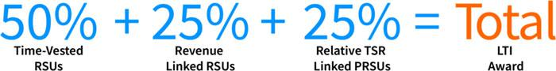

The table below shows the amount of Time-Vested and Performance-Vested RSUs our Compensation Committee awarded our named executive officers in 2019. In general, the Compensation Committee believes that the size of the award granted to an executive officer should increase based on the executive officer’s level of responsibility within the Company.

Name | Time-Vested RSUs | Revenue-Linked PRSUs | Relative TSR-Linked PRSUs
Rohit Kapoor | 28,910 | 14,455 | 14,455
Vishal Chhibbar | 7,085 | 3,543 | 3,542
Pavan Bagai | 10,925 | 5,463 | 5,462
Nalin Miglani | 6,175 | 3,088 | 3,087
Vikas Bhalla | 6,830 | 3,415 | 3,415
Samuel Meckey | 5,370 | 2,685 | 2,685

- The Time-Vested RSUs will vest in increments of 25% on each of the first four anniversaries of the grant date, subject to continuous service with the Company through the applicable vesting date.

- The Committee believes these Time-Vested RSUs provide an important role in promoting retention of our executive officers.

- The “Performance-Vested” portion of the 2019 RSUs (“PRSUs”) are split into two types that each vest based on separate performance measures as follows:

  - Revenue-Linked PRSUs: 50% of these performance-based restricted stock unit awards will cliff-vest on December 31 of the third fiscal year in the performance period, subject to achievement of threshold Company revenues against an aggregate revenue target over the grant’s three year performance period of January 1, 2019 to December 31, 2021 and continuous employment through December 31, 2021 — we call these awards “Revenue-Linked PRSUs.” The ultimate amount of Revenue-Linked PRSUs that a recipient earns may be up to 200% of the target award of Revenue-Linked RSUs. To the extent the Company’s revenue falls in between 90% and 98%, the percentage of Revenue-Based RSUS earned will be

EXLSERVICE.COM ⁄ 57

determined based on straight line interpolation calculated using a revenue target range between 90% and 100% and a funding range between 0% and 100%. Likewise, if performance is between 102% and 110%, the percentage of Revenue-Based RSUs earned will be determined based on straight line interpolation calculated using a revenue target range between 100% and 110% and a funding range between 100% and 200%. The chart below sets forth the revenue target achievement thresholds and corresponding funding percentage:

Revenue Target Achievement | Funding Percentage
110% or more | 200%
98% to 102% | 100%
90% or less | 0%

- Relative TSR-Linked PRSUs: The remaining 50% of the performance-based restricted stock unit awards cliff-vest on December 31 of the third fiscal year in the performance period, based on the achievement of relative total stockholder return performance of the Company against a peer group over the grant’s three-year performance period of January 1, 2019 to December 31, 2021 and continuous employment through December 31, 2021 — we call these awards “Relative TSR-Linked PRSUs.” The Company’s TSR for the TSR performance period will be computed and then compared to the TSR of the companies in the TSR peer group, which is comprised of the public companies traded on either the NYSE or NASDAQ stock markets in our 8-digit Global Industry Classification Standard sub-industry group. This comparator set is more appropriate than the compensation peer group for this purpose as it provides a more robust comparison of our performance to the marketplace by the inclusion of more companies and eliminating size as a selection criteria, which is more relevant for compensation than performance comparison. For the Relative TSR-Linked PRSUs granted in 2019, the Company included a negative TSR cap. Under the negative TSR cap, if the total stockholder return is negative over the course of the three year performance period, no named executive officer may receive greater than 100% funding of the TSR-Linked PRSUs.

The percentage of Relative TSR-Linked PRSUs earned will be determined based on straight-line interpolation to the extent the Company’s TSR falls in between the 20th and 80th percentiles, as per the chart below:

 | Percentage of Relative TSR-Linked
TSR Peer Group Percentile | PRSUs Earned
80.0 or more | 200%
65.0 | 150%
50.0 | 100%
35.0 | 50%
20.0 or less | 0%

- The Committee believes the PRSUs focus our executives on key drivers of our Company’s business that will ultimately lead to creation of additional stockholder value.

EXLSERVICE.COM ⁄ 58

Payout of Awards Granted in Prior Fiscal Years

This was the third and final performance year for the 2017 performance-based restricted stock units. We achieved 102.61% of the revenue target for the revenue-linked restricted stock units resulting in 126.14% of target funding of those grants. The Company’s TSR performance was at the 51.2 percentile amongst its peer group, resulting in the executives earning 104.07% of the 2017 relative TSR-linked restricted stock units pursuant to the terms of the original grant.

Benefits and Perquisites

We offer employee benefits coverage in order to:

- provide our global workforce with a reasonable level of financial support in the event of illness or injury; and

- provide market-competitive benefits that enhance productivity and job satisfaction through programs that focus on work/life balance.

The benefits available for all U.S. employees include customary medical and dental coverage, disability insurance and life insurance. In addition, our 401(k) plan provides a reasonable level of retirement income reflecting employees’ careers with us. A number of our U.S. employees, including our U.S.-based named executive officers, participate in these plans. The cost of employee benefits is partially borne by our employees, including our named executive officers. Our named executive officers in India, Messrs. Bagai and Bhalla, are eligible to participate in the Company’s pension benefit, health and welfare and fringe benefit plans otherwise available to executive employees in India.

We generally do not provide significant perquisites or personal benefits to executive officers other than our Vice Chairman and CEO and our executive officers in India. Our Vice Chairman and CEO is provided a limited number of perquisites which we believe are reasonable and consistent with market trends, which are intended to be part of a competitive overall compensation program. A discussion of the benefits provided to our Vice Chairman and CEO is provided under “Employment Agreements” beginning on page 65.

Risk and Compensation Policies

Our Compensation Committee has taken into account its discussions with management and FW Cook regarding our compensation practices and has concluded that any risks arising from our compensation policies and practices are not reasonably likely to have a material adverse effect on the Company. This conclusion was based on the features of our compensation programs, practices and policies set forth under “Executive Compensation Program, Practices and Policies” on page 46.

Severance and Change-in-Control Benefits

Each named executive officer is party to an employment agreement or letter that sets forth the terms of his or her employment, including compensation, which was negotiated through arms’-length contract negotiations. Under these employment agreements or letters, we are obligated to pay severance or other enhanced benefits upon termination of their employment. A discussion of the severance and other enhanced benefits provided to our named executive officers is provided under “Potential Payments upon Termination or Change in Control at Fiscal 2019 Year-End” beginning on page 71.

We have provided change-in-control severance protection for some of our executive officers, including our named executive officers. Our Compensation Committee believes that such protection is intended to preserve employee morale and productivity and encourage retention in the face of the disruptive impact of an actual or rumored change in control. In addition, for executive officers, the program is intended to align executive officers’ and stockholders’

EXLSERVICE.COM ⁄ 59

interests by enabling executive officers to consider corporate transactions that are in the best interests of our stockholders and other constituents without undue concern over whether the transactions may jeopardize the executive officers’ own employment.

Senior executive officers, including our named executive officers, have enhanced levels of benefits based on their job level, seniority and probable loss of employment after a change in control. We also consider it likely that it will take more time for senior executive officers to find new employment.

2020 Compensation

For fiscal year 2020, we enhanced our executive stock ownership policy by adding an additional ownership threshold requirement that our CEO and executive committee members must satisfy with respect to our common stock and vested common stock equivalents. We generally continued the annual bonus program and our long-term equity incentives, subject, of course, to new performance goals. For 2020, our Company-Wide Performance Metrics under our annual bonus program was revised such that 40% is based on revenue; 30% on adjusted operating profit margin (AOPM); and 30% on Adjusted EPS. In addition, the split between the Company, Business Unit and Individual components has changed for Messrs. Bhalla and Meckey. Lastly, our Compensation Committee made certain market-based adjustments in compensation to be more competitive and, as a result, the performance-based portion of Mr. Kapoor’s long-term incentive compensation mix became larger than his service-based component (previously the split was 50-50). In light of current global and economic conditions, the Compensation Committee will continue to monitor our 2020 executive compensation program in the second half of the year.

Deductibility Cap on Executive Compensation

The Tax Cuts and Jobs Act of 2017 significantly altered our ability to deduct for federal income tax purposes compensation paid to certain of our executives. Prior to its passage, Section 162(m) of the Code limited our ability to deduct compensation paid to our named executive officers (other than our chief financial officer) in excess of $1 million per year, unless the compensation was “performance-based”, as described in the regulations under Code Section 162(m). In general, the Tax Cuts and Jobs Act of 2017 eliminated the exception from Code Section 162(m)’s deduction limits for performance-based compensation, clarified that chief financial officers are covered by the deduction limitation, and made certain other changes, including providing for transition relief for written binding contracts in effect on November 2, 2017.

As in the past, our Compensation Committee expects to continue to take into consideration the tax deductibility of compensation, but reserves the right to authorize payments that may not be deductible if it believes that the payments are appropriate and consistent with our compensation philosophy.

Despite the changes made to Code Section 162(m) outlined above, our Compensation Committee does not anticipate a shift away from variable or performance-based compensation payable to our named executive officers. Similarly, we do not expect to apply less rigor in the process by which we establish performance goals or evaluate performance against pre-established goals with respect to compensation paid to our named executive officers.

EXLSERVICE.COM ⁄ 60

Compensation Committee Report

The Compensation Committee of the board of directors of ExlService Holdings, Inc. has reviewed and discussed the Compensation Discussion and Analysis with our management and, based on such review and discussion, has recommended to the board of directors of ExlService Holdings, Inc. that the Compensation Discussion and Analysis be included in our Annual Report on Form 10-K for the fiscal year ended December 31, 2019, and our proxy statement relating to the Annual Meeting.

COMPENSATION COMMITTEE

Ms. Anne Minto (Chair)
Ms. Deborah Kerr
Mr. Som Mittal
Mr. Clyde W. Ostler
Mr. Garen K. Staglin
Ms. Jaynie M. Studenmund

EXLSERVICE.COM ⁄ 61

Summary Compensation Table for Fiscal Year 2019

The following table sets forth information for compensation earned in fiscal years 2017, 2018 and 2019 by our named executive officers:

 |  |  |  |  |  |  | Change in
 |  |  |  |  |  |  | Pension
 |  |  |  |  |  |  | Value and
 |  |  |  |  |  | Non-Equity | Nonqualified
 |  |  |  |  |  | Incentive | Deferred
 |  |  |  |  | Stock | Plan | Compensation | All Other
Name and |  | Salary |  | Bonus | Awards | Compensation | Earnings | Compensation |  | Total
Principal Position | Year | ($) |  | ($) | _{($)}(4) | _{($)}(5) | _{($)}(6) | ($) |  | ($)
Rohit Kapoor | 2019 | 720,000 |  | — | 4,121,410 | 1,304,453 | — | 49,354 | (7) | 6,195,217
Vice Chairman & CEO | 2018 | 720,000 |  | — | 3,791,277 | 532,748 | — | 61,484 |  | 5,105,509
 | 2017 | 620,000 |  | — | 3,145,687 | 591,028 | — | 41,413 |  | 4,398,128
Vishal Chhibbar | 2019 | 427,808 |  | — | 1,010,024 | — | — | 11,289 | (8) | 1,449,121
Former Executive Vice President | 2018 | 437,671 |  | — | 928,709 | 173,210 | — | 11,465 |  | 1,551,056
and CFO | 2017 | 400,000 |  |  | 717,639 | 252,608 | — | 8,990 |  | 1,379,237
Pavan Bagai | 2019 | 311,554 | (2) | — | 1,557,454 | 323,814 | 6,129 | 47,893 | (9) | 2,246,845
President & Chief Operating | 2018 | 301,448 |  | — | 1,339,363 | 133,946 | 17,124 | 57,284 |  | 1,849,164
Officer and Interim CFO⁽¹⁾ | 2017 | 296,139 |  | — | 1,134,418 | 265,561 | 6,059 | 66,207 |  | 1,768,384
Nalin Miglani | 2019 | 450,000 |  | — | 880,294 | 411,735 | — | 9,444₍₁₀₎ |  | 1,751,473
Executive Vice President and | 2018 | 440,137 |  | — | 809,936 | 164,579 | — | 8,640 |  | 1,423,292
Chief Human Resources Officer | 2017 | 410,000 |  | — | 705,312 | 249,083 | — | 8,490 |  | 1,372,885
Vikas Bhalla | 2019 | 263,809 | (3) | — | 973,685 | 285,636 | 5,186 | 40,367₍₁₁₎ |  | 1,568,683
Executive Vice President and | 2018 | — |  | — | — | — | — | — |  | —
Business Head, Insurance | 2017 | — |  | — | — | — | — | — |  | —
Samuel Meckey | 2019 | 425,000 |  | — | 765,547 | 364,320 | — | 9,444₍₁₂₎ |  | 1,564,311
Executive Vice President and | 2018 | — |  | — | — | — | — | — |  | —
Business Head, Healthcare | 2017 | — |  | — | — | — | — | — |  | —

- In addition to his other roles, Mr. Bagai served as our interim Chief Financial Officer in December 2019.

- The amount set forth in the “Salary” column for Mr. Bagai includes $127,487 of base salary, $129,796 of a cash supplementary allowance, $32,934 of housing allowance (which Mr. Bagai elected to receive in cash), $10,620 of travel allowance (which Mr. Bagai elected to receive in cash), $210 of medical allowance (which Mr. Bagai elected to receive in cash), and $10,507 of a car allowance (which Mr. Bagai elected to receive in cash). The values set forth in this column are before any compensation reduction under any Company 401(k) savings or non-qualified plan.

- The amount set forth in the “Salary” column for Mr. Bhalla includes $107,874 of base salary, $92,802 of a cash supplementary allowance, $32,923 of housing allowance (which Mr. Bhalla elected to receive in cash), $8,986 of travel allowance (which Mr. Bhalla elected to receive in cash), $210 of medical allowance (which Mr. Bhalla elected to receive in cash), and $21,014 of a car allowance (which Mr. Bhalla elected to receive in cash). The values set forth in this column are before any compensation reduction under any Company 401(k) savings or non-qualified plan.

- Amounts reflect the total grant date fair value of awards (RSUs and revenue based PRSUs) and Monte Carlo value of awards (TSR based PRSUs) (recognized for financial statement reporting purposes for the fiscal years ended December 31, 2017, 2018 and 2019, in accordance with FASB ASC Topic 718 (disregarding any forfeiture assumptions). Assumptions used in the calculation of these amounts are included (i) for 2019, in footnotes 2 and 23 to the audited financial statements for the fiscal year ended December 31, 2019, included in the 2019 Form 10-K; (ii) for 2018, in footnotes 2 and 24 to the audited financial statements for the fiscal year ended December 31, 2018, included in our Annual Report on Form 10-K

EXLSERVICE.COM ⁄ 62

filed with the Securities and Exchange Commission on February 28, 2019; and (iii) for 2017, in footnotes 2 and 21 to the audited financial statements for the fiscal year ended December 31, 2017, included in our Annual Report on Form 10-K filed with the Securities and Exchange Commission on February 27, 2018. With respect to stock awards granted in 2019, the table below sets forth the value attributable to performance restricted stock units valued at target achievement. Performance restricted stock units granted in 2019 may pay out up to 200% of the target award, which would have amounted to the grant date fair values listed as the maximum total grant date fair value for each named executive officer in the table below.

Name | Target Total Grant Date Fair Value ($) | Maximum Total Grant Date Fair Value ($)
Rohit Kapoor | 2,261,629 | 4,523,259
Vishal Chhibbar | 554,246 | 1,108,491
Pavan Bagai | 854,649 | 1,709,298
Nalin Miglani | 483,056 | 966,113
Vikas Bhalla | 534,311 | 1,068,622
Samuel Meckey | 420,095 | 840,190

- Reflects the cash incentive bonuses earned in respect of 2019 and paid in 2020. For details on our annual incentive bonus program, see “Compensation Discussion and Analysis—Incentive Bonus” beginning on page 53.

- Reflects the present value of accruals under the Gratuity Plan for Indian employees. Information regarding our Gratuity Plan (including the assumptions used to calculate these amounts) may be found under “Pension Benefits For Fiscal Year 2019” beginning on page 70.

- Amount for Mr. Kapoor includes the travel allowance provided for under his employment agreement, to be used for once-a-year business class airfare for himself and his family between the United States and India ($20,605), costs associated with use of an automobile and driver in India ($358), car lease rental ($5,372), contribution to our 401(k) plan ($9,000), Company-paid life insurance ($444) and tax preparation assistance ($13,575).

- Amount for Mr. Chhibbar includes Company-paid life insurance ($444) and tax preparation assistance ($10,845).

- Amount for Mr. Bagai includes housing allowance ($30,809.70), contributions to the Employees’ Provident Fund Scheme (a statutorily required defined contribution program for Indian employees) ($15,298.40), costs associated with use of an automobile and driver in India ($453.90), home internet and telephone charges ($1,331.40).

- Amount for Mr. Miglani includes contribution to our 401(k) plan ($9,000) and Company-paid life insurance premiums ($444).

- Amount for Mr. Bhalla includes car allowance ($21,014.12), contributions to the Employees’ Provident Fund Scheme (a statutorily required defined contribution program for Indian employees) ($12,944.80), costs associated with use of an automobile and driver in India ($5,253.57), home internet and telephone charges ($1,154.92).

- Amount for Mr. Meckey includes contribution to our 401(k) plan ($9,000) and Company-paid life insurance premiums ($444).

Unless otherwise specified, U.S. dollar figures in this proxy statement have been converted from Indian rupees at a rate of 71.38 Indian rupees to $1.00, the Indian rupee to U.S. dollar exchange rate in effect as of December 31, 2019. Some of the information in the Summary Compensation Tables for fiscal years 2018 and 2017 was converted using the exchange rates in effect as set forth below:

Fiscal Year | Rate | Exchange Rate of INR per
 |  | US$1
2018 | December 31, 2018 | 69.77
2017 | December 31, 2017 | 63.87

EXLSERVICE.COM ⁄ 63

Grants of Plan-Based Awards Table for Fiscal Year 2019

The following table sets forth information concerning grants of stock and option awards and non-equity incentive plan awards granted to our named executive officers during fiscal year 2019:

 |  |  |  |  |  |  | Estimated Future Payouts |  |  |  |  |  |  |  | Estimated Future Payouts
 |  |  |  |  |  |  | Under Non-Equity Incentive |  |  |  |  |  |  |  |  | Under Equity Incentive |  |  |  |  |  |  |  | All Other
 |  |  |  |  |  |  |  |  |  | Plan Awards⁽¹⁾ |  |  |  |  |  |  |  | Plan Awards |  |  |  |  |  | Stock |  |  | Grant Date
 |  |  |  |  |  |  |  |  |  |  |  |  |  |  |  |  |  |  |  |  |  |  |  | Awards: |  |  | Grant Date
 |  |  |  |  |  |  |  |  |  |  |  |  |  |  |  |  |  |  |  |  |  |  |  | Number of |  |  | Fair Value
 |  |  |  |  |  |  |  |  |  |  |  |  |  |  |  |  |  |  |  |  |  |  |  | Shares of |  |  | of Stock
 |  |  |  |  |  |  |  |  |  |  |  |  |  |  |  |  |  |  |  |  |  |  |  | Stock or |  |  | and Option
 |  |  |  |  |  |  | Threshold |  |  | Target |  | Maximum |  |  | Threshold |  |  | Target |  | Maximum |  |  |  | Units |  |  | Awards⁽⁵⁾
Name |  |  |  | Grant Date |  | ($) |  |  | ($) |  |  |  | ($) | (#) |  | (#) |  |  |  |  | (#) |  | (#) |  |  |  | ($)
Rohit |  |  |  |  |  |  |  |  | 1,080,000 |  |  | 2,234,520
Kapoor |  |  | 2/20/2019 |  |  |  |  |  |  |  |  |  |  |  |  |  |  |  |  |  |  |  | 28,910 |  | (4) |  | 1,859,780
 |  |  | 2/20/2019 |  |  |  |  |  |  |  |  |  |  |  |  | 14,455 |  |  |  | (2) | 28,910 |  |  |  |  |  | 929,890
 |  |  | 2/20/2019 |  |  |  |  |  |  |  |  |  |  |  |  | 14,455 |  |  |  | (3) | 28,910 |  |  |  |  |  | 1,331,739 | (6)
Vishal |  |  |  |  |  |  |  |  | 337,500 |  |  |  | 696,600
Chhibbar |  |  | 2/20/2019 |  |  |  |  |  |  |  |  |  |  |  |  |  |  |  |  |  |  |  | 7,085 |  | (4) |  | 455,778
 |  |  | 2/20/2019 |  |  |  |  |  |  |  |  |  |  |  |  | 3,543 |  |  |  | (2) | 7,086 |  |  |  |  |  | 227,921
 |  |  | 2/20/2019 |  |  |  |  |  |  |  |  |  |  |  |  | 3,542 |  |  |  | (3) | 7,084 |  |  |  |  |  | 326,324 | (6)
Pavan |  |  |  |  |  |  |  |  | 273,186 |  |  |  | 565,221
Bagai |  |  | 2/20/2019 |  |  |  |  |  |  |  |  |  |  |  |  |  |  |  |  |  |  |  | 10,925 |  | (4) |  | 702,805
 |  |  | 2/20/2019 |  |  |  |  |  |  |  |  |  |  |  |  | 5,463 |  |  |  | (2) | 10,926 |  |  |  |  |  | 351,435
 |  |  | 2/20/2019 |  |  |  |  |  |  |  |  |  |  |  |  | 5,462 |  |  |  | (3) | 10,924 |  |  |  |  |  | 503,214 | (6)
Nalin |  |  |  |  |  |  |  |  | 337,500 |  |  |  | 696,600
Miglani |  |  | 2/20/2019 |  |  |  |  |  |  |  |  |  |  |  |  |  |  |  |  |  |  |  | 6,175 |  | (4) |  | 397,238
 |  |  | 2/20/2019 |  |  |  |  |  |  |  |  |  |  |  |  | 3,088 |  |  |  | (2) | 6,176 |  |  |  |  |  | 198,651
 |  |  | 2/20/2019 |  |  |  |  |  |  |  |  |  |  |  |  | 3,087 |  |  |  | (3) | 6,174 |  |  |  |  |  | 284,405 | (6)
Vikas |  |  |  |  |  |  |  |  | 231,157 |  |  |  | 473,410
Bhalla |  |  | 2/20/2019 |  |  |  |  |  |  |  |  |  |  |  |  |  |  |  |  |  |  |  | 6,830 |  | (4) |  | 439,374
 |  |  | 2/20/2019 |  |  |  |  |  |  |  |  |  |  |  |  | 3,415 |  |  |  | (2) | 6,830 |  |  |  |  |  | 219,687
 |  |  | 2/20/2019 |  |  |  |  |  |  |  |  |  |  |  |  | 3,415 |  |  |  | (3) | 6,830 |  |  |  |  |  | 314,624 | (6)
Samuel |  |  |  |  |  |  |  |  | 318,750 |  |  |  | 652,800
Meckey |  |  | 2/20/2019 |  |  |  |  |  |  |  |  |  |  |  |  |  |  |  |  |  |  |  | 5,370 |  | (4) |  | 345,452
 |  |  | 2/20/2019 |  |  |  |  |  |  |  |  |  |  |  |  | 2,685 |  |  |  | (2) | 5,370 |  |  |  |  |  | 172,726
 |  |  | 2/20/2019 |  |  |  |  |  |  |  |  |  |  |  |  | 2,685 |  |  |  | (3) | ,370 |  |  |  |  |  | 247,369 | 6)

- These amounts reflect the target and maximum cash incentive bonuses set for 2019. For details of our annual incentive bonus program, see “Compensation Discussion and Analysis – Incentive Bonus” beginning on page 53.

- Represents annual awards of Revenue-Linked PRSUs granted under the 2018 Plan, subject to the vesting set forth in footnote 7.

- Represents annual awards of Relative TSR-Linked PRSUs granted under the 2018 Plan, subject to the vesting set forth in footnote 7.

- Represents annual awards of restricted stock units granted under the 2018 Plan, subject to the vesting set forth in footnote 7.

- Represents one-time special retention awards of restricted stock units granted under the 2018 plan, subject to the vesting set forth in footnote 7.

EXLSERVICE.COM ⁄ 64

- The grant date fair value of the estimated future payouts for the Relative TSR-Linked PRSUs are based on the Monte Carlo value.

- The vesting schedules of the stock grants mentioned in the table are as follows for each named executive officer (subject to continued employment through each applicable vesting date):

Grant Date | Vesting Start Date | Vesting Schedule
2/20/2019 | 2/20/2019 | Revenue Linked PRSUs: 100% vesting on
 |  | 12/31/2021
2/20/2019 | 2/29/2019 | Relative TSR-Linked PRSUs: 100% vesting on
 |  | 12/31/2021
2/20/2019 | 2/20/2019 | Restricted Stock Units: Vesting over 4 years –
 |  | 25% each year

Employment Agreements

In addition to the terms described below, the employment and severance agreements for each of our named executive officers include severance, termination and/or noncompetition provisions, which are described below under “Potential Payments upon Termination or Change in Control at Fiscal 2019 Year-End” beginning on page 71.

Rohit Kapoor

Mr. Kapoor serves as our Vice Chairman and CEO, and is based at our executive offices in New York, New York. Our engagement of Mr. Kapoor has been under the terms of employment agreements for over 14 years. On September 19, 2017, we entered into an amended and restated employment agreement with Mr. Kapoor that became effective on January 1, 2018. That employment agreement provides for an initial term from January 1, 2018 until December 31, 2020, and automatically renews for successive one-year periods unless terminated with 120 days’ prior notice.

- Salary, Bonus and Equity: Mr. Kapoor’s base salary increased to $720,000, effective April 1, 2018 and was held constant in 2019. Mr. Kapoor’s base salary can be increased at our sole discretion and cannot be decreased unless a Company-wide decrease in pay is implemented. Mr. Kapoor can earn an annual cash bonus, with a target of 150% of base salary and a maximum of 326% of base salary, based upon the attainment of performance criteria determined by our Compensation Committee. Mr. Kapoor remains eligible to receive equity-based awards annually during the term, in amounts and forms determined by the Compensation Committee, but with vesting terms no less favorable than ratable vesting over four years from the date of grant.

- Personal Benefits: We provide Mr. Kapoor with certain personal benefits, including certain club memberships, home office supplies, term life insurance policy (with a face value of $500,000), once-a-year business class airfare between the United States and India for the executive and his family, up to $12,000 for personal tax and estate planning expenses, up to $1,400 per month car allowance, up to $12,000 per year for expenses associated with maintaining an automobile in India (including cost of a driver), personal security for the executive and his family while in India, reimbursement for first-class business travel, and a per diem allowance for certain trips. In addition, his employment agreement entitles him to certain other benefits in the event he is relocated to India, but which are not applicable currently as he maintains a U.S. residency.

Mr. Kapoor’s employment agreement also includes severance, termination and noncompetition provisions which are described below under “Potential Payments upon Termination or Change in Control at Fiscal 2019 Year-End” beginning on page 71.

EXLSERVICE.COM ⁄ 65

Vishal Chhibbar

Mr. Chhibbar served as our Executive Vice President and CFO until his last day of employment on December 13, 2019. Mr. Chhibbar was subject to confidentiality restrictions at all times, as well as noncompetition, nondisparagement and nonsolicitation restrictions during his employment and for one year thereafter.

Pavan Bagai

Mr. Bagai serves as our President and Chief Operating Officer, and is based in India. We entered into two employment agreements with him, effective July 31, 2002 and August 1, 2002, respectively and a severance letter, effective March 15, 2011, each of which will continue throughout Mr. Bagai’s employment with the Company.

- Salary, Bonus and Equity: Mr. Bagai’s annual fixed compensation, measured in U.S. dollars rather than his home currency of Indian rupees (using an exchange rate of 71.38 INR to 1 USD, which was the exchange rate on December 31, 2019), was decreased to $364,248 effective April 1, 2019. Mr. Bagai’s annual fixed compensation includes base salary, as well as amounts available as a leave travel allowance, a housing allowance, an automobile allowance, a medical allowance and a cash supplementary allowance. In addition, Mr. Bagai can earn an annual cash bonus, with a target of 75% of annual fixed compensation and a maximum of 163% of annual fixed compensation, based upon the attainment of performance criteria determined by our Compensation Committee. Mr. Bagai is also eligible, subject to performance and other conditions, to receive annual equity awards at the discretion of the Compensation Committee.

Mr. Bagai’s agreements also includes severance, termination and noncompetition provisions which are described below under “Potential Payments upon Termination or Change in Control at Fiscal 2019 Year-End” beginning on page 71.

Nalin Miglani

Mr. Miglani serves as our Executive Vice President and Chief Human Resources Officer, and is based at our executive offices in New York, New York. We entered into an employment agreement with him, effective December 1, 2014, which will continue throughout Mr. Miglani’s employment with the Company.

- Salary, Bonus and Equity: Mr. Miglani’s base salary was held constant at $450,000 in 2019 but may be increased from time to time by our Board. While employed, Mr. Miglani can earn an annual cash bonus, with a target of 75% of base salary and a maximum of 162% of base salary, based upon attainment of performance criteria determined by our Compensation Committee. Mr. Miglani is also eligible, subject to performance and other conditions, to receive annual equity awards at the discretion of the Compensation Committee. Mr. Miglani’s employment agreement provided for: (i) an initial equity award of 20,000 restricted stock units that will vest according to the schedule described below under “Outstanding Equity Awards at Fiscal 2019 Year-End” beginning on page 68 and (ii) a one-time joining bonus of $200,000 half of which was paid on the commencement of his employment and the other half paid in March 2015, based on his continued service with the Company. Mr. Miglani received $100,000 in connection with his relocation from Amsterdam to New York in 2014.

Mr. Miglani’s employment agreement also includes severance, termination and noncompetition provisions which are described below under “Potential Payments upon Termination or Change in Control at Fiscal 2019 Year-End” beginning on page 71.

EXLSERVICE.COM ⁄ 66

Vikas Bhalla

Mr. Bhalla serves as our Executive Vice President and Business Head, Insurance, and is based in India. We entered into an employment agreement with him, effective April 28, 2001 and a severance letter, effective March 15, 2011, each of which will continue throughout Mr. Bhalla’s employment with the Company.

- Salary, Bonus and Equity: Mr. Bhalla’s annual fixed compensation, measured in U.S. dollars rather than his home currency of Indian rupees (using an exchange rate of 71.38 INR to 1 USD, which was the exchange rate on December 31, 2019), was decreased from $344,450 to $308,210 effective April 1, 2019. Mr. Bhalla’s annual fixed compensation includes base salary, as well as amounts available as a leave travel allowance, a housing allowance, an automobile allowance, a medical allowance and a cash supplementary allowance. In addition, Mr. Bhalla can earn an annual cash bonus, with a target of 75% of annual fixed compensation and a maximum of 162% of annual fixed compensation, based upon the attainment of performance criteria determined by our Compensation Committee. Mr. Bhalla is also eligible, subject to performance and other conditions, to receive annual equity awards at the discretion of the Compensation Committee.

Mr. Bhalla’s agreements also includes severance, termination and noncompetition provisions which are described below under “Potential Payments upon Termination or Change in Control at Fiscal 2019 Year-End” beginning on page 71.

Samuel Meckey

Mr. Meckey serves as our Executive Vice President and Business Head, Healthcare, and is based at our executive offices in New York, New York. We entered into an employment agreement with him, effective November 5, 2018, which will continue throughout Mr. Meckey’s employment with the Company.

- Salary, Bonus and Equity: Mr. Meckey’s annual fixed compensation was held constant at $425,000 in 2019. In addition, Mr. Meckey can earn an annual cash bonus, with a target of 75% of annual fixed compensation and a maximum of 162% of annual fixed compensation, based upon the attainment of performance criteria determined by our Compensation Committee. Mr. Meckey is also eligible, subject to performance and other conditions, to receive annual equity awards at the discretion of the Compensation Committee.

Mr. Meckey’s agreements also includes severance, termination and noncompetition provisions which are described below under “Potential Payments upon Termination or Change in Control at Fiscal 2019 Year-End” beginning on page 71.

EXLSERVICE.COM ⁄ 67

Outstanding Equity Awards at Fiscal 2019 Year-End

The following table sets forth the equity awards we have made to our named executive officers that were outstanding as of December 31, 2019. The market values set forth in the table are based on a price of $69.46, which was the closing price of our stock on December 31, 2019.

 |  |  |  |  | Option Awards |  |  |  |  |  |  |  |  |  | Stock Awards
 |  |  |  |  |  |  |  |  |  |  |  |  |  |  |  |  | Equity
 |  |  |  |  |  |  |  |  |  |  |  |  |  |  |  |  | Incentive |  | Equity
 |  |  |  |  |  |  |  |  |  |  |  |  |  |  | Market |  | Plan Awards: |  | Incentive Plan
 |  |  |  |  |  |  |  |  |  |  |  |  | Number of |  | Value of |  | Number of |  | Awards: Market
 |  |  |  |  |  |  |  |  |  |  |  |  | Shares |  | Shares or |  | Unearned |  | or Payout Value
 |  |  |  |  | Number of |  | Number of |  |  |  |  |  | or Units |  | Units of |  | Shares, Units |  | of Unearned
 |  |  |  |  | Securities |  | Securities |  |  |  |  |  | of Stock |  | Stock |  | or Other |  | Shares, Units
 |  |  | Option / |  | Underlying |  | Underlying |  |  |  |  |  | That |  | That Have |  | Rights That |  | or Other Rights
 |  |  | Stock |  | Unexercised |  | Unexercised |  | Option |  | Option |  | Have Not |  | Not |  | Have Not |  | That Have Not
 |  |  | Award |  | Options (#) |  | Options (#) |  | Exercise |  | Expiration |  | Vested |  | Vested |  | Vested |  | Vested
 | Name |  | Grant Date |  | Exercisable⁽¹⁾ |  | Unexercisable |  | Price ($) |  | Date |  | (#)⁽²⁾ |  | ($)⁽⁴⁾ |  | (#)⁽³⁾ |  | ($)⁽⁴⁾
 | Rohit |  | 2/7/2012 |  | 29,259 |  | — |  | 24.77 |  | 2/7/2022
 | Kapoor |  | 2/24/2016 |  |  |  |  |  |  |  |  |  | 9,375 |  | 651,188
 |  |  | 2/23/2017 |  |  |  |  |  |  |  |  |  | 15,945 |  | 1,107,540
 |  |  | 2/22/2018 |  |  |  |  |  |  |  |  |  | 22,504 |  | 1,563,128 |  | 30,006^{(a)}
 |  |  | 2/22/2018 |  |  |  |  |  |  |  |  |  |  |  |  |  |  |  | 2,084,217
 |  |  | 2/22/2018 |  |  |  |  |  |  |  |  |  |  |  |  |  | 30,004^{(b)} |  | 2,084,078
 |  |  | 2/20/2019 |  |  |  |  |  |  |  |  |  | 28,910 |  | 2,008,089 |  | 14,455^{(c)}
 |  |  | 2/20/2019 |  |  |  |  |  |  |  |  |  |  |  |  |  |  |  | 1,004,044
 |  |  | 2/20/2019 |  |  |  |  |  |  |  |  |  |  |  |  |  | 14,455^{(d)} |  | 1,004,044
 | Vishal |  | 2/24/2016 |  |  |  |  |  |  |  |  |  | 1,750 |  | 121,555
 | Chhibbar |  | 2/23/2017 |  |  |  |  |  |  |  |  |  | 3,638 |  | 252,695
 |  |  | 2/22/2018 |  |  |  |  |  |  |  |  |  | 5,513 |  | 382,933 |  | 7,350^{(a)}
 |  |  | 2/22/2018 |  |  |  |  |  |  |  |  |  |  |  |  |  |  |  | 510,531
 |  |  | 2/22/2018 |  |  |  |  |  |  |  |  |  |  |  |  |  | 7,350^{(b)} |  | 510,531
 |  |  | 2/20/2019 |  |  |  |  |  |  |  |  |  | 7,085 |  | 492,124 |  | 3,543^{(c)}
 |  |  | 2/20/2019 |  |  |  |  |  |  |  |  |  |  |  |  |  |  |  | 246,097
 |  |  | 2/20/2019 |  |  |  |  |  |  |  |  |  |  |  |  |  | 3,542^{(d)} |  | 246,027
 | Pavan |  | 2/24/2016 |  |  |  |  |  |  |  |  |  | 3,125 |  | 217,063
 | Bagai |  | 2/23/2017 |  |  |  |  |  |  |  |  |  | 5,750 |  | 399,395
 |  |  | 2/22/2018 |  |  |  |  |  |  |  |  |  | 7,950 |  | 552,207 |  | 10,600^{(a)}
 |  |  | 2/22/2018 |  |  |  |  |  |  |  |  |  |  |  |  |  |  |  | 736,276
 |  |  | 2/22/2018 |  |  |  |  |  |  |  |  |  |  |  |  |  | 10,600^{(b)} |  | 736,276
 |  |  | 2/20/2019 |  |  |  |  |  |  |  |  |  | 10,925 |  | 758,851 |  | 5,463^{(c)}
 |  |  | 2/20/2019 |  |  |  |  |  |  |  |  |  |  |  |  |  |  |  | 379,460
 |  |  | 2/20/2019 |  |  |  |  |  |  |  |  |  |  |  |  |  | 5,462^{(d)} |  | 379,391
 | Nalin |  | 2/24/2016 |  |  |  |  |  |  |  |  |  | 1,500 |  | 104,190
 | Miglani |  | 2/23/2017 |  |  |  |  |  |  |  |  |  | 3,575 |  | 248,320
 |  |  | 2/22/2018 |  |  |  |  |  |  |  |  |  | 4,808 |  | 333,964 |  | 6,410^{(a)}
 |  |  | 2/22/2018 |  |  |  |  |  |  |  |  |  |  |  |  |  |  |  | 445,239
 |  |  | 2/22/2018 |  |  |  |  |  |  |  |  |  |  |  |  |  | 6,410^{(b)} |  | 445,239
 |  |  | 2/20/2019 |  |  |  |  |  |  |  |  |  | 6,175 |  | 428,916 |  | 3,088^{(c)}
 |  |  | 2/20/2019 |  |  |  |  |  |  |  |  |  |  |  |  |  |  |  | 214,492
 |  |  | 2/20/2019 |  |  |  |  |  |  |  |  |  |  |  |  |  | 3,087^{(d)} |  | 214,423
 | Vikas |  | 2/24/2016 |  |  |  |  |  |  |  |  |  | 1,625 |  | 112,873
 | Bhalla |  | 2/23/2017 |  |  |  |  |  |  |  |  |  | 2,723 |  | 189,140
 |  |  | 2/22/2018 |  |  |  |  |  |  |  |  |  | 4,992 |  | 346,744 |  | 6,656^{(a)}
 |  |  | 2/22/2018 |  |  |  |  |  |  |  |  |  |  |  |  |  |  |  | 462,326
 |  |  | 2/22/2018 |  |  |  |  |  |  |  |  |  |  |  |  |  | 6,654^{(b)} |  | 462,187
 |  |  | 2/20/2019 |  |  |  |  |  |  |  |  |  | 6,830 |  | 474,412 |  | 3,415^{(c)}
 |  |  | 2/20/2019 |  |  |  |  |  |  |  |  |  |  |  |  |  |  |  | 237,206
 |  |  | 2/20/2019 |  |  |  |  |  |  |  |  |  |  |  |  |  | 3,415^{(d)} |  | 237,206
 | Samuel |  | 11/8/2018 |  |  |  |  |  |  |  |  |  | 6,380 |  | 443,155
 | Meckey |  | 2/20/2019 |  |  |  |  |  |  |  |  |  | 5,370 |  | 373,000 |  | 2,685^{(c)}
 |  |  | 2/20/2019 |  |  |  |  |  |  |  |  |  |  |  |  |  |  |  | 186,500
 |  |  | 2/20/2019 |  |  |  |  |  |  |  |  |  |  |  |  |  | 2,685^{(d)} |  | 186,500

- The stock option awards for Mr. Kapoor became vested in increments of 25% on each of the first, second, third and fourth anniversaries of the grant date, generally subject to continued employment through each applicable vesting date.

EXLSERVICE.COM ⁄ 68

- The restricted stock unit awards in this table vest and convert to shares in accordance with the following schedule (generally subject to continued employment through each applicable vesting date): 25% of the restricted stock units vest on each of the first, second, third and fourth anniversaries of the grant date.

- The performance restricted stock unit awards in this table vest and convert to shares in accordance with the following schedules (generally subject to continued employment through the applicable vesting date and achievement of applicable performance goals):

  - 100% of the restricted stock units vest on December 31, 2020. This amount represents the 2018 Revenue-Linked PRSUs and reflects maximum performance.

  - 100% of the restricted stock units vest on December 31, 2020. This amount represents the 2018 Relative TSR-Linked PRSUs and reflects maximum performance.

  - 100% of the restricted stock units vest on December 31, 2021. This amount represents 2019 Revenue-Linked PRSUs and reflects target performance.

  - 100% of the restricted stock units vest on December 31, 2021. This amount represents 2019 Relative TSR-Linked PRSUs and reflects target performance.

- The price used in determining the market values set forth in this table is $69.46, which was the closing price of our stock on December 31, 2019.

Option Exercises and Stock Vested During Fiscal Year 2019

The following table provides additional information about the value realized by our named executive officers on option award exercises and stock award vesting during fiscal year 2019:

 | Option Awards |  | Stock Awards
 | Number of Shares | Value | Number of Shares
 | Acquired on | Realized on | Acquired on | Value Realized
 | Exercise | Exercise | Vesting | on Vesting
Name | (#) | ($) | (#) | ($)
Rohit Kapoor | 18,241 | 841,498 | 70,929 | 4,883,578
Vishal Chhibbar | 33,000 | 1,679,807 | 8,406 | 535,362
Pavan Bagai | — | — | 26,887 | 1,844,141
Nalin Miglani | — | — | 15,521 | 1,070,423
Vikas Bhalla | — | — | 13,717 | 935,835
Samuel Meckey | — | — | 2,126 | 147,034

EXLSERVICE.COM ⁄ 69

Pension Benefits for Fiscal Year 2019

The following table discloses the present value of accumulated benefits payable to each of the named executive officers and the years of service credited to each named executive under the Gratuity Plan for Indian Employees as of December 31, 2019:

 |  | Number of Years | Present Value | Payments During
 |  | Credited Service | of Accumulated | Last Fiscal Year
Name | Plan Name | (#)⁽¹⁾ | Benefit ($) | ($)
Pavan Bagai | Gratuity Plan for Indian Employees⁽²⁾ | 17 | 104,196 | —
Vikas Bhalla | Gratuity Plan for Indian Employees⁽²⁾ | 19 | 98,538 | —

- Consists of the number of years of service credited as of December 31, 2019 for the purpose of determining benefit service under the Gratuity Plan. Credited service is determined based on the completed years of continuous employment (rounded to the nearest whole number of years) with the Company since the executive’s date of hire.

- Liabilities with regard to the Gratuity Plans are determined by actuarial valuation using the projected unit credit method. Under this method, we determine our liability based upon the discounted value of salary increases until the date of separation arising from retirement, death, resignation or other termination of services. Critical assumptions used in measuring the plan expense and projected liability under the projected unit credit method include the discount rate, expected return on assets and the expected increase in the compensation rates. Details regarding the assumptions used in the calculation of these amounts are included in footnote 20 to the audited financial statements for the fiscal year ended December 31, 2019 included in the 2019 Form 10-K.

We are required to provide all Indian employees with benefits under the Gratuity Plan, a defined benefit pension plan in India. Distributions from the Gratuity Plan are made in a single lump sum following retirement from the Company. An executive’s benefit under the Gratuity Plan is determined at any time as the executive’s annual base salary (determined based on the executive’s most recent monthly base salary) divided by 26, multiplied by 15, and the product multiplied by the executive’s completed years of continuous service with the Company. An executive has a vested and nonforfeitable right to payment of his accrued Gratuity Plan benefit only after five years of service. The present value of Messrs. Bagai and Bhalla’s accumulated benefits has been determined based on their monthly basic salary rates in effect on December 31, 2019, which are approximately $10,624 and $8,989, respectively.

EXLSERVICE.COM ⁄ 70

Potential Payments upon Termination or Change in Control at Fiscal 2019 Year-End

The following tables summarize the amounts payable to each named executive officer upon a change in control or termination of his employment with us on December 31, 2019. In calculating potential payments for purposes of this disclosure, we have quantified our equity-based payments using the closing stock price on December 31, 2019, which was $69.46. Some of the capitalized terms used in the employment agreements for our named executive officers are defined in the section entitled “Certain Defined Terms” on page 77.

Rohit Kapoor

Cash Severance: If Mr. Kapoor’s employment were terminated by us without “cause” or by the executive for “good reason” (in each case, as described below) on December 31, 2019, he would have been entitled to cash severance consisting of:

- continuation of his base salary for 24 months;

- his actual bonus, if any, earned for the year of termination, determined as if he had been employed for the full year of termination, paid ratably over the remaining period of base salary payments;

- any unpaid bonus amounts from prior periods;

- any accrued but unpaid base salary and vacation days or unreimbursed expenses;

- costs of continued COBRA coverage under the Company’s group health plan on behalf of the executive and his eligible dependents (described in more detail below), until the earlier of (x) the 18-month anniversary of termination and (y) the date the executive becomes eligible to receive comparable benefits from a subsequent employer; and

- continuation of life insurance coverage until the earlier of (x) the 18-month anniversary of termination and (y) the date the executive commences employment with a subsequent employer.

Change-in-Control Cash Severance: If Mr. Kapoor’s employment is terminated by us without “cause” or by the executive for “good reason” (in each case, as described above) within 12 months following a “change in control” or in specific contemplation of a change in control, the executive will receive, in lieu of the cash severance described above, (1) a lump sum payment equal to 24 months of base salary and (2) his actual bonus, if any, earned for the year of termination, determined as if he had been employed for the full year of termination, paid ratably over the remaining period of base salary payments.

Death or Disability: If Mr. Kapoor’s employment terminates due to his death or is terminated by either the executive or us due to his disability, he (or his estate) will be entitled to a prorated portion of his projected bonus amount for the year of termination.

Noncompetition and Nonsolicitation Provisions: Mr. Kapoor is subject to confidentiality and nondisparagement restrictions at all times, as well as noncompetition and nonsolicitation restrictions during his employment and for one year thereafter.

Annual Equity Awards: If Mr. Kapoor’s employment is terminated by us without cause or by Mr. Kapoor for good reason, Mr. Kapoor will be treated as if he was still employed by the Company for a period of two years following the termination date. On a “change in control” (as defined in the 2006 Plan, 2015 Plan, or 2018 Plan, as applicable) or on death, Mr. Kapoor’s outstanding annual equity awards will vest as described below:

EXLSERVICE.COM ⁄ 71

- Time-Vested RSUs: If a change in control occurs prior to the end of the four-year vesting period, Mr. Kapoor’s Time-Vested RSUs will be advanced by one year. In addition, all of Mr. Kapoor’s outstanding Time-Vested RSUs will become fully vested if, he is terminated without cause in specific contemplation of or within 12 months following a change in control or, he voluntarily terminates his employment for good reason within 12 months following a change in control. If Mr. Kapoor dies before the end of the four-year vesting period, all of Mr. Kapoor’s outstanding Time-Vested RSUs will become fully vested.

- Revenue-Linked PRSUs: If a change in control occurs prior to the end of the performance period, 100% of target of Mr. Kapoor’s Revenue-Linked PRSUs will be deemed earned, will be subject to a three-year installment vesting schedule and will be advanced by one year under such schedule. In addition, all of Mr. Kapoor’s outstanding Revenue-Linked PRSUs will become fully vested if, (i) he is terminated without cause in specific contemplation of or within 12 months following a change in control; (ii) he voluntarily terminates his employment for good reason within 12 months following a change in control; or (iii) he dies following a change in control. If Mr. Kapoor dies prior to the end of the performance period and no change in control has occurred, Mr. Kapoor will become vested in a portion of the outstanding Revenue-Linked PRSUs equal to (x) the number of completed full months during the three-year performance period up to the date of Mr. Kapoor’s death divided by (y) 36 multiplied by (z) 100% of Mr. Kapoor’s Revenue-Linked PRSUs.

- Relative TSR-Linked PRSUs: If a change in control occurs on or prior to the first anniversary of the grant date, 100% of target of Mr. Kapoor’s Relative TSR-Linked PRSUs will be deemed earned. If a change in control occurs after the first anniversary of the grant date, the performance period will be deemed to end on the date of the change in control and the Compensation Committee will determine the number of earned Relative TSR-Linked PRSUs based on the TSR of the Company and the peer group as of such date. In either scenario, the Relative TSR-Linked PRSUs that are deemed earned will be subject to a three year installment vesting schedule and will be advanced by one year under such schedule. In addition, all of Mr. Kapoor’s outstanding Relative TSR-Linked PRSUs will become fully vested if, following or in specific contemplation of a change in control, he is terminated without cause or, following a change in control, he (i) voluntarily terminates his employment for good reason or (ii) dies. If Mr. Kapoor dies prior to the end of the performance period and no change in control has occurred, Mr. Kapoor will become vested in a portion of the outstanding Relative TSR-Linked PRSUs equal to (x) the number of completed full months during the 3 year performance period up to the date of Mr. Kapoor’s death divided by (y) 36 multiplied by (z) 100% of Mr. Kapoor’s Relative TSR-Linked PRSUs.

Release of Claims: Mr. Kapoor’s severance payments and termination-related equity acceleration are subject to his execution of a release of claims against us, his not having committed a material breach of the restrictive covenants that has remained uncured for 15 days after we have given him notice of such breach and his resignation from the board of directors and all committees thereof, if requested by the Company.

Code Section 280G: Mr. Kapoor’s employment agreement also contains a “modified cut-back” provision such that any payments that constitute “excess parachute payments” under Section 280G of the Code will be reduced to an amount that does not trigger the applicable excise taxes, to the extent such reduced amount is larger than the amount Mr. Kapoor would have received on a present-value net-after-tax basis (including excise taxes) absent such a reduction.

EXLSERVICE.COM ⁄ 72

Indicative Payouts for Rohit Kapoor

 |  |  |  |  |  | Termination Without
 |  |  |  |  |  | Cause or for Good
 |  |  |  |  |  | Reason Following
 |  |  |  |  |  | Change in Control or
 |  |  |  | Termination for |  | Termination Without
 |  |  |  | Good Reason |  | Cause in Specific
 | Death Prior to a | Death After a |  | or Without | Change in | Contemplation of
Payments upon | Change in | Change in | Disability | Cause | Control | Change in Control
Termination | Control ($) | Control ($) | ($) | ($) | ($) | ($)
Base salary payout | — | — | — | 1,440,000 | — | 1,440,000
Bonus payout | 1,304,453 | 1,304,453 | 1,304,453 | 1,304,453 | — | 1,304,453
Life insurance | — | — | — | 4,149 | — | 4,149
Health insurance | — | — | — | 36,676 | — | 36,676
Restricted stock units | 5,329,944 | 5,329,944 | — | 3,804,810 | 2,227,999 | 5,329,944
Performance restricted stock units | 2,058,797 | 3,571,216 | — | 4,092,236⁽¹⁾ | 2,901,921 | 3,571,216

- As described above, upon his termination for good reason or without cause, Mr. Kapoor is treated as having continued his employment for two additional years for purposes of his annual equity awards. The information in this table was calculated assuming target performance over the additional two year-period, however, the actual payment would depend upon the Company’s actual performance following Mr. Kapoor’s termination.

Pavan Bagai

Either Mr. Bagai or we may terminate Mr. Bagai’s employment at any time with three months’ notice (or pay three months’ salary in lieu of notice). If Mr. Bagai is terminated by us without “cause” (other than due to disability) at any time following a change in control or in specific contemplation of a change in control, or if Mr. Bagai resigns for “good reason” following a “change in control” (as defined in the 2015 Plan), Mr. Bagai will receive a cash severance payment equal to twelve months’ of his then-current annual fixed compensation, payable in twelve equal monthly installments.

On a “change in control” (as defined in the 2006 Plan, 2015 Plan, or 2018 Plan, as applicable) or death, Mr. Bagai’s outstanding equity awards will vest as described below:

- Time-Vested RSUs: If a change in control occurs prior to the end of the four-year vesting period, Mr. Bagai’s Time-Vested RSUs will be advanced by one year. In addition, all of Mr. Bagai’s outstanding Time-Vested RSUs will become fully vested if, following or in specific contemplation of a change in control, he is terminated without cause or, following a change in control, he terminates his employment for good reason. If Mr. Bagai dies before the end of the four-year vesting period, all of Mr. Bagai’s outstanding Time-Vested RSUs will become fully vested.

- Revenue-Linked PRSUs: If a change in control occurs prior to the end of the performance period, 100% of Mr. Bagai’s Revenue-Linked PRSUs will be deemed earned, will be subject to a new three year installment vesting schedule and will be advanced by one year under such schedule. In addition, all of Mr. Bagai’s outstanding Revenue-Linked PRSUs will become fully vested if, following or in specific contemplation of a change in control, he is terminated without cause or, following a change in control, he (i) terminates his employment for good reason or, (ii) dies. If Mr. Bagai dies prior to the end of the performance period and no change in control has occurred, Mr. Bagai will become vested in a portion of the outstanding Revenue-Linked PRSUs equal to (x) the

EXLSERVICE.COM ⁄ 73

number of completed full months during the 3 year performance period up to the date of Mr. Bagai’s death divided by (y) 36 multiplied by (z) 100% of Mr. Bagai’s Revenue-Linked PRSUs.

- Relative TSR-Linked PRSUs: If a change in control occurs on or prior to the first anniversary of the grant date, 100% of Mr. Bagai’s Relative TSR-Linked PRSUs will be deemed earned. If a change in control occurs after the first anniversary of the grant date, the performance period will be deemed to end on the date of the change in control and the Compensation Committee will determine the number of earned Relative TSR-Linked PRSUs based on the TSR of the Company and the peer group as of such date. In either scenario, the Relative TSR-Linked PRSUs that are deemed earned will be subject to a new three year installment vesting schedule and will be advanced by one year under such schedule. In addition, all of Mr. Bagai’s outstanding, earned TSR-Linked PRSUs will become fully vested if, following or in specific contemplation of a change in control, he is terminated without cause or, following a change in control, he (i) voluntarily terminates his employment for good reason or, (ii) dies. If Mr. Bagai dies prior to the end of the performance period and no change in control has occurred, Mr. Bagai will become vested in a portion of the outstanding Relative TSR-Linked PRSUs equal to (x) the number of completed full months during the 3 year performance period up to the date of Mr. Bagai’s death divided by (y) 36 multiplied by (z) 100% of Mr. Bagai’s Relative TSR-Linked PRSUs.

Mr. Bagai’s severance payments and termination-related equity acceleration are subject to his execution of a waiver and release of claims against us. Mr. Bagai is subject to confidentiality restrictions at all times, as well as noncompetition and nonsolicitation restrictions for two years following termination of his employment.

Indicative Payouts for Pavan Bagai

 |  |  |  |  |  | Termination Without Cause or
 |  |  |  |  |  | for Good Reason Following
 |  |  |  | Termination for |  | Change in Control or
 | Death Prior to a | Death After a |  | Good Reason |  | Termination Without Cause in
 | Change in | Change in | Disability | or Without | Change in | Specific Contemplation of
Payments upon | Control | Control | Disability | Cause | Control | Change in Control
Payments upon | Control | Control | ($) | Cause | Control | Change in Control
Termination | ($) | ($) | ($) | ($) | ($) | ($)
Base salary payout | — | — | — | 364,248 | — | 364,248
Restricted stock units | 1,927,515 | 1,927,515 | — | — | 790,542 | 1,927,515
Performance restricted |  |  | —
stock units | 743,800 | 1,311,058 |  | — | 1,058,133 | 1,311,058
Government-required |  |  | 104,196
payouts⁽¹⁾ | 104,196 | 104,196 |  | 104,196 | — | 104,196

(1) Represents distributions under the Gratuity Plan, which is due to Mr. Bagai because he has earned over five years of credited service.

EXLSERVICE.COM ⁄ 74

Nalin Miglani

Either Mr. Miglani or we may terminate Mr. Miglani’s employment at any time (though we must give Mr. Miglani 30 days’ notice if the termination is without “cause” and Mr. Miglani must give us 90 days’ advance notice upon any resignation). If Mr. Miglani’s employment with the Company is terminated by the Company without “cause” (other than due to death or disability) or by Mr. Miglani for “good reason” (both “cause” and “good reason” as defined above), Mr. Miglani will receive a cash severance payment equal to 12 months base salary, with 25% payable as a lump sum payment and the remaining 75% payable in accordance with the Company’s regular payroll practices.

On a “change in control” (as defined in the 2006 Plan, 2015 Plan, or 2018 Plan, as applicable) or death, Mr. Miglani’s outstanding equity awards will vest in the same manner as described for Mr. Bagai’s outstanding equity awards beginning on page 73.

Mr. Miglani’s severance payments and termination-related equity acceleration are subject to his execution of a release of claims against us. Mr. Miglani is subject to confidentiality restrictions at all times, as well as noncompetition, nondisparagement and nonsolicitation restrictions during his employment and for one year thereafter.

Indicative Payouts for Nalin Miglani

 |  |  |  |  | Termination Without Cause or for
 |  |  |  |  | Good Reason Following Change in
 | Death Prior to a | Death After a | Termination for |  | Control or Termination Without Cause
 | Change in | Change in | Good Reason or | Change in | in Specific Contemplation of Change
 | Control | Control | Without Cause | Control | in Control
Payments upon | ($) | ($) | ($) | ($) | ($)
Termination
Base salary payout | — | — | 450,000 | — | 450,000
Restricted stock units | 1,115,389 | 1,115,389 | — | 446,888 | 1,115,389
Performance restricted
stock units | 439,798 | 762,844 | — | 619,887 | 762,844

Vikas Bhalla

Either Mr. Bhalla or we may terminate Mr. Bhalla’s employment at any time with three months’ notice (or pay three months’ salary in lieu of notice). If Mr. Bhalla is terminated by us without “cause” (other than due to disability) at any time following a change in control or in specific contemplation of a change in control, or if Mr. Bhalla resigns for “good reason” after at least six months following a “change in control” (as defined in the 2015 Plan), Mr. Bhalla will receive a cash severance payment equal to twelve months’ of his then-current annual fixed compensation, payable in twelve equal monthly installments.

On a “change in control” (as defined in the 2006 Plan, 2015 Plan, or 2018 Plan, as applicable) or death, Mr. Bhalla’s outstanding equity awards will vest in the same manner as described for Mr. Bagai’s outstanding equity awards beginning on page 73.

Mr. Bhalla’s severance payments and termination-related equity acceleration are subject to his execution of a waiver and release of claims against us. Mr. Bhalla is subject to confidentiality restrictions at all times, as well as noncompetition and nonsolicitation restrictions for two years following termination of his employment.

EXLSERVICE.COM ⁄ 75

Indicative Payouts for Vikas Bhalla

 | Death | Death |  |  | Termination Without Cause or for Good
 | Prior to a | After a | Termination for |  | Reason Following Change in Control or
 | Change | Change in | Good Reason or | Change in | Termination Without Cause in Specific
Payments upon | in Control | Control | Without Cause | Control | Contemplation of Change in Control
Termination | ($) | ($) | ($) | ($) | ($)
Base salary payout | — | — | 308,210 | — | 308,210
Restricted stock units | 1,123,168 | 1,123,168 | — | 441,592 | 1,123,168
Performance restricted
stock units | 466,308 | 821,121 | — | 663,000 | 821,121
Government-required
payouts⁽¹⁾ | 98,538 | 98,538 | 98,538 |  | 98,538

(1) Represents distributions under the Gratuity Plan, which is due to Mr. Bhalla because he has earned over five years of credited service.

Samuel Meckey

Either Mr. Meckey or we may terminate Mr. Meckey’s employment at any time (though we must give Mr. Meckey 30 days’ notice if the termination is without “cause” and Mr. Meckey must give us 60 days’ advance notice upon any resignation). If Mr. Meckey’s employment with the Company is terminated by the Company without “cause” (other than due to death or disability) or by Mr. Meckey for “good reason” (both “cause” and “good reason” as defined above), Mr. Meckey will receive a cash severance payment equal to 12 months base salary, with 25% payable as a lump sum payment and the remaining 75% payable in accordance with the Company’s regular payroll practices.

On a “change in control” (as defined in the 2018 Plan) or death, Mr. Meckey’s outstanding equity awards will vest in the same manner as described for Mr. Bagai’s outstanding equity awards on page 73.

Mr. Meckey’s severance payments and termination-related equity acceleration are subject to his execution of a release of claims against us. Mr. Meckey is subject to confidentiality restrictions at all times, as well as noncompetition, nondisparagement and nonsolicitation restrictions during his employment and for one year thereafter.

EXLSERVICE.COM ⁄ 76

Indicative Payouts for Samuel Meckey

 | Death |  |  |  | Termination Without Cause or for Good
 | Prior to a | Death After | Termination for |  | Reason Following Change in Control or
 | Change | a Change | Good Reason or | Change in | Termination Without Cause in Specific
Payments upon | in Control | in Control | Without Cause | Control | Contemplation of Change in Control
Termination | ($) | ($) | ($) | ($) | ($)
Base salary payout | — | — | 425,000 | — | 425,000
Restricted stock units | 816,155 | 816,155 | — | 240,957 | 816,155
Performance
restricted stock units | 124,321 | 373,000 | — | 248,679 | 373,000

Certain Defined Terms

Definition of Cause

The following definition of “cause” applies to Messrs. Kapoor, Chhibbar, Bagai, Miglani, Bhalla and Meckey unless stated otherwise. “Cause” will occur if: (i) there is a final nonappealable conviction of, or pleading of no contest to, (1) a crime of moral turpitude which causes serious economic injury or serious injury to our reputation or (2) a felony; (ii) the executive engages in fraud, embezzlement, gross negligence, self-dealing, dishonesty or other gross and willful misconduct which causes serious and demonstrable injury to us; (iii) the executive materially violates any of our material policies (for Mr. Kapoor, which is not remedied within 15 days of receipt of notice from the Company specifying the breach in reasonable detail); (iv) the executive willfully and continually fails to substantially perform his duties (other than for reason of physical or mental incapacity) which continues beyond 15 days after we notify him in writing of his need to substantially improve his performance; provided that a failure to achieve performance objectives will not by itself constitute cause and no act or failure to act shall be considered “willful” unless done or failed to be done by the executive in bad faith and without a reasonable belief that his actions or omission was in our best interest; (v) the executive fails to reasonably cooperate in a governmental investigation involving us; (vi) the executive materially, knowingly and intentionally fails to comply with applicable laws with respect to the execution of the Company’s business operations (subject to a presumption of good faith if the executive is following advice of counsel); (vii) the executive fails to follow his supervisor’s (or, for Messrs. Kapoor and Bagai our board of directors’) lawful instructions and does not remedy the failure for 15 days after we give him written notice; (viii) the executive’s use of alcohol or drugs materially interferes with the performance of his duties; (ix) for Mr. Kapoor only, he fails to take reasonable steps to end certain affiliations specified in his employment agreement within six months after a request by our board of directors; or (x) for Mr. Kapoor only, he materially breaches any material term of his employment agreement which is not remedied within 15 days of receipt of notice from the Company specifying the breach in reasonable detail.

Definition of Good Reason

For Mr. Kapoor, “good reason” generally means: (i) his duties or responsibilities are substantially reduced, he is required to report to anyone other than our board of directors, or his title as our officer is adversely changed; however, if following a change in control, his new title and authority are similar to his old title and authority, then any change in

EXLSERVICE.COM ⁄ 77

the executive’s title will not constitute a significant reduction in his duties and authorities, it being understood that “good reason” shall be deemed to exist if Mr. Kapoor is no longer the chief executive officer of the Company or any entity that acquires the Company; (ii) his base salary is reduced, or his target annual bonus opportunity is reduced below 100% of his base salary; (iii) the office or location where he is based in the metropolitan New York City area is moved more than 30 miles, and the new location is more than 30 miles from his primary residence in the metropolitan New York City area; or (iv) we breach any material term of his employment agreement. If Mr. Kapoor plans to terminate his employment for good reason, he must notify us within 45 days following the date the executive first becomes aware of the circumstances giving rise to good reason and must allow us 30 days to remedy the problem.

The following definition of “good reason” applies to Messrs. Chhibbar, Bagai, Miglani, Bhalla and Meckey unless stated otherwise. “Good reason” means, without the executive’s prior written consent: (i) the executive’s duties or responsibilities are substantially reduced, or he is required to report to anyone other than our board of directors, or our CEO; (ii) the executive’s title as our officer is adversely changed; however, if following a change in control (as defined in the 2015 Plan and 2018 Plan, as applicable), his new title and authority are similar to his old title and authority, then any change in the executive’s title will not constitute a significant reduction in his duties and authorities; (iii) for Mr. Bagai only, the executive’s base salary or annual cash bonus opportunity is reduced, other than in connection with a proportionate reduction impacting all members of our executive committee; (iv) for Messrs. Chhibbar, Miglani and Meckey only, there is a change in the office or location where the executive is based of more than 50 miles and such new office or location is more than 50 miles from the executive’s primary residence; or (v) we breach any material term of the executive’s employment agreement or severance agreement. If the executive plans to terminate his employment for good reason, he must notify us within 30 days following the date the executive first becomes aware of the circumstances giving rise to good reason and must allow us 30 days to remedy the problem.

Definition of Change in Control

A “change in control” (as generally defined in Mr. Kapoor’s employment agreement, the 2006 Plan the 2015 Plan, and the 2018 Plan, as applicable) generally means any of the following events: (i) any person or group becomes a beneficial owner (within the meaning of Rule 13d-3 under the Exchange Act) of more than 50% (50% or more in the 2006 Plan) of either (1) the combined voting power of our then-outstanding voting securities entitled to vote in the election of directors or (2) our outstanding shares of common stock, assuming all rights to acquire common stock through options, warrants, conversion of convertible stock or debt, and the like are exercised; (ii) a majority of the members of our board of directors changes from those in office as of the date of Mr. Kapoor’s employment agreement or the effective date of the 2006 Plan, 2015 Plan or 2018 Plan (as applicable), except that the election of any new director whose election or nomination was approved by at least two-thirds of our incumbent directors will not be regarded towards a change in the majority for these purposes; (iii) our dissolution or liquidation; (iv) the sale, transfer or other disposition of all or substantially all of our business or our assets; or (v) consummation of a reorganization, recapitalization, merger, consolidation or similar transaction with another entity which requires the approval of our stockholders; however, any such transaction will not be a change in control if after the transaction (1) more than 50% of the total voting power of the resulting entity or its ultimate parent is represented by what were our outstanding voting securities before the transaction in substantially the same proportion among holders; (2) no person or group is or becomes the beneficial owner of more than 50% (50% or more in the 2006 Plan) of the total voting power of the outstanding voting securities eligible to elect members of our board of directors of the parent or surviving company; and (3) at least a majority of the members of our board of directors of the parent or surviving company following the transaction were our board members when our board first approved the transaction.

EXLSERVICE.COM ⁄ 78

CEO Pay Ratio

In accordance with SEC rules and the Dodd-Frank Wall Street Reform and Consumer Protection Act, presented below is an estimate of the ratio of our CEO’s annual total compensation to our median employee’s annual total compensation (our “Pay Ratio”). Due to the size and complexity of our organization, which as of March 31, 2020 was made up of over 32,700 professionals throughout the world, with delivery centers in over 10 countries, our Pay Ratio is based on reasonable assumptions and estimates described below.

We calculated our Pay Ratio by looking at our entire employee population (excluding our CEO) as of December 31, 2019, but excluding leased employees and independent contractors. We then calculated each employee’s “total pay” using the sum of his or her fixed pay / base salary and variable pay (including any performance bonus, sales commission, and retention or signing bonus). We also annualized total pay for all full-time and part-time employees that were employed for less than the full fiscal year 2019.

For all employees located in jurisdictions other than the United States, a cost-of-living adjustment was made to align their compensation with the cost-of-living standards in the United States, the jurisdiction in which our CEO resides. Finally, we identified the median employee and calculated his or her annual total compensation and the CEO’s annual total compensation in the manner required by Item 402(u) of Regulation S-K, to determine the pay ratio shown in the table below.


Pay Ratio – All Employees (with COLA)⁽¹⁾

Chief Executive Officer’s Annual Total Compensation | $6,195,217
Median Employee’s Annual Total Compensation | $10,342
Ratio of Chief Executive Officer’s Annual Total Compensation to Median Employee’s Annual Total | 599:1
Compensation

- 2019 Mercer Combined Index. Our median employee, identified without performing a cost-of-living adjustment, is based in India and had an annual total compensation of $6,676, resulting in a pay ratio of 928:1.

Approximately 93% of our employees are located outside of the United States, primarily in India and the Philippines. As is common with many global companies, our compensation programs are market based, and as such they may differ for employees based on the country where an employee works. Accordingly, we believe that it is important to show our pay-ratio calculated in a similar manner as described above using the median U.S.-based employee to provide a commensurable view of our pay practices.

Pay Ratio – United States Employees
Chief Executive Officer’s Annual Total Compensation | $6,195,217
Median Employee’s Annual Total Compensation | $76,414
Ratio of Chief Executive Officer’s Annual Total Compensation to Median Employee’s Annual Total | 81:1
Compensation
 | EXLSERVICE.COM ⁄ 79

Director Compensation for Fiscal Year 2019

The following table sets forth information for compensation earned in fiscal year 2019 by our non-executive directors who served during fiscal year 2019:

 | Fees Earned |  | All Other
Name⁽¹⁾ | or Paid in | Stock Awards | Compensation
Name⁽¹⁾ | Cash ($) | _{($)}(2)(3) | ($)⁽⁴⁾ | Total ($)
David Kelso | 92,500 | 110,000 | — | 202,500
Deborah Kerr | 80,000 | 110,000 | — | 190,000
Anne Minto | 90,000 | 110,000 | 28,765 | 228,765
Som Mittal | 80,000 | 110,000 | 23,887 | 213,887
Clyde Ostler | 95,000 | 110,000 | — | 205,000
Vikram Pandit | 72,500 | 110,000 | — | 182,500
Nitin Sahney | 82,500 | 110,000 | — | 192,500
Garen Staglin | 130,000 | 210,000 | 52,116 | 392,116
Jaynie Studenmund | 82,500 | 110,000 | — | 192,500

- Mr. Kapoor’s compensation during 2019 was based solely on his role as CEO, as disclosed in the “Summary Compensation Table for Fiscal Year 2019” beginning on page

62 and discussed in “Compensation Discussion and Analysis” beginning on page 62. He does not receive any additional compensation for his services as a director.

- Amounts reflect the aggregate grant date fair value of stock awards and option awards recognized for financial statement reporting purposes for the fiscal year ended December 31, 2019, in accordance with FASB ASC Topic 718 (disregarding any forfeiture assumptions). Assumptions used in the calculation of these amounts are included in footnotes 2 and 23 to our audited financial statements for the fiscal year ended December 31, 2019 included in the 2019 Form 10-K.

- The outstanding equity awards held by our non-employee directors on December 31, 2019 is set forth on the table below:

 | No. of Securities | No. of Securities
 | Underlying | Underlying | No. of Shares
 | Unexercised | Unexercised | or Units of
 | Options (#) | Options (#) | Stock That Have Not
Name | Exercisable | Unexercisable | Vested
David Kelso | 26,294 | 0 | 1,796
Deborah Kerr | 0 | 0 | 1,796
Anne Minto | 3,093 | 0 | 1,796
Som Mittal | 0 | 0 | 1,796
Clyde Ostler | 7,258 | 0 | 1,796
Vikram Pandit | 0 | 0 | 1,796
Nitin Sahney | 0 | 0 | 1,796
Garen Staglin | 15,831 | 0 | 3,498
Jaynie Studenmund | 0 | 0 | 1,796




- For Ms. Minto and Mr. Mittal, amount reflects our reimbursement to the director for tax planning fees as well as tax gross-up amounts ($6,395 for Ms. Minto and $12,373 for Mr. Mittal). For Mr. Staglin, amount reflects our reimbursement for costs associated with secretarial services.

EXLSERVICE.COM ⁄ 80

For 2019, non-employee directors (other than the non-executive Chairman) were eligible to receive an annual retainer fee in the amount of $60,000 in cash and $110,000 in equity valued at the time of grant. The non-executive Chairman of our board of directors was eligible to receive an annual retainer fee in the amount of $ 110,000 in cash and $210,000 in equity valued at the time of grant. New non-employee directors who join our board of directors during a calendar quarter are eligible to receive the full cash fee for such calendar quarter and a pro-rated equity grant. The chairperson of our Audit Committee was eligible to receive an additional annual fee of $25,000 in cash, and other members of our Audit Committee were eligible to receive an additional annual fee of $12,500 in cash. The Chairpersons of committees other than our Audit Committee were eligible to receive an additional annual fee of $20,000 in cash, and members of committees other than our Audit Committee were eligible to receive an additional annual fee of $10,000.

There are no additional fees payable for attendance at our board or committee meetings (whether in person, telephonic or otherwise). We make quarterly cash payments to our directors who elect to receive a portion of their director fees in the form of cash.

Holders of restricted stock units do not receive the underlying shares of common stock until the units have vested and are settled. The restricted stock units issued to each of our non-employee directors will settle on the earliest of:

- such director’s death;

- 180 days following the end of such director’s term on our board of directors, or if the director has satisfied our stock ownership guidelines and made an election prior to the grant, the vesting date of the award; and

- the occurrence of a “change in control,” as defined in the 2006 Plan or 2015 Plan, as applicable, that satisfies the requirements of Section 409A of the Code.

EXLSERVICE.COM ⁄ 81

STOCK OWNERSHIP OF DIRECTORS, EXECUTIVE OFFICERS AND CERTAIN BENEFICIAL OWNERS

Unless otherwise indicated, the table below sets forth information with respect to the beneficial ownership of our common stock by:

- each of our directors and each of our named executive officers individually;

- each person who is known to be the beneficial owner of more than 5% of our common stock; and

- all of our current directors and current executive officers (i.e., not just named executive officers) as a group.

The amounts and percentages of common stock beneficially owned below are as of March 31, 2020 (the “Determination Date”), and are reported on the basis of the regulations of the SEC governing the determination of beneficial ownership of securities. Under these rules, a person is deemed to be a beneficial owner of a security if that person has or shares voting power, which includes the power to vote or to direct the voting of such security, or investment power, which includes the power to dispose of or to direct the disposition of such security. A person is also deemed to be a beneficial owner of any securities of which that person has a right to acquire beneficial ownership within 60 days of the Determination Date. Under these rules, more than one person may be deemed to be a beneficial owner of the same securities. Except as otherwise indicated below, each of the persons named in the table has sole voting and investment power with respect to the securities beneficially owned by such person as set forth opposite such person’s name.


Beneficial Ownership
 |  |  | Vested but Unsettled
Name and Address |  |  | Restricted Stock
of Beneficial Owner⁽¹⁾ | Shares | %(2) | Units⁽³⁾ | Total
5% Beneficial Owners
Blackrock Inc.⁽⁴⁾ | 5,107,172 | 14.88 | —
Vanguard Group, Inc.⁽⁵⁾ | 3,562,322 | 10.38 | —
FMR LLC ⁽⁶⁾ | 2,105,848 | 6.14 | —
NEOs and Directors
Pavan Bagai | 44,060 | * | — | 44,060
Vishal Chhibbar | 18,036⁽⁷⁾ | * | — | 18,036
Rohit Kapoor | 898,671 ⁽⁸⁾ | 2.62 | — | 898,671
David B. Kelso | 30,005⁽⁹⁾ | * | 38,061 | 68,066
Deborah Kerr | — | * | 10,127 | 10,127
Samuel Meckey | 2,350 | * | — | 2,350
Nalin Miglani | — | * | — | —
Anne E. Minto | 3,093⁽¹⁰⁾ | * | 17,278 | 20,371

EXLSERVICE.COM ⁄ 82



Beneficial Ownership
 |  |  | Vested but Unsettled
Name and Address |  |  | Restricted Stock
of Beneficial Owner⁽¹⁾ | Shares | %(2) | Units⁽³⁾ | Total
Som Mittal | 5,657 | * | 8,874 | 14,531
Clyde W. Ostler | 26,820 ⁽¹¹⁾ | * | 34,445 | 61,625
Vikram S. Pandit | — | * | 1,199 | 1,199
Nitin Sahney | — | * | 6,703 | 6,703
Garen K. Staglin | 29,663⁽¹²⁾ | * | 49,343 | 79,006
Jaynie M. Studenmund | 2,220 | * | 1,240 | 3,460
All current directors and executive officers as | 1,099,964 | 3.20
a group (18 persons)⁽¹³⁾ | (14)

*Less than 1%.

- Unless otherwise noted, the business address of each beneficial owner is c/o ExlService Holdings, Inc., 320 Park Avenue, 29th Floor, New York, New York 10022.

- Based on 34,315,996 shares outstanding as of the Determination Date.

- For non-management directors, this column includes restricted stock units (previously granted for service on the Board) that have vested but are unsettled. Because vested restricted stock units generally settle 180 days following the director’s term of service (see “Director Compensation for Fiscal Year 2019” for additional details on settlement), the units are not treated as beneficially owned under SEC rules because the holder does not have the right to acquire the underlying stock within 60 days of the Determination Date. However, restricted stock units that are vested but unsettled provide a meaningful alignment with the Company’s stockholders, and they count towards our stock ownership policy for non-employee directors, which requires directors to maintain stock ownership of at least five times their respective annual retainers.

- Based on the Schedule 13G/A filed on February 4, 2020, BlackRock, Inc. had sole voting power with respect to 5,047,869 shares and sole dispositive power with respect to 5,107,172 shares. The business address of Blackrock, Inc. is 55 East 52nd Street, New York, New York 10022.

- Based on the Schedule 13G/A filed on February 12, 2020, Vanguard Group, Inc. had sole voting power with respect to 72,043 shares, shared voting power with respect to 5,534 shares, sole dispositive power with respect to 3,490,393 shares and shared dispositive power with respect to 71,929 shares. The business address of Vanguard Group, Inc. is 100 Vanguard Boulevard, Malvern, PA 19355.

- Based on the Schedule 13G/A filed on February 7, 2020, FMR LLC had sole voting power with respect to 667,458 shares and sole dispositive power with respect to 2,105,848 shares. The business address of FMR LLC is 245 Summer Street, Boston, Massachusetts 02210.

- Based on the Form 4 filed by Mr. Chhibbar on April 16, 2019, the last filing pursuant to Section 16 under the Exchange Act prior to his departure from the Company.

- The amount includes: (a) 177,134 shares of our common stock owned indirectly by Mr. Kapoor through a family trust created in 2016 under a 2005 grantor-retained annuity trust, for which Mr. Kapoor’s spouse and Mr. Kapoor’s brother are the co-trustees and share dispositive and voting control over the shares in the trust, (b) 40,219 shares of our common stock owned indirectly by Mr. Kapoor through a family trust created in 2016 under a 2013 grantor retained annuity trust, for which Mr. Kapoor’s spouse and Mr.

Kapoor’s brother are the co-trustees and share dispositive and voting control over the shares in the trust, (c) 84,000 shares of our common stock owned indirectly by Mr. Kapoor through a spousal lifetime access trust, for which Mr. Kapoor’s spouse and Mr. Kapoor’s brother are the co-trustees and share dispositive and voting control over the shares in the trust, (d) 84,000 shares of our common stock owned indirectly by Mr. Kapoor through a spousal lifetime access trust for Mr. Kapoor’s spouse, for which Mr. Kapoor and Mr. Kapoor’s brother are the co-trustees and share dispositive and voting control over the shares in the trust, and (e) 233,185 shares of our common stock owned indirectly by Mr. Kapoor through a family trust for which Mr. Kapoor is the investment advisor to Commonwealth Trust Company, the trustee.

- This amount consists of 26,294 shares of our common stock of which Mr. Kelso has the right to acquire beneficial ownership within 60 days of the Determination Date pursuant to currently vested and exercisable stock options.

- This amount consists of 3,093 shares of our common stock of which Ms. Minto has the right to acquire beneficial ownership within 60 days of the Determination Date pursuant to currently vested and exercisable stock options.

EXLSERVICE.COM ⁄ 83

- This amount includes 7,528 shares of our common stock of which Mr. Ostler has the right to acquire beneficial ownership within 60 days of the Determination Date pursuant to currently vested and exercisable stock options.

- This amount includes 1,854 shares of our common stock owned indirectly by Mr. Staglin through an irrevocable family trust created in 2018, for which Mr. Staglin’s spouse is the sole beneficiary and trustee with sole dispositive and voting control over the shares in the trust, and 7,258 shares of our common stock of which Mr. Staglin has the right to acquire beneficial ownership within 60 days of the Determination Date pursuant to currently vested and exercisable stock options.

- Includes all nine current non-employee directors and our nine current executive officers.

- This amount includes an aggregate of 54,723 shares of our common stock of which our current directors and current executive officers have the right to acquire beneficial ownership within 60 days of the Determination Date pursuant to currently vested and exercisable stock options.

EXLSERVICE.COM ⁄ 84

CERTAIN RELATIONSHIPS AND RELATED PERSON TRANSACTIONS

Review and Approval of Related Party Transactions

We review all relationships and transactions in which we, our directors and executive officers or their immediate family members and our 5% stockholders are participants to determine whether such persons have a direct or indirect material interest in such transactions. Our Code of Conduct and Ethics instructs our directors, officers and employees to report the facts and circumstances of any such transaction or potential transaction to our General Counsel or our Audit Committee. Our board of directors has adopted a policy regarding the review of potential related party transactions. Under this policy, our General Counsel will review the facts and circumstances of any covered transaction. If our General Counsel determines that the transaction involves a related party transaction and if the amount involved does not equal or exceed $120,000, our General Counsel will approve or disapprove the transaction. If our General Counsel determines that the transaction involves a related party transaction and if the amount involved equals or exceeds $120,000, our General Counsel will refer the transaction to our Audit Committee for consideration. In the course of reviewing, approving or ratifying a disclosable related party transaction, our General Counsel and Audit Committee considers all factors it considers appropriate, including but not limited to the factors in the box to the right.

Factors Used in Assessing Related Party Transactions

- The nature of the related party transaction

- The related party’s interest in the transaction

- The material terms of the transaction, including the amount involved and type of transaction

- The importance of the transaction to us and to the related party

- Whether the transaction would impair the judgment of a director or executive officer to act in our best interest

Related Party Transactions

As required under SEC rules, transactions that are determined to be directly or indirectly material to us or a related person and which involve amounts exceeding $120,000 in the previous fiscal year are disclosed in our proxy statement.

On October 1, 2018, the Company entered into the Investment Agreement with the Orogen Echo LLC, an affiliate of The Orogen Group LLC (the “Purchaser”). One of the Company’s directors, Vikram Pandit, is the Chairman and Chief Executive Officer of The Orogen Group LLC. Under the terms of the Investment Agreement, the Company issued to the Purchaser $150,000,000 in aggregate principal amount of 3.50% Convertible Senior Notes due October 1, 2024. In addition, we appointed Mr. Pandit, a nominee of the Purchaser, to our board of directors pursuant to the Investment Agreement. After considering the facts and circumstances regarding the relationship, the Board has determined that the Investment Agreement does not impair Mr. Pandit’s independence under applicable Nasdaq standards and federal securities laws.

EXLSERVICE.COM ⁄ 85

AUDIT COMMITTEE REPORT

The Audit Committee of the board of directors of ExlService Holdings, Inc. assists our board of directors in fulfilling its oversight responsibilities with respect to the following:

- our accounting and financial reporting processes, including the integrity of the financial statements and other financial information provided by us to our stockholders, the public, stock exchanges and others;

- our compliance with legal and regulatory requirements;

- our registered independent public accounting firm’s qualifications and independence;

- the audit of our financial statements; and

- the performance of our internal audit function and independent registered public accounting firm.

In connection with these responsibilities, the Audit Committee met with management and Deloitte & Touche LLP to review and discuss the December 31, 2019 audited consolidated financial statements. The Audit Committee also discussed with Deloitte & Touche LLP the matters required to be discussed by the applicable requirements of the Public Company Accounting Oversight Board and the SEC. The Audit Committee also received written disclosures and the letter from Deloitte & Touche LLP required by Rule 3526 of the Public Company Accounting Oversight Board (Communications with Audit Committees Concerning Independence), and the Audit Committee discussed with Deloitte & Touche LLP the firm’s independence.

Based on the review and discussions referred to above, the Audit Committee approved the inclusion of the audited financial statements in the Company’s Annual Report on Form 10-K for the fiscal year ended December 31, 2019.

AUDIT COMMITTEE

Mr. Clyde W. Ostler (Chairman)

Mr. David B. Kelso

Mr. Vikram Pandit

Mr. Nitin Sahney

Ms. Jaynie Studenmund

EXLSERVICE.COM ⁄ 86

PROPOSAL 1 — ELECTION OF DIRECTORS

The Nominees

Our Nominating and Governance Committee has nominated, and our board of directors has designated, Mses. Minto and Studenmund and Messrs. Kapoor, Kelso, Mittal and Ostler to stand for election as directors at the Annual Meeting.

Term of Office

Effective at the 2019 Annual Meeting of Stockholders, the classification of the Board of Directors began to be phased out, such that (i) at the 2019 Annual Meeting of Stockholders, each of the directors formerly in Class I were elected to hold office for a term of one year, (ii) at the Annual Meeting, each of the Directors in former Class I and in Class II will be elected to hold office for a term of one year, and (iii) at the 2021 Annual Meeting of Stockholders, each of the Directors in former Class I, former Class II and Class III will be elected to hold office for a term of one year, and thereafter the classification of the Board of Directors will terminate in its entirety. Thus, if elected, each of the director nominees will serve a term of one year on our board of directors, until our 2021 Annual Meeting of Stockholders or until their successors are duly elected and qualified in accordance with our by-laws.

Voting Instructions and Substitutes

The proxies given to the proxy holders will be voted or not voted as directed and, if no direction is given, will be voted FOR these six nominees. Our board of directors knows of no reason why any of these nominees should be unable or unwilling to serve. However, if for any reason any nominee should be unable or unwilling to stand for election, the shares represented by proxies will be voted for the election of any substitute nominee designated by our board of directors to fill the vacancy.

General Information about Nominees

The age, tenure on our board of directors and committee membership, if any, of each nominee appears below. Information regarding the business experience during at least the last five years and directorships of other publicly owned corporations of each nominee can be found above under “Our Board of Directors.” Other information required with respect to any solicitation of proxies in connection with the election of directors is found elsewhere in this proxy statement.

Name | Age | Director Since | Independent | Committee Membership
Rohit Kapoor, Vice | 55 | April 2012 | No | None
Chairman and CEO
David Kelso | 67 | July 2006 | Yes | Nominating and Governance Committee (Chair)
 |  |  |  | Audit Committee
Anne Minto | 66 | March 2013 | Yes | Compensation Committee (Chair)
 |  |  |  | Nominating and Governance Committee
Som Mittal | 68 | December 2013 | Yes | Compensation Committee
 |  |  |  | Nominating and Governance Committee
Clyde Ostler | 73 | December 2007 | Yes | Audit Committee (Chair)
 |  |  |  | Compensation Committee
Jaynie Studenmund | 65 | September 2018 | Yes | Audit Committee
 |  |  |  | Compensation Committee

EXLSERVICE.COM ⁄ 87

Required Vote

The affirmative vote of a majority of votes (meaning the number of shares voted “for” a nominee must exceed the number of shares voted “against” such nominee) cast in person or represented by proxy and entitled to vote at the Annual Meeting will elect the six nominees as directors for a term of one year. If any nominee for director receives a greater number of votes “against” his or her election than votes “for” such election, our by-laws provide that such person will tender to the board of directors his or her resignation as a director. Unless marked to the contrary, proxies received will be voted “FOR” the nominees.


Our board recommends that you vote:

FOR | the election of Mses. Minto and Studenmund and Messrs. Kapoor, Kelso, Mittal and Ostler as directors of
FOR | the Company.

EXLSERVICE.COM ⁄ 88

PROPOSAL 2 — RATIFICATION OF THE APPOINTMENT OF INDEPENDENT REGISTERED PUBLIC ACCOUNTING FIRM

Our Audit Committee has appointed Deloitte & Touche LLP (“Deloitte”) as the independent registered public accounting firm to audit the Company’s and its subsidiaries’ books, records and accounts for the fiscal year 2020. Our board of directors has endorsed this appointment. Ratification of the appointment of Deloitte by our stockholders is not required by law. However, as a matter of good corporate practice, such appointment is being submitted to our stockholders for ratification at the Annual Meeting. If our stockholders do not ratify the appointment, our board of directors and our Audit Committee will reconsider whether or not to retain Deloitte, but may nonetheless retain Deloitte. Even if the appointment is ratified, the Audit Committee in its discretion may change such appointment at any time during the year if it determines that such change would be in the best interests of the Company and our stockholders.

In retaining Deloitte as the Company’s independent registered public accounting firm, the Audit Committee considered whether the provision of non-audit services by Deloitte was compatible with maintaining Deloitte’s independence and concluded that it was. Representatives of Deloitte are expected to be present at the Annual Meeting. They will have an opportunity to make a statement, if they desire to do so, and will be available to respond to appropriate questions. Deloitte has served as our independent registered public accounting firm since February 28, 2018.

Change in Accountants

Ernst & Young LLP (“EY”) audited our consolidated financial statements for fiscal year 2017. On February 27, 2018, pursuant to the Audit Committee determination, the Company dismissed EY as the Company’s independent registered public accounting firm. EY’s reports on the Company’s consolidated financial statements as of and for the fiscal year ended December 31, 2017 did not contain an adverse opinion or disclaimer of opinion, nor were they qualified or modified as to uncertainty, audit scope, or accounting principles. During the fiscal year ended December 31, 2017, and the subsequent interim periods through February 27, 2018, there were: (i) no disagreements within the meaning of Item 304(a)(1)(iv) of Regulation S-K and the related instructions between the Company and EY on any matters of accounting principles or practices, financial statement disclosure, or auditing scope or procedure which, if not resolved to EY’s satisfaction, would have caused EY to make reference thereto in their reports; and (ii) no “reportable events” within the meaning of Item 304(a)(1)(v) of Regulation S-K.

In connection with the filing of the Company’s Current Report on Form 8-K dated February 27, 2018 (the “Form 8-K”), the Company provided EY with a copy of the above disclosures, and requested that EY furnish a letter addressed to the SEC stating whether or not EY agrees with the statements in the immediately preceding paragraph. The Company subsequently received the requested letter, and a copy of EY’s letter, dated March 1, 2018, was filed as Exhibit 16.1 to the Form 8-K.

As of February 28, 2018, pursuant to the Audit Committee’s determination, the Company engaged Deloitte to serve as its independent registered public accounting firm for fiscal year 2018. During the fiscal year ended December 31, 2017 and the subsequent interim periods through February 28, 2018, neither the Company nor anyone on its behalf consulted with Deloitte regarding: (i) the application of accounting principles to a specific transaction, either completed or proposed, or the type of audit opinion that might be rendered on the Company's financial statements, and neither a written report nor oral advice was provided to the Company that Deloitte concluded was an important factor considered by the Company in reaching a decision as to any accounting, auditing, or financial reporting issue; (ii) any matter that

EXLSERVICE.COM ⁄ 89

was the subject of a disagreement within the meaning of Item 304(a)(1)(iv) of Regulation S-K and the related instructions; or (iii) any reportable event within the meaning of Item 304(a)(1)(v) of Regulation S-K.

The change in independent registered public accounting firm did not result from any dissatisfaction with the quality of professional services rendered by EY.

Audit and Non-Audit Fees

The following is a summary of the fees billed or expected to be billed to us by the Company’s independent registered public accounting firm for professional services rendered in each of the last two fiscal years:

 | Fiscal | Fiscal
Fee Category | 2019 | 2018
 | (in thousands)
Audit Fees | $1,391 | $1,425
Audit-Related Fees | 114 | —
Tax Fees | 696 | 523
All Other Fees | — | 54
Total Fees | $2,201 | $2,002

Audit Fees: Consist of fees billed or expected to be billed for professional services rendered for the audit of our consolidated financial statements, including (i) the audit of effectiveness of internal control over financial reporting, (ii) review of our consolidated financial statements included in our quarterly reports, and (iii) services that are normally provided by our registered independent public accountants including services in connection with statutory or regulatory filings or engagements for those fiscal years.

Audit-Related Fees: Consist of fees billed for assurance and related services that are reasonably related to the performance of the audit or review of our consolidated financial statements and are not reported under “Audit Fees.” These services include SSAE 18 service organization audits and due diligence in connection with acquisition activity.

Tax Fees: Consist primarily of fees billed or expected to be billed for other tax filing and advisory projects.

All Other Fees: Consist of fees billed or expected to be billed for other permissible work performed by the Company’s independent public registered accounting firm that does not meet the above category descriptions.

Our Audit Committee pre-approves and is responsible for the engagement of all auditing services provided by our independent registered public accountants and all non-auditing services to be provided by such accountants to the extent permitted under Section 10A of the Exchange Act, including all fees and other terms of engagement. Our Audit Committee may delegate the authority to pre-approve audit and permitted non-audit services between meetings of our Audit Committee to a designated member of our Audit Committee, provided that the decisions made by such member are presented to our full Audit Committee for ratification at its next scheduled meeting.

All of the fees paid to Deloitte in fiscal year 2019 were pre-approved by the Audit Committee.

EXLSERVICE.COM ⁄ 90

Required Vote

The ratification of the appointment of Deloitte as our independent registered public accounting firm requires the affirmative vote of a majority of shares present in person or represented by proxy and entitled to vote at the Annual Meeting. Unless marked to the contrary, proxies received will be voted “FOR” ratification of the appointment.


Our board recommends that you vote:
_{FOR} the ratification of the appointment of Deloitte as our independent registered public accounting firm.

EXLSERVICE.COM ⁄ 91

PROPOSAL 3 — ADVISORY (NON-BINDING) VOTE ON EXECUTIVE COMPENSATION

Proposal 3 is a vote, on a non-binding advisory basis, to approve the compensation of our executive officers as described in this proxy statement. Although the vote is advisory and is not binding on the board of directors, our Compensation Committee will take into account the outcome of the vote when considering future executive compensation decisions. We refer to this vote as the “say-on-pay” vote.

At the 2018 Annual Meeting of Stockholders, our stockholders voted on a proposal relating to the frequency of the “say-on-pay” vote. We recommended, and our stockholders approved on a non-binding advisory basis, an annual say-on-pay vote. Accordingly, we include the say-on-pay vote each year as a regular part of each Annual Meeting of Stockholders, and the next such say-on-pay vote will occur at next year’s Annual Meeting of Stockholders. The next vote on the frequency of the “say-on-pay” vote will be held at the Annual Meeting to be held in 2023.

- Our board of directors is committed to corporate governance best practices and recognizes the significant interest of stockholders in executive compensation matters.

- Our board of directors believes that our current executive compensation program directly links executive compensation to our performance and aligns the interests of our executive officers with those of our stockholders. For example, the bulk of our annual incentive bonuses are earned based on achievement of two core financial metrics: Adjusted EPS and revenues. As we discuss in greater detail in our Compensation Discussion and Analysis, these financial metrics focus our named executive officers on top-line revenues and bottom-line earnings that are likely to make meaningful contributions to our future financial performance. We believe rewarding our executives with incentive pay based on achievement of these three financial metrics closely aligns management with the interests of our stockholders.

In addition, our philosophy places more emphasis on variable elements of compensation (such as incentive bonuses and equity-based compensation) than fixed remuneration.

Our stockholders have the opportunity to vote for, against or abstain from voting on the following resolution:

“Resolved, that the stockholders approve on an advisory basis the compensation of our named executive officers, as disclosed pursuant to the compensation disclosure rules of the SEC (which disclosure shall include the Compensation Discussion and Analysis, the compensation tables and any related material disclosed in this proxy statement).”

The above-referenced disclosures related to the compensation of our named executive officers appear beginning at page 42 of this proxy statement.

EXLSERVICE.COM ⁄ 92

Required Vote

The approval, on an advisory (non-binding) basis, of the compensation of our named executive officers requires the affirmative vote of a majority of shares present in person or represented by proxy and entitled to vote at the Annual Meeting. Unless marked to the contrary, proxies received will be voted “FOR” the approval of the compensation of our named executive officers.


Our board recommends that you vote:

FOR | the approval, on an advisory (non-binding) basis, of the compensation of our named executive officers
FOR | as disclosed pursuant to the compensation disclosure rules of the SEC (including the Compensation
 | Discussion and Analysis, the compensation tables and any related material disclosed in this proxy
 | statement)
 | EXLSERVICE.COM ⁄ 93

STOCKHOLDER PROPOSALS AND DIRECTOR NOMINATIONS FOR THE 2021 ANNUAL MEETING

Stockholder proposals intended to be included in our proxy materials for the 2021 Annual Meeting of Stockholders (“2021 Annual Meeting”) must be received by the deadline calculated in accordance with SEC Rule 14a-8, which is 120 days before the anniversary of the date of this year’s proxy statement. This year’s deadline is Friday, December 25, 2020. Such proposals must include the information required by SEC rules, and should be sent in writing by courier or certified mail to the Corporate Secretary of the Company at 320 Park Avenue, 29th Floor, New York, New York 10022. Stockholder proposals that are sent to any other person or location or by any other means may not be received in a timely manner and thus may be ineligible for inclusion.

Stockholders who intend to submit proposals at the 2021 Annual Meeting but whose proposals are not included in the proxy materials for the meeting, and stockholders who intend to submit nominations for directors at the 2021 Annual Meeting, are required to notify the Corporate Secretary of the Company (at the address above) of their proposal or nominations not less than 90 days, nor more than 120 days, before the anniversary of this year’s Annual Meeting of Stockholders, in accordance with our by-laws. Such notices of proposals for the 2021 Annual Meeting must be delivered between February 15, 2021 and March 17, 2021. Special notice provisions apply under the by-laws if the date of the 2021 Annual Meeting is more than 30 days before or 70 days after the anniversary date of this year’s Annual Meeting of Stockholders.

Any notice of proposed business or nomination, whether or not included in our proxy statement, must include the information required under our by-laws, including Section 2.11.4, in order for the matter to be eligible for consideration at the 2021 Annual Meeting. The presiding officer of the 2021 Annual Meeting may refuse to acknowledge any matter or nomination not made in compliance with the procedures in our by-laws. Our by-laws can be found on our website and the current SEC rules for submitting stockholder proposals can be obtained from the SEC at: Division of Corporation Finance, 100 F. Street, N.E., Washington, DC 20549, or through the SEC’s Internet website at www.sec.gov.

EXLSERVICE.COM ⁄ 94

MISCELLANEOUS

Delivery of Documents to Stockholders Sharing an Address

If you are the beneficial owner, but not the record holder, of shares of our common stock, your broker, bank, trust or other nominee may only deliver one copy of this proxy statement and the 2019 Form 10-K, which serves as our Annual Report to Stockholders under Regulation

14A (the “2019 Annual Report”), to multiple stockholders who share an address unless that nominee has received contrary instructions from one or more of the stockholders. We will deliver promptly, upon written or oral request, a separate copy of this proxy statement and the 2019 Annual Report to a stockholder at a shared address to which a single copy of the documents was delivered. A stockholder who wishes to receive a separate copy of the proxy statement and annual report, now or in the future, should submit this request to our investor relations department through the Investor Relations page of our website at https://ir.exlservice.com/. Beneficial owners sharing an address who are receiving multiple copies of proxy materials and annual reports and who wish to receive a single copy of such materials in the future will need to contact their broker, bank, trust or other nominee to request that only a single copy of each document be mailed to all stockholders at the shared address in the future.

Electronic Access to Proxy Statement and Annual Report

This proxy statement and our 2019 Annual Report may be viewed on our website at www.exlservice.com and at www.proxyvote.com by following the instructions provided in the Internet Notice. If you are a stockholder of record, you can elect to access future annual reports and proxy statements electronically by marking the appropriate box on your proxy form. If you choose this option, you will receive a proxy form in mid-May listing the website locations and your choice will remain in effect until you notify us by mail that you wish to resume mail delivery of these documents. If you hold your common stock through a bank, broker or another holder of record, refer to the information provided by that entity for instructions on how to elect this option.

EXLSERVICE.COM ⁄ 95

OTHER MATTERS

Our board of directors does not know of any other business that will be presented at the Annual Meeting. If any other business is properly brought before the Annual Meeting, your proxy holders will vote on it as they think best unless you direct them otherwise in your proxy instructions.

Whether or not you intend to be present at the Annual Meeting, we urge you to submit your signed proxy promptly.

By Order of the Board of Directors,

Ajay Ayyappan
Senior Vice President, General Counsel and Corporate Secretary

New York, New York
April 24, 2020

We will furnish without charge to each person whose proxy is being solicited, upon the written request of any such person, a copy of the 2019 Form 10-K, as filed with the SEC, as well as copies of exhibits to the 2019 Form 10-K, but for copies of exhibits will charge a reasonable fee per page to any requesting stockholder. Stockholders may make such request in writing to ExlService Holdings, Inc., 320 Park Avenue, 29th Floor, New York, New York 10022, Attention: Investor Relations. The request must include a representation by the stockholder that as of April 17, 2020, the stockholder was entitled to vote at the Annual Meeting.

EXLSERVICE.COM ⁄ 96



