Table of Contents

UNITED STATES
SECURITIES AND EXCHANGE COMMISSION

Washington, D.C. 20549

SCHEDULE 14A

Proxy Statement Pursuant to Secton 14(a) of the

Securites Exchange Act of 1934

Filed by the Registrant ☒ Filed by a party other than the Registrant ☐

Check the appropriate box:

- Preliminary Proxy Statement

- Confdental, for Use of the Commission Only (as permited by Rule 14a-6(e)(2))

- Defnitve Proxy Statement

- Defnitve Additonal Materials

- Solicitng Material Under Rule 240.14a-12

ExlService Holdings, Inc.

(Name of Registrant as Specifed In Its Charter)

(Name of Person(s) Filing Proxy Statement, if other than the Registrant)

Payment of Filing Fee (Check the appropriate box):

- No fee required.

- Fee paid previously with preliminary materials.

- Fee computed on table in exhibit required by Item 25(b) per Exchange Act Rules 14a-6(i)(1) and 0-11.

Table of Contents

Table of Contents

320 Park Avenue, 29th Floor
New York, NY 10022

(212) 277-7100

Dear Stockholder,

As we refect on the past year, 2023 was defned by growth and contnued evoluton. The most signifcant development was EXL’s contnued integraton of emerging artfcial intelligence (“AI”) technology into our longstanding data-led strategy. We achieved this by unlocking key synergies between data and AI. To create beter outcomes for our clients, we leverage our deep experience with data to employ AI in more reliable ways, and we use AI to refne and enrich our data. This integraton of AI into our data-led strategy positoned us well for industry-leading performance over the past year and will contnue to do so looking forward to 2024, our 25th anniversary year, and beyond.
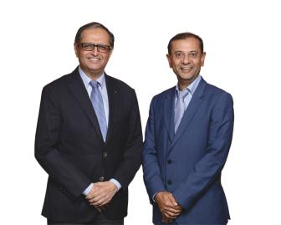

Our earnings numbers help tell that story. In 2023, we generated strong growth across both Analytcs and Digital Operatons and Solutons. Our 2023 revenue was

$1.63 billion, representng growth of 16% over 2022. We also grew adjusted EPS(1) to $1.43, up 19% from $1.20 in 2022.

Our ability to contnue executng at this high level, despite fast-moving changes in technology and market dynamics, is the result of sound executon, our diferentated strategy, our balanced portolio of businesses and our amazing team of more than 50,000 people commited to constant improvement. In 2023, we established an AI

Center of Excellence with 1,500 specialists. Our employees spent 1.3 million hours training through our democratzed self-learning platorm, with more than a quarter of our employees taking advantage of AI training and development tools and more than 57% of our employees partcipatng in digital skills training. We developed several generatve AI applicatons for internal use in areas such as employee self-service, recruitng and fnance, and embedded AI into our core solutons. We now have more than 150 AI use cases, with over 30 deployments in producton with go-live for 6 clients.

- Adjusted EPS is a non-GAAP fnancial measure. See “Non-GAAP Reconciliaton” later in this proxy statement.

 | EXL 2024 Proxy Statement | /

Table of Contents

This year’s Proxy Statement highlights contnued progress on our sustainability eforts, which contribute to our business success. We have installed solar power projects at several of our centers in India and also transitoned several centers in India and the UK to renewable energy through open access arrangements, which has helped reduce our Scope 2 greenhouse gas emissions. We have contnued our focus on diversity, equity and inclusion by developing diverse leadership and building an inclusive work culture where our employees are empowered to bring their authentc contributons, collaborate and drive innovaton. Making good on our commitment to not only run a world class business, but to also support our people and the communites in which we operate, we signifcantly increased our community engagement partcipaton: EXL employees contributed more than 37,000 volunteer hours as part of our community engagement eforts, up approximately 22,000 hours from the prior year, and more than 19,000 of our employees joined EXL-sponsored community engagement initatves, up from 7,000 partcipants in 2022.

We are proud of this progress, and the external recognitons we received for these eforts, including for the fourth year as one of America’s Most Responsible Companies by Newsweek and Statsta, Inc., for the third year as one of Barron’s 100 Most Sustainable Companies and a Gold ratng from EcoVadis. You can read more about our commitment to sustainability on our website, in our Sustainability Report and in the “Sustainability” secton of this Proxy Statement.

On behalf of the board of directors of ExlService Holdings, Inc., we are pleased to invite you to the 2024 Annual Meetng of Stockholders, which will be held on June 20, 2024. We look forward to sharing more about our company at the Annual Meetng. We encourage you to carefully read the atached 2024 Annual Meetng of Stockholders and Proxy Statement, which contains important informaton about the maters to be voted upon and instructons on how you can vote your shares.

Your vote is important to us. Please vote as soon as possible whether or not you plan to partcipate in the Annual Meetng.

The board of directors and management look forward to your atendance at the Annual Meetng.

Sincerely,
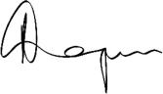
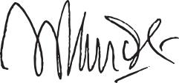

Rohit Kapoor

Chair and CEO

Vikram Pandit

Lead Director

/

EXL 2024 Proxy Statement

Table of Contents

Notce of 2024 Annual Meetng of Stockholders

Dear Stockholder:

You are cordially invited to the 2024 Annual Meetng of Stockholders of ExlService Holdings, Inc., a Delaware corporaton (the “Company”), for the purposes of votng on the following maters:

- the electon of eight members of the board of directors of the Company;

- the ratfcaton of the appointment of Deloite & Touche LLP as the independent registered public accountng frm of the Company for fscal year 2024;

- the approval, on a non-binding advisory basis, of the compensaton of the named executve ofcers of the Company;

- the approval of the Fourth Amended and Restated Certfcate of Incorporaton to provide for, among other things, ofcer exculpaton; and

- the transacton of such other business as may properly come before the Annual Meetng or any adjournment or postponement thereof.

We will hold our Annual Meetng in virtual format only, via live audio webcast (rather than at any physical locaton) on June 20, 2024 at 9:00 AM, Eastern Time. Our virtual meetng platorm will allow for full partcipaton as if you were atending physically. You or your proxyholder may partcipate, vote, and examine our stockholder list at the Annual Meetng by visitng www.virtualshareholdermeetng.com/EXLS2024 and using your 16-digit control number.

If you are a stockholder of record at the close of business on April 23, 2024, the record date for the Annual Meetng, you are enttled to vote at the Annual Meetng. A list of stockholders as of the record date will be available for examinaton for any purpose germane to the Annual Meetng, during ordinary business hours, at the Company’s executve ofces at 320 Park Avenue, 29th Floor, New York, New York 10022, for a period of 10 days prior to the date of the Annual Meetng. If our corporate headquarters are closed during the 10 days prior to the Annual Meetng, you may send a writen request to the Corporate Secretary at our corporate headquarters, and we will arrange a method for you to inspect the list.

Please note the technical requirements for virtual atendance at the Annual Meetng, as described in the enclosed Proxy Statement beginning on page 122 under the heading “Annual Meetng Q&A.”

Pursuant to rules promulgated by the Securites and Exchange Commission, we are providing access to our proxy materials over the Internet. On or about April 29, 2024, we will mail a Notce of Internet Availability of Proxy Materials (the “Internet Notce”) to each of our stockholders of record and benefcial owners at the close of business on the record date. On the date of mailing of the

Internet Notce, all stockholders and benefcial owners will have the ability to access all of the proxy materials on a website referred to in the Internet Notce. These proxy materials will be available free of charge.

Whether or not you expect to atend the Annual Meetng, the Company encourages you to promptly vote and submit your proxy (i) by Internet (by following the instructons provided in the Internet Notce), (ii) by phone (by following the instructons provided in

 | EXL 2024 Proxy Statement | /

Table of Contents

the Internet Notce) or (iii) by requestng that proxy materials be sent to you by mail that will include a proxy card that you can use to vote by completng, signing, datng and returning the proxy card in the prepaid postage envelope provided. Votng by proxy will not deprive you of the right to atend the Annual Meetng or to vote your shares. You can revoke a proxy at any tme before it is exercised by votng at the Annual Meetng, by delivering a subsequent proxy or by notfying the inspector of electons in writng of such revocaton prior to the Annual Meetng. YOUR SHARES CANNOT BE VOTED UNLESS YOU EITHER (I) VOTE BY USING THE INTERNET, (II) VOTE BY PHONE, (III) REQUEST PROXY MATERIALS BE SENT TO YOU BY MAIL AND THEN USE THE PROXY CARD PROVIDED BY MAIL TO CAST YOUR VOTE BY COMPLETING, SIGNING AND RETURNING THE PROXY CARD BY MAIL OR (IV) ATTEND THE ANNUAL MEETING AND VOTE.

By Order of the Board of Directors
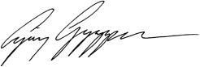

Ajay Ayyappan

Executve Vice President, General Counsel and Corporate Secretary

New York, New York

April 29, 2024

/
/ | EXL 2024 Proxy Statement

Table of Contents

2024 Proxy Statement

Table of contents

2024 Proxy Statement Summary |  |  |  |  |  |  |  |  |  |  |  |  |  |  |  |  |  |  |  | 1
Our board of directors |  |  |  |  |  |  |  |  |  |  |  |  |  |  |  |  |  |  |  | 13
Corporate governance |  |  |  |  |  |  |  |  |  |  |  |  |  |  |  |  |  |  |  | 25
Sustainability |  |  |  |  |  |  |  |  |  |  |  |  |  |  |  |  |  |  |  | 44
Our executve ofcers |  |  |  |  |  |  |  |  |  |  |  |  |  |  |  |  |  |  |  | 57
Executve compensaton |  |  |  |  |  |  |  |  |  |  |  |  |  |  |  |  |  |  |  | 60
 | Compensaton Discussion and Analysis |  |  |  |  |  |  |  |  |  |  |  |  |  |  |  |  |  |  | 60
 | Compensaton and Talent Management Commitee Report |  |  |  |  |  |  |  |  |  |  |  |  |  |  |  |  |  |  | 83
 | Summary compensaton table for fscal year 2023 |  |  |  |  |  |  |  |  |  |  |  |  |  |  |  |  |  |  | 84
Stock ownership of directors, executve ofcers and certain benefcial owners |  |  |  |  |  |  |  |  |  |  |  |  |  |  |  |  |  |  |  | 105
Certain relatonships and related person transactons |  |  |  |  |  |  |  |  |  |  |  |  |  |  |  |  |  |  |  | 107
Audit Commitee Report |  |  |  |  |  |  |  |  |  |  |  |  |  |  |  |  |  |  |  | 108
Proposal 1 — Electon of directors |  |  |  |  |  |  |  |  |  |  |  |  |  |  |  |  |  |  |  | 109
Proposal 2 — Ratfcaton of the appointment of independent registered public accountng frm |  |  |  |  |  |  |  |  |  |  |  |  |  |  |  |  |  |  |  | 111
Proposal 3 — Advisory (non-binding) vote to approve executve compensaton |  |  |  |  |  |  |  |  |  |  |  |  |  |  |  |  |  |  |  | 113
Proposal 4 — Fourth Amended and Restated Certfcate of Incorporaton to provide for, among other things, ofcer
 | exculpaton |  |  |  |  |  |  |  |  |  |  |  |  |  |  |  |  |  |  | 115
Miscellaneous |  |  |  |  |  |  |  |  |  |  |  |  |  |  |  |  |  |  |  | 118
Stockholder proposals and director nominatons for the 2025 Annual Meetng |  |  |  |  |  |  |  |  |  |  |  |  |  |  |  |  |  |  |  | 118
Non-GAAP Reconciliaton |  |  |  |  |  |  |  |  |  |  |  |  |  |  |  |  |  |  |  | 120
Annual Meetng Q&A |  |  |  |  |  |  |  |  |  |  |  |  |  |  |  |  |  |  |  | 122
Other maters |  |  |  |  |  |  |  |  |  |  |  |  |  |  |  |  |  |  |  | 127

 | EXL 2024 Proxy Statement | /

Table of Contents

2024 Proxy Statement summary

Summary

Below is a summary of select components of this Proxy Statement, including informaton regarding this year’s stockholder meetng, nominees for our board of directors, summary of our business, performance highlights and selectve executve compensaton informaton. This summary does not contain all of the informaton that you should consider prior to submitng your proxy, and you should review the entre Proxy Statement and our Annual Report on Form 10-K for the fscal year ended December 31, 2023 (the “2023 Form 10-K”). We refer to the fscal year ended December 31, 2023 as “fscal year 2023,” “fscal 2023,” and “2023.” Unless otherwise indicated, all prior period informaton has been adjusted to refect the 5-for-1 forward stock split of our common stock efected in August 2023.

Meetng agenda, votng maters and recommendatons*

Votng proposal item | Board vote recommendaton
1. Electon of directors | FOR the electon of each nominee
 | (pg. 109)
Required vote: Afrmatve vote of a majority of votes cast
2. Ratfcaton of appointment of independent | FOR (pg. 111)
registered public accountng frm

Required vote: Afrmatve vote of a majority of shares present in person or represented by proxy and enttled to vote

3. Advisory (non-binding) Say-on-Pay vote to FOR (pg. 113)
approve executve compensaton

Required vote: Afrmatve vote of a majority of shares present in person or represented by proxy and enttled to vote

4. Fourth Amended and Restated Certfcate of | FOR (pg. 115)
Incorporaton to provide for, among other things,
ofcer exculpaton

Required vote: Afrmatve vote of a majority of the outstanding shares of our common stock enttled to vote

- Virtual atendance at our Annual Meetng will consttute presence in person for purposes of quorum and votng at the Annual Meetng.

2024 Proxy Statement summary


Annual meetng informaton

Time and date:

9:00 AM (Eastern Time)
June 20, 2024

Record date:

April 23, 2024

Place:

Virtual format only via live audio webcast

Votng:

Stockholders as of the Record Date are enttled to vote


Votng methods

Internet (pre-meetng):

www.proxyvote.com

Mail:

Follow instructons on the Internet notce

Phone:

Call the number listed on the Internet notce

Electronically:

Atend the Annual Meetng and vote electronically

If you are the benefcial owner of shares held in the name of a brokerage, bank, trust or other nominee as a custodian (also referred to as shares held in “street name”), your broker, bank, trustee or nominee will provide you with materials and instructons for votng your shares. See page 123 for additonal details.

_{EXL 2024 Proxy Statement} _{/ 1}

Table of Contents

2024 Proxy Statement summary

Our business

We are a leading data analytcs and digital operatons and solutons company. We partner with clients using a data and AI-led approach to reinvent business models, drive beter business outcomes and unlock growth with speed. EXL harnesses the power of data, analytcs, artfcial intelligence (“AI”), and deep industry knowledge to transform operatons for the world’s leading corporatons in industries including insurance, healthcare, banking and fnancial services, media and retail, among others. EXL was founded in 1999 with the core values of innovaton, collaboraton, excellence, integrity and respect. We are headquartered in New York, and have approximately 54,000 employees as of December 31, 2023, spanning six contnents.

Company’s three year performance

 |  |  | Revenue (Year-over-year growth %)
Revenue by segment informaton ($ in millions) |  | 2021 YOY% |  | 2022 YOY% |  |  | 2023 YOY%
 | Insurance | $382.0 | 11.8% | $448.7 | 17.5% |  | $529.9 | 18.1%
Healthcare |  | 112.4 | 10.9% | 97.4 | -13.4% |  | 106.0 | 8.9%
Emerging Business |  | 167.2 | 9.5% | 218.6 | 30.7% |  | 265.7 | 21.5%
Analytcs |  | 460.7 | 27.0% | 647.3 | 40.5% |  | 729.1 | 12.6%
Consolidated |  | $1,112.3 | 17.1% | $1,412.0 | 25.8% |  | $1,630.7 | 15.5%

2 | / | EXL 2024 Proxy Statement

Table of Contents

2024 Proxy Statement summary
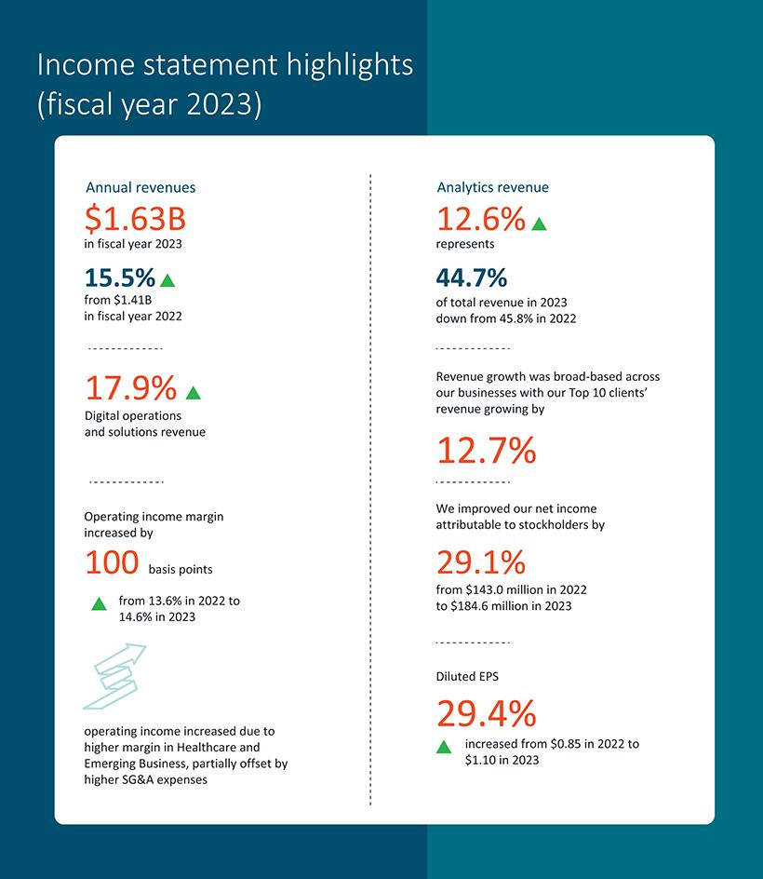

EXL 2024 Proxy Statement / 3

Table of Contents

2024 Proxy Statement summary
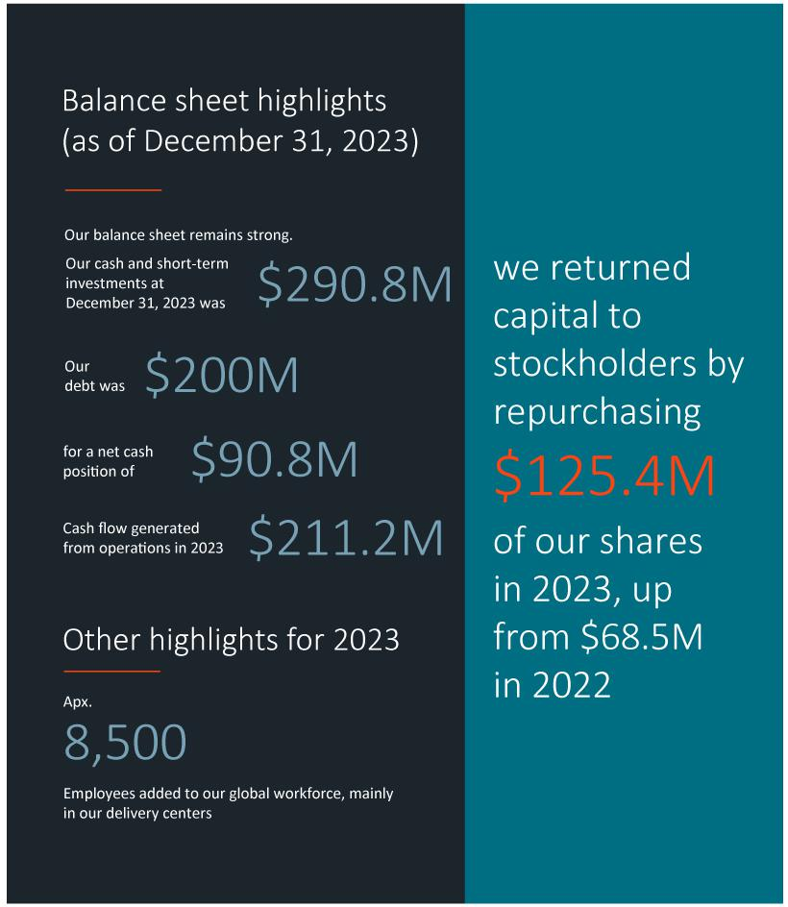

4 | / | EXL 2024 Proxy Statement

Table of Contents

2024 Proxy Statement summary

Total stockholder return

The graphs below compare our 1-year, 3-year and 5-year cumulatve total stockholder return (“TSR”) as of December 31, 2023 with the median TSR for companies comprising Nasdaq, S&P 600 and our peer group.

1-Year TSR 3-Year TSR 5-Year TSR
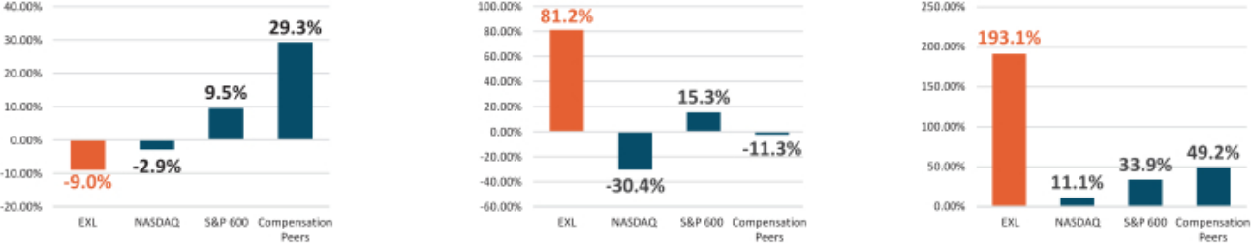

 | EXL 2024 Proxy Statement | / 5

Table of Contents

2024 Proxy Statement summary

Corporate governance highlights

The following informaton is based on our board profle immediately following our Annual Meetng (assuming the electon of our eight director nominees) and refects current board practces.
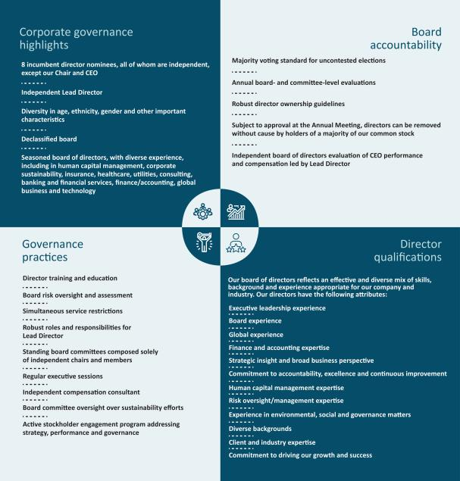

6 | / | EXL 2024 Proxy Statement

Table of Contents

2024 Proxy Statement summary

Nominees for electon as directors
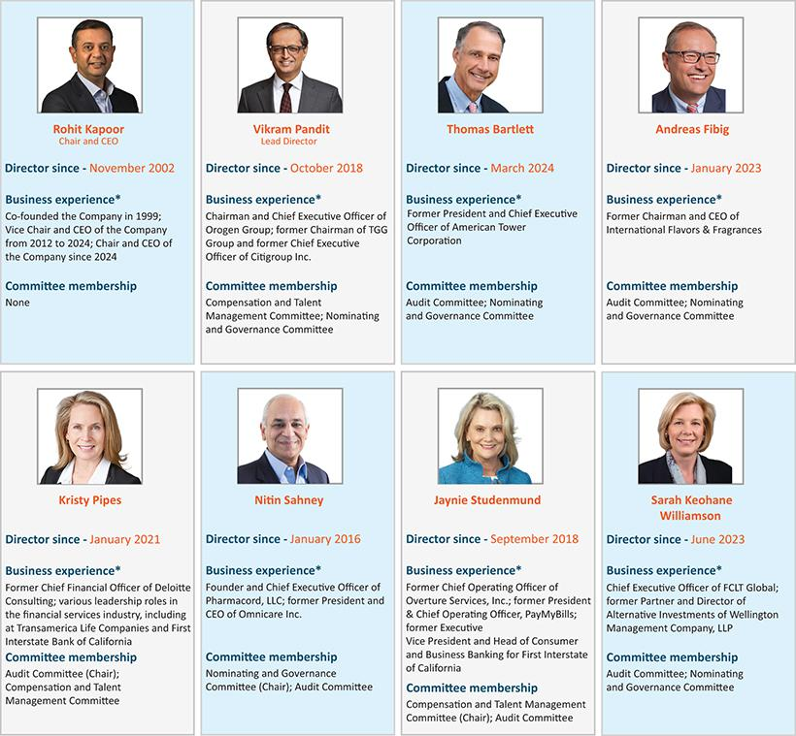

EXL 2024 Proxy Statement / 7

Table of Contents

2024 Proxy Statement summary

Director nominees - skills matrix

Our director nominees review and indicate whether they are experts in each of the skills and areas of experience listed below. An “expert,” for purpose of the skills set forth in this skill matrix, means an individual who, based on career experience (other than as an EXL director), has developed and contnues to maintain comprehensive knowledge and command over the subject mater, including relevant updates. Defnitons for each of these skills, as well as a descripton for how these are considered for candidates for directors, can be found under “Director Qualifcatons” beginning on page 29 of this Proxy Statement.

 | Finance |  | Public |  |  | Digital |  |  | Risk | Informaton |  | Mergers
 | and | Executve | company |  | Human capital | operatons |  | Global | oversight and | and cyber |  | and
 | accountng | leadership | governance | Analytcs | management | and solutons | Marketng | experience | management | security | ESG | acquisitons
Rohit Kapoor | ✓ | ✓ | ✓ | ✓ | ✓ | ✓ | ✓ | ✓ | ✓ |  |  | ✓
Vikram Pandit | ✓ | ✓ | ✓ | ✓ | ✓ | ✓ |  | ✓ |  |  |  | ✓
Thomas Bartlet | ✓ | ✓ | ✓ |  | ✓ | ✓ |  | ✓ | ✓ |  |  | ✓
Andreas Fibig |  | ✓ | ✓ |  | ✓ |  | ✓ | ✓ |  |  | ✓ | ✓
Kristy Pipes | ✓ | ✓ | ✓ | ✓ | ✓ |  |  | ✓ | ✓ | ✓
Nitn Sahney | ✓ | ✓ | ✓ |  |  |  |  |  |  |  |  | ✓
Jaynie Studenmund | ✓ | ✓ | ✓ | ✓ | ✓ | ✓ | ✓ | ✓ | ✓ |  | ✓ | ✓
Sarah K. Williamson | ✓ | ✓ | ✓ |  |  |  |  | ✓ | ✓ |  | ✓ | ✓

8 | / | EXL 2024 Proxy Statement

Table of Contents

2024 Proxy Statement summary

Board statstcs*

Board tenure
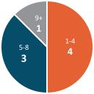

Gender diversity
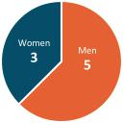

Racial and ethnic diversity
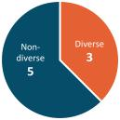

Age distributon
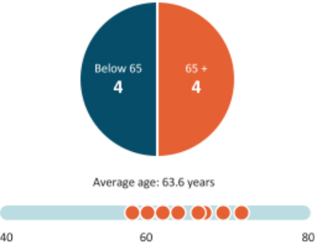

Board independence
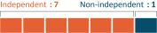

* Following our Annual Meetng, assuming electon of all nominees

 | EXL 2024 Proxy Statement | / 9

Table of Contents

2024 Proxy Statement summary

Our purpose and core values
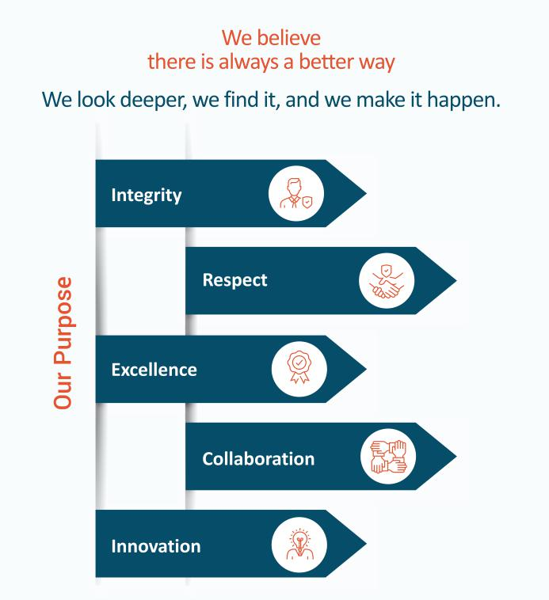

10 | /
10 | / | EXL 2024 Proxy Statement

Table of Contents

2024 Proxy Statement summary

Sustainability

At EXL, we believe that there is always a beter way; we look deeper, fnd it, and make it happen. This purpose informs our corporate culture, which, in turn, is rooted in our fve core values. In line with our purpose, values and culture, we are commited to fnding a beter way through sustainability initatves that are aligned with our long-term corporate strategy and designed to beneft our stockholders, clients, employees, communites and manage expectatons and commitments across various stakeholder groups. See “Sustainability” beginning on page 44 below for more details on our recent accomplishments in sustainability.
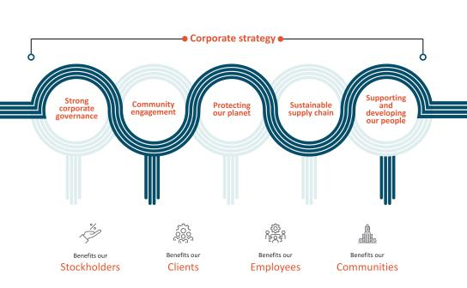

Compensaton Overview

- Compensaton philosophy: Our executve compensaton philosophy is focused on pay-for-performance.

- Over 98% Say-on-Pay approval of 2022 compensaton: At our 2023 Annual Meetng of Stockholders, our stockholders approved, on a non-binding advisory basis, the compensaton paid to our named executve ofcers for fscal year 2022. Over 98% of the votes present in person or by proxy (excluding broker non-votes) voted in favor of fscal year 2022 compensaton.

- Annual incentve program: Our annual incentve program contnued to use the same, formulaic performance criteria for 2023 as it has been using for several years, which includes:

–Company-wide metrics (75%)—Revenue and adjusted operatng proft margin (“AOPM”)

–Individual metrics (25%)—Linked to areas of performance that are specifc to each executve

- In 2023, we achieved 100.6% of our revenue performance target, and 101.4% of our AOPM target resultng in annual incentve payout calculatons for our named executve ofcers, ranging from 113% of target performance to 133% of target performance.

 | EXL 2024 Proxy Statement | / 11

Table of Contents

2024 Proxy Statement summary

- Long-term equity incentve program: We also contnued our equity incentve program, which in 2023 included grantng a balanced mix of tme-vested restricted stock units and performance-based restricted stock units to all of our named executve ofcers. The performance-based restricted stock units were comprised of relatve total stockholder return-linked restricted stock units and revenue-linked restricted stock units.

- In 2023, we also granted one-tme stock optons to all the members of our Executve Commitee (which includes our named executve ofcers), except for our Chair and CEO.

- This was the third and fnal performance year for the performance-based restricted stock units granted in 2021, which were linked to the Company’s TSR performance relatve to a peer group. The Company’s TSR performance was at the 96th percentle among its peer group, resultng in the executves earning 200% of the target funding of those grants.

- Compensaton Policies. Our compensaton program is designed to refect appropriate governance practces aligned with the needs of our business, and includes, among others, the following features: robust clawback policy; robust stock ownership guidelines; limited perquisites; no excise tax gross-ups; and an ant-hedging and ant-pledging policy. See “Executve compensaton program, practces and policies” beginning on page 65 below.

Compensaton mix

Chair & CEO | NEO compensaton mix
compensaton mix | (Excluding Chair & CEO)
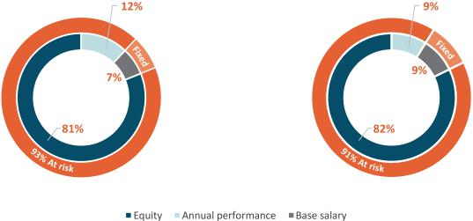

* Base salary also includes items included in “All Other Compensaton” in the Summary Compensaton Table on page 84.

12 | /
12 | / | EXL 2024 Proxy Statement

Table of Contents

Our board of directors

Our board of directors

Our board of directors currently consists of nine directors (including our eight director nominees, and one of our directors who currently serves on the board, but will not stand for re-electon) with diverse experience, including in analytcs, digital operatons and solutons, client industries, informaton and cybersecurity, human capital management, sustainability, and fnance and accountng, among others.
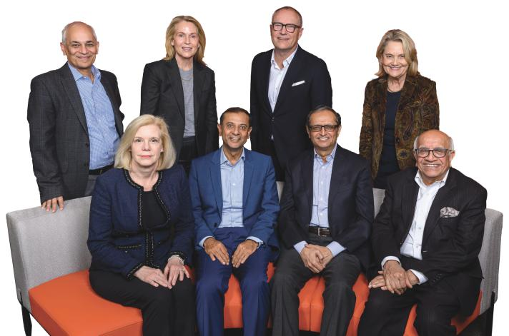

From top lef: Nitn Sahney (Independent Director and Nominatng and Governance Commitee Chair), Kristy Pipes (Independent Director and Audit Commitee Chair), Andreas Fibig (Independent Director) Jaynie Studenmund, (Independent Director and Compensaton and Talent Management Commitee Chair)

From botom lef: Sarah K. Williamson, (Independent Director) , Rohit Kapoor (Chair and CEO), Vikram Pandit (Lead Director), Som Mital* (Independent

Director). Not pictured: Thomas Bartlet (Independent Director)

* Not standing for re-electon

 | EXL 2024 Proxy Statement | / 13

Table of Contents

Our board of directors

Board diversity matrix

2024 Board diversity matrix (as of April 29, 2024)*

Total number of directors: |  | 9
 | Female | Male
Part I: Gender identty
Directors | 3 | 6
Part II: Demographic background
Asian | — | 4
White (other than Middle Eastern) | 3 | 2

* Includes our nine current directors, including our eight nominees for electon at the Annual Meetng.

2023 Board diversity matrix (as of April 29, 2023)

Total number of directors: |  | 9
 | Female | Male
Part I: Gender identty
Directors | 3 | 6
Part II: Demographic background
Asian | — | 4
White (other than Middle Eastern) | 3 | 2
14 / EXL 2024 Proxy Statement

Table of Contents

Our board of directors

Director nominees for electon at the Annual Meetng

Upon the recommendaton of our Nominatng and Governance Commitee, we are pleased to propose eight of our existng directors as nominees for electon as directors at the Annual Meetng. As previously disclosed, one of our current directors, Mr. Mital, will not be standing for re-electon at the Annual Meetng; the remaining eight directors are our director nominees at the Annual Meetng.

The following tables provide a summary of our board compositon by tenure, age, gender and independence immediately afer our Annual Meetng (assuming the electon of all nominees).

Board tenure Age distributon Gender diversity Board independence
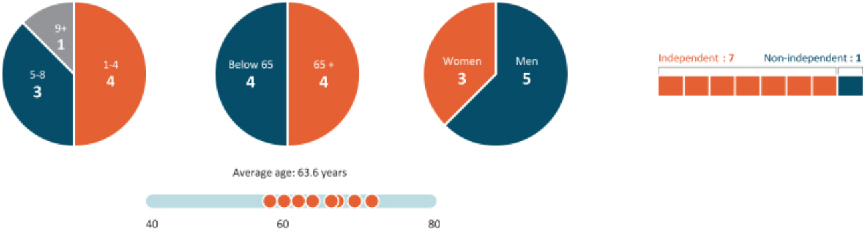

* Following our Annual Meetng, assuming electon of all nominees

 | EXL 2024 Proxy Statement | / 15

Table of Contents

Our board of directors

Our nominees for electon as directors at the Annual Meetng are as follows:


Rohit Kapoor

Vikram Pandit

Chair and CEO


Lead Director



Thomas Bartlet

Independent Director


Andreas Fibig

Independent Director


Kristy Pipes | Nitn Sahney
Independent Director and Chair of the Audit | Independent Director and Chair of the
Commitee | Nominatng and Governance Commitee
 | Sarah K. Williamson
Jaynie Studenmund | Independent Director
Independent Director and Chair of the
Compensaton and Talent Management Commitee


We believe that our director nominees, individually and together as a whole, possess the requisite skills, experience and qualifcatons necessary to maintain an efectve board to serve the best interests of the Company and its stockholders described below under “Director qualifcatons” beginning on page 29.

16 | / | EXL 2024 Proxy Statement

Table of Contents

Our board of directors

The name, age (as of the date of this Proxy Statement), principal occupaton and other informaton, including the specifc experience, qualifcatons, atributes or skills that led to the conclusion that such person should serve as a director of the Company, with respect to each of the nominees, are set forth below. There are no family relatonships among any of our directors or executve ofcers.

Nominees for electon at the Annual Meetng - Biographical informaton

Rohit Kapoor

Director since November 2002 | Chair (since 2024) and CEO (since 2008) Non-independent


SKILLS
Finance
and accountng
Executve
leadership
(within the last 5 years)
Public company
governance
Analytcs

Age: 59 — co-founded EXL in April 1999 and has served as our Chair and CEO since April 2024, and previously our Vice Chair and CEO since April 2012 and as a director since November 2002. He previously served as our President and CEO from May 2008 to March 2012. Mr. Kapoor’s business experience, skills and directorships are detailed below. The Company has concluded that, in connecton with Mr. Kapoor’s experience as a founder and current role as CEO of the Company, Mr. Kapoor should serve as a director.

Commitees: N/A

Business experience at the Company

• Chair and CEO (2024 - present)

• Vice Chair and CEO (2012 - 2024)

• President and CEO (2008 - 2012)

• Various senior leadership roles, including CFO and COO (2000 - 2008)

Other business experience

• Business head, Deutsche Bank, a fnancial services provider (1999 - 2000)

• Various capacites at Bank of America in the United States and Asia, including India (1991 - 1999)

Human capital
management

Digital operatons and
solutons

Marketng

Global
experience

Risk oversight and
management

Mergers and
acquisitons

Other relevant experience

• Lead independent director, director and member of the audit commitee, CA Technologies, Inc. (NASDAQ: CA), a
sofware services company (2011 - 2018)

• Member, Board of Directors, American India Foundaton (AIF)

• Member, Board of Directors, Pratham (Tristate Chapter)

 | EXL 2024 Proxy Statement | / 17

Table of Contents

Our board of directors

Vikram S. Pandit

Director since October 2018 | Lead Director since 2024 (Chair of Board from 2022 - 2024) Independent


Age: 67 — is Chairman and Chief Executve Ofcer of The Orogen Group, which makes signifcant long-term strategic investments in fnancial services companies and related businesses. Mr. Pandit’s business experience, skills and directorships are detailed below. The Company has concluded, based in part on Mr. Pandit’s more than 30 years of experience in the fnancial services industry, including his experience as Chief Executve Ofcer, and a member of the board of directors, of Citgroup Inc. (NYSE: C), that Mr. Pandit should serve as a director.

Commitees:

• Compensaton and Talent Management; Nominatng and Governance

Business experience
SKILLS

Finance
and accountng

Executve
leadership

(within the last 5 years)

• Chairman and Chief Executve Ofcer, The Orogen Group LLC (July 2016 - present)

• Chairman, TGG Group (February 2014 - June 2016)

• Chief Executve Ofcer, Citgroup Inc. (December 2007 - October 2012)

Public directorships during past fve years

Public company

governance

• Director and member of the nominatng and governance and fnance commitees, Virtusa Corporaton (NASDAQ: VRTU) (2017
- 2021)

Analytcs

• Lead Independent Director, chair of the human resources and compensaton commitee and member of the corporate

governance and nominatng commitee, former member of the audit commitee, Bombardier Inc. (TSX: BBD) (2014 - 2021)

Human capital
management

- Digital operatons and solutons

Global
experience

Mergers and acquisitons

Other relevant experience

• Director, Citgroup Inc. (December 2007 - October 2012)

• Director, Fair Square Financial Holdings (2017 - 2021)

• Director, Westcor Land Title Insurance Company (2020 - present)

• Chairman, JM Financial Credit Solutons Ltd. (2014 - present)

• Member of the Board of Overseers of Columbia Business School

• Member of the Board of Visitors of Columbia School of Engineering and Applied Science

18 | / | EXL 2024 Proxy Statement

Table of Contents

Our board of directors

Thomas Bartlet

Director since March 2024 Independent


SKILLS

- Finance

and accountng

- Executve leadership

(within the last 5 years) Public company
governance

Human capital
management

Digital operatons and solutons

- Global experience

- Risk oversight and management

- Mergers and acquisitons

Age: 66 — is a seasoned business executve with extensive experience in technology and management of real estate.

Mr. Bartlet’s business experience, skills and directorships are detailed below. The Company has concluded, based in part on Mr. Bartlet’s experience as the former Chief Executve Ofcer of American Tower Corporaton, as well as his prior executve experience at Verizon Communicatons, that Mr. Bartlet should serve as a director.

Commitees:

• Audit*; Nominatng and Governance

Business experience

• Former Chief Executve Ofcer of American Tower Corporaton (2020-2023); Executve vice president and chief fnancial ofcer
(2009-2020); Treasurer (July 2017-Nov. 2018, 2012-2013)

• Various operatons and business development roles with predecessor companies and afliates, including most recently senior
vice president and corporate controller, Verizon Communicatons (1984-2009)

• Began career at Deloite, Haskins & Sells

Public directorships during past fve years

• Director and member of the audit commitee and the compensaton commitee, Ots Worldwide Corporaton (NYSE: OTIS)
(2023-present)

• Director and member of the audit commitee and chair of the fnance commitee, Equinix, Inc. (Nasdaq: EQIX) (2013-2021)

• Director, American Tower Corporaton (NYSE: AMT) (2020-2024)

Other relevant experience

• Member, Board of Advisors of the Rutgers Business School

• Member, Samaritans Advisory Council

• Former member, Business Roundtable

• Former member, Massachusets Insttute of Technology Presidental CEO Advisory Board

• Former member, World Economic Forum’s Informaton and Communicatons Technology Board of Governors

• Former member, Natonal Associaton of Real Estate Investment Trust (NAREIT) Executve Commitee

* Audit commitee fnancial expert under applicable SEC rules and regulatons.

 | EXL 2024 Proxy Statement | / 19

Table of Contents

Our board of directors

Andreas Fibig

Director since January 2023 independent


Age: 62 — is a leader in the biosciences, healthcare and pharmaceutcal industries. Mr. Fibig’s business experience, skills and directorships are detailed below. The Company has concluded, based in part on Mr. Fibig’s experience as Chairman and CEO of Internatonal Flavors & Fragrance, Inc. and his expertse from over 25 years in the biosciences, healthcare and the pharmaceutcal industries, as well as in ESG, that Mr. Fibig should serve as a director.

Commitees:

• Audit; Nominatng and Governance Commitee

Business experience

• Chairman and Chief Executve Ofcer, Internatonal Flavors & Fragrances, Inc., a food ingredients, beverage, scent, healthcare
SKILLS |  | and biosciences company (2014 - 2022)

- Executve leadership
(within the last 5 years) Public company

- governance Human capital
management

Marketng

Global

experience

ESG

Mergers and acquisitons

• President and Chairman of the Board of Management, Bayer Healthcare Pharmaceutcals, LLC a global pharmaceutcal
company (2008 - 2014)

• Senior Vice President/General Manager and various leadership positons, Pfzer, Inc., a multnatonal pharmaceutcal and
biotechnology company (2000 - 2008))

Public directorships during past fve years

• Director, Internatonal Flavors & Fragrances, Inc. (2011 - 2022, Chairman from 2014 - 2022)

• Independent director and member of the research and development commitee, former member of the audit commitee,
Novo-Nordisk A/S (NYSE: NVO), a global healthcare company (2018 - present)

• Independent director and member of the audit commitee and fnance and risk policy commitee, Bunge Limited (NYSE: BG), a
global agribusiness and food company (2016 - 2018)

Other relevant experience

• Chairman, Simtra (formerly Baxter Bioscience), a pharmaceutcal contract development and manufacturing organizaton
(2023 - present)

• Director, Indigo Agriculture, an agricultural technology company (2022 - present)

• Director, EvodiaBio, a bioindustrial aroma company (2022 - present)

20 / | EXL 2024 Proxy Statement

Table of Contents

Our board of directors

Kristy Pipes

Director since January 2021 independent


Age: 65 — is a leader in the professional services industry. Ms. Pipes’s business experience, skills and directorships are detailed below. The Company has concluded, based in part on Ms. Pipes’s experience as the Chief Financial Ofcer and as a member of the Management Commitee of Deloite Consultng, LLP and her expertse in the consultng and fnancial services industry that Ms. Pipes should serve as a director.

Commitees:

• Audit (Chair)*; Compensaton and Talent Management

Business experience
 | SKILLS
 | SKILLS |  | • | Chief Financial Ofcer, member of the Management Commitee and various leadership positons, Deloite Consultng LLP, a
 | Finance |  | •
 | Finance |  |  | management consultng frm (1999 - 2019)
 | and accountng |  |  | management consultng frm (1999 - 2019)
 |  |  | • | Vice President and Manager, Finance Division, Transamerica Life Companies (1997 - 1999)
 | Executve
 | Executve |  | • | Senior Vice President and Chief of Staf for the President and CEO, among other senior management positons, First Interstate
 | leadership |  | •
 |  |  |  | Bank of California (1985 - 1996)

Public company

governance

Public directorships during past fve years

- Analytcs

• Director and chair of the audit commitee, and member of the nominatng, governance and sustainability commitee, Public Storage (NYSE: PSA), an internatonal self storage company
(2020 - present)

Human capital
management

Global
experience

Risk oversight and
management

Informaton and
cybersecurity

• Director and chair of the audit commitee, AECOM (NYSE: ACM), an internatonal infrastructure consultng frm (2022 - present)

• Director and member of the nominatng, governance, and sustainability commitee, Savers Value Village (NYSE: SVV) one of the
world’s largest thrif retailers (2023 - present)

• Director and chair of the audit commitee, and member of the nominatng/corporate governance commitee, PS Business Parks,
Inc. (NYSE: PSB), a commercial property real estate investment trust (2019 - 2022)

* Audit commitee fnancial expert under applicable SEC rules and regulatons.

 | EXL 2024 Proxy Statement | / 21

Table of Contents

Our board of directors

Nitn Sahney

Director since January 2016 Independent


SKILLS

Finance

and accountng

Executve

leadership

(within the last 5 years)

Public company

governance

Mergers and

acquisitons

Age: 61 — Is a leader in the healthcare industry with over 25 years of experience across all areas of healthcare. Mr. Sahney’s business experience, skills and directorships are detailed below. The Company has concluded, based in part on Mr. Sahney’s experience as CEO of PharmaCord and Omnicare, Inc. and his expertse in the healthcare industry garnered from more than two decades of experience, that Mr. Sahney should serve as a director.

Commitees:

• Nominatng and Governance (Chair); Audit

Business experience

• Founder, Member-Manager and Chief Executve Ofcer, PharmaCord, LLC, a company that helps biopharma manufacturers
address product access hurdles (2016 - present)

• Operatng Advisor, Clayton Dubilier & Rice Funds, a private equity frm (2016 - 2017)

• President and CEO (2014 - 2015) and President and COO (2012 - 2014) of Omnicare Inc., a former New York Stock Exchange-
listed Fortune 500 company in the long-term care and specialty care industries

• Manager of a healthcare investment fund (2008 - 2010)

• Founder and CEO of RxCrossroads, a specialty pharmaceutcal company (2001 - 2007)

• Prior leadership positons with Cardinal Healthcare, a global healthcare services and products company

Public directorships during past fve years

• Director and member of the audit commitee and the nominatng and governance commitee, Opton Care Health, Inc. (NASDAQ: OPCH) (2019 - 2023)

Other relevant experience

• Member of the Board of Trustees, University of Louisville (2016 - 2019)

22 | / | EXL 2024 Proxy Statement

Table of Contents

Our board of directors

Jaynie Studenmund

Director since September 2018 independent


Age: 69 — is a seasoned executve with signifcant experience as a top line executve leading fnancial services and digital companies. She also has extensive experience as a public company director. Ms. Studenmund’s business experience, skills and directorships are detailed below. The Company has concluded, based in part on Ms. Studenmund’s extensive public company board experience, together with her knowledge and experience in the digital, fnancial services, health care and consumer business sectors, and her expertse in compensaton and corporate governance, that Ms. Studenmund should serve as a director.

Commitees:

• Compensaton and Talent Management (Chair), Audit*

SKILLS

Finance
and accountng

Executve
leadership

Business experience

• Chief Operatng Ofcer, Overture Services, a pioneer in paid search and search engine marketng
(2001 - 2004)

• President & Chief Operatng Ofcer, PayMyBills, the leading consumer bill payment and presentment company (1999 - 2001)

Public company

governance

Analytcs

Human capital

management

Digital operatons

and solutons

Marketng

Global

experience

Risk oversight and management

ESG

Mergers and

acquisitons

• Previously for over two decades served as Executve Vice President and Head of Consumer and Business Banking for three of
the naton’s largest banks at the tme and primarily for First Interstate of California. Today, these three banks form the
backbone of Chase’s and Wells Fargo’s consumer business in California following the era of bank consolidaton.

• Management Consultant, Booz, Allen & Hamilton

Public directorships during past fve years

• Director and chair of the compensaton commitee and member of the risk management commitee, Pacifc Premier Bancorp
(Nasdaq: PPBI), a top performing regional bank (2019 -present)

• Director and member of the contracts commitee, audit commitee and nominaton and governance commitee, Western
Asset Management funds, a major global fxed income fund, and director of afliated funds for Western Asset Management
(2004 - present)

• Director and chair of the compensaton commitee and member of the nominatng and governance commitee, CoreLogic, Inc.
(NYSE: CLGX) untl its acquisiton in 2021 (2012 -2021)

Other relevant experience

• Director, compensaton commitee chair and member of the compliance commitee, Pinnacle Entertainment (Nasdaq: PNK)
untl its acquisiton in 2018 (2012 - 2018)

• Member of the Natonal Associaton of Corporate Directors (“NACD”) Directorship 100, 2021, as one of the top public
company directors in the U.S.; Named to Women Inc.’s 2019 Most Infuental Corporate Directors listng

• Board chair emeritus and life trustee, Huntngton Health, an afliate of Cedars Sinai Health

• Trustee and board member, and member of the fnance, audit and compensaton commitees, J. Paul Gety Trust

* Audit commitee fnancial expert under applicable SEC rules and regulatons.

 | EXL 2024 Proxy Statement | / 23

Table of Contents

Our board of directors

Sarah K. Williamson

Director since June 2023 Independent


SKILLS

Finance

and accountng

Executve

leadership

(within the last 5 years)

Age: 60 — is a leader in the global fnancial services and investment industries. Ms. Williamson’s business experience, skills and directorships are detailed below. The Company has concluded, based in part on Ms. Williamson’s experience as the Chief Executve Ofcer of FCLTGlobal, as well as her prior experience at Wellington Management Company, LLP and her expertse in the global fnancial services and investment industries, that Ms. Williamson should serve as a director.

Commitees:

• Audit*; Nominatng and Governance

Business experience

• Chief Executve Ofcer, FCLTGlobal, a not-for-proft organizaton dedicated to encouraging long-term behaviors in business and
investment decision-making (2016 - present)

• Partner, Global Director of Alternatve Investments, among other senior positons, Wellington Management Company LLP, a
private independent investment management frm (1995 - 2016)

• Senior Consultant, McKinsey & Company (1989-1994)

Public company

governance

Global

experience

Public directorships during past fve years

• Director and member of the audit commitee and the compensaton commitee, Evercore (NYSE: EVR), a public investment bank (2018 - present)

Risk oversight and management

ESG

Other relevant experience

• Board chair, Whitehead Insttute for Biomedical Research, a non-proft research insttuton at the Massachusets Insttute of
Technology

• Member of the board, MITIMCo, the Massachusets Insttute of Technology Investment Management Company

Mergers and
acquisitons

• Member of the board, Women’s Foundaton of Boston

• Member, Council on Foreign Relatons, an independent American think tank focused on internatonal relatons and U.S. foreign
policy

* Audit commitee fnancial expert under applicable SEC rules and regulatons.

24 | / | EXL 2024 Proxy Statement

Table of Contents

Corporate governance

Corporate governance

Director independence

In determining director independence, the board of directors considered the transactons and relatonships set forth below under “Certain Relatonships and Related Person Transactons—Related Party Transactons” and routne service arrangements between the Company and Westcor Land Title Insurance Company (“Westcor”). During 2023, one of our directors, Mr. Pandit, served as a non-executve director and, through his ownership in The Orogen Group (see below for informaton on Mr. Pandit’s relatonship with The Orogen Group), owned an immaterial indirect equity interest, in Westcor. Mr. Pandit is not, and was not during 2023, a partner, controlling shareholder or executve ofcer of Westcor.

Based on its review of all applicable relatonships, our board of directors has determined that all of the members on our board of directors, other than Mr. Kapoor, meet the independence requirements of the Nasdaq Stock Market and federal securites laws.

Meetng atendance

We expect our directors to atend all board meetngs and meetngs of commitees on which they serve. We also expect our directors to spend sufcient tme and meet as frequently as necessary to discharge their responsibilites properly. It is our policy that all of our directors standing for electon should atend our Annual Meetngs of Stockholders absent exceptonal cause.

Incumbent director meetng atendance
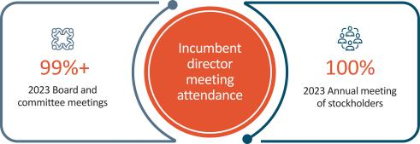

Board and Commitee meetngs in 2023


EXL 2024 Proxy Statement / 25

Table of Contents

Corporate governance

Corporate governance framework

Our board is responsible for providing governance and oversight over the efectveness of policy and decision-making with respect to the strategy, operatons and management of EXL, in order to enhance our fnancial performance and stockholder value over the long term.

Our board’s commitment to strong corporate governance is informed by the fve core values of our corporate culture: innovaton, respect, integrity, excellence and collaboraton. Our board seeks to maintain best practces in corporate governance by reviewing and updatng our governance policies, as appropriate, at least annually, and provides oversight over our risk management and strategic planning as relates to our growth, human capital management, and sustainability maters, each as discussed further below.


Governance policies

Our Corporate Governance Guidelines and other governance policies, including our commitee charters and Code of Conduct and Ethics, codify our corporate governance framework.

The Corporate Governance Guidelines address board responsibilites and conduct, director qualifcatons and membership maters, director orientaton and contnuing educaton, board and commitee meetngs, and stock ownership by non-management directors, among other topics.

Our commitee charters specifcally set out the authority and responsibilites of the commitees of the board.

Our Code of Conduct and Ethics is applicable to our directors, ofcers and full and part-tme employees, and anyone who works on EXL’s behalf, including suppliers, subcontractors and partners, and details how they should conduct themselves when dealing with fellow employees, clients, suppliers, partners, compettors and the general public. Our Code of Conduct and Ethics is reviewed at least annually by the Audit Commitee and audited periodically as part of our compliance and legal audits. Our personnel receive periodic training on the Code and we conduct voluntary anonymous surveys to gauge our employees’ knowledge, understanding and sentment with respect to our ethical culture. We encourage a “speak up” culture and provide many avenues for our employees to raise concerns and ask questons. We are commited to identfying potental compliance issues as early as possible and investgatng and remediatng them promptly. Our Corporate Governance Guidelines, commitee charters, and other corporate governance policies are all available on our website at htps://ir.exlservice.com/corporate-governance.

26 | / | EXL 2024 Proxy Statement

Table of Contents

 |  |  |  |  |  |  | Corporate governance
Beyond the board room
 |  |  | Director onboarding |  |  |  | Director contnuing educaton
 |  |  | All new directors partcipate in an |  |  |  | We encourage our directors to partcipate in director
 |  |  | orientaton program shortly afer |  |  |  | contnuing educaton (“DCE”):
 |  |  | their electon or appointment, which |  |  |  | • We provide reimbursements for partcipaton in DCE
 |  |  | is overseen by the Nominatng and
 |  |  | Governance Commitee. New |  |  |  | courses
 |  |  | directors |  |  |  | • We provide reimbursement for partcipaton in DCE courses.
 |  |  | partcipate in site visits and presentatons by
 |  |  | senior management. By the end of orientaton, |  |  |  | • We maintain a subscripton for our directors with the NACD and our
 |  |  | our new directors are familiar with our:
 |  |  |  |  |  |  | directors actvely take part in NACD oferings. For example, Ms.
 |  |  |  |  |  |  | Studenmund is on an NACD Southern California special commitee
 |  | • strategic and business plans
 |  |  |  |  |  |  | that meets regularly to discuss compensaton commitee maters.
 |  | • signifcant fnancial, accountng and risk
 |  |  |  |  |  |  | • We provide regular updates to our directors on corporate governance
 |  |  | management maters
 |  |  | • compliance programs, and |  |  |  | and ESG maters, executve compensaton developments and trends,
 |  |  |  |  |  |  | accountng standards changes, risk management maters and other
 |  |  | • corporate governance framework.
 |  |  |  |  |  |  | legal and other topics of interest from a variety of internal and
 |  |  |  |  |  |  | external sources.
 |  |  | Employee engagement |  |  |  | Our directors are actve DCE partcipants: For example, in 2023, Ms. Pipes:
 |  |  |  |  |  |  | • atended an NACD forum on resiliency and risk,
 |  |  | Our directors are generally invited to
 |  |  | visit any EXL ofce and have complete |  |  |  | • partcipated in over 90 hours of courses and trainings on AI, audit
 |  |  | and open access to our management
 |  |  |  |  |  |  | commitee efectveness, cybersecurity and ESG, among other topics,
 |  |  | and employees.
 |  |  |  |  |  |  | and
 |  |  | They also take part in EXL company initatves in |  |  |  | • received an NACD Cybersecurity certfcaton following her
 |  |  |  |  |  |  | partcipaton in the NACD’s course on Cybersecurity led by Carnegie
 |  |  | which they can engage with our employees,
 |  |  |  |  |  |  | Mellon University.
 |  |  | stakeholders and community members directly.
 |  |  | For example: |  |  |  | In 2023, while visitng our India ofces, our directors had the opportunity to
 |  |  | • In 2023, our directors had several
 |  |  |  |  |  |  | meet with NASSCOM leadership to discuss a wide range of industry-related
 |  |  | opportunites to engage directly with our
 |  |  |  |  |  |  | topics.
 |  |  | employees, including through partcipatng
 |  |  | in an employee townhall in our Gurgaon and |  |  |  | In additon, Ms. Williamson atended the Stanford University Directors’
 |  |  | Noida, India centers, and through Mses.
 |  |  |  |  |  |  | College in June 2023.
 |  |  | Pipes, Studenmund and Williamson |  |  |  | Certain of our directors are also involved in industry-level or general
 |  |  | partcipatng in a freside chat for senior |  |  |  | governance maters. For example:
 |  |  | women employees.
 |  |  |  |  |  |  | • Ms. Williamson’s work as the CEO of FCLTGlobal involves assistng the
 |  |  | • In January 2024, Ms. Williamson
 |  |  |  |  |  |  | boards of directors of its member companies with governance maters
 |  |  | partcipated in a virtual conference ttled |  |  |  | and investor-corporate engagement, among others.
 |  |  | “Diversity and Innovaton: A powerful |  |  |  | • Mr. Mital is the former president and chairman of the Natonal
 |  |  | connecton” with over 500 EXL
 |  |  | employees as part of our Women@EXL |  |  |  | Associaton of Sofware and Service Companies (“NASSCOM”), an
 |  |  |  |  |  |  | Indian trade associaton and governance group focused on the
 |  |  | Talks Series. See “Diversity, equity and
 |  |  | inclusion” on page 49 of this Proxy |  |  |  | informaton technology and business process outsourcing industry, in
 |  |  | Statement for more informaton on our |  |  |  | which we, and many of our U.S. peer companies with operatons in
 |  |  |  |  |  |  | India, are members. He advises NASSCOM on best practces for
 |  |  | Women@EXL employee resource group.
 |  |  |  |  |  |  | corporate governance and is currently assistng NASSCOM in the
 |  |  |  |  |  |  | development of data privacy legislaton in India.


Kristy Pipes

Sarah K. Williamson

Som Mital

Jaynie Studenmund

Independent director

Independent director

Independent director

Independent director

 | EXL 2024 Proxy Statement | / 27

Table of Contents

Corporate governance

Board leadership structure

Our board of directors is currently led by Rohit Kapoor, our Chair and CEO, and Vikram Pandit, our Lead Director. Our Chair and CEO, a non-independent director, was appointed to his current Chair role in April 2024, at which tme Mr. Pandit, an independent director and our former Chair, was appointed Lead Director. In recent years, including in 2023, our board has updated and strengthened the role of the Lead Director to include the functons and responsibilites listed below.


Rohit Kapoor

Chair and CEO

Vikram Pandit

Lead Director
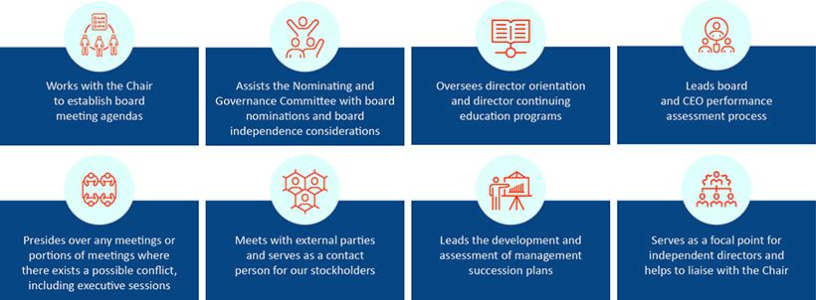

Our Sixth Amended and Restated By-laws (our “By-laws”) provide that our Chair or, in the absence of our Chair, our Lead Director, or in the absence of both our Chair and Lead Director, our CEO, calls meetngs of our board of directors to order and acts as the chair for those board meetngs. In the absence of our Chair, our Lead Director, and our CEO, a majority of our directors present may elect as chair of the meetng any director present. Independent directors meet at least quarterly in executve session without any management directors or members of the Company’s management present. Our Corporate Governance Guidelines provide that in the absence of our Chair, our Lead Director or, in the absence of the Lead Director, a director chosen by the directors meetng in executve session, presides at all executve sessions.

The board of directors does not have a permanent policy or practce regarding the combinaton of the Chair and CEO role. At present, the board believes that consolidatng the Chair and CEO positons allows our CEO to contribute his experience and perspectve regarding management and leadership of the Company towards the goals of improved corporate governance and greater management accountability. This structure also provides greater informaton fow between the management team and directors. At the same tme, the presence of our Lead Director ensures that the board can retain sufcient delineaton of responsibilites, such that our Lead Director and our Chair and CEO may each successfully and efectvely perform and discharge their respectve dutes and, as a corollary, enhance our prospects for success. As a result, the Company benefts from the ability to integrate the collectve leadership and corporate governance experience of our Lead Director and our Chair and CEO, while retaining the ability to facilitate the functoning of the board of directors independently of our management and to focus on our commitment to corporate governance.

For the foregoing reasons, our board of directors has determined that its leadership structure is appropriate and in the best interests of our stockholders at this tme.

28 | / | EXL 2024 Proxy Statement

Table of Contents

Corporate governance

Director qualifcatons, refreshment and evaluatons

Director qualifcatons

The board of directors considers it paramount to achieving excellence in corporate governance to assemble a board of directors that, taken together, has the breadth of skills, qualifcatons, experience and atributes appropriate for functoning as the board of our Company and working productvely with management. The Nominatng and Governance Commitee of the board is responsible for recommending nominees who are qualifed and bring a diverse set of skills and qualifcatons to oversee the Company efectvely.

The Nominatng and Governance Commitee has not formally established any

minimum qualifcatons for director candidates, but pursuant to our Corporate Governance Guidelines, our board seeks independent directors from diverse professional and personal backgrounds who combine a broad spectrum of experience and expertse with a reputaton for integrity. The board believes that its membership should refect a diversity of gender, race, ethnicity, age, and skills and experience in the context of the needs of the board and endeavors

to consider such criteria, when applicable, for positons on the board. The Nominatng and Governance Commitee assesses each director candidate on this basis. The Nominatng and Governance Commitee considers a number of factors in selectng director candidates, including, among others: ethical standards and integrity; independence; diversity of professional and personal backgrounds; skills and experience; other public company directorships; and fnancial literacy and expertse; communicaton skills; and ability and willingness to comply with Company policies and procedures.

Key skills and atributes

we look for in board nominees

Strategic insight and broad business perspectve

Critcal and innovatve thinking

High ethical standards and integrity

Mutual respect for other board members

Ability to debate constructvely

Candid, assertve, open minded

Availability and commitment to serve

Commitment to accountability, excellence and contnuous improvement

Commitment to driving our growth and success Proven leadership skills

In light of our business, the primary areas of experience, qualifcatons and atributes typically sought and put forward by the Nominatng and Governance Commitee in director candidates include, but are not limited to, the following:


Executve leadership

Experience holding signifcant leadership positons, including as a CEO or head of a signifcant business, to help us drive business strategy, growth and performance.

Finance and accountng
Experience with fnance, accountng or fnancial reportng processes, to help drive fnancial performance.

Global companies
Experience working outside of the United States or with multnatonal companies, to help facilitate our global expansion.

 | EXL 2024 Proxy Statement | / 29

Table of Contents

Corporate governance


Board experience

Understanding of public company board of director and fduciary dutes, to help provide perspectve on corporate governance best practces and related maters.



Data and AI

Experience with data analytcs, digital operatons and solutons, artfcial intelligence and machine learning, and other key technologies that are central to our business.



Client and industry knowledge

Experience with our key client industries, including insurance, healthcare, banking and fnancial services, fnance/accountng, and our other capabilites, to help deepen our knowledge of our key industry vertcals and markets in which we do business.



Risk oversight/management
Experience assessing and overseeing the overall risk profle of multnatonal public companies.



Human capital management

Experience in management and development of human capital, including management of a large workforce, diversity and inclusion, talent development, workplace health and safety, compensaton and other human capital issues.



Diverse backgrounds

We seek directors with diverse professional and personal backgrounds and perspectves to promote the values of diversity and inclusion from the top and to provide perspectve from varying viewpoints.



Experience in sustainability maters
Experience in managing sustainability maters, incorporatng them into business and strategy and associated risks.



Informaton and cybersecurity
Experience in informaton and cybersecurity maters, best practces and associated risks.



Mergers and acquisitons
Experience in mergers and acquisitons as a component of business development and strategy.


Marketng
Experience in marketng and branding of multnatonal companies.

30 | / | EXL 2024 Proxy Statement

Table of Contents

Refreshment

Our Nominatng and Governance Commitee considers the size and compositon of our board (and its commitees) on a contnual basis with an aim toward creatng a balanced board with extensive experience and insttutonal knowledge, and fresh perspectve and insight.

Consideratons include whether the compositon of the board of directors (and its commitees) includes sufcient diversity and independent skill sets and background as appropriate for our immediate and long-term strategic needs. These consideratons are also informed by discussions with our investors through stockholder engagement. In terms of diversity, our board, following the Annual Meetng will be 37.5% diverse in terms of gender and 37.5% diverse in terms of ethnic/racial diversity.

Our Nominatng and Governance Commitee also considers the length of tenure of the directors as a whole. Following the Annual Meetng (assuming the electon of all nominees), we will have the following balance of tenures:
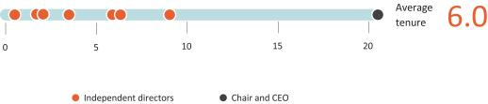

Corporate governance

Board refreshment


ADDITIONS EXITS

2024 | 2024
Thomas Bartlet | Som Mital
2023 | 2023
Andreas Fibig | Anne Minto
Sarah K. Williamson | Clyde Ostler

While the Company does not maintain term limits, our Corporate Governance Guidelines provide that the expectaton for new directors is a maximum term of ten years. Each of our director nominees, other than Mr. Kapoor, our Chair and CEO, has served on the board for less than ten years as of the date of this Proxy Statement. The board actvely manages board refreshment and succession planning at the board and commitee level. For example, the board generally expects that each member serve on two commitees, and that each commitee chair serve for a maximum of fve years. The board expects that over the next few years, the commitee and board compositon will contnue to change due to rotaton and retrement. The Nominatng and Governance Commitee will identfy successors based on the goal of maintaining the board’s overall balance of experience and perspectve. A recommendaton regarding board (and commitee) compositon is shared with the full board of directors on an annual basis.

 | EXL 2024 Proxy Statement | / 31

Table of Contents

Corporate governance

Board refreshment process
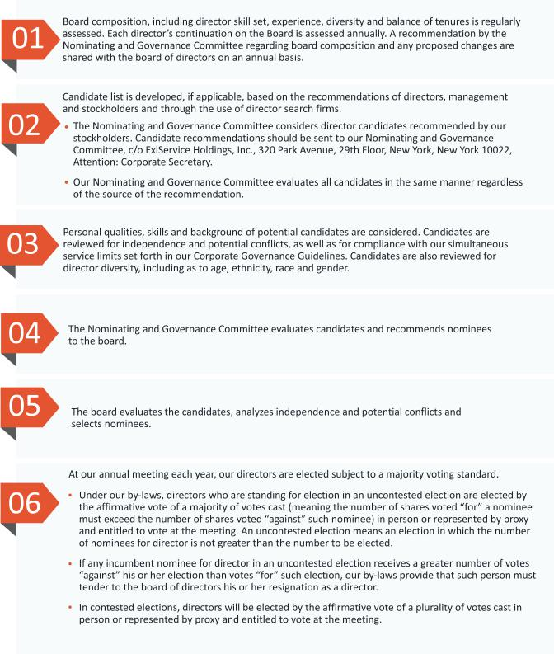

32 | / | EXL 2024 Proxy Statement

Table of Contents

Corporate governance

Commitee rotaton

We rotate commitee and commitee chair assignments based on the current compositon of the board. Recent rotatons include the following:
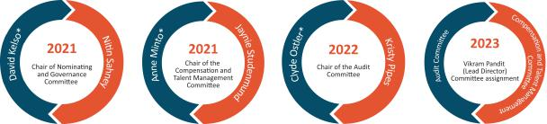

* Former director

Board evaluatons

We consider the contnued efectveness of the board and its commitees as critcal to our long-term success and stockholder value. The board evaluates its performance and the performance of its commitees and each director on an annual basis through the following process:
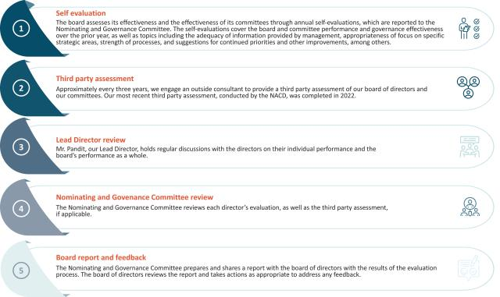

 | EXL 2024 Proxy Statement | / 33

Table of Contents

Corporate governance

Succession planning

Our board of directors (without the partcipaton of the CEO), guided by our Lead Director, is responsible for developing and annually reassessing succession plans for our CEO and other key executve ofcers of the Company, and preparing contngency plans for interim CEO succession in the event of an unexpected occurrence for board review. In additon, our Compensaton and Talent Management Commitee is responsible for ensuring appropriate compensaton strategies and design to align with the retenton and recruitment of our key executve ofcers. We actvely plan for the succession of our executve ofcers (including those who are retring or departng from the Company), and regularly consider our strong pipeline of internal and external candidates. As part of this process, in April 2024, Vikas Bhalla and Vivek Jetley, who had been serving as Executve Vice President and Business Head, Insurance and Executve Vice President and Business Head, Analytcs, respectvely, were each promoted to President of EXL in additon to their business head roles. In their expanded roles, they will take on broader Company-wide responsibilites, including supportng our Chair and CEO to drive overall corporate performance and the adopton of our data and AI-led solutons. We generally consider succession planning and associated executve compensaton maters on the following schedule:
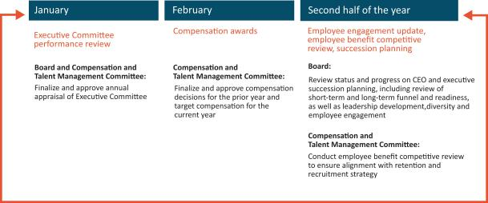

Commitees

Our board of directors currently has three standing commitees: the Audit Commitee, the Compensaton and Talent Management Commitee and the Nominatng and Governance Commitee. As discussed above, our board of directors has determined that each member of the Audit, Compensaton and Talent Management and Nominatng and Governance Commitees meets the independence and experience requirements of the Nasdaq Stock Market and federal securites laws. Copies of our commitee charters can be found on the Investor Relatons page of our website at: htps://ir.exlservice.com/corporate-governance. Informaton on our website referred to in this Proxy Statement does not consttute a part of this Proxy Statement.

34 | / | EXL 2024 Proxy Statement

Table of Contents

Corporate governance

The following table sets forth the current chairs and members of each standing commitee of the board of directors. As an executve director, Mr. Kapoor, our Chair and CEO, does not serve on any board commitee.

Audit | Compensaton and | Nominatng and
Commitee | Talent Management Commitee | Governance Commitee


Vikram Pandit

(Lead Director)

Thomas Bartlet *

Andreas Fibig

Som Mital+

Kristy Pipes*

Nitn Sahney

Jaynie Studenmund*

Sarah K. Williamson*

Commitee Chair Member
- Not standing for re-electon
*Audit Commitee Financial Expert

 | EXL 2024 Proxy Statement | / 35

Table of Contents

Corporate governance

Audit Commitee

Our Audit Commitee oversees and assists our board of directors in fulflling its oversight responsibilites with respect to our accountng and fnancial reportng processes, including the integrity of the fnancial statements and other fnancial informaton provided by us to our stockholders, the public, stock exchanges and others; our compliance with legal and regulatory requirements; our independent registered public accountng frm’s qualifcatons and independence; the audit of our fnancial statements; the performance of our internal audit functon and independent registered public accountng frm; the Company’s cybersecurity program and cyber strategy-related risks; business contnuity and disaster recovery planning; our Code of Conduct and Ethics and the processes used to disseminate it to our employees and monitor their compliance with our Code of Conduct and Ethics; and environmental, social and governance-related disclosure, processes and controls. Its risk oversight is discussed below beginning on page 39. Our Audit Commitee charter permits the commitee to form and delegate authority to subcommitees when appropriate, provided that the subcommitees are composed entrely of directors who satsfy the applicable requirement of federal securites laws as well as independence requirements of the Nasdaq Stock Market.

Our Audit Commitee has direct responsibility for the appointment, compensaton, retenton (including terminaton) and oversight of our independent registered public accountng frm, and our independent registered public accountng frm reports directly to our Audit Commitee. It also reviews and approves specifed related-party transactons as required by the rules of the Nasdaq Stock Market, and oversees the Company’s cybersecurity program and cyber strategy-related risks. The Audit Commitee was established in accordance with Secton 3(a)(58)(A) of the Securites Exchange Act of 1934 (the “Exchange Act”). Our Audit Commitee annually reviews and assesses the adequacy of its charter and its own performance.

The members of our Audit Commitee are appointed by our board of directors. All members of the commitee must also be recommended by our Nominatng and Governance Commitee.

Audit Commitee profle


- Kristy Pipes, Chair*

- Thomas Bartlet*
 | Andreas Fibig
 | Nitn Sahney
 | Jaynie Studenmund*
 | Sarah K. Williamson*
 | • | Accountng and fnancial reportng processes
 | • | Our independent registered public accountng frm’s appointment and
 |  | independence
 | • | The audit of our fnancial statements and internal audit functon
 | • | Other key areas including cybersecurity, ESG disclosures, processes
 |  | and controls, litgaton, business contnuity and disaster recovery,
 |  | compliance and regulatory enforcement maters


*Audit commitee fnancial expert under applicable SEC rules and regulatons

 |  | 7 commitee meetngs in 2023
36 / | EXL 2024 Proxy Statement

Table of Contents

Corporate governance

Compensaton and Talent Management Commitee

Our Compensaton and Talent Management Commitee reviews and recommends policies relatng to compensaton and benefts of our directors, ofcers and employees and is responsible for approving the compensaton of our Chair and CEO and other executve ofcers, as well as our employee benefts policies, programs and administraton. The commitee reviews, evaluates and makes recommendatons to our board of directors with respect to our incentve compensaton plans and equity-based plans and administers the issuance of awards under our equity incentve plans. It also provides oversight with respect to human capital management maters, including diversity, equity and inclusion, and talent and leadership engagement, development and training. The commitee’s charter permits the commitee to form and delegate authority to subcommitees when appropriate, provided that the subcommitees are composed entrely of directors who satsfy the applicable independence requirements of the Nasdaq Stock Market.

The Compensaton and Talent Management Commitee charter also permits the commitee to retain advisors, consultants or other professionals to assist the commitee to evaluate director, Chair and CEO

Compensaton and Talent Management Commitee profle


or other senior executve compensaton and to carry out its dutes. For 2023, our Compensaton and Talent Management Commitee retained the services of Farient Advisors LLC (“Farient”), a qualifed and independent compensaton consultant, to aid the commitee in performing its review of executve compensaton including executve compensaton benchmarking and peer group analysis. Our Compensaton and Talent Management Commitee annually reviews and assesses the adequacy of its charter and its own performance. Additonal informaton regarding our

Jaynie Studenmund, Chair

Som Mital
Vikram Pandit
Kristy Pipes




Compensaton and Talent Management Commitee’s processes and procedures for considering executve compensaton are addressed in the Compensaton Discussion and Analysis below.

• Overall compensaton risk management, including recommending
incentve compensaton plans

• Retenton of advisors or other compensaton consultants

• Oversight of human capital management maters, including diversity,
equity and inclusion

• No interlocks or insider partcipaton

6 commitee meetngs in 2023

The members of our Compensaton and Talent Management Commitee are appointed by our board of directors. All new members of the commitee must be recommended by our Nominatng and Governance Commitee.

During 2023, none of our executve ofcers served as a member of the board of directors or compensaton commitee (or similar) of any entty that has one or more executve ofcers who serve on our board of directors or Compensaton and Talent Management Commitee.

 | EXL 2024 Proxy Statement | / 37

Table of Contents

Corporate governance

Nominatng and Governance Commitee

Our Nominatng and Governance Commitee is responsible for:

- identfying and recommending candidates for electon to our board of directors using selecton criteria approved by our board of directors, reviewing compositon of the board and commitee membership and overseeing board refreshment and director compensaton and benefts maters, (ii) developing and recommending to our board of directors Corporate Governance Guidelines, including independence standards, and other board procedures or corporate governance policies, as well as any changes to such guidelines, procedures or policies or to any of our organizatonal documents; (iii) overseeing our board of director and management evaluatons and our director educaton program, and

- overseeing our environmental, social and governance-related goals, policies and practces. The commitee’s charter permits the commitee to form and delegate authority to subcommitees when appropriate, provided that the subcommitees are composed entrely of directors who satsfy the applicable independence requirements of the Nasdaq Stock Market.

 |  |  | Nominatng and Governance Commitee profle
 |  | Nitn Sahney, Chair
 |  | Thomas Bartlet
 |  | Andreas Fibig
 |  | Som Mital
 |  | Vikram Pandit
 |  | Sarah K. Williamson
 |  | • | Reviewing compositon of the board, overseeing board refreshment and
 |  |  | identfying and recommending board candidates
 |  | • | Developing and recommending governance practces, including our
 |  |  | Corporate Governance Guidelines
 |  | • | Overseeing board evaluatons
 |  | • | Overseeing our ESG goals, policies and practces
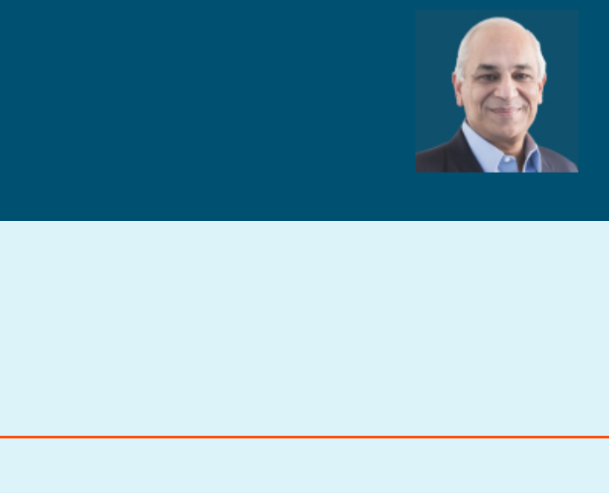

4 commitee meetngs in 2023

Our Nominatng and Governance Commitee reviews writen and oral informaton provided by and about candidates and considers any additonal criteria it feels are appropriate to ensure that all director nominees possess appropriate skills and experience to serve as a member of our board of directors.

It also oversees our director onboarding and training program, which provides new directors with training regarding the Company’s policies and procedures and specifc requirements that may be needed based on the director’s commitee memberships.

In additon, the Nominatng and Governance Commitee oversees and reviews the Company’s ESG goals, policies and programs and the Company’s corporate governance policies and practces regularly. It is responsible for reviewing and assessing the adequacy of our organizatonal documents, and recommending any changes and annually reviewing and assessing the adequacy of its charter and its own performance. The members of our Nominatng and Governance Commitee are appointed by our board of directors.

38 | / | EXL 2024 Proxy Statement

Table of Contents

Corporate governance

Board and commitee oversight of risk management


Full board oversight

Our board of directors is ultmately responsible for overseeing EXL’s risk management actvites as a whole.

- Our management is responsible for development of our risk management framework and methodological guidelines. Management, and ultmately, our Chair and CEO, is responsible for our day-to-day risks, and, because we are exposed to fnancial risks in multple areas of our business, day-to-day risk management actvites and processes are performed by multple members of our senior and other management.

Our management assists the board in identfying strategic and operatng
risks that could afect the achievement of our business goals and objectves, assessing the likelihood and potental impact of these risks and proposing courses of acton to mitgate and/or respond to these risks.

 | Audit Commitee |  | Nominatng and Governance |  |  | Compensaton and Talent
 | Responsible for primary oversight of our risk |  | Commitee |  |  | Management Commitee
 | management, fnancial and cybersecurity risk |  | Responsible for risk relatng to sustainability |  |  | Responsible for executve and employee
 | and reportng internal and external audit |  | maters, conficts of interest, and oversight of |  |  | compensaton and retenton-related risk, as well
 | controls and regulatory requirements. Reviews |  | corporate governance policies and practces as a |  |  | as other human capital management-related
 | and discusses with management our enterprise |  | risk- management-related measure. |  |  | risk.
 | risk assessment, major fnancial risk and
 | cybersecurity exposures and the steps
 | management has taken to monitor, control and
 | manage such exposures, including our risk
 | management guidelines and policies. Reviews
 | and discusses with other board commitees our
 | sustainability programs and related maters.


Our management maintains, as part of our disclosure controls and procedures, a separate disclosure commitee whose meetngs’ atendees generally include our CEO, Chief Financial Ofcer, General Counsel, other members of our Executve Commitee, members of our investor relatons, controllership, tax, compliance, internal audit and legal teams, as well as our external auditors and outside counsel. As part of its review of our quarterly and annual reports the disclosure commitee helps facilitate understanding by the Audit Commitee and our full board of directors of new or changing risks afectng us.

 | EXL 2024 Proxy Statement | / 39

Table of Contents

Corporate governance

Cybersecurity risk management

Given the nature of our business, EXL is highly focused on maintaining a robust and comprehensive program that identfes and manages a broad range of cybersecurity and data privacy, referred to collectvely herein as “cybersecurity,” risks on behalf of our clients and their customers, as well as our employees, contractors and any relevant third partes. Cybersecurity is managed by our cross-functonal cybersecurity apex body, the Management Security, Contnuity and Privacy Forum, which is comprised of representatves from our management, business unit heads, and enterprise functons, such as legal, human resources, growth and strategy, compliance, technology and informaton security. Our Audit Commitee has primary oversight over cybersecurity and receives briefngs from management throughout the year, typically on a quarterly basis, regarding our security risk management, including cybersecurity-related risks, vulnerabilites, policies, practces, and strategic initatves. At least once a year, our board receives a report from management on our cybersecurity posture, our readiness and our capability to reduce the risk of, detect and respond to a cyber-atack. Our cybersecurity team consists of qualifed technical cybersecurity professionals, business contnuity specialists and atorneys. We regularly conduct cybersecurity and other risk assessments and compliance audits both internally and through third party auditors that we independently engage or that we engage in connecton with our certfcaton to certain internatonal standards. We also regularly assess and deploy technical safeguards and conduct vulnerability assessment and penetraton testng of our technology environment independently and through third partes. We use the outcome of these assessments to align our cybersecurity program and technical safeguards with the evolving cybersecurity threat landscape and adjust and augment our security controls environment as required. We also periodically engage third-party experts to review and assess our cybersecurity governance and management, including as may relate to our use of suppliers and third party partners. In 2022 and 2023, our board and senior management completed cybersecurity tabletop exercises to further our preparedness in the event of a need to address a variety of cybersecurity threat scenarios. Our directors also partcipated in a walkthrough of our Cyber Defense Center in Noida, India during their September 2023 visit to India.
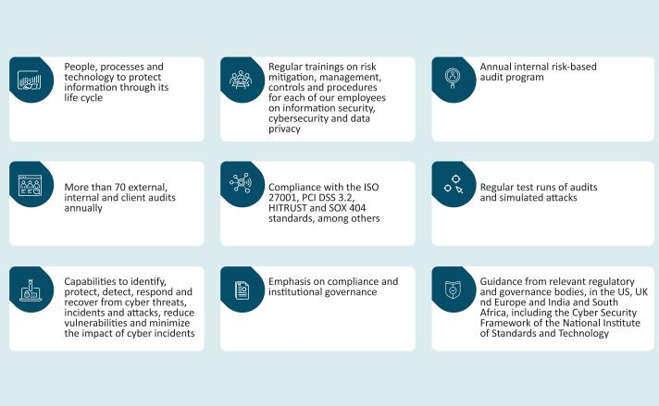

For more details on our cybersecurity program, see “Sustainability – Cybersecurity at EXL” on page 54.

40 | / | EXL 2024 Proxy Statement

Table of Contents

Corporate governance

Sustainability risk management

Our board reviews and receives regular reports on sustainability risks, including those relatng to sustainability disclosures, employee safety, environmental-related eforts, human capital management maters, and corporate governance trends and best practces. We also receive third-party limited assurance of the informaton contained in our Sustainability Report from a Big 4 accountng frm afliate.

Each of our board commitees is involved in oversight over sustainability-related risks as relate to maters within their purview:
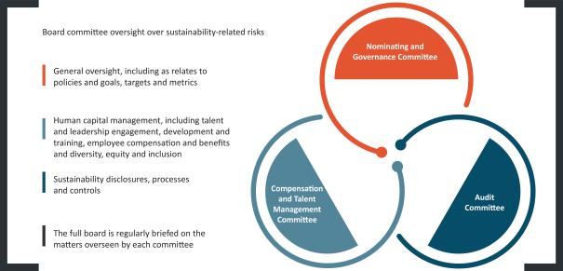

We maintain a cross functonal management-level sustainability steering commitee (“ESG Steering Commitee”), which is responsible for setng our sustainability/ESG strategy and risk management, keeping our management and board up-to-date on ESG-related developments, overseeing our internal and external disclosure on ESG maters, and providing implementaton support across our Company. The ESG Steering Commitee works in close coordinaton with the board, and provides the board with advice and assistance in its oversight of ESG risks and other maters. For more details on our ESG and sustainability-related eforts, see “Sustainability” on page 44.

Artfcial intelligence risk management

We have a centralized, cross-functonal Artfcial Intelligence (“AI”) Governance Commitee that is led by the General Counsel and Chief Informaton Ofcer and supported by our corporate compliance team, and engineering, digital, analytcs and applicable business leads, which oversees high-risk AI projects. The AI Governance Commitee is guided by our global AI Governance Policy. Our board and our Audit Commitee are briefed from tme to tme by management, as well as by third-party frms, on AI-related risks and opportunites, including in-depth discussions regarding current AI deployments with our customers. For more details on responsible AI, see “Responsible artfcial intelligence” on page 54.

 | EXL 2024 Proxy Statement | / 41

Table of Contents

Corporate governance

Stockholder engagement

In 2023 and contnuing into early 2024, we contnued our formal governance-focused stockholder outreach program. Given our frequent engagement and the maturity of our stockholder outreach program, a number of our stockholders that we engaged with in prior years indicated that they had all required informaton at this tme, and elected to defer meetng again to a future year. For the meetngs we conducted with our stockholders in 2023 and early 2024, EXL was represented by our management and members of our legal and investor relatons teams. We discussed the below topics:


Outreach to stockholders by
~80% shares outstanding during 2023-2024 season
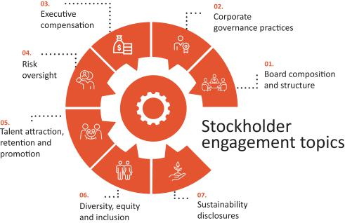

EXL also regularly interacts and shares informaton with our stockholders through our quarterly earnings calls, investor meetngs, SEC flings and publicatons on our website, among others, including in 2023, our sustainability materiality analysis. The feedback received from our stockholders is shared with and reviewed by our board, which is used to inform and focus our decisions relatng to our governance and sustainability practces and to improve our disclosure.

42 | / | EXL 2024 Proxy Statement

Table of Contents

Corporate governance

Communicatons with the board

Stockholders interested in contactng our board of directors, Lead Director or the directors who meet in executve session are invited to do so by writng to:

Board of Directors of ExlService Holdings, Inc.

c/o Corporate Secretary

ExlService Holdings, Inc.

320 Park Avenue, 29th Floor

New York, New York 10022

All other stockholder communicatons addressed to our board of directors will be referred to our Chair and CEO and our Lead Director and tracked by our Corporate Secretary. Stockholder communicatons specifcally addressed to a partcular director will be referred to that director.

Complaints and concerns relatng to our accountng, internal accountng controls or auditng maters should be communicated to our Audit Commitee, which consists solely of non-employee directors. Any such communicaton may be anonymous and may be reported to our Audit Commitee through our General Counsel by writng to:

Audit Commitee of the Board of Directors

ExlService Holdings, Inc.

320 Park Avenue, 29th Floor

New York, New York 10022

Atn: General Counsel

All such concerns will be reviewed under Audit Commitee directon and oversight by our General Counsel, our Head of Internal Audit or such other persons as our Audit Commitee determines to be appropriate. Confdentality will be maintained to the fullest extent possible, consistent with the need to conduct an adequate review. Prompt and appropriate correctve acton will be taken when and as warranted in the judgment of our Audit Commitee. We prepare periodic summary reports of all such communicatons for our Audit Commitee.

 | EXL 2024 Proxy Statement | / 43

Table of Contents

Sustainability

Sustainability

In line with our mission of looking deeper to fnd a beter way for our clients, at EXL we are commited to doing our part to build a beter future by operatng in a responsible and sustainable manner that is aligned with our business goals. We believe that by integratng sustainable practces into our business model, working towards positve social change, and providing transparent reportng on those practces and our progress, we are a stronger and more resilient organizaton that is best able to deliver long-term value to our stakeholders.

Recent actvites

In 2023 and contnuing into 2024, we took a number of steps to contnue improving our sustainability program. These recent actvites include:


Aligning our sustainability program with our corporate strategy, which is aimed at ensuring that the sustainability initatves that we choose to undertake create value and contribute to our business goals. For example, we seek to review and measure the return on

1 investment received from our sustainability-related initatves. For more informaton on sustainability-related return on investment, please review our Sustainability Report, available on our website at www.exlservice.com/about/sustainability.



Contnuing to build on existng actons in environmental stewardship, including:

• transitoning additonal delivery centers to 100% green energy in India, joining the existng centers that beneft from this

- initatve in India and the UK, and resultng in an increase of our renewable energy portolio to ~30% on an annualized basis, and

 |  | • | installing roofop solar facilites in two additonal delivery centers in India, bringing our total to fve delivery centers with roofop
 |  |  | solar facilites, among other green actons
 |  | Demonstratng our commitment to providing transparency and meaningful disclosure on sustainability-related informaton,
 |  | including through:
 |  | • | contnuing to update our Sustainability page on our website, which highlights all of our relevant sustainability-related policies,
 |  |  | reports, certfcatons and awards, targets and actvites, available at www.exlservice.com/about/sustainability
 |  | • | publishing our fourth Annual Sustainability Report developed in accordance with the 2021 Global Reportng Initatve (GRI)
 |  |  | Standard, the Sustainability Accountng Standards Board (SASB) Sofware and IT Services Standard (2018), and the Task Force on
 |  | 3 | Climate-Related Financial Disclosures (TCFD), with assurance from a Big 4 accountng frm afliate, which is available on the
 |  | 3 | Sustainability page of our website at www.exlservice.com/about/sustainability
 |  | • | implementng the controls, processes and frameworks around sustainability data collecton and reportng that we developed at
 |  |  | the end of 2022
 |  | • | completng a Company-wide internal amplifcaton campaign aimed at driving employee support and partcipaton in our
 |  |  | sustainability eforts
 |  | • | engaging with our management, employees, clients and investors in a materiality assessment conducted by an independent
 |  |  | third party, through which we identfed priority sustainability topics to help inform our sustainability strategy and reportng,
 |  |  | the results of which are available on the Sustainability page of our website at www.exlservice.com/about/sustainability


Contnued to actvely promote Company-sponsored community engagement by our employees, including through:
4 | • | Engaging more than 19,000 volunteers overall in 2023, who contributed more than 37,000 hours of their tme to our community
4 |  | engagement initatves around the globe
 | • | Bringing local relevance to our global community engagement initatves through our CSR champion teams comprised of

 | employee volunteers, who own local-level community engagement actvites and drive partcipaton within their home regions
44 / | EXL 2024 Proxy Statement

Table of Contents

Sustainability
Community engagement
EXL is focused on empowering our employees to assist the members of the communites in which we live and work to develop market-
relevant skills. We provide programming on skills development for adults and children within our communites:

Skills to Win Initatve

Skills to Win focuses on equipping people in our communites with the skills that the market demands. We provide training on employability skills for back-ofce roles, fnance and accountng, and data and analytcs and digital capabilites, as well as life and general workplace skills. A porton of the Skills to Win Programming is delivered in person, and a porton is delivered online.

In 2023, we contnued to scale the Skills to Win Initatve, reaching 400 more individual benefciaries than we reached in the prior year. Skills to Win is opening new doors for employment and earnings for partcipants in the United States, the Philippines, India, the United Kingdom and South Africa.

Over the past six years, we have contnued to evolve this initatve to refect new and emerging skills and strengthen our portolio of courses and actvites ofered through Skills to Win. In 2022, we created a new focus area for our Skills to Win Initatve to target bringing STEM skills-and in partcular, coding skills- to girls, women and non-binary people in our communites, which we further expanded in 2023. We currently partcipate in coding skills and awareness programming in India, the Philippines, South Africa and the United Kingdom through partnerships with organizatons and insttutons in each of those locatons.

Educaton as a Foundaton Initatve

Educaton as a Foundaton provides school-aged children with a foundaton in data and analytcs skills, as well as extracurricular actvites such as art, music, ftness, and languages and life skills, all of which will enable them to positon themselves as future leaders. We use a blend of online and in person learning platorms, and have expanded the role of our students’ parents as co-educators.

Over the past two years, we have also added a new focus in our content on the physical and mental wellbeing of our students and their families. For example, in 2023, we collaborated with our non-proft partner organizatons and afliated schools in India to reintegrate into the educaton system female students who had previously exited formal schooling, through the delivery of educaton on specifc skills, including mental wellness and personal hygiene, as well as direct educatonal skills.

Like our Skills to Win Initatve, in 2023, we were able to contnue to scale this program, in part as a result of our use of a hybrid in-classroom and virtual format, to reach more than 8,000 more students than we had in the prior year.

In 2023, we brought this program to more than 3,800 people in |  | In 2023, we brought this program to more than 19,200 students
our communites across the globe. |  | worldwide.

Our employees are an integral part of our community strategy. They share their skills and experience working on advanced digital technologies through volunteering and partcipate in charitable eforts – either through fnancial or in-kind donatons. We support our employees’ charitable eforts by enabling payroll giving and/or recurring donatons and providing company matching. Our use of virtual volunteering has made partcipaton in our community engagement programming even easier for our employees, and has enabled us to reach more people through our programming.

We seek to increase engagement across our organizaton in our community initatves. We hold an annual awards ceremony to recognize our employee volunteers for their contributons. In 2023, we hosted geography-specifc trainings for certain of our employees who we appointed to be our local “CSR champions.” Our CSR champions assist us in driving interest and partcipaton across our employee base in our community engagement programming and enabling our global initatves to refect local maters.

We also organize and take part on an organizatonal level in fundraising and in-kind donaton initatves. In 2023, we hosted employee fundraisers for several causes, including to provide meals to individuals afected by the February 2023 earthquake in Turkey and Syria and support humanitarian eforts by providing critcal aid, medical care, and supplies to the afected people and their families due to Israel-Hamas confict. At the end of 2023, more than 4,500 EXL employees in the Philippines partcipated in a donaton drive to provide essentals like clothing and shoes, canned goods and books to their communites.

We are proud to report that in 2023, more than 19,000 EXL employees partcipated in our CSR actvites by donatng their tme or resources.

 | EXL 2024 Proxy Statement | / 45

Table of Contents

Sustainability
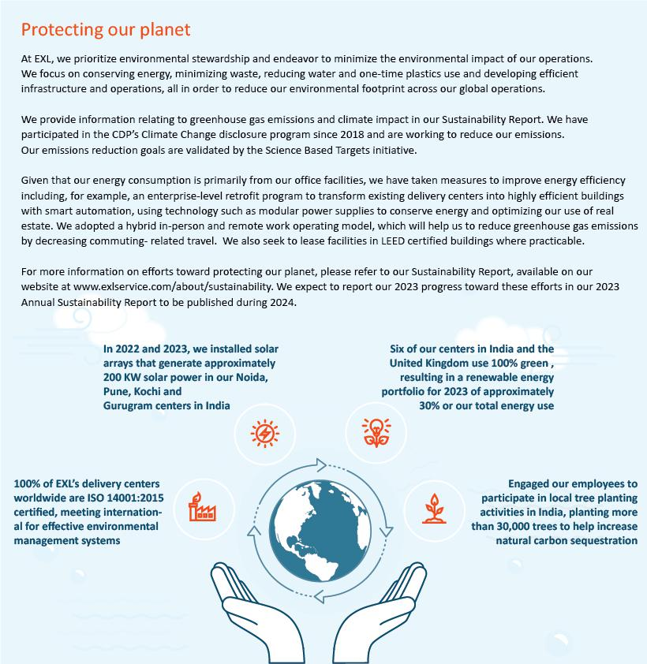

46 | / | EXL 2024 Proxy Statement

Table of Contents

Sustainability

Human rights and sustainable supply chain

Human rights

Our Human Rights Policy details our commitment to human rights and our zero tolerance for workplace harassment and discriminaton and preventng forced labor and trafcking and other abuses.

Sustainable supply chain

To ensure that our suppliers’ business conduct aligns with our expectatons, we collect background informaton from our new suppliers on their policies and performance relatng to economic and environmental, data privacy, and labor rights maters. We ask our suppliers to atest to their compliance with our Supplier Standards of Conduct, which set out commitments relatng to creatng a more sustainable and responsible world through addressing human rights, labor rights and environmental issues. We generally maintain the right to review our suppliers’ practces at onboarding and throughout our engagement.

We seek to procure our materials from local suppliers, to the extent practcable.

Our supplier diversity programs encourage the engagement of suppliers of diverse backgrounds, including, without limitaton, suppliers owned by people belonging to minority groups, women, the LGBTQ+ community, and veterans, specially-abled people, and small business enterprises.

Supportng and developing our people

Our people are our primary assets and our workforce stands out as our primary diferentator, critcal to delivering the data-driven solutons that propel our business forward and support our long-term strategic growth. At EXL, we prioritze the acquisiton, development, and engagement of critcal talent with sophistcated skills and expertse who can help us to deliver for our clients and evolve with their evolving needs. We are dedicated to developing our employees’ success through fostering engagement, ofering comprehensive workforce training, and promotng contnuous capability development. We embrace a diversity of perspectves and experiences and emphasize a fair and inclusive culture rooted in our core values. We regularly conduct employee surveys to monitor our employee satsfacton and engagement, as further described below and employ people analytcs in our talent management processes to optmize our delivery of our talent acquisiton and development strategy. On an annual basis, our Compensaton and Talent Management Commitee previews, and then our full board reviews, a comprehensive human capital strategic review prepared by management.

 | EXL 2024 Proxy Statement | / 47

Table of Contents

Sustainability

Headquartered in New York, we are made up of approximately 54,160 professionals as of December 31, 2023, with more than 50 ofces spanning six contnents.

EXL locatons
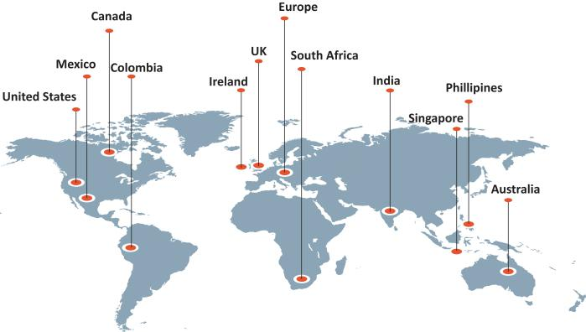

48 | / | EXL 2024 Proxy Statement

Table of Contents

Sustainability

Diversity, equity and inclusion

Diversity, equity and inclusion (“DEI”) is a focus at EXL, as we believe that our employees’ diversity of perspectve and experience are key to our ability to innovate on a global scale, in line with our long-term corporate strategy. We believe that creatng a diverse and inclusive environment is the responsibility of all of our people managers, but the overall governance of our DEI program is led by our human resources leadership team, together with our Diversity and Inclusion Council, and is ultmately overseen by our board. Our Diversity and Inclusion Council, which consists of a global, diverse mix of leaders, provides input and helps set directon on key DEI priorites and actons, conducts periodic reviews of the progress of our program and provides executon leadership for specifc initatves. The following are select key diversity data points as of December 31, 2023*:

43% | 23% | 24% | 52% | 52%
Gender Diversity | Gender Diversity | Gender Diversity | Racial and Ethnic | Racial and
Company-wide | Company-wide Vice | Senior Management | Diversity | Ethnic Diversity
 | President and Up |  | U.S. Employees | Senior Management

*Senior Management includes members of our Executve Commitee and Operatng Commitee. U.S. Employees includes diversity data as self-reported by employees. Our DEI philosophy aims to create a fair and inclusive work environment that harnesses the power of diversity to drive organizatonal success. We focus on each element of our DEI strategy as follows:

 | Diversity: We strive to create a workplace that is representatve of the diversity in the communites where we work in and clients that
D | we serve.
D | • | Focus on hiring channels that drive more diverse talent pools
D | • | Concerted eforts to build diverse hiring slates for senior leadership roles both internally and externally
 | • | Training programs to raise awareness and promote diversity and inclusion through in-person workshops, virtual sessions and
 |  | e-learning opportunites
 | Equity: We strive to create a workplace with a level playing feld where employees collaborate efectvely and can reach their full
E | potental.
E | • | Annual pay equity study conducted internally or through a third-party consultant to review pay variatons among our employees
 |  | and identfy any gaps. Our assessments have not revealed any systematc pay inequity to date.
 | • | Development programs aimed to accelerate the professional development of women at mid-management levels
 | Inclusion: We strive to create a workplace where employees are accepted and supported, feel that they can be themselves and are
 | ofered opportunites to build allyship and community, which drives more innovaton and creatvity.
I | • | Women@EXL employee resource group, which provides opportunites for networking and mentoring to further career
I |  | development, support and empower women at EXL
 | • | LGBTQ+ employee resource group, which fosters an environment where employees feel uplifed, safe, included and valued as part
 |  | of the EXL community
 | • | Diversity and inclusion sentment measured through employee engagement pulse surveys

 | EXL 2024 Proxy Statement | / 49

Table of Contents

Sustainability

Talent recruitment, development and retenton



Talent-frst

mindset for our

multfaceted talent needs

We view talent as a diferentator for our Company’s compettve advantage and, under the leadership of our board and senior executves, are commited to a talent-frst mindset. Our talent model is based on building a distributed workforce for our multfaceted talent needs.

Integrated talent

management

framework

We maintain an integrated talent management framework, employing actve collaboraton between our recruitment, capability development and human resource functons. We use data, technology, including an AI-driven infrastructure, and business insights to help us create a global talent network and stay ahead of the dynamic talent economy, while building a future ready workforce.

Actve role for senior

leadership

Our senior leadership team and board play a critcal role in defning our talent priorites to align with our strategic vision for each of our business units, as well as with our clients’ priorites.

Contnuous employee development


From the tme they join EXL, we focus on developing our employees by promotng opportunites for large-scale upskilling and reskilling, while fostering a learning environment conducive to individual skill-building and career advancement. We build role-specifc capabilites in our employees to be able to place the right people in the right roles. We maintain rigorous promoton standards, and compettve compensaton packages that include incentve-based compensaton.

Our capability development framework is focused on developing our employees’ digital and industry knowledge and leadership as a means to develop our talent internally. We achieve this through our learning academies, and through partnerships with industry organizatons, insttutes, business schools and consultng frms. We use a learning management system, reNew, that permits our employees to engage in self-directed learning by partcipatng in collaboratve trainings that are personalized to their interests and positons and are delivered virtually from any locaton, at any tme. We also maintain a learning marketplace that provides employees with regularly updated best-in-class digital trainings and certfcatons.

Academies
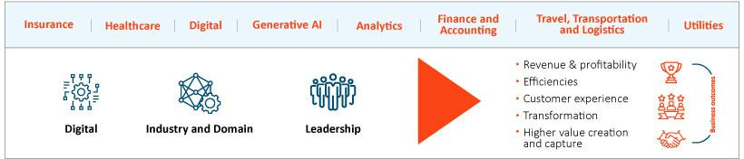

50 | / | EXL 2024 Proxy Statement

Table of Contents

Sustainability

2023 Training
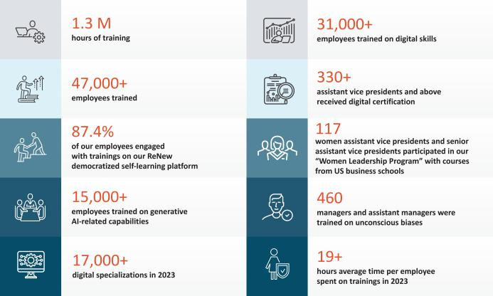

 | EXL 2024 Proxy Statement | / 51

Table of Contents

Sustainability

Employee engagement and communicaton

We consider communicaton and engagement with our approximately 54,000 employees distributed throughout more than 50 ofces worldwide to be important to our ability to promote our ONE EXL culture that prioritzes inclusivity and collaboraton, especially following our adopton of a hybrid operatng model with our employees working remotely and in-ofce. We contnued to rely on, and improve, our digital communicaton and collaboraton platorms and mult-channel approach to keeping our employees informed. In partcular, we engage with our employees through:
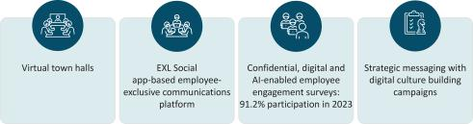

Benefts
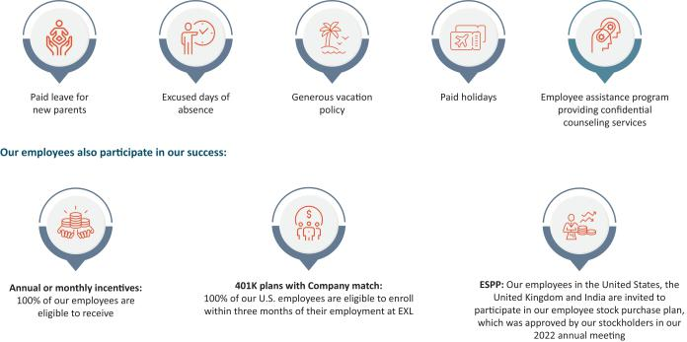

52 | / | EXL 2024 Proxy Statement

Table of Contents

Sustainability

Employee health, safety and wellbeing

Because our people are so important to us, we have always viewed employee health, safety and wellbeing as one of our top commitments. EXL has a well-defned Health and Safety Management System that is certfed to ISO 45001:2018. In 2023, we received a Five Star Ratng from the Britsh Safety Council for best practces in occupatonal health and safety in our United Kingdom and India centers. We periodically provide trainings on health and safety to our employees, suppliers and partners. In 2023, health and safety training e-module was mandatory for all of our employees. We also conduct a risk assessment every six months with the aim of minimizing risk in the workplace. We have received a number of recognitons and awards for our eforts in employee health and safety, detailed below under “Sustainability achievements, certfcatons and awards” on page 55. We also have a number of initatves to promote our employees’ wellbeing:
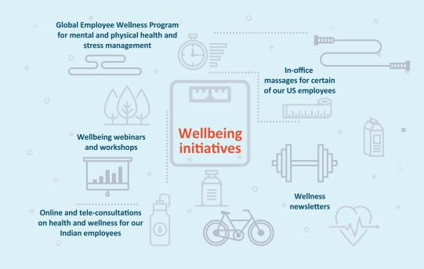

 | EXL 2024 Proxy Statement | / 53

Table of Contents

Sustainability

Cybersecurity at EXL

We are commited to protectng the confdentality, integrity, availability and privacy of the informaton assets of our clients and their customers, as well as our employees, vendors and any other third partes, that are shared with us and for which we are responsible. We maintain a comprehensive informaton and cybersecurity and data privacy program, based on defned policies processes and practces to safeguard the security, confdentality, integrity, availability and protecton of this informaton that we aim to contnually strengthen in order to mitgate material vulnerabilites and the impact of cyber incidents and comply with applicable privacy laws and regulatons.

For more informaton on our cybersecurity risk management, please see “Cybersecurity risk management” on page 40. For more informaton on our informaton security and data privacy procedures, please refer to the 2023 Form 10-K, Item 1C.

Responsible artfcial intelligence

We seek to ensure that our use of AI in our business and operatons is ethical and trustworthy and that its development and applicaton is based on the principles of fairness, security, reliability, transparency, accountability, and privacy. We have a centralized, cross-functonal AI Governance Commitee that is led by the General Counsel and Chief Informaton Ofcer and supported by our corporate compliance team, and engineering, digital, analytcs and applicable business leads, which oversees AI projects. Pursuant to our AI Governance Policy, for each new deployment of AI, we assess the AI model against the principles of trustworthy AI described above. Our AI Governance Policy also provides guidelines on general use, regulatory compliance, data privacy and security, best practces for front-end and back-end development and human oversight. Our use of AI and management of its risks is reported to the board and the Audit Commitee from tme to tme. See “Artfcial intelligence risk management” on page 41.

54 | / | EXL 2024 Proxy Statement

Table of Contents

Sustainability

Sustainability achievements, certfcatons and awards

Health and safety management system, 100% of our delivery centers as of December 31, 2023, are certfed to

ISO 45001:2018, meetng internatonal standards for occupatonal health and safety

100% our delivery centers worldwide are ISO 14001:2015 certfed, meetng internatonal standards for

efectve environmental management systems.


Reportng pursuant to SASB Sofware
and IT Services Standards (2018), 2021 GRI
Partcipant
Standards, TCFD and the
United Natons Global Compact
United Natons Sustainable

Development Goals

Partcipant in the CDP’s Climate Change disclosure program with respect to GHG emissions and climate change data
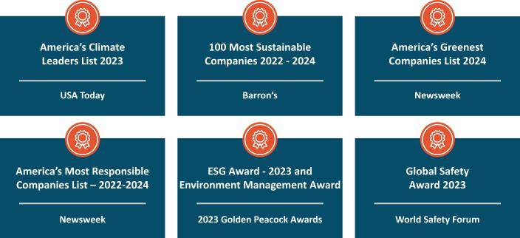

 | EXL 2024 Proxy Statement | / 55

Table of Contents

Sustainability

Sustainability scorecard
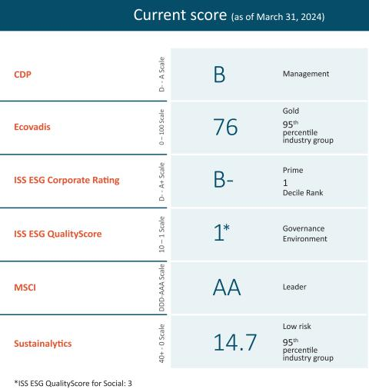

Environmental, social and governance maters and pay-for-performance at EXL

A porton of our CEO’s total compensaton is ted to the achievement of specifc performance goals relatng to ESG maters. For more informaton, see “Detailed review of compensaton components – Annual incentves – Determinaton of individual performance measure achievement” on page 75.

Sustainability oversight

For more informaton on our oversight of sustainability and ESG-related maters and risks, see “Sustainability risk management” on page 41.

Learn more about sustainability and environmental, social and governance maters at EXL

Please visit www.exlservice.com/about/sustainability to learn more about our eforts toward sustainability and the impacts we are making on our communites and the environment. Informaton on our website referred to in this Proxy Statement does not consttute a part of this Proxy Statement.

56 | / | EXL 2024 Proxy Statement

Table of Contents

Our Executve Commitee

Our Executve Commitee
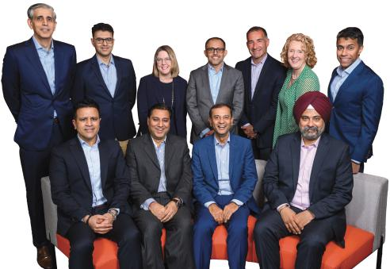

From back lef: Vivek Jetley, President of EXL and Business Head, Analytcs, Vikas Bhalla, President of EXL and Business Head, Insurance, Anita Mahon, Executve Vice President and Business Head, Healthcare, Narasimha Kini, Executve Vice President and Business Head, Emerging Business, Maurizio Nicolelli, Executve Vice President and Chief Financial Ofcer, Pamela Harrison, Executve Vice President and Chief Human Resources Ofcer, Ajay Ayyappan, Executve Vice President, General Counsel and Corporate Secretary

From front lef: Andy Logani, Executve Vice President and Chief Digital Ofcer, Vishal Chhibbar, Executve Vice President and Chief Growth and Strategy Ofcer, Rohit Kapoor, Chair and CEO, Baljinder Singh, Executve Vice President, Global Chief Informaton Ofcer, and Head of Enterprise Digital Transformaton

 | EXL 2024 Proxy Statement | / 57

Table of Contents

Our Executve Commitee

Executve Commitee biographies

The following are biographies for each of the members of our Executve Commitee. Of the members of our Executve Commitee, Rohit Kapoor, Ajay Ayyappan, Vikas Bhalla, Vishal Chhibbar, Pamela Harrison, Vivek Jetley, Narasimha Kini, Anita Mahon and Maurizio Nicolelli are considered executve ofcers.

Rohit Kapoor (age 59) | Chair and CEO

See secton enttled “Our board of directors” above.

Ajay Ayyappan (age 46) | Executve Vice President, General Counsel and Corporate Secretary

Mr. Ayyappan has served as our Executve Vice President, General Counsel and Corporate Secretary since February 2023. He previously served as our Senior Vice President, General Counsel and Corporate Secretary (December 2018 to February 2023), our Vice President, Actng General Counsel and Corporate Secretary (August 2018 to December 2018), our Vice President, Deputy General Counsel and Assistant Secretary (April 2014 to August 2018) and our Vice President and Assistant General Counsel (March 2007 to March 2014). Prior to joining us, Mr. Ayyappan was a corporate associate at the law frm, Morgan, Lewis & Bockius LLP.

Vikas Bhalla (age 52) | President of EXL and Business Head, Insurance

Mr. Bhalla has served as our President of EXL and Business Head, Insurance since April 2024 and previously as our Executve Vice President and Business Head, Insurance since January 2014 and as our Head of Outsourcing since November 2009. He previously served as Vice President, Operatons of EXL India (June 2006 to October 2009), as Vice President, Migratons, Quality and Process Excellence of EXL India (April 2002 to June 2006) and as Director, Quality Initatves of EXL India (May 2001 to March 2002). From May 1998 to May 2001, Mr. Bhalla served in various capacites at General Electric, including as the Quality Leader and E-Business Leader for GE Plastcs India. Mr. Bhalla is based in India.

Vishal Chhibbar (age 56) | Executve Vice President and Chief Growth and Strategy Ofcer

 | Mr. Chhibbar has served as our Executve Vice President and Chief Growth and Strategy Ofcer since July 2023. Mr. Chhibbar was
 | EXL’s chief fnancial ofcer from 2009 – 2019, and also previously served as the head of Finance and Accountng at EXL. Between
 | 2019 and his return to EXL as chief fnancial ofcer at Brillio and president and chief fnancial ofcer of EPIQ. Mr. Chhibbar has also
 | served in various fnancial leadership roles across companies such as GE Capital, American Express Bank and Xerox.
 | Pamela Harrison (age 59) | Executve Vice President and Chief Human Resources Ofcer
 | Ms. Harrison has served as our Executve Vice President and Chief Human Resources Ofcers since June 2023. She previously served
 | as executve vice president of human resources at Genworth Financial, and as a director of human resources of business
 | transformaton at Latham & Watkins LLP.
58 / | EXL 2024 Proxy Statement


Table of Contents







Our Executve Commitee

Vivek Jetley (age 49) | President of EXL and Business Head, Analytcs

Mr. Jetley has served as our President of EXL and Business Head, Analytcs since April 2024 and previously as our Executve Vice President and Business Head, Analytcs since January 2020. He previously served in various leadership roles with us, including heading enterprise strategy and setng up a strategic deal team. Mr. Jetley has been with EXL since 2006. Prior to joining us, Mr. Jetley was a Partner at Inducts.

Narasimha Kini (age 55) | Executve Vice President and Business Head, Emerging Business

Mr. Kini has served as our Executve Vice President and Business Head, Emerging Business since October 2021. He previously served in several leadership roles with us, including in our strategic initatves and fnance and accountng services. Mr. Kini has been with EXL since 2001. Prior to joining us, Mr. Kini was a Finance Leader at Willis Faber.

Anand “Andy” Logani (age 47) | Executve Vice President and Chief Digital Ofcer

Mr. Logani has served as our Executve Vice President and Chief Digital Ofcer since January 2024. Since joining EXL in 2001, he has served in various leadership positons with us, including as Chief Digital Ofcer and as our Global Head of Life & Annuity Insurance business. Prior to joining us, Mr. Logani was a member of the strategic sales team at Kuehne & Nagel.

Anita Mahon (age 55) | Executve Vice President and Business Head, Healthcare

Ms. Mahon has served as our Executve Vice President and Business Head, Healthcare since May 2022, and previously served as our Executve Vice President and Chief Growth Ofcer (March 2020 to May 2022). Prior to joining us, Ms. Mahon served as Vice President, Data, Strategy & Portolio Ofcer at IBM Watson Health, a business unit focused on developing cognitve and data-driven technologies to advance health. Ms. Mahon joined IBM in 2016 through its acquisiton of Truven Health Analytcs, a healthcare informaton and analytcs business, where she served as Chief Strategy Ofcer. Prior to Truven, she held other leadership roles that placed her at the intersecton of strategy, technology and analytcs.

Maurizio Nicolelli (age 55) | Executve Vice President and Chief Financial Ofcer

Mr. Nicolelli has served as our Executve Vice President and Chief Financial Ofcer since February 2020. Prior to joining the Company, Mr. Nicolelli served as Senior Vice President and Chief Financial Ofcer of Casa Systems beginning in 2019. He previously served 23 years at FactSet Research Systems, where he was Senior Vice President, Principal and Chief Financial Ofcer from 2009 to 2018.

Baljinder Singh (age 51) | Executve Vice President, Global Chief Informaton Ofcer, and Head of Enterprise Digital Transformaton

Mr. Singh has served as our Executve Vice President and Global Chief Informaton Ofcer since January 2024. Mr. Singh has been with EXL for more than 24 years, joining us as part of the founding leadership team. He has held several leadership roles at EXL across technology, transformaton, digital solutons, platorms development, and informaton security. He is based in India.

EXL 2024 Proxy Statement / 59

Table of Contents

Executve compensaton

Executve compensaton

Compensaton Discussion and Analysis

Table of Contents

Named executve ofcers |  |  |  |  |  |  |  |  |  |  |  |  |  |  |  |  |  |  |  |  |  |  |  |  |  |  |  |  |  |  |  | 61
Executve summary |  |  |  |  |  |  |  |  |  |  |  |  |  |  |  |  |  |  |  |  |  |  |  |  |  |  |  |  |  |  |  | 61
 | Select 2023 fnancial and business highlights |  |  |  |  |  |  |  |  |  |  |  |  |  |  |  |  |  |  |  |  |  |  |  |  |  |  |  |  |  |  | 61
 | Total stockholder return |  |  |  |  |  |  |  |  |  |  |  |  |  |  |  |  |  |  |  |  |  |  |  |  |  |  |  |  |  |  | 5
 | Awards and industry recogniton |  |  |  |  |  |  |  |  |  |  |  |  |  |  |  |  |  |  |  |  |  |  |  |  |  |  |  |  |  |  | 62
 | Clients and operatons |  |  |  |  |  |  |  |  |  |  |  |  |  |  |  |  |  |  |  |  |  |  |  |  |  |  |  |  |  |  | 63
 | Summary of key compensaton consideratons & decisions in 2023 |  |  |  |  |  |  |  |  |  |  |  |  |  |  |  |  |  |  |  |  |  |  |  |  |  |  |  |  |  |  | 63
 | Pay-for-performance |  |  |  |  |  |  |  |  |  |  |  |  |  |  |  |  |  |  |  |  |  |  |  |  |  |  |  |  |  |  | 63
Executve compensaton program, practces and policies |  |  |  |  |  |  |  |  |  |  |  |  |  |  |  |  |  |  |  |  |  |  |  |  |  |  |  |  |  |  |  | 65
Overview of compensaton policies and philosophies |  |  |  |  |  |  |  |  |  |  |  |  |  |  |  |  |  |  |  |  |  |  |  |  |  |  |  |  |  |  |  | 67
Compensaton process: roles and responsibilites |  |  |  |  |  |  |  |  |  |  |  |  |  |  |  |  |  |  |  |  |  |  |  |  |  |  |  |  |  |  |  | 68
Components of executve compensaton for 2023 |  |  |  |  |  |  |  |  |  |  |  |  |  |  |  |  |  |  |  |  |  |  |  |  |  |  |  |  |  |  |  | 70
Detailed review of compensaton components |  |  |  |  |  |  |  |  |  |  |  |  |  |  |  |  |  |  |  |  |  |  |  |  |  |  |  |  |  |  |  | 71
 | Base salary |  |  |  |  |  |  |  |  |  |  |  |  |  |  |  |  |  |  |  |  |  |  |  |  |  |  |  |  |  |  | 71
 | Annual incentves |  |  |  |  |  |  |  |  |  |  |  |  |  |  |  |  |  |  |  |  |  |  |  |  |  |  |  |  |  |  | 72
 | Long-term equity incentves |  |  |  |  |  |  |  |  |  |  |  |  |  |  |  |  |  |  |  |  |  |  |  |  |  |  |  |  |  |  | 76
Fiscal year 2023 awards
Payout of awards granted in prior fscal years |  |  |  |  |  |  |  |  |  |  |  |  |  |  |  |  |  |  |  |  |  |  |  |  |  |  |  |  |  |  |  | 80
Benefts and perquisites |  |  |  |  |  |  |  |  |  |  |  |  |  |  |  |  |  |  |  |  |  |  |  |  |  |  |  |  |  |  |  | 80
Clawback Policy |  |  |  |  |  |  |  |  |  |  |  |  |  |  |  |  |  |  |  |  |  |  |  |  |  |  |  |  |  |  |  | 80
Stock Ownership Policy |  |  |  |  |  |  |  |  |  |  |  |  |  |  |  |  |  |  |  |  |  |  |  |  |  |  |  |  |  |  |  | 81
Risk and compensaton policies |  |  |  |  |  |  |  |  |  |  |  |  |  |  |  |  |  |  |  |  |  |  |  |  |  |  |  |  |  |  |  | 81
Severance and change-in-control benefts |  |  |  |  |  |  |  |  |  |  |  |  |  |  |  |  |  |  |  |  |  |  |  |  |  |  |  |  |  |  |  | 81
Compensaton and Talent Management Commitee Report |  |  |  |  |  |  |  |  |  |  |  |  |  |  |  |  |  |  |  |  |  |  |  |  |  |  |  |  |  |  |  | 83
Summary compensaton table for fscal year 2023 |  |  |  |  |  |  |  |  |  |  |  |  |  |  |  |  |  |  |  |  |  |  |  |  |  |  |  |  |  |  |  | 84
Grants of plan-based awards table for fscal year 2023 |  |  |  |  |  |  |  |  |  |  |  |  |  |  |  |  |  |  |  |  |  |  |  |  |  |  |  |  |  |  |  | 86
NEO Employment agreements |  |  |  |  |  |  |  |  |  |  |  |  |  |  |  |  |  |  |  |  |  |  |  |  |  |  |  |  |  |  |  | 87
Outstanding equity awards at fscal 2023 year-end |  |  |  |  |  |  |  |  |  |  |  |  |  |  |  |  |  |  |  |  |  |  |  |  |  |  |  |  |  |  |  | 88
Opton exercises and stock vested during fscal year 2023 |  |  |  |  |  |  |  |  |  |  |  |  |  |  |  |  |  |  |  |  |  |  |  |  |  |  |  |  |  |  |  | 90
Pension benefts for fscal year 2023 |  |  |  |  |  |  |  |  |  |  |  |  |  |  |  |  |  |  |  |  |  |  |  |  |  |  |  |  |  |  |  | 90
Potental payments upon terminaton or change in control at fscal 2023 year-end |  |  |  |  |  |  |  |  |  |  |  |  |  |  |  |  |  |  |  |  |  |  |  |  |  |  |  |  |  |  |  | 90
Certain defned terms |  |  |  |  |  |  |  |  |  |  |  |  |  |  |  |  |  |  |  |  |  |  |  |  |  |  |  |  |  |  |  | 98
CEO pay rato |  |  |  |  |  |  |  |  |  |  |  |  |  |  |  |  |  |  |  |  |  |  |  |  |  |  |  |  |  |  |  | 99
Director compensaton for fscal year 2023 |  |  |  |  |  |  |  |  |  |  |  |  |  |  |  |  |  |  |  |  |  |  |  |  |  |  |  |  |  |  |  | 103

60 | / | EXL 2024 Proxy Statement

Table of Contents

Executve compensaton

Named Executve Ofcers

As determined in accordance with SEC rules, our named executve ofcers (“NEOs”) for 2023 are:

Rohit Kapoor, our Chair and CEO

Maurizio Nicolelli, our Executve Vice President and CFO

Vikas Bhalla, our President of EXL and Business Head, Insurance

Vivek Jetley, our President of EXL and Business Head, Analytcs

Anita Mahon, our Executve Vice President and Business Head, Healthcare

Executve summary

Select 2023 fnancial and business highlights

- Our annual revenues increased 15.5% from $1.41 billion in fscal year 2022 to $1.63 billion in fscal year 2023. Analytcs revenue increased 12.6% and digital operatons and solutons revenue increased 17.9%.

- We improved our net income atributable to stockholders by 29.1% from $143.0 million in fscal year 2022 to $184.6 million in fscal year 2023.

- Our diluted EPS increased from $0.85 in fscal year 2022 to $1.10 in fscal year 2023, an increase of 29.4%.

- We added approximately 8,500 employees to our global workforce, mainly in our delivery centers.

 | EXL 2024 Proxy Statement | / 61

Table of Contents

Executve compensaton

- In 2023, we returned capital to stockholders by repurchasing $125.4 million of shares. The Company’s board of directors authorized a $300 million common stock repurchase program beginning January 1, 2022, which was replaced by a subsequently authorized new $500 million common stock repurchase program beginning March 1, 2024.

- As of December 31, 2023, our 1-year TSR was -9.0% which was lower than our comparator groups; however, on a longer-term basis, our 3- and 5-year TSR of 81.2% and 193.1% far exceeded our comparator groups and refect our long-term growth expectatons and performance.

Awards and industry recogniton

- Our people are our primary assets, and they contnue to be recognized across the industry.

- As in prior years, we contnued to receive numerous industry recognitons and awards, including:

–Leader in the Everest Group Advanced Analytcs and Insights Services PEAK Matrix® Assessment 2023

–Major Player in the IDC MarketScape for Artfcial Intelligence Services 2023

–Leader in the Everest Group Property & Casualty Insurance BPS PEAK Matrix® Assessment 2023

–Leader and Star Performer in the Everest Group Life and Annuites Insurance BPS and TPA PEAK Matrix® Assessment 2023

–Leader in the ISG Provider Lens™ for Insurance Services 2023: U.S. — Property & Casualty Insurance BPO Services, Life & Retrement Insurance BPO Services and Life & Retrement TPA Services and UK — Property & Casualty Insurance BPO Services

–Earned the 2023 XCelent Award for Individual Life Insurance Policy Administraton, and recognized as a “Luminary” in Celent’s 2023 Individual Life Report

–Leader in the Everest Group Clinical and Care Management Operatons Services PEAK Matrix® Assessment 2023

–Leader in the Everest Group Healthcare Data and Analytcs Services PEAK Matrix® Assessment 2023

–Leader in ISG Provider Lens™ Healthcare Digital Services 2023 for Payer Digital Transformaton Services

–Leader in the 2023 Gartner® Magic Quadrant™ for Finance and Accountng Business Process Outsourcing

–Leader in ISG Provider Lens™ Healthcare Digital Services 2023 for Payer Digital Transformaton Services

–Named to Forbes America’s Best Midsize Companies list 2023

62 | / | EXL 2024 Proxy Statement

Table of Contents

Executve compensaton

Clients and operatons

- In 2023, we won 63 new clients, adding to the 59 new clients we won in 2022.

Summary of key compensaton consideratons & decisions in 2023

The following highlights the Compensaton and Talent Management Commitee’s key consideratons and compensaton decisions in 2023.

Items | Consideratons and decisions
Stockholder Input | Over 98% of our stockholders approved, on a non-binding basis (excluding broker non-votes), of our compensaton of our NEOs. In
 | 2023, we contnued to engage with our stockholders about our executve compensaton program, as described on page 65.
Base Salaries | Base salaries that became efectve on October 1, 2022 remained efectve for 2023. There were no additonal increases in 2023.
Annual Incentves | We contnued to base our annual incentves on achievement of Company goals (revenue and AOPM) and personal performance goals.
 | In 2023, we delivered 100.6% of our revenue performance target and 101.4% of our AOPM target, resultng in annual incentve
 | payout calculatons for our NEOs, ranging from 113% of target performance to 133% of target performance of the named executve
 | ofcers.
Equity Incentves | In 2023, consistent with prior years, we granted tme-based and performance-based restricted stock units to our NEOs. Performance-
 | based restricted stock units are linked to the achievement of cumulatve revenue and relatve TSR.
 | In additon, in 2023 we granted one-tme stock opton awards to a group of executves including our NEOs, other than the CEO.
 | Both the tme-based restricted stock units and stock optons vest ratably over four years based on contnued employment and the
 | performance-based restricted stock units clif vest at the end of a three-year performance period based on our achievement of the
 | performance metrics.

Pay-for-performance

Our executve compensaton philosophy is focused on pay-for-performance. In this regard, we link a signifcant porton of each NEO’s total compensaton to the achievement of specifed performance goals. This variable compensaton is “at-risk” and rewards performance and contributons to both short- and long-term fnancial performance.

 | EXL 2024 Proxy Statement | / 63

Table of Contents

Executve compensaton

As illustrated by the following charts, the majority of compensaton that may be earned by our named executve ofcers is ted to the achievement of fnancial performance metrics (annual incentve awards and PRSUs) or fuctuates with the underlying value of our common stock (PRSUs, RSUs and optons).

Chair & CEO | NEO compensaton mix
compensaton mix | (Excluding Chair & CEO)

* Base salary also includes items included in “All Other Compensaton” in the Summary Compensaton Table on page 84.

64 | / | EXL 2024 Proxy Statement

Table of Contents

Executve compensaton

Executve compensaton program, practces and policies

Our compensaton programs, practces and policies are reviewed and re-evaluated regularly and are subject to change from tme to tme in line with market best practces, including alignment of pay with performance. Our executve compensaton philosophy is aligned with our core values, focused on pay-for-performance and designed to refect appropriate governance practces aligned with the needs of our business. Listed below are some of the Company’s more signifcant practces and policies that were in efect during fscal year 2023, which were adopted to drive performance and to align our executves’ interests with those of our stockholders.

What we do |  | What we don’t do
 | Align our executve pay with performance: We link a signifcant porton |  | No opton repricing: We prohibit opton repricing without stockholder
 | of each NEO’s total compensaton to the achievement of specifc |  | approval.
 | performance goals.
 | Variable compensaton is “at-risk” and rewards performance and
 | contributons to both short- and long-term fnancial performance.
 | Use appropriate peer groups when establishing compensaton: We |  | No opton backdatng or discountng: We prohibit opton backdatng and
 | established a peer group to help us review market practces and design |  | discountng.
 | a compettve compensaton program. The criteria for peer group
 | selecton include, annual revenues, similarity in business model and
 | strategic focus, scope of operatons, potental mobility of talent and
 | industry alignment.
 | We set compensaton of our executve ofcers at levels that we believe
 | are appropriate relatve to the compensaton paid to similarly situated
 | ofcers of our peers, giving consideraton to market and other factors.
 | Ensure equity compensaton best practces: We design annual long- |  | No excessive overhang or diluton: We do not have excessive overhang
 | term equity incentves to encourage our executves to maintain a long- |  | or diluton from equity grants.
 | term view of stockholder value creaton and to encourage retenton.
 | Our standard annual restricted stock unit awards are granted on the
 | basis of the executve’s prior year’s performance and are subject to
 | tme or performance-based vestng conditons. A signifcant porton of
 | such awards only pay out according to the achievement of Company
 | performance goals covering a 3-year period.
 | We hold dividends accrued under our equity awards, if any, untl the
 | recipient vests in the underlying shares or units.
 |  |  | EXL 2024 Proxy Statement / 65

Table of Contents

Executve compensaton

What we do |  | What we don’t do
 | Maintain an independent Compensaton and Talent Management |  | Limited perquisites: We provide our named executve ofcers with only
 | Commitee and consultant: Compensaton decisions for our NEOs are |  | limited perquisites and personal benefts that serve an important
 | approved by a Compensaton and Talent Management Commitee |  | business purpose in additon to the regular benefts ofered to all
 | composed of non-employee independent directors. |  | employees.
 | Our Compensaton and Talent Management Commitee is advised by an |  | We consider the perquisites and personal benefts that we ofer to our
 | independent consultant who reports directly to the Compensaton and |  | executves in India to be customary benefts which allow us to remain
 | Talent Management Commitee and provides no other services to the |  | compettve for top talent.
 | Company or management.
 | Mitgate risks: The mix and design of our compensaton programs |  | No tax gross-ups: We do not provide gross-ups to any of our named
 | serves to mitgate operatonal, fnancial, legal, regulatory, strategic and |  | executve ofcers for any excise taxes imposed with respect to
 | reputatonal risks. |  | Secton 280G (change-in-control payments) or Secton 409A (nonqualifed
 |  |  | deferred compensaton) of the U.S. Internal Revenue Code of 1986, as
 |  |  | amended (which we refer to as the “Code”).
 | Maintain a clawback policy: We updated our clawback policy in 2023, |  | No hedging: We maintain a policy in which the following persons are
 | to bring it into compliance with the newly adopted NASDAQ listng |  | prohibited from engaging in hedging transactons involving our shares
 | standards. In additon to mandatng recoupment of erroneously |  | and other securites: our directors and their secretaries and other
 | awarded incentve based compensaton in the event of a fnancial |  | assistants; our executve ofcers and their secretaries and other
 | restatement as required under the new listng standards, our policy also |  | assistants; our employees in the accountng, fnance and legal
 | allows for recoupment of compensaton in the event of an executve’s |  | departments; the members and permanent invitees of our operatng and
 | misconduct and covers both performance-based and tme-based equity |  | executve commitees; and all of our vice president level 2 and 3 ofcers
 | awards. |  | (whom we refer to collectvely as “Reportng Persons”). For this purpose,
 |  |  | “hedging” refers to any strategy to ofset or reduce the risk of price
 |  |  | fuctuatons in our shares or other securites or to protect, in whole or in
 |  |  | part, against declines in the value of our shares or other securites. This
 |  |  | prohibiton thus applies to all transactons in derivatve securites based
 |  |  | on our stock such as other securites, including puts, calls, swaps and
 |  |  | collar arrangements.
 | Maintain a robust stock ownership policy: We maintain a robust stock |  | No pledging: Under our policy mentoned above, Reportng Persons (as
 | ownership policy that requires each covered executve to maintain |  | defned above) are only permited to pledge shares of our stock that
 | aggregate stock ownership equal to at least two tmes his or her base |  | exceed those required to be owned under our stock ownership policy
 | salary (six tmes for the CEO). See page 71 for a discussion of that |  | described above.
 | policy.
 | We maintain a similar stock ownership policy for our non-employee
 | directors. See page 81 for a discussion of that policy.
 | As of December 15, 2023, all covered executves and directors were in
 | compliance with the applicable stock ownership policy.
66 / EXL 2024 Proxy Statement

Table of Contents

Executve compensaton

Overview of compensaton policies and philosophies

We believe that our long-term success is linked to our ability to recruit, train, motvate and retain employees at every level. There is signifcant compettve pressure in our industry for qualifed managers with a track record of achievement. It is critcal that we recruit, train, motvate and retain highly talented individuals at all levels of the organizaton who are commited to our core values of innovaton, collaboraton, excellence, integrity and mutual respect. We believe that our executve compensaton programs are integral to achieving this end.

Our Compensaton and Talent Management Commitee bases its executve compensaton programs on the following objectves, which guide us in establishing all of our compensaton programs:


Compensaton should be based on responsibility and performance.



Our compensaton program should deliver top-ter compensaton in return for top-ter individual and company performance, and lower-ter compensaton for individual performance and/or our performance that falls short of expectatons.



Pay-for-performance and retenton must be balanced to ensure the ongoing motvaton and commitment of our employees.



Compensaton should balance long-term and short-term objectves.

Equity-based compensaton should be higher for employees with higher levels of responsibility and greater infuence on long-term results.



To enable us to atract and retain top talent, compensaton should refect the value of the job in the marketplace.



Compensaton programs should be easy to understand.



Compensaton should be administered uniformly across the Company with clear-cut objectves and performance metrics.

EXL 2024 Proxy Statement / 67

Table of Contents

Executve compensaton

Compensaton process: roles and responsibilites

Our Compensaton and Talent Management Commitee has established a number of processes to assist it in ensuring that our executve compensaton programs are achieving their objectves. Our Compensaton and Talent Management Commitee, our management and our independent compensaton consultant are each engaged in these processes, as described in greater detail below.

Company | Establishment of performance measures
performance – | At the beginning of each year, or the end of the prior year, our Compensaton and Talent Management Commitee establishes the Company-
Compensaton and | wide and relevant business line performance measures on which our named executve ofcers’ annual cash incentve awards and equity
Talent Management | incentve awards are largely based. These measures refect targets that are intended to encourage stretch performance.
Commitee | Assessment of Company performance
 | At the end of the performance period, the Compensaton and Talent Management Commitee reviews and certfes our performance
 | achievement in relaton to the pre-established targets, and considers the appropriateness of adjustments to the performance criteria and
 | calculatons of performance achievement to determine payout for cash and equity incentve awards.
Individual | The evaluaton of an individual’s performance determines a porton of the payouts under our annual incentve program and infuences any
performance – | changes in base salary for each of our named executve ofcers.
board of directors,
Compensaton | Assessment of CEO performance
and Talent | For Mr. Kapoor, our board of directors reviews and provides feedback on a self-evaluaton prepared by Mr. Kapoor. Once all directors have
Management | given feedback on Mr. Kapoor’s performance, our Lead Director and Chair of the Compensaton and Talent Management Commitee lead a
Commitee, and | comprehensive discussion of the full board of directors on Mr. Kapoor’s performance, leadership accomplishments and overall competence
CEO | to evaluate the achievement of established objectves.
 | Assessment of performance for all other NEOs and executve ofcers
 | For all other NEOs and executve ofcers, Mr. Kapoor makes a performance assessment and compensaton recommendaton to our board of
 | directors. He bases the performance assessments on our named executve ofcers’ self-evaluatons and his performance assessments of
 | each of them.
 | Our board of directors reviews the performance assessments with Mr. Kapoor and evaluates the achievement of established objectves by
 | each executve ofcer and his or her business line, if applicable, and his or her contributon to our performance, leadership accomplishments
 | and overall competence.
Other maters | Our Compensaton and Talent Management Commitee periodically reviews related maters such as succession planning and management,
relevant to | evaluaton of management performance, changes in the scope of managerial responsibilites, and consideraton of the business
compensaton | environment, and considers such maters in making compensaton decisions. The Compensaton and Talent Management Commitee also
decisions – | takes into account an executve ofcer’s job responsibilites, performance, qualifcatons and skills in determining individual compensaton
Compensaton and | levels.
Talent Management
Commitee

68 | / | EXL 2024 Proxy Statement

Table of Contents

 |  |  |  | Executve compensaton
 | Independent | For 2023, the Compensaton and Talent Management Commitee retained the services of Farient, a qualifed and independent
compensaton |  | compensaton consultant, to aid the Compensaton and Talent Management Commitee in performing its dutes. The Compensaton and
consultant |  | Talent Management Commitee’s compensaton consultant assists in:
 |  | • reviewing our executve pay philosophy,
 |  | • collectng and evaluatng external market data regarding executve compensaton and performance,
 |  | • | selectng peer group companies,
 |  | • | reviewing the Proxy Statement,
 |  | • advising the Compensaton and Talent Management Commitee on developing trends and best practces in executve
 |  |  | compensaton and compensaton governance, and
 |  | • advising the Compensaton and Talent Management Commitee on incentve plan design that aligns with our strategy.
 |  | In additon, Farient advises our Nominatng and Corporate Governance Commitee regarding director compensaton. Other than performing
 |  | these consultng services, Farient does not provide other services to us or our executve ofcers. We have afrmatvely determined that no
 |  | confict of interest has arisen in connecton with the work of Farient as compensaton consultant for the Compensaton and Talent
 |  | Management Commitee.
 | Peer market data | We review peer compensaton data on an annual basis in order to set compensaton for each following year. At the tme compensaton
Compensaton and |  | decisions were made for our senior executve ofcers in 2023, our Compensaton and Talent Management Commitee reviewed publicly
 |  | available compensaton data. In partnership with our independent compensaton consultant, we have established a list of criteria to assess
Talent Management
 |  | the relevance of diferent companies to be included in our compensaton peer group. The criteria by which we select our peers includes
Commitee and |  | companies that are in similar industries, have similar business models (operatng in similar markets, requiring similar executve talent skills
independent |  | and subject to similar market forces), and are within a revenue range of around half our revenues to four tmes our revenues.
compensaton
consultants |  | The following chart shows the peer group companies that we used to make 2023 compensaton decisions, as well as the respectve
 |  | industries and 2023 revenues of each:
 |  |  |  |  | 2023
 |  |  |  |  | Revenue
 |  | Company |  | Industry | ($MM, USD)
 |  | EPAM Systems, Inc. |  | IT Consultng and Other Services | $4,691
 |  | Genpact Limited |  | Data Processing and Outsourced Services | $4,477
 |  | Splunk Inc. |  | Applicaton Sofware | $4,216
 |  | Verisk Analytcs, Inc. |  | Research and Consultng Services | $2,681
 |  | TTEC Holdings, Inc. |  | Data Processing and Outsourced Services | $2,463
 |  | Teradata Corporaton |  | Systems Sofware | $1,833
 |  | ExlService Holdings, Inc. |  | Data Processing and Outsourced Services | $1,631
 |  | Fair Isaac Corporaton |  | Applicaton Sofware | $1,514
 |  | WNS (Holdings) Limited |  | Data Processing and Outsourced Services | $1,224
 |  | CGS Systems Internatonal, Inc. |  | Data Processing and Outsourced Services | $1,169
 |  | MultPlan Corporaton |  | Health Care Technology | $ 962
 |  | Perfcient, Inc. |  | IT Consultng and Other Services | $ 907
 |  | Guidewire Sofware, Inc. |  | Applicaton Sofware | $ 905
 |  |  |  | EXL 2024 Proxy Statement | / 69

Table of Contents

Executve compensaton

In June of 2023, we updated the peer group companies that we used to make 2024 pay decisions as follows: CSG Systems and Multplan were removed due to weak business model ft in both cases, and were replaced with Informatca, Thoughtworks Holding, and UIPath, which refects our emphasis on technology-based consultng and analytcs oferings.

We use a separate peer group for measuring performance under our PRSUs, as described under “Compensaton—Fiscal year 2023 awards.”

Management also used compensaton survey data from Aon Consultng, comprised of companies within our global industry with whom we compete for talent. While the Compensaton and Talent Management Commitee reviewed and considered the data provided by these surveys, it did not consider or review the compensaton paid to executves at the component companies included within such surveys and did not use this informaton or any other data as a defnitve benchmark to set executve compensaton for fscal year 2023.

Our Compensaton and Talent Management Commitee reviews compensaton informaton provided by Farient and other third-party data to evaluate each executve’s base salary, annual cash incentves and equity incentves when changes in compensaton are considered. Compensaton decisions are designed to promote our fundamental business objectves and strategy.

Our Compensaton and Talent Management Commitee uses the compensaton data to obtain a general understanding of current market practces, so it can design our executve compensaton program to be compettve. Market data is not used exclusively, but rather as a point of reference to draw comparisons and distnctons.

Components of executve compensaton for 2023

For 2023, the compensaton of executve ofcers consisted of the following fve primary components:

Compensaton component | Descripton | Objectves
Base salary | Fixed compensaton that is reviewed annually and is | Provide a base level of compensaton that
 | based on performance, experience, responsibilites, | corresponds to the job functon performed.
 | skill set and market value. | Atract, retain, reward and motvate qualifed and
 |  | experienced executves.
Annual incentves | “At-risk” compensaton earned based on | Incentvize executves to achieve annual goals that
 | performance measured against pre-established | ultmately contribute to long-term company growth
 | annual goals. | and stockholder return.
 | 75% of each NEO’s award is ted to Company-wide
 | performance with the remaining 25% to the
 | achievement of individualized goals.
Long-term incentves | “At-risk” compensaton in the form of equity awards | Align executve interests with those of stockholders.
 | whose value fuctuates according to stockholder | Reward contnuous service with the company.
 | value. | Reward contnuous service with the company.
 | RSU Awards: | Incentvize executves to achieve goals that drive
 | RSU Awards: | company performance over the long-term.
 | - 40% of the award vests based on contnued
 | service.
 | - 60% vests based on achievement of revenue
 | and total stockholder return goals.
 | One-Time Opton Awards (for all NEOs other than the
 | CEO):
 | - 100% of the award vests based on contnued
 | service.
70 / EXL 2024 Proxy Statement

Table of Contents

 |  | Executve compensaton
Compensaton component | Descripton | Objectves
Other benefts | Broad-based benefts provided to company | Provide a total compensaton package that is
 | employees (e.g., health and group insurance), a | compettve with the marketplace and addresses
 | retrement savings plan and other personal benefts | unique needs, especially for overseas executves.
 | where appropriate and as required by local law.
Severance and change | Protect executves during potentally tumultuous | Allow executves to focus on generatng stockholder
in control protectons | corporate transacton. | value during a change in control transacton.
 | Provide post-employment compensaton upon other | Provide market-compettve post-employment
 | involuntary terminatons. | compensaton recognizing executves likely require
 |  | more tme to fnd subsequent employment.

Detailed review of compensaton components

Base salary

As discussed above, we provide our executve ofcers fxed cash compensaton commensurate with their performance, experience, responsibilites, skill set and market value. This atracts and retains an appropriate caliber of talent for the positon and provides a base wage that is not subject to our performance risk. In setng base salaries for 2023, our Compensaton and Talent Management Commitee considered:

Individual performance | The degree to which the executve met and exceeded expectatons.
Market data | Market data to test reasonableness of compensaton.
Overall compensaton mix | Senior employees should have a greater porton of their compensaton ted to increasing stockholder
 | value.
 | EXL 2024 Proxy Statement / 71

Table of Contents

Executve compensaton

Upon completng its review, the Compensaton and Talent Management Commitee determined it was appropriate to keep 2023 base salaries at the levels set in October 2022 for all of our named executve ofcers. The fxed compensaton amount for Mr. Bhalla covers not only base salary, but also amounts available as a travel allowance, an automobile allowance, a housing allowance, and a cash supplementary allowance, consistent with compensaton practces in India.

 | 2023 Base salary /
Name | annual fxed
Name | compensaton ($)
Rohit Kapoor | 815,000
Maurizio Nicolelli | 510,000
Vikas Bhalla | INR 27,900,000(1)
Vivek Jetley | 500,000
Anita Mahon | 450,000

(1) Equivalent to $335,304, converted at 83.21 INR to 1 USD, which was the exchange rate on December 29, 2023.

Annual incentves

We have established an annual cash incentve program in order to align our executve ofcers’ goals with our performance targets for the current year and to encourage meaningful contributons to our future fnancial performance. Our Compensaton and Talent Management Commitee approved the framework of our annual incentve program in late 2022 for awards payable in respect of 2023 performance. Under the program, annual incentve award target amounts, expressed as a percentage of base salary or annual fxed compensaton, are established for partcipants at the beginning of each year. Funding of potental annual incentve award payouts for the year are determined by our fnancial results for the year relatve to predetermined performance measures and our assessment of each named executve ofcer’s performance relatve to his or her predetermined individual performance goals. If our performance falls short of target, our aggregate funding of the annual incentve pool declines. If we do not achieve a minimum threshold for the established fnancial performance objectves, then the annual incentve pool is not funded for that partcular objectve. The Compensaton and Talent Management Commitee has the discreton under the 2018 Plan to adjust an award payout from the amount yielded by the formula at the end of the performance period for reasons including, but not limited to, the efect of changes in laws or regulatory rules, acquisitons or divesttures, reorganizaton or restructuring, extraordinary accountng items, foreign exchange gains or losses, and/or any specifc unusual or non-recurring events. The Compensaton and Talent Management Commitee did not apply any such discretonary adjustments for the 2023 annual incentve awards.

72 | / | EXL 2024 Proxy Statement

Table of Contents

Executve compensaton

Our Compensaton and Talent Management Commitee considered the following when establishing the awards for 2023:

Annual incentve award targets

Annual incentve award targets were established based on job responsibilites and comparable market data. Our objectve was to set targets such that total annual cash compensaton was within the broad middle range of market data and a substantal porton of that compensaton was linked to our performance. Our Compensaton and Talent Management Commitee established the following annual incentve award targets (expressed as a percentage of base salary or annual fxed compensaton) as well as maximum targets for each named executve ofcer for 2023, which remained unchanged versus the prior year.

Name | Annual incentve award target | Annual incentve award maximum
Rohit Kapoor | 150% of base salary | 300% of base salary
Maurizio Nicolelli | 75% of base salary | 150% of base salary
Vikas Bhalla | 75% of annual fxed compensaton | 150% of annual fxed compensaton
Vivek Jetley | 75% of base salary | 150% of base salary
Anita Mahon | 75% of base salary | 150% of base salary

Performance measures

Our executves were eligible to earn annual incentves with 75% of the award based on their achievement of Company-wide performance metrics and the remaining 25% of the award based on individual performance. Consistent with prior years, the Company-wide porton of 2023 annual incentves was based 50% in part on the Company’s revenue goal, and 50% in part on the Company’s adjusted operatng proft margin (AOPM) for all employees, including our named executve ofcers. Individual performance goals are unique to each of our executve positons within the organizaton. The Compensaton and Talent Management Commitee believes achievement of these performance metrics will drive our business and, in turn, lead to increased stockholder value.

 | EXL 2024 Proxy Statement | / 73

Table of Contents

Executve compensaton

Determinaton of fnancial performance achievement

For 2023, our Compensaton and Talent Management Commitee established a revenue target of $1.61 billion (which was 12.7% higher than our actual revenue for the prior year and 21.4% higher than our prior year’s target performance) and an AOPM target of $306.32 million (which was 22.1% higher than our actual for the prior year and 23.8% higher than our prior year’s target). As shown below, the porton of annual incentve award payments that were subject to these fnancial performance measures could have ranged from zero to 200% of the target depending on the achievement of the performance goals.

Performance targets: revenue ($1.61 billion); and AOPM ($306.32 million)

% of performance achieved compared to target goal |  | % of target porton funded*
Above 110% |  | 200%
At 100% |  | 100%
At 90% |  | 10%
Less than 90% |  | 0%

*Linear interpolaton for performance between discrete points.

Based on our performance during the 2023 fscal year, we achieved 100.6% of our revenue performance target (resultng in funding of 106.0%), and 101.4% of our AOPM target (resultng in funding of 114.3%), which together yielded a weighted funding of 110.2%. For purposes of achievement of fnancial performance targets, revenue and AOPM are measured using the estmates and assumptons (partcularly, currency exchange rates) at the tme the targets are established.

74 | / | EXL 2024 Proxy Statement

Table of Contents

Executve compensaton

Determinaton of individual performance measure achievement

Our named executve ofcers earn a porton of their annual incentve awards based on the achievement of individual performance measures designed to balance the named executve ofcers’ eforts between the achievement of near-term objectves that improve specifc processes or performance metrics and long-term objectves that increase the Company’s value, economic impact, and sustained stockholder returns. For more informaton on the process for determining individual performance measure achievement, please see “Compensaton process: roles and responsibilites” on page 68. Below is a summary of each named executve ofcer’s individual performance measures, as well as a summary of each named executve ofcer’s achievements in light of the designated performance measures:

Named Executve
Ofcer | 2023 Individual performance measure |  |  | 2023 Individual performance achievement
Rohit Kapoor | • | Drive proftability with sustained | • | Led growth resultng in 2023 revenues of $1,631 million, 15.5% over
 |  | momentum |  | 2022 revenue, sustained proftability and adjusted EPS⁽¹⁾ of $1.43,
 | • | Improve Adjusted Operatng Proft Margin |  | up by more than 19% over 2022
 | • | Leverage data-led positoning to promote a | • | AOPM improved by 100 bps from 2022 to 2023
 |  | market-leading brand for digital and | • | Executed a company-wide strategic pivot toward generatve AI
 |  | analytcs solutons | • | Contnued focus on talent acquisiton and strong progress on
 | • | Improve employee experience through |  | building diverse and expanded leadership and key digital, AI and
 |  | greater engagement |  | data-related capabilites
 | • | Contnued focus on diversity, equity, and | • | Progressed on ESG maters, including by leading our CSR team to
 |  | inclusion strategies |  | surpass its volunteer partcipaton goal, and increasing company-
 | • | Progression on improving ESG metrics |  | wide and VP+ gender diversity
Maurizio Nicolelli | • | Drive proftable growth agenda | • | EPS growth rate outperformed revenue growth rate
 |  | emphasizing EPS growth | • | Drove long-term tax strategy resultng in current benefts and a
 | • | Execute on long-term tax strategy |  | pathway to future benefts
Vikas Bhalla | • | Deliver proftable growth in Insurance | • | Drove revenue growth of Insurance business with strong gross
 |  | business 2023 with sustained momentum |  | margins
 | • | Leverage data-led positoning to | • | Developed and enhanced existng digital-led solutons for insurance
 |  | commercialize & grow AI:OS and other |  | business that helped to expand client relatonships and win new
 |  | digital solutons |  | clients
Vivek Jetley | • | Drive proftability and build high growth | • | Grew Analytcs business with a focus on decision analytcs, data
 |  | business for Analytcs |  | management and payments business
 | • | Build EXL’s data management capabilites, | • | Created signifcant foundatonal capabilites in data management,
 |  | build our data assets and drive partnerships |  | executed a strategic pivot in Analytcs business toward generatve AI,
 |  |  |  | drove key partnerships
Anita Mahon | • | Deliver proftable growth | • | Drove Healthcare revenue with strong gross margins
 | • | Strengthen talent and contnue to develop | • | Solidifed core team through a focus on talent acquisiton and strong
 |  | the One EXL mindset in our culture |  | progress on building diverse leadership. Championed women’s
 |  |  |  | diversity initatves

- Adjusted EPS is a non-GAAP fnancial measure. See “Non-GAAP Reconciliaton” beginning on page 120 for more details, as well as a reconciliaton of the non-GAAP measures used herein.

 | EXL 2024 Proxy Statement | / 75

Table of Contents

Executve compensaton

The table below sets out the 2023 annual incentve awards paid to our named executve ofcers (paid in March 2024):

 | Overall Percentage | 2023 Actual annual
 | Atainment of | incentve awarded
Name | Target Bonus | ($)⁽¹⁾
Rohit Kapoor | 124% | 1,514,253
Maurizio Nicolelli | 120% | 459,441
Vikas Bhalla | 128% | 320,917
Vivek Jetley | 113% | 422,307
Anita Mahon | 133% | 447,577

- The exchange rate used for the conversion from Indian rupees to U.S. dollars for Mr. Bhalla was 83.21 INR to 1 USD, which was the exchange rate on December 29, 2023.

Long-term equity incentves

The Compensaton and Talent Management Commitee believes long-term equity awards provide employees with the incentve to stay with us for longer periods of tme, which in turn provides greater stability as we grow. These incentves foster the long-term perspectve necessary for contnued success in our business because the value of the awards is directly linked to long-term performance of our stock price, thereby ensuring that our executve ofcers are properly focused on stockholder value.

The Compensaton and Talent Management Commitee elects to grant tme-vested and performance-vested restricted stock unit awards because these awards ofer executves the opportunity to receive shares of our common stock on or shortly following the date that the restrictons lapse. Such awards serve both to reward and retain executves because value is linked to the price of our stock, the executve must generally remain employed by the Company through the date that the restrictons lapse, and the performance-vested awards require achievement of certain performance goals. For these reasons, restricted stock unit awards provide a signifcant degree of alignment between the interests of our executves and stockholders.

The Compensaton and Talent Management Commitee also believes that the mix between Time-Vested RSUs and Performance-Vested RSUs provides an appropriate balance between incentvizing our executves to contnue their employment with the Company and ensuring they are focused on generatng long-term fnancial performance and sustained stockholder value, which, in turn, results in additonal compensaton.

76 | / | EXL 2024 Proxy Statement

Table of Contents

Executve compensaton

Compensaton

2023 Annual Restricted Stock Unit Awards

Under our equity compensaton program, our named executve ofcers received restricted stock units under the 2018 Omnibus Incentve Plan approved by the Company’s stockholders at the annual meetng of stockholders held in June 2018 (the “2018 Plan”). 40% of the restricted stock units vest based on contnued employment over four years, and 60% percent of the restricted stock units may be earned based on our relatve TSR performance and our revenue performance during a three-year performance period, as shown below.

40% | + | 36% | + | 24% | = | Total
Time-vested |  | Relatve TSR-linked |  | Revenue-linked |  | Restricted Stock
RSUs |  | PRSUs |  | PRSUs |  | Unit Award

Our Compensaton and Talent Management Commitee selected revenue and relatve TSR as the performance measures for the PRSUs because revenue is a key driver of stockholder value, thus aligning stockholder and executve interests and relatve TSR incorporates a comparatve component that requires our stock to outperform our industry classifcaton peers for awards to vest. In additon, both the revenue and relatve TSR performance measures encourage a focus on our strategic goals of long-term fnancial performance and market share growth.

2023 Opton Awards

In June 2023, the Compensaton and Talent Management Commitee granted stock optons to all NEOs other than the CEO. The goal of the grants was to provide wealth creaton opportunites that are aligned to stockholder value and to positon these NEOS’ total direct compensaton for 2023 at median or above in response to the very compettve talent market in which the Company is operatng. Accordingly, the Compensaton and Talent Management Commitee elected stock optons as the vehicle for these grants in order to incentvize recipients to increase the value of the Company’s stock price, and further align their interests with those of our stockholders, as the optons are only valuable to the recipients if our stock price appreciates over the exercise price. The grants vest in four equal installments on the frst four anniversaries of the grant date.

 | EXL 2024 Proxy Statement | / 77

Table of Contents

Executve compensaton

The table below shows the target dollar value of Time-Vested RSUs, Performance-Vested RSUs and optons our Compensaton and Talent Management Commitee awarded our named executve ofcers in 2023. In general, the Compensaton and Talent Management Commitee believes that the size of the award granted to an executve ofcer should increase based on the executve ofcer’s level of responsibility within the Company. The number of shares subject to each NEO’s Time-Vested RSU and Performance-Vested RSU (assuming a “target” level of performance) was determined by dividing the NEO’s target dollar value by the average stock closing price for the preceding month. The number of shares subject to each NEO’s opton grant was determined by dividing the applicable target opton value by the Black Scholes value of a share ($12.03 on a post-stock split basis).

 |  | Target | Target
 | Target | Revenue-Linked | Relatve TSR-Linked | Target Opton
Name | Time-Vested RSUs ($) | PRSUs ($) | PRSUs ($) | Awards ($)
Rohit Kapoor | 3,560,000 | 2,136,000 | 3,204,000 | —
Maurizio Nicolelli | 560,000 | 336,000 | 504,000 | 1,500,000
Vikas Bhalla | 600,000 | 360,000 | 540,000 | 3,000,000
Vivek Jetley | 600,000 | 360,000 | 540,000 | 3,000,000
Anita Mahon | 440,000 | 264,000 | 396,000 | 1,500,000

- The “Time-Vested RSUs” will vest in increments of 25% on each of the frst four anniversaries of the grant date, subject to contnuous service with the Company through the applicable vestng date.

–The Compensaton and Talent Management Commitee believes these Time-Vested RSUs provide an important role in promotng retenton of our executve ofcers.

- The “Performance-Vested” porton of the 2023 RSUs (“PRSUs”) are split into two types that each vest based on separate performance measures as follows:

–Revenue-Linked PRSUs: 40% of these performance-based restricted stock unit awards will clif-vest on December 31 of the third fscal year in the performance period, subject to achievement of threshold Company revenues against an aggregate revenue target over the grant’s three-year performance period of January 1, 2023, to December 31, 2025, and contnuous employment through December 31, 2025. The ultmate amount of Revenue-Linked PRSUs that a recipient earns may be up to 200% of the target award of Revenue-Linked PRSUs. To the extent the Company’s revenue falls in between the outlined target achievements, the percentage of Revenue-Based PRSUs earned will be determined based on straight line interpolaton. The chart below sets forth the revenue target achievement

thresholds and corresponding funding percentage:
 | Revenue target achievement | Percentage of Revenue-Linked PRSUs earned
 | 110% or more | 200%
 | At 100% | 100%
90% |  | 25%
78 / EXL 2024 Proxy Statement

Table of Contents

Executve compensaton

–Relatve TSR-Linked PRSUs: The remaining 60% of the performance-based restricted stock unit awards clif-vests on December 31 of the third fscal year in the performance period, based on the achievement of a threshold level of relatve total stockholder return performance of the Company against a performance peer group over the grant’s three-year performance period of January 1, 2023, to December 31, 2025, and contnuous employment through December 31, 2025. The Company’s TSR for the TSR performance period will be computed and then compared to the TSR of the companies in the “performance peer group,” which is comprised of the public companies traded on either the NYSE or NASDAQ stock markets in our 8-digit Global Industry Classifcaton Standard sub-industry group. In the Compensaton and Talent Management Commitee’s view, this comparator set is more appropriate than the compensaton peer group for this purpose as it provides a more robust comparison of our performance to the marketplace by the inclusion of more companies and eliminaton of size as a selecton criterion, which is more relevant for compensaton than performance comparison. For the Relatve TSR-Linked PRSUs granted in 2023, the Company included a negatve TSR cap. Under the negatve TSR cap, if the total stockholder return is negatve over the course of the three-year performance period, no named executve ofcer may receive greater than 100% funding of the TSR-Linked PRSUs.

- The percentage of Relatve TSR-Linked PRSUs earned will be determined based on straight-line interpolaton to the extent the Company’s TSR falls in between the 20th and 80th percentles, as per the chart below:

TSR peer group percentle | Percentage of Relatve TSR-Linked PRSUs earned
80.0 or more | 200%
65.0 | 150%
50.0 | 100%
35.0 | 50%
21.0 | 3.33%
20.0 or less | 0%

–The Compensaton and Talent Management Commitee believes the PRSUs focus our executves on key drivers of our Company’s business that will ultmately lead to creaton of additonal stockholder value.

- The Optons were granted to all NEOs other than the CEO and they will vest in increments of 25% on each of the frst four anniversaries of the grant date, subject to contnuous service with the Company through the applicable vestng date.

–The Compensaton and Talent Management Commitee believes these optons serve an important retentve purpose by making 2023 target total direct compensaton levels for the NEOs (other than the CEO) compettve, and incentvizing these NEOs to increase the value of the Company’s stock price.

 | EXL 2024 Proxy Statement | / 79

Table of Contents

Executve compensaton

Payout of awards granted in prior fscal years

This was the third and fnal performance year for the 2021 performance-based restricted stock units, which exclusively had a relatve TSR metric. The Company’s TSR performance was at the 96th percentle among its peer group, resultng in the executves earning 200% of the 2021 relatve TSR-linked restricted stock units pursuant to the terms of the original grant.

 | Threshold |  | Maximum
Performance Metric | (3.33%) | Target (100%) | (200%) | Actual Performance
TSR(1) | 21st | 50th | 80th or > | 96th percentle
 | percentle | percentle | percentle | 96th percentle

2021-2023 PSU Final Payout Percentage: 200%

- As noted above, the TSR peer group for this performance metric is comprised of the public companies traded on either the NYSE or NASDAQ stock markets in our 8-digit Global Industry Classifcaton Standard sub-industry group.

Benefts and perquisites

We ofer employee benefts coverage in order to:

- provide our global workforce with a reasonable level of fnancial support in the event of illness or injury; and

- provide market-compettve benefts that enhance productvity and job satsfacton through programs that focus on work/life balance.

The benefts available for all U.S. employees include customary medical and dental coverage, disability insurance, life insurance and a 401(k) plan. A number of our U.S. employees, including our U.S.-based named executve ofcers, partcipate in these plans. The cost of employee benefts is partally borne by our employees, including our named executve ofcers. Our named executve ofcer in India, Mr. Bhalla, is eligible to partcipate in the Company’s pension beneft, health and welfare and fringe beneft plans otherwise available to executve employees in India.

We generally do not provide signifcant perquisites or personal benefts to executve ofcers other than our CEO and executve ofcers in India. Our CEO is provided a limited number of perquisites which we believe are reasonable and consistent with market trends, and which are intended to be part of a compettve overall compensaton program. A discussion of the benefts provided to our CEO is provided under “NEO Employment agreements” beginning on page 87.

Clawback Policy

In 2023, we updated our clawback policy to bring it into compliance with new NASDAQ listng standards implementng clawback rules under the Dodd-Frank Wall Street Reform and Consumer Protecton Act. In the event a restatement of our fnancial statements is required, incentve-based compensaton ted to a fnancial reportng measure that was “received” under the rules by covered executve ofcers in the three prior completed fscal years will be recalculated (if applicable) based on the updated fnancial statements. Incentve compensaton deemed to have been erroneously received as a result of the restatement will be subject to recoupment. The method of recoupment will be determined by the board or a commitee of the board.

In additon, our clawback policy contains an additonal recoupment trigger in the event of executve ofcer misconduct. If the board or a commitee of the board determines that an executve violated material Company policies, misstated fnancial or other material informaton about the Company, commited fraud or misconduct, breached a restrictve covenant or other agreement

80 | / | EXL 2024 Proxy Statement

Table of Contents

Executve compensaton

with the Company, engaged in other conduct that is detrimental to the business or reputaton of the Company, or was identfed by the Department of Justce as having engaged in wrongdoing (including through supervisory actvity), the board or a commitee of the board may in its sole discreton recoup compensaton (including tme-based equity awards) from that executve ofcer. Amounts recoupable under the misconduct trigger may include compensaton that would not otherwise be subject to recoupment under the NASDAQ listng standards.

Stock Ownership Policy

Our executve stock ownership policy requires:

- Our CEO to maintain aggregate stock ownership equal to at least six tmes his base salary (countng common stock, vested restricted stock units and unvested tme-based restricted stock units) and three tmes his base salary (when excluding unvested tme-based restricted stock units).

- Other members of our executve commitee (including our named executve ofcers) to maintain aggregate stock ownership equal to at least two tmes their base salary (countng common stock and vested restricted stock units).

Common stock is counted toward the ownership requirement if it is owned by or for the beneft of the executve, the executve’s spouse or the executve’s children sharing the same household. Unearned performance-based restricted stock units and unexercised optons (including in-the-money optons) do not count toward the ownership requirement.

New executves generally have fve years to meet the ownership requirement, whereas existng executves generally have three years to meet any increased ownership requirements as a result of base salary increases. During the applicable phase-in period, executves generally must retain at least 50% of shares delivered (net of tax) following the vestng of an equity award untl the ownership requirement is met. If the ownership requirement is not met at the end of the phase-in period, executves generally may not sell any shares (other than to satsfy taxes) untl the ownership requirement is met.

All covered executves were in compliance with the executve stock ownership policy as of the December 15, 2023 measurement date.

Compensaton risk assessment

Our Compensaton and Talent Management Commitee has taken into account its discussions with management and Farient regarding our compensaton practces and has concluded that any risks arising from our compensaton policies and practces are not reasonably likely to have a material adverse efect on the Company. This conclusion was based on the features of our compensaton programs, practces and policies set forth under “Executve compensaton program, practces and policies” on page 65.

Severance and change-in-control benefts

Each named executve ofcer is party to an employment agreement that sets forth the terms of his or her employment, including compensaton, which was negotated through arms’-length contract negotatons. Under these employment agreements or leters, we are obligated to pay severance or other enhanced benefts upon terminaton of their employment. A discussion of the

 | EXL 2024 Proxy Statement | / 81

Table of Contents

Executve compensaton

severance and other enhanced benefts provided to our named executve ofcers is provided under “Potental payments upon terminaton or change in control at fscal 2023 year-end” beginning on page 90.

We have provided change-in-control severance protecton for some of our executve ofcers, including our named executve ofcers. Our Compensaton and Talent Management Commitee believes that such protecton is intended to preserve employee morale and productvity and encourage retenton in the face of the disruptve impact of an actual or rumored change in control. In additon, for executve ofcers, the program is intended to align executve ofcers’ and stockholders’ interests by enabling executve ofcers to consider corporate transactons that are in the best interests of our stockholders and other consttuents without undue concern over whether the transactons may jeopardize the executve ofcers’ own employment.

Senior executve ofcers, including our named executve ofcers, have enhanced levels of benefts based on their job level, seniority and probable loss of employment afer a change in control. We also consider it likely that it will take more tme for senior executve ofcers to fnd new employment.

82 | / | EXL 2024 Proxy Statement

Table of Contents

Executve compensaton

Compensaton and Talent Management Commitee Report

The Compensaton and Talent Management Commitee of the board of directors of ExlService Holdings, Inc. has reviewed and discussed the Compensaton Discussion and Analysis with our management and, based on such review and discussion, has recommended to the board of directors of ExlService Holdings, Inc. that the Compensaton Discussion and Analysis be included in our Annual Report on Form 10-K for the fscal year ended December 31, 2023, and our Proxy Statement relatng to the Annual Meetng.

Compensaton and Talent Management Commitee

Ms. Jaynie Studenmund (Chair)

Mr. Som Mital

Mr. Vikram Pandit

Ms. Kristy Pipes

 | EXL 2024 Proxy Statement | / 83

Table of Contents

Executve compensaton

Summary compensaton table for fscal year 2023

The following table sets forth informaton for compensaton earned in fscal years 2021, 2022 and 2023 by our named executve ofcers:

 |  |  |  |  |  |  |  | Change in
 |  |  |  |  |  |  |  | pension value
 |  |  |  |  |  |  |  | and
 |  |  |  |  |  |  | Non-equity | nonqualifed
 |  |  |  |  |  |  | incentve | deferred
 |  |  |  |  | Stock | Opton | plan | compensaton | All other
Name and |  |  | Salary | Bonus | awards | awards | compensaton | earnings | compensaton |  | Total
principal positon |  | Year | ($)⁽¹⁾ | ($)⁽²⁾ | ($)⁽³⁾ | ($)⁽³⁾ | ($)⁽⁴⁾ | ($)⁽⁵⁾ | ($) |  | ($)
Rohit Kapoor | 2023 |  | 815,000 | — | 9,982,605 | — | 1,514,253 | — | 34,148 | (7) | 12,346,006
Chair & CEO | 2022 |  | 766,384 | — | 8,356,213 | — | 1,829,887 | — | 58,423 |  | 11,010,906
 | 2021 |  | 742,603 | — | 7,209,918 | — | 2,050,000 | — | 31,068 |  | 10,033,589
Maurizio Nicolelli | 2023 |  | 510,000 | — | 1,570,763 | 1,615,392 | 459,441 | — | 10,947 | (8) | 4,166,543
Executve Vice |  | 2022 | 483,822 | — | 1,810,865 | — | 554,929 | — | 9,654 |  | 2,859,270
President and CFO |  | 2021 | 475,000 | 100,000⁽⁶⁾ | 2,220,441 | — | 640,498 | — | 9,204 |  | 3,445,143
Vikas Bhalla | 2023 |  | 300,188 | — | 1,681,606 | 3,230,785 | 320,917 | 5,642 | 18,383 | (9) | 5,557,521
President of EXL | 2022 |  | 265,432 | — | 1,964,960 | — | 357,340 | 20,200 | 18,233 |  | 2,626,165
and Business | 2021 |  | 276,716 | — | 2,711,454 | — | 444,718 | 16,865 | 19,034 |  | 3,468,787
Head, Insurance |  |  |  |  |  |  |  |  |  |  | 3,468,787
Vivek Jetley | 2023 |  | 500,000 | — | 1,681,606 | 3,230,785 | 422,307 | — | 10,404 |  | 5,845,102
President of EXL |  | 2022 | 440,164 | — | 1,862,689 | — | 525,488 | — | 9,654 | (10) | 2,837,996
and Business |  | 2021 | 415,068 | — | 2,429,371 | — | 586,146 | — | 9,204 |  | 3,439,789
Head, Analytcs |  |  |  |  |  |  |  |  |  |  | 3,439,789
Anita Mahon | 2023 |  | 450,000 | — | 1,234,421 | 1,615,392 | 447,577 | — | 10,404 | (11) | 3,757,795
Executve Vice | 2022 |  | — | — | — | — | — | — | — |  | —
President and Global Head, | 2021 |  | — | — | — | — | — | — | — |  | —
Healthcare |  |  |  |  |  |  |  |  |  |  | —

- The amount set forth in the “Salary” column for Mr. Bhalla includes $117,357 of base salary, $104,382 of a cash supplementary allowance, $46,640 of housing allowance (which Mr. Bhalla elected to receive instead in cash), $9,776 of travel allowance (which Mr. Bhalla elected to receive instead in cash), and $22,033 of a special car allowance (which Mr. Bhalla elected to receive instead in cash).
- There were no discretonary bonuses paid in 2023.

- Amounts refect the total grant date fair value of awards (RSUs and revenue-based PRSUs), Monte Carlo value of awards (TSR-based PRSUs) and Black Scholes value of awards (optons) (recognized for fnancial statement reportng purposes for the fscal years ended December 31, 2021, 2022 and 2023, as applicable, in accordance with FASB ASC Topic 718 (disregarding any forfeiture assumptons)). Assumptons used in the calculaton of these amounts are included (i) for 2023 , in footnotes 2 and 23 to the audited fnancial statements for the fscal year ended December 31, 2023, included in our Annual Report on Form 10-K fled with the Securites and Exchange Commission on February 29, 2024; (ii) for 2022, in footnotes 2 and 23 to the audited fnancial statements for the fscal year ended December 31, 2022, included in our Annual Report on Form 10-K fled with the Securites and Exchange Commission on February 23, 2023; and (iii) for 2021, in footnotes 2 and 22 to the audited fnancial statements for the fscal year ended December 31, 2021, included in our Annual Report on Form 10-K fled with the Securites and Exchange Commission on February 24, 2022. With respect to stock awards granted in 2023, the table below sets forth the value atributable to performance restricted stock units valued at target achievement. Performance restricted stock units granted in 2023 may pay out up to 200% of the target award, which would have amounted to the grant date fair values listed as the maximum total grant date fair value for each named executve ofcer in the table below.

Name | Total grant date fair value ($) | Maximum total grant date fair value ($)
Rohit Kapoor | 6,371,776 | 12,743,552
Maurizio Nicolelli | 1,002,596 | 2,005,193
Vikas Bhalla | 1,073,350 | 2,146,700

84 | / | EXL 2024 Proxy Statement

Table of Contents

 |  | Executve compensaton
Name | Total grant date fair value ($) | Maximum total grant date fair value ($)
Vivek Jetley | 1,073,350 | 2,146,700
Anita Mahon | 787,906 | 1,575,812

- Refects the annual incentve awards earned in respect of 2023 and paid in 2024. For details on our annual incentve program, see “Compensaton Discussion and Analysis—Annual incentves” beginning on page 72.

- Refects the present value of accruals under the Gratuity Plan for Indian employees. Informaton regarding our Gratuity Plan (including the assumptons used to calculate these amounts) may be found under “Pension benefts for fscal year 2023” beginning on page 90.

- Mr. Nicolelli received a joining bonus of $225,000 in connecton with his commencement of employment in 2020, $125,000 of which was paid in 2020 and $100,000 of which was paid in 2021. This amount represents the second and fnal installment of such joining bonus.

- Amount for Mr. Kapoor includes the travel allowance ($23,744) provided for under his employment agreement, to be used for once-a-year business class airfare for himself and his family between the United States and India, contributon to our 401(k) plan ($9,900), and Company-paid life insurance premiums ($504). In additon, certain travel expenses for Mr. Kapoor’s spouse to accompany him on business trips were provided at no incremental cost to the Company.
- Amount for Mr. Nicolelli includes contributon to our 401(k) plan ($9,900), travel expenses ($543) and Company-paid Life Insurance premiums ($504).

- Amount for Mr. Bhalla includes contributons to the Employees’ Provident Fund Scheme (a statutorily required defned contributon program for Indian employees) ($14,083), costs associated with use of an automobile and driver in India ($3,351), and home internet and telephone charges ($950).
- Amount for Mr. Jetley includes contributons to 401(k) plan ($9,900) and Company-paid Life Insurance premiums ($504).
- Amount for Ms. Mahon includes contributons to 401(k) plan ($9,900) and Company-paid Life Insurance premiums ($504).

Unless otherwise specifed, U.S. dollar fgures in this Proxy Statement have been converted from Indian rupees at a rate of 83.21 Indian rupees to $1.00, the Indian rupee to U.S. dollar exchange rate in efect as of December 29, 2023. Some of the informaton in the Summary Compensaton Tables for fscal years 2022 and 2021 was converted using the exchange rates in efect as set forth below:

Fiscal year | Rate | Exchange rate of INR to US $1
2022 | December 30, 2022 | 82.72
2021 | December 31, 2021 | 74.33
 |  | EXL 2024 Proxy Statement | / 85

Table of Contents

Executve compensaton

Grants of plan-based awards table for fscal year 2023

The following table sets forth informaton concerning grants of stock and opton awards and non-equity incentve plan awards granted to our named executve ofcers during fscal year 2023:

 |  |  |  | Estmated future payouts under |  |  | Estmated future payouts |  |  |  | All other
 |  |  |  |  |  |  |  |  |  |  | opton
 |  |  |  | non-equity incentve plan awards⁽¹⁾ |  |  | under equity incentve plan awards |  |  |  | opton
Name |  |  |  |  |  |  |  |  |  | All other | awards: | Exercise
Name |  |  |  |  |  |  |  |  |  | stock awards: | number of | or base | Grant Date Fair
 |  |  |  |  |  |  |  |  |  | number of | securites | price of | Value of Stock
 |  |  |  |  |  |  |  |  |  | shares of | underlying | the | and Opton
 |  | Grant |  | Threshold | Target | Maximum | Threshold | Target | Maximum | stock or units | opton | opton | Awards
 |  | date |  | ($) | ($) | ($) | (#) | (#) | (#) | (#) | (#) | awards | ($)
 |  |  |  | — | 1,222,500 | 3,667,500
Rohit | 2/15/2023 |  |  |  |  |  |  |  |  | 104,480⁽⁴⁾ |  |  | 3,610,829
Kapoor | 2/15/2023 |  |  |  |  |  | 15,673 | 62,690⁽²⁾ | 125,380 |  |  |  | 2,166,566
 | 2/15/2023 |  |  |  |  |  | 3,131 | 94,030⁽³⁾ | 188,060 |  |  |  | 4,205,210⁽⁶⁾
 |  |  |  | — | 382,500 | 573,750
Maurizio |  | 2/15/2023 |  |  |  |  |  |  |  | 16,440⁽⁴⁾ |  |  | 568,166
Maurizio |  | 2/15/2023 |  |  |  |  | 2,466 | 9,865⁽²⁾ | 19,730 |  |  |  | 340,934
Nicolelli |  | 2/15/2023 |  |  |  |  | 2,466 | 9,865⁽²⁾ | 19,730 |  |  |  | 340,934
Nicolelli |  | 2/15/2023 |  |  |  |  | 493 | 14,795⁽³⁾ | 29,590 |  |  |  | 661,662⁽⁶⁾
 |  | 6/21/2023 |  |  |  |  |  |  |  |  | 134,325⁽⁵⁾ | $ 30.15 | 1,615,392⁽⁷⁾
 |  |  |  | — | 251,478 | 377,217
Vikas | 2/15/2023 |  |  |  |  |  |  |  |  | 17,600⁽⁴⁾ |  |  | 608,256
Vikas | 2/15/2023 |  |  |  |  |  | 2,640 | 10,560⁽²⁾ | 21,120 |  |  |  | 364,954
Bhalla |  |  |  |  |  |  | 2,640 | 10,560⁽²⁾ | 21,120 |  |  |  | 364,954
Bhalla | 2/15/2023 |  |  |  |  |  | 527 | 15,840⁽³⁾ | 31,680 |  |  |  | 708,396⁽⁶⁾
 | 6/21/2023 |  |  |  |  |  |  |  |  |  | 268,650⁽⁵⁾ | $ 30.15 | 3,230,785⁽⁷⁾
 |  |  |  | — | 375,000 | 562,500
Vivek |  | 2/15/2023 |  |  |  |  |  |  |  | 17,600⁽⁴⁾ |  |  | 608,256
Vivek |  | 2/15/2023 |  |  |  |  | 2,640 | 10,560⁽²⁾ | 21,120 |  |  |  | 364,954
Jetley |  | 2/15/2023 |  |  |  |  | 2,640 | 10,560⁽²⁾ | 21,120 |  |  |  | 364,954
Jetley |  | 2/15/2023 |  |  |  |  | 527 | 15,840⁽³⁾ | 31,680 |  |  |  | 708,396⁽⁶⁾
 |  | 6/21/2023 |  |  |  |  |  |  |  |  | 268,650⁽⁵⁾ | $ 30.15 | 3,230,785⁽⁷⁾
 |  |  |  | — | 337,500 | 506,250
 | 2/15/2023 |  |  |  |  |  |  |  |  | 12,920⁽⁴⁾ |  |  | 446,515
Anita Mahon | 2/15/2023 |  |  |  |  |  | 1,939 | 7,755⁽²⁾ | 15,510 |  |  |  | 268,013
 | 2/15/2023 |  |  |  |  |  | 387 | 11,625⁽³⁾ | 23,250 |  |  |  | 519,893⁽⁶⁾
 | 6/21/2023 |  |  |  |  |  |  |  |  |  | 134,325⁽⁵⁾ | $ 30.15 | 1,615,392⁽⁷⁾
- These amounts refect the target and maximum cash incentve bonuses set for 2023. There is no threshold amount reported for the cash incentve bonus as the individual performance measure (25% of the total bonus) does not have a threshold performance below which no payment will be made. However, the Company performance metric (75% of the total bonus) does have a threshold. For details of our annual incentve bonus program, see “Compensaton Discussion and Analysis—Annual incentves” beginning on page 72.
- Represents annual PRSU—Revenue based awards granted under the 2018 Plan, which will clif vest, subject to performance, on December 31, 2025.
- Represents annual PRSU—TSR based awards granted under the 2018 Plan, which will clif vest, subject to performance, on December 31, 2025.
- Represents annual awards of restricted stock units granted under the 2018 Plan, subject to ratable vestng on the frst four anniversaries of the grant date.
- Represents stock opton awards granted under the 2018 Plan, subject to ratable vestng on the frst four anniversaries of the grant date.
- The grant date fair value of the estmated future payouts under equity incentve plan awards for TSR Linked PRSUs is based on the Monte Carlo value.
- The grant date fair value for stock optons is based on the Black Scholes Fair Market value.

86 | / | EXL 2024 Proxy Statement

Table of Contents

Executve compensaton

NEO Employment agreements

We maintain employment agreements with each of the NEOs. Each agreement generally provides for base salary, target bonus opportunity, eligibility to receive equity-based awards, partcipaton in our beneft plans, severance, and in certain cases, specifed perquisites.

Salary

Mr. Kapoor’s employment agreement provides a minimum base salary of $750,000, which may not be decreased unless a Company-wide decrease in pay is implemented. The base salaries that were in efect for our NEOs during the 2023 year are described on page 71 above.

Target Bonus Opportunites

Target bonus opportunity as a percentage of base salary, as specifed in the NEO employment agreements, is as follows: Mr. Kapoor, 150% (with a

maximum of 310%), Messrs. Nicolelli, Bhalla and Jetley and Ms. Mahon: 75%.

Equity Awards

The NEOS are generally eligible to receive annual equity awards in the discreton of the Compensaton and Talent Management Commitee. Mr. Kapoor’s employment agreement provides that in determining his annual equity award, the Compensaton and Talent Management Commitee will consider, among other factors, an aggregate “baseline” value equal to $4,925,000, Company and individual performance, shareholder input on executve compensaton, and market data.

India-Specifc Compensaton Arrangement

Mr. Bhalla’s annual fxed compensaton includes base salary, as well as amounts available as a leave travel allowance, a housing allowance, an automobile allowance, a medical allowance and a cash supplementary allowance.

Perquisites for CEO

Mr. Kapoor’s employment agreement specifes certain perquisites to which he is enttled, including: (1) certain club memberships in the United States and India, (2) home ofce supplies, (3) term life insurance policy (with a face value of $500,000), (4) once-a-year business class airfare between the United States and India for the executve and his family, (5) up to $30,000 for personal tax and estate planning expenses (increased from $12,000 pursuant to an amendment to the Kapoor Agreement, efectve as of February 16, 2023), (6) up to $1,400 per month car allowance for an automobile in the United States,

- up to $12,000 per year for expenses associated with maintaining an automobile in India (including cost of a driver), (8) personal security for the executve and his family while in India, and (9) a per diem allowance for certain trips. In additon, his employment agreement enttles him to certain other benefts in the event he is relocated to India, but which are not applicable currently as he maintains a U.S. residency. The employment agreements for other U.S. based NEOs do not detail the perquisites to which the NEOs may be enttled. Please see the “All Other Compensaton” column of the Summary Compensaton Table on page 84 above for informaton about the perquisites the NEOs received in 2023.

 | EXL 2024 Proxy Statement | / 87

Table of Contents

Executve compensaton

Severance

The NEO employment agreements include severance, terminaton and/or noncompetton provisions, which are described below under “Potental payments upon terminaton or change in control at fscal 2023 year-end” beginning on page 90.

Outstanding equity awards at fscal 2023 year-end

 |  |  |  | Opton Awards |  |  |  |  | Stock Awards
 |  |  |  |  |  |  |  | Market |  | Equity incentve
 |  |  |  |  |  |  | Number | value of | Equity incentve plan | plan awards:
 |  |  |  | Number of |  |  | of shares | shares | awards: | Market or payout
 |  |  |  | shares |  |  | or units | or units | Number of | value of
 |  |  | Number of shares | underlying the |  |  | of stock | of stock | unearned shares, | unearned
 |  |  | underlying the | unexercised | Opton |  | that | that | units or other rights | shares, units or
 |  |  | unexercised | Stock Optons | Exercise | Opton | have not | have not | that have not | other rights that
 |  |  | Stock Optons | (#) | Price | Expiraton | vested | vested | vested | have not vested
Name |  | Grant Date | (#) Exercisable⁽¹⁾ | Unexercisable⁽¹⁾ | ($) | Date | (#) | ($)⁽⁶⁾ | _{(#)}(5)(7) | ($)⁽⁶⁾
Rohit |  | 2/20/2020 |  |  |  |  | 29,400⁽²⁾ | 906,990
Kapoor |  | 2/17/2021 |  |  |  |  | 88,500⁽²⁾ | 2,730,225
 |  | 2/16/2022 |  |  |  |  | 94,365⁽²⁾ | 2,911,160
 |  | 2/15/2023 |  |  |  |  | 104,480⁽²⁾ | 3,223,208
 |  | 2/16/2022 |  |  |  |  |  |  | 150,990 | 4,658,042
 |  | 2/16/2022 |  |  |  |  |  |  | 226,470 | 6,986,600
 |  | 2/15/2023 |  |  |  |  |  |  | 62,690 | 1,933,987
 |  | 2/15/2023 |  |  |  |  |  |  | 94,030 | 2,900,826
 | Maurizio | 2/3/2020 |  |  |  |  | 7,375⁽²⁾ | 227,519
Nicolelli |  | 2/19/2020 |  |  |  |  | 5,460⁽²⁾ | 168,441
 |  | 2/17/2021 |  |  |  |  | 17,300⁽²⁾ | 533,705
 |  | 2/16/2022 |  |  |  |  | 14,565⁽²⁾ | 449,330
 |  | 9/1/2021 |  |  |  |  | 27,075⁽⁴⁾ | 835,264
 |  | 2/15/2023 |  |  |  |  | 16,440⁽²⁾ | 507,174
 |  | 6/21/2023 |  | 134,325 | 30.15 | 6/21/2033
 |  | 2/16/2022 |  |  |  |  |  |  | 23,310 | 719,114
 |  | 2/16/2022 |  |  |  |  |  |  | 34,950 | 1,078,208
 |  | 2/15/2023 |  |  |  |  |  |  | 9,865 | 304,335
 |  | 2/15/2023 |  |  |  |  |  |  | 14,795 | 456,426
 |  | 3/31/2022 |  |  |  |  | 20,885⁽³⁾ | 644,302
 | Vikas | 2/19/2020 |  |  |  |  | 10,375⁽²⁾ | 320,069
Bhalla |  | 2/17/2021 |  |  |  |  | 18,350⁽²⁾ | 566,098
 |  | 2/16/2022 |  |  |  |  | 16,305⁽²⁾ | 503,009
 |  | 9/1/2021 |  |  |  |  | 40,610⁽⁴⁾ | 1,252,819
 |  | 2/15/2023 |  |  |  |  | 17,600⁽²⁾ | 542,960
 |  | 6/21/2023 |  | 268,650 | 30.15 | 6/21/2033
 |  | 2/16/2022 |  |  |  |  |  |  | 26,090 | 804,877
 |  | 2/16/2022 |  |  |  |  |  |  | 39,130 | 1,207,161
 |  | 2/15/2023 |  |  |  |  |  |  | 10,560 | 325,776

88 | / | EXL 2024 Proxy Statement

Table of Contents

 |  |  |  |  |  |  |  |  | Executve compensaton
 |  |  |  | Opton Awards |  |  |  |  | Stock Awards
 |  |  |  |  |  |  |  | Market |  | Equity incentve
 |  |  |  |  |  |  | Number | value of | Equity incentve plan | plan awards:
 |  |  |  | Number of |  |  | of shares | shares | awards: | Market or payout
 |  |  |  | shares |  |  | or units | or units | Number of | value of
 |  |  | Number of shares | underlying the |  |  | of stock | of stock | unearned shares, | unearned
 |  |  | underlying the | unexercised | Opton |  | that | that | units or other rights | shares, units or
 |  |  | unexercised | Stock Optons | Exercise | Opton | have not | have not | that have not | other rights that
 |  |  | Stock Optons | (#) | Price | Expiraton | vested | vested | vested | have not vested
Name |  | Grant Date | (#) Exercisable⁽¹⁾ | Unexercisable⁽¹⁾ | ($) | Date | (#) | ($)⁽⁶⁾ | _{(#)}(5)(7) | ($)⁽⁶⁾
 |  | 2/15/2023 |  |  |  |  |  |  | 15,840 | 488,664
 |  | 3/31/2022 |  |  |  |  | 20,885⁽³⁾ | 644,302
 | Vivek | 2/19/2020 |  |  |  |  | 5,460⁽²⁾ | 168,441
Jetley |  | 2/17/2021 |  |  |  |  | 14,890⁽²⁾ | 459,357
 |  | 9/1/2021 |  |  |  |  | 40,610⁽⁴⁾ | 1,252,819
 |  | 2/16/2022 |  |  |  |  | 15,150⁽²⁾ | 467,378
 |  | 2/15/2023 |  |  |  |  | 17,600⁽²⁾ | 542,960
 |  | 6/21/2023 |  | 268,650 | 30.15 | 6/21/2033
 |  | 2/16/2022 |  |  |  |  |  |  | 24,240 | 747,804
 |  | 2/16/2022 |  |  |  |  |  |  | 36,360 | 1,121,706
 |  | 2/15/2023 |  |  |  |  |  |  | 10,560 | 325,776
 |  | 2/15/2023 |  |  |  |  |  |  | 15,840 | 488,664
 |  | 3/31/2022 |  |  |  |  | 20,885⁽³⁾ | 644,302
 | Anita | 3/2/2020 |  |  |  |  | 2,490⁽²⁾ | 76,817
Mahon |  | 3/2/2020 |  |  |  |  | 5,460⁽²⁾ | 168,441
 |  | 2/17/2021 |  |  |  |  | 11,800⁽²⁾ | 364,030
 |  | 2/16/2022 |  |  |  |  | 9,900⁽²⁾ | 305,415
 |  | 9/1/2021 |  |  |  |  | 27,075⁽⁴⁾ | 835,264
 |  | 2/15/2023 |  |  |  |  | 12,920⁽²⁾ | 398,582
 |  | 6/21/2023 |  | 134,325 | 30.15 | 6/21/2033
 |  | 2/16/2022 |  |  |  |  |  |  | 15,840 | 488,664
 |  | 2/16/2022 |  |  |  |  |  |  | 23,760 | 732,996
 |  | 2/15/2023 |  |  |  |  |  |  | 7,755 | 239,242
 |  | 2/15/2023 |  |  |  |  |  |  | 11,625 | 358,631
 |  | 3/31/2022 |  |  |  |  | 15,060⁽³⁾ | 464,601
- The stock opton awards in this table became or will become vested and exercisable as to 25% of the underlying grant on each of the frst four anniversaries of the grant date, generally subject to contnued employment through each applicable vestng date.

- The restricted stock units vest as to 25% of the underlying grant on each of the frst four anniversaries of the grant date.

- We ofered NEOs (other than the CEO) the opportunity to partcipate in a Share Matching Program (“SMP”) in 2022. The SMP provided an opportunity for those NEOs to receive one restricted stock unit for every share of Company common stock acquired through the setlement of vested equity incentve awards or through open market purchases in the frst quarter of 2022 and subsequently held for a two-year period. The SMP restricted stock units vest as to 1/3 of the underlying grant on the second anniversary of the grant date and 2/3 on the third anniversary of the grant date.

- The restricted stock units granted in September 2021 vested as to 1/3 of the underlying grant on September 1, 2023, and the remaining 2/3 will vest on September 1, 2024.

- The Performance Restricted Stock Unit awards in this table vest and convert to shares, subject to performance, at the end of a three-year performance period, generally subject to contnued employment through such date. The vestng date for awards granted in 2022 is December 31, 2024 and for awards granted in 2023 is December 31, 2025.

- The price used in determining the market values set forth in this table is $30.85, which was the closing price of our stock on December 29, 2023.

- The amounts shown in this column refect target performance with the excepton of the 2022 Revenue-Linked PRSUs and the 2022 Relatve TSR-Linked PRSUs. Amounts shown in this column for the 2022 Revenue-Linked PRSUs and the 2022 Relatve TSR-Linked PRSUs refect maximum performance.

 | EXL 2024 Proxy Statement | / 89

Table of Contents

Executve compensaton

Opton exercises and stock vested during fscal year 2023

The following table provides additonal informaton about the value realized by our named executve ofcers on opton award exercises and stock award vestng during fscal year 2023.

 | Opton awards |  | Stock awards
 | Number of shares | Value realized on | Number of shares | Value realized on
 | acquired on | exercise | acquired on | vestng
Name | exercise | ($) | vestng | ($)
Rohit Kapoor | — | — | 495,245 | 16,257,963
Maurizio Nicolelli | — | — | 109,060 | 3,533,355
Vikas Bhalla | — | — | 127,220 | 4,108,477
Vivek Jetley | — | — | 101,410 | 3,253,190
Anita Mahon | — | — | 77,875 | 2,493,776

Pension benefts for fscal year 2023

The following table discloses the present value of accumulated pension benefts payable to Mr. Bhalla.

 |  | Number of | Present value | Payments during
 |  | years credited | of accumulated | last fscal year
Name | Plan name | service (#)(1) | beneft ($)(2) | ($)
Vikas Bhalla | Gratuity Plan for Indian Employees | 23 | 129,769 | —

- Consists of the number of years of service credited as of December 31, 2023 for the purpose of determining beneft service under the Gratuity Plan. Credited service is determined based on the completed years of contnuous employment (rounded to the nearest whole number of years) with the Company since the executve’s date of hire.

- Liabilites with regard to the Gratuity Plans are determined by actuarial valuaton using the projected unit credit method. Under this method, we determine our liability based upon the discounted value of salary increases untl the date of separaton arising from retrement, death, resignaton or other terminaton of services. Critcal assumptons used in measuring the plan expense and projected liability under the projected unit credit method include the discount rate, expected return on assets and the expected increase in the compensaton rates. Details regarding the assumptons used in the calculaton of these amounts are included in footnote 20 to the audited fnancial statements for the fscal year ended December 31, 2023 included in our Annual Report on Form 10-K fled with the Securites and Exchange Commission on February 29, 2024.

We are required to provide all Indian employees with benefts under the Gratuity Plan, a statutory, defned beneft pension plan in India. Distributons from the Gratuity Plan are made in a single lump sum following retrement from the Company. An executve’s beneft under the Gratuity Plan is determined at any tme as the executve’s annual base salary (determined based on the executve’s most recent monthly base salary) divided by 26, multplied by 15, and the product multplied by the executve’s completed years of contnuous service with the Company. An executve has a vested and nonforfeitable right to payment of his accrued Gratuity Plan beneft only afer fve years of service. The present value of Mr. Bhalla’s accumulated benefts has been determined based on his monthly basic salary rate in efect on December 31, 2023, which was approximately $9,780.

Potental payments upon terminaton or change in control at fscal 2023 year-end

The following tables summarize the amounts payable to each named executve ofcer upon a change in control or terminaton of his employment with us on December 31, 2023. In calculatng potental payments for purposes of this disclosure, we have

90 | / | EXL 2024 Proxy Statement

Table of Contents

Executve compensaton

quantfed our equity-based payments using the closing stock price on December 29, 2023, which was $30.85. Some of the capitalized terms used in the employment agreements for our named executve ofcers are defned in the secton enttled “Certain defned terms” on page 98.

Rohit Kapoor

Severance on Terminaton Without “Cause,” “Good Reason,” or “Retrement”

If Mr. Kapoor’s employment were terminated by us without “cause” or by him for “good reason” (in each case, as described below), he would be enttled to cash severance consistng of: (1) contnuaton of his base salary for 24 months; (2) his actual bonus, if any, earned for the year of terminaton, determined as if he had been employed for the full year of terminaton, paid ratably over the remaining base salary contnuaton period; (3) 18 month contnuaton of life insurance coverage; and (4) only with respect to terminaton by us without cause, 18 months of post-terminaton COBRA payments or reimbursements, as applicable; provided, however, that the life insurance and COBRA benefts described in this sentence will terminate if Mr. Kapoor is eligible to receive comparable benefts from a subsequent employer prior to the conclusion of the 18 month post-terminaton period. If Mr. Kapoor’s employment terminated as a result of his retrement (described below), he would be enttled only to items (3) and (4) from the prior sentence.

Mr. Kapoor will not receive any enhanced cash severance benefts in the event that he is terminated without “cause” or for “good reason” in connecton with a “Change in Control;” however, rather than salary contnuaton being paid in installments, he will receive his cash payment equal to 24 months of base salary in a lump sum.

Severance on Death or Disability

If Mr. Kapoor’s employment terminates due to his death or disability, he (or his estate) will be enttled to a prorated porton of his projected bonus amount for the year of terminaton.

Treatment of Equity

On a qualifying event described below, Mr. Kapoor’s outstanding equity awards will vest as follows:

Time-Vested RSUs:

- Terminaton without Cause or for Good Reason (not in connecton with a Change in Control): If Mr. Kapoor is terminated without cause or for good reason, Mr. Kapoor’s Time-Vested RSUs will remain outstanding and eligible to vest for a period of 27 months following the terminaton date; any Time-Vested RSUs that do not vest in this period will be forfeited.

- Change in Control: If a change in control occurs prior to the end of the four-year vestng period, any porton of Mr. Kapoor’s Time-Vested RSUs that would have vested within the 12 months following the change in control will vest.

- Terminaton without Cause or Resignaton for Good Reason in Connecton with a Change in Control: All of Mr. Kapoor’s outstanding Time-Vested RSUs will become fully vested on terminaton if, within 12 months following or in specifc contemplaton of a change in control, he is terminated without cause or, within 12 months following a change in control, resigns for good reason.

 | EXL 2024 Proxy Statement | / 91

Table of Contents

Executve compensaton

- Death: If Mr. Kapoor dies before the end of the four-year vestng period, all of his outstanding Time-Vested RSUs will become fully vested.

- Retrement: If Mr. Kapoor retres at age 60 or older, his unvested Time-Vested RSUs will remain outstanding and eligible to vest for a period of 27 months following his retrement. Because Mr. Kapoor is not yet 60, he is ineligible for retrement treatment with respect to his equity.

Revenue-Linked PRSUs:

  - Change in Control: If a change in control occurs prior to the end of the performance period, 100% of Mr. Kapoor’s Revenue-Linked PRSUs will be deemed earned and converted to tme-vested RSUs. They will retroactvely be deemed subject to a three-year ratable vestng schedule, with each deemed vestng date occurring on the last day of each calendar year within the performance period. Any RSUs that are deemed to have vested on a date prior to the change in control, as well as any RSUs that are deemed scheduled to vest within the next 12 months, will vest upon the change in control. Any remaining RSUs will be subject to tme-based vestng through the last day of the original three-year performance period.

  - Terminaton in Connecton with a Change in Control: All of Mr. Kapoor’s outstanding Revenue-Linked PRSUs (which converted to tme-vested RSUs on the change in control, in accordance with the explanaton provided above) will become fully vested if

    - following or in specifc contemplaton of a change in control, Mr. Kapoor is terminated without cause, or (ii) within 12 months following a change in control, he resigns for good reason.

  - Death: If Mr. Kapoor dies prior to the end of the performance period, he will generally become vested in the target number of Revenue-Linked PRSUs.

  - Retrement: If Mr. Kapoor retres at age 60 or older, his unvested Revenue-Linked PRSUs will remain outstanding and eligible to vest for a period of 27 months following his retrement. Because Mr. Kapoor is not yet 60, he is ineligible for retrement treatment with respect to his equity.

- Relatve TSR-Linked PRSUs:

  - Change in Control:

      - If a change in control occurs on or prior to the frst anniversary of the grant date, 100% of Mr. Kapoor’s Relatve TSR-Linked PRSUs will be deemed earned.

      - If a change in control occurs afer the frst anniversary of the grant date, the performance period will be deemed to end on the date of the change in control and the Compensaton and Talent Management Commitee will determine the number of earned Relatve TSR-Linked PRSUs based on actual performance as of the change in control.

      - In either scenario, the Relatve TSR-Linked PRSUs that are deemed earned will convert to tme-vested RSUs. They will retroactvely be deemed subject to a three-year ratable vestng schedule, with each deemed vestng date occurring on the last day of each calendar year within the performance period. Any RSUs that are deemed to have vested on a prior date, as well as any RSUs that are deemed scheduled to

92 | / | EXL 2024 Proxy Statement

Table of Contents

Executve compensaton

vest within the next 12 months, will vest upon the change in control. Any remaining RSUs will be subject to tme-based vestng through the last day of the original three-year performance period.

- Terminaton without Cause or Resignaton for Good Reason in Connecton with a Change in Control: All of Mr. Kapoor’s outstanding, earned TSR-Linked PRSUs (which converted to tme-vested RSUS on the change in control, in accordance with the explanaton provided above) will become fully vested if (i) following, or in specifc contemplaton of a change in control,

Mr. Kapoor is terminated without cause or (ii) within 12 months following a change in control, he resigns for good reason.

- Death. If Mr. Kapoor dies prior to the end of the performance period, he will generally become vested in the target number of TSR-Linked PRSUs.

- Retrement: If Mr. Kapoor retres at age 60 or older, his unvested TSR-Linked PRSUs will remain outstanding and eligible to vest for a period of 27 months following his retrement. Because Mr. Kapoor is not yet 60, he is ineligible for retrement treatment with respect to his equity.

Mr. Kapoor’s severance payments and terminaton-related equity acceleraton are subject to his executon of a waiver and release of claims against us. Mr. Kapoor is subject to perpetual confdentality and non-disparagement restrictons as well as noncompetton and non-solicitaton restrictons during his employment and for one year thereafer.

Code Secton 280G

Mr. Kapoor’s employment agreement also contains a “modifed cut-back” provision such that any payments that consttute “excess parachute payments” under Secton 280G of the Code will be reduced to an amount that does not trigger the applicable excise taxes, to the extent such reduced amount is larger than the amount Mr. Kapoor would have received on a present value net-afer-tax basis (including excise taxes) absent such a reducton.

 |  |  |  |  |  | Terminaton
 |  |  |  |  |  | without cause or for
 |  |  |  |  |  | good reason
 |  |  |  |  |  | following change
 |  |  |  |  |  | in control or
 |  |  |  |  |  | terminaton
 |  |  |  |  |  | without cause in
 |  |  |  | Terminaton for |  | specifc
 | Death prior to a | Death afer a |  | good reason or | Change in | contemplaton of
Payments upon | change in control | change in control | Disability | without cause⁽¹⁾ | control | change in control
Terminaton | ($) | ($) | ($) | ($) | ($) | ($) | Retrement
Base salary payout | — | — | — | 1,630,000 | — | 1,630,000 | —
Bonus payout | 1,514,253 | 1,514,253 | 1,514,253 | 1,514,253 | — | 1,514,253 | —
Life insurance | — | — | — | 4,239 | — | 4,239 | —
Health insurance | — | — | — | 47,070 | — | 47,070 | —
Restricted stock units | 9,771,583 | 9,771,583 | — | 8,965,781 | 4,048,291 | 9,771,583 | —
Performance restricted stock units | 10,657,133 | 10,657,133 | — | 10,657,133 | 13,955,847 | 10,657,133 | —

- As described above, upon his terminaton for good reason or without cause, Mr. Kapoor is treated as having contnued his employment for 27 additonal months for purposes of his annual equity awards. The informaton in this table was calculated assuming target performance over the additonal 27-month period, however, the actual payment would depend upon the Company’s actual performance following Mr. Kapoor’s terminaton.

 | EXL 2024 Proxy Statement | / 93

Table of Contents

Executve compensaton

All Other NEOs

Either we or the applicable NEO may terminate his or her employment at any tme with 30 days’ notce (if terminaton is by the Company) or 90 days’ notce (if terminaton is by the NEO). If the NEO is terminated by us without “cause” (other than due to death or disability), or resigns for “good reason”, the NEO will receive a cash severance payment equal to twelve months’ of then-current base salary, with 25% payable on the frst payroll date at least 10 days following terminaton and the remainder payable in nine equal monthly installments.

On a qualifying event described below, the NEOs’ outstanding equity awards will vest as follows:

- Time-Vested RSUs:

    - Change in Control: If a change in control occurs prior to the end of the four-year vestng period, any porton of the NEO’s Time-Vested RSUs that would have vested within the 12 months following the change in control will accelerate and vest.

    - Terminaton without Cause or Resignaton for Good Reason in Connecton with a Change in Control: All of the NEO’s outstanding Time-Vested RSUs will become fully vested if, following or in specifc contemplaton of a change in control, the NEO is terminated without cause or, following a change in control, resigns for good reason.

    - Death: If the NEO dies before the end of the four-year vestng period, all of the NEO’s outstanding Time-Vested RSUs will become fully vested.

    - Retrement: If the NEO retres at age 60 or older with at least 10 years of service and the applicable award has been outstanding for at least 6 months, the NEO will become vested in all unvested RSUs that would have vested within the next 12 months absent the NEO’s retrement. If the NEO retres at age 60 or older with at least 5 years of service but less than 10 years, the number of Time-Vested RSUs that the NEO will become vested in will be calculated as described in the preceding sentence and then (i) for awards granted prior to 2023, reduced by 50%, and (ii) for awards granted in 2023, reduced by a pro rata percentage to refect the NEO’s total years of service to the Company (5 years = 50% reducton, 6 years = 40%, 7 years = 30%, 8 years = 20%, 9 years = 10%).

  - Revenue-Linked PRSUs:

    - Change in Control: If a change in control occurs prior to the end of the performance period, 100% of the NEO’s Revenue-Linked PRSUs will be deemed earned and converted to tme-vested RSUs. They will retroactvely be deemed subject to a three-year ratable vestng schedule, with each deemed vestng date occurring on the last day of each calendar year within the performance period. Any RSUs that are deemed to have vested on date prior to the change in control, as well as any RSUs that are deemed scheduled to vest within the next 12 months, will vest upon the change in control. Any remaining RSUs will be subject to tme-based vestng through the last day of the original three-year performance period.

    - Terminaton in Connecton with a Change in Control: All of the NEO’s outstanding Revenue-Linked PRSUs (which converted to tme-vested RSUs on the change in control, in accordance with the explanaton provided above) will become fully vested if

(i) following or in specifc contemplaton of a change in control, the NEO is terminated without cause or, following a change in control, resigns for good reason or (ii) if the NEO dies following a change in control.

94 | / | EXL 2024 Proxy Statement

Table of Contents

Executve compensaton

  - Death: If the NEO dies prior to the end of the performance period and no change in control has occurred, the NEO will become vested in a pro rata porton of the target number of Revenue-Linked PRSUs.

  - Retrement: If the NEO retres at age 60 or older with at least 10 years of service and the applicable award has been outstanding for at least 6 months, the award will remain outstanding through the end of the applicable performance period and vest pro-rata, based on actual performance at the end of such period. If the NEO retres at 60 years old or older with at least 5 years and fewer than 10 years of service and the applicable award has been outstanding for at least 6 months, the award will be calculated as described in the preceding sentence and then (i) for awards granted prior to 2023, reduced by 50%, and (ii) for awards granted in 2023, reduced by a pro rata percentage to refect the NEO’s total years of service to the Company (5 years = 50% reducton, 6 years = 40%, 7 years = 30%, 8 years = 20%, 9 years = 10%). Because none of the NEOs are 60, no NEO is eligible for retrement treatment with respect to his or her equity.

- Relatve TSR-Linked PRSUs:

  - Change in Control:

    - If a change in control occurs on or prior to the frst anniversary of the grant date, 100% of the NEO’s Relatve TSR-Linked PRSUs will be deemed earned.

    - If a change in control occurs afer the frst anniversary of the grant date, the performance period will be deemed to end on the date of the change in control and the Compensaton and Talent Management Commitee will determine the number of earned Relatve TSR-Linked PRSUs based on actual performance as of the change in control.

    - In either scenario, the Relatve TSR-Linked PRSUs that are deemed earned will convert to tme-vested RSUs. They will retroactvely be deemed subject to a three-year ratable vestng schedule, with each deemed vestng date occurring on the last day of each calendar year within the performance period. Any RSUS that are deemed to have vested on a prior date, as well as any RSUs that are deemed scheduled to vest within the next 12 months, will vest upon the change in control. Any remaining RSUs will be subject to tme-based vestng through the last day of the original three-year performance period.

  - Terminaton without Cause or Resignaton for Good Reason in Connecton with a Change in Control: All of the NEO’s outstanding, earned TSR-Linked PRSUs (which converted to tme-vested RSUS on the change in control, in accordance with the explanaton provided above) will become fully vested if (i) following or in specifc contemplaton of a change in control, the NEO is terminated without cause or, following a change in control, resigns for good reason or (ii) if the NEO dies following a change in control.

  - Death. If the NEO dies prior to the end of the performance period and no change in control has occurred, the NEO will become vested in a pro rata porton of the target number of Revenue-Linked PRSUs.

  - Retrement: Relatve TSR-Linked PRSUS receive the same treatment as described above for the Revenue-Linked PRSUs.

 | EXL 2024 Proxy Statement | / 95

Table of Contents

Executve compensaton

- September 2021 RSU Grant: With respect to the restricted stock units granted in September 2021, the grant will only accelerate (i) on the NEO’s death or (ii) if in the twelve months following or in specifc contemplaton of a change in control, the NEO is terminated without cause.

- Share Matching Program 2022 Awards: All of the NEO’s outstanding SMP RSUs will become fully vested if, following or in specifc contemplaton of a change in control, the NEO is terminated without cause or, following a change in control, the NEO terminates employment for good reason. If an NEO dies before the end of the vestng period, all of the applicable NEO’s outstanding SMP RSUs will become fully vested.

- Optons:

  - Change in Control: If a change in control occurs prior to the end of the four-year vestng period, any porton of the NEO’s optons that would have vested within the 12 months following the change in control will accelerate and vest.

  - Terminaton without Cause or Resignaton for Good Reason in Connecton with a Change in Control: All of the NEO’s outstanding optons will become fully vested if, following or in specifc contemplaton of a change in control, the NEO is terminated without cause or resigns for good reason.

  - Death: If the NEO dies before the end of the four-year vestng period, all outstanding optons will become fully vested.

  - Retrement: If the NEO retres at age 60 or older with at least 10 years of service and the applicable award has been outstanding for at least 6 months, the NEO will become vested in all unvested optons that would have vested within the next 12 months if the NEO had not retred. If the NEO retres at 60 years old or older with at least 5 years of service but less than 10, the number of vested optons will be calculated as described in the preceding sentence and then reduced by a pro rata percentage to refect the NEO’s total years of service to the Company (5 years = 50% reducton, 6 years = 40%, 7 years = 30%, 8 years = 20%, 9 years = 10%). Because none of the NEOs are 60, no NEO is eligible for retrement treatment with respect to his or her optons.

  - Exercise: Generally, vested optons are exercisable untl the earlier of: (1) 90 days following terminaton and (2) the date preceding the tenth anniversary of the opton grant date.

96 | / | EXL 2024 Proxy Statement

Table of Contents

Executve compensaton

Each NEO’s severance payments and terminaton-related equity acceleraton are subject to the NEO’s executon of a waiver and release of claims against us. The NEOs are subject to confdentality restrictons at all tmes, as well as non-competton and non-solicitaton restrictons for two years following terminaton of employment.

Indicatve Payouts for All Non-CEO NEOs

 |  |  |  |  |  |  | Terminaton
 |  |  |  |  |  |  | without cause or
 |  |  |  |  |  |  | for good reason
 |  |  |  |  |  |  | following change
 |  |  |  |  |  |  | in control or
 |  |  |  |  |  |  | terminaton
 |  |  |  |  |  |  | without cause in
 |  |  |  |  | Terminaton for |  | specifc
 |  | Payments | Death prior to a | Death afer a | good reason or | Change in | contemplaton of
 |  | upon | change in control | change in control | without cause | control | change in control | Retrement
 |  | terminaton | ($) | ($) | ($) | ($) | ($) | ($)
 | Maurizio Nicolelli | Base salary payout | — | — | 510,000 | — | 510,000 | —
 |  | Restricted stock units | 2,721,433 | 2,721,433 | — | 939,383 | 2,721,433 | —
 |  | Performance restricted stock units | 853,003 | 1,659,422 | — | 2,163,730 | 1,659,422 | —
 |  | Optons | 94,028 | 94,028 | — | 23,507 | 94,028 | —
 |  | Share Match Program | 644,302 | 644,302 | — | — | 644,302 | —
 | Vikas Bhalla | Base salary payout | — | — | 335,304 | — | 335,304 | —
 |  | Restricted stock units | 3,184,954 | 3,184,954 | — | 906,527 | 3,184,954 | —
 |  | Performance restricted stock units | 942,491 | 1,820,459 | — | 2,397,415 | 1,820,459 | —
 |  | Optons | 188,055 | 188,055 | — | 47,014 | 188,055 | —
 |  | Government-required payouts | 129,769 | 129,769 | 129,769 | — | 129,769 | —
 |  | Share Match Program | 644,302 | 644,302 | — | — | 644,302 | —
 | Vivek Jetley | Base salary payout | — | — | 500,000 | — | 500,000 | —
 |  | Restricted stock units | 2,890,954 | 2,890,954 | — | 689,613 | 2,890,954 | —
 |  | Performance restricted stock units | 894,980 | 1,749,195 | — | 2,266,052 | 1,749,195 | —
 |  | Optons | 188,055 | 188,055 | — | 47,014 | 188,055 | —
 |  | Share Match Program | 644,302 | 644,302 | — | — | 644,302 | —
 | Anita Mahon | Base salary payout | — | — | 450,000 | — | 450,000 | —
 |  | Restricted stock units | 2,148,548 | 2,148,548 | — | 628,723 | 2,148,548 | —
 |  | Performance restricted stock units | 606,751 | 1,208,703 | — | 1,524,565 | 1,208,703 | —
 |  | Optons | 94,028 | 94,028 | — | 23,507 | 94,028 | —
 |  | Share Match Program | 464,601 | 464,601 | — | — | 464,601 | —

 | EXL 2024 Proxy Statement | / 97

Table of Contents

Executve compensaton

Certain defned terms

Defniton of cause

The following defniton of “cause” generally applies to all named executve ofcers unless stated otherwise. “Cause” will occur if: (i) there is a fnal non-appealable convicton of, or pleading of no contest to, (1) a crime of moral turpitude which causes serious economic injury or serious injury to our reputaton or (2) a felony; (ii) the executve engages in fraud, embezzlement, gross negligence, self-dealing, dishonesty or other gross and willful misconduct which causes serious and demonstrable injury to us; (iii) the executve materially violates any of our material policies (for Mr. Kapoor, which is not remedied within 15 days of receipt of notce from the Company specifying the breach in reasonable detail); (iv) the executve willfully and contnually fails to substantally perform his or her dutes (other than for reason of physical or mental incapacity) which contnues beyond 15 days afer we notfy the executve in writng of the need to substantally improve performance; provided that a failure to achieve performance objectves will not by itself consttute cause and no act or failure to act shall be considered “willful” unless done or failed to be done by the executve in bad faith and without a reasonable belief that his actons or omission was in our best interest; (v) the executve fails to reasonably cooperate in a governmental investgaton involving the Company; (vi) the executve materially, knowingly and intentonally fails to comply with applicable laws with respect to the executon of the Company’s business operatons (subject to a presumpton of good faith if the executve is following advice of counsel); (vii) the executve fails to follow his supervisor’s (or, for Mr. Kapoor, our board of directors’) lawful instructons and does not remedy the failure for 15 days afer we give him writen notce;

- the executve’s use of alcohol or drugs materially interferes with the performance of his or her dutes; (ix) for Mr. Kapoor only, he fails to take reasonable steps to end certain afliatons specifed in his employment agreement within six months afer a request by our board of directors; or (x) for Mr. Kapoor only, he materially breaches any material term of his employment agreement which is not remedied within 15 days of receipt of notce from the Company specifying the breach in reasonable detail.

Defniton of good reason

For Mr. Kapoor, “good reason” generally means: (i) his dutes or responsibilites are substantally reduced, he is required to report to anyone other than our board of directors, or his ttle as our ofcer is adversely changed; however, if following a change in control, his new ttle and authority are similar to his old ttle and authority, then any change in the executve’s ttle will not consttute a signifcant reducton in his dutes and authorites, it being understood that “good reason” shall be deemed to exist if Mr. Kapoor is no longer the chief executve ofcer of the Company or any entty that acquires the Company;

- his base salary is reduced, or his target annual bonus opportunity is reduced below 100% of his base salary; (iii) the ofce or locaton where he is based in the metropolitan New York City area is moved more than 30 miles, and the new locaton is more than 30 miles from his primary residence in the metropolitan New York City area; or (iv) we breach any material term of his employment agreement. If Mr. Kapoor plans to terminate his employment for good reason, he must notfy us within 45 days following the date the executve frst becomes aware of the circumstances giving rise to good reason and must allow us 30 days to remedy the problem.

The following defniton of “good reason” applies to Mr. Nicolelli, Bhalla and Jetley and Ms. Mahon unless stated otherwise. “Good reason” means, without the executve’s prior writen consent: (i) the executve’s dutes or responsibilites are substantally reduced, or he or she is required to report to anyone other than our board of directors, or our CEO; (ii) the executve’s ttle as our ofcer is adversely changed; however, if following a change in control (as defned in the 2018 Plan), his or her new ttle and authority are similar to the old ttle and authority, then any change in the executve’s ttle will not consttute a signifcant reducton

98 | / | EXL 2024 Proxy Statement

Table of Contents

Executve compensaton

in his dutes and authorites; (iii) there is a change in the ofce or locaton where the executve is based of more than 50 miles (100 kilometers for

Mr. Bhalla); or (iv) we breach any material term of the executve’s employment agreement. If the executve plans to terminate his or her employment for good reason, he or she must provide us with a notce of terminaton within 30 days following the date the executve frst becomes aware of the circumstances giving rise to good reason and must allow us 30 days to remedy the problem.

Defniton of change in control

A “change in control” (as generally defned in Mr. Kapoor’s employment agreement and the 2018 Plan, as applicable) generally means any of the following events: (i) subject to certain exceptons, any person, entty or group becomes a benefcial owner of more than 50% of either (1) the combined votng power of our then-outstanding votng securites enttled to vote in the electon of directors or (2) our outstanding shares of common stock (taking into account as outstanding all rights to acquire common stock through optons, warrants, conversion of convertble stock or debt, and the like); (ii) a majority of the members of our board of directors changes from those in ofce as of the date of Mr. Kapoor’s employment agreement (August 3, 2020) or the efectve date of the 2018 Plan (as applicable), except that the electon of any new director whose electon or nominaton was approved by at least two-thirds of our incumbent directors will not be regarded towards a change in the majority for these purposes; (iii) our dissoluton or liquidaton; (iv) the sale, transfer or other dispositon of all or substantally all of our business or our assets; or (v) consummaton of a reorganizaton, recapitalizaton, merger, consolidaton or similar transacton with another entty which requires the approval of our stockholders; however, any such transacton will not be a change in control if afer the transacton (1) more than 50% of the total votng power of the resultng entty or its ultmate parent is represented by what were our outstanding votng securites before the transacton in substantally the same proporton among holders; (2) no person or group is or becomes the benefcial owner of more than 50% of the total votng power of the outstanding votng securites eligible to elect members of the board of directors of the parent or surviving company; and (3) at least a majority of the members of our board of directors of the parent or surviving company following the transacton were our board members when our board frst approved the transacton.

Defniton of retrement

A “retrement” generally means an NEO’s voluntary terminaton of employment that is efectve afer he or she reaches age 60.

Defniton of disability

“Disability” generally means the NEO’s incapacity, due to mental, physical or emotonal injury or illness, such that the NEO is substantally unable to perform his or her dutes hereunder for a period of six (6) consecutve months (or 180 days for Mr. Kapoor).

CEO pay rato

In accordance with SEC rules and the Dodd-Frank Wall Street Reform and Consumer Protecton Act, presented below is an estmate of the rato of our CEO’s annual total compensaton to our median employee’s annual total compensaton (our “Pay Rato”). Due to the size and complexity of our organizaton, which as of December 31, 2023, was made up of approximately 54,160 professionals throughout the world, with delivery centers in over 10 countries, our Pay Rato is based on reasonable assumptons and estmates described below.

 | EXL 2024 Proxy Statement | / 99

Table of Contents

Executve compensaton

We selected the median employee used for Pay Rato in 2023 by looking at our entre full-tme and part-tme employee populaton (excluding our CEO) as of December 31, 2023, but excluding leased employees and independent contractors. Each employee’s “total pay” was calculated using the sum of his or her fxed pay / base salary and variable pay (including any performance bonus, sales commission, and retenton or signing bonus). We also annualized total pay for all full-tme and part-tme employees that were employed for less than the full fscal year 2023.

For all employees located in jurisdictons other than the United States, a cost-of-living adjustment was made to align their compensaton with the higher cost-of-living standards in the United States, the jurisdicton in which our CEO resides. We converted all amounts paid in a foreign currency to U.S. dollars using the exchange rate as of December 29, 2023 for each jurisdicton in which we have employees. Finally, we identfed the median employee and calculated his annual total compensaton and the CEO’s annual total compensaton in the manner required by Item 402(u) of Regulaton S-K, to determine the pay rato shown in the table below.

Pay Rato – all employees (with COLA)(1)

Chief Executve Ofcer’s annual total compensaton | $ | 12,346,006
Median employee’s annual total compensaton | $ | 13,235
Rato of Chief Executve Ofcer’s annual total compensaton to median employee’s annual total compensaton |  | 933:1

- 2023 Mercer Combined Index. Our median employee, identfed without performing a cost-of-living adjustment, is based in India and had an annual total compensaton of $7,669, resultng in a pay rato of 1,610:1.

Approximately 95% of our employees are located outside of the United States, primarily in India and the Philippines, where the cost of living is lower than in the United States, as is employee compensaton. As is common with many global companies, our compensaton programs are market based, and as such they may difer for employees based on the country where an employee works. Accordingly, we believe that it is important to show our pay-rato calculated in a similar manner as described above using the median U.S.-based employee to provide a commensurable view of our pay practces.

Pay Rato – United States employees

Chief Executve Ofcer’s annual total compensaton | $ | 12,346,006
Median employee’s annual total compensaton | $ | 105,442
Rato of Chief Executve Ofcer’s annual total compensaton to median employee’s annual total compensaton |  | 117:1
100 / EXL 2024 Proxy Statement

Table of Contents

Executve compensaton

Pay versus performance

Our executve compensaton philosophy is focused on pay-for-performance. In this regard, we link a signifcant porton of each NEO’s total compensaton to the achievement of specifed performance goals. This variable compensaton is “at-risk” and rewards performance and contributons to both short- and long-term fnancial performance.

In accordance with SEC rules and the Dodd-Frank Wall Street Reform and Consumer Protecton Act, the following table shows the past four fscal years’ total compensaton for our named executve ofcers as set forth in the Summary Compensaton Table, the “compensaton actually paid” to our named executve ofcers (as determined under SEC rules), our total shareholder return (TSR), the TSR of our peer group over the same period, our net income, and our revenue, which we have selected as our Company Selected Measure because of its role as a component of both our annual and long-term incentve compensaton program.

2023 Pay versus performance table

 |  |  | Avg. Summary |  |  |  |  | Company Selected Measure:
 | Summary | Compensaton Compensaton Table Avg. compensaton |  |  |  |  |  | Company Selected Measure:
 | Compensaton Table actually paid to |  | total for other | actually paid to |  |  |  | Revenue
 | total for CEO⁽¹⁾ | _{CEO}(1)(3) | NEOs⁽²⁾ | other NEOs⁽²⁾⁽³⁾ | TSR⁽⁴⁾ | Peer group TSR⁽⁴⁾ | Net income | Revenue
 |  |  |  |  |  |  |  | ($ in millions)
Year | ($) | ($) | ($) | ($) | ($) | ($) | ($ in millions) | ($ in millions)
2023 | 12,346,006 | 8,676,507 | 4,831,740 | 1,838,204 | 222 | 89 | 184.6 | 1,630.7
2022 | 11,010,906 | 16,069,419 | 2,697,045 | 4,081,949 | 244 | 116 | 143 | 1,412
2021 | 10,033,589 | 19,117,355 | 3,445,143 | 5,740,391 | 208 | 130 | 115 | 1,122
2020 | 7,141,267 | 8,690,902 | 1,913,189 | 3,166,120 | 123 | 102 | 89 | 958

- The CEO for each of 2023, 2022, 2021, and 2020 was Rohit Kapoor.

- The other named executve ofcers for each applicable year are as follows:

  - 2023: Maurizio Nicolelli, Vikas Bhalla, Vivek Jetley, and Anita Mahon

  - 2022: Maurizio Nicolelli, Vikas Bhalla, Vivek Jetley, and Ankor Rai

  - 2021: Maurizio Nicolelli, Vikas Bhalla, Vivek Jetley, and Samuel Meckey

  - 2020: Maurizio Nicolelli, Pavan Bagai, Nalin Miglani, Vikas Bhalla, and Samuel Meckey

- SEC rules require certain adjustments be made to the Summary Compensaton Table totals to determine “compensaton actually paid” as reported in the Pay versus Performance Table. “Compensaton actually paid” does not represent cash and/or equity value transferred to, or actually earned or realized by, the applicable named executve ofcer without restricton, but rather is a valuaton calculated under applicable SEC rules. In general, “compensaton actually paid” is calculated as summary compensaton table total compensaton adjusted to (a) include the value of any pension beneft (or loss) atributed to the past fscal year, including on account of any amendments adopted during such year; and (b) include the fair market value of equity awards as of December 31, 2023, or, if earlier, the vestng date (rather than the grant date) and factor in dividends and interest accrued with respect to such awards. For purposes of the pension valuaton adjustments shown below, there was no prior service cost to report. In additon, for purposes of the equity award adjustments shown below, no equity awards were cancelled due to failure to meet vestng conditons, no equity awards were granted and vested in the same year, and there are no dividends or interest accrued to report. The following table details these adjustments:

 |  |  |  |  |  |  |  | Add change in
 |  |  |  |  |  |  | Add change in | value of
 |  |  |  |  |  | Add year-end value value of unvested |  | equity awards
 |  | Summary | Deduct change |  |  | of unvested equity | equity awards | granted in prior | Total
 |  | Compensaton | in pension | Add pension | Deduct equity | awards granted in | granted in prior | years which | Compensaton
 |  | Table total | value | service cost | awards | year | years | vested in year | Actually Paid
Year | Executve(s) | ($) | ($) | ($) | ($) | ($) | ($) | ($) | ($)
2023 | CEO | 12,346,006 | 0 | 0 | 9,982,605 | 8,058,020 | (1,219,025) | (525,890) | 8,676,507
 | Other NEOs | 4,831,740 | 5,643 | 129,782 | 3,965,188 | 1,385,839 | (364,652) | (173,675.00) | 1,838,204

- TSR is determined based on the value of an inital fxed investment of $100. The peer group TSR represents TSR of the peer group, consistng of Genpact Limited and WNS (Holdings) Limited, as disclosed in our Form 10-K performance graph pursuant to Regulaton S-K Item 201(e)(1)(ii).

 | EXL 2024 Proxy Statement | / 101

Table of Contents

Executve compensaton

Relatonship between “compensaton actually paid” and performance measures

The following comparisons describe the relatonships between the amounts included in the pay versus performance table above for each of 2023, 2022, 2021 and 2020, including (i) the relatonship between our TSR and our peer group TSR, and (ii) the relatonship between compensaton actually paid to our CEO and other NEOs and revenue (our Company-Selected Measure), TSR, and net income:
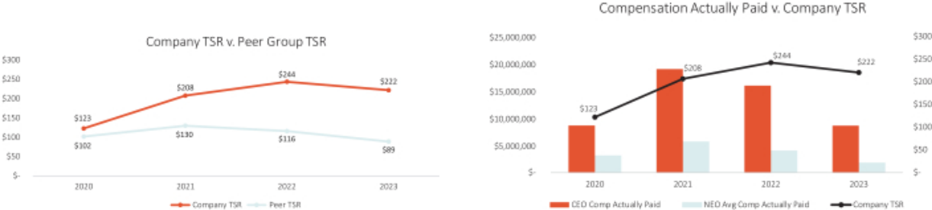

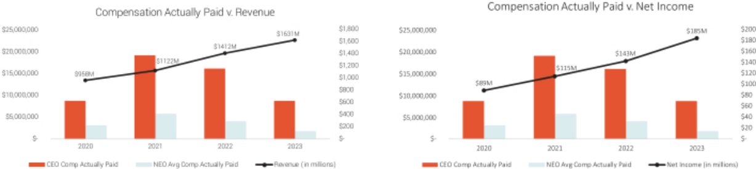

2023 Performance measures

As noted above, our Compensaton and Talent Management Commitee believes in a wholistc evaluaton of our executves’ and our Company’s performance and uses a mix of performance measures throughout our annual and long-term incentve programs to align executve pay with stockholder value creaton. As required by SEC rules, in 2023, the fnancial performance measures identfed as the most important and used by us to link compensaton actually paid for our for named executve ofcers’ are listed below.


Revenue

Adjusted Operatng Proft Margin

Relatve TSR

102 | / | EXL 2024 Proxy Statement

Table of Contents

Executve compensaton

Director compensaton for fscal year 2023

The following table sets forth informaton for compensaton earned in fscal year 2023 by our non-executve directors who served during fscal year 2023:

 | Fees earned or |  |  |  | All Other
 | paid in cash |  | Stock awards |  | compensaton |  | Total
Name(1) | ($) |  | _{($)}(2)(3) |  | ($)(4) |  | ($)
Andreas Fibig(5) | 85,000 |  | 273,808 |  | — |  | 358,808
Anne Minto(6) | 42,500 |  | — |  | 19,591 |  | 62,091
Som Mital | 85,000 |  | 190,000 |  | 321 |  | 275,321
Clyde Ostler(6) | 42,500 |  | — |  | — |  | 42,500
Vikram Pandit | 85,000 |  | 290,000 |  | — |  | 375,000
Kristy Pipes | 97,500 |  | 190,000 |  | — |  | 287,500
Nitn Sahney | 95,000 |  | 190,000 |  | — |  | 285,000
Jaynie Studenmund | 95,000 |  | 190,000 |  | — |  | 285,000
Sarah K. Williamson(7) | 63,750 |  | 190,000 |  | — |  | 253,750

- Mr. Kapoor’s compensaton during 2023 was based solely on his role as CEO, as disclosed in the “Summary compensaton table for fscal year 2023” beginning on page 84 and discussed in “Compensaton Discussion and Analysis” beginning on page 60. He does not receive any additonal compensaton for his services as a director.

- Amounts refect the aggregate grant date fair value of stock awards recognized for fnancial statement reportng purposes for the fscal year ended December 31, 2023, in accordance with FASB ASC Topic 718 (disregarding any forfeiture assumptons). Assumptons used in the calculaton of these amounts are included in footnotes 2 and 23 to our audited fnancial statements for the fscal year ended December 31, 2023 included in the 2023 Form 10-K.

- The outstanding equity awards, comprised entrely of unvested restricted stock units, held by each of our non-employee directors on December 31, 2023 are as follows: for each of Ms. Minto and Mr. Ostler: 0; Mr. Fibig: 8,515; for each of Mr. Mital, Ms. Pipes, Mr. Sahney, Ms. Studenmund, and Ms. Williamson: 6,050; and Mr. Pandit: 9,235.

- For Ms. Minto and Mr. Mital, amount refects our reimbursement to the director for fees associated with tax preparer services.

- Mr. Fibig joined the board efectve January 10, 2023. The value of his stock award represents a pro-rated porton of the annual equity award in respect of his service from January 10, 2023 through the Company’s 2023 annual meetng of stockholders, and the annual equity award he received in June 2023.

- Ms. Minto and Mr. Ostler retred as directors in June 2023. The amounts included in this table in respect of each such directors’ cash fees refects a pro-rated amount for the period during 2023 that each served as a director. Ms. Minto and Mr. Ostler did not receive any stock awards in respect of their 2023 service.

- Ms. Williamson joined the board in June 2023. The amount included in this table in respect of her cash fees refects a pro-rated amount for the period during 2023 that she served as director.

For 2023, non-executve directors were eligible to receive an annual retainer fee in the amount of $85,000 in cash and $190,000 in equity, granted in the form of tme-based restricted stock units, valued at the tme of grant. As the non-executve Board Chair during 2023, Mr. Pandit, was eligible to receive an additonal $100,000 in restricted stock units valued at the tme of grant. New non-employee directors who join our board of directors during a calendar quarter are eligible to receive the full cash fee for such calendar quarter and a pro-rated equity grant. The chair of our Audit Commitee was eligible to receive an additonal annual fee of $12,500 in cash, and the chairs of our Compensaton and Talent Management Commitee and Nominatng and Governance Commitee were each eligible to receive an additonal annual fee of $10,000 in cash.

There are no additonal fees payable for atendance at our board or commitee meetngs (whether in person, telephonic or otherwise). We make quarterly cash payments in respect of the director fees to our directors.

 | EXL 2024 Proxy Statement | / 103

Table of Contents

Executve compensaton

Directors who hold restricted stock units do not receive the underlying shares of common stock untl the units have vested and are setled. The restricted stock units granted to directors generally vest upon the earliest of (i) the frst anniversary of the date of grant, (ii) the date on which the director’s term on the board expires if the director is not subsequently elected to a new term and (iii) a change in control. The restricted stock units issued to each of our non-employee directors will generally setle on the earliest of (i) the director’s death, (ii) a change in control, or (iii) 180 days following the end of the director’s term on our board of directors. However, in lieu of setlement 180 days following the director’s term, a director may elect in advance that the units be setled on an alternate delivery date following the director’s service on the board, or if the director has satsfed our stock ownership guidelines, upon the vestng date of the award.

We maintain a non-employee director stock ownership policy that requires directors to maintain stock ownership of at least fve tmes their respectve annual cash retainers (countng common stock, vested restricted stock units and unvested tme-based restricted stock units). New directors have fve years from their appointment date to atain the required stock ownership levels, whereas existng directors generally have three years to meet any increased ownership requirements as a result of annual cash retainer increases.

Common stock is counted toward the ownership requirement if it is owned by or for the beneft of the director, the director’s spouse or the director’s children sharing the same household. During the applicable phase-in period, directors generally must retain at least 50% of shares delivered following the vestng of an equity award untl the ownership requirement is met. If the ownership requirement is not met at the end of the phase-in period, directors generally may not sell any shares untl the ownership requirement is met. Notwithstanding these share retenton requirements, directors may sell shares to satsfy tax obligatons arising with respect to equity awards.

As of December 15, 2023, all applicable directors were in compliance with this policy.

We updated our non-employee director compensaton program for 2024 to provide for an increase in the annual equity grant to $215,000, while maintaining a cash retainer of $85,000. The Lead Director or Independent Chair, as applicable, is also eligible to receive annually an additonal $100,000 in restricted stock units valued at the tme of grant. Additonally, the annual fees for the chairs of the Audit Commitee and Compensaton and Talent Management Commitee increased to $17,500 each and the fee for the chair of Nominatng and Governance Commitee increased to $15,000.

104 | / | EXL 2024 Proxy Statement

Table of Contents

Stock ownership of directors, executve ofcers and certain benefcial owners

Stock ownership of directors, executve ofcers and certain benefcial owners

Unless otherwise indicated, the table below sets forth informaton with respect to the benefcial ownership of our common stock by:

- each of our directors and each of our named executve ofcers individually;

- each person who is known to be the benefcial owner of more than 5% of our common stock; and

- all of our current directors and current executve ofcers (i.e., not just named executve ofcers) as a group.

The amounts and percentages of common stock benefcially owned below are as of March 31, 2024 (the “Determinaton Date”) and are reported on the basis of the regulatons of the SEC governing the determinaton of benefcial ownership of securites. Under these rules, a person is deemed to be a benefcial owner of a security if that person has or shares votng power, which includes the power to vote or to direct the votng of such security, or investment power, which includes the power to dispose of or to direct the dispositon of such security. A person is also deemed to be a benefcial owner of any securites of which that person has a right to acquire benefcial ownership within 60 days of the Determinaton Date. Under these rules, more than one person may be deemed to be a benefcial owner of the same securites. Except as otherwise indicated below, each of the persons named in the table has sole votng and investment power with respect to the securites benefcially owned by such person as set forth opposite such person’s name.

 |  |  | Vested but
Name and address(1) | Shares | %(2) | unsetled RSUs(3) | Total
Named Executve Ofcers
Rohit Kapoor | 4,225,755⁽⁴⁾ | 2.60% | — | 4,225,755
Maurizio Nicolelli | 150,985 | * | — | 150,985
Vikas Bhalla | 127,046 | * | — | 127,046
Vivek Jetley | 337,847 | * | — | 337,847
Anita M. Mahon | 94,527 | * | — | 94,527
Directors
Thomas Bartlet | — | — | — | —
Andreas Fibig | 3,000 | * | 2,465 | 5,465
Som Mital | — | * | 79,320 | 79,320
Vikram S. Pandit | 1,551,970⁽⁵⁾ | * | 46,360 | 1,598,330
Kristy Pipes | — | * | 17,400 | 17,400
Nitn Sahney | — | * | 68,465 | 68,465
Jaynie Studenmund | 18,225 | * | 41,150 | 59,375
Sarah K. Williamson | — | * | — | —
All current directors and executve ofcers as a group (17 people)⁽⁶⁾ | 6,751,711 | 4.16%

 | EXL 2024 Proxy Statement | / 105

Table of Contents

Stock ownership of directors, executve ofcers and certain benefcial owners

 | Benefcial ownership
Name and address(1) | Shares | %(2)
5% Benefcial owners
Blackrock Inc.⁽⁷⁾ | 21,267,361 | 13.09%
The Vanguard Group, Inc.⁽⁸⁾ | 17,015,630 | 10.48%
FMR LLC⁽⁹⁾ | 8,769,272 | 5.40%

*Less than 1%.

- Unless otherwise noted, the business address of each benefcial owner is c/o ExlService Holdings, Inc., 320 Park Avenue, 29th Floor, New York, New York 10022.

- Based on 162,425,610 shares outstanding as of the Determinaton Date.

- For non-management directors, this column includes restricted stock units (previously granted for service on the board) that have vested but are unsetled. Because vested restricted stock units generally setle 180 days following the director’s term of service (see “Director compensaton for fscal year 2023” for additonal details on setlement), the units are not treated as benefcially owned under SEC rules because the holder does not have the right to acquire the underlying stock within 60 days of the Determinaton Date. However, restricted stock units that are vested but unsetled provide a meaningful alignment with the Company’s stockholders, and they count towards our stock ownership policy for non-employee directors, which requires directors to maintain stock ownership of at least fve tmes their respectve annual retainers.

- The amount includes: (a) 885,670 shares of our common stock owned indirectly by Mr. Kapoor through a family trust created in 2016 under a 2005 grantor-retained annuity trust, for which

Mr. Kapoor’s spouse and Mr. Kapoor’s brother are the co-trustees and share dispositve and votng control over the shares in the trust, (b) 201,095 shares of our common stock owned indirectly by Mr. Kapoor through a family trust created in 2016 under a 2013 grantor retained annuity trust, for which Mr. Kapoor’s spouse and Mr. Kapoor’s brother are the co-trustees and share dispositve and votng control over the shares in the trust, (c) 420,000 shares of our common stock owned indirectly by Mr. Kapoor through a spousal lifetme access trust, for which Mr. Kapoor’s spouse and

Mr. Kapoor’s brother are the co-trustees and share dispositve and votng control over the shares in the trust, (d) 420,000 shares of our common stock owned indirectly by Mr. Kapoor through a spousal lifetme access trust for Mr. Kapoor’s spouse, for which Mr. Kapoor and Mr. Kapoor’s brother are the co-trustees and share dispositve and votng control over the shares in the trust, and

- 665,925 shares of our common stock owned indirectly by Mr. Kapoor through a family trust created in 2016 for which Mr. Kapoor is the investment advisor to Commonwealth Trust Company, the trustee.

(5) Mr. Pandit has shared dispositve and votng control over the reported securites, which are held by Orogen Echo LLC (“OE”). The Orogen Group LLC (“Orogen”) is the sole member of OE and

Mr. Pandit is the Chairman and Chief Executve Ofcer of Orogen. Orogen Holdings LLC and Atairos-Orogen Holdings, LLC are the sole members with joint investment control of Orogen. Mr. Pandit has majority votng control of Orogen Holdings LLC.

(6) Includes eight current non-employee directors and our nine current executve ofcers as of the Determinaton Date.

(7) Based on the Schedule 13G/A fled on January 23, 2024, Blackrock, Inc. had sole votng power with respect to 20,690,552 shares and sole dispositve power with respect to 21,267,361 shares. The business address of Blackrock, Inc. is 55 East 52nd Street, New York, New York 10022.

(8) Based on the Schedule 13G/A fled on February 13, 2024, The Vanguard Group, Inc. had shared votng power with respect to 299,801 shares, sole dispositve power with respect to 16,539,920 shares and shared dispositve power with respect to 475,710 shares. The business address of The Vanguard Group, Inc. is 100 Vanguard Boulevard, Malvern, PA 19355.

(9) Based on the Schedule 13G/A fled on February 9, 2024, FMR LLC had sole votng power with respect to 8,760,776 shares and sole dispositve power with respect to 8,769,272 shares. The business address of FMR LLC is 245 Summer Street, Boston, Massachusets 02210.

106 | / | EXL 2024 Proxy Statement

Table of Contents

Certain relatonships and related person transactons

Certain relatonships and related person transactons

Review and approval of related party transactons

We review all relatonships and transactons in which we, our directors and executve ofcers or their immediate family members and our 5% stockholders are partcipants to determine whether such persons have a direct or indirect material interest in such transactons. Our Code of Conduct and Ethics instructs our directors, ofcers and employees to report the facts and circumstances of any such transacton or potental transacton to our General Counsel or our Audit Commitee. Our board of directors has adopted a policy regarding the review of potental related party transactons. Under this policy, our General Counsel will review the facts and

- Factors used in assessing related party transactons


• The nature of the related party transacton

• The related party’s interest in the transacton

• The material terms of the transacton, including the
amount involved and type of transacton

• The importance of the transacton to us and to the related
party

• Whether the transacton would impair the judgment of a
director or executve ofcer to act in our best interest

circumstances of any covered transacton. If our General Counsel determines that the transacton involves a related party transacton and the amount involved does not equal or exceed $120,000, our General Counsel will approve or disapprove the transacton. If our General Counsel determines that the transacton involves a related party transacton and the amount involved equals or exceeds $120,000, our General Counsel will refer the transacton to our Audit Commitee for consideraton. In the course of reviewing, approving or ratfying a disclosable related party transacton, our General Counsel and Audit Commitee considers all factors it considers appropriate, including but not limited to the factors in the box to the right.

Related party transactons

As required under SEC rules, transactons that are determined to be directly or indirectly material to us or a related person and which involve amounts exceeding $120,000 in the previous fscal year are disclosed in our Proxy Statement. There were no related person transactons in fscal year 2023.

 | EXL 2024 Proxy Statement | / 107

Table of Contents

Audit Commitee Report

Audit Commitee Report

The Audit Commitee of the board of directors of ExlService Holdings, Inc. assists our board of directors in fulflling its oversight responsibilites with respect to the following:

- our accountng and fnancial reportng processes, including the integrity of the fnancial statements and other fnancial informaton provided by us to our stockholders, the public, stock exchanges and others;

- our compliance with legal and regulatory requirements;

- our registered independent public accountng frm’s qualifcatons and independence;

- the audit of our fnancial statements; and

- the performance of our internal audit functon and independent registered public accountng frm.

In connecton with these responsibilites, the Audit Commitee met with management and Deloite & Touche LLP to review and discuss the December 31, 2023 audited consolidated fnancial statements. The Audit Commitee also discussed with Deloite & Touche LLP the maters required to be discussed by the applicable requirements of the Public Company Accountng Oversight Board and the SEC. The Audit Commitee also received writen disclosures and the leter from Deloite & Touche LLP required by Rule 3526 of the Public Company Accountng Oversight Board (Communicatons with Audit Commitees Concerning Independence), and the Audit Commitee discussed with Deloite & Touche LLP the frm’s independence.

Based on the review and discussions referred to above, the Audit Commitee approved the inclusion of the audited fnancial statements in the Company’s Annual Report on Form 10-K for the fscal year ended December 31, 2023.

Audit Commitee

Ms. Kristy Pipes (Chair)

Mr. Thomas Bartlet

Mr. Andreas Fibig

Mr. Nitn Sahney

Ms. Jaynie Studenmund

Ms. Sarah K. Williamson

108 | / | EXL 2024 Proxy Statement

Table of Contents

Proposal 1 — Electon of directors

Proposal 1 — Electon of directors

The nominees

Our Nominatng and Governance Commitee has nominated, and our board of directors has designated, Mses. Pipes, Studenmund and Williamson and Messrs. Kapoor, Pandit, Bartlet, Fibig, and Sahney to stand for electon as directors at the Annual Meetng. Mr. Mital will not be standing for re-electon at the Annual Meetng. Mr. Bartlet was identfed and recommended to the Nominatng and Governance Commitee by a third-party search frm.

Term of ofce

If elected, each of the director nominees will serve a term of one year on our board of directors, untl our 2025 Annual Meetng of Stockholders or untl their respectve successors are duly elected and qualifed in accordance with our By-laws.

Votng instructons and substtutes

The proxies given to the proxy holders will be voted or not voted as directed and, if no directon is given, will be voted FOR these eight nominees. Our board of directors knows of no reason why any of these nominees should be unable or unwilling to serve. However, if for any reason any nominee should be unable or unwilling to stand for electon, the shares represented by proxies will be voted for the electon of any substtute nominee designated by our board of directors to fll the vacancy.

General informaton about nominees

The age as of the date of this Proxy Statement, tenure on our board of directors and commitee membership, if any, of each nominee appears below. Informaton regarding the business experience during at least the last fve years and directorships of other publicly owned corporatons of each nominee can be found above under “Our board of directors.” Other informaton required with respect to any solicitaton of proxies in connecton with the electon of directors is found elsewhere in this Proxy Statement.

 | EXL 2024 Proxy Statement | / 109

Table of Contents

Proposal 1 — Electon of directors
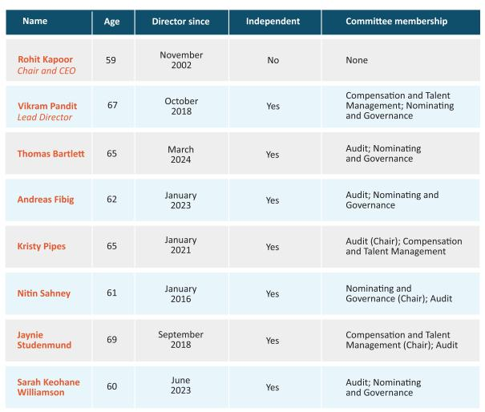

Required vote

The afrmatve vote of a majority of votes cast (meaning the number of shares voted “for” a nominee must exceed the number of shares voted “against” such nominee) at the Annual Meetng will elect the eight nominees as directors for a term of one year. If any nominee for director receives a greater number of votes “against” his or her electon than votes “for” such electon, our By-laws provide that such person will tender to the board of directors his or her resignaton as a director. Unless marked to the contrary, proxies received will be voted “FOR” the nominees.


Our board recommends that you vote

FOR the electon of Mses. Pipes, Studenmund and Williamson and Messrs. Kapoor, Pandit, Bartlet, Fibig, and Sahney as directors of the Company

110 | / | EXL 2024 Proxy Statement

Table of Contents

Proposal 2 — Ratfcaton of the appointment of independent registered public accountng frm

Proposal 2 — Ratfcaton of the appointment of independent registered public accountng frm

Our Audit Commitee has appointed Deloite & Touche LLP (“Deloite”) as the independent registered public accountng frm to audit the Company’s and its subsidiaries’ books, records and accounts for the fscal year 2024. Our board of directors has endorsed this appointment. Ratfcaton of the appointment of Deloite by our stockholders is not required by law. However, as a mater of good corporate practce, such appointment is being submited to our stockholders for ratfcaton at the Annual Meetng. If our stockholders do not ratfy the appointment, our board of directors and our Audit Commitee will reconsider whether or not to retain Deloite, but may nonetheless retain Deloite. Even if the appointment is ratfed, the Audit Commitee in its discreton may change such appointment at any tme during the year if it determines that such change would be in the best interests of the Company and our stockholders.

In retaining Deloite as the Company’s independent registered public accountng frm, the Audit Commitee considered whether the provision of non-audit services by Deloite was compatble with maintaining Deloite’s independence and concluded that it was. Representatves of Deloite are expected to be present at the Annual Meetng. They will have an opportunity to make a statement, if they desire to do so, and will be available to respond to appropriate questons. Deloite has served as our independent registered public accountng frm since February 28, 2018.

Audit and non-audit fees

The following is a summary of the fees billed or expected to be billed to us by the Company’s independent registered public accountng frm for professional services rendered in each of the last two fscal years:

 | Fiscal | Fiscal
Fee category | 2023 | 2022
 |  | (in thousands)
Audit fees | $1,550 | $1,529
Audit-related fees | — | —
Tax fees | 37 | 45
All other fees | 30 | 33
Total fees | $1,617 | $1,607

 | EXL 2024 Proxy Statement | / 111

Table of Contents

Proposal 2 — Ratfcaton of the appointment of independent registered public accountng frm

Audit fees:

Consist of fees billed or expected to be billed for professional services rendered for the audit of our consolidated fnancial statements, including (i) the audit of efectveness of internal control over fnancial reportng, (ii) review of our consolidated fnancial statements included in our quarterly reports, and

- services that are normally provided by our independent registered public accountants including services in connecton with statutory or regulatory flings or engagements for those fscal years.

Audit-related fees:

Consist of fees billed for assurance and related services that are reasonably related to the performance of the audit or review of our consolidated fnancial statements and are not reported under “Audit Fees.”

Tax fees:

Consist primarily of fees billed or expected to be billed for other tax fling and advisory projects.

All other fees:

Consist of fees billed or expected to be billed for other permissible work performed by our independent registered public accountng frm that does not meet the above category descriptons.

Our Audit Commitee pre-approves and is responsible for the engagement of all auditng services provided by our independent registered public accountants and all non-auditng services to be provided by such accountants to the extent permited under Secton 10A of the Exchange Act, including all fees and other terms of engagement. Our Audit Commitee may delegate the authority to pre-approve audit and permited non-audit services between meetngs of our Audit Commitee to a designated member of our Audit Commitee, provided that the decisions made by such member are presented to our full Audit Commitee for ratfcaton at its next scheduled meetng.

All of the fees paid to Deloite in fscal year 2023 were pre-approved by the Audit Commitee.

Required vote

The ratfcaton of the appointment of Deloite as our independent registered public accountng frm requires the afrmatve vote of a majority of shares present in person or represented by proxy and enttled to vote at the Annual Meetng. Unless marked to the contrary, proxies received will be voted “FOR” ratfcaton of the appointment.


Our board recommends that you vote:

FOR the ratfcaton of the appointment of Deloite as our independent
registered public accountng frm

112 | / | EXL 2024 Proxy Statement

Table of Contents

Proposal 3 — Advisory (non-binding) vote to approve executve compensaton

Proposal 3 — Advisory (non-binding) vote to approve executve compensaton

Proposal 3 is a vote, on a non-binding advisory basis, to approve the compensaton of our executve ofcers as described in this Proxy Statement. Although the vote is advisory and is not binding on the board of directors, our Compensaton and Talent Management Commitee will take into account the outcome of the vote when considering future executve compensaton decisions. We refer to this vote as the “say-on-pay” vote.

At the 2023 Annual Meetng of Stockholders, our stockholders voted on a proposal relatng to the frequency of the “say-on-pay” vote. We recommended, and our stockholders approved on a non-binding advisory basis, an annual say-on-pay vote. Accordingly, we include the say-on-pay vote each year as a regular part of each Annual Meetng of Stockholders. The next vote on the frequency of the “say-on-pay” vote will be held at the 2029 Annual Meetng of Stockholders.

- Our board of directors is commited to corporate governance best practces and recognizes the signifcant interest of stockholders in executve compensaton maters.

- Our board of directors believes that our current executve compensaton program directly links executve compensaton to our performance and aligns the interests of our executve ofcers with those of our stockholders. For example, the bulk of our annual incentve awards is earned based on achievement of two core fnancial metrics: revenues and AOPM. As we discuss in greater detail in our Compensaton Discussion and Analysis, these fnancial metrics focus our named executve ofcers on top-line revenues and botom-line earnings that are likely to make meaningful contributons to our future fnancial performance. We believe rewarding our executves with incentve pay based on achievement of these fnancial metrics closely aligns management with the interests of our stockholders.

In additon, our philosophy places more emphasis on variable elements of compensaton (such as annual incentves and equity-based compensaton) than fxed remuneraton.

Our stockholders have the opportunity to vote for, against or abstain from votng on the following resoluton:

“Resolved, that the stockholders approve on an advisory basis the compensaton of our named executve ofcers, as disclosed pursuant to the compensaton disclosure rules of the SEC (which disclosure shall include the Compensaton Discussion and Analysis, the compensaton tables and any related material disclosed in this Proxy Statement).”

The above-referenced disclosures related to the compensaton of our named executve ofcers appear beginning at page 61 of this Proxy Statement.

 | EXL 2024 Proxy Statement | / 113

Table of Contents

Proposal 3 — Advisory (non-binding) vote to approve executve compensaton

Required vote

The approval, on an advisory (non-binding) basis, of the compensaton of our named executve ofcers requires the afrmatve vote of a majority of shares present in person or represented by proxy and enttled to vote at the Annual Meetng. Unless marked to the contrary, proxies received will be voted “FOR” the approval of the compensaton of our named executve ofcers.


Our board recommends that you vote:

the approval, on an advisory (non-binding) basis, of the compensaton of
our named executve ofcers as disclosed pursuant to the compensaton
FOR disclosure rules of the SEC (including the Compensaton Discussion and Analysis, the compensaton tables and any related material disclosed in this Proxy Statement)

114 | / | EXL 2024 Proxy Statement

Table of Contents

Proposal 4 — Fourth Amended and Restated Certfcate of Incorporaton

Proposal 4 — Fourth Amended and Restated Certfcate of Incorporaton to provide for, among other things, ofcer exculpaton

The board of directors has unanimously approved and declared advisable, and recommends that our stockholders adopt, a proposal to amend and restate our Restated Certfcate of Incorporaton to refect new Delaware law provisions regarding ofcer exculpaton (the “Ofcer Exculpaton Provisions”) and to efect certain other changes as described below. Set forth in Annex A to this Proxy Statement is a form of the proposed Fourth Amended and Restated Certfcate of Incorporaton that would be adopted should this proposal 4 be approved by stockholders at the Annual Meetng.

Ofcer Exculpaton

Secton 7 of our Restated Certfcate of Incorporaton currently includes a provision, authorized under the General Corporaton Law of the State of Delaware (the “DGCL”), that eliminates the personal liability of directors for monetary damages for breach of fduciary duty as a director to the fullest extent permited by the DGCL.

Prior to 2022, the DGCL did not allow for similar eliminaton or limitaton of ofcers’ personal liability. As a result, stockholder plaintfs employed tactcs of bringing certain claims against individual ofcers when such claims would otherwise be exculpated and dismissed if brought against directors. However, the State of Delaware, which is the Company’s state of incorporaton, recently amended Secton 102(b)(7) of the DGCL to enable Delaware corporatons to limit the personal liability of certain of their ofcers in limited circumstances (the “Secton 102(b)(7) Amendment”). The Secton 102(b)(7) Amendment was adopted to address inconsistent treatment between ofcers and directors and address rising litgaton and insurance costs for stockholders.

The board of directors believes that there is a need for directors and ofcers to remain free of the risk of fnancial ruin as a result of an unintentonal misstep. The nature of the role of directors and ofcers ofen requires them to make decisions on crucial maters. Frequently, directors and ofcers must make decisions in response to tme-sensitve opportunites and challenges in an evolving macroeconomic and regulatory environment, without the beneft of hindsight. The board of directors believes that exculpaton provisions empower both directors and ofcers to exercise their best judgment in furtherance of stockholder interests. In additon, adoptng an exculpaton provision that aligns with Delaware law could prevent costly and protracted litgaton that distracts our ofcers from important operatonal and strategic maters.

The board of directors also expects that exculpaton clauses applicable to ofcers could become widely used by public corporatons, including our peers, and that failing to adopt the Ofcer Exculpaton Provisions could negatvely impact our ability to recruit and retain exceptonal ofcer candidates who value the protecton from potental exposure to liabilites, costs of defense, and other risks of proceedings that would be aforded by protecton similar to that aforded by the Ofcer Exculpaton Provisions. Additonally, the Ofcer Exculpaton Provisions will align the protectons for our ofcers with those protectons already aforded to our directors.

In light of the Secton 102(b)(7) Amendment, we propose to amend and restate our Restated Certfcate of Incorporaton to add a provision exculpatng certain of the Company’s ofcers from liability, as permited by Delaware law, similar to the protectons currently available for directors of the Company in our current Restated Certfcate of Incorporaton. If this proposal is approved and our current Restated Certfcate of Incorporaton is amended and restated, the Company’s ofcers, in additon to the

 | EXL 2024 Proxy Statement | / 115

Table of Contents

Proposal 4 — Fourth Amended and Restated Certfcate of Incorporaton

Company’s directors, would be exculpated from monetary liability for fduciary duty breaches, solely to the extent permited under Secton 102(b)(7) of the DGCL. With these changes, we aim to strike a balance between stockholders’ interest in accountability and their interest in the Company being able to atract and retain quality ofcers to work on its behalf. For these reasons, our board of directors has determined that it is in the best interests of the Company and its stockholders to seek to update the exculpaton provision.

Other Modifcatons

Our board of directors is also recommending the following changes to our Restated Certfcate of Incorporaton to remove inapplicable or outdated provisions, which changes are included in the draf Fourth Amended and Restated Certfcate of Incorporaton set forth in Annex A:

- Removing all references to a series of our capital stock designated as Series A Preferred Stock, which were repurchased in 2006 in connecton with our inital public ofering (the “IPO”). These references appear in Sectons 4, 5.3 and Annex B of our Restated Certfcate of Incorporaton.

- Removing all references to a series of our capital stock designated as Series B Common Stock, which were automatcally converted into our shares of Common Stock in connecton with our IPO. These references appear in Sectons 5.1(b) and Annex A of our Restated Certfcate of Incorporaton.

Proposed Changes

If approved, Secton 7 of our current Restated Certfcate of Incorporaton would be amended to read as follows:

- Limitaton of Liability. To the fullest extent permited by the General Corporaton Law, as the same exists or may hereafer be amended, a Director or ofcer of the Corporaton shall not be personally liable to the Corporaton or its stockholders for monetary damages for breach of fduciary duty as a Director or ofcer. Any amendment, repeal or modifcaton of the foregoing provision shall not adversely afect any right or protecton of a Director or ofcer of the Corporaton hereunder in respect of any act or omission occurring prior to the tme of such amendment, repeal or modifcaton.

In additon, the Fourth Amended and Restated Certfcate of Incorporaton would efect the following edits to our Restated Certfcate of Incorporaton:

- The second sentence of Secton 4 would be amended to remove the words “, of which 45,833.36 are designated as Series A Preferred Stock (“Series A Preferred Stock”).”

- Sectons 5.1(b) and 5.3 and Annexes A and B would be deleted in their entretes.

If stockholders approve this proposal 4, the changes described in this proposal 4 will become legally efectve upon the fling of the Fourth Amended and Restated Certfcate of Incorporaton with the Secretary of State of the State of Delaware, which is expected to occur shortly following the Annual Meetng. However, even if stockholders approve this proposal 4, our board of directors may, in its sole discreton, abandon this acton without further shareholder acton prior to the efectveness of the fling of the Fourth

116 | / | EXL 2024 Proxy Statement

Table of Contents

Proposal 4 — Fourth Amended and Restated Certfcate of Incorporaton

Amended and Restated Certfcate of Incorporaton and, if abandoned, the changes refected therein, including regarding ofcer exculpaton, will not become efectve. If stockholders do not approve this proposal 4, our Restated Certfcate of Incorporaton will not be amended and restated and the modifcatons, including the Ofcer Exculpaton Provisions, described in this proposal 4 will not take efect.

Required vote

The approval of the Fourth Amended and Restated Certfcate of Incorporaton to provide for, among other things, ofcer exculpaton requires the afrmatve vote of the holders of a majority of our outstanding shares of common stock, votng together as a single class. Unless marked to the contrary, proxies received will be voted “FOR” approval of the Fourth Amended and Restated Certfcate of Incorporaton.


Our board recommends that you vote:

the approval of the Fourth Amended and Restated Certfcate of ^{FOR} Incorporaton to provide for, among other things, ofcer exculpaton

 | EXL 2024 Proxy Statement | / 117

Table of Contents

Miscellaneous

Miscellaneous

Stockholder proposals and director nominatons for the 2025 Annual Meetng

Stockholder proposals intended to be included in our proxy materials for the 2025 Annual Meetng of Stockholders (“2025 Annual Meetng”) must be received by the deadline calculated in accordance with SEC Rule 14a-8, which is 120 days before the anniversary of the date of this year’s Proxy Statement. This year’s deadline is December 30, 2024. Such proposals must include the informaton required by SEC rules, and should be sent in writng by courier or certfed mail to the Corporate Secretary of the Company at 320 Park Avenue, 29th Floor, New York, New York 10022. Stockholder proposals that are sent to any other person or locaton or by any other means may not be received in a tmely manner and thus may be ineligible for inclusion.

Stockholders who intend to submit proposals at the 2025 Annual Meetng but whose proposals are not included in the proxy materials for the meetng, and stockholders who intend to submit nominatons for directors at the 2025 Annual Meetng, are required to notfy the Corporate Secretary of the Company (at the address above) of their proposal or nominatons not less than 90 days, nor more than 120 days, before the anniversary of this year’s Annual Meetng of Stockholders, in accordance with our By-laws. Such notces of proposals for the 2025 Annual Meetng must be delivered between February 19, 2025 and March 21, 2025. Special notce provisions apply under the By-laws if the date of the 2025 Annual Meetng is more than 30 days before or 70 days afer the anniversary date of this year’s Annual Meetng of Stockholders.

Any notce of proposed business or nominaton, whether or not included in our Proxy Statement, must include the informaton required under our By-laws, including Secton 2.11.4, in order for the mater to be eligible for consideraton at the 2025 Annual Meetng. In additon, to comply with the universal proxy rules, stockholders who intend to solicit proxies in support of director nominees other than the Company’s nominees must provide notce that sets forth the informaton required by Rule 14a-19 under the Exchange Act no later than April 20, 2025.

The presiding ofcer of the 2025 Annual Meetng may refuse to acknowledge any mater or nominaton not made in compliance with the procedures in our By-laws. Our By-laws can be found on our website and the current SEC rules for submitng stockholder proposals can be obtained from the SEC at: Division of Corporaton Finance, 100 F. Street, N.E., Washington, DC 20549, or through the SEC’s Internet website at www.sec.gov.

Delivery of documents to stockholders sharing an address

If you are the benefcial owner, but not the record holder, of shares of our common stock, your broker, bank, trust or other nominee may only deliver one copy of this Proxy Statement and the 2023 Form 10-K, which serves as our Annual Report to Stockholders under Regulaton 14A (the “2023 Annual Report”), to multple stockholders who share an address unless that nominee has received contrary instructons from one or more of the stockholders. We will deliver promptly, upon writen or oral request, a separate copy of this Proxy Statement and the 2023 Annual Report to a stockholder at a shared address to which a single copy of the documents was delivered. A stockholder who wishes to receive a separate copy of the Proxy Statement and annual report, now or in the future, should submit this request to our investor relatons department through the Investor Relatons page of our website at htps://ir.exlservice.com/. Benefcial owners sharing an address who are receiving multple copies of proxy

118 | / | EXL 2024 Proxy Statement

Table of Contents

Miscellaneous

materials and annual reports and who wish to receive a single copy of such materials in the future will need to contact their broker, bank, trust or other nominee to request that only a single copy of each document be mailed to all stockholders at the shared address in the future.

Electronic access to Proxy Statement and Annual Report

This proxy statement and our 2023 Annual Report may be viewed on our website at www.exlservice.com and at www.proxyvote.com by following the instructons provided in the Internet Notce. If you are a stockholder of record, you can elect to access future annual reports and proxy statements electronically by marking the appropriate box on your proxy form. If you choose this opton, you will receive a proxy form in mid-May listng the website locatons and your choice will remain in efect untl you notfy us by mail that you wish to resume mail delivery of these documents. If you hold your common stock through a bank, broker or another holder of record, refer to the informaton provided by that entty for instructons on how to elect this opton.

Delinquent Secton 16(a) reports

Secton 16(a) of the Exchange Act requires our directors, executve ofcers and holders of more than 10% of the Company’s common stock to fle reports with the SEC regarding their ownership and changes in ownership of our securites. Based upon our examinaton of the copies of Forms 3, 4, and 5, and amendments thereto fled electronically with the SEC and the writen representatons of our reportng persons, we believe that all reports were fled on a tmely basis during fscal 2023.

Forward-looking statements

This Proxy Statement contains forward-looking statements within the meaning of the United States Private Securites Litgaton Reform Act of 1995. You should not place undue reliance on these statements because they are subject to numerous uncertaintes and factors relatng to our operatons and business environment, all of which are difcult to predict and many of which are beyond our control. These statements ofen include words such as “may,” “will,” “should,” “believe,” “expect,” “antcipate,” “intend,” “plan,” “estmate” or similar expressions. These statements are based on assumptons that we have made in light of our experience in the industry as well as our perceptons of historical trends, current conditons, expected future developments and other factors we believe are appropriate under the circumstances. As you read and consider this Proxy Statement, you should understand that these statements are not guarantees of performance or results. They involve known and unknown risks, uncertaintes and assumptons. Although we believe that these forward-looking statements are based on reasonable assumptons, you should be aware that many factors could afect our actual fnancial results or results of operatons and could cause actual results to difer materially from those in the forward-looking statements. For a more detailed discussion of these factors, see the informaton under “Risk Factors” and “Management’s Discussion and Analysis of Financial Conditon and Results of Operatons” in the 2023 Form 10-K.

 | EXL 2024 Proxy Statement | / 119

Table of Contents

Non-GAAP Reconciliaton

Non-GAAP Reconciliaton

The Company reports its fnancial results in accordance with U.S. generally accepted accountng principles (“GAAP”). However, certain non-GAAP measures have been provided in this Proxy Statement.

These non-GAAP fnancial measures are not based on any comprehensive set of accountng rules or principles, should not be considered a substtute for, or superior to, fnancial measures calculated in accordance with GAAP, and may be diferent from non-GAAP fnancial measures used by other companies. Accordingly, the fnancial results calculated in accordance with GAAP and reconciliatons from those fnancial statements should be carefully evaluated.

The Company believes that non-GAAP fnancial measures – present additonal useful comparisons between current results and results in prior operatng periods, providing investors with a supplemental view of the underlying trends of the Company’s business. The Company also uses

these non-GAAP fnancial measures in making fnancial, operatng, planning and compensaton decisions and in evaluatng the Company’s performance.

Non-GAAP measures/ inputs for Proxy statement 2024

Descripton of Adjusted Financial Measures to GAAP Measures

Our adjusted net income and adjusted diluted EPS refers to net income as per GAAP, adjusted for non-cash expenses like stock-based compensaton expense and amortzaton of acquisiton-related intangible assets and certain non-recurring expenses/(benefts) that the management believe can provide useful supplemental informaton for investors analyzing period-to-period comparisons of the Company’s results and comparisons of the Company’s results with the results of other companies. Our adjusted net income and adjusted diluted EPS also excludes the efects of income tax on such adjustments, as applicable.

120 | / | EXL 2024 Proxy Statement

Table of Contents

Non-GAAP Reconciliaton

The following table shows the reconciliaton of non-GAAP fnancial measures for the year ended December 31, 2023 and 2022:

Reconciliaton of Adjusted Net Income and Adjusted Diluted Earnings Per Share (Amounts in thousands, except per share data)

 |  |  | Year ended
 |  |  | December 31,
 |  |  | 2023 |  | 2022
Net income (GAAP) |  | $ | 184,558 | $ | 142,968
add: Stock-based compensaton expense |  |  | 58,437 |  | 49,366
add: Amortzaton of acquisiton-related intangibles |  |  | 14,678 |  | 17,109
add/(subtract): Allowance/(reversal) for expected credit losses^{(a)} |  |  | 1,436 |  | —
add/(subtract): Changes in fair value of contngent consideraton |  |  | 1,900 |  | 8,500
add/(subtract): Other expenses/(benefts)^{(b)} |  |  | 1,102 |  | 635
subtract: Tax impact on stock-based compensaton expense^{(c)} |  |  | (17,333) |  | (9,785)
subtract: Tax impact on amortzaton of acquisiton-related intangibles |  |  | (3,622) |  | (4,151)
add/(subtract): Tax impact on allowance/(reversal) for expected credit losses |  |  | (364) |  | —
add: Tax impact on changes in fair value of contngent consideraton |  |  | 152 |  | —
add/(subtract): Tax impact on other expenses/(benefts) |  |  | (280) |  | (29)
add/(subtract): Other tax expenses/(benefts)^{(d)} |  |  | 223 |  | (1,079)
Adjusted net income (Non-GAAP) |  | $ | 240,887 | $ | 203,534
Adjusted diluted earnings per share (Non-GAAP) |  | $ | 1.43 | $ | 1.20

- To exclude the efects of material allowance/(reversal) for expected credit losses on accounts receivables related to a customer bankruptcy event.

- To exclude provision for litgaton maters of $613 and $1,061, efects of lease terminaton of $489 and ($560) and other items, individually insignifcant of $nil and $134 for the year ended December 31, 2023 and 2022, respectvely.

- Tax impact includes $15,055 and $5,881 for the year ended December 31, 2023 and 2022 respectvely related to discrete beneft recognized in income tax expense in accordance with ASU No. 2016-09, Compensaton - Stock Compensaton.

- To exclude other tax expenses/(benefts) related to certain deferred tax assets and liabilites.

 | EXL 2024 Proxy Statement | / 121

Table of Contents

Annual Meetng Q&A

Annual Meetng Q&A

Who is providing this Proxy Statement?

This Proxy Statement is being furnished to you in connecton with the solicitaton by the board of directors of ExlService Holdings, Inc., a Delaware corporaton (“us,” “we,” “our” or the “Company”), of proxies to be used at our 2024 Annual Meetng of Stockholders (the “Annual Meetng”) to be held in virtual format only via live audio webcast at the website www.virtualshareholdermeetng.com/EXLS2024 on June 20, 2024 at 9:00 AM, Eastern Time, and any adjournments or postponements thereof.

How are the proxy materials being made available?

In accordance with rules and regulatons adopted by the Securites and Exchange Commission (the “SEC”), instead of mailing a printed copy of our proxy materials to each stockholder of record, the Company furnishes proxy materials via the Internet. If you received a Notce of Internet Availability of Proxy Materials (the “Internet Notce”) by mail, you will not receive a printed copy of our proxy materials other than as described herein. Instead, the Internet Notce will instruct you as to how you may access and review all of the important informaton contained in the proxy materials. The Internet Notce also instructs you as to how you may submit your proxy over the Internet or by phone. If you received an Internet Notce by mail and would like to receive a printed copy of our proxy materials, you should follow the instructons for requestng proxy materials included in the Internet Notce.

Our Notce of Annual Meetng, Proxy Statement and form of proxy card are each available at www.proxyvote.com. You may access these materials and provide your proxy by following the instructons provided in the Internet Notce.

When will the internet notce be sent?

We antcipate the Internet Notce will be sent to stockholders on or about April 29, 2024. This Proxy Statement and the form of proxy relatng to the Annual Meetng will be made available via the Internet to stockholders on or prior to the date that the Internet Notce is frst sent.

Who can vote?

Only stockholders who own shares of our common stock at the close of business on April 23, 2024, the record date for the Annual Meetng, can vote at the Annual Meetng. As of the close of business on April 23, 2024, the record date, we had 162,438,150 shares of common stock outstanding and enttled to vote. Each holder of common stock is enttled to one vote for each share held as of the record date for the Annual Meetng.

Is cumulatve votng applicable in the electon of directors?

There is no cumulatve votng in the electon of directors.

122 | / | EXL 2024 Proxy Statement

Table of Contents

Annual meetng Q&A

How do I vote my shares?

If your shares are registered directly in your name with Computershare Trust Company, N.A., our transfer agent (which means you are a “stockholder of record”), you can vote your proxy by (i) Internet, (ii) by phone or (iii) by requestng that proxy materials be sent to you by mail that will include a proxy card that you can use to vote by completng, signing, datng and returning the proxy card in the prepaid postage envelope provided. Please refer to the specifc instructons set forth in the Internet Notce.

If you are the benefcial owner of shares held in the name of a brokerage, bank, trust or other nominee as a custodian (also referred to as shares held in “street name”), your broker, bank, trustee or nominee will provide you with materials and instructons for votng your shares. In additon to votng by mail, a number of banks and brokerage frms partcipate in a program provided through Broadridge Financial Solutons, Inc. (“Broadridge”) that ofers telephone and Internet votng optons. Votes submited by telephone or by using the Internet through Broadridge’s program must be received by 11:59 p.m. Eastern Time, on June 19, 2024.

You also have the right to vote electronically at the Annual Meetng if you decide to atend. Our board of directors recommends that you vote by Internet, phone or mail even if you choose to atend the Annual Meetng. If you are a “stockholder of record,” you may vote your shares electronically at the Annual Meetng. If you hold your shares in “street name,” you must obtain a proxy from your broker, bank, trustee or nominee giving you the right to vote the shares electronically at the Annual Meetng or your vote at the Annual Meetng will not be counted.

You will not be able to vote your shares unless you use one of the methods described above to designate a proxy or you vote electronically at the Annual Meetng.

Can I revoke my proxy?

You can revoke your proxy at any tme before it is exercised in any of the following ways:

- by votng at the Annual Meetng;
- by submitng writen notce of revocaton to the inspector of electons prior to the Annual Meetng; or
- by submitng another properly executed proxy of a later date to the inspector of electons prior to the Annual Meetng.

How is a quorum established at the Annual Meetng?

A quorum, which is a majority of the issued and outstanding shares of our common stock as of the record date of April 23, 2024, must be present, in person or by proxy, to conduct business at the Annual Meetng. A quorum is calculated based on the number of shares represented by the stockholders atending the Annual Meetng in person and by their proxy holders. If you indicate an abstenton as your votng preference for all maters to be acted upon at the Annual Meetng, your shares will be counted toward a quorum but they will not be voted on any mater. Virtual atendance at our Annual Meetng consttutes presence in person for purposes of quorum at the Annual Meetng.

 | EXL 2024 Proxy Statement | / 123

Table of Contents

Annual meetng Q&A

What is a “broker non-vote”?

If you are the benefcial owner of shares held in “street name” by a broker, then your broker, as the record holder of the shares, must vote those shares in accordance with your instructons. If you fail to provide instructons to your broker, under the New York Stock Exchange rules (which apply to brokers even though our shares are listed on the Nasdaq Stock Market), your broker will not be authorized to vote your shares on “non-routne” proposals as described below. As a result, a “broker non-vote” occurs. However, without your instructons, your broker has discretonary authority to vote your shares with respect to “routne” proposals only.

How many votes are needed to approve each proposal and what is the efect of abstentons and/or broker non-votes?

If you submit your proxy, but do not mark your votng preference, the proxy holders will vote your shares (i) FOR the electon of all eight nominees for director, (ii) FOR the ratfcaton of the appointment of our independent registered public accountng frm, (iii) FOR the approval on an advisory (non-binding) basis of the compensaton of our named executve ofcers, (iv) FOR the approval of the Fourth Amended and Restated Certfcate of Incorporaton; and (vii) as described below, in the judgment of the proxy holder on any other maters properly presented at the Annual Meetng.

The chart below summarizes, for each proposal described in this Proxy Statement, the board’s votng recommendaton, the votng approval standard, and the efect of abstentons and broker non-votes. Virtual atendance at our Annual Meetng will consttute presence “in person” for purposes of votng at the Annual Meetng.

 |  | Votng approval |  |  | Efect of
 | Board votng | Votng approval | Efect of | Routne or | broker non-
Proposal | recommendaton | standard | abstentons⁽¹⁾ | non-routne | vote⁽²⁾
1: Electon of directors | FOR the electon | Afrmatve vote of a | No efect | Non-routne | No efect
 | of each nominee | majority of votes cast(3)
2: The ratfcaton of the appointment of our independent | FOR | Majority of shares | Vote | Routne | N/A
registered public accountng frm |  | present and enttled to | against(4)
 |  | vote
3: The advisory (non-binding) approval of the compensaton of | FOR | Majority of shares | Vote | Non-routne | No efect
our named executve ofcers |  | present and enttled to | against(4)
 |  | vote
4: The approval of the Fourth Amended and Restated | FOR | Afrmatve vote of a | Vote | Non-routne | Vote
Certfcate of Incorporaton to provide for, among other things, |  | majority of shares | against(4) |  | against
ofcer exculpaton |  | outstanding

- If you wish to abstain from votng on a proposal, you must indicate, or mark ABSTAIN, while votng. If a proxy is submited with no directon given, the proxies given to the proxy holders will be voted in accordance with the board recommendatons.

- As discussed above under “What is a broker non-vote?,” brokers will not be enttled to vote on “non-routne” proposals unless benefcial owners provide votng instructons.

124 | / | EXL 2024 Proxy Statement

Table of Contents

Annual meetng Q&A

- Under our By-Laws, directors who are standing for electon at the Annual Meetng will be elected by the afrmatve vote of a majority of votes cast (meaning the number of shares voted “for” a nominee must exceed the number of shares voted “against” such nominee) by stockholders in person or represented by proxy and enttled to vote at the Annual Meetng. If any incumbent nominee for director receives a greater number of votes “against” his or her electon than votes “for” such electon, our By-laws provide that such person will tender to the board of directors his or her resignaton as a director. You may cast your vote in favor of electng all of the nominees as directors, against one or more nominees, or abstain from votng your shares.

- Under the General Corporaton Law of the State of Delaware, shares that abstain consttute shares that are present and enttled to vote and, accordingly, have the practcal efect of being voted “against” these proposals requiring a majority of shares present and enttled to vote or those based on total shares outstanding).

Are there other maters to be acted upon at the meetng?

Our board of directors presently is not aware of any maters, other than those specifcally stated in the Notce of Annual Meetng, which are to be presented for acton at the Annual Meetng. If any mater other than those described in this Proxy Statement is presented at the Annual Meetng on which a vote may properly be taken, the shares represented by proxies will be voted in accordance with the judgment of the person or persons votng those shares.

What about adjournments and postponements?

Any acton on the items of business described above may be considered at the Annual Meetng at the tme and on the date specifed above or at any tme and date to which the Annual Meetng is properly adjourned or postponed.

Who pays for solicitaton of proxies?

We will pay the cost of printng and mailing proxy materials and postng them on the Internet. Upon request, we will reimburse brokers, dealers, banks and trustees, or their nominees, for reasonable expenses incurred by them in forwarding proxy materials to benefcial owners of shares of our common stock.

How can I atend the Annual Meetng and why is the Company holding the Annual Meetng in a virtual only format?

As we have done in recent years, we will hold a virtual Annual Meetng rather than a meetng at any physical locaton. We believe that holding a meetng in a virtual format provides an opportunity for broader stockholder partcipaton.

To atend and partcipate in the Virtual Annual Meetng, stockholders will need to access the live audio webcast of the meetng. To do so, stockholders of record will need to visit www.virtualshareholdermeetng.com/EXLS2024 and use their 16-digit Control Numbers provided in the Internet Notce to log in to this website, and benefcial owners of shares held in street name will need to follow the instructons provided by the broker, bank or other nominee that holds their shares. We encourage stockholders to log in to this website and access the webcast before the Annual Meetng’s start tme. Further instructons on how to atend, partcipate in and vote at the Annual Meetng, including how to demonstrate your ownership of our stock as of the record date, are available at www.virtualshareholdermeetng.com/EXLS2024. Please note you will only be able to atend, partcipate and vote in the meetng using this website. All references to atending the Annual Meetng “in person” in this Proxy Statement shall mean atending the live webcast at the Annual Meetng.

 | EXL 2024 Proxy Statement | / 125

Table of Contents

Annual meetng Q&A

How do I submit questons at the Annual Meetng?

We are commited to ensuring that our stockholders will be aforded the same rights and opportunites to partcipate in a virtual Annual Meetng as they would at a meetng held at a physical locaton. You will be able to submit questons during our Annual Meetng by visitng www.virtualshareholdermeetng.com/EXLS2024. We will try to answer as many stockholder-submited questons as tme permits that comply with the meetng rules of conduct as determined by the chair of the meetng. However, we reserve the right to edit profanity or other inappropriate language, or to exclude questons that are not pertnent to meetng maters or that are otherwise inappropriate. If we receive substantally similar questons, we will group such questons together and provide a single response to avoid repetton.

Will the Annual Meetng be recorded?

A recording of the Annual Meetng will be available online at www.virtualshareholdermeetng.com/EXLS2024 for approximately 12 months following the meetng date.

What if I have technical difcultes or trouble accessing the virtual Annual Meetng?

We will have technicians ready to assist you with any technical difcultes you may have accessing the live webcast of the Annual Meetng. A technical support phone number will be posted on www.virtualshareholdermeetng.com/EXLS2024 that you may call if you experience technical difcultes during the check-in process or during the Annual Meetng.

What if I have further questons?

If you have any further questons about votng your shares or atending the Annual Meetng, please call our Investor Relatons Department at (212) 277-7100 or email at ir@exlservice.com.

Important

Please promptly vote and submit your proxy before the Annual Meetng by (i) Internet (by following the instructons provided in the Internet Notce), (ii) by phone (by following the instructons provided in the Internet Notce) or (iii) by requestng that proxy materials be sent to you by mail that will include a proxy card that you can use to vote by completng, signing, datng and returning the proxy card in the prepaid postage envelope provided. This will not limit your right to atend or vote at the Annual Meetng.

126 | / | EXL 2024 Proxy Statement

Table of Contents

Other maters

Other maters

Our board of directors does not know of any other business that will be presented at the Annual Meetng. If any other business is properly brought before the Annual Meetng, your proxy holders will vote on it as they think best unless you direct them otherwise in your proxy instructons.

Whether or not you intend to be present at the Annual Meetng, we urge you to submit your signed proxy promptly.

By Order of the Board of Directors,

Ajay Ayyappan

Executve Vice President, General Counsel and Corporate Secretary

New York, New York

April 29, 2024

We will furnish without charge to each person whose proxy is being solicited, upon the writen request of any such person, a copy of the 2023 Form 10-K, as fled with the SEC, as well as copies of exhibits to the 2023 Form 10-K, but for copies of exhibits will charge a reasonable fee per page to any requestng stockholder. Stockholders may make such request in writng to ExlService Holdings, Inc., 320 Park Avenue, 29th Floor, New York, New York 10022, Atenton: Investor Relatons. The request must include a representaton by the stockholder that as of April 23, 2024, the stockholder was enttled to vote at the Annual Meetng.

 | EXL 2024 Proxy Statement | / 127

Table of Contents

Annex A

Annex A

FOURTH AMENDED AND RESTATED

CERTIFICATE OF INCORPORATION

OF

EXLSERVICE HOLDINGS, INC.

(Pursuant to Sectons 242 and 245 of the

General Corporaton Law of the State of Delaware)

ExlService Holdings, Inc. (the “Corporaton”), a corporaton organized and existng under and by virtue of the provisions of the General Corporaton Law of the State of Delaware (the “General Corporaton Law”),

DOES HEREBY CERTIFY:

FIRST: That the name of the Corporaton is ExlService Holdings, Inc. The original Certfcate of Incorporaton of the Corporaton was fled with the Secretary of State of the State of Delaware on the October 29, 2002. The frst Amended and Restated Certfcate of Incorporaton of the Corporaton was fled with the Secretary of State of the State of Delaware on December 13, 2002. The second Amended and Restated Certfcate of Incorporaton of the Corporaton was fled with the Secretary of State of the State of Delaware on October 24, 2006. The Restated Certfcate of Incorporaton of the Corporaton was fled with the Secretary of State of the State of Delaware on August 1, 2023.

SECOND: That the Board of Directors of the Corporaton duly adopted resolutons proposing to amend and restate the Restated Certfcate of Incorporaton of the Corporaton, declaring said amendment and restatement to be advisable and in the best interests of the Corporaton and its stockholders, and authorizing the appropriate ofcers of the Corporaton to solicit the consent of the stockholders therefor, which resoluton setng forth the proposed amendment and restatement is as follows:

RESOLVED, that the Restated Certfcate of Incorporaton of the Corporaton be amended and restated in its entrety to read as follows:

- Name. The name of the corporaton is “ExlService Holdings, Inc.”

- Address; Registered Ofce and Agent. The address of the Corporaton’s registered ofce in the State of Delaware is 1209 Orange Street, City of Wilmington, County of New Castle, State of Delaware 19801; and the name of its registered agent at such address is The Corporaton Trust Company.

- Purposes. The purpose of the Corporaton is to engage in any lawful act or actvity for which corporatons may be organized under the General Corporaton Law.

 | EXL 2024 Proxy Statement | / A-1

Table of Contents

Annex A

- Number of Shares. The Corporaton is authorized to issue two classes of stock to be designated, respectvely, “Common Stock” and “Preferred Stock.” The total number of shares of all classes of stock which the Corporaton shall have authority to issue is 415,000,000 shares, consistng of (i) 400,000,000 shares of Common Stock, $0.001 par value per share (“Common Stock”), and (ii) 15,000,000 shares of Preferred Stock, $0.001 par value per share (“Preferred Stock”).

- Classes of Shares. The designaton, relatve rights, preferences and limitatons of the shares of each class are as follows:

5.1 Common Stock. Except as otherwise provided by law or by this Certfcate of Incorporaton and subject to the express terms of any series of shares of Preferred Stock, the holders of outstanding shares of Common Stock shall exclusively possess votng power for the electon of Directors and for all other purposes, each holder of record of shares of Common Stock shall be enttled to one vote for each share of Common Stock standing in his or her name on the books of the Corporaton. Except as otherwise provided by law or by this Certfcate of Incorporaton and subject to the express terms of any series of shares of Preferred Stock, the holders of shares of Common Stock shall be enttled, to the exclusion of the holders of shares of Preferred Stock of any and all series, to receive such dividends as from tme to tme may be declared by the Board of Directors of the Corporaton (the “Board”). In the event of any liquidaton, dissoluton or winding up of the Corporaton, whether voluntary or involuntary, subject to the rights, if any, of the holders of any outstanding series of Preferred Stock, the holders of shares of Common Stock shall be enttled to share ratably according to the number of shares of Common Stock held by them in all remaining assets of the Corporaton available for distributon to its stockholders. Subject to the rights of the holders of any one or more series of Preferred Stock then outstanding, the number of authorized shares of any class or classes of stock may be increased or decreased (but not below the number of shares thereof then outstanding) by the afrmatve vote of the holders of a majority of the stock of the Corporaton enttled to vote, irrespectve of the provisions of Secton 242(b)(2) of the General Corporaton Law or any corresponding provision hereinafer enacted.

5.2 Preferred Stock. The shares of Preferred Stock may be issued from tme to tme in one or more series of any number of shares, provided that the aggregate number of shares issued and not retred of any and all such series shall not exceed the total number of shares of Preferred Stock hereinabove authorized, and with such powers, including votng powers, if any, and the designatons, preferences and relatve, partcipatng, optonal or other special rights, if any, and any qualifcatons, limitatons or restrictons thereof, all as shall hereafer be stated and expressed in the resoluton or resolutons providing for the designaton and issue of such shares of Preferred Stock from tme to tme adopted by the Board pursuant to authority so to do which is hereby expressly vested in the Board. The powers, including votng powers, if any, preferences and relatve, partcipatng, optonal and other special rights of each series of Preferred Stock, and the qualifcatons, limitatons or restrictons thereof, if any, may difer from those of any and all other series at any tme outstanding. Each series of shares of Preferred Stock: (a) may have such votng rights or powers, full or limited, if any; (b) may be subject to redempton at such tme or tmes and at such prices, if any; (c) may be enttled to receive dividends (which may be cumulatve or non-cumulatve) at such rate or rates, on such conditons and at such tmes, and payable in preference to, or in such relaton to, the dividends payable on any other class or classes or series of stock, if any; (d) may have such rights upon the voluntary or involuntary liquidaton, winding up or dissoluton of, upon any distributon of the assets of, or in the event of any merger, sale or consolidaton of, the Corporaton, if any; (e) may be made convertble into or exchangeable for, shares of any other class or classes or of any other series of the same or any other class or classes of stock of the Corporaton

A-2 | / | EXL 2024 Proxy Statement

Table of Contents

Annex A

(or any other securites of the Corporaton or any other person) at such price or prices or at such rates of exchange and with such adjustments, if any;

- may be enttled to the beneft of a sinking fund to be applied to the purchase or redempton of shares of such series in such amount or amounts, if any;

- may be enttled to the beneft of conditons and restrictons upon the creaton of indebtedness of the Corporaton or any subsidiary, upon the issue of any additonal shares (including additonal shares of such series or of any other series) and upon the payment of dividends or the making of other distributons on, and the purchase, redempton or other acquisiton by the Corporaton or any subsidiary of, any outstanding shares of the Corporaton, if any; (h) may be subject to restrictons on transfer or registraton of transfer, or on the amount of shares that may be owned by any person or group of persons; and (i) may have such other relatve, partcipatng, optonal or other special rights, qualifcatons, limitatons or restrictons thereof, if any; all as shall be stated in said resoluton or resolutons of the Board providing for the designaton and issue of such shares of Preferred Stock.

- Board of Directors.

6.1 Number of Directors. The business and afairs of the Corporaton shall be managed by, or under the directon of, the Board. Unless and except to the extent that the Amended and Restated By-laws of the Corporaton, as such By-laws may be amended from tme to tme (the “By-laws”), shall so require, the electon of the Directors of the Corporaton need not be by writen ballot. Except as otherwise provided for or fxed pursuant to the provisions of Secton 5 of this Certfcate of Incorporaton relatng to the rights of the holders of any series of Preferred Stock to elect additonal Directors, the total number of Directors consttutng the entre Board shall be not less than 6 nor more than 12, with the then authorized number of Directors being fxed from tme to tme by the Board. During any period when the holders of any series of Preferred Stock have the right to elect additonal Directors as provided for or fxed pursuant to the provisions of Secton 5 hereof, then upon commencement and for the duraton of the period during which such right contnues:

- the then otherwise total authorized number of Directors of the Corporaton shall automatcally be increased by such specifed number of Directors, and the holders of such Preferred Stock shall be enttled to elect the additonal Directors so provided for or fxed pursuant to said provisions, and (ii) each such additonal Director shall serve untl such Director’s successor shall have been duly elected and qualifed, or untl such Director’s right to hold such ofce terminates pursuant to said provisions, whichever occurs earlier, subject to his or her earlier death, disqualifcaton, resignaton or removal. Except as otherwise provided by the Board in the resoluton or resolutons establishing such series, whenever the holders of any series of Preferred Stock having such right to elect additonal Directors are divested of such right pursuant to the provisions of such stock, the terms of ofce of all such additonal Directors elected by the holders of such stock, or elected to fll any vacancies resultng from the death, resignaton, disqualifcaton or removal of such additonal Directors, shall forthwith terminate and the total and authorized number of Directors of the Corporaton shall be reduced accordingly.

6.2 Terms of Directors. Subject to the provisions of this Certfcate of Incorporaton relatng to directors elected by the holders of one or more series of Preferred Stock, votng as a separate series or with one or more other series of Preferred Stock, at each annual meetng of stockholders commencing with the 2019 annual meetng of stockholders, directors of the corporaton other than those in the 2020 Class and 2021 Class (each as defned below) shall be elected for a term of one year, expiring at the next succeeding annual meetng of stockholders. Each director of the corporaton who was elected at the 2017 annual meetng of stockholders for a three-year term expiring in 2020 (the “2020 Class”), and each director of the corporaton who was elected at the 2018 annual meetng of stockholders for a three-year term expiring in 2021 (the “2021 Class”), including any person appointed to

 | EXL 2024 Proxy Statement | / A-3

Table of Contents

Annex A

fll any vacancy occurring with respect to any director in the 2020 Class or the 2021 Class (each of whom shall be deemed to be a member of the class of directors in which the vacancy occurred), shall contnue to hold ofce untl the end of the term for which such director was elected or appointed, as applicable. Subject to the provisions of this Certfcate of Incorporaton relatng to directors elected by the holders of one or more series of Preferred Stock, votng as a separate series or with one or more other series of Preferred Stock, (a) commencing with the 2020 annual meetng of stockholders, all directors of the corporaton other than those in the 2021 Class will be elected for a term of one year, and (b) commencing with the 2021 annual meetng of stockholders, all directors of the corporaton will be elected for a term of one year. In all cases, each director shall serve untl such director’s successor has been duly elected and qualifed or untl such director’s earlier death, disqualifcaton, resignaton or removal.

6.3 Vacancies and Newly Created Directorships. Subject to the rights of the holders of any one or more series of Preferred Stock then outstanding, newly created directorships resultng from any increase in the authorized number of Directors or any vacancies on the Board resultng from death, resignaton, retrement, disqualifcaton, removal from ofce or other cause shall be flled solely by the afrmatve vote of a majority of the remaining Directors then in ofce, even if less than a quorum of the Board. Any Director so chosen shall hold ofce untl the expiraton of the term of ofce of the Director whom he or she has replaced and untl his or her successor shall be duly elected and qualifed or untl such Director’s earlier death, disqualifcaton, resignaton or removal. No decrease in the number of Directors shall shorten the term of any incumbent Director.

6.4 Removal of Directors. Unless otherwise restricted by applicable law and except for such additonal Directors, if any, as are elected by the holders of any series of Preferred Stock as provided for or fxed pursuant to the provisions of Secton 5 hereof, any Director, or the entre Board, may be removed from ofce at any tme, with or without cause, by the afrmatve vote of the holders of at least a majority of the total votng power of the outstanding shares of capital stock of the Corporaton enttled to vote generally in the electon of Directors, votng together as a single class.

- Limitaton of Liability. To the fullest extent permited by the General Corporaton Law, as the same exists or may hereafer be amended, a Director or ofcer of the Corporaton shall not be personally liable to the Corporaton or its stockholders for monetary damages for breach of fduciary duty as a Director or ofcer. Any amendment, repeal or modifcaton of the foregoing provision shall not adversely afect any right or protecton of a Director or ofcer of the Corporaton hereunder in respect of any act or omission occurring prior to the tme of such amendment, repeal or modifcaton.

- Indemnifcaton.

8.1 Right to Indemnifcaton. The Corporaton shall indemnify and hold harmless, to the fullest extent permited by applicable law as it presently exists or may hereafer be amended, any person (a “Covered Person”) who was or is made or is threatened to be made a party or is otherwise involved in any acton, suit or proceeding, whether civil, criminal, administratve or investgatve (a “Proceeding”), by reason of the fact that he or she, or a person for whom he or she is the legal representatve, is or was a Director or ofcer of the Corporaton or, while a Director or ofcer of the Corporaton, is or was serving at the request of the Corporaton as a director, ofcer, employee or agent of another corporaton or of a partnership, joint venture, trust, enterprise or nonproft entty (an “Other Entty”), including service with respect to employee beneft plans, against all liability and loss sufered and expenses (including atorneys’ fees) reasonably incurred by such Covered Person. Notwithstanding the preceding sentence, except as

A-4 | / | EXL 2024 Proxy Statement

Table of Contents

Annex A

otherwise provided in Secton 8.3, the Corporaton shall be required to indemnify a Covered Person in connecton with a Proceeding (or part thereof) commenced by such Covered Person only if the commencement of such Proceeding (or part thereof) by the Covered Person was authorized by the Board.

8.2 Prepayment of Expenses. The Corporaton shall pay the expenses (including atorneys’ fees) incurred by a Covered Person in defending any Proceeding in advance of its fnal dispositon, provided, however, that, to the extent required by applicable law, such payment of expenses in advance of the fnal dispositon of the Proceeding shall be made only upon receipt of an undertaking by the Covered Person to repay all amounts advanced if it should be ultmately determined that the Covered Person is not enttled to be indemnifed under this Secton 8 or otherwise.

8.3 Claims. If a claim for indemnifcaton or advancement of expenses under this Secton 8 is not paid in full within 30 days afer a writen claim therefor by the Covered Person has been received by the Corporaton, the Covered Person may fle suit to recover the unpaid amount of such claim and, if successful, shall be enttled to be paid the expense of prosecutng such claim. In any such acton the Corporaton shall have the burden of proving that the Covered Person is not enttled to the requested indemnifcaton or advancement of expenses under applicable law.

8.4 Nonexclusivity of Rights. The rights conferred on any Covered Person by this Secton 8 shall not be exclusive of any other rights that such Covered Person may have or hereafer acquire under any statute, provision of this Certfcate of Incorporaton, the By-laws, agreement, vote of stockholders or disinterested Directors or otherwise.

8.5 Other Sources. The Corporaton’s obligaton, if any, to indemnify or to advance expenses to any Covered Person who was or is serving at its request as a Director, ofcer, employee or agent of an Other Entty shall be reduced by any amount such Covered Person collects as indemnifcaton or advancement of expenses from such Other Entty.

8.6 Amendment or Repeal. Any repeal or modifcaton of the foregoing provisions of this Secton 8 shall not adversely afect any right or protecton hereunder of any Covered Person in respect of any act or omission occurring prior to the tme of such repeal or modifcaton.

8.7 Other Indemnifcaton and Prepayment of Expenses. This Secton 8 shall not limit the right of the Corporaton, to the extent and in the manner permited by applicable law, to indemnify and to advance expenses to persons other than Covered Persons when and as authorized by appropriate corporate acton.

- Adopton, Amendment and/or Repeal of By-Laws. In furtherance and not in limitaton of the powers conferred by the laws of the State of Delaware, the Board is expressly authorized to make, alter and repeal the By-laws, subject to the power of the Stockholders of the Corporaton to alter or repeal any By-laws whether adopted by them or otherwise. Notwithstanding any other provisions of this Certfcate of Incorporaton or the By-laws (and notwithstanding the fact that a lesser percentage may be permited by applicable law, this Certfcate of Incorporaton or the By-laws), but in additon to any afrmatve vote of the holders

 | EXL 2024 Proxy Statement | / A-5

Table of Contents

Annex A

of any partcular class of stock of the Corporaton required by applicable law or this Certfcate of Incorporaton, the afrmatve vote of the holders of at least 66 2/3% of the votng power of the shares of the then outstanding votng stock of the Corporaton, votng together as a single class, shall be required to adopt new By-laws or to alter, amend or repeal the By-laws.

- Certfcate Amendments. The Corporaton reserves the right at any tme, and from tme to tme, to amend, alter, change or repeal any provision contained in this Certfcate of Incorporaton. In additon, other provisions authorized by the laws of the State of Delaware at the tme in force may be added or inserted, in the manner now or hereafer prescribed by applicable law. All rights, preferences and privileges of whatsoever nature conferred upon stockholders, Directors or any other persons whomsoever by and pursuant to this Certfcate of Incorporaton in its present form or as hereafer amended are granted and held subject to the rights the Corporaton has reserved in this Secton 10. Notwithstanding any other provisions of this Certfcate of Incorporaton or the By-laws (and notwithstanding the fact that a lesser percentage may be permited by applicable law, this Certfcate of Incorporaton or the By-laws), but in additon to any afrmatve vote of the holders of any partcular class of stock of the Corporaton required by applicable law or this Certfcate of Incorporaton, the afrmatve vote of the holders of at least 66 2/3% of the votng power of the shares of the then outstanding votng stock of the Corporaton, votng together as a single class, shall be required to amend or repeal, or adopt any provisions inconsistent with Sectons 6, 9, 10, 11 or 12 of this Certfcate of Incorporaton.

- Writen Consent Prohibiton. Except as otherwise provided for or fxed pursuant to the provisions of Secton 5 of this Certfcate of Incorporaton relatng to the rights of holders of any series of Preferred Stock, no acton that is required or permited to be taken by the stockholders of the Corporaton at any annual or special meetng of stockholders may be efected by writen consent of stockholders in lieu of a meetng of stockholders, unless the acton to be efected by writen consent of stockholders and the taking of such acton by such writen consent have expressly been approved in advance by the Board.

- Special Meetngs of the Corporaton’s Stockholders. Unless otherwise provided by applicable law and subject to the express terms of any series of shares of Preferred Stock, a special meetng of the Corporaton’s stockholders may be called only by (a) the Corporaton’s Chairman of the Board or (b) a majority of the members of the Board, and may not be called by any other person or persons.

WITNESS the signature of this Fourth Amended and Restated Certfcate of Incorporaton this [ | ] day of [ ], 2024.
EXLSERVICE HOLDINGS, INC.
By:
Name:
Name: | Rohit Kapoor
Title: | Chief Executve Ofcer, Chair and Director

A-6 | / | EXL 2024 Proxy Statement

Table of Contents


Table of Contents
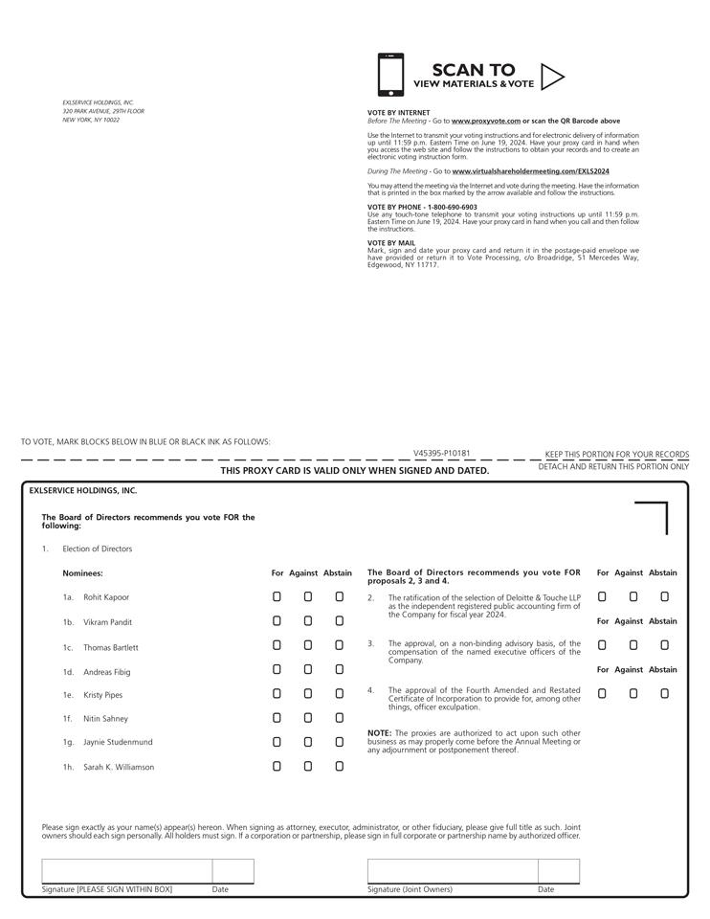

Table of Contents


