Table of Contents

UNITED STATES
SECURITIES AND EXCHANGE COMMISSION

Washington, D.C. 20549

SCHEDULE 14A

Proxy Statement Pursuant to Secton 14(a) of the

Securites Exchange Act of 1934

Filed by the Registrant ☒ Filed by a party other than the Registrant ☐

Check the appropriate box:

- Preliminary Proxy Statement

- Confdental, for Use of the Commission Only (as permited by Rule 14a-6(e)(2))

- Defnitve Proxy Statement

- Defnitve Additonal Materials

- Solicitng Material Under Rule 240.14a-12

ExlService Holdings, Inc.

(Name of Registrant as Specifed In Its Charter)

(Name of Person(s) Filing Proxy Statement, if other than the Registrant)

Payment of Filing Fee (Check the appropriate box):

- No fee required.

- Fee paid previously with preliminary materials.

- Fee computed on table in exhibit required by Item 25(b) per Exchange Act Rules 14a-6(i)(1) and 0-11.

Table of Contents


Table of Contents

Dear Stockholder,

2024 was EXL’s 25th anniversary year, and we are proud of how far the Company has come in the last 25 years. We proactvely evolved from our start in business process outsourcing, to becoming the leader in data and artfcial intelligence (“AI”) that we are today. Our 2024 results underscore the success of this strategic pivot. Our data and AI-led strategy is built on decades of domain expertse, proprietary data and key investments in data management, analytcs, and AI capabilites. By executng on that strategy, we outperformed our peer group and delivered our 18th consecutve quarter of revenue growth by the end of 2024.

320 Park Avenue, 29th Floor

New York, NY 10022

(212) 277-7100


Rohit Kapoor Vikram Pandit

Chairman and CEO Lead Director

We generated total revenues of $1.838 billion in 2024, representng growth of 12.7% over 2023. We also grew adjusted EPS1 to $1.65, up 15.4% from $1.43 in 2023 and $1.20 in 2022.

We atribute this growth to a combinaton of our diferentated strategy, sound executon, key investments and bold innovaton. We are proud to be the partner of choice to implement AI and data-led digital services and solutons for our clients as they work to reimagine their workfows to keep up with a rapidly changing market. Our deep domain expertse, innate understanding of system complexites, robust data management capabilites, strong AI profciencies and emphasis on strong governance positon us well to help our clients operatonalize AI at scale. We bring value to our clients every day by delivering solutons that optmize accuracy, cost and latency and drive greater efciency, accuracy and scalability across complex business operatons.

In 2024, we also launched our own specialized LLMs to address the complex needs of our clients and an Enterprise AI Platorm to accelerate generatve AI development. We collaborated with NVIDIA, Databricks, Microsof and AWS to bring these solutons to life. We also scaled our existng proprietary solutons. Our ITI Data acquisiton further expanded our data management and engineering capabilites, strengthening our oferings in banking and healthcare.

We contnue to count our EXL colleagues as our primary asset and are not only seeking to acquire new talent and businesses to help us meet our business strategy, but also to upskill and grow our existng talent base to address the new demands of the data and AI-driven economy. Our team’s spirit of educaton and advancement is inspiring, and we seek to encourage and empower all of our people to learn and grow with us. To that end, our people completed 1.3 million hours of training across our global workforce, and we are contnuing to invest heavily in upskilling. Similarly, in 2024, more than 30,000 of our employees gave back to our communites by donatng their tme or resources to our corporate social responsibility initatves with a focus on skills development and educaton, helping to create the next generaton future ready workforce.

(1) Adjusted EPS is a non-GAAP fnancial measure. See “Non-GAAP Reconciliaton” later in this proxy statement.

 | EXL 2025 Proxy Statement | /

Table of Contents

We are proud of this progress, and the external recognitons we received for these eforts, including for the fourth year as one of America’s Most Responsible Companies by Newsweek and Statsta, Inc, as well as, in 2025, one of the Best Employers in Asia-Pacifc by the Financial Times, and one of the Most Trusted Companies in America and one of America’s Most Successful Mid-Cap Companies by Forbes, among many other industry awards.

On behalf of the board of directors of ExlService Holdings, Inc., we are pleased to invite you to the 2025 Annual Meetng of Stockholders, which will be held on June 17, 2025. We look forward to sharing more about our Company at the Annual Meetng. We encourage you to carefully read the atached 2025 Annual Meetng of Stockholders and Proxy Statement, which contains important informaton about the maters to be voted upon and instructons on how you can vote your shares.

Your vote is important to us. Please vote as soon as possible whether or not you plan to partcipate in the Annual Meetng.

The board of directors and management look forward to your atendance at the Annual Meetng.

Sincerely,
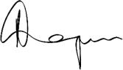
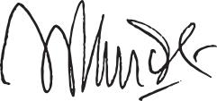

Rohit Kapoor | Vikram Pandit
Chairman and CEO | Lead Director
/ EXL 2025 Proxy Statement

Table of Contents

Notce of 2025 Annual Meetng of Stockholders

Dear Stockholder:

You are cordially invited to the 2025 Annual Meetng of Stockholders of ExlService Holdings, Inc., a Delaware corporaton (the “Company”), for the purposes of votng on the following maters:

- the electon of seven members of the board of directors of the Company;

- the ratfcaton of the appointment of Deloite & Touche LLP as the independent registered public accountng frm of the Company for fscal year 2025;

- the approval, on a non-binding advisory basis, of the compensaton of the named executve ofcers of the Company;

- the approval of the ExlService Holdings, Inc. 2025 Omnibus Incentve Plan; and

- the transacton of such other business as may properly come before the Annual Meetng or any adjournment or postponement thereof.

We will hold our Annual Meetng in virtual format only, via live audio webcast (rather than at any physical locaton) on June 17, 2025 at 8:30 AM, Eastern Time. Our virtual meetng platorm will allow for full partcipaton as if you were atending physically. You or your proxyholder may partcipate, vote, and examine our stockholder list at the Annual Meetng by visitng www.virtualshareholdermeetng.com/EXLS2025 and using your 16-digit control number.

If you are a stockholder of record at the close of business on April 24, 2025, the record date for the Annual Meetng, you are enttled to vote at the Annual Meetng. A list of stockholders as of the record date will be available for examinaton for any purpose germane to the Annual Meetng, during ordinary business hours, at the Company’s executve ofces at 320 Park Avenue, 29th Floor, New York, New York 10022, for a period of 10 days prior to the date of the Annual Meetng. If our corporate headquarters are closed during the 10 days prior to the Annual Meetng, you may send a writen request to the Corporate Secretary at our corporate headquarters, and we will arrange a method for you to inspect the list.

Please note the technical requirements for virtual atendance at the Annual Meetng, as described in the enclosed Proxy Statement beginning on page 127 under the heading “Annual Meetng Q&A.”

Pursuant to rules promulgated by the Securites and Exchange Commission, we are providing access to our proxy materials over the Internet. On or about April 29, 2025, we will mail a Notce of Internet Availability of Proxy Materials (the “Internet Notce”) to each of our stockholders of record and benefcial owners at the close of business on the record date. On the date of mailing of the

Internet Notce, all stockholders and benefcial owners will have the ability to access all of the proxy materials on a website referred to in the Internet Notce. These proxy materials will be available free of charge.

Whether or not you expect to atend the Annual Meetng, the Company encourages you to promptly vote and submit your proxy (i) by Internet (by following the instructons provided in the Internet Notce), (ii) by phone (by following the instructons provided in the Internet Notce) or (iii) by requestng that proxy materials be sent to you by mail that will include a proxy card that you can use to vote by completng, signing, datng and returning the proxy card in the prepaid postage envelope provided. Votng by proxy will

 | EXL 2025 Proxy Statement | /

Table of Contents

not deprive you of the right to atend the Annual Meetng or to vote your shares. You can revoke a proxy at any tme before it is exercised by votng at the Annual Meetng, by delivering a subsequent proxy or by notfying the inspector of electons in writng of such revocaton prior to the Annual Meetng.

YOUR SHARES CANNOT BE VOTED UNLESS YOU EITHER (I) VOTE BY USING THE INTERNET, (II) VOTE BY PHONE, (III) REQUEST PROXY MATERIALS BE SENT TO YOU BY MAIL AND THEN USE THE PROXY CARD PROVIDED BY MAIL TO CAST YOUR VOTE BY COMPLETING, SIGNING AND RETURNING THE PROXY CARD BY MAIL OR (IV) ATTEND THE ANNUAL MEETING AND VOTE.

By Order of the Board of Directors
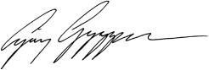

Ajay Ayyappan

Executve Vice President, General Counsel and Corporate Secretary

New York, New York

April 29, 2025

/ | EXL 2025 Proxy Statement

Table of Contents

2025 Proxy Statement

Table of contents

2025 Proxy Statement summary |  |  |  |  |  |  |  |  |  |  |  |  |  |  |  |  |  |  |  |  |  |  | 1
Our board of directors |  |  |  |  |  |  |  |  |  |  |  |  |  |  |  |  |  |  |  |  |  |  | 12
Corporate governance |  |  |  |  |  |  |  |  |  |  |  |  |  |  |  |  |  |  |  |  |  |  | 21
Sustainability |  |  |  |  |  |  |  |  |  |  |  |  |  |  |  |  |  |  |  |  |  |  | 40
Our Executve Commitee |  |  |  |  |  |  |  |  |  |  |  |  |  |  |  |  |  |  |  |  |  |  | 50
Executve compensaton |  |  |  |  |  |  |  |  |  |  |  |  |  |  |  |  |  |  |  |  |  |  | 54
 | Compensaton Discussion and Analysis |  |  |  |  |  |  |  |  |  |  |  |  |  |  |  |  |  |  |  |  |  | 54
 | Compensaton and Talent Management Commitee Report |  |  |  |  |  |  |  |  |  |  |  |  |  |  |  |  |  |  |  |  |  | 77
 | Summary compensaton table for fscal year 2024 |  |  |  |  |  |  |  |  |  |  |  |  |  |  |  |  |  |  |  |  |  | 78
Stock ownership of directors, executve ofcers and certain benefcial owners |  |  |  |  |  |  |  |  |  |  |  |  |  |  |  |  |  |  |  |  |  |  | 100
Certain relatonships and related person transactons |  |  |  |  |  |  |  |  |  |  |  |  |  |  |  |  |  |  |  |  |  |  | 102
Audit Commitee Report |  |  |  |  |  |  |  |  |  |  |  |  |  |  |  |  |  |  |  |  |  |  | 103
Proposal 1 — Electon of directors |  |  |  |  |  |  |  |  |  |  |  |  |  |  |  |  |  |  |  |  |  |  | 104
Proposal 2 — Ratfcaton of the appointment of independent registered public accountng frm |  |  |  |  |  |  |  |  |  |  |  |  |  |  |  |  |  |  |  |  |  |  | 106
Proposal 3 — Advisory (non-binding) vote to approve executve compensaton |  |  |  |  |  |  |  |  |  |  |  |  |  |  |  |  |  |  |  |  |  |  | 108
Proposal 4 — Approval of the ExlService Holdings, Inc. 2025 Omnibus Incentve Plan |  |  |  |  |  |  |  |  |  |  |  |  |  |  |  |  |  |  |  |  |  |  | 110
Miscellaneous |  |  |  |  |  |  |  |  |  |  |  |  |  |  |  |  |  |  |  |  |  |  | 123
Stockholder proposals and director nominatons for the 2026 Annual Meetng |  |  |  |  |  |  |  |  |  |  |  |  |  |  |  |  |  |  |  |  |  |  | 123
Non-GAAP Reconciliaton |  |  |  |  |  |  |  |  |  |  |  |  |  |  |  |  |  |  |  |  |  |  | 125
Annual Meetng Q&A |  |  |  |  |  |  |  |  |  |  |  |  |  |  |  |  |  |  |  |  |  |  | 127
Other maters |  |  |  |  |  |  |  |  |  |  |  |  |  |  |  |  |  |  |  |  |  |  | 132
Annex A: 2025 Omnibus Incentve Plan |  |  |  |  |  |  |  |  |  |  |  |  |  |  |  |  |  |  |  |  |  |  | A-1

 | EXL 2025 Proxy Statement | /

Table of Contents

2025 Proxy Statement summary

Summary

Below is a summary of select components of this Proxy Statement, including informaton regarding this year’s stockholder meetng, nominees for our board of directors, summary of our business, performance highlights and selectve executve compensaton informaton. This summary does not contain all of the informaton that you should consider prior to submitng your proxy, and you should review the entre Proxy Statement and our Annual Report on Form 10-K for the fscal year ended December 31, 2024 (the “2024 Form 10-K”). We refer to the fscal year ended December 31, 2024 as “fscal year 2024,” “fscal 2024,” and “2024.”

Meetng agenda, votng maters and recommendatons*

Votng proposal item | Board vote recommendaton
1. Electon of directors | FOR the electon of each nominee
 | (pg. 104)
Required vote: Afrmatve vote of a majority of votes cast
2. Ratfcaton of appointment of independent | FOR (pg. 106)
registered public accountng frm

Required vote: Afrmatve vote of a majority of shares present in person or represented by proxy and enttled to vote

3. Advisory (non-binding) Say-on-Pay vote to FOR (pg. 108)
approve executve compensaton

Required vote: Afrmatve vote of a majority of shares present in person or represented by proxy and enttled to vote

4. Approval of the ExlService Holdings, Inc. 2025 FOR (pg. 110)
Omnibus Incentve Plan

Required vote: Afrmatve vote of a majority of shares present in person or represented by proxy and enttled to vote

- Virtual atendance at our Annual Meetng will consttute presence in person for purposes of quorum and votng at the Annual Meetng.

2025 Proxy Statement summary
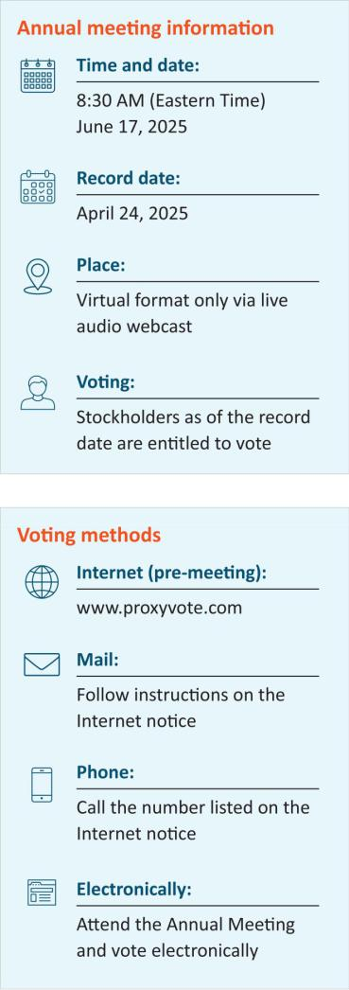

If you are the benefcial owner of shares held in the name of a brokerage, bank, trust or other nominee as a custodian (also referred to as shares held in “street name”), your broker, bank, trustee or nominee will provide you with materials and instructons for votng your shares. See page 128 for additonal details.

EXL 2025 Proxy Statement / 1

Table of Contents

2025 Proxy Statement summary

Our business

We are a global data and artfcial intelligence (“AI”) company that ofers services and solutons to reinvent client business models, drive beter outcomes and unlock growth with speed. EXL harnesses the power of data, AI and deep industry knowledge to transform businesses, including the world’s leading corporatons in industries including insurance, healthcare, banking and fnancial services, media and retail, among others. EXL was founded in 1999 with the core values of innovaton, collaboraton, excellence, integrity and respect. We are headquartered in New York, and have approximately 59,500 employees as of December 31, 2024, spanning six contnents.

Beginning in 2025, we began to implement operatonal and structural changes to accelerate the executon of our data and AI strategy, capture a greater share of the growing AI market and drive EXL’s long-term growth. The new operatng model is comprised of Industry Market Units (“IMUs”) to focus on delivering higher value to clients leveraging our full suite of capabilites; and Strategic Growth Units to focus on rapidly advancing our capabilites specifc to various industries and client needs. For further informaton, please refer to our Annual Report on Form 10-K for the fscal year ended December 31, 2024.

Company’s three-year performance

 |  | Revenue (Year-over-year growth %)
Revenue by segment informaton ($ in millions) | 2022 YOY% |  | 2023 YOY% |  |  | 2024 YOY%
Insurance | $448.7 | 17.5% | $529.9 | 18.1% |  | $614.0 | 15.9%
Healthcare | 97.4 | - 13.4% | 106.0 | 8.9% |  | 116.4 | 9.8%
Emerging Business | 218.6 | 30.7% | 265.7 | 21.5% |  | 311.7 | 17.3%
Analytcs | 647.3 | 40.5% | 729.1 | 12.6% |  | 796.3 | 9.2%
Consolidated | $1,412.0 | 25.8% | $1,630.7 | 15.5% |  | $1,838.4 | 12.7%

Efectve from the frst quarter of 2025, our reportng segments changed, aligned to our new IMUs. The revised presentaton is refected in our Quarterly Report on Form 10-Q for the quarter ended March 31, 2025 fled with the SEC.

2 | / | EXL 2025 Proxy Statement

Table of Contents

2025 Proxy Statement summary
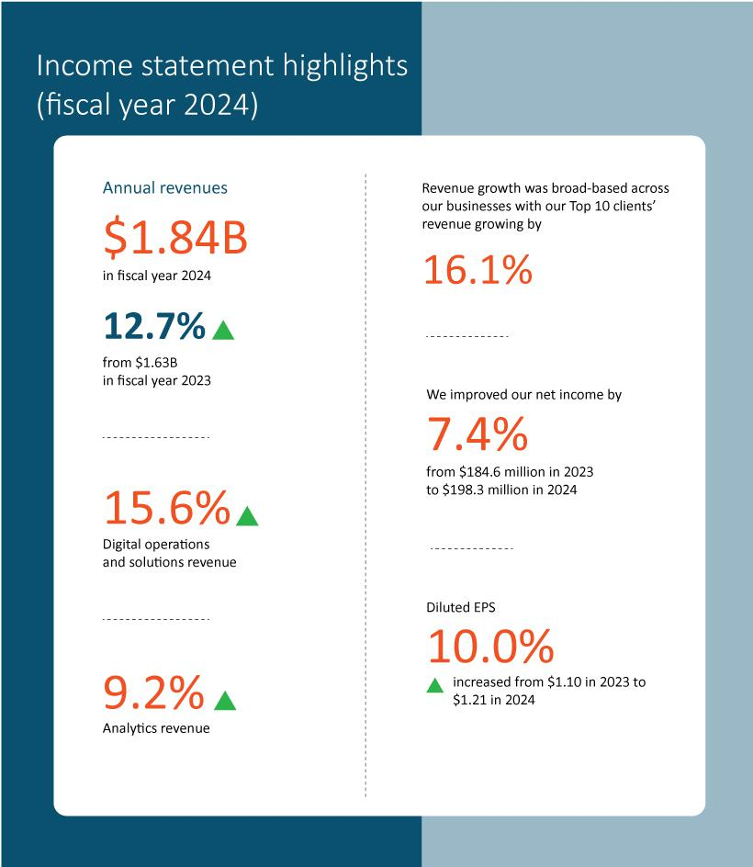

EXL 2025 Proxy Statement / 3

Table of Contents

2025 Proxy Statement summary
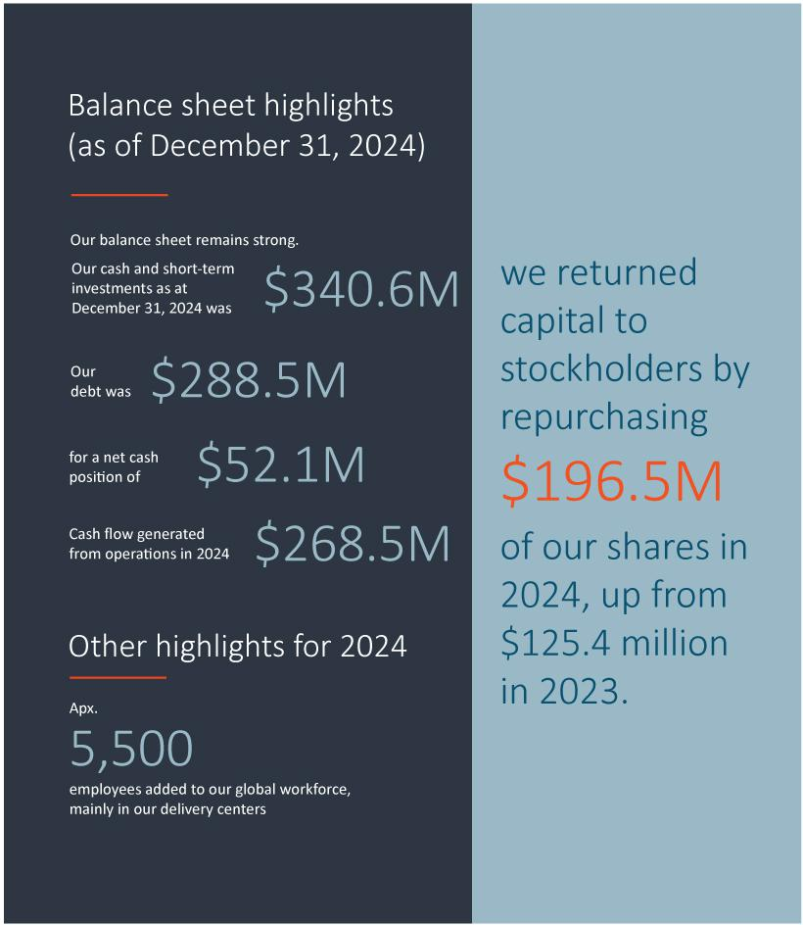

4 | / | EXL 2025 Proxy Statement

Table of Contents

2025 Proxy Statement summary

Total stockholder return

The graphs below compare our 1-year, 3-year and 5-year cumulatve total stockholder return (“TSR”) as of December 31, 2024 with the median TSR for companies comprising Nasdaq, S&P 400 and our peer group.
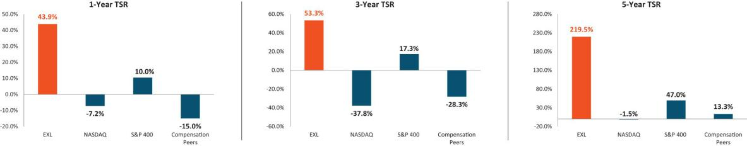

 | EXL 2025 Proxy Statement | / 5

Table of Contents

2025 Proxy Statement summary

Corporate governance highlights

The following informaton is based on our board profle immediately following our Annual Meetng (assuming the electon of our seven director nominees) and refects current board practces.
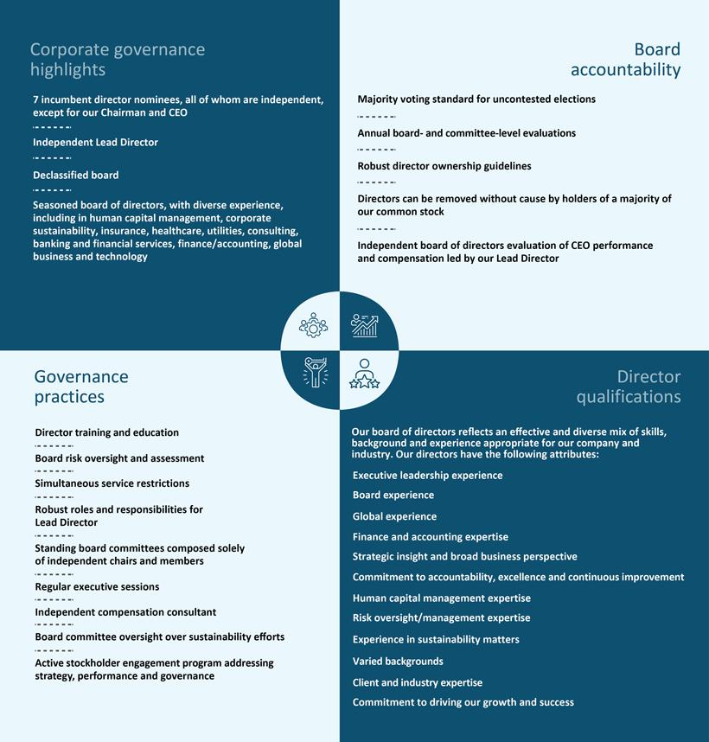

6 | / | EXL 2025 Proxy Statement

Table of Contents

2025 Proxy Statement summary

Nominees for electon as directors
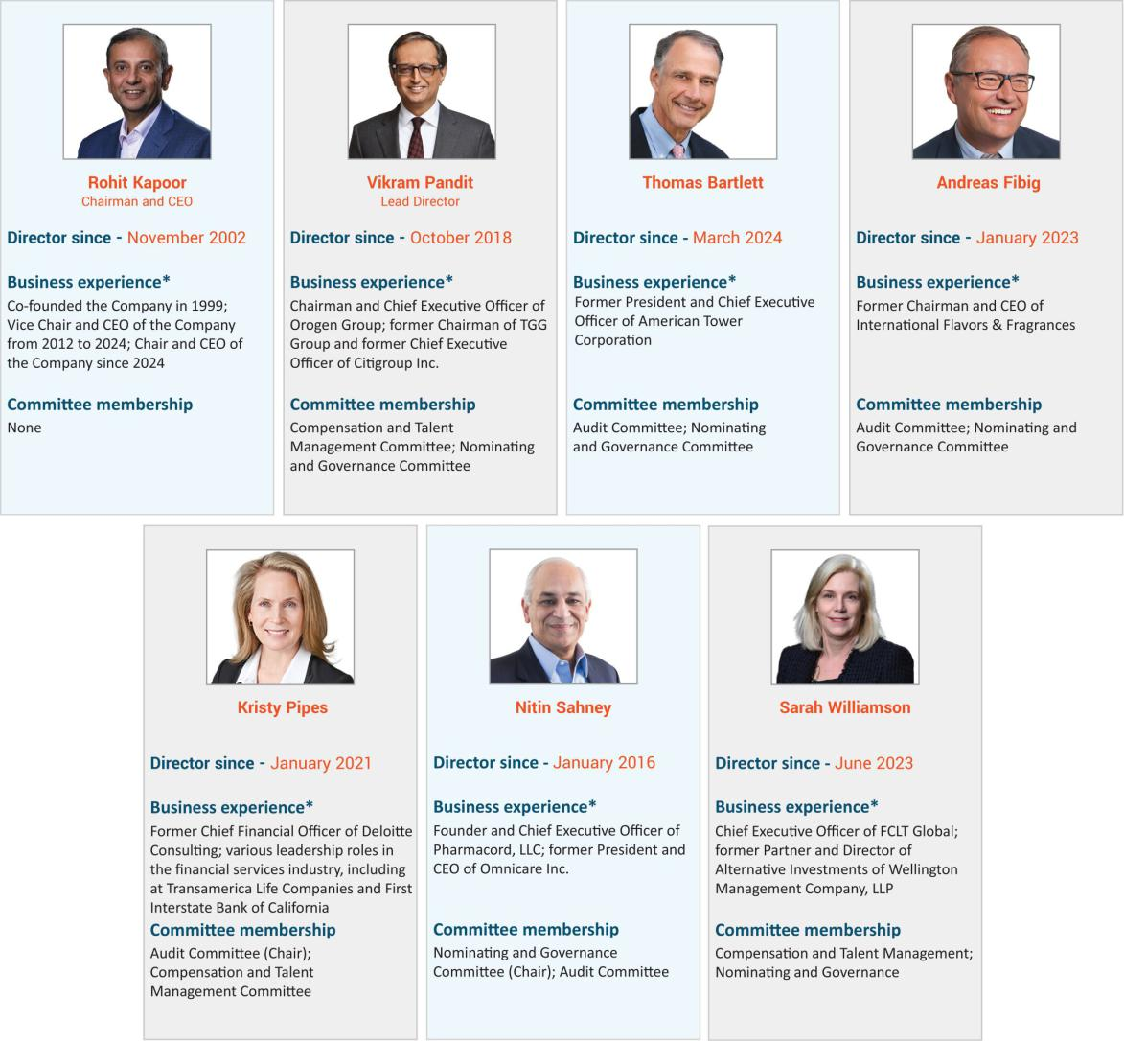

 | EXL 2025 Proxy Statement | / 7

Table of Contents

2025 Proxy Statement summary

Director nominees - skills matrix

Our director nominees review and indicate whether they are experts in each of the skills and areas of experience listed below. An “expert,” for purpose of the skills set forth in this skill matrix, means an individual who, based on career experience (other than as an EXL director), has developed and contnues to maintain comprehensive knowledge and command over the subject mater, including relevant updates. Defnitons for each of these skills, as well as a descripton for how these are considered for candidates for directors, can be found under “Director qualifcatons” beginning on page 25 of this Proxy Statement.
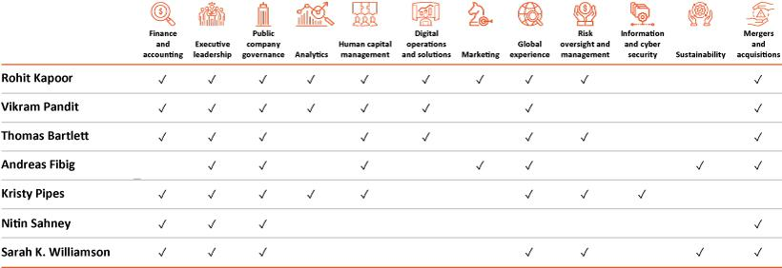

Board statstcs*
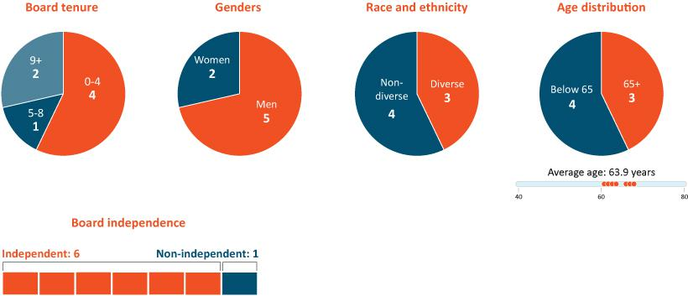

* Following our Annual Meetng, assuming electon of all nominees.

8 | / | EXL 2025 Proxy Statement

Table of Contents

2025 Proxy Statement summary

Our purpose and core values


 | EXL 2025 Proxy Statement | / 9

Table of Contents

2025 Proxy Statement summary

Sustainability

In line with our purpose, values and culture, we pursue sustainability initatves that are aligned with our long-term corporate strategy and designed to beneft our stockholders, clients, employees, communites and manage expectatons and commitments across various stakeholder groups. See “Sustainability” beginning on page 40 below for more details on our recent accomplishments in sustainability.
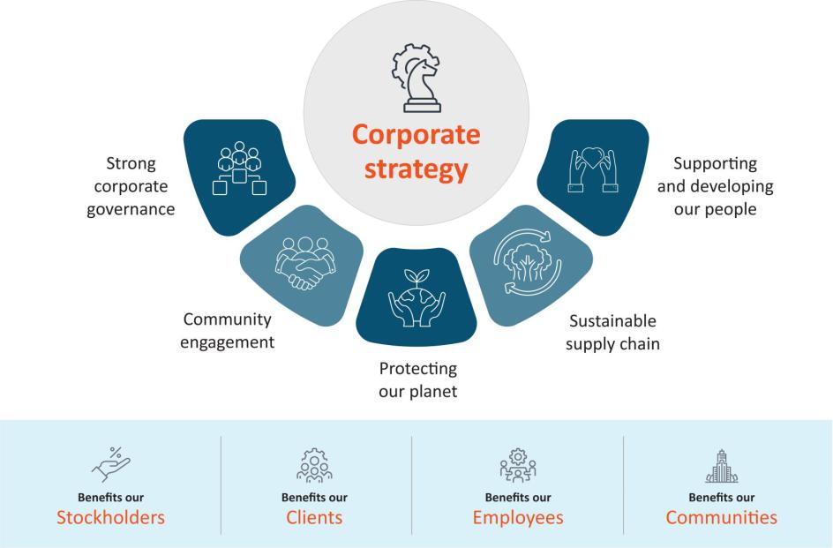

Compensaton Overview

  - Compensaton philosophy: Our executve compensaton philosophy is focused on pay-for-performance.

  - Approximately 98% Say-on-Pay approval of 2024 compensaton: At our 2024 Annual Meetng of Stockholders, our stockholders approved, on a non-binding advisory basis, the compensaton paid to our named executve ofcers for fscal year 2023. Approximately 98% of the votes present in person or by proxy (excluding broker non-votes) voted in favor of fscal year 2023 compensaton.

  - Annual incentve program: Our annual incentve program contnued to use the same, formulaic performance criteria for 2024 as it has been using for several years, which includes:

–Company-wide metrics (75%)—Revenue and adjusted operatng proft margin (“AOPM”)

–Individual metrics (25%)—Linked to areas of performance that are specifc to each executve

- In 2024, we achieved 99.4% of our revenue performance target, and 99.2% of our AOPM target resultng in annual incentve payout calculatons for our named executve ofcers, ranging from 84% of target performance to 117% of target performance.

  - Long-term equity incentve program: We also contnued our equity incentve program, which in 2024 included grantng a balanced mix of tme-vested restricted stock units and performance-based restricted stock units to all of our named executve ofcers. The performance-based restricted stock units were comprised of relatve total stockholder return-linked restricted stock units and revenue-linked restricted stock units.

10 | / | EXL 2025 Proxy Statement

Table of Contents

2025 Proxy Statement summary

- This was the third and fnal performance year for the performance-based restricted stock units granted in 2022, which were linked to the Company’s revenue and TSR performance relatve to a peer group. We achieved 112.5% of the revenue target for the revenue-linked restricted stock units resultng in 200% of target funding of those grants. The Company’s TSR performance was at the 92nd percentle among its peer group, resultng in the executves earning 200% of the target funding of those grants. In the aggregate, the performance-based restricted stock units granted in 2022 achieved vestng of shares at 200% of target performance.

  - Compensaton Policies. Our compensaton program is designed to refect appropriate governance practces aligned with the needs of our business, and includes, among others, the following features: robust clawback policy; robust stock ownership guidelines; limited perquisites; no excise tax gross-ups; and an ant-hedging and ant-pledging policy. See “Executve compensaton program, practces and policies” beginning on page 59 below.

Compensaton mix
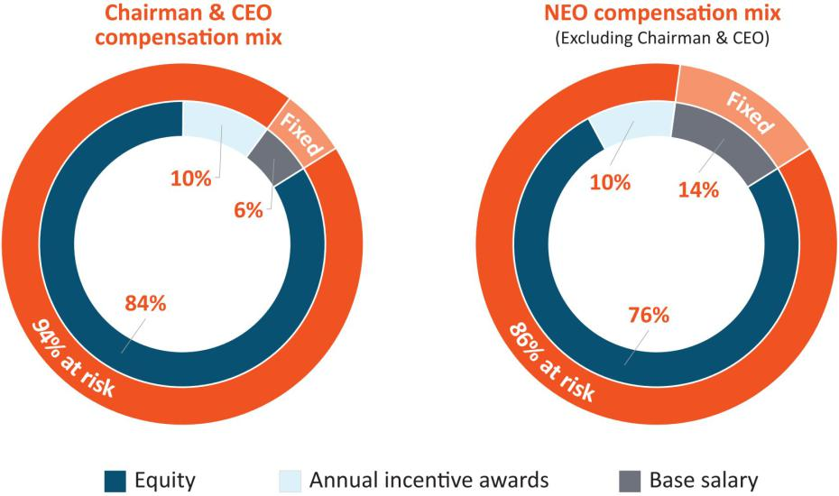

* Base salary also includes items included in “All Other Compensaton” in the Summary Compensaton Table on page 78.

 | EXL 2025 Proxy Statement | / 11

Table of Contents

Our board of directors

Our board of directors

Our board of directors currently consists of eight directors (including our seven director nominees, and one of our directors who currently serves on the board, but will not stand for re-electon) with varied experience, including in analytcs, digital operatons and solutons, client industries, informaton and cybersecurity, human capital management, sustainability, and fnance and accountng, among others.


From lef: Andreas Fibig (Independent Director), Kristy Pipes (Independent Director and Audit Commitee Chair), Nitn Sahney (Independent Director and Nominatng and Governance Commitee Chair), Rohit Kapoor (Chairman and CEO), Sarah K. Williamson (Independent Director), Jaynie Studenmund*, (Independent Director and Compensaton and Talent Management Commitee Chair), Vikram Pandit (Lead Director), Thomas Bartlet (Independent Director)

* Not standing for re-electon

12 | / | EXL 2025 Proxy Statement

Table of Contents

Our board of directors

Director nominees for electon at the Annual Meetng

Upon the recommendaton of our Nominatng and Governance Commitee, we are pleased to propose seven of our existng directors as nominees for electon as directors at the Annual Meetng. As previously disclosed, one of our current directors, Ms. Studenmund, will not be standing for re-electon at the Annual Meetng; the remaining seven directors are our director nominees at the Annual Meetng. Ms. Studenmund will contnue to serve as Chair of the Compensaton and Talent Management Commitee untl the earlier of the Annual Meetng or a replacement independent director is named Chair.

Our nominees for electon as directors at the Annual Meetng are as follows:
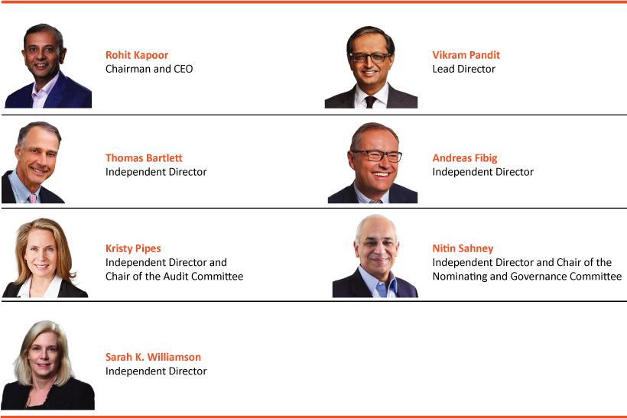

We believe that our director nominees, individually and together as a whole, possess the requisite skills, experience and qualifcatons necessary to maintain an efectve board to serve the best interests of the Company and its stockholders as described below under “Director qualifcatons” beginning on page 25.

The name, age (as of the date of this Proxy Statement), principal occupaton and other informaton, including the specifc experience, qualifcatons, atributes or skills that led to the conclusion that such person should serve as a director of the Company, with respect to each of the nominees, are set forth below. There are no family relatonships among any of our directors or executve ofcers.

 | EXL 2025 Proxy Statement | / 13

Table of Contents

Our board of directors

Nominees for electon at the Annual Meetng – Biographical informaton
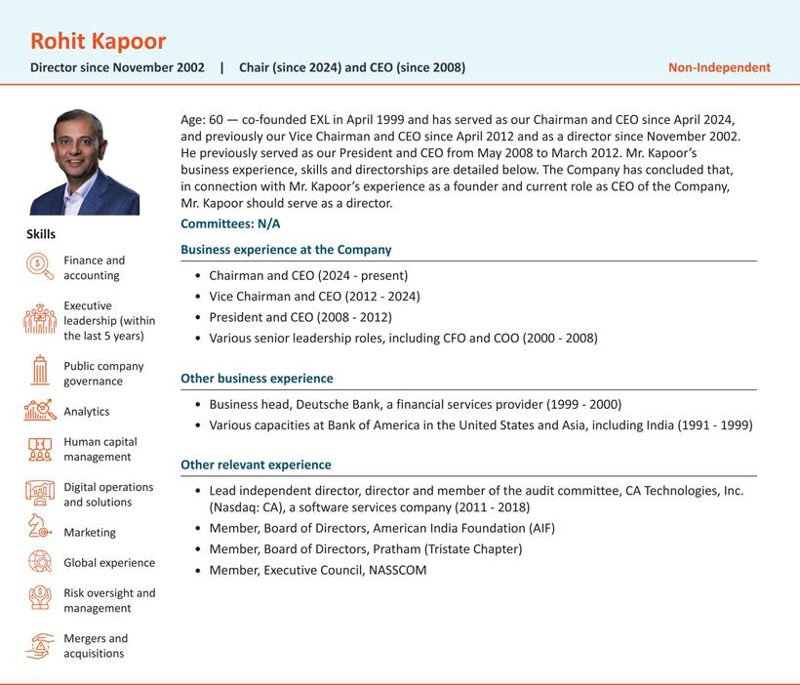

14 | / | EXL 2025 Proxy Statement

Table of Contents

Our board of directors
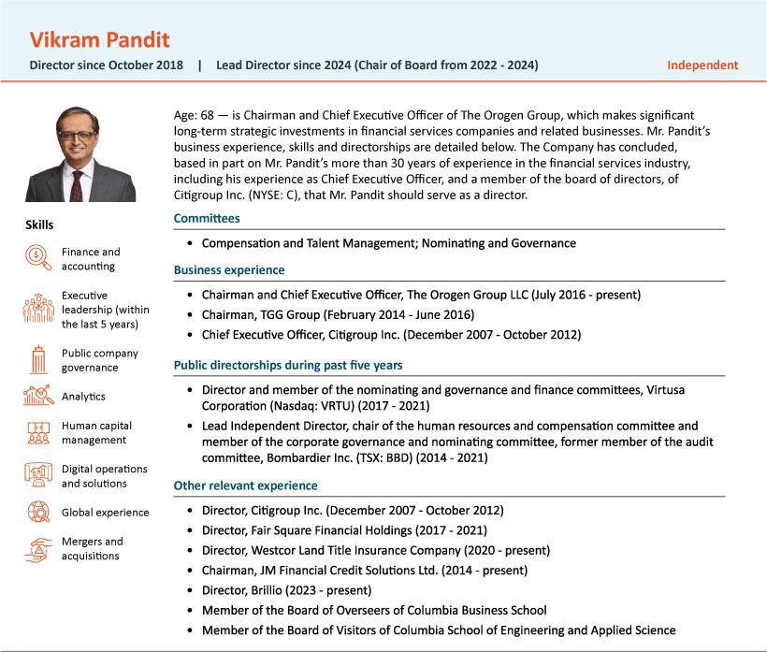

 | EXL 2025 Proxy Statement | / 15

Table of Contents

Our board of directors
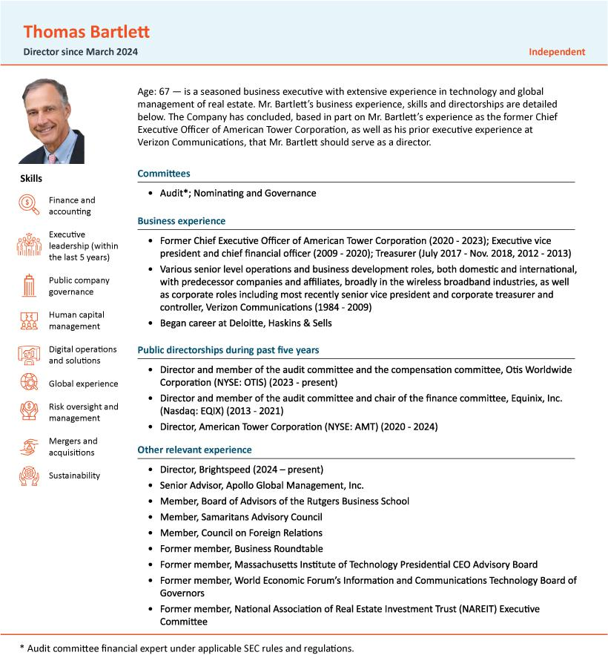

16 | / | EXL 2025 Proxy Statement

Table of Contents

Our board of directors
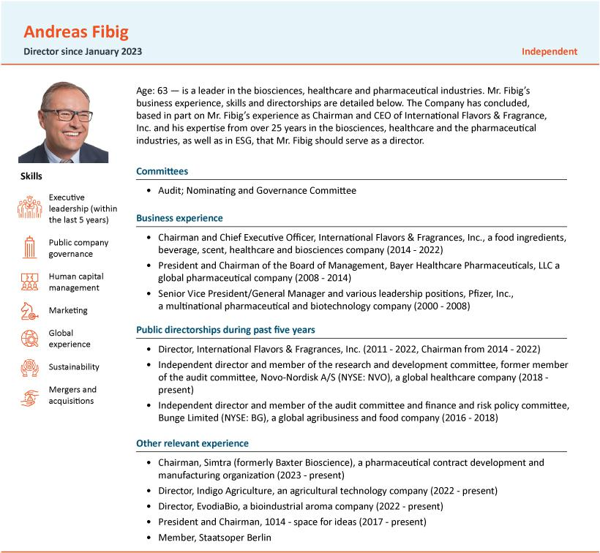

 | EXL 2025 Proxy Statement | / 17

Table of Contents

Our board of directors
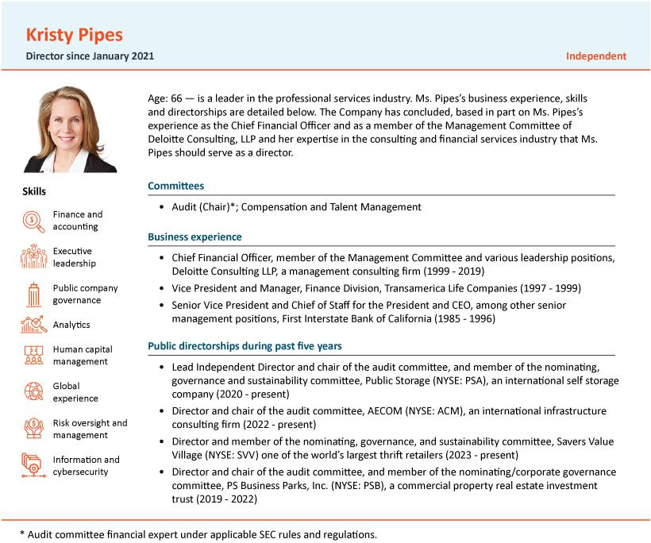

18 | / | EXL 2025 Proxy Statement

Table of Contents

Our board of directors
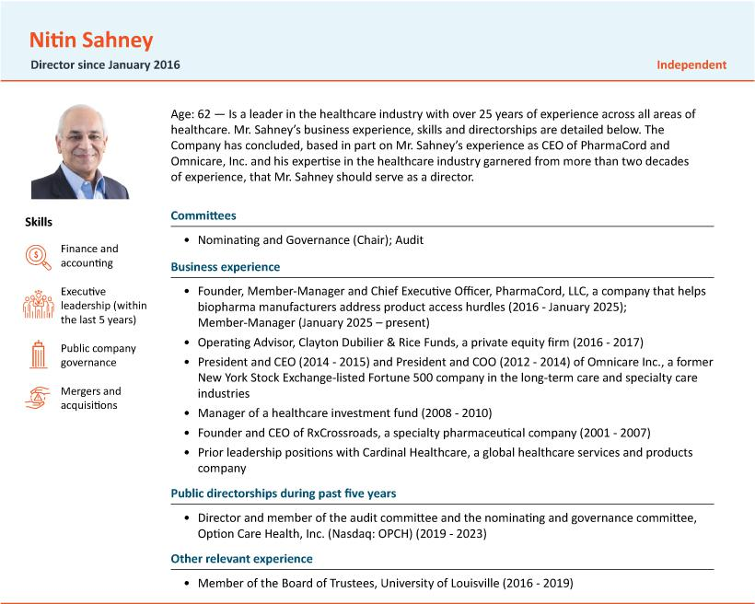

 | EXL 2025 Proxy Statement | / 19

Table of Contents

Our board of directors
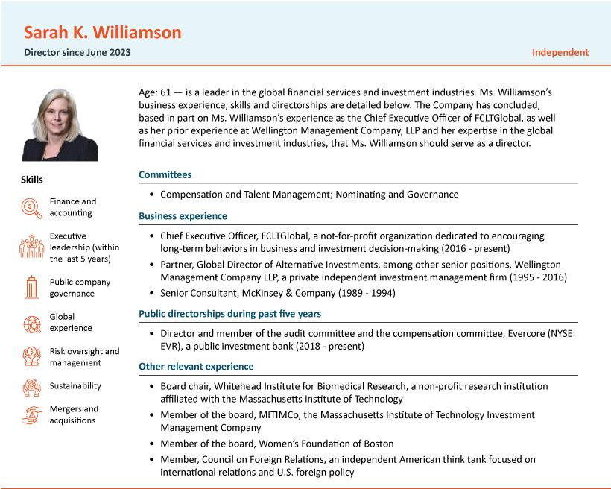

20 | / | EXL 2025 Proxy Statement

Table of Contents

Corporate governance

Corporate governance

Director independence

In determining director independence, the board of directors considered the transactons and relatonships set forth below under “Certain Relatonships and Related Person Transactons—Related Party Transactons” and routne service arrangements between the Company and Westcor Land Title Insurance Company (“Westcor”). During 2024, one of our directors, Mr. Pandit, served as a non-executve director and, through his ownership in The Orogen Group (see below for informaton on Mr. Pandit’s relatonship with The Orogen Group), owned an immaterial indirect equity interest, in Westcor. Mr. Pandit is not, and was not during 2024, a partner, controlling shareholder or executve ofcer of Westcor.

Based on its review of all applicable relatonships, our board of directors has determined that all of the members on our board of directors, other than Mr. Kapoor, meet the independence requirements of the Nasdaq Stock Market and federal securites laws.

Meetng atendance

We expect our directors to atend all board meetngs and meetngs of commitees on which they serve. We also expect our directors to spend sufcient tme and meet as frequently as necessary to discharge their responsibilites properly. It is our policy that all of our directors standing for electon should atend our Annual Meetngs of Stockholders absent exceptonal cause.

Incumbent director meetng atendance
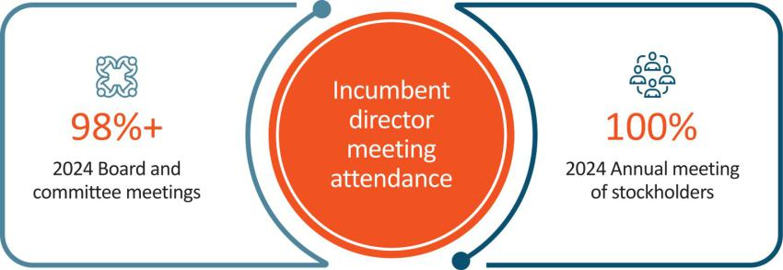

Board and Commitee meetngs in 2024
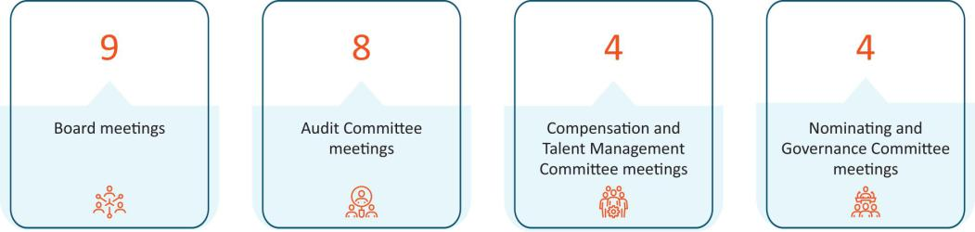

 | EXL 2025 Proxy Statement | / 21

Table of Contents

Corporate governance

Corporate governance framework

Our board is responsible for providing governance and oversight over the efectveness of policy and decision-making with respect to the strategy, operatons and management of EXL, to enhance our fnancial performance and stockholder value over the long term.

Our board’s commitment to strong corporate governance is informed by the fve core values of our corporate culture: innovaton, respect, integrity, excellence and collaboraton. Our board seeks to maintain best practces in corporate governance by reviewing our governance policies, at least annually and making updates as appropriate. Our board provides oversight over our risk management and strategic planning as relates to our growth, human capital management, and sustainability maters, each as discussed further below.
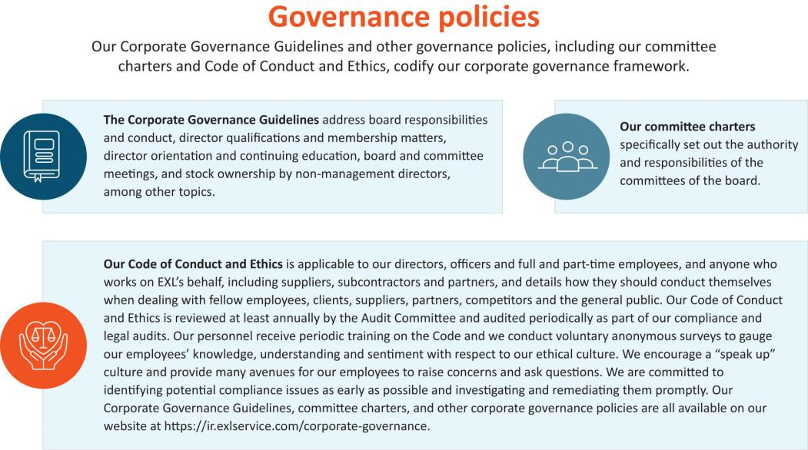

22 | / | EXL 2025 Proxy Statement

Table of Contents

Corporate governance

Beyond the board room
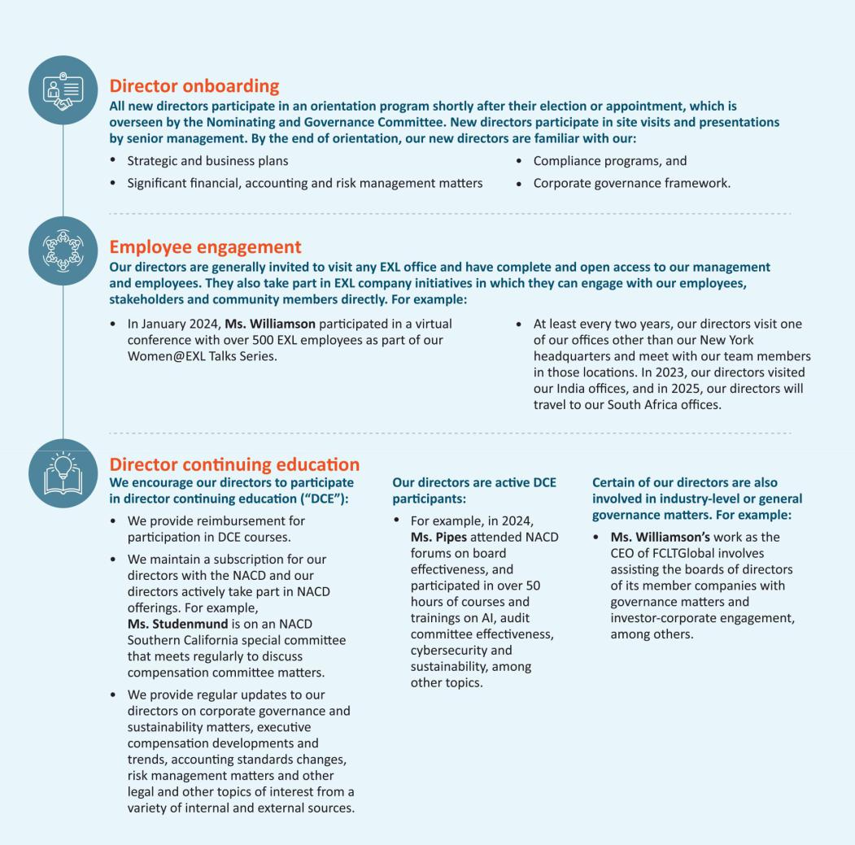

 | EXL 2025 Proxy Statement | / 23

Table of Contents

Corporate governance

Board leadership structure

Our board of directors is currently led by Rohit Kapoor, our Chairman and CEO, and Vikram Pandit, our Lead Director. Our Chairman and CEO, a non-independent director, was appointed to his current Chairman role in April 2024, at which tme Mr. Pandit, an independent director and our former Chair, was appointed Lead Director. Our Sixth Amended and Restated By-laws (our “By-laws”) and our board policies and practces provide for the following functons and responsibilites, among others, of our Chairman and our Lead Director:
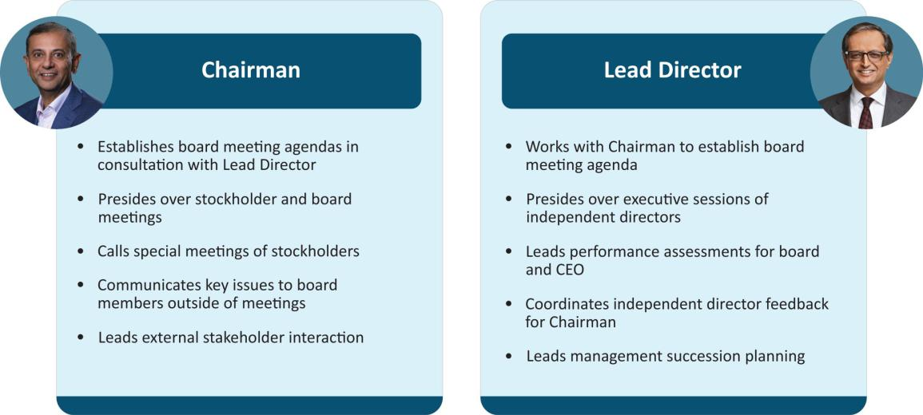

Specifcally, our By-laws provide that our Chairman or, in the absence of our Chairman, our Lead Director, or in the absence of both our Chairman and Lead Director, our CEO, calls meetngs of our board of directors to order and acts as the chairman for those board meetngs. In the absence of our Chairman, our Lead Director, and our CEO, a majority of our directors present may elect as chair of the meetng any director present. Our Chairman can call special meetngs of our stockholders, in additon to a majority of the members of our board. In additon, our Lead Director: assists the Nominatng and Governance Commitee with board nominatons and board independence consideratons; oversees director orientaton and director contnuing educaton programs; and meets with external partes as requested by our Chairman or other stakeholders. Independent directors meet at least quarterly in executve session without any management directors or members of our management present. Our Corporate Governance Guidelines provide that in the absence of our Chairman, our Lead Director or, in the absence of the Lead Director, a director chosen by the directors meetng in executve session, presides at all executve sessions.

The board of directors does not have a permanent policy or practce regarding the combinaton of the Chairman and CEO role. At present, the board believes that consolidatng the Chairman and CEO positons allows our CEO to contribute his experience and perspectve regarding management and leadership of the Company towards the goals of improved corporate governance and greater management accountability. This structure also provides greater informaton fow between the management team and directors. At the same tme, the presence of our Lead Director ensures that the board can retain sufcient delineaton of responsibilites, such that our Lead Director and our Chairman and CEO may each successfully and efectvely perform and discharge their respectve dutes and, as a corollary, enhance our prospects for success. As a result, the Company benefts from the ability to integrate the collectve leadership and corporate governance experience of our Lead Director and our Chairman and CEO, while retaining the ability to facilitate the functoning of the board of directors independently of our management and to focus on our commitment to corporate governance.

For the foregoing reasons, our board of directors has determined that its leadership structure is appropriate and in the best interests of our stockholders at this tme.

24 | / | EXL 2025 Proxy Statement

Table of Contents

Corporate governance

Director qualifcatons, refreshment and evaluatons

Director qualifcatons

The board of directors considers it paramount to achieving excellence in corporate governance to assemble a board of directors that, taken together, has the breadth of skills, qualifcatons, experience and atributes appropriate for functoning as the board of our Company and working productvely with management. The Nominatng and Governance Commitee of the board is responsible for recommending nominees who are qualifed and bring a diverse set of skills and qualifcatons to oversee the Company efectvely.
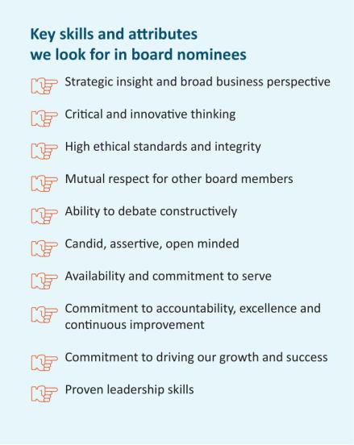

The Nominatng and Governance Commitee has not formally established any

minimum qualifcatons for director candidates, but pursuant to our Corporate Governance Guidelines, our board seeks independent directors from diverse professional and personal backgrounds who combine a broad spectrum of experience and expertse with a reputaton for integrity. The board believes that its directors should possess a range of backgrounds, skills and experiences and endeavors to consider such criteria in the context of the needs of the board. The Nominatng and Governance Commitee assesses each director candidate on this basis. The Nominatng and Governance Commitee considers a number of factors in selectng director candidates, including, among others: ethical standards and integrity; independence; professional and personal backgrounds; skills and experience; other public company directorships; and fnancial literacy and expertse; communicaton skills; and ability and willingness to comply with Company policies and procedures.

In light of our business, the primary areas of experience, qualifcatons and atributes typically sought and put forward by the Nominatng and Governance Commitee in director candidates include, but are not limited to, the following:


Executve leadership

Experience holding signifcant leadership positons, including as a CEO or head of a signifcant business, to help us drive business strategy, growth and performance.



Finance and accountng
Experience with fnance, accountng or fnancial reportng processes, to help drive fnancial performance.



Global companies
Experience working outside of the United States or with multnatonal companies, to help facilitate our global expansion.

 | EXL 2025 Proxy Statement | / 25

Table of Contents

Corporate governance


Board experience

Understanding of public company board of director and fduciary dutes, to help provide perspectve on corporate governance best practces and related maters.



Data and AI

Experience with data analytcs, digital operatons and solutons, artfcial intelligence and machine learning, and other key technologies that are central to our business.



Client and industry knowledge

Experience with our key client industries, including insurance, healthcare, banking and fnancial services, fnance/accountng, and our other capabilites, to help deepen our knowledge of our key industry vertcals and markets in which we do business.



Risk oversight/management
Experience assessing and overseeing the overall risk profle of multnatonal public companies.



Human capital management

Experience in management and development of human capital, including management of a large workforce, diversity and inclusion, talent development, workplace health and safety, compensaton and other human capital issues.



Varied backgrounds
We seek directors with varied professional and personal backgrounds and perspectves to provide a range of viewpoints.



Experience in sustainability maters
Experience in managing sustainability maters, incorporatng them into business and strategy and associated risks.



Informaton and cybersecurity
Experience in informaton and cybersecurity maters, best practces and associated risks.



Mergers and acquisitons
Experience in mergers and acquisitons as a component of business development and strategy.



Marketng
Experience in marketng and branding of multnatonal companies.

26 | / | EXL 2025 Proxy Statement

Table of Contents

Corporate governance

Refreshment

Our Nominatng and Governance Commitee considers the size and compositon of our board (and its commitees) on a contnual basis with an aim toward creatng a balanced board with extensive experience and insttutonal knowledge, and fresh perspectve and insight.
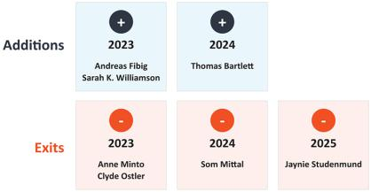

Consideratons include whether the compositon of the board of directors (and its commitees) includes sufcient diversity of experience and skill sets, as appropriate for our immediate and long-term strategic needs. These consideratons are also informed by discussions with our investors through stockholder engagement.

Our Nominatng and Governance Commitee also considers the length of tenure of the directors as a whole. Following the Annual Meetng (assuming the electon of all nominees), we will have the following balance of tenures:
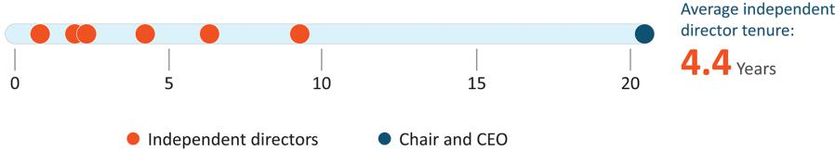

While the Company does not maintain term limits, our Corporate Governance Guidelines provide that the expectaton for new directors is a maximum term of ten years. Each of our director nominees, other than Mr. Kapoor, our Chairman and CEO, has served on the board for less than ten years as of the date of this Proxy Statement. The board actvely manages board refreshment and succession planning at the board and commitee level. For example, the board generally expects that each member serves on two commitees, and that each commitee chair serves for a maximum of fve years. The board expects that over the next few years, the commitee and board compositon will contnue to change due to rotaton and retrement. The Nominatng and Governance Commitee will identfy successors based on the goal of maintaining the board’s overall balance of experience and perspectve. A recommendaton regarding board (and commitee) compositon is shared with the full board of directors on an annual basis.

 | EXL 2025 Proxy Statement | / 27

Table of Contents

Corporate governance

Board refreshment process
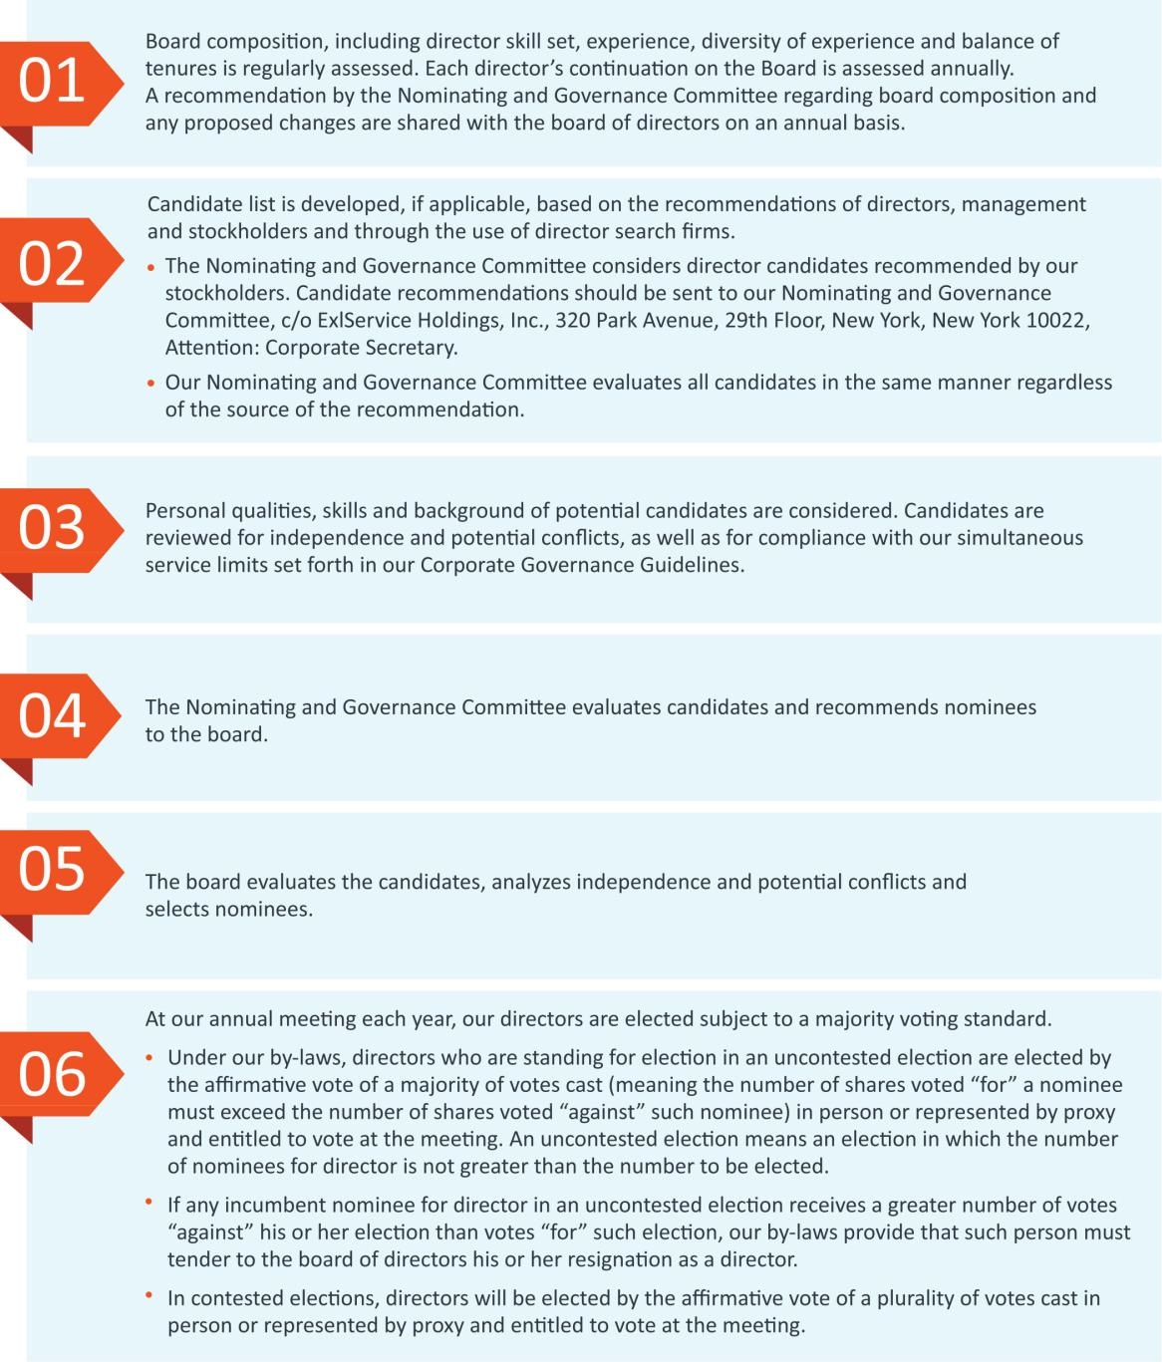

28 | / | EXL 2025 Proxy Statement

Table of Contents

Corporate governance

Commitee rotaton

We rotate commitee and commitee chair assignments based on the current compositon of the board. Recent rotatons and expected rotatons (including the upcoming June 2025 rotaton of the Nominatng and Governance Commitee chair from Mr. Sahney to Mr. Fibig and the Compensaton and Talent Management Commitee chair due to Ms. Studenmund’s retrement from the board) are as follows:
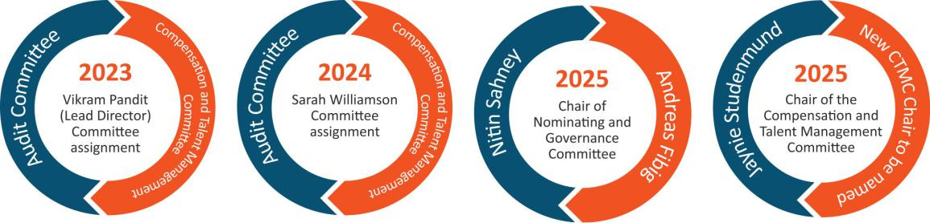

Board evaluatons

We consider the contnued efectveness of the board and its commitees as critcal to our long-term success and stockholder value. The board evaluates its performance and the performance of its commitees and each director on an annual basis through the following process:
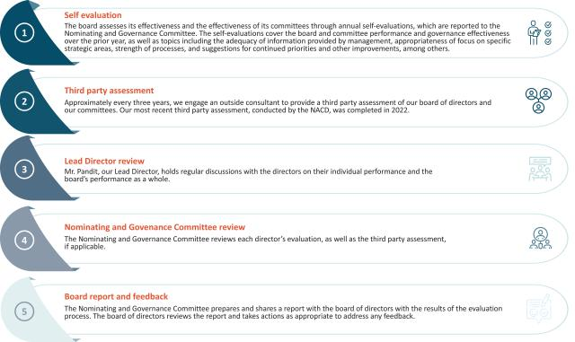

 | EXL 2025 Proxy Statement | / 29

Table of Contents

Corporate governance

Succession planning

Our board of directors (without the partcipaton of the CEO), guided by our Lead Director, is responsible for developing and annually reassessing succession plans for our CEO and other key executve ofcers of the Company, and preparing contngency plans for interim CEO succession in the event of an unexpected occurrence for board review. In additon, our Compensaton and Talent Management Commitee is responsible for ensuring appropriate compensaton strategies and design to align with the retenton and recruitment of our key executve ofcers. We actvely plan for the succession of our executve ofcers (including those who are retring or departng from the Company), and regularly consider our strong pipeline of internal and external candidates. As part of this process, in April 2024, Vikas Bhalla and Vivek Jetley, were each promoted to President of EXL in additon to their business head roles, and became responsible for broader Company-wide responsibilites. In additon, in the frst quarter of 2025 we re-aligned several leaders within the Company to enhance collaboraton between groups and accelerate innovaton in areas such as data modernizaton and artfcial intelligence. These new roles are refected below under “Our Executve Ofcers.”

We generally consider succession planning and associated executve compensaton maters on the following schedule:
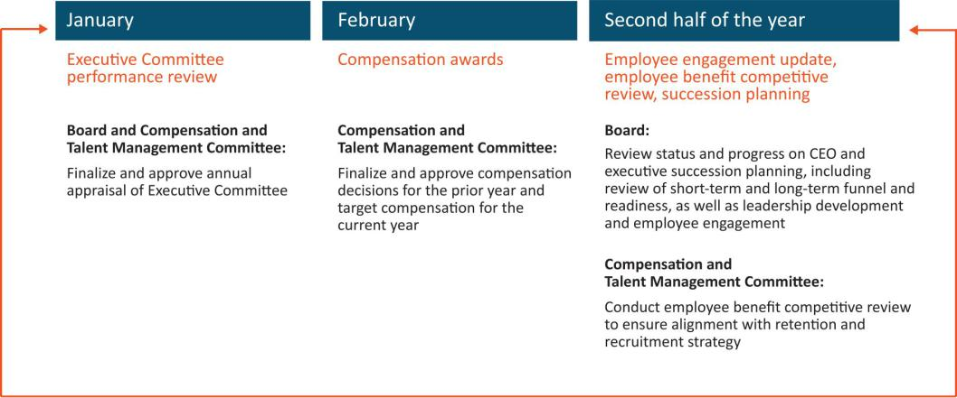

Commitees

Our board of directors currently has three standing commitees: the Audit Commitee, the Compensaton and Talent Management Commitee and the Nominatng and Governance Commitee. As discussed above, our board of directors has determined that each member of the Audit, Compensaton and Talent Management and Nominatng and Governance Commitees meets the independence and experience requirements of the Nasdaq Stock Market and federal securites laws. Copies of our commitee charters can be found on the Investor Relatons page of our website at: htps://ir.exlservice.com/corporate-governance. Informaton on our website referred to in this Proxy Statement does not consttute a part of this Proxy Statement.

30 | / | EXL 2025 Proxy Statement

Table of Contents

Corporate governance

The following table sets forth the current chairs and members of each standing commitee of the board of directors. Mr. Sahney will be Chair of the Nominatng and Governance Commitee untl June 2025, when Mr. Fibig will become Chair. Ms. Studenmund, who is not standing for re-electon at the Annual Meetng, will be Chair of the Compensaton and Talent Management Commitee untl a replacement independent director, yet to be named, will become Chair. As an executve director, Mr. Kapoor, our Chairman and CEO, does not serve on any board commitee.
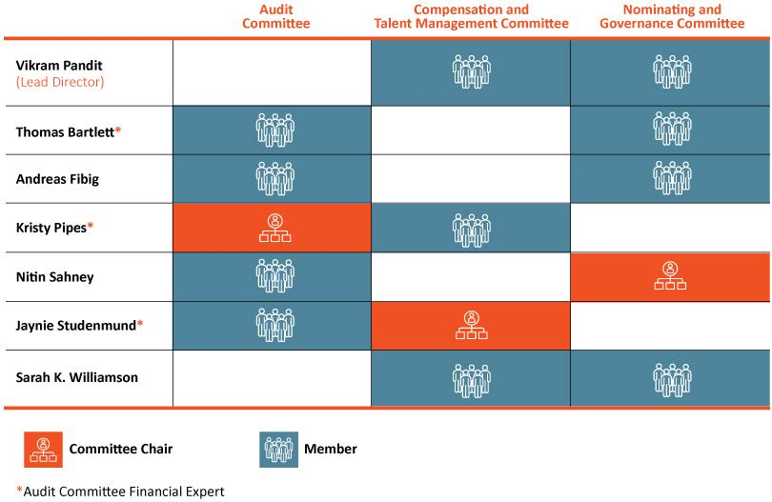

 | EXL 2025 Proxy Statement | / 31

Table of Contents

Corporate governance

Audit Commitee

Our Audit Commitee oversees and assists our board of directors in fulflling its oversight responsibilites with respect to our accountng and fnancial reportng processes, including the integrity of the fnancial statements and other fnancial informaton provided by us to our stockholders, the public, stock exchanges and others; our compliance with legal and regulatory requirements; our independent registered public accountng frm’s qualifcatons and independence; the audit of our fnancial statements; the performance of our internal audit functon and independent registered public accountng frm; the Company’s cybersecurity program and cyber strategy-related risks; business contnuity and disaster recovery planning; our Code of Conduct and Ethics and the processes used to disseminate it to our employees and monitor their compliance with its requirements; corporate insurance; and sustainability-related disclosures, processes and controls. Its risk oversight is discussed below beginning on page 35. Our Audit Commitee charter permits the commitee to form and delegate authority to subcommitees when appropriate, provided that the subcommitees are composed entrely of directors who satsfy the applicable requirement of federal securites laws as well as independence requirements of the Nasdaq Stock Market.

Our Audit Commitee has direct responsibility for the appointment, compensaton, retenton (including terminaton) and oversight of our independent registered public accountng frm, and our independent registered public accountng frm reports directly to our Audit Commitee. It also reviews and approves specifed related-party transactons as required by the rules of the Nasdaq Stock Market, and oversees the Company’s cybersecurity program and cyber strategy-related risks. The Audit Commitee was established in accordance with Secton 3(a)(58)(A) of the Securites Exchange Act of 1934 (the “Exchange Act”). Our Audit Commitee annually reviews and assesses the adequacy of its charter and its own performance.

The members of our Audit Commitee are appointed by our board of directors. All members of the commitee must also be recommended by our Nominatng and Governance Commitee.

Audit Commitee profle


- Kristy Pipes, Chair*

- Thomas Bartlet*
Andreas Fibig
Nitn Sahney
Jaynie Studenmund*



• Accountng and fnancial reportng processes

• Our independent registered public accountng frm’s appointment and
independence

• The audit of our fnancial statements and internal audit functon

• Other key areas including cybersecurity, litgaton, business contnuity
and disaster recovery, compliance, sustainability-related disclosures
processes and controls, corporate insurance and regulatory
enforcement maters

*Audit commitee fnancial expert under applicable SEC rules and regulatons

 |  | 8 commitee meetngs in 2024
32 / | EXL 2025 Proxy Statement

Table of Contents

Corporate governance

Compensaton and Talent Management Commitee

Our Compensaton and Talent Management Commitee reviews and recommends policies relatng to compensaton and benefts of our directors, ofcers and employees and is responsible for approving the compensaton of our Chairman and CEO and other executve ofcers, as well as our employee benefts policies, programs and administraton. The commitee reviews, evaluates and makes recommendatons to our board of directors with respect to our incentve compensaton plans and equity-based plans and administers the issuance of awards under our equity incentve plans. It also provides oversight with respect to human capital management maters, including talent and leadership engagement, development and training. The commitee’s charter permits the commitee to form and delegate authority to subcommitees when appropriate, provided that the subcommitees are composed entrely of directors who satsfy the applicable independence requirements of the Nasdaq Stock Market.

The Compensaton and Talent Management Commitee charter also permits the commitee to retain advisors, consultants or other professionals to assist the commitee to evaluate director, Chairman and CEO or other senior executve compensaton and to carry out its dutes. For 2024, our Compensaton and Talent Management Commitee retained the services of Farient Advisors LLC (“Farient”), a qualifed and independent compensaton consultant, to aid the commitee in performing its review of executve compensaton including executve compensaton benchmarking and peer group analysis. Our Compensaton and Talent Management Commitee annually reviews and assesses the adequacy of its charter and its own performance. Additonal informaton regarding our Compensaton and Talent Management Commitee’s processes and procedures for considering executve compensaton are addressed in the Compensaton Discussion and Analysis below.

Compensaton and Talent Management Commitee profle


- Jaynie Studenmund, Chair

- Vikram Pandit
- Kristy Pipes
- Sarah K. Williamson



• Overall compensaton risk management, including recommending
incentve compensaton plans

• Retenton of advisors or other compensaton consultants

• Oversight of human capital management maters

• No interlocks or insider partcipaton

4 commitee meetngs in 2024

The members of our Compensaton and Talent Management Commitee are appointed by our board of directors. All new members of the commitee must be recommended by our Nominatng and Governance Commitee. Ms. Studenmund, who is not standing for re-electon at the Annual Meetng, will contnue to serve as Chair untl the Annual Meetng.

During 2024, none of our executve ofcers served as a member of the board of directors or compensaton commitee (or similar) of any entty that has one or more executve ofcers who serve on our board of directors or Compensaton and Talent Management Commitee.

 | EXL 2025 Proxy Statement | / 33

Table of Contents

Corporate governance

Nominatng and Governance Commitee

Our Nominatng and Governance Commitee is responsible for:

- identfying and recommending candidates for electon to our board of directors using selecton criteria approved by our board of directors, reviewing compositon of the board and commitee membership and overseeing board refreshment and director compensaton and benefts maters, (ii) developing and recommending to our board of directors Corporate Governance Guidelines, including independence standards, and other board procedures or corporate governance policies, as well as any changes to such guidelines, procedures or policies or to any of our organizatonal documents; (iii) overseeing our board of director and management evaluatons and our director educaton program, and

- overseeing our sustainability-related goals, policies and practces. The commitee’s charter permits the commitee to form and delegate authority to subcommitees when appropriate, provided that the subcommitees are composed entrely of directors who satsfy the applicable independence requirements of the Nasdaq Stock Market.

Nominatng and Governance Commitee profle


Nitn Sahney, Chair

Thomas Bartlet
Andreas Fibig
Vikram Pandit
Sarah K. Williamson
• | Reviewing compositon of the board, overseeing board refreshment and
 | identfying and recommending board candidates
• | Developing and recommending governance practces, including our
 | Corporate Governance Guidelines
• | Overseeing board evaluatons
• | Overseeing our sustainability goals, policies and practces
 | 4 commitee meetngs in 2024

Our Nominatng and Governance Commitee reviews writen and oral informaton provided by and about candidates and considers any additonal criteria it feels are appropriate to ensure that all director nominees possess appropriate skills and experience to serve as a member of our board of directors.

It also oversees our director onboarding and training program, which provides new directors with training regarding the Company’s policies and procedures and specifc requirements that may be needed based on the director’s commitee memberships.

In additon, the Nominatng and Governance Commitee oversees and reviews the Company’s sustainability goals, policies and programs and the Company’s corporate governance policies and practces regularly. It is responsible for reviewing and assessing the adequacy of our organizatonal documents, and recommending any changes and annually reviewing and assessing the adequacy of its charter and its own performance. The members of our Nominatng and Governance Commitee are appointed by our board of directors.

34 | / | EXL 2025 Proxy Statement

Table of Contents

Corporate governance

Board and commitee oversight of risk management


Full board oversight

Our board of directors is ultmately responsible for overseeing EXL’s risk management actvites as a whole.

- Our management is responsible for development of our risk management framework and methodological guidelines. Management, and ultmately, our Chairman and CEO, is responsible for our day-to-day risks, and, because we are exposed to fnancial risks in multple areas of our business, day-to-day risk management actvites and processes are performed by multple members of our senior and other management.

Our management assists the board in identfying strategic and operatng
risks that could afect the achievement of our business goals and objectves, assessing the likelihood and potental impact of these risks and proposing courses of acton to mitgate and/or respond to these risks.

 | Audit Commitee |  | Nominatng and Governance |  |  | Compensaton and Talent
 | Responsible for primary oversight of our risk |  | Commitee |  |  | Management Commitee
 | management, fnancial and cybersecurity risk |  | Responsible for risk relatng to sustainability |  |  | Responsible for executve and employee
 | and reportng internal and external audit |  | maters, conficts of interest, and oversight of |  |  | compensaton and retenton-related risk, as well
 | controls and regulatory requirements. Reviews |  | corporate governance policies and practces as a |  |  | as other human capital management-related
 | and discusses with management our enterprise |  | risk- management-related measure. |  |  | risk.
 | risk assessment, major fnancial risk and
 | cybersecurity exposures and the steps
 | management has taken to monitor, control and
 | manage such exposures, including our risk
 | management guidelines and policies. Reviews
 | and discusses with other board commitees our
 | sustainability disclosures, processes and controls
 | and related maters.


Our management maintains, as part of our disclosure controls and procedures, a separate disclosure commitee. Disclosure meetng atendees generally include our CEO, Chief Financial Ofcer, General Counsel, other members of our Executve Commitee, members of our investor relatons, controllership, tax, compliance, internal audit and legal teams, as well as our external auditors and outside counsel. As part of its review of our quarterly and annual reports the disclosure commitee helps facilitate understanding by the Audit Commitee and our full board of directors of new or changing risks that may afect us.

 | EXL 2025 Proxy Statement | / 35

Table of Contents

Corporate governance

Cybersecurity risk management

Given the nature of our business, EXL is highly focused on maintaining a robust and comprehensive program that identfes and manages a broad range of cybersecurity and data privacy, referred to collectvely herein as “cybersecurity,” risks on behalf of our clients and their customers, as well as our employees, contractors and any relevant third partes. Cybersecurity is managed by our cross-functonal cybersecurity apex body, the Management Security, Contnuity and Privacy Forum, which is comprised of representatves from our management, business unit heads, and enterprise functons, such as legal, human resources, growth and strategy, compliance, technology and informaton security. Our Audit Commitee has primary oversight over cybersecurity and receives briefngs from management throughout the year, typically on a quarterly basis, regarding our security risk management, including cybersecurity-related risks, vulnerabilites, policies, practces, and strategic initatves. At least once a year, our board receives a report from management on our cybersecurity posture, our readiness and our capability to reduce the risk of, detect and respond to a cyber-atack. Our cybersecurity team consists of qualifed technical cybersecurity professionals, business contnuity specialists and atorneys. We regularly conduct cybersecurity and other risk assessments and compliance audits both internally and through third party auditors that we independently engage or that we engage in connecton with our certfcaton to certain internatonal standards. We also regularly assess and deploy technical safeguards and conduct vulnerability assessment and penetraton testng of our technology environment independently and through third partes. We use the outcome of these assessments to align our cybersecurity program and technical safeguards with the evolving cybersecurity threat landscape and adjust and augment our security controls environment as required. We also periodically engage third-party experts to review and assess our cybersecurity governance and management, including as may relate to our use of suppliers and third party partners. In 2024, our board and senior management completed cybersecurity tabletop exercises to further our preparedness in the event of a need to address a variety of cybersecurity threat scenarios.
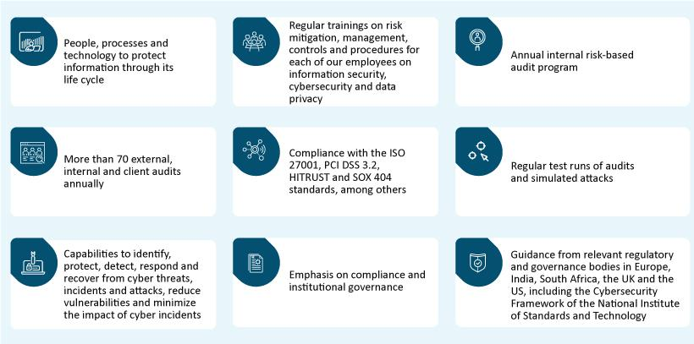

For more details on our cybersecurity program, see “Sustainability – Cybersecurity at EXL” on page 47.

36 | / | EXL 2025 Proxy Statement

Table of Contents

Corporate governance

Sustainability risk management

Our board reviews and receives regular reports on sustainability risks, including those relatng to sustainability disclosures, employee safety, environmental-related eforts, human capital management maters, and corporate governance trends and best practces. We also receive third-party limited assurance of the informaton contained in our Sustainability Report from a Big 4 accountng frm afliate.

Each of our board commitees is involved in oversight over sustainability-related risks as relate to maters within their purview:
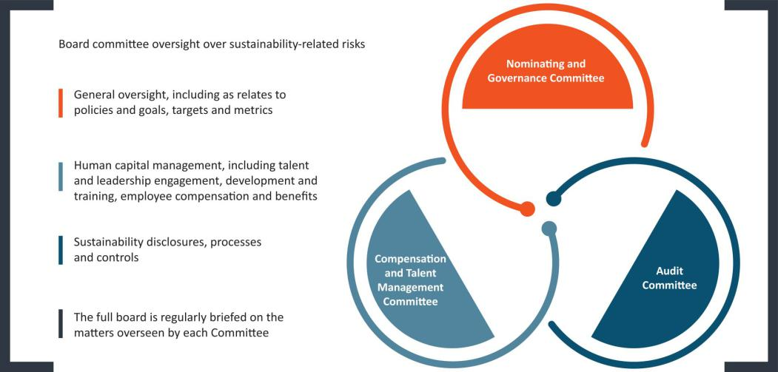

We maintain a cross functonal management-level sustainability steering commitee (“Sustainability Steering Commitee”), which is responsible for setng our sustainability strategy and risk management, keeping our management and board up-to-date on sustainability-related developments, overseeing our internal and external disclosure on sustainability maters, and providing implementaton support across our Company. The Sustainability Steering Commitee works in close coordinaton with the board, and provides the board with advice and assistance in its oversight of sustainability risks and other maters. For more details on our sustainability-related eforts, see “Sustainability” on page 40.

Artfcial intelligence risk management

We have a centralized, cross-functonal AI Governance Commitee, which oversees the use of AI models by EXL, and is jointly led by our General Counsel and Chief Informaton Ofcer and supported by our corporate compliance team, and engineering, digital, analytcs and applicable business leads. The AI Governance Commitee is guided by our global AI Governance Policy. Our board and our Audit Commitee are briefed from tme to tme by management and third-party frms on AI-related risks and opportunites, including in-depth discussions regarding current AI deployments with our customers. For more details on the use of responsible AI, see “Responsible artfcial intelligence” on page 48.

 | EXL 2025 Proxy Statement | / 37

Table of Contents

Corporate governance

Stockholder engagement

In 2024 and contnuing into early 2025, we contnued our formal governance-focused stockholder outreach program. Given our frequent engagement and the maturity of our stockholder outreach program, a number of our stockholders that we engaged with in prior years indicated that they had all required informaton at this tme, and elected to defer meetng again to a future year. For the meetngs we conducted with our stockholders in 2024 and early 2025, EXL was represented by our management and members of our legal and investor relatons teams. We discussed the below topics:

~79% | Outreach to stockholders by
~79% | shares outstanding during
~79% | 2024-2025 season
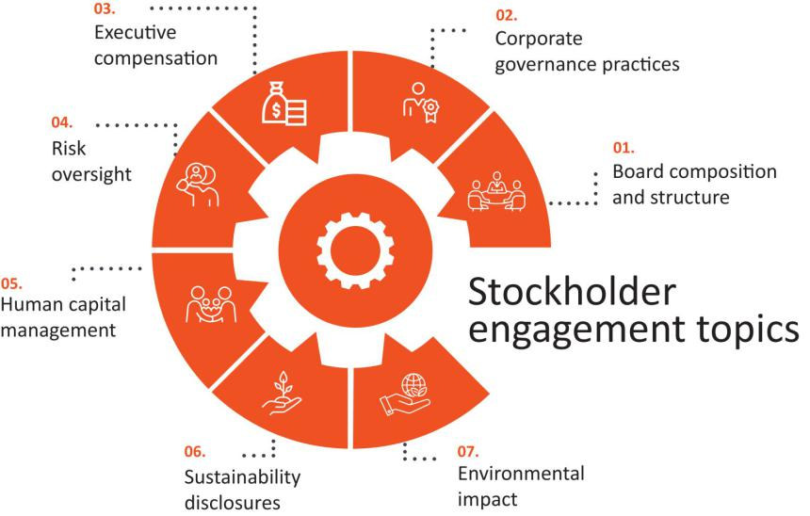

EXL also regularly interacts and shares informaton with our stockholders through our quarterly earnings calls, investor meetngs, SEC flings and publicatons on our website, among others. The feedback received from our stockholders is shared with and reviewed by our board, which is used to inform and focus our decisions relatng to our governance and sustainability practces and to improve our disclosures.

38 | / | EXL 2025 Proxy Statement

Table of Contents

Corporate governance

Communicatons with the board

Stockholders interested in contactng our board of directors, Lead Director or the directors who meet in executve session are invited to do so by writng to:

Board of Directors of ExlService Holdings, Inc.

c/o Corporate Secretary

ExlService Holdings, Inc.

320 Park Avenue, 29th Floor

New York, New York 10022

All other stockholder communicatons addressed to our board of directors will be referred to our Chairman and CEO and our Lead Director and tracked by our Corporate Secretary. Stockholder communicatons specifcally addressed to a partcular director will be referred to that director.

Complaints and concerns relatng to our accountng, internal accountng controls or auditng maters should be communicated to our Audit Commitee, which consists solely of non-employee directors. Any such communicaton may be anonymous and may be reported to our Audit Commitee through our General Counsel by writng to:

Audit Commitee of the Board of Directors

ExlService Holdings, Inc.

320 Park Avenue, 29th Floor

New York, New York 10022

Atn: General Counsel

All such concerns will be reviewed under Audit Commitee directon and oversight by our General Counsel, our Head of Internal Audit or such other persons as our Audit Commitee determines to be appropriate. Confdentality will be maintained to the fullest extent possible, consistent with the need to conduct an adequate review. Prompt and appropriate correctve acton will be taken when and as warranted in the judgment of our Audit Commitee. We prepare periodic summary reports of all such communicatons for our Audit Commitee.

 | EXL 2025 Proxy Statement | / 39

Table of Contents

Sustainability

Sustainability

In line with our mission of fnding a beter way for our clients, at EXL we are commited to doing our part to build a beter future by operatng in a responsible and sustainable manner that is aligned with and supports our business goals. We believe that by integratng sustainable practces into our business model, working towards positve social change, and providing transparent reportng on those practces and our progress, all in a manner that contributes to our corporate strategy, we are a stronger and more resilient organizaton that is best able to deliver long-term value to our stakeholders.

Community engagement
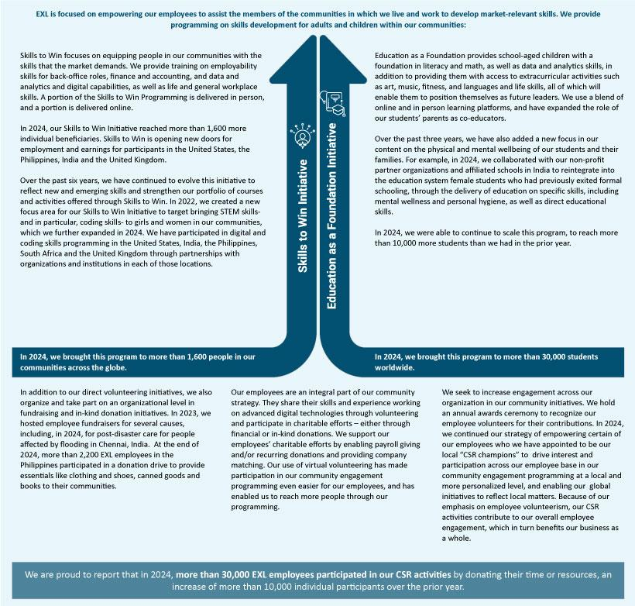

40 | / | EXL 2025 Proxy Statement

Table of Contents

Sustainability
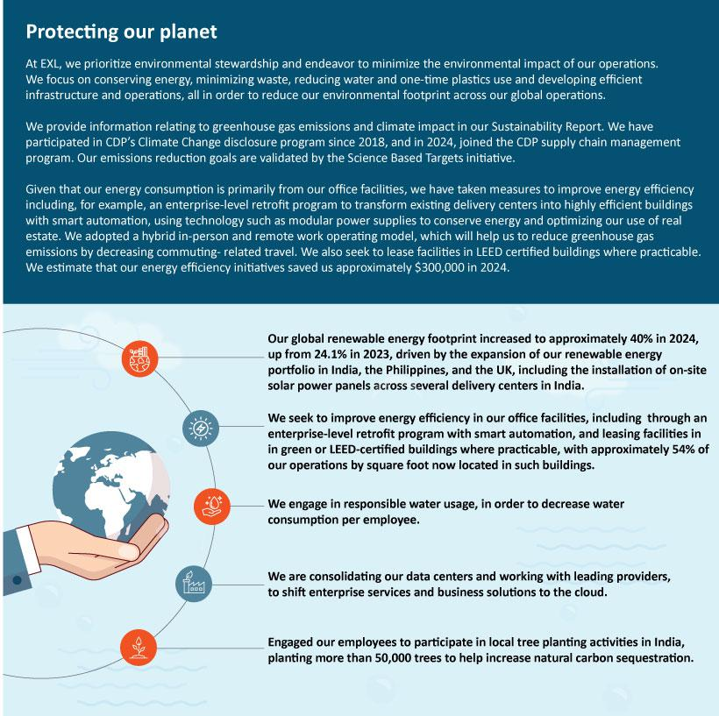

EXL 2025 Proxy Statement / 41

Table of Contents

Sustainability

Human rights and sustainable supply chain

Human rights

Our Human Rights Policy details our commitment to human rights and our zero tolerance for workplace harassment and discriminaton and preventng forced labor and trafcking and other abuses.

Sustainable supply chain

To ensure that our suppliers’ business conduct aligns with our expectatons, we collect background informaton from our new suppliers on their policies and performance relatng to economic and environmental, data privacy, and labor rights maters. We ask our suppliers to atest to their compliance with our Supplier Standards of Conduct, which set out commitments relatng to creatng a more sustainable and responsible world through addressing human rights, labor rights and environmental issues. We generally maintain the right to review our suppliers’ practces at onboarding and throughout our engagement. In 2024, we joined the CDP supply chain management program in order to beter understand our suppliers’ emissions and environmental practces.

We seek to procure our materials from local suppliers, to the extent practcable.

Supportng and developing our people

Our people are our greatest asset and our workforce stands out as our key diferentator, essental to delivering the data and AI-driven solutons that drive our business forward and support our long-term strategic growth. At EXL, we focus on atractng, developing and engaging top talent with advanced domain, data and AI skills and expertse to meet our clients’ needs and adapt to their evolving expectatons. We are commited to fostering our employees’ success by promotng engagement, providing extensive workforce upskilling and reskilling, and enabling contnuous capability development. We value diverse perspectves and experiences and seek to cultvate culture aligned with our core values. To understand employee satsfacton and engagement, we regularly conduct surveys and we leverage people analytcs to refne our talent management strategies. On an annual basis, our Compensaton and Talent Management Commitee reviews a comprehensive human capital strategic review prepared by management, followed by a full board review.

42 | / | EXL 2025 Proxy Statement

Table of Contents

Sustainability

Headquartered in New York, we are made up of approximately 59,500 professionals as of December 31, 2024, with more than 50 ofces spanning six contnents.

EXL locatons
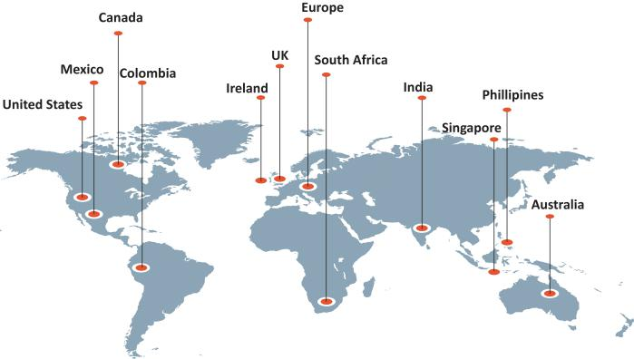

Our workplace culture

We believe that our employees’ diversity of perspectve and experience are key to our ability to innovate on a global scale, in line with our long-term corporate strategy. We believe that creatng an inclusive environment is the responsibility of all of our people managers, but the overall governance of workplace culture is led by our human resources leadership team and is ultmately overseen by our board. A global, cross-functonal mix of leaders provides input and helps set directon on key priorites and actons, conducts periodic reviews and provides executon leadership for specifc initatves. We aim to foster an inclusive and productve work culture and environment that harnesses the power of our people to drive organizatonal success.

 | EXL 2025 Proxy Statement | / 43

Table of Contents

Sustainability

Talent recruitment, development and retenton



Talent-frst

mindset for our

multfaceted talent needs

We view talent as a diferentator for our Company’s compettve advantage and, under the leadership of our board and senior executves, are commited to a talent-frst mindset. Our talent model is based on building a distributed workforce for our multfaceted talent needs.

Integrated talent

management

framework

We maintain an integrated talent management framework, employing actve collaboraton between our recruitment, capability development and human resource functons. We use data, technology, including an AI-driven infrastructure, and business insights to help us create a global talent network and stay ahead of the dynamic talent economy, while building a future ready workforce.

Actve role for senior

leadership

Our senior leadership team and board play a critcal role in defning our talent priorites to align with our strategic vision for each of our business units, as well as with our clients’ priorites.

Contnuous employee development


From the tme they join EXL, we focus on developing our employees by promotng opportunites for large-scale upskilling and reskilling, while fostering a learning environment conducive to individual skill-building and career advancement. We build role-specifc capabilites in our employees to be able to place the right people in the right roles. We maintain rigorous promoton standards, and compettve compensaton packages that include incentve-based compensaton.

Our capability development framework is focused on developing our employees’ digital and industry knowledge and leadership as a means to develop our talent internally. We achieve this through our learning academies, and through partnerships with industry organizatons, insttutes, business schools and consultng frms. We use a learning management system, reNew, that permits our employees to engage in self-directed learning by partcipatng in collaboratve trainings that are personalized to their interests and positons and are delivered virtually from any locaton, at any tme. We also maintain a learning marketplace that provides employees with regularly updated best-in-class digital trainings and certfcatons.

Academies
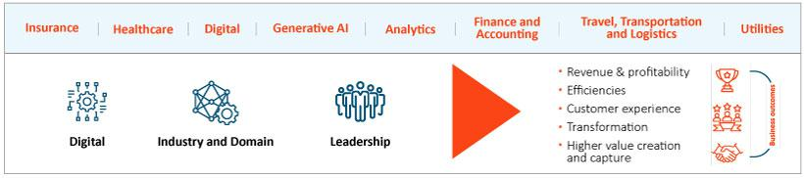

44 | / | EXL 2025 Proxy Statement

Table of Contents

Sustainability

2024 Training
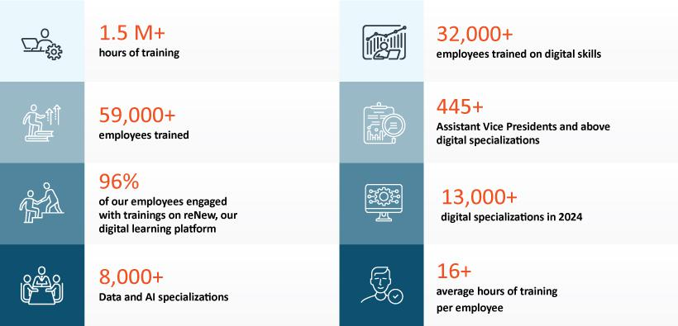

 | EXL 2025 Proxy Statement | / 45

Table of Contents

Sustainability

Employee engagement and communicaton

We consider communicaton and engagement with our approximately 59,500 employees distributed throughout more than 50 ofces and in remote working locatons worldwide to be important to our ability to promote our ONE EXL culture that prioritzes inclusivity and collaboraton. We contnued to rely on, and improve, our digital communicaton and collaboraton platorms and mult-channel approach to keeping our employees informed. In partcular, we engage with our employees through:
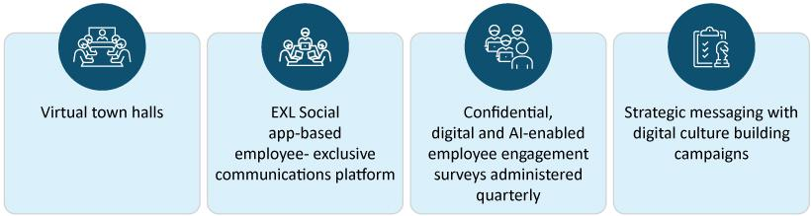

Benefts
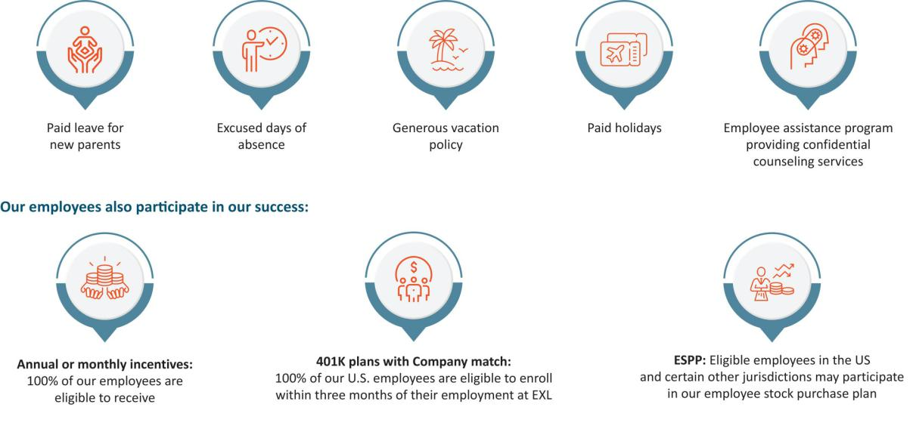

46 | / | EXL 2025 Proxy Statement

Table of Contents

Sustainability

Employee health, safety and wellbeing

Because our people are so important to us, we have always viewed employee health, safety and wellbeing as one of our top commitments. EXL has a well-defned Health and Safety Management System that is certfed to ISO 45001:2018. In 2024, we received a Five Star Ratng from the Britsh Safety Council for best practces in occupatonal health and safety in our United Kingdom, India, Philippines, Europe and South Africa centers. We periodically provide trainings on health and safety to our employees, suppliers and partners. In 2024, health and safety training e-module was mandatory for all of our employees. We also conduct a risk assessment every six months with the aim of minimizing risk in the workplace. We have also established Company-wide and worksite-specifc workplace safety objectves that are integrated into our EHS Management System. Where practcal, we seek to integrate EHS with our business actvites, focusing on conductng our actvites in an environmentally responsible manner and ensuring the health and safety of our employees, contractors, customers, visitors and the communites in which we operate. We also have a number of initatves to promote our employees’ wellbeing:


Cybersecurity at EXL

We are commited to protectng the confdentality, integrity, availability and privacy of the informaton assets of our clients and their customers, as well as our employees, vendors and any other third partes, that are shared with us and for which we are responsible. We maintain a comprehensive informaton and cybersecurity and data privacy program, based on defned policies processes and practces to safeguard the security, confdentality, integrity, availability and protecton of this informaton that we aim to contnually strengthen in order to mitgate material vulnerabilites and the impact of cyber incidents and comply with applicable privacy laws and regulatons.

For more informaton on our cybersecurity risk management, please see “Cybersecurity risk management” on page 36. For more informaton on our informaton security and data privacy procedures, please refer to the 2024 Form 10-K, Item 1C.

 | EXL 2025 Proxy Statement | / 47

Table of Contents

Sustainability

Responsible artfcial intelligence

We seek to ensure that our use of AI in our business and operatons is ethical and trustworthy and that its development and applicaton is based on the principles of fairness, security, reliability, transparency, accountability, and privacy. We have a centralized, cross-functonal AI Governance Commitee that is jointly led by the General Counsel and Chief Informaton Ofcer and supported by our corporate compliance team, and engineering, digital, analytcs and applicable business leads, which oversees the use of AI models by EXL. Pursuant to our AI Governance Policy, for each new deployment of AI created by EXL, we assess the AI model against the principles of trustworthy AI described above. Our AI Governance Policy also provides guidelines on regulatory compliance, data privacy and security, best practces for front-end and back-end development and human oversight as it relates to the use of responsible AI. Our management of these risks is reported to the board and the Audit Commitee from tme to tme. See “Artfcial intelligence risk management” on page 37. We also place emphasis on ensuring that our people are trained in AI and responsible AI. See “2024 Training” on page 45.

Sustainability scorecard
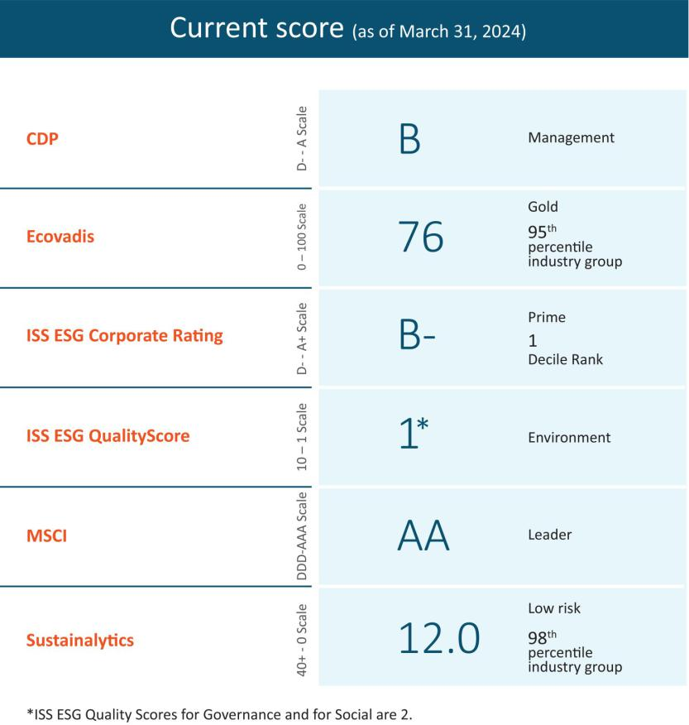

48 | / | EXL 2025 Proxy Statement

Table of Contents

Sustainability

Sustainability maters and pay-for-performance at EXL

Contnued focus on sustainability initatves aligned with business strategy and return on investment is a factor in determining in our CEO’s total compensaton. The achievement of specifc performance goals relatng to sustainability maters relevant to our overall business strategy. For more informaton, see “Detailed review of compensaton components – Annual incentves – Determinaton of individual performance measure achievement” on page 68.

Sustainability oversight

For more informaton on our oversight of sustainability and sustainability-related maters and risks, see “Sustainability risk management” on page 37.

Learn more about sustainability maters at EXL

Please visit www.exlservice.com/about/sustainability to learn more about our eforts toward sustainability, the impacts we are making on our communites and the environment and how this contributes to our business strategy. Informaton on our website referred to in this Proxy Statement does not consttute a part of this Proxy Statement.

 | EXL 2025 Proxy Statement | / 49

Table of Contents

Our Executve Commitee

Our Executve Commitee
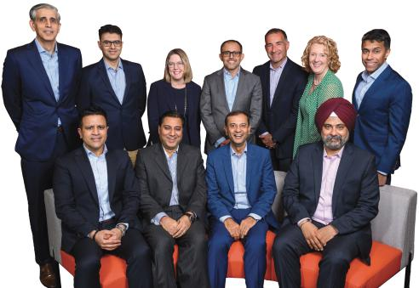

From back lef: Vivek Jetley, President and Head of Insurance, Healthcare and Life Sciences; Vikas Bhalla, President and Head of AI Services and Operatons; Anita Mahon, Chief Strategy and M&A Ofcer*; Narasimha Kini, Executve Vice President, Banking & Capital Markets and Diversifed Industries; Maurizio Nicolelli, Executve Vice President and Chief Financial Ofcer; Pamela Harrison, Executve Vice President and Chief Human Resources Ofcer; Ajay Ayyappan, Executve Vice President, General Counsel and Corporate Secretary

From front lef: Andy Logani, Executve Vice President and Chief Digital and AI Ofcer; Vishal Chhibbar, Executve Vice President, Internatonal Growth Markets and Chief Growth Ofcer; Rohit Kapoor, Chairman and CEO; Baljinder Singh, Executve Vice President, Global Chief Informaton Ofcer, and Head of Enterprise Digital Transformaton

*Ms. Mahon served on our Executve Commitee through April 1, 2025.

50 | / | EXL 2025 Proxy Statement

Table of Contents

Our Executve Commitee

Executve Commitee biographies

The following are biographies for each of the members of our Executve Commitee. Of the members of our Executve Commitee, Rohit Kapoor, Ajay Ayyappan, Vikas Bhalla, Vishal Chhibbar, Pamela Harrison, Vivek Jetley, Narasimha Kini and Maurizio Nicolelli are considered executve ofcers. Anita Mahon served on our Executve Commitee through April 1, 2025.


Rohit Kapoor (age 60) | Chairman and CEO

See secton enttled “Our board of directors” above.


Ajay Ayyappan (age 47) | Executve Vice President, General Counsel and Corporate Secretary

Mr. Ayyappan has served as our Executve Vice President, General Counsel and Corporate Secretary since February 2023. He previously served as our Senior Vice President, General Counsel and Corporate Secretary (December 2018 to February 2023), our Vice President, Actng General Counsel and Corporate Secretary (August 2018 to December 2018), our Vice President, Deputy General Counsel and Assistant Secretary (April 2014 to August 2018) and our Vice President and Assistant General Counsel (March 2007 to March 2014). Prior to joining us, Mr. Ayyappan was a corporate associate at the law frm, Morgan, Lewis & Bockius LLP.


Vikas Bhalla (age 53) | President and Head of AI Services and Operatons

Mr. Bhalla has served as our President and Head of AI Services and Operatons Strategic Growth Unit since the introducton of our new operatng model in 2025. Previously, he served as President and Business Head, Insurance since April 2024 and, prior to that, as our Executve Vice President and Business Head, Insurance since January 2014 and as our Head of Outsourcing since November

2009. He previously served as Vice President, Operatons of EXL India (June 2006 to October 2009), as Vice President, Migratons, Quality and Process Excellence of EXL India (April 2002 to June 2006) and as Director, Quality Initatves of EXL India (May 2001 to March 2002). From May 1998 to May 2001, Mr. Bhalla served in various capacites at General Electric, including as the Quality Leader and E-Business Leader for GE Plastcs India. Mr. Bhalla is based in India.


Vishal Chhibbar (age 57) | Executve Vice President, Internatonal Growth Markets and Chief Growth Ofcer

Mr. Chhibbar has served as our Executve Vice President, Internatonal Growth Markets and Chief Growth Ofcer Unit since the introducton of our new operatng model in 2025. Previously, he served as our Chief Growth and Strategy Ofcer since July 2023. Mr. Chhibbar was EXL’s chief fnancial ofcer from 2009 – 2019, and also previously served as the head of Finance and Accountng at EXL. Between 2019 and his return to EXL as chief fnancial ofcer at Brillio and president and chief fnancial ofcer of EPIQ.

Mr. Chhibbar has also served in various fnancial leadership roles across companies such as GE Capital, American Express Bank and Xerox.

 | EXL 2025 Proxy Statement | / 51

Table of Contents

Our Executve Commitee


Pamela Harrison (age 60) | Executve Vice President and Chief Human Resources Ofcer

Ms. Harrison has served as our Executve Vice President and Chief Human Resources Ofcers since June 2023. She previously served as executve vice president of human resources at Genworth Financial, and as a director of human resources of business transformaton at Latham & Watkins LLP.


Vivek Jetley (age 50) | President and Head of Insurance, Healthcare and Life Sciences

Mr. Jetley has served as our President and Head of Insurance, Healthcare and Life Sciences since the introducton of our new operatng model in 2025. Previously, he served as President and Business Head, Analytcs since April 2024 and previously as our Executve Vice President and Business Head, Analytcs since January 2020. He previously served in various leadership roles with us, including heading enterprise strategy and setng up a strategic deal team. Mr. Jetley has been with EXL since 2006. Prior to joining us, Mr. Jetley was a Partner at Inducts.


Narasimha Kini (age 56) | Executve Vice President, Banking & Capital Markets and Diversifed Industries Mr. Kini has served

 | as our Executve Vice President, Banking & Capital Markets and Diversifed Industries since the introducton of our new operatng
 | model in 2025. Previously, he served as our Executve Vice President and Business Head, Emerging Business since October 2021. He
 | previously served in several leadership roles with us, including in our strategic initatves and fnance and accountng services.
 | Mr. Kini has been with EXL since 2001. Prior to joining us, Mr. Kini was a Finance Leader at Willis Faber.
 | Anand “Andy” Logani (age 48) | Executve Vice President and Chief Digital and AI Ofcer
 | Mr. Logani has served as our Executve Vice President and Chief Digital and AI Ofcer since the introducton of our new operatng
 | model in 2025. Previously, he served as our Executve Vice President and Chief Digital Ofcer since January 2024. Since joining EXL in
 | 2001, he has served in various leadership positons with us, including as Chief Digital Ofcer and as our Global Head of Life & Annuity
 | Insurance business. Prior to joining us, Mr. Logani was a member of the strategic sales team at Kuehne & Nagel.
 | Anita Mahon (age 56) | Executve Vice President and Chief Strategy and M&A Ofcer
 | Ms. Mahon has served as our Executve Vice President and Chief Strategy and M&A Ofcer since the introducton of our new
 | operatng model in 2025. Previously, she served as our Executve Vice President and Business Head, Healthcare since May 2022, and
 | served prior to that as our Executve Vice President and Chief Growth Ofcer (March 2020 to May 2022). Prior to joining us,
 | Ms. Mahon served as Vice President, Data, Strategy & Portolio Ofcer at IBM Watson Health, a business unit focused on developing
 | cognitve and data-driven technologies to advance health. Ms. Mahon joined IBM in 2016 through its acquisiton of Truven Health
 | Analytcs, a healthcare informaton and analytcs business, where she served as Chief Strategy Ofcer. Prior to Truven, she held other
 | leadership roles that placed her at the intersecton of strategy, technology and analytcs.
52 / | EXL 2025 Proxy Statement



Table of Contents

Our Executve Commitee


Maurizio Nicolelli (age 56) | Executve Vice President and Chief Financial Ofcer

Mr. Nicolelli has served as our Executve Vice President and Chief Financial Ofcer since February 2020. Prior to joining the Company, Mr. Nicolelli served as Senior Vice President and Chief Financial Ofcer of Casa Systems beginning in 2019. He previously served 23 years at FactSet Research Systems, where he was Senior Vice President, Principal and Chief Financial Ofcer from 2009 to 2018.


Baljinder Singh (age 52) | Executve Vice President, Global Chief Informaton Ofcer, and Head of Enterprise Digital Transformaton

Mr. Singh has served as our Executve Vice President and Global Chief Informaton Ofcer since January 2024. Mr. Singh has been with EXL for more than 24 years, joining us as part of the founding leadership team. He has held several leadership roles at EXL across technology, transformaton, digital solutons, platorms development, and informaton security. He is based in India.

 | EXL 2025 Proxy Statement | / 53

Table of Contents

Executve compensaton

Executve compensaton

Compensaton Discussion and Analysis

Table of Contents

Named executve ofcers |  |  |  |  |  |  |  |  |  |  |  |  |  |  |  |  |  |  |  |  |  |  |  |  |  |  |  |  |  |  |  |  |  | 55
Executve summary |  |  |  |  |  |  |  |  |  |  |  |  |  |  |  |  |  |  |  |  |  |  |  |  |  |  |  |  |  |  |  |  |  | 55
 | Select 2024 fnancial and business highlights |  |  |  |  |  |  |  |  |  |  |  |  |  |  |  |  |  |  |  |  |  |  |  |  |  |  |  |  |  |  |  |  | 55
 | Awards and recognitons |  |  |  |  |  |  |  |  |  |  |  |  |  |  |  |  |  |  |  |  |  |  |  |  |  |  |  |  |  |  |  |  | 56
 | Clients and operatons |  |  |  |  |  |  |  |  |  |  |  |  |  |  |  |  |  |  |  |  |  |  |  |  |  |  |  |  |  |  |  |  | 57
 | Summary of key compensaton consideratons & decisions in 2024 |  |  |  |  |  |  |  |  |  |  |  |  |  |  |  |  |  |  |  |  |  |  |  |  |  |  |  |  |  |  |  |  | 57
 | Pay-for-performance |  |  |  |  |  |  |  |  |  |  |  |  |  |  |  |  |  |  |  |  |  |  |  |  |  |  |  |  |  |  |  |  | 57
Executve compensaton program, practces and policies |  |  |  |  |  |  |  |  |  |  |  |  |  |  |  |  |  |  |  |  |  |  |  |  |  |  |  |  |  |  |  |  |  | 59
Overview of compensaton policies and philosophies |  |  |  |  |  |  |  |  |  |  |  |  |  |  |  |  |  |  |  |  |  |  |  |  |  |  |  |  |  |  |  |  |  | 61
Compensaton process: roles and responsibilites |  |  |  |  |  |  |  |  |  |  |  |  |  |  |  |  |  |  |  |  |  |  |  |  |  |  |  |  |  |  |  |  |  | 62
Components of executve compensaton for 2024 |  |  |  |  |  |  |  |  |  |  |  |  |  |  |  |  |  |  |  |  |  |  |  |  |  |  |  |  |  |  |  |  |  | 64
Detailed review of compensaton components |  |  |  |  |  |  |  |  |  |  |  |  |  |  |  |  |  |  |  |  |  |  |  |  |  |  |  |  |  |  |  |  |  | 65
 | Base salary |  |  |  |  |  |  |  |  |  |  |  |  |  |  |  |  |  |  |  |  |  |  |  |  |  |  |  |  |  |  |  |  | 65
 | Annual cash incentve program |  |  |  |  |  |  |  |  |  |  |  |  |  |  |  |  |  |  |  |  |  |  |  |  |  |  |  |  |  |  |  |  | 66
 | Long-term equity incentves |  |  |  |  |  |  |  |  |  |  |  |  |  |  |  |  |  |  |  |  |  |  |  |  |  |  |  |  |  |  |  |  | 70
2024 Annual Restricted Stock Unit Awards |  |  |  |  |  |  |  |  |  |  |  |  |  |  |  |  |  |  |  |  |  |  |  |  |  |  |  |  |  |  |  |  |  | 71
Payout of awards granted in prior fscal years |  |  |  |  |  |  |  |  |  |  |  |  |  |  |  |  |  |  |  |  |  |  |  |  |  |  |  |  |  |  |  |  |  | 73
Benefts and perquisites |  |  |  |  |  |  |  |  |  |  |  |  |  |  |  |  |  |  |  |  |  |  |  |  |  |  |  |  |  |  |  |  |  | 73
Clawback Policy |  |  |  |  |  |  |  |  |  |  |  |  |  |  |  |  |  |  |  |  |  |  |  |  |  |  |  |  |  |  |  |  |  | 74
Stock Ownership Policy |  |  |  |  |  |  |  |  |  |  |  |  |  |  |  |  |  |  |  |  |  |  |  |  |  |  |  |  |  |  |  |  |  | 75
Securites Trading Policy |  |  |  |  |  |  |  |  |  |  |  |  |  |  |  |  |  |  |  |  |  |  |  |  |  |  |  |  |  |  |  |  |  | 75
Compensaton risk assessment |  |  |  |  |  |  |  |  |  |  |  |  |  |  |  |  |  |  |  |  |  |  |  |  |  |  |  |  |  |  |  |  |  | 75
Severance and change-in-control benefts |  |  |  |  |  |  |  |  |  |  |  |  |  |  |  |  |  |  |  |  |  |  |  |  |  |  |  |  |  |  |  |  |  | 75
Timing of equity awards |  |  |  |  |  |  |  |  |  |  |  |  |  |  |  |  |  |  |  |  |  |  |  |  |  |  |  |  |  |  |  |  |  | 76
Compensaton and Talent Management Commitee Report |  |  |  |  |  |  |  |  |  |  |  |  |  |  |  |  |  |  |  |  |  |  |  |  |  |  |  |  |  |  |  |  |  | 77
Summary compensaton table for fscal year 2024 |  |  |  |  |  |  |  |  |  |  |  |  |  |  |  |  |  |  |  |  |  |  |  |  |  |  |  |  |  |  |  |  |  | 78
Grants of plan-based awards table for fscal year 2024 |  |  |  |  |  |  |  |  |  |  |  |  |  |  |  |  |  |  |  |  |  |  |  |  |  |  |  |  |  |  |  |  |  | 80
NEO Employment agreements |  |  |  |  |  |  |  |  |  |  |  |  |  |  |  |  |  |  |  |  |  |  |  |  |  |  |  |  |  |  |  |  |  | 81
Outstanding equity awards at fscal 2024 year-end |  |  |  |  |  |  |  |  |  |  |  |  |  |  |  |  |  |  |  |  |  |  |  |  |  |  |  |  |  |  |  |  |  | 82
Opton exercises and stock vested during fscal year 2024 |  |  |  |  |  |  |  |  |  |  |  |  |  |  |  |  |  |  |  |  |  |  |  |  |  |  |  |  |  |  |  |  |  | 84
Pension benefts for fscal year 2024 |  |  |  |  |  |  |  |  |  |  |  |  |  |  |  |  |  |  |  |  |  |  |  |  |  |  |  |  |  |  |  |  |  | 84
Potental payments upon terminaton or change in control at fscal 2024 year-end |  |  |  |  |  |  |  |  |  |  |  |  |  |  |  |  |  |  |  |  |  |  |  |  |  |  |  |  |  |  |  |  |  | 84
Certain defned terms |  |  |  |  |  |  |  |  |  |  |  |  |  |  |  |  |  |  |  |  |  |  |  |  |  |  |  |  |  |  |  |  |  | 92
CEO pay rato |  |  |  |  |  |  |  |  |  |  |  |  |  |  |  |  |  |  |  |  |  |  |  |  |  |  |  |  |  |  |  |  |  | 93
Director compensaton for fscal year 2024 |  |  |  |  |  |  |  |  |  |  |  |  |  |  |  |  |  |  |  |  |  |  |  |  |  |  |  |  |  |  |  |  |  | 98

54 | / | EXL 2025 Proxy Statement

Table of Contents

Executve compensaton

Named Executve Ofcers

As determined in accordance with SEC rules, our named executve ofcers (“NEOs”) for 2024 are:

Rohit Kapoor, our Chairman and CEO

Maurizio Nicolelli, our Executve Vice President and CFO

Vikas Bhalla, our President and Head of AI Services and Operatons*

Vivek Jetley, our President and Head of Insurance, Healthcare and Life Sciences *

Vishal Chhibbar, our Executve Vice President, Internatonal Growth Markets and Chief Growth Ofcer

*Messrs. Bhalla and Jetley were each promoted, efectve April 1, 2024, from executve vice president to president in additon to their business head roles.

Executve summary

Select 2024 fnancial and business highlights

- Our annual revenues increased 12.7% from $1.6 billion in fscal year 2023 to $1.8 billion in fscal year 2024. Analytcs revenue increased 9.2% and digital operatons and solutons revenue increased 15.6%.

- We improved our net income atributable to stockholders by 7.4% from $184.6 million in fscal year 2023 to $198.3 million in fscal year 2024.

- Our diluted EPS increased from $1.10 in fscal year 2023 to $1.21 in fscal year 2024, an increase of 10%.

- We added approximately 5,500 employees to our global workforce, mainly in our delivery centers.

 | EXL 2025 Proxy Statement | / 55

Table of Contents

Executve compensaton

- In 2024, we returned capital to stockholders by repurchasing $196.5 million of shares. Our board of directors authorized a new $500 million common stock repurchase program beginning March 1, 2024. On March 15, 2024, we entered into a 2024 ASR Agreement with Citbank to repurchase shares of our common stock for an aggregate purchase price of $125.0 million, as part of our 2024 Repurchase Program.

- As of December 31, 2024, our 1-year TSR was 43.9%, our 3- year TSR was 53.3% and our 5-year TSR was 219.5%, in each case, outperforming our comparator groups and refectng our short and long-term growth expectatons and performance.

Awards and recognitons
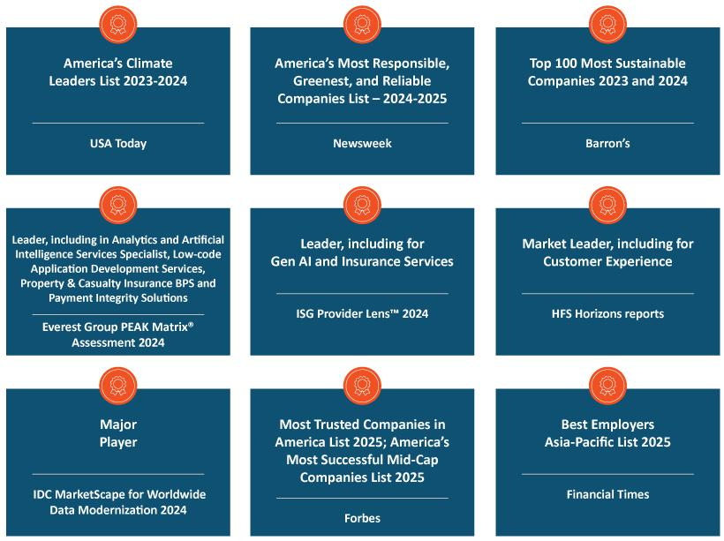

56 | / | EXL 2025 Proxy Statement

Table of Contents

Executve compensaton

Clients and operatons

- In 2024, we won 69 new clients, adding to the 63 new clients we won in 2023.

- Acquired ITI Data, a data management solutons frm that works with eight of the world’s largest banks, fnancial services and healthcare companies.

- Launched EXL Insurance LLM, developed using NVIDIA AI sofware that addresses the highly specialized needs of the insurance industry.

Summary of key compensaton consideratons & decisions in 2024

The following highlights the Compensaton and Talent Management Commitee’s key consideratons and compensaton decisions in 2024.

Items | Consideratons and decisions
Stockholder Input | Approximately 98% of our stockholders approved, on a non-binding basis (excluding broker non-votes), of our compensaton of our
 | NEOs. In 2024, we contnued to engage with our stockholders about our executve compensaton program, as described on page 108.
Base Salaries | The majority of our named executve ofcers received a base salary increase, which had not been increased since October 1, 2022.
Annual Incentves | Our annual incentves contnued to be based on achievement of Company goals (revenue and AOPM) and personal performance
 | goals. In 2024, we delivered 99.4% of our revenue performance target and 99.2% of our AOPM target, resultng in annual incentve
 | payouts, ranging from 84% to 117% of target performance for our named executve ofcers.
Equity Incentves | Consistent with prior years, we granted tme-based and performance-based restricted stock units to our NEOs. Performance-based
 | restricted stock units are linked to the achievement of cumulatve revenue and relatve TSR.
 | The tme-based restricted stock units vest 25% per year over four years based on contnued employment and the performance-based
 | restricted stock units clif vest at the end of a three-year performance period based on our achievement of the performance metrics.

Pay-for-performance

Our executve compensaton philosophy is focused on pay-for-performance. In this regard, we link a signifcant porton of each NEO’s total compensaton to the achievement of specifed performance goals. This variable compensaton is “at-risk” and rewards performance and contributons to both short- and long-term fnancial performance.

 | EXL 2025 Proxy Statement | / 57

Table of Contents

Executve compensaton

As illustrated by the following charts, the majority of the compensaton that may be earned by our named executve ofcers is ted to the achievement of fnancial performance metrics (annual incentve awards and PRSUs) or fuctuates with the underlying value of our common stock (PRSUs and RSUs).

* Base salary also includes items included in “All Other Compensaton” in the Summary Compensaton Table on page 78.

58 | / | EXL 2025 Proxy Statement

Table of Contents

Executve compensaton

Executve compensaton program, practces and policies

Our compensaton programs, practces and policies are reviewed and re-evaluated regularly and are subject to change from tme to tme in line with market best practces, including alignment of pay with performance. Our executve compensaton philosophy is aligned with our core values, focused on pay-for-performance and designed to refect appropriate governance practces aligned with the needs of our business. Listed below are some of the Company’s more signifcant practces and policies that were in efect during fscal year 2024, which are intended to drive performance and to align our executves’ interests with those of our stockholders.

What we do |  | What we don’t do
 | Align our executve pay with performance: We link a signifcant porton |  | No opton repricing: We prohibit opton repricing without stockholder
 | of each NEO’s total compensaton to the achievement of specifc |  | approval.
 | performance goals.
 | Variable compensaton is “at-risk” and rewards performance and
 | contributons to both short- and long-term fnancial performance.
 | Use appropriate peer groups when establishing compensaton: We |  | No opton backdatng or discountng: We prohibit opton backdatng and
 | establish a peer group to help us review market practces and design a |  | discountng.
 | compettve compensaton program. The criteria for peer group
 | selecton include annual revenues, similarity in business model and
 | strategic focus, scope of operatons, potental mobility of talent and
 | industry alignment.
 | We set compensaton of our executve ofcers at levels that we believe
 | are appropriate relatve to the compensaton paid to similarly situated
 | ofcers of our peers, giving consideraton to market and other factors.
 | Ensure equity compensaton best practces: We design annual long- |  | No excessive overhang or diluton: We do not have excessive overhang
 | term equity incentves to encourage our executves to maintain a long- |  | or diluton from equity grants.
 | term view of stockholder value creaton and to encourage retenton.
 | Our standard annual equity awards are granted on the basis of the
 | executve’s prior year’s performance and are subject to tme or
 | performance-based vestng conditons. A signifcant porton of such
 | awards only pay out according to the achievement of Company
 | performance goals covering a 3-year period.
 | We hold dividends accrued under our equity awards, if any, untl the
 | recipient vests in the underlying shares or units.
 |  |  | EXL 2025 Proxy Statement / 59

Table of Contents

Executve compensaton

What we do |  | What we don’t do
 | Maintain an independent Compensaton and Talent Management |  | Perquisites: We do not provide our named executve ofcers with
 | Commitee and compensaton consultant: Compensaton decisions for |  | signifcant perquisites or personal benefts. We believe the limited
 | our NEOs are approved by a Compensaton and Talent Management |  | perquisites we do ofer are reasonable and consistent with market
 | Commitee composed of non-employee independent directors. |  | trends. In additon, we consider the perquisites and personal benefts
 | Our Compensaton and Talent Management Commitee is advised by an |  | that we ofer to our executves in India to be customary benefts which
 |  |  | allow us to remain compettve for top talent.
 | independent compensaton consultant who reports directly to the |  | allow us to remain compettve for top talent.
 | Compensaton and Talent Management Commitee and provides no
 | other services to the Company or management.
 | Mitgate risks: The mix and design of our compensaton programs |  | No tax gross-ups: We do not provide gross-ups to any of our named
 | serves to mitgate operatonal, fnancial, legal, regulatory, strategic and |  | executve ofcers for any excise taxes imposed with respect to
 | reputatonal risks. |  | Secton 280G (change-in-control payments) or Secton 409A (nonqualifed
 |  |  | deferred compensaton) of the U.S. Internal Revenue Code of 1986, as
 |  |  | amended (which we refer to as the “Code”).
 | Maintain a clawback policy: Our clawback policy, which covers both |  | No hedging: We maintain a policy in which the following persons are
 | performance-based and tme-based awards, mandates recoupment of |  | prohibited from engaging in hedging transactons involving our shares
 | erroneously awarded incentve based compensaton in the event of a |  | and other securites: our directors and their secretaries and other
 | fnancial restatement and allows for recoupment of compensaton in |  | assistants; our executve ofcers and their secretaries and other
 | the event of an executve’s misconduct. |  | assistants; our employees in the accountng, fnance and legal
 |  |  | departments; the members and permanent invitees of our operatng and
 |  |  | executve commitees; and all of our vice president level 2 and 3 ofcers
 |  |  | (whom we refer to collectvely as “Reportng Persons”). For this purpose,
 |  |  | “hedging” refers to any strategy to ofset or reduce the risk of price
 |  |  | fuctuatons in our shares or other securites or to protect, in whole or in
 |  |  | part, against declines in the value of our shares or other securites. This
 |  |  | prohibiton thus applies to all transactons in derivatve securites based
 |  |  | on our stock such as other securites, including puts, calls, swaps and
 |  |  | collar arrangements.
 | Maintain a robust stock ownership policy: We maintain a robust stock |  | No pledging: Under our policy mentoned above, Reportng Persons (as
 | ownership policy that requires each covered executve to maintain |  | defned above) are only permited to pledge shares of our stock that
 | aggregate stock ownership equal to at least two tmes his or her base |  | exceed those required to be owned under our stock ownership policy
 | salary (six tmes for the CEO). See page 75 for a discussion of that |  | described above.
 | policy.
 | We maintain a similar stock ownership policy for our non-employee
 | directors, requiring them to maintain aggregate stock ownership equal
 | to at least fve tmes their annual cash retainer. See page 75 for a
 | discussion of that policy.
 | As of December 16, 2024, all covered executves and directors were in
 | compliance with the applicable stock ownership policy.
60 / EXL 2025 Proxy Statement

Table of Contents

Executve compensaton
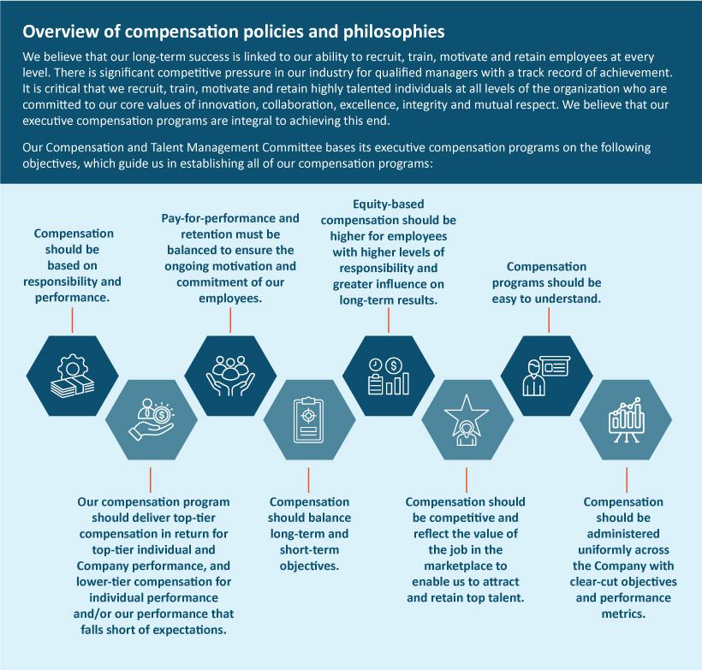

 | EXL 2025 Proxy Statement | / 61

Table of Contents

Executve compensaton

Compensaton process: roles and responsibilites

Our Compensaton and Talent Management Commitee has established a number of processes to assist it in ensuring that our executve compensaton programs are achieving their objectves. Our Compensaton and Talent Management Commitee, our management and our independent compensaton consultant are each engaged in these processes, as described in greater detail below.

Company | Establishment of performance measures
performance – | At the beginning of each year, or the end of the prior year, our Compensaton and Talent Management Commitee establishes the Company-
Compensaton and | wide and relevant business line performance measures on which our named executve ofcers’ annual cash incentve awards and equity
Talent Management | incentve awards are largely based. These measures refect targets that are intended to encourage stretch performance.
Commitee | Assessment of Company performance
 | At the end of the performance period, the Compensaton and Talent Management Commitee reviews and certfes our performance
 | achievement in relaton to the pre-established targets and considers the appropriateness of adjustments to the performance criteria and
 | calculatons of performance achievement to determine payout for cash and equity incentve awards.
Individual | The evaluaton of an individual’s performance determines a porton of the payouts under our annual incentve program and infuences any
performance – | changes in base salary for each of our named executve ofcers.
board of directors,
Compensaton | Assessment of CEO performance
and Talent | For Mr. Kapoor, our board of directors reviews and provides feedback on a self-evaluaton prepared by Mr. Kapoor. Once all directors have
Management | given feedback on Mr. Kapoor’s performance, our Lead Director and Chair of the Compensaton and Talent Management Commitee lead a
Commitee, and | comprehensive discussion of the full board of directors on Mr. Kapoor’s performance, leadership accomplishments and overall competence to
CEO | evaluate the achievement of established objectves.
 | Assessment of performance for all other NEOs and executve ofcers
 | For all other NEOs and executve ofcers, Mr. Kapoor makes a performance assessment and compensaton recommendaton to our
 | Compensaton and Talent Management Commitee. He bases the performance assessments on our named executve ofcers’ self-evaluatons
 | and his performance assessments of each of them.
 | Our board of directors reviews the performance assessments with Mr. Kapoor and evaluates the achievement of established objectves by
 | each executve ofcer and his or her business line, if applicable, and his or her contributon to our performance, leadership accomplishments
 | and overall competence.
Other maters | Our Compensaton and Talent Management Commitee periodically reviews related maters such as succession planning and management,
relevant to | evaluaton of management performance, changes in the scope of managerial responsibilites, and consideraton of the business environment,
compensaton | and considers such maters in making compensaton decisions. The Compensaton and Talent Management Commitee also considers an
decisions – | executve ofcer’s job responsibilites, performance, qualifcatons and skills in determining individual compensaton levels.
Compensaton and
Talent Management
Commitee
62 / EXL 2025 Proxy Statement

Table of Contents

 |  |  |  | Executve compensaton
Independent | For 2024, the Compensaton and Talent Management Commitee retained the services of Farient, a qualifed and independent
compensaton | compensaton consultant, to aid the Compensaton and Talent Management Commitee in performing its dutes. The Compensaton and
consultant | Talent Management Commitee’s compensaton consultant assists in:
 | • reviewing our executve pay philosophy,
 | • collectng and evaluatng external market data regarding executve compensaton and performance,
 | • | selectng peer group companies,
 | • | reviewing the Proxy Statement,
 | • advising the Compensaton and Talent Management Commitee on developing trends and best practces in executve
 |  | compensaton and compensaton governance, and
 | • advising the Compensaton and Talent Management Commitee on incentve plan design that aligns with our strategy.
 | In additon, Farient advises our Nominatng and Governance Commitee regarding director compensaton from tme to tme. Other than
 | performing these consultng services, Farient does not provide other services to us or our executve ofcers. We have afrmatvely
 | determined that no confict of interest has arisen in connecton with the work of Farient as compensaton consultant for the Compensaton
 | and Talent Management Commitee.
Peer market data | We review peer compensaton data on an annual basis in order to set compensaton for each following year. At the tme compensaton
Compensaton and | decisions were made for our senior executve ofcers in 2024, our Compensaton and Talent Management Commitee reviewed publicly
Compensaton and | available compensaton data. In partnership with our independent compensaton consultant, we have established a list of criteria to assess
Talent Management
Talent Management | the relevance of diferent companies to be included in our compensaton peer group. The criteria by which we select our peers includes
Commitee and | companies that are in similar industries, have similar business models (operatng in similar markets, requiring similar executve talent skills
independent | and subject to similar market forces), and are within a revenue range of around half our revenues to three tmes our revenues.
compensaton
consultants | The following chart shows the peer group companies that we used to make 2024 compensaton decisions, as well as the respectve
 | industries and 2024 revenues of each:
 |  |  |  |  | 2024
 |  |  |  | Revenue
 | Company |  | Industry | ($MM, USD)
 | EPAM Systems, Inc. |  | IT Consultng and Other Services |  | $4,728
 | Genpact Limited |  | Data Processing and Outsourced Services |  | $4,767
 | Verisk Analytcs, Inc. |  | Research and Consultng Services |  | $2,882
 | TTEC Holdings, Inc. |  | Data Processing and Outsourced Services |  | $2,208
 | ExlService Holdings, Inc. |  | Data Processing and Outsourced Services |  | $1,838
 | Teradata Corporaton |  | Systems Sofware |  | $1,750
 | Fair Isaac Corporaton |  | Applicaton Sofware |  | $1,718
 | Informatca Inc. |  | Applicaton Sofware |  | $1,640
 | WNS (Holdings) Limited |  | Data Processing and Outsourced Services |  | $1,323
 | UiPath Inc. |  | Systems Sofware |  | $1,308
 | Guidewire Sofware, Inc. |  | Applicaton Sofware |  | $980
 | Perfcient, Inc. |  | IT Consultng and Other Services |  | n/a
 | Splunk Inc. |  | Applicaton Sofware |  | n/a
 | Thoughtworks Holding, Inc. |  | IT Consultng and Other Services |  | n/a
 |  |  |  | EXL 2025 Proxy Statement | / 63

Table of Contents

Executve compensaton

In June of 2024, we updated the peer group companies that we used to make 2025 pay decisions as follows: Splunk was removed due to its acquisiton by CISCO and was replaced with Dun & Bradstreet which provides business-to-business data and analytcs. In additon, each of Perfcient and Thoughtworks will be removed in future years as they were acquired in 2024.

We use a separate peer group for measuring performance under our PRSUs, as described under “Compensaton—2024 Annual Restricted Stock Unit Awards.”

Management also used compensaton survey data from Aon Consultng, comprised of companies within our global industry with whom we compete for talent. While the Compensaton and Talent Management Commitee reviewed and considered the data provided by these surveys, it did not consider or review the compensaton paid to executves at the component companies included within such surveys and did not use this informaton or any other data as a defnitve benchmark to set executve compensaton for fscal year 2024.

Our Compensaton and Talent Management Commitee reviews compensaton informaton provided by Farient and other third-party data to evaluate each executve’s base salary, annual cash incentves and equity incentves when changes in compensaton are considered. Compensaton decisions are designed to promote our fundamental business objectves and strategy.

Our Compensaton and Talent Management Commitee uses the compensaton data to obtain a general understanding of current market practces, so it can design our executve compensaton program to be compettve. Market data is not used exclusively, but rather as a point of reference to draw comparisons and distnctons.

Components of executve compensaton for 2024

For 2024, the compensaton of executve ofcers consisted of the following fve primary components:

Compensaton component | Descripton | Objectves
Base salary | Fixed compensaton that is reviewed annually and is | Provide a base level of compensaton that
 | based on performance, experience, responsibilites, | corresponds to the job functon performed.
 | skill set and market value. | Atract, retain, reward and motvate qualifed and
 |  | experienced executves.
Annual incentves | “At-risk” compensaton earned based on | Incentvize executves to achieve annual goals that
 | performance measured against pre-established | ultmately contribute to long-term company growth
 | annual goals. | and stockholder return.
 | 75% of each NEO’s award is ted to Company-wide
 | performance with the remaining 25% to the
 | achievement of individualized goals.
Long-term incentves | “At-risk” compensaton in the form of equity awards | Align executve interests with those of stockholders.
 | whose value fuctuates according to stockholder | Reward contnuous service with the Company.
 | value. | Reward contnuous service with the Company.
 | RSU Awards: | Incentvize executves to achieve goals that drive
 | RSU Awards: | company performance over the long-term.
 | - 40% of the award vests based on contnued
 | service.
 | - 60% vests based on achievement of revenue
 | and relatve total stockholder return goals.
64 / EXL 2025 Proxy Statement

Table of Contents

 |  | Executve compensaton
Compensaton component | Descripton | Objectves
Other benefts | Broad-based benefts provided to employees (e.g., | Provide a total compensaton package that is
 | health and group insurance), a retrement savings | compettve with the marketplace and addresses
 | plan and other personal benefts where appropriate | unique needs, especially for overseas executves.
 | and as required by local law.
Severance and change | Protect executves during potentally tumultuous | Allow executves to focus on generatng stockholder
in control protectons | corporate transacton. | value during a change in control transacton.
 | Provide post-employment compensaton upon other | Provide market-compettve post-employment
 | involuntary terminatons. | compensaton recognizing executves likely require
 |  | more tme to fnd subsequent employment.

Detailed review of compensaton components

Base salary

As discussed above, we provide our named executve ofcers fxed cash compensaton commensurate with their performance, experience, responsibilites, skill set and market value. This atracts and retains an appropriate caliber of talent for these positons and provides a base wage that is not subject to our performance risk. In setng base salaries for 2024, our Compensaton and Talent Management Commitee considered:

Individual performance | The degree to which the executve met and exceeded expectatons.
Market data | Market data to test reasonableness of compensaton.
Overall compensaton mix | Senior executves should have a greater porton of their compensaton ted to increasing stockholder value.
 | EXL 2025 Proxy Statement / 65

Table of Contents

Executve compensaton

Upon completng its review, the Compensaton and Talent Management Commitee determined it was appropriate to increase base salaries for each of our NEOs (other than Mr. Chhibbar who joined the Company in July of 2023) because the NEOs had not received a compensaton increase since October 2022 and based on overall Company performance. In additon, for Messrs. Bhalla and Jetley, the Compensaton and Talent Management Commitee determined that a larger increase (18% and 10%, respectvely) was appropriate, as a result of each of their promotons from Executve Vice President to President in April 2024. The fxed compensaton amount for Mr. Bhalla covers not only base salary, but also amounts available as a travel allowance, an automobile allowance, a housing allowance, and a cash supplementary allowance, consistent with compensaton practces in India.

 |  |  | Percentage
 | 2023 Base salary / | 2024 Base salary / | change to
Name | annual fxed | annual fxed | annual fxed
Name | compensaton ($/INR) | compensaton ($/INR) | compensaton (%)
Rohit Kapoor | 815,000 | 840,000 | 3%
Maurizio Nicolelli | 510,000 | 540,000 | 6%
Vikas Bhalla (1) | INR 27,900,000(2) | INR 33,000,000(2) | 18%
Vivek Jetley | 500,000 | 550,000 | 10%
Vishal Chhibbar | N/A(3) | 500,000 | —

- For Mr. Bhalla, total annual fxed compensaton is determined and paid in Indian rupees.

- Equivalent to $335,304 for 2023 base salary and $385,446 for 2024 base salary, converted, respectvely, at 83.208 INR to 1 USD, which was the exchange rate on December 29, 2023, and 85.615 INR to 1 USD, which was the exchange rate on December 31, 2024.

- Mr. Chhibbar’s 2023 compensaton is not included in the table above because he was not an NEO in 2023.

Annual cash incentve program

We have established an annual cash incentve program under our the ExlService Holdings, Inc. 2018 Omnibus Incentve Plan, approved by the Company’s stockholders at the annual meetng of stockholders held in June 2018 (the “2018 Plan”), in order to align our executve ofcers’ goals with our performance targets for the current year and to encourage meaningful contributons to our future fnancial performance. Our Compensaton and Talent Management Commitee approved the same framework for our annual incentve program in late 2023 for awards payable in respect of 2024 performance as we have used in prior years. Under the program, annual incentve award target amounts, expressed as a percentage of base salary or annual fxed compensaton, are established for partcipants at the beginning of each year. Funding of potental annual incentve award payouts for the year are determined by our fnancial results for the year relatve to predetermined performance measures and our assessment of each named executve ofcer’s performance relatve to his or her predetermined individual performance goals. If our performance falls short of target, our aggregate funding of the annual incentve pool declines. If we do not achieve a minimum threshold for the established fnancial performance objectves, then the annual incentve pool is not funded for that partcular objectve. The Compensaton and Talent Management Commitee has the discreton under the 2018 Plan to adjust an award payout from the amount yielded by the formula at the end of the performance period for reasons including, but not limited to, the efect of changes in laws or regulatory rules, acquisitons or divesttures, reorganizaton or restructuring, extraordinary accountng items, foreign exchange gains or losses, and/or any specifc unusual or non-recurring events. The Compensaton and Talent Management Commitee did not apply any such discretonary adjustments for the 2024 annual incentve awards.

66 | / | EXL 2025 Proxy Statement

Table of Contents

Executve compensaton

Our Compensaton and Talent Management Commitee considered the following when establishing the awards for 2024:

Annual incentve award targets

Annual incentve award targets were established based on job responsibilites and comparable market data. Our objectve was to set targets such that total annual cash compensaton was within the broad middle range of market data and a substantal porton of that compensaton was linked to our performance. Our Compensaton and Talent Management Commitee established the following annual incentve award targets (expressed as a percentage of base salary or annual fxed compensaton) as well as maximum targets for each named executve ofcer for 2024, which remained unchanged versus the prior year.

Name | Annual incentve award target(1) | Annual incentve award maximum
Rohit Kapoor | 150% of base salary | 300% of base salary
Maurizio Nicolelli | 75% of base salary | 150% of base salary
Vikas Bhalla | 75% of annual fxed compensaton | 150% of annual fxed compensaton
Vivek Jetley | 75% of base salary | 150% of base salary
Vishal Chhibbar | 75% of base salary | 150% of base salary

(1) Annual incentve award target is a % of base salary for US based employees and annual fxed compensaton for Mr. Bhalla, who is based in India.

Performance measures

Our executves were eligible to earn annual incentves with 75% of the award based on their achievement of Company-wide performance metrics and the remaining 25% of the award based on individual performance. Consistent with prior years, the Company-wide porton of the 2024 annual incentve program was based 50% on the Company’s revenue goal and 50% on the Company’s adjusted operatng proft margin (AOPM) for all employees, including our named executve ofcers. Individual performance goals are unique to each of our executve positons within the organizaton. The Compensaton and Talent Management Commitee believes achievement of these performance metrics will drive our business and, in turn, lead to increased stockholder value.

 | EXL 2025 Proxy Statement | / 67

Table of Contents

Executve compensaton

Determinaton of fnancial performance achievement

For 2024, our Compensaton and Talent Management Commitee established a revenue target of $1.84 billion (which was 13.6% higher than our actual revenue for the prior year and 14.3% higher than our prior year’s target performance) and an AOPM target of $357.1 million (which was 15.2% higher than our actual AOPM for the prior year and 16.6% higher than our prior year’s target performance). As shown below, the porton of annual incentve award payments that were subject to these fnancial performance measures could have ranged from zero to 200% of the target depending on the achievement of the performance goals.

Performance targets: revenue ($1.84 billion); and AOPM ($357.1 million)

% of performance achieved compared to target goal | % of target porton funded*
Above 110% | 200%
At 100% | 100%
At 90% | 10%
Less than 90% | 0%

*Linear interpolaton for performance between discrete points.

Based on our performance during the 2024 fscal year, we achieved revenue performance of $1.83 billion, which was equal to 99.4% of our revenue performance target (resultng in funding of 94.9% based on the chart above), and AOPM performance of approximately $354.1 million, which was equal to 99.2% of our AOPM target (resultng in funding of 92.6% based on the chart above), which together yielded a weighted funding of 93.8% for the Company-wide performance metric. For purposes of achievement of fnancial performance targets, revenue and AOPM are measured using the estmates and assumptons (partcularly, currency exchange rates) at the tme the targets are established.

Determinaton of individual performance measure achievement

Our named executve ofcers earn a porton of their annual incentve awards based on the achievement of individual performance measures designed to balance the named executve ofcers’ eforts between the achievement of near-term objectves that improve specifc processes or performance metrics and long-term objectves that increase the Company’s value, economic impact, and sustained stockholder returns. For more informaton on the process for determining individual performance measure achievement, please see “Compensaton process: roles and responsibilites” on page 62. Below is a summary of each named

68 | / | EXL 2025 Proxy Statement

Table of Contents

Executve compensaton

executve ofcer’s individual performance measures, as well as a summary of each named executve ofcer’s achievements in light of the designated performance measures applicable to each such executve’s role during 2024:

Named Executve
Ofcer | 2024 Individual performance measure |  |  | 2024 Individual performance achievement
Rohit Kapoor | • | Drive proftability with sustained | • | Led growth resultng in 2024 revenue of $1.8 billion (12.7% year-over-
 |  | momentum |  | year growth) with sustained proftability and adjusted EPS⁽¹⁾ of $1.65
 | • | Improve adjusted operatng proft margin |  | (15.4% year-over-year growth)
 | • | Execute strategic pivot to data and AI-led | • | AOPM improved by 10 bps from 2023 to 2024, reaching 19.4%
 |  | positoning | • | Executed a successful pivot to data and AI-led market positoning,
 | • | Develop robust partnerships |  | resultng in a 53% revenue share from data and AI; acquired and
 | • | Improve employee experience through |  | integrated ITI Data, expanding the Company’s data management
 |  | greater engagement |  | capabilites; developed and launched EXL Insurance LLM, among others
 | • | Contnued focus on sustainability | • | Built a large partner-led pipeline with key industry players with advances
 |  |  |  | on joint market oferings and GTM actons
 |  |  | • | Contnued focus on talent upskilling, expanded leadership backgrounds
 |  |  |  | and expertse and digital capabilites, including through 1.8 million hours
 |  |  |  | dedicated to upskilling, with over 20% of colleagues trained on future AI
 |  |  |  | and data needs
 |  |  | • | Progressed sustainability initatves aligned with business strategy and
 |  |  |  | focus on ROI, and received industry recognitons
Maurizio Nicolelli | • | Drive proftable growth agenda | • | Full year EPS growth rate outperformed revenue growth rate
 |  | emphasizing EPS growth | • | Implemented long-term tax strategy resultng in optmized tax rate and
 | • | Drive long-term tax strategy |  | pathway to future benefts
 | • | Expand investor base | • | Expanded our overall investor base and existng investor positons. Three
 |  |  |  | of our new investors joined our top 20 investors.
Vikas Bhalla | • | Deliver proftable growth in Insurance | • | Drove insurance revenue with strong gross margins
 |  | business in 2024 with sustained | • | Developed processes and procedures aimed at strengthening the frst line
 |  | momentum |  | of compliance, including early warning scorecard for top accounts
 | • | Focus on strong executon and service
 |  | delivery
Vivek Jetley | • | Drive revenue and proftability for Analytcs | • | Grew Analytcs revenue 9% year-over-year with improved proftability
 | • | Realize EXL Ventures Lab concept | • | Executed EXL Ventures Lab IdeaTank actvity enterprise-wide, generatng
 |  |  |  | over 1,500 ideas, with fnalists being driven from concept to Company
 |  |  |  | adopton
Vishal Chhibbar | • | Contnue rigor around growth vectors | • | Grew the overall deal pipeline by ~50% and large deal wins by ~22%
 | • | Empower sales teams by building sales | • | Empowered sales leaders, leading to an increase in average win rate
 |  | capability and ecosystem | • | Revamped the new joiner training programs, reducing frst-year atriton
 |  |  |  | of front-end colleagues

- Adjusted EPS is a non-GAAP fnancial measure. See “Non-GAAP Reconciliaton” beginning on page 125 for more details, as well as a reconciliaton of the non-GAAP measures used herein.

 | EXL 2025 Proxy Statement | / 69

Table of Contents

Executve compensaton

The table below sets out the 2024 annual incentve awards paid to our named executve ofcers (paid in March 2025):

 | Overall percentage | 2024 Actual annual
 | atainment of | incentve awarded
Name | target bonus | ($)(1)
Rohit Kapoor | 117% | 1,440,000
Maurizio Nicolelli | 102% | 394,215
Vikas Bhalla | 105% | 269,216
Vivek Jetley | 84% | 323,153
Vishal Chhibbar | 105% | 394,917

- The exchange rate used for the bonus conversion from Indian rupees to U.S. dollars for Mr. Bhalla was 85.615 INR to 1 USD, which was the exchange rate on December 31, 2024.

Long-term equity incentves

The Compensaton and Talent Management Commitee believes long-term equity awards provide employees with the incentve to stay with us for longer periods of tme, which in turn provides greater stability as we grow. These incentves foster the long-term perspectve necessary for contnued success in our business because the value of the awards is directly linked to long-term performance of our stock price, thereby ensuring that our executve ofcers are properly focused on stockholder value.

The Compensaton and Talent Management Commitee elects to grant Time-Vested and Performance-Vested restricted stock unit (“RSUs”) awards because these awards ofer executves the opportunity to receive shares of our common stock on or shortly following vestng. Such awards serve both to reward and retain executves: value is linked to the price of our stock, the executve must generally remain employed by the Company through the applicable vestng dates to receive shares and the performance-vested awards require achievement of certain performance goals. For these reasons, restricted stock unit awards provide a signifcant degree of alignment between the interests of our executves and stockholders.

The Compensaton and Talent Management Commitee also believes that the mix between Time-Vested RSUs and Performance-Vested RSUs provides an appropriate balance between incentvizing our executves to contnue their employment with the Company and ensuring they are focused on generatng long-term fnancial performance and sustained stockholder value, which, in turn, results in additonal compensaton.

70 | / | EXL 2025 Proxy Statement

Table of Contents

Executve compensaton

Equity compensaton

2024 Annual Restricted Stock Unit Awards

Under our equity compensaton program, our named executve ofcers received restricted stock units under the 2018 Plan. 40% of the restricted stock units vest based on contnued employment over four years, and 60% percent of the restricted stock units may be earned based on our relatve TSR performance and our revenue performance during a three-year performance period, as shown below.

40% | + | 36% | + | 24% | = | Total
Time-vested |  | Relatve TSR-linked |  | Revenue-linked |  | Long-Term Incentve
RSUs |  | PRSUs |  | PRSUs |  | Award

Our Compensaton and Talent Management Commitee selected revenue and relatve TSR as the performance measures for the PRSUs because revenue is a key driver of stockholder value, thus aligning stockholder and executve interests, and relatve TSR incorporates a comparatve component that measures our stock performance against industry peers. In additon, both the revenue and relatve TSR performance measures encourage a focus on our strategic goals of long-term fnancial performance and market share growth.

The table below shows the target dollar value of Time-Vested RSUs and Performance-Vested RSUs our Compensaton and Talent Management Commitee awarded our named executve ofcers in 2024. In general, the Compensaton and Talent Management Commitee believes that the size of the award granted to an executve ofcer should increase based on the executve ofcer’s level of responsibility within the Company. The number of shares subject to each NEO’s Time-Vested RSU and Performance-Vested RSU (assuming a “target” level of performance) was determined by dividing the NEO’s target dollar value by the average stock closing price for the preceding month – see the “Grants of plan-based awards table for fscal year 2024” below.

 |  | Target | Target | Total Target
 | Target | Revenue-Linked | Relatve TSR-Linked | Total Target
Name | Time-Vested RSUs ($) | PRSUs ($) | PRSUs ($) | Equity ($)
Rohit Kapoor | 4,200,000 | 2,520,000 | 3,780,000 | 10,500,000
Maurizio Nicolelli | 700,000 | 420,000 | 630,000 | 1,750,000
Vikas Bhalla | 1,200,000 | 720,000 | 1,080,000 | 3,000,000
Vivek Jetley | 1,200,000 | 720,000 | 1,080,000 | 3,000,000
Vishal Chhibbar | 700,000 | 420,000 | 630,000 | 1,750,000

- The “Time-Vested RSUs” will vest in increments of 25% on each of the frst four anniversaries of the grant date, generally subject to contnuous service with the Company through the applicable vestng date.

–The Compensaton and Talent Management Commitee believes these Time-Vested RSUs provide an important role in promotng retenton of our executve ofcers.

 | EXL 2025 Proxy Statement | / 71

Table of Contents

Executve compensaton

- The “Performance-Vested” porton of the 2024 RSUs (“PRSUs”) are split into two types that each vest based on separate performance measures as follows:

–Revenue-Linked PRSUs: 40% of these performance-based restricted stock unit awards will clif-vest on December 31 of the third fscal year in the performance period, subject to achievement of threshold Company revenues against an aggregate revenue target over the grant’s three-year performance period of January 1, 2024 to December 31, 2026, and contnuous employment through December 31, 2026. The ultmate amount of Revenue-Linked PRSUs that a recipient earns may be up to 200% of the target award of Revenue-Linked PRSUs. To the extent the Company’s revenue falls in between the outlined target achievements, the percentage of Revenue-Linked

PRSUs earned will be determined based on straight line interpolaton between these points. The chart below sets forth the revenue achievement levels and the corresponding funding percentage:

Revenue achievement levels | Percentage of Revenue-Linked PRSUs earned
110% or more | 200%
At 100% | 100%
90% | 25%

–Relatve TSR-Linked PRSUs: The remaining 60% of the performance-based restricted stock unit awards clif-vests on December 31 of the third fscal year in the performance period, based on the achievement of a threshold level of the Company’s total stockholder return performance relatve to a performance peer group over the grant’s three-year performance period of January 1, 2024 to December 31, 2026, and contnuous employment through December 31, 2026. The Company’s TSR for the TSR performance period will be computed and then compared to the TSR of the companies in the “performance peer group,” which is comprised of the public companies traded on either the NYSE or Nasdaq stock markets in our 8-digit Global Industry Classifcaton Standard sub-industry group. In the Compensaton and Talent Management Commitee’s view, this comparator set is more appropriate than the compensaton peer group for this purpose as it provides a more robust comparison of our performance to the marketplace by the inclusion of more companies and eliminaton of size as a selecton criterion, which is more relevant for compensaton than performance comparison. For the Relatve TSR-Linked PRSUs granted in 2024, the Company included a negatve TSR cap. Under the negatve TSR cap, if the Company’s total stockholder return is negatve over the course of the three-year performance period, no named executve ofcer may receive greater than 100% funding of the TSR-Linked PRSUs, even if the Company’s performance as compared to the performance peer group exceeds the 50th percentle.

72 | / | EXL 2025 Proxy Statement

Table of Contents

Executve compensaton

The percentage of Relatve TSR-Linked PRSUs earned will be determined based on straight-line interpolaton to the extent the

Company’s TSR falls in between the 20th and 80th percentles, as per the chart below:

TSR peer group percentle | Percentage of Relatve TSR-Linked PRSUs earned
80.0 or more | 200%
50.0 | 100%
21.0 | 3.33%
20.0 or less | 0%

The Compensaton and Talent Management Commitee believes the PRSUs focus our executves on key drivers of our Company’s business that will ultmately lead to creaton of additonal stockholder value.

Payout of awards granted in prior fscal years

This was the third and fnal performance year for the 2022 performance-based restricted stock units. Our cumulatve three-year revenue target was approximately $4.4 billion. We achieved approximately $4.9 billion for the three-year period, which was 112.5% of the revenue target for the revenue-linked PRSUs, resultng in the executves earning 200% of the 2022 revenue-linked PRSUs. The Company’s TSR performance was at the 92nd percentle among its peer group, resultng in the executves earning 200% of the 2022 relatve TSR-Linked PRSUs pursuant to the terms of the original grant.

 | Threshold
 | (25% for Revenue |  | Maximum
Performance Metric | and 3.33% for TSR) | Target (100%) | (200%) | Actual Performance
Revenue | 90% | 100% | 110% | 112.5%
TSR⁽¹⁾ | 21st | 50th | 80th or > | 92nd percentle
 | percentle | percentle | percentle

2022-2024 PSU Final Payout Percentage: 200%

- As noted above, the TSR peer group for this performance metric is comprised of the public companies traded on either the NYSE or Nasdaq stock markets in our 8-digit Global Industry Classifcaton Standard sub-industry group.

Benefts and perquisites

We ofer employee benefts coverage in order to:

- provide our global workforce with a reasonable level of fnancial support in the event of illness or injury; and

- provide market-compettve benefts that enhance productvity and job satsfacton through programs that focus on work/life balance.

The benefts available for all U.S. employees include customary medical and dental coverage, disability insurance, life insurance and a 401(k) plan. A number of our U.S. employees, including our U.S.-based named executve ofcers, partcipate in these plans.

 | EXL 2025 Proxy Statement | / 73

Table of Contents

Executve compensaton

The cost of employee benefts is partally borne by our employees, including our named executve ofcers. Mr. Bhalla, who is located in India, is eligible to partcipate in the Company’s pension beneft, health and welfare and fringe beneft plans otherwise available to executve employees in India.

We generally do not provide our named executve ofcers with signifcant perquisites or personal benefts. Our CEO is provided a limited number of perquisites which we believe are reasonable and consistent with market trends, and which are intended to be part of a compettve overall compensaton program. A discussion of the benefts provided to our CEO is provided under “NEO Employment agreements” beginning on page 81. In additon, we consider the perquisites and personal benefts that we ofer to our executves in India to be customary benefts which allow us to remain compettve for top talent. We also may provide limited perquisites to executve ofcers upon hire, such as relocaton costs and legal fees.

Clawback Policy

In 2023, we updated our clawback policy to bring it into compliance with new Nasdaq listng standards implementng clawback rules under the Dodd-Frank Wall Street Reform and Consumer Protecton Act. In the event a restatement of our fnancial statements is required, incentve-based compensaton ted to a fnancial reportng measure that was “received” under the rules by covered executve ofcers in the three prior completed fscal years will be recalculated (if applicable) based on the updated fnancial statements. Incentve compensaton deemed to have been erroneously received as a result of the restatement will be subject to recoupment. The method of recoupment will be determined by the board or a commitee of the board.

In additon, our clawback policy contains an additonal recoupment trigger in the event of executve ofcer misconduct. If the board or a commitee of the board determines that an executve violated material Company policies, misstated fnancial or other material informaton about the Company, commited fraud or misconduct, breached a restrictve covenant or other agreement with the Company, engaged in other conduct that is detrimental to the business or reputaton of the Company, or was identfed by the Department of Justce as having engaged in wrongdoing (including through supervisory actvity), the board or a commitee of the board may in its sole discreton recoup compensaton (including tme-based equity awards) from that executve ofcer. Amounts recoupable under the misconduct trigger may include compensaton that would not otherwise be subject to recoupment under the Nasdaq listng standards.

74 | / | EXL 2025 Proxy Statement

Table of Contents

Executve compensaton

Stock Ownership Policy

Our executve stock ownership policy requires:

- Our CEO to maintain aggregate stock ownership equal to at least six tmes his base salary (countng common stock, vested restricted stock units and unvested tme-based restricted stock units) and three tmes his base salary (when excluding unvested tme-based restricted stock units).

- Other members of our executve commitee (including our named executve ofcers) to maintain aggregate stock ownership equal to at least two tmes their base salaries (countng common stock and vested restricted stock units).

Common stock is counted toward the ownership requirement if it is owned by or for the beneft of the executve, the executve’s spouse or the executve’s children sharing the same household. Unearned performance-based restricted stock units and unexercised optons (including in-the-money optons) do not count toward the ownership requirement.

New executves generally have fve years to meet the ownership requirement, whereas existng executves generally have three years to meet any increased ownership requirements as a result of base salary increases. During the applicable phase-in period, executves generally must retain at least 50% of shares delivered (net of tax) following the vestng of an equity award untl the ownership requirement is met. If the ownership requirement is not met at the end of the phase-in period, executves generally may not sell any shares (other than to satsfy taxes) untl the ownership requirement is met.

All covered executves were in compliance with the executve stock ownership policy as of the December 16, 2024 measurement date.

Securites Trading Policy

The Company has adopted an insider trading policy that governs the purchase, sale, and/or other transactons of our securites by our directors, ofcers and employees. A copy of our insider trading policy was fled as Exhibit 19.1 to the 2024 Form 10-K. In additon, with regard to the Company’s trading in its own securites, it is the Company’s policy to comply with the federal securites laws and the applicable exchange listng requirements.

Compensaton risk assessment

Our Compensaton and Talent Management Commitee has taken into account its discussions with management and Farient regarding our compensaton practces and has concluded that any risks arising from our compensaton policies and practces are not reasonably likely to have a material adverse efect on the Company. This conclusion was based on the features of our compensaton programs, practces and policies set forth under “Executve compensaton program, practces and policies” on page 59.

Severance and change-in-control benefts

Each named executve ofcer is party to an employment agreement that sets forth the terms of his or her employment, including compensaton, which was negotated through arms’-length contract negotatons. Under these employment agreements or leters,

 | EXL 2025 Proxy Statement | / 75

Table of Contents

Executve compensaton

we are obligated to pay severance or other enhanced benefts upon terminaton of their employment. A discussion of the severance and other enhanced benefts provided to our named executve ofcers is provided under “Potental payments upon terminaton or change in control at fscal 2024 year-end” beginning on page 84.

We provide change-in-control severance protecton for some of our executve ofcers, including our named executve ofcers. Our Compensaton and Talent Management Commitee believes that such protecton preserves employee morale and productvity and encourages retenton in the face of the disruptve impact of an actual or rumored change in control. In additon, for executve ofcers, the program is intended to align executve ofcers’ and stockholders’ interests by enabling executve ofcers to consider corporate transactons that are in the best interests of our stockholders and other consttuents without undue concern over whether the transactons may jeopardize the executve ofcers’ own employment.

Senior executve ofcers, including our named executve ofcers, have enhanced levels of benefts based on their job level, seniority and probable loss of employment afer a change in control. We also consider it likely that it will take more tme for senior executve ofcers to fnd new employment.

Timing of equity awards

While we have in the past granted stock optons in certain years, we do not currently have a practce or policy regarding stock opton grant tming, because stock optons are not part of our typical long-term incentve program. We did not grant stock optons in 2024. Our current long-term incentve program is comprised of tme-vested restricted stock units and performance-based restricted stock units. We generally grant annual equity awards to our named executve ofcers and other eligible employees at the Compensaton and Talent Management Commitee’s regularly scheduled meetng in February of each year or shortly thereafer. This meetng is scheduled far in advance. Outside of our annual equity award cycle, we grant equity awards at other tmes throughout the year, such as to new employee hires, to employees receiving promotons, for retentve purposes, or in other relevant circumstances. Separate from our long-term incentve program, we maintain the ExlService Holdings, Inc. 2022 Employee Stock Purchase Plan, which allows eligible employees to receive an opton to automatcally purchase the Company’s shares of common stock through payroll deductons at a discount on the last day of the applicable ofering period.

76 | / | EXL 2025 Proxy Statement

Table of Contents

Executve compensaton

Compensaton and Talent Management Commitee Report

The Compensaton and Talent Management Commitee of the board of directors of ExlService Holdings, Inc. has reviewed and discussed the Compensaton Discussion and Analysis with our management and, based on such review and discussion, has recommended to the board of directors of ExlService Holdings, Inc. that the Compensaton Discussion and Analysis be included in our Annual Report on Form 10-K for the fscal year ended December 31, 2024, and our Proxy Statement relatng to the Annual Meetng.

Compensaton and Talent Management Commitee

Ms. Jaynie Studenmund (Chair)

Mr. Vikram Pandit

Ms. Kristy Pipes

Ms. Sarah K. Williamson

 | EXL 2025 Proxy Statement | / 77

Table of Contents

Executve compensaton

Summary compensaton table for fscal year 2024

The following table sets forth informaton for compensaton earned in fscal years 2022, 2023 and 2024 by our named executve ofcers:

 |  |  |  |  |  |  |  | Change in
 |  |  |  |  |  |  |  | pension value
 |  |  |  |  |  |  |  | and
 |  |  |  |  |  |  | Non-equity | nonqualifed
 |  |  |  |  |  |  | incentve | deferred
 |  |  |  |  | Stock | Opton | plan | compensaton | All other
Name and |  |  | Salary | Bonus | awards | awards | compensaton | earnings | compensaton |  | Total
principal positon |  | Year | ($) | ($) | _{($)}(1) | ($) | _{($)}(2) | _{($)}(3) | ($) |  | ($)
Rohit Kapoor | 2024 |  | 821,284 | — | 11,847,065 | — | 1,440,000 | — | 58,647 | (4 ) | 14,166,996
Chairman & CEO | 2023 |  | 815,000 | — | 9,982,605 | — | 1,514,253 | — | 34,148 |  | 12,346,006
 | 2022 |  | 766,384 | — | 8,356,213 | — | 1,829,887 | — | 58,423 |  | 11,010,906
Maurizio Nicolelli | 2024 |  | 517,541 | — | 1,979,695 | — | 394,215 | — | 11,106 | (5 ) | 2,902,557
Executve Vice |  | 2023 | 510,000 | — | 1,570,763 | 1,615,392 | 459,441 | — | 10,947 |  | 4,166,543
President and CFO |  | 2022 | 483,822 | — | 1,810,865 | — | 554,929 | — | 9,654 |  | 2,859,270
Vikas Bhalla⁽⁶⁾ | 2024 |  | 320,342 | — | 3,394,217 | — | 269,216 | 29,540 | 18,644 | (7 ) | 4,031,959
President and | 2023 |  | 300,188 | — | 1,681,606 | 3,230,785 | 320,917 | 5,642 | 18,383 |  | 5,557,521
Head of AI Services |  |  |  |  |  |  |  |  |  |  | 5,557,521
and Operatons | 2022 |  | 265,432 | — | 1,964,960 | — | 357,340 | 20,200 | 18,233 |  | 2,626,165
Vivek Jetley | 2024 |  | 512,568 | — | 3,394,217 | — | 323,153 | — | 11,106 | (8 ) | 4,241,045
President and |  | 2023 | 500,000 | — | 1,681,606 | 3,230,785 | 422,307 | — | 10,404 |  | 5,845,102
Head of Insurance, |  | 2022 | 440,164 | — | 1,862,689 | — | 525,488 | — | 9,654 |  | 2,837,996
Healthcare and Life |  |  |  |  |  |  |  |  |  |  | 2,837,996
Sciences
Vishal Chhibbar | 2024 |  | 500,000 | 100,000(9) | 1,979,695 | — | 394,917 | — | 11,106 | (10 ) | 2,985,718
Executve Vice President,
Internatonal Growth
Markets and Chief
Growth Ofcer

- Amounts refect the total grant date fair value of awards (RSUs and Revenue-Linked PRSUs) and Monte Carlo value of awards (TSR-Linked PRSUs) recognized for fnancial statement reportng purposes for the fscal years ended December 31, 2022, 2023 and 2024, in accordance with FASB ASC Topic 718 (disregarding any forfeiture assumptons). Assumptons used in the calculaton of these amounts are included for 2024 in footnotes 2 and 23 to the audited fnancial statements for the fscal year ended December 31, 2024, included in our Annual Report on Form 10-K fled with the Securites and Exchange Commission on February 25, 2025; for 2023, in footnotes 2 and 23 to the audited fnancial statements for the fscal year ended December 31, 2023, included in our Annual Report on Form 10-K fled with the Securites and Exchange Commission on February 29, 2024; for 2022, in footnotes 2 and 23 to the audited fnancial statements for the fscal year ended December 31, 2022, included in our Annual Report on Form 10-K fled with the Securites and Exchange Commission on February 23, 2023. With respect to performance-based stock awards granted in 2024 (Revenue-Linked PRSUs and TSR-Linked PRSUs), the table below sets forth the value atributable to such units based on target achievement, the probable outcome of such performance measures; this value is included in the “Stock awards” column. Performance-based restricted stock units granted in 2024 may pay out up to 200% of the target award, which would have amounted to the grant date fair values listed as the maximum total grant date fair value for each named executve ofcer in the table below.

Name | Total grant date fair value ($) | Maximum total grant date fair value ($)
Rohit Kapoor | 7,786,517 | 15,573,033
Maurizio Nicolelli | 1,299,645 | 2,599,290
Vikas Bhalla | 2,228,261 | 4,456,523

78 | / | EXL 2025 Proxy Statement

Table of Contents

 |  | Executve compensaton
Name | Total grant date fair value ($) | Maximum total grant date fair value ($)
Vivek Jetley | 2,228,261 | 4,456,523
Vishal Chhibbar | 1,299,645 | 2,599,290

- Refects the annual cash incentve awards earned in respect of 2024 and paid in 2025. For details on our annual incentve program, see “Compensaton Discussion and Analysis—Annual Cash Incentve Program” beginning on page 66.

- Refects the present value of accruals under the Gratuity Plan for Indian employees. Informaton regarding our Gratuity Plan (including the assumptons used to calculate these amounts) may be found under “Pension benefts for fscal year 2024” beginning on page 84.

- Amount for Mr. Rohit Kapoor includes the travel allowance ($11,866) provided for under his employment agreement, to be used for once-a-year business class airfare for himself and his family between the United States and India, contributon to our 401(k) plan ($10,350), personal tax and estate planning expenses ($35,675) and Company-paid Life Insurance premiums ($756). In additon, certain travel expenses for Mr.Kapoor’s spouse to accompany him on business trips were provided at no incremental cost to the Company.
- Amount for Mr. Maurizio Nicolelli includes contributon to our 401(k) plan ($10,350) and Company-paid Life Insurance premiums ($756).
- Mr. Bhalla’s compensaton is paid in Indian rupees. The amounts set forth for him in this table have been converted from Indian rupees, where applicable, at a rate of 85.615 (for 2024),

83.208 (for 2023) and 82.72 (for 2022) Indian rupees to $1.00, the Indian rupee to U.S. dollar exchange rate in efect as of the last day of the applicable fscal year. The amount set forth in the “Salary” column for Mr. Bhalla for 2024 includes the following elements of his total direct compensaton: $119,269 of base salary, $131,503 of a cash supplementary allowance, $59,635 of housing allowance (which Mr. Bhalla elected to receive instead in cash) and $9,935 of travel allowance (which Mr. Bhalla elected to receive instead in cash).

- Amount for Mr. Vikas Bhalla includes contributons to the Employees’ Provident Fund Scheme (a statutorily required defned contributon program for Indian employees) ($14,312), costs associated with use of an automobile and driver in India ($378), home internet and telephone charges ($787) and tax assistance ($3,167).
- Amount for Mr. Vivek Jetley includes contributons to our 401(k) plan ($10,350) and Company-paid Life Insurance premiums ($756).

- Mr. Chhibbar received a joining bonus of $200,000 in connecton with his commencement of employment in 2023, $100,000 of which was paid in 2023 and $100,000 of which was paid in 2024. This amount represents the second and fnal installment of such joining bonus.
- Amount for Mr. Vishal Chhibbar includes contributons to our 401(k) plan ($10,350) and Company-paid Life Insurance premiums ($756).

 | EXL 2025 Proxy Statement | / 79

Table of Contents

Executve compensaton

Grants of plan-based awards table for fscal year 2024

The following table sets forth informaton concerning grants of stock and opton awards and non-equity incentve plan awards granted to our named executve ofcers during fscal year 2024:

 |  |  |  | Estmated future payouts under |  |  | Estmated future payouts
 |  |  |  | non-equity incentve plan awards⁽¹⁾ |  |  | under equity incentve plan awards |  |  |  | All other
Name |  |  |  |  |  |  |  |  |  |  | opton
Name |  |  |  |  |  |  |  |  |  | All other | awards: | Exercise
 |  |  |  |  |  |  |  |  |  | stock awards: | number of | or base | Grant Date Fair
 |  |  |  |  |  |  |  |  |  | number of | securites | price of | Value of Stock
 |  |  |  |  |  |  |  |  |  | shares of | underlying | the | and Opton
 |  | Grant |  | Threshold | Target | Maximum | Threshold | Target | Maximum | stock or units⁽²⁾ | opton | opton | Awards⁽³⁾
 |  | date |  | ($) | ($) | ($) | (#) | (#) | (#) | (#) | (#) | awards | ($)
 |  |  |  | — | 1,231,926 | 3,695,779
Rohit | 2/28/2024 |  |  |  |  |  |  |  |  | 134,100 |  |  | 4,060,548
Kapoor | 2/28/2024 |  |  |  |  |  | 20,115 | 80,460(4) | 160,920 |  |  |  | 2,436,329
 | 2/28/2024 |  |  |  |  |  | 4,019 | 120,690(5) | 241,380 |  |  |  | 5,350,188
 |  |  |  | — | 388,156 | 582,234
Maurizio |  | 2/27/2024 |  |  |  |  |  |  |  | 22,348 |  |  | 680,050
Nicolelli |  | 2/27/2024 |  |  |  |  | 3,352 | 13,409(4) | 26,818 |  |  |  | 408,036
 |  | 2/27/2024 |  |  |  |  | 670 | 20,113(5) | 40,226 |  |  |  | 891,609
 |  |  |  | — | 255,638 | 383,457
Vikas | 2/27/2024 |  |  |  |  |  |  |  |  | 38,316 |  |  | 1,165,956
Bhalla | 2/27/2024 |  |  |  |  |  | 5,748 | 22,990(4) | 45,980 |  |  |  | 699,586
 | 2/27/2024 |  |  |  |  |  | 1,148 | 34,484(5) | 68,968 |  |  |  | 1,528,676
 |  |  |  | — | 384,426 | 576,639
Vivek |  | 2/27/2024 |  |  |  |  |  |  |  | 38,316 |  |  | 1,165,956
Jetley |  | 2/27/2024 |  |  |  |  | 5,748 | 22,990(4) | 45,980 |  |  |  | 699,586
 |  | 2/27/2024 |  |  |  |  | 1,148 | 34,484(5) | 68,968 |  |  |  | 1,528,676
 |  |  |  | — | 375,000 | 562,500
Vishal | 2/27/2024 |  |  |  |  |  |  |  |  | 22,348 |  |  | 680,050
Chhibbar | 2/27/2024 |  |  |  |  |  | 3,352 | 13,409(4) | 26,818 |  |  |  | 408,036
 | 2/27/2024 |  |  |  |  |  | 670 | 20,113(5) | 40,226 |  |  |  | 891,609

- These amounts refect the target and maximum cash incentve bonuses set for 2024. There is no threshold amount reported for the cash incentve bonus as the individual performance measure (25% of the total bonus) does not have a threshold performance below which no payment will be made. However, the Company performance metric (75% of the total bonus) does have a threshold. For details of our annual incentve bonus program, see “Compensaton Discussion and Analysis—Annual Cash Incentve Program” beginning on page 66.
- Represents annual awards of restricted stock units granted under the 2018 Plan, subject to ratable vestng on the frst four anniversaries of the grant date.

- Amounts in this column refect the total grant date fair value at target performance of Revenue-Linked PRSUs and Monte Carlo value of TSR-Linked PRSUs recognized for fnancial statement reportng purposes, in accordance with FASB ASC Topic 718 (disregarding any forfeiture assumptons).
- Represents annual PRSU—Revenue-Linked PRSUs granted under the 2018 Plan, which will clif vest, subject to performance, on December 31, 2026.
- Represents annual PRSU—TSR-Linked awards granted under the 2018 Plan, which will clif vest, subject to performance, on December 31, 2026.

80 | / | EXL 2025 Proxy Statement

Table of Contents

Executve compensaton

NEO Employment agreements

We maintain employment agreements with each of the NEOs. Each agreement, as amended from tme to tme, generally provides for base salary, target bonus opportunity, eligibility to receive equity-based awards, partcipaton in our beneft plans, severance, and in certain cases, specifed perquisites.

Salary

Mr. Kapoor’s employment agreement provides a minimum base salary of $750,000, which may not be decreased unless a Company-wide decrease in pay is implemented. The base salaries that were in efect for our NEOs during the 2024 year are described on page 65-66 above.

Target Bonus Opportunites

Target bonus opportunity as a percentage of base salary, as specifed in the NEO employment agreements, is as follows: Mr. Kapoor, 150% (with a maximum of 310% set forth in his employment agreement, and subject to any other annual cap set by the Compensaton and Talent Management Commitee, as described further above), Messrs. Nicolelli, Bhalla, Jetley and Chhibbar: 75%.

Equity Awards

The NEOS are generally eligible to receive annual equity awards in the discreton of the Compensaton and Talent Management Commitee. Mr. Kapoor’s employment agreement provides that in determining his annual equity award, the Compensaton and Talent Management Commitee will consider, among other factors, an aggregate “baseline” value equal to $4,925,000, Company and individual performance, shareholder input on executve compensaton, and market data.

India-Specifc Compensaton Arrangement

Mr. Bhalla’s annual fxed compensaton includes base salary, as well as amounts available as a travel allowance, a housing allowance, an automobile/driver allowance, contributons to the Employees’ Provident Fund scheme, a medical allowance, a cash supplementary allowance and statutory gratuity.

Perquisites for CEO

Mr. Kapoor’s employment agreement specifes certain perquisites to which he is enttled, including: (1) certain club memberships in the United States and India, (2) home ofce supplies, (3) term life insurance policy (with a face value of $500,000), (4) once-a-year business class airfare between the United States and India for the executve and his family, (5) personal tax and estate planning expenses, (6) car allowance for an automobile in the United States,

- expenses associated with maintaining an automobile in India (including cost of a driver), (8) personal security for the executve and his family while in India, and (9) a per diem allowance for certain trips. In additon, his employment agreement enttles him to certain other benefts in the event he is relocated to India, but which are not applicable currently as he maintains a U.S. residency. The employment agreements for other U.S.-based NEOs do not detail the perquisites to which the NEOs may be enttled. Please see the “All Other Compensaton” column of the Summary Compensaton Table on page 78 above for informaton about the perquisites the NEOs received in 2024.

 | EXL 2025 Proxy Statement | / 81

Table of Contents

Executve compensaton

Severance

The NEO employment agreements include severance, terminaton and/or noncompetton provisions, which are described below under “Potental payments upon terminaton or change in control at fscal 2024 year-end” beginning on page 84.

New Hire Compensaton

Pursuant to Mr. Chhibbar’s employment agreement, in connecton with his commencement of employment in July of 2023, he was enttled to receive:

- a joining bonus of $200,000, half of which was paid at the tme he commenced employment in 2023 and the other half of which was paid in March 2024, (2) a sign-on opton grant in 2023, subject to pro-rata vestng over a four year period commencing on the grant date and (3) reimbursement for certain relocaton and legal fees, with an aggregate maximum reimbursement of $50,000.

Outstanding equity awards at fscal 2024 year-end

 |  |  | Opton Awards |  |  |  |  | Stock Awards
 |  |  |  |  |  |  | Market |  | Equity incentve
 |  |  |  |  |  | Number | value of | Equity incentve plan | plan awards:
 |  |  | Number of |  |  | of shares | shares | awards: | Market or payout
 |  |  | shares |  |  | or units | or units | Number of | value of
 |  | Number of shares | underlying the |  |  | of stock | of stock | unearned shares, | unearned
 |  | underlying the | unexercised | Opton |  | that | that | units or other rights | shares, units or
 |  | unexercised | Stock Optons | Exercise | Opton | have not | have not | that have not | other rights that
 |  | Stock Optons | (#) | Price | Expiraton | vested | vested | vested | have not vested
Name | Grant Date | (#) Exercisable⁽¹⁾ | Unexercisable⁽¹⁾ | ($) | Date | (#) | ($)⁽²⁾ | _{(#)}(3)(4) | ($)⁽²⁾
Rohit | 2/17/2021 |  |  |  |  | 44,250(5) | 1,963,815
Kapoor | 2/16/2022 |  |  |  |  | 62,910(5) | 2,791,946
 | 2/15/2023 |  |  |  |  | 78,360(5) | 3,477,617
 | 2/28/2024 |  |  |  |  | 134,100(5) | 5,951,358
 | 2/15/2023 |  |  |  |  |  |  | 125,380 | 5,564,364
 | 2/15/2023 |  |  |  |  |  |  | 188,060 | 8,346,103
 | 2/28/2024 |  |  |  |  |  |  | 160,920 | 7,141,630
 | 2/28/2024 |  |  |  |  |  |  | 241,380 | 10,712,444
Maurizio | 2/17/2021 |  |  |  |  | 8,650(5) | 383,887
Nicolelli | 2/16/2022 |  |  |  |  | 9,710(5) | 430,930
 | 2/15/2023 |  |  |  |  | 12,330(5) | 547,205
 | 2/27/2024 |  |  |  |  | 22,348(5) | 991,804
 | 6/21/2023 | 33,580 | 100,745 | 30.15 | 6/21/2033
 | 2/15/2023 |  |  |  |  |  |  | 19,730 | 875,617
 | 2/15/2023 |  |  |  |  |  |  | 29,590 | 1,313,204
 | 2/27/2024 |  |  |  |  |  |  | 26,818 | 1,190,183
 | 2/27/2024 |  |  |  |  |  |  | 40,226 | 1,785,230
 | 3/31/2022 |  |  |  |  | 13,925(6) | 617,992

82 | / | EXL 2025 Proxy Statement

Table of Contents

 |  |  |  |  |  |  |  |  | Executve compensaton
 |  |  | Opton Awards |  |  |  |  | Stock Awards
 |  |  |  |  |  |  | Market |  | Equity incentve
 |  |  |  |  |  | Number | value of | Equity incentve plan | plan awards:
 |  |  | Number of |  |  | of shares | shares | awards: | Market or payout
 |  |  | shares |  |  | or units | or units | Number of | value of
 |  | Number of shares | underlying the |  |  | of stock | of stock | unearned shares, | unearned
 |  | underlying the | unexercised | Opton |  | that | that | units or other rights | shares, units or
 |  | unexercised | Stock Optons | Exercise | Opton | have not | have not | that have not | other rights that
 |  | Stock Optons | (#) | Price | Expiraton | vested | vested | vested | have not vested
Name | Grant Date | (#) Exercisable⁽¹⁾ | Unexercisable⁽¹⁾ | ($) | Date | (#) | ($)⁽²⁾ | _{(#)}(3)(4) | ($)⁽²⁾
Vikas | 2/17/2021 |  |  |  |  | 9,175(5) | 407,187
Bhalla | 2/16/2022 |  |  |  |  | 10,870(5) | 482,411
 | 2/15/2023 |  |  |  |  | 13,200(5) | 585,816
 | 2/27/2024 |  |  |  |  | 38,316(5) | 1,700,464
 | 6/21/2023 | 67,160 | 201,490 | 30.15 | 6/21/2033
 | 2/15/2023 |  |  |  |  |  |  | 21,120 | 937,306
 | 2/15/2023 |  |  |  |  |  |  | 31,680 | 1,405,958
 | 2/27/2024 |  |  |  |  |  |  | 45,980 | 2,040,592
 | 2/27/2024 |  |  |  |  |  |  | 68,968 | 3,060,800
 | 3/31/2022 |  |  |  |  | 13,925(6) | 617,992
Vivek | 2/17/2021 |  |  |  |  | 7,445(5) | 330,409
Jetley | 2/16/2022 |  |  |  |  | 10,100(5) | 448,238
 | 2/15/2023 |  |  |  |  | 13,200(5) | 585,816
 | 2/27/2024 |  |  |  |  | 38,316(5) | 1,700,464
 | 6/21/2023 | 67,160 | 201,490 | 30.15 | 6/21/2033
 | 2/15/2023 |  |  |  |  |  |  | 21,120 | 937,306
 | 2/15/2023 |  |  |  |  |  |  | 31,680 | 1,405,958
 | 2/27/2024 |  |  |  |  |  |  | 45,980 | 2,040,592
 | 2/27/2024 |  |  |  |  |  |  | 68,968 | 3,060,800
 | 3/31/2022 |  |  |  |  | 13,925(6) | 617,992
Vishal | 2/27/2024 |  |  |  |  | 22,348 | 991,804
Chhibbar | 7/10/2023 | 33,500 | 100,515 | 30.15 | 7/10/2033
 | 2/27/2024 |  |  |  |  |  |  | 26,818 | 1,190,183
 | 2/27/2024 |  |  |  |  |  |  | 40,226 | 1,785,230

- The stock opton awards in this table became or will become vested and exercisable as to 25% of the underlying grant on each of the frst four anniversaries of the grant date, generally subject to contnued employment through each applicable vestng date.

- The price used in determining the market values set forth in this table is $44.38, which was the closing price of our stock on December 31, 2024.

- The performance-based restricted stock unit awards in this table vest and convert to shares, subject to performance, at the end of a three-year performance period, generally subject to contnued employment through such date. The vestng date for awards granted in 2023 is December 31, 2025 and for awards granted in 2024 is December 31, 2026.

- Amounts shown in this column for the 2023 and 2024 PRSUs refect maximum performance.

- The restricted stock units vest as to 25% of the underlying grant on each of the frst four anniversaries of the grant date.

- We ofered NEOs who were employed in 2022 (other than the CEO) the opportunity to partcipate in a Share Matching Program (“SMP”) at that tme. The SMP provided an opportunity for those NEOs to receive one restricted stock unit for every share of Company common stock acquired through the setlement of vested equity incentve awards or through open market purchases in the frst quarter of 2022 and subsequently held for a two-year period. The SMP restricted stock units vested as to 1/3 of the underlying grant on the second anniversary of the grant date (March 31, 2024) and will vest as to the remaining 2/3 of the underlying grant on the third anniversary of the grant date.

 | EXL 2025 Proxy Statement | / 83

Table of Contents

Executve compensaton

Opton exercises and stock vested during fscal year 2024

The following table provides additonal informaton about the value realized by our named executve ofcers on opton award exercises and stock award vestng during fscal year 2024.

 | Opton awards |  |  | Stock awards
 | Number of shares | Value realized on | Number of shares |  | Value realized on
 | acquired on | exercise | acquired on |  | vestng
Name | exercise | ($) | vestng | ($)
Rohit Kapoor | — | — | 508,685 |  | 22,566,507
Maurizio Nicolelli | — | — | 115,785 |  | 4,785,988
Vikas Bhalla | — | — | 135,215 |  | 5,588,262
Vivek Jetley | — | — | 123,565 |  | 5,146,174
Vishal Chhibbar | — | — | — |  | —

Pension benefts for fscal year 2024

The following table discloses the present value of accumulated pension benefts payable to Mr. Bhalla.

 |  | Number of | Present value | Payments during
 |  | years credited | of accumulated | last fscal year
Name | Plan name | service (#)(1) | beneft ($)(2) | ($)
Vikas Bhalla | Gratuity Plan for Indian Employees | 24 | 155,661 | —

- Consists of the number of years of service credited as of December 31, 2024 for the purpose of determining beneft service under the Gratuity Plan. Credited service is determined based on the completed years of contnuous employment (rounded to the nearest whole number of years) with the Company since the executve’s date of hire.

- Liabilites with regard to the Gratuity Plan are determined by actuarial valuaton using the projected unit credit method. Under this method, we determine our liability based upon the discounted value of salary increases untl the date of separaton arising from retrement, death, resignaton or other terminaton of services. Critcal assumptons used in measuring the plan expense and projected liability under the projected unit credit method include the discount rate, expected return on assets and the expected increase in the compensaton rates. Details regarding the assumptons used in the calculaton of these amounts are included in footnote 20 to the audited fnancial statements for the fscal year ended December 31, 2024 included in our Annual Report on Form 10-K fled with the Securites and Exchange Commission on February 25, 2025.

We are required to provide all Indian employees with benefts under the Gratuity Plan, a statutory, defned beneft pension plan in India. Distributons from the Gratuity Plan are made in a single lump sum following retrement from the Company. An executve’s beneft under the Gratuity Plan is determined at any tme as the executve’s annual basic salary (determined based on the executve’s most recent monthly basic salary divided by 26, multplied by 15), and the product multplied by the executve’s completed years of contnuous service with the Company. An executve has a vested and nonforfeitable right to payment of his accrued Gratuity Plan beneft only afer fve years of service. The present value of Mr. Bhalla’s accumulated benefts has been determined based on his monthly basic salary rate in efect on December 31, 2024, which was approximately $11,242.

Potental payments upon terminaton or change in control at fscal 2024 year-end

The following tables summarize the amounts payable to each named executve ofcer upon a change in control or terminaton of his employment with us on December 31, 2024. In calculatng potental payments for purposes of this disclosure, we have

84 | / | EXL 2025 Proxy Statement

Table of Contents

Executve compensaton

quantfed our equity-based payments using the closing stock price on December 31, 2024, which was $44.38. Some of the capitalized terms used in the employment agreements for our named executve ofcers are defned in the secton enttled “Certain defned terms” on page 92-93.

Rohit Kapoor

Severance on Terminaton Without “Cause,” “Good Reason,” or “Retrement”

If Mr. Kapoor’s employment were terminated by us without “cause” or by him for “good reason” (in each case, as described below), he would be enttled to cash severance consistng of: (1) contnuaton of his base salary for 24 months; (2) his actual bonus, if any, earned for the year of terminaton, determined as if he had been employed for the full year of terminaton, paid ratably over the remaining base salary contnuaton period; (3) 18 month contnuaton of life insurance coverage; and (4) only with respect to terminaton by us without cause, 18 months of post-terminaton COBRA payments or reimbursements, as applicable; provided, however, that the life insurance and COBRA benefts described in this sentence will terminate if Mr. Kapoor is eligible to receive comparable benefts from a subsequent employer prior to the conclusion of the 18 month post-terminaton period. If Mr. Kapoor’s employment terminated as a result of his retrement (described below), he would be enttled only to items (3) and (4) from the prior sentence.

Mr. Kapoor will not receive any enhanced cash severance benefts in the event that he is terminated without “cause” or for “good reason” in connecton with a “Change in Control” (as defned in Mr. Kapoor’s employment agreement); however, rather than salary contnuaton being paid in installments, he will receive his cash payment equal to 24 months of base salary in a lump sum.

Severance on Death or Disability

If Mr. Kapoor’s employment terminates due to his death or disability, he (or his estate) will be enttled to a prorated porton of his projected bonus amount for the year of terminaton.

Treatment of Equity

On a qualifying event described below, Mr. Kapoor’s outstanding equity awards will vest as follows:

Time-Vested RSUs:

- Terminaton without cause or for good reason (not in connecton with a change in control): If Mr. Kapoor is terminated without cause or for good reason, Mr. Kapoor’s Time-Vested RSUs will remain outstanding and eligible to vest for a period of 27 months following the terminaton date; any Time-Vested RSUs that do not vest in this period will be forfeited.

- Change in control: If a change in control occurs prior to the end of the four-year vestng period, any porton of Mr. Kapoor’s Time-Vested RSUs that would have vested within the 12 months following the change in control will vest.

- Terminaton without cause or resignaton for good reason in connecton with a change in control: All of Mr. Kapoor’s outstanding Time-Vested RSUs will become fully vested on terminaton if, within 12 months following or in specifc contemplaton of a change in control, he is terminated without cause or, within 12 months following a change in control, resigns for good reason.

 | EXL 2025 Proxy Statement | / 85

Table of Contents

Executve compensaton

- Death: If Mr. Kapoor dies before the end of the four-year vestng period, all of his outstanding Time-Vested RSUs will become fully vested.

- Retrement: If Mr. Kapoor retres at age 60 or older, his unvested Time-Vested RSUs will remain outstanding and eligible to vest for a period of 27 months following his retrement.

Revenue-Linked PRSUs:

- Change in control: If a change in control occurs prior to the end of the performance period, 100% of Mr. Kapoor’s Revenue-Linked PRSUs will be deemed earned and converted to Time-Vested RSUs. They will retroactvely be deemed subject to a three-year ratable vestng schedule, with each deemed vestng date occurring on the last day of each calendar year within the performance period. Any such RSUs that are deemed to have vested on a date prior to the change in control, as well as any RSUs that are deemed scheduled to vest within the next 12 months, will vest upon the change in control. Any remaining RSUs will be subject to tme-based vestng through the last day of the original three-year performance period.

- Terminaton in connecton with a change in control: All of Mr. Kapoor’s outstanding Revenue-Linked PRSUs (which converted to Time-Vested RSUs on the change in control, in accordance with the explanaton provided above) will become fully vested if

(i) following or in specifc contemplaton of a change in control, Mr. Kapoor is terminated without cause, or (ii) within 12 months following a change in control, he resigns for good reason.

- Death: If Mr. Kapoor dies prior to the end of the performance period, he will generally become vested in the target number of Revenue-Linked PRSUs.

- Retrement: If Mr. Kapoor retres at age 60 or older, his unvested Revenue-Linked PRSUs will remain outstanding and eligible to vest for a period of 27 months following his retrement.

Relatve TSR-Linked PRSUs:

- Change in control:

  - If a change in control occurs on or prior to the frst anniversary of the grant date, 100% of Mr. Kapoor’s Relatve TSR-Linked PRSUs will be deemed earned.

  - If a change in control occurs afer the frst anniversary of the grant date, the performance period will be deemed to end on the date of the change in control and the Compensaton and Talent Management Commitee will determine the number of earned Relatve TSR-Linked PRSUs based on actual performance as of the change in control.

  - In either scenario, the Relatve TSR-Linked PRSUs that are deemed earned will convert to Time-Vested RSUs. They will retroactvely be deemed subject to a three-year ratable vestng schedule, with each deemed vestng date occurring on the last day of each calendar year within the performance period. Any such RSUs that are deemed to have vested on a prior date, as well as any RSUs that are deemed scheduled to vest within the next 12 months, will vest upon the change in control. Any remaining RSUs will be subject to tme-based vestng through the last day of the original three-year performance period.

86 | / | EXL 2025 Proxy Statement

Table of Contents

Executve compensaton

- Terminaton without cause or resignaton for good reason in connecton with a change in control: All of Mr. Kapoor’s outstanding, earned TSR-Linked PRSUs (which converted to Time-Vested RSUS on the change in control, in accordance with the explanaton provided above) will become fully vested if (i) following, or in specifc contemplaton of a change in control,

Mr. Kapoor is terminated without cause or (ii) within 12 months following a change in control, he resigns for good reason.

- Death. If Mr. Kapoor dies prior to the end of the performance period, he will generally become vested in the target number of TSR-Linked PRSUs.

- Retrement: If Mr. Kapoor retres at age 60 or older, his unvested TSR-Linked PRSUs will remain outstanding and eligible to vest for a period of 27 months following his retrement.

Mr. Kapoor’s severance payments and terminaton-related equity acceleraton are subject to his executon of a waiver and release of claims against us. Mr. Kapoor is subject to perpetual confdentality and non-disparagement restrictons as well as noncompetton and non-solicitaton restrictons during his employment and for one year thereafer.

Code Secton 280G

Mr. Kapoor’s employment agreement also contains a “modifed cut-back” provision such that any payments that consttute “excess parachute payments” under Secton 280G of the Code will be reduced to an amount that does not trigger the applicable excise taxes, to the extent such reduced amount is larger than the amount Mr. Kapoor would have received on a present value net-afer-tax basis (including excise taxes) absent such a reducton.

 |  |  |  |  |  | Terminaton
 |  |  |  |  |  | without cause or for
 |  |  |  |  |  | good reason
 |  |  |  |  |  | following change
 |  |  |  |  |  | in control or
 |  |  |  |  |  | terminaton
 |  |  |  |  |  | without cause in
 |  |  |  | Terminaton for |  | specifc
 | Death prior to a | Death afer a |  | good reason or | Change in | contemplaton of
Payments upon | change in control | change in control | Disability | without cause⁽¹⁾ | control | change in control
Terminaton | ($) | ($) | ($) | ($) | ($) | ($) | Retrement
Base salary payout | — | — | — | 1,680,000 | — | 1,680,000 | —
Bonus payout | 1,440,000 | 1,440,000 | 1,440,000 | 1,440,000 | — | 1,440,000 | —
Life insurance | — | — | — | 9,450 | — | 9,450 | 9,450
Health insurance | — | — | — | 49,640 | — | 49,640 | 49,640
Restricted stock units | 14,184,736 | 14,184,736 | — | 12,696,896 | 6,006,833 | 14,184,736 | 12,696,896
Performance-based restricted stock units | 15,882,271 | 15,882,271 | — | 15,882,271 | 15,480,271 | 15,882,271 | 15,882,271

- As described above, upon his terminaton for good reason or without cause, Mr. Kapoor is treated as having contnued his employment for 27 additonal months for purposes of his annual equity awards. The informaton in this table was calculated assuming target performance over the additonal 27-month period, however, the actual payment would depend upon the Company’s actual performance following Mr. Kapoor’s terminaton.

 | EXL 2025 Proxy Statement | / 87

Table of Contents

Executve compensaton

All Other NEOs

Either we or the applicable NEO may terminate his or her employment at any tme with 30 days’ notce (if terminaton is by the Company) or 90 days’ notce (if terminaton is by the NEO). If the NEO is terminated by us without “cause” (other than due to death or disability), or resigns for “good reason”, the NEO will receive a cash severance payment equal to twelve months’ of then-current base salary, with 25% payable on the frst payroll date at least 10 days following terminaton and the remainder payable in nine equal monthly installments.

On a qualifying event described below, the NEOs’ outstanding equity awards will vest as follows:

- Time-Vested RSUs:

  - Change in control: If a change in control occurs prior to the end of the four-year vestng period, any porton of the NEO’s Time-Vested RSUs that would have vested within the 12 months following the change in control will accelerate and vest.

  - Terminaton without cause or resignaton for good reason in connecton with a change in control: All of the NEO’s outstanding Time-Vested RSUs will become fully vested if, following or in specifc contemplaton of a change in control, the NEO is terminated without cause or, following a change in control, resigns for good reason.

  - Death: If the NEO dies before the end of the four-year vestng period, all of the NEO’s outstanding Time-Vested RSUs will become fully vested.

  - Retrement: If the NEO retres at age 60 or older with at least 10 years of service and the applicable award has been outstanding for at least 6 months, the NEO will become vested in all unvested RSUs that would have vested within the next 12 months absent the NEO’s retrement. If the NEO retres at age 60 or older with at least 5 years of service but less than 10 years, the number of Time-Vested RSUs that the NEO will become vested in will be calculated as described in the preceding sentence and then (i) for awards granted prior to 2023, reduced by 50%, and (ii) for awards granted in 2023 and thereafer, reduced by a pro rata percentage to refect the NEO’s total years of service to the Company (5 years = 50% reducton, 6 years = 40%, 7 years = 30%, 8 years = 20%, 9 years = 10%).

- Revenue-Linked PRSUs:

  - Change in control: If a change in control occurs prior to the end of the performance period, 100% of the NEO’s Revenue-Linked PRSUs will be deemed earned and converted to Time-Vested RSUs. They will retroactvely be deemed subject to a three-year ratable vestng schedule, with each deemed vestng date occurring on the last day of each calendar year within the performance period. Any such RSUs that are deemed to have vested on date prior to the change in control, as well as any RSUs that are deemed scheduled to vest within the next 12 months, will vest upon the change in control. Any remaining RSUs will be subject to tme-based vestng through the last day of the original three-year performance period.

  - Terminaton in connecton with a change in control: All of the NEO’s outstanding Revenue-Linked PRSUs (which converted to Time-Vested RSUs on the change in control, in accordance with the explanaton provided above) will become fully vested if

(i) following or in specifc contemplaton of a change in control, the NEO is terminated without cause or, following a change in control, resigns for good reason or (ii) if the NEO dies following a change in control.

88 | / | EXL 2025 Proxy Statement

Table of Contents

Executve compensaton

  - Death: If the NEO dies prior to the end of the performance period and no change in control has occurred, the NEO will become vested in a pro rata porton of the target number of Revenue-Linked PRSUs.

  - Retrement: If the NEO retres at age 60 or older with at least 10 years of service and the applicable award has been outstanding for at least 6 months, the award will remain outstanding through the end of the applicable performance period and vest pro-rata, based on actual performance at the end of such period. If the NEO retres at 60 years old or older with at least 5 years and fewer than 10 years of service and the applicable award has been outstanding for at least 6 months, the award will be calculated as described in the preceding sentence and then (i) for awards granted prior to 2023, reduced by 50%, and (ii) for awards granted in 2023 and thereafer, reduced by a pro rata percentage to refect the NEO’s total years of service to the Company (5 years = 50% reducton, 6 years = 40%, 7 years = 30%, 8 years = 20%, 9 years = 10%). Because none of the non-CEO NEOs are 60, none is eligible for retrement treatment with respect to his or her equity.

- Relatve TSR-Linked PRSUs:

  - Change in control:

    - If a change in control occurs on or prior to the frst anniversary of the grant date, 100% of the NEO’s Relatve TSR-Linked PRSUs will be deemed earned.

    - If a change in control occurs afer the frst anniversary of the grant date, the performance period will be deemed to end on the date of the change in control and the Compensaton and Talent Management Commitee will determine the number of earned Relatve TSR-Linked PRSUs based on actual performance as of the change in control.

    - In either scenario, the Relatve TSR-Linked PRSUs that are deemed earned will convert to Time-Vested RSUs. They will retroactvely be deemed subject to a three-year ratable vestng schedule, with each deemed vestng date occurring on the last day of each calendar year within the performance period. Any RSUs that are deemed to have vested on a prior date, as well as any RSUs that are deemed scheduled to vest within the next 12 months, will vest upon the change in control. Any remaining RSUs will be subject to tme-based vestng through the last day of the original three-year performance period.

  - Terminaton without cause or resignaton for good reason in connecton with a change in control: All of the NEO’s outstanding, earned TSR-Linked PRSUs (which converted to Time-Vested RSUS on the change in control, in accordance with the explanaton provided above) will become fully vested if (i) following or in specifc contemplaton of a change in control, the NEO is terminated without cause or, following a change in control, resigns for good reason or (ii) if the NEO dies following a change in control.

  - Death. If the NEO dies prior to the end of the performance period and no change in control has occurred, the NEO will become vested in a pro rata porton of the target number of Relatve TSR-Linked PRSUs.

  - Retrement: Relatve TSR-Linked PRSUS receive the same treatment as described above for the Revenue-Linked PRSUs.

 | EXL 2025 Proxy Statement | / 89

Table of Contents

Executve compensaton

- Share Matching Program 2022 Awards: The applicable NEO’s outstanding SMP RSUs will become fully vested if, following or in specifc contemplaton of a change in control, the NEO is terminated without cause or, following a change in control, the NEO terminates employment for good reason. If an NEO dies before the end of the vestng period, all of the applicable NEO’s outstanding SMP RSUs will become fully vested.

- Optons:

  - Change in control: If a change in control occurs prior to the end of the four-year vestng period, any porton of the NEO’s optons that would have vested within the 12 months following the change in control will accelerate and vest.

  - Terminaton without cause or resignaton for good reason in connecton with a change in control: All of the NEO’s outstanding optons will become fully vested if, following or in specifc contemplaton of a change in control, the NEO is terminated without cause or, following a change in control, the NEO resigns employment for good reason.

  - Death: If the NEO dies before the end of the four-year vestng period, all outstanding optons will become fully vested.

  - Retrement: If the NEO retres at age 60 or older with at least 10 years of service and the applicable award has been outstanding for at least 6 months, the NEO will become vested in all unvested optons that would have vested within the next 12 months if the NEO had not retred. If the NEO retres at 60 years old or older with at least 5 years of service but less than 10, the number of vested optons will be calculated as described in the preceding sentence and then reduced by a pro rata percentage to refect the NEO’s total years of service to the Company (5 years = 50% reducton, 6 years = 40%, 7 years = 30%, 8 years = 20%, 9 years = 10%). Because none of the non-CEO NEOs are 60, none is eligible for retrement treatment with respect to his or her optons.

  - Exercise: Generally, vested optons are exercisable untl the earlier of: (1) 90 days following terminaton and (2) the date preceding the tenth anniversary of the opton grant date.

90 | / | EXL 2025 Proxy Statement

Table of Contents

Executve compensaton

Each NEO’s severance payments and terminaton-related equity acceleraton are generally subject to the NEO’s executon of a waiver and release of claims against us. The NEOs are subject to confdentality restrictons at all tmes, as well as non-competton and non-solicitaton restrictons for one year following terminaton of employment.

Indicatve Payouts for All Non-CEO NEOs

 |  |  |  |  |  | Terminaton
 |  |  |  |  |  | without cause or
 |  |  |  |  |  | for good reason
 |  |  |  |  |  | following change
 |  |  |  |  |  | in control or
 |  |  |  |  |  | terminaton
 |  |  |  |  |  | without cause in
 |  |  |  | Terminaton for |  | specifc
 | Payments | Death prior to a | Death afer a | good reason or | Change in | contemplaton of
 | upon | change in control | change in control | without cause | control | change in control | Retrement
 | terminaton | ($) | ($) | ($) | ($) | ($) | ($)
Maurizio Nicolelli | Base salary payout | — | — | 540,000 | — | 540,000 | —
 | Restricted stock units | 2,353,826 | 2,353,826 | — | 1,029,705 | 2,353,826 | —
 | Performance-based restricted stock units | 1,225,496 | 2,987,022 | — | 2,491,169 | 2,987,022 | —
 | Optons | 1,433,601 | 1,433,601 | — | 477,861 | 1,433,601 | —
 | Share Match Program | 617,992 | 617,992 | — | — | 617,992 | —
Vikas Bhalla | Base salary payout | — | — | 385,446 | — | 385,446 | —
 | Restricted stock units | 3,175,877 | 3,175,877 | — | 1,268,780 | 3,175,877 | —
 | Performance-based restricted stock units | 1,631,274 | 4,155,832 | — | 3,305,685 | 4,155,832 | —
 | Optons | 2,867,203 | 2,867,203 | — | 955,722 | 2,867,203 | —
 | Government-required payouts | 155,661 | 155,661 | 155,661 | — | 155,661 | —
 | Share Match Program | 617,992 | 617,992 | — | — | 617,992 | —
Vivek Jetley | Base salary payout | — | — | 550,000 | — | 550,000 | —
 | Restricted stock units | 3,064,927 | 3,064,927 | — | 1,174,916 | 3,064,927 | —
 | Performance-based restricted stock units | 1,631,274 | 4,155,832 | — | 3,305,685 | 4,155,832 | —
 | Optons | 2,867,203 | 2,867,203 | — | 955,722 | 2,867,203 | —
 | Share Match Program | 617,992 | 617,992 | — | — | 617,992 | —
Vishal Chhibbar | Base salary payout | — | — | 500,000 | — | 500,000 | —
 | Restricted stock units | 991,804 | 991,804 | — | 247,951 | 991,804 | —
 | Performance-based restricted stock units | 495,853 | 1,487,706 | — | 991,854 | 1,487,706 | —
 | Optons | 1,430,328 | 1,430,328 | — | 476,758 | 1,430,328 | —
 | Share Match Program | — | — | — | — | — | —

 | EXL 2025 Proxy Statement | / 91

Table of Contents

Executve compensaton

Certain defned terms

Defniton of cause

The following defniton of “cause” generally applies to all named executve ofcers unless stated otherwise. “Cause” will occur if: (i) there is a fnal non-appealable convicton of, or pleading of no contest to, (1) a crime of moral turpitude which causes serious economic injury or serious injury to our reputaton or (2) a felony; (ii) the executve engages in fraud, embezzlement, gross negligence, self-dealing, dishonesty or other gross and willful misconduct which causes serious and demonstrable injury to us; (iii) the executve materially violates any of our material policies (for Mr. Kapoor, which is not remedied within 15 days of receipt of notce from the Company specifying the breach in reasonable detail); (iv) the executve willfully and contnually fails to substantally perform his or her dutes (other than for reason of physical or mental incapacity) which contnues beyond 15 days afer we notfy the executve in writng of the need to substantally improve performance, provided that a failure to achieve performance objectves will not by itself consttute cause and no act or failure to act shall be considered “willful” unless done or failed to be done by the executve in bad faith and without a reasonable belief that his or her acton or omission was in our best interest; (v) the executve fails to reasonably cooperate in a governmental investgaton involving the Company; (vi) the executve materially, knowingly and intentonally fails to comply with applicable laws with respect to the executon of the Company’s business operatons (subject to a presumpton of good faith if the executve is following advice of counsel); (vii) the executve fails to follow his or her supervisor’s (or, for Mr. Kapoor, our board of directors’) lawful instructons and does not remedy the failure for 15 days afer we give him or her writen notce; (viii) the executve’s use of alcohol or drugs materially interferes with the performance of his or her dutes; (ix) for Mr. Kapoor only, he fails to take reasonable steps to end certain afliatons specifed in his employment agreement within six months afer a request by our board of directors; or

- for Mr. Kapoor only, he materially breaches any material term of his employment agreement which is not remedied within 15 days of receipt of notce from the Company specifying the breach in reasonable detail.

Defniton of good reason

For Mr. Kapoor, “good reason” generally means: (i) his dutes or responsibilites are substantally reduced, he is required to report to anyone other than our board of directors, or his ttle as our ofcer is adversely changed; however, if following a change in control, his new ttle and authority are similar to his old ttle and authority, then any change in the executve’s ttle will not consttute a signifcant reducton in his dutes and authorites, it being understood that “good reason” shall be deemed to exist if Mr. Kapoor is no longer the chief executve ofcer of the Company or any entty that acquires the Company;

- his base salary is reduced, or his target annual bonus opportunity is reduced below 100% of his base salary; (iii) the ofce or locaton where he is based in the metropolitan New York City area is moved more than 30 miles, and the new locaton is more than 30 miles from his primary residence in the metropolitan New York City area; or (iv) we breach any material term of his employment agreement. If Mr. Kapoor plans to terminate his employment for good reason, he must notfy us within 45 days following the date the executve frst becomes aware of the circumstances giving rise to good reason and must allow us 30 days to remedy the problem.

The following defniton of “good reason” applies to Mr. Nicolelli, Bhalla, Jetley and Chhibbar unless stated otherwise. “Good reason” means, without the executve’s prior writen consent: (i) the executve’s dutes or responsibilites are substantally reduced, or he or she is required to report to anyone other than our board of directors, or our CEO; (ii) the executve’s ttle as our ofcer is adversely changed; however, if following a change in control (as defned in the 2018 Plan), his or her new ttle and authority are similar to the old ttle and authority, then any change in the executve’s ttle will not consttute a signifcant reducton

92 | / | EXL 2025 Proxy Statement

Table of Contents

Executve compensaton

in his or her dutes and authorites; (iii) there is a change in the ofce or locaton where the executve is based of more than 50 miles (100 kilometers for Mr. Bhalla); or (iv) we breach any material term of the executve’s employment agreement. If the executve plans to terminate his or her employment for good reason, he or she must provide us with a notce of terminaton within 30 days following the date the executve frst becomes aware of the circumstances giving rise to good reason and must allow us 30 days to remedy the problem.

Defniton of change in control

A “change in control” (as generally defned in Mr. Kapoor’s employment agreement and the 2018 Plan, as applicable) generally means any of the following events: (i) subject to certain exceptons, any person, entty or group becomes a benefcial owner of more than 50% of either (1) the combined votng power of our then-outstanding votng securites enttled to vote in the electon of directors or (2) our outstanding shares of common stock (taking into account as outstanding all rights to acquire common stock through optons, warrants, conversion of convertble stock or debt, and the like); (ii) a majority of the members of our board of directors changes from those in ofce as of the date of Mr. Kapoor’s employment agreement (August 3, 2020) or the efectve date of the 2018 Plan (as applicable), except that the electon of any new director whose electon or nominaton was approved by at least two-thirds of our incumbent directors will not be regarded towards a change in the majority for these purposes; (iii) our dissoluton or liquidaton; (iv) the sale, transfer or other dispositon of all or substantally all of our business or our assets; or (v) consummaton of a reorganizaton, recapitalizaton, merger, consolidaton or similar transacton with another entty which requires the approval of our stockholders; however, any such transacton will not be a change in control if afer the transacton (1) more than 50% of the total votng power of the resultng entty or its ultmate parent is represented by what were our outstanding votng securites before the transacton in substantally the same proporton among holders; (2) no person or group is or becomes the benefcial owner of more than 50% of the total votng power of the outstanding votng securites eligible to elect members of the board of directors of the parent or surviving company; and (3) at least a majority of the members of our board of directors of the parent or surviving company following the transacton were our board members when our board frst approved the transacton.

Defniton of disability

“Disability” generally means the NEO’s incapacity, due to mental, physical or emotonal injury or illness, such that the NEO is substantally unable to perform his or her dutes hereunder for a period of six (6) consecutve months (or 180 days for Mr. Kapoor).

CEO pay rato

In accordance with SEC rules and the Dodd-Frank Wall Street Reform and Consumer Protecton Act, presented below is an estmate of the rato of our CEO’s annual total compensaton to our median employee’s annual total compensaton (our “Pay Rato”). Due to the size and complexity of our organizaton, which as of December 31, 2024, was made up of approximately 59,996 professionals throughout the world, with delivery centers in over 13 countries, our Pay Rato is based on the reasonable assumptons and estmates described below.

We selected the median employee used for Pay Rato in 2024 by looking at our entre full-tme and part-tme employee populaton (excluding our CEO) as of December 31, 2024, but excluding leased employees and independent contractors. Each employee’s “total pay” was calculated using the sum of his or her fxed pay / base salary and variable pay (including any performance bonus,

 | EXL 2025 Proxy Statement | / 93

Table of Contents

Executve compensaton

sales commission, and retenton or signing bonus). We also annualized total pay for all full-tme and part-tme employees that were employed for less than the full fscal year 2024.

For all employees located in jurisdictons other than the United States, a cost-of-living adjustment was made to align their compensaton with the higher cost-of-living standards in the United States, the jurisdicton in which our CEO resides. We converted all amounts paid in a foreign currency to U.S. dollars using the exchange rate as of December 31, 2024 for each jurisdicton in which we have employees. Finally, we identfed the median employee and calculated his annual total compensaton and the CEO’s annual total compensaton in the manner required by Item 402(u) of Regulaton S-K, to determine the pay rato shown in the table below.

Pay Rato – all employees (with COLA)(1)

Chief Executve Ofcer’s annual total compensaton | $ | 14,166,996
Median employee’s annual total compensaton | $ | 10,890
Rato of Chief Executve Ofcer’s annual total compensaton to median employee’s annual total compensaton |  | 1,301:1

- 2024 Mercer Combined Index. Our median employee, identfed without performing a cost-of-living adjustment, is based in India and had an annual total compensaton of $6,043, resultng in a pay rato of 2,344:1.

Approximately 95% of our employees are located outside of the United States, primarily in India and the Philippines, where the cost of living is lower than in the United States, as is employee compensaton. As is common with many global companies, our compensaton programs are market based, and as such they may difer for employees based on the country where an employee works. Accordingly, we believe that it is important to show our pay-rato calculated in a similar manner as described above using the median U.S.-based employee to provide a commensurable view of our pay practces.

Pay Rato – United States employees

Chief Executve Ofcer’s annual total compensaton | $ | 14,166,996
Median employee’s annual total compensaton | $ | 147,681
Rato of Chief Executve Ofcer’s annual total compensaton to median employee’s annual total compensaton |  | 96:1
94 / EXL 2025 Proxy Statement

Table of Contents

Executve compensaton

Pay versus performance

Our executve compensaton philosophy is focused on pay-for-performance. In this regard, we link a signifcant porton of each NEO’s total compensaton to the achievement of specifed performance goals. This variable compensaton is “at-risk” and rewards performance and contributons to both short- and long-term fnancial performance.

In accordance with SEC rules and the Dodd-Frank Wall Street Reform and Consumer Protecton Act, the following table shows the past four fscal years’ total compensaton for our named executve ofcers as set forth in the Summary Compensaton Table, the “compensaton actually paid” to our named executve ofcers (as determined under SEC rules), our total shareholder return (TSR), the TSR of our peer group over the same period, our net income, and our revenue, which we have selected as our Company Selected Measure because of its role as a component of both our annual and long-term incentve compensaton program.

2024 Pay versus performance table

 |  |  | Avg. Summary
 | Summary | Compensaton | Compensaton Table | Avg. compensaton |  |  |  | Company Selected Measure:
 | Compensaton Table | actually paid to | total for other | actually paid to |  |  |  | Company Selected Measure:
 |  |  |  |  |  |  |  | Revenue
 | total for CEO⁽¹⁾ | _{CEO}(1)(3) | NEOs⁽²⁾ | other NEOs⁽²⁾⁽³⁾ | TSR⁽⁴⁾ | Peer group TSR⁽⁴⁾ | Net income | Revenue
Year | ($) | ($) | ($) | ($) | ($) | ($) | ($ in millions) | ($ in millions)
2024 | 14,166,996 | 28,702,408 | 3,540,320 | 7,968,804 | 319 | 98 | 198.3 | 1,838.4
2023 | 12,346,006 | 8,676,507 | 4,831,740 | 1,838,204 | 222 | 89 | 184.6 | 1,630.7
2022 | 11,010,906 | 16,069,419 | 2,697,045 | 4,081,949 | 244 | 116 | 143 | 1,412
2021 | 10,033,589 | 19,117,355 | 3,445,143 | 5,740,391 | 208 | 130 | 115 | 1,122
2020 | 7,141,267 | 8,690,902 | 1,913,189 | 3,166,120 | 123 | 102 | 89 | 958

- The CEO for each of 2024, 2023, 2022, 2021, and 2020 was Rohit Kapoor.

- The other named executve ofcers for each applicable year are as follows:

  - 2024: Maurizio Nicolelli, Vikas Bhalla, Vivek Jetley and Vishal Chhibbar

  - 2023: Maurizio Nicolelli, Vikas Bhalla, Vivek Jetley and Anita Mahon

  - 2022: Maurizio Nicolelli, Vikas Bhalla, Vivek Jetley, and Ankor Rai

  - 2021: Maurizio Nicolelli, Vikas Bhalla, Vivek Jetley, and Samuel Meckey

  - 2020: Maurizio Nicolelli, Pavan Bagai, Nalin Miglani, Vikas Bhalla, and Samuel Meckey

 | EXL 2025 Proxy Statement | / 95

Table of Contents

Executve compensaton

- SEC rules require certain adjustments be made to the Summary Compensaton Table totals to determine “compensaton actually paid” as reported in the Pay versus Performance Table. “Compensaton actually paid” does not represent cash and/or equity value transferred to, or actually earned or realized by, the applicable named executve ofcer without restricton, but rather is a valuaton calculated under applicable SEC rules. In general, “compensaton actually paid” is calculated as Summary Compensaton Table total compensaton adjusted to (a) include the increased value (or loss) of any pension beneft atributed to the past fscal year, including on account of any amendments adopted during such year; and (b) include the fair market value of equity awards as of December 31, 2024, or, if earlier, the vestng date (rather than the grant date) and factor in dividends and interest accrued with respect to such awards. For purposes of the pension valuaton adjustments shown below, there was no prior service cost to report. In additon, for purposes of the equity award adjustments shown below, no equity awards were cancelled due to failure to meet vestng conditons, no equity awards were granted and vested in the same year, and there are no dividends or interest accrued to report. The following table details the applicable adjustments:

 |  |  |  |  |  |  |  | Add change in
 |  |  |  |  |  |  | Add change in | value of
 |  |  |  |  |  | Add year-end value | value of unvested | equity awards
 |  | Summary | Deduct change |  |  | of unvested equity | equity awards | granted in prior | Total
 |  | Compensaton | in pension | Add pension | Deduct equity | awards granted in | granted in prior | years which | Compensaton
 |  | Table total | value | service cost | awards | year | years | vested in year | Actually Paid
Year | Executve(s) | ($) | ($) | ($) | ($) | ($) | ($) | ($) | ($)
2024 | CEO | 14,166,996 | 0 | 0 | 11,847,065 | 14,878,395 | 4,630,507 | 6,873,575 | 28,702,408
 | Other NEOs | 3,540,320 | 29,540 | 155,661 | 2,686,956 | 3,365,335 | 2,632,711 | 991,273 | 7,968,804

- TSR is determined based on the value of an inital fxed investment of $100. The peer group TSR represents TSR of the peer group, consistng of Genpact Limited and WNS (Holdings) Limited, as disclosed in our Form 10-K performance graph pursuant to Regulaton S-K Item 201(e)(1)(ii).

Relatonship between “compensaton actually paid” and performance measures

The following comparisons describe the relatonships between the amounts included in the pay versus performance table above for 2020 - 2024, including

- the relatonship between our TSR and our peer group TSR, and (ii) the relatonship between compensaton actually paid to our CEO and other NEOs and revenue (our Company-Selected Measure), TSR and net income:
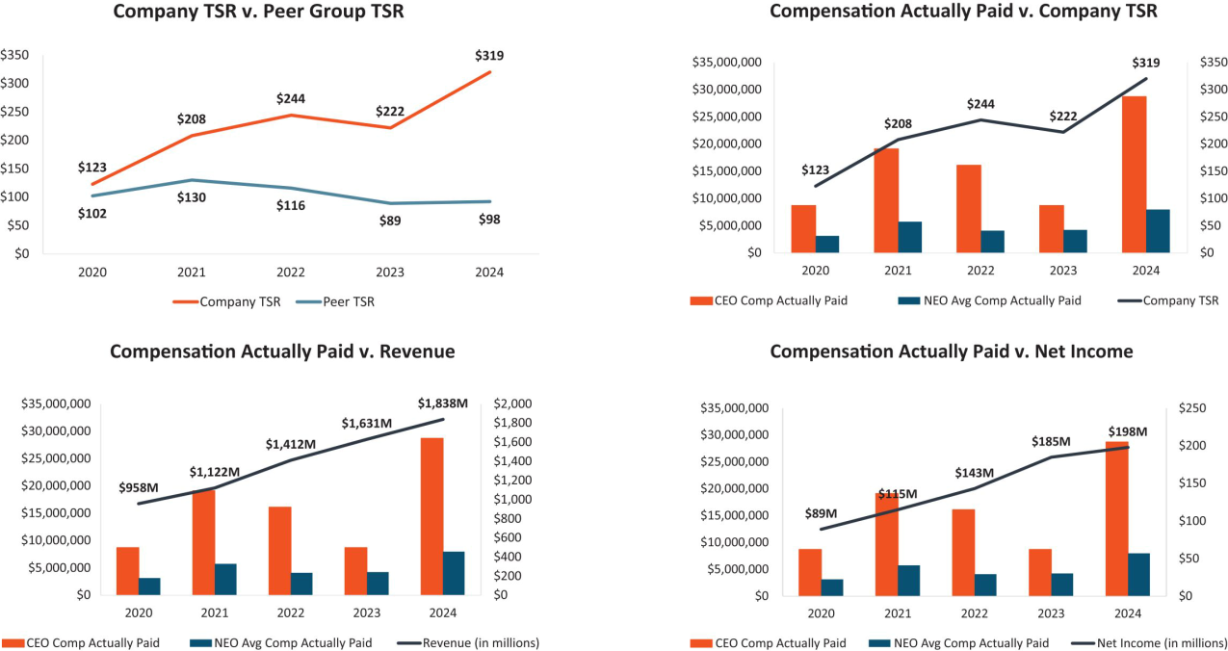

96 | / | EXL 2025 Proxy Statement

Table of Contents

Executve compensaton

2024 Performance measures

As noted above, our Compensaton and Talent Management Commitee believes in a holistc evaluaton of our executves’ and our Company’s performance and uses a mix of performance measures throughout our annual and long-term incentve programs to align executve pay with stockholder value creaton. As required by SEC rules, in 2024, the fnancial performance measures identfed as the most important and used by us to link compensaton actually paid for our named executve ofcers are listed below.


Revenue

Adjusted Operatng Proft Margin

Relatve TSR

 | EXL 2025 Proxy Statement | / 97

Table of Contents

Executve compensaton

Director compensaton for fscal year 2024

The following table sets forth informaton for compensaton earned in fscal year 2024 by our non-executve directors who served during fscal year 2024:

 |  | Fees earned or |  | All Other
 |  | paid in cash | Stock awards | compensaton | Total
Name(1) |  | ($) | _{($)}(2)(3) | _{($)}(4) | ($)
Thomas Bartlet(5) |  | 85,000 | 277,268 |  | 362,268
Andreas Fibig |  | 85,000 | 215,000 |  | 300,000
Som Mital(6) |  | 42,500 |  | 7,954 | 265,454
Vikram Pandit |  | 85,000 | 315,000 |  | 400,000
Kristy Pipes |  | 102,500 | 215,000 |  | 317,500
Nitn Sahney |  | 100,000 | 215,000 |  | 315,000
Jaynie Studenmund |  | 102,500 | 215,000 |  | 317,500
Sarah K. Williamson |  | 85,000(7) | 215,000 |  | 300,000

- Mr. Kapoor’s compensaton during 2024 was based solely on his role as CEO, as disclosed in the “Summary compensaton table for fscal year 2024” beginning on page 78 and discussed in “Compensaton Discussion and Analysis” beginning on page 54. He does not receive any additonal compensaton for his services as a director.

- Amounts refect the aggregate grant date fair value of stock awards recognized for fnancial statement reportng purposes for the fscal year ended December 31, 2024, in accordance with FASB ASC Topic 718 (disregarding any forfeiture assumptons). Assumptons used in the calculaton of these amounts are included in footnotes 2 and 23 to our audited fnancial statements for the fscal year ended December 31, 2024 included in the 2024 Form 10-K.

- The outstanding equity awards, comprised entrely of unvested restricted stock units, held by each of our non-employee directors on December 31, 2024 are as follows: for Mr. Mital: 0; for each of Mr. Fibig, Ms. Pipes, Mr. Sahney, Ms. Studenmund and Ms. Williamson: 7,060; for Mr. Bartlet: 9,033; and for Mr. Pandit: 10,344.

- For Mr. Mital, amount refects our reimbursement to the director for fees associated with tax preparer services.

- Mr. Bartlet was elected to the Board on March 6, 2024. The value of his stock award represents a pro-rated porton of the annual equity award in respect of his service from March 6, 2024 through the Company’s 2024 annual meetng of stockholders, and the annual equity award he received in June 2024.

- Mr. Mital resigned from the board, efectve as of the 2024 annual meetng of stockholders. The amount included in this table in respect of his cash fees refects a pro-rated amount for the period during 2024 that he served as a director. Mr. Mital did not receive any stock awards in respect of his 2024 service.

- Ms. Williamson elected to receive her cash retainer in the form of tme-based restricted stock units.

Pursuant to changes adopted to the non-executve director compensaton program in 2023, efectve in 2024, non-executve directors were eligible to receive an annual retainer fee in the amount of $85,000 in cash and $215,000 in equity, granted in the form of tme-based restricted stock units, valued at the tme of grant. As the non-executve Board Chair and then the Lead Director during 2024, Mr. Pandit, was eligible to receive an additonal $100,000 in restricted stock units valued at the tme of grant. New non-employee directors who join our board of directors during a calendar quarter are eligible to receive the full cash fee for such calendar quarter and a pro-rated equity grant. The chairs of our Audit Commitee and Compensaton and Talent Management Commitee were eligible to receive an additonal annual fee of $17,500 in cash, and the chair of our Nominatng and Governance Commitee was eligible to receive an additonal annual fee of $15,000 in cash. Directors may elect to receive their cash retainer fee in the form of tme-based restricted stock units, which vest 50% on the date of the Annual Meetng and 50% on the last day of the calendar year (or an earlier change in control). The grants will generally setle at the same tme as our annual equity awards, as described below.

98 | / | EXL 2025 Proxy Statement

Table of Contents

Executve compensaton

We have updated our non-executve director compensaton program for 2025: non-executve directors are now eligible to receive a retainer fee in the amount of $100,000 in cash and $230,000 in equity, granted in the form of tme-based restricted stock units, valued at the tme of grant.

There are no additonal fees payable for atendance at our board or commitee meetngs (whether in person, telephonic or otherwise). We make quarterly cash payments in respect of the director fees to our directors. Directors who hold restricted stock units do not receive the underlying shares of common stock untl the units have vested and are setled. The restricted stock units granted to directors generally vest upon the earliest of (i) the frst anniversary of the date of grant, (ii) the date on which the director’s term on the board expires if the director is not subsequently elected to a new term and (iii) a change in control. The restricted stock units issued to each of our non-employee directors will generally setle on the earliest of (i) the director’s death, (ii) a change in control, or (iii) 180 days following the end of the director’s term on our board of directors. However, in lieu of setlement 180 days following the director’s term, a director may elect in advance that the units be setled on an alternate delivery date following the director’s service on the board, or if the director has satsfed our stock ownership guidelines, upon the vestng date of the award.

We maintain a non-employee director stock ownership policy that requires directors to maintain stock ownership of at least fve tmes their respectve annual cash retainers (countng common stock, vested restricted stock units and unvested tme-based restricted stock units). New directors have fve years from their appointment date to atain the required stock ownership levels, whereas existng directors generally have three years to meet any increased ownership requirements as a result of annual cash retainer increases.

Common stock is counted toward the ownership requirement if it is owned by or for the beneft of the director, the director’s spouse or the director’s children sharing the same household. During the applicable phase-in period, directors generally must retain at least 50% of shares delivered following the vestng of an equity award untl the ownership requirement is met. If the ownership requirement is not met at the end of the phase-in period, directors generally may not sell any shares untl the ownership requirement is met other than to satsfy tax obligatons arising with respect to equity awards.

As of December 16, 2024, all applicable directors were in compliance with this policy.

 | EXL 2025 Proxy Statement | / 99

Table of Contents

Stock ownership of directors, executve ofcers and certain benefcial owners

Stock ownership of directors, executve ofcers and certain benefcial owners

Unless otherwise indicated, the table below sets forth informaton with respect to the benefcial ownership of our common stock by:

- each of our directors and each of our named executve ofcers individually;

- each person who is known to be the benefcial owner of more than 5% of our common stock; and

- all of our current directors and current executve ofcers (i.e., not just named executve ofcers) as a group.

The amounts and percentages of common stock benefcially owned below are as of March 31, 2025 (the “Determinaton Date”) and are reported on the basis of the regulatons of the SEC governing the determinaton of benefcial ownership of securites. Under these rules, a person is deemed to be a benefcial owner of a security if that person has or shares votng power, which includes the power to vote or to direct the votng of such security, or investment power, which includes the power to dispose of or to direct the dispositon of such security. A person is also deemed to be a benefcial owner of any securites of which that person has a right to acquire benefcial ownership within 60 days of the Determinaton Date. Under these rules, more than one person may be deemed to be a benefcial owner of the same securites. Except as otherwise indicated below, each of the persons named in the table has sole votng and investment power with respect to the securites benefcially owned by such person as set forth opposite such person’s name.

 |  |  |  |  | Vested but
 |  | Name and address(1) | Shares | %(2) | unsetled RSUs(3) | Total
 |  | Named Executve Ofcers
 |  | Rohit Kapoor | 3,595,145(4) | 2.21% | — | 3,595,145
 |  | Maurizio Nicolelli | 242,090(5) | * | — | 242,090
 |  | Vikas Bhalla | 227,206(6) | * | — | 227,206
 |  | Vivek Jetley | 453,763(7) | * | — | 453,763
 |  | Vishal Chhibbar | 40,876(8) | * | — | 40,876
 |  | Directors
 |  | Thomas Bartlet | — | — | 1,973 | 1,973
 |  | Andreas Fibig | 3,000 | — | 8,515 | 11,515
 |  | Vikram S. Pandit | 1,551,970(9) | — | 55,595 | 1,607,565
 |  | Kristy Pipes | 0 | — | 23,450 | 23,450
 |  | Nitn Sahney | 0 | — | 74,515 | 74,515
 |  | Jaynie Studenmund | 14,580 | — | 47,200 | 61,780
 |  | Sarah K. Williamson | 0 | — | 8,842 | 8,842
 |  | All current directors and executve ofcers as a group (16 people)⁽¹⁰⁾ | 6,583,751 | 4.04% | 220,090 | 6,803,841
100 |  | / EXL 2025 Proxy Statement

Table of Contents

Stock ownership of directors, executve ofcers and certain benefcial owners

 | Benefcial ownership
Name and address(1) | Shares | %(2)
5% Benefcial owners
Blackrock Inc.⁽¹¹⁾ | 23,308,871 | 14.33
The Vanguard Group, Inc.⁽¹²⁾ | 17,015,630 | 10.46
FMR LLC⁽¹³⁾ | 9,364,312 | 5.76

*Less than 1%.

- Unless otherwise noted, the business address of each benefcial owner is c/o ExlService Holdings, Inc., 320 Park Avenue, 29th Floor, New York, New York 10022.

- Based on 162,683,343 shares outstanding as of the Determinaton Date.

- For non-management directors, this column includes restricted stock units (previously granted for service on the board) that have vested but are unsetled. Because vested restricted stock units generally setle 180 days following the director’s term of service (see “Director compensaton for fscal year 2023” for additonal details on setlement), the units are not treated as benefcially owned under SEC rules because the holder does not have the right to acquire the underlying stock within 60 days of the Determinaton Date. However, we separately present these amounts because restricted stock units that are vested but unsetled provide a meaningful alignment with the Company’s stockholders, and they count towards our stock ownership policy for non-employee directors, which requires directors to maintain stock ownership of at least fve tmes their respectve annual retainers.

- The amount includes: (a) 885,670 shares of our common stock owned indirectly by Mr. Kapoor through a family trust created in 2016 under a 2005 grantor-retained annuity trust, for which

Mr. Kapoor’s spouse and Mr. Kapoor’s brother are the co-trustees and share dispositve and votng control over the shares in the trust, (b) 201,095 shares of our common stock owned indirectly by Mr. Kapoor through a family trust created in 2016 under a 2013 grantor retained annuity trust, for which Mr. Kapoor’s spouse and Mr. Kapoor’s brother are the co-trustees and share dispositve and votng control over the shares in the trust, (c) 420,000 shares of our common stock owned indirectly by Mr. Kapoor through a spousal lifetme access trust, for which Mr. Kapoor’s spouse and

Mr. Kapoor’s brother are the co-trustees and share dispositve and votng control over the shares in the trust, (d) 420,000 shares of our common stock owned indirectly by Mr. Kapoor through a spousal lifetme access trust for Mr. Kapoor’s spouse, for which Mr. Kapoor and Mr. Kapoor’s brother are the co-trustees and share dispositve and votng control over the shares in the trust, and

- 665,925 shares of our common stock owned indirectly by Mr. Kapoor through a family trust created in 2016 for which Mr. Kapoor is the investment advisor to Commonwealth Trust Company, the trustee.

(5) This amount consists of 33,580 shares of our common stock of which Mr. Nicolelli has the right to acquire benefcial ownership within 60 days of the Determinaton Date pursuant to currently vested and exercisable stock optons.

(6) This amount consists of 67,160 shares of our common stock of which Mr. Bhalla has the right to acquire benefcial ownership within 60 days of the Determinaton Date pursuant to currently vested and exercisable stock optons.

(7) This amount consists of 67,160 shares of our common stock of which Mr. Jetley has the right to acquire benefcial ownership within 60 days of the Determinaton Date pursuant to currently vested and exercisable stock optons.

(8) This amount consists of 33,500 shares of our common stock of which Mr. Chhibbar has the right to acquire benefcial ownership within 60 days of the Determinaton Date pursuant to currently vested and exercisable stock optons.

(9) Mr. Pandit has shared dispositve and votng control over the reported securites, which are held by Orogen Echo LLC (“OE”). The Orogen Group LLC (“Orogen”) is the sole member of OE and

Mr. Pandit is the Chairman and Chief Executve Ofcer of Orogen. Orogen Holdings LLC and Atairos-Orogen Holdings, LLC are the sole members with joint investment control of Orogen. Mr. Pandit has majority votng control of Orogen Holdings LLC.

(10) Includes seven current non-employee directors and our nine current executve ofcers as of the Determinaton Date.

(11) Based on the Schedule 13G/A fled on November 12, 2024, Blackrock, Inc. had sole votng power with respect to 22,315,731 shares and sole dispositve power with respect to 23,308,871 shares. The business address of Blackrock, Inc. is 55 East 52nd Street, New York, New York 10022.

(12) Based on the Schedule 13G/A fled on February 13, 2024, The Vanguard Group, Inc. had shared votng power with respect to 299,801 shares, sole dispositve power with respect to 16,539,920 shares and shared dispositve power with respect to 475,710 shares. The business address of The Vanguard Group, Inc. is 100 Vanguard Boulevard, Malvern, PA 19355.

(13) Based on the Schedule 13G/A fled on February 12, 2025, FMR LLC had sole votng power with respect to 9,353,547 shares and sole dispositve power with respect to 9,364,312 shares. The business address of FMR LLC is 245 Summer Street, Boston, Massachusets 02210.

 | EXL 2025 Proxy Statement | / 101

Table of Contents

Certain relatonships and related person transactons

Certain relatonships and related person transactons

Review and approval of related party transactons | Factors used in assessing related party transactons
We review all relatonships and transactons in which we, our directors and executve | • | The nature of the related party transacton
ofcers or their immediate family members and our 5% stockholders are partcipants | • | The related party’s interest in the transacton
to determine whether such persons have a direct or indirect material interest in such | • | The material terms of the transacton, including the amount
transactons. Our Code of Conduct and Ethics instructs our directors, ofcers and |  | involved and type of transacton
employees to report the facts and circumstances of any such transacton or potental | • | The importance of the transacton to us and to the related
transacton to our General Counsel or our Audit Commitee. Our board of directors |  | party
has adopted a policy regarding the review of potental related party | • | Whether the transacton would impair the judgment of a
transactons. Under this policy, our General Counsel will review the facts and |  | director or executve ofcer to act in our best interest
circumstances of any covered transacton. If our General Counsel determines that the transacton involves a related party transacton and the amount involved does not equal or exceed $120,000, our General Counsel will approve or disapprove the transacton. If our General Counsel determines that the transacton involves a related party transacton and the amount involved equals or exceeds $120,000, our General Counsel will refer the transacton to our Audit Commitee for consideraton. In the course of reviewing, approving or ratfying a disclosable related party transacton, our General Counsel and Audit Commitee considers all factors it considers appropriate, including but not limited to the factors in the box to the right.

Related party transactons

As required under SEC rules, transactons since the beginning of our last fscal year, or any currently proposed transacton, in which we are a partcipant and which involve amounts exceeding $120,000, and in which any related person had or will have a direct or indirect material interest are disclosed in our Proxy Statement. Other than as set forth below, there were no such related person transactons in fscal year 2024.

In 2024, the Company entered into a routne services agreement with PharmaCord, LLC (“PharmaCord”) for the development of an automated beneft verifcaton soluton, pursuant to which the Company estmates total revenue of approximately $370,000, of which $200,000 was recorded in 2024. One of the Company’s directors, Nitn Sahney, is the founder and member-manager, and during 2024 was also the majority equity owner and chief executve ofcer, of PharmaCord. Mr. Sahney has no specifc bonus or other compensaton ted to the contract with our Company, and was not involved in any negotatons regarding this service contract. The terms of the contract (including the fees) with PharmaCord are, in the Company’s opinion, no less favorable than the Company would have been able to negotate with an unrelated party, and the transacton was approved by the Audit Commitee. Afer considering the facts and circumstances regarding the relatonship, our board of directors has determined that the PharmaCord relatonship did not and does not impair Mr. Sahney’s independence under applicable Nasdaq standards and federal securites laws.

102 | / | EXL 2025 Proxy Statement

Table of Contents

Audit Commitee Report

Audit Commitee Report

The Audit Commitee of the board of directors of ExlService Holdings, Inc. assists our board of directors in fulflling its oversight responsibilites with respect to the following:

- our accountng and fnancial reportng processes, including the integrity of the fnancial statements and other fnancial informaton provided by us to our stockholders, the public, stock exchanges and others;

- our compliance with legal and regulatory requirements;

- our registered independent public accountng frm’s qualifcatons and independence;

- the audit of our fnancial statements; and

- the performance of our internal audit functon and independent registered public accountng frm.

In connecton with these responsibilites, the Audit Commitee met with management and Deloite & Touche LLP to review and discuss the December 31, 2024 audited consolidated fnancial statements. The Audit Commitee also discussed with Deloite & Touche LLP the maters required to be discussed by the applicable requirements of the Public Company Accountng Oversight Board and the SEC. The Audit Commitee also received writen disclosures and the leter from Deloite & Touche LLP required by Rule 3526 of the Public Company Accountng Oversight Board (Communicatons with Audit Commitees Concerning Independence), and the Audit Commitee discussed with Deloite & Touche LLP the frm’s independence.

Based on the review and discussions referred to above, the Audit Commitee approved the inclusion of the audited fnancial statements in the Company’s Annual Report on Form 10-K for the fscal year ended December 31, 2024.

Audit Commitee

Ms. Kristy Pipes (Chair)

Mr. Thomas Bartlet

Mr. Andreas Fibig

Mr. Nitn Sahney

Ms. Jaynie Studenmund

 | EXL 2025 Proxy Statement | / 103

Table of Contents

Proposal 1 — Electon of directors

Proposal 1 — Electon of directors

The nominees

Our Nominatng and Governance Commitee has nominated, and our board of directors has designated, Mr. Kapoor, Mr. Pandit, Mr. Bartlet, Mr. Fibig, Ms. Pipes, Mr. Sahney and Ms. Williamson to stand for electon as directors at the Annual Meetng. Ms. Studenmund will not be standing for re-electon at the Annual Meetng.

Term of ofce

If elected, each of the director nominees will serve a term of one year on our board of directors, untl our 2026 Annual Meetng of Stockholders or untl their respectve successors are duly elected and qualifed in accordance with our By-laws.

Votng instructons and substtutes

The proxies given to the proxy holders will be voted or not voted as directed and, if no directon is given, will be voted FOR these seven nominees. Our board of directors knows of no reason why any of these nominees should be unable or unwilling to serve. However, if for any reason any nominee should be unable or unwilling to stand for electon, the shares represented by proxies will be voted for the electon of any substtute nominee designated by our board of directors to fll the vacancy.

General informaton about nominees

The age as of the date of this Proxy Statement, tenure on our board of directors and commitee membership, if any, of each nominee appears below. Informaton regarding the business experience during at least the last fve years and directorships of other publicly owned corporatons of each nominee can be found above under “Our board of directors.” Other informaton required with respect to any solicitaton of proxies in connecton with the electon of directors is found elsewhere in this Proxy Statement.

104 | / | EXL 2025 Proxy Statement

Table of Contents

Proposal 1 — Electon of directors
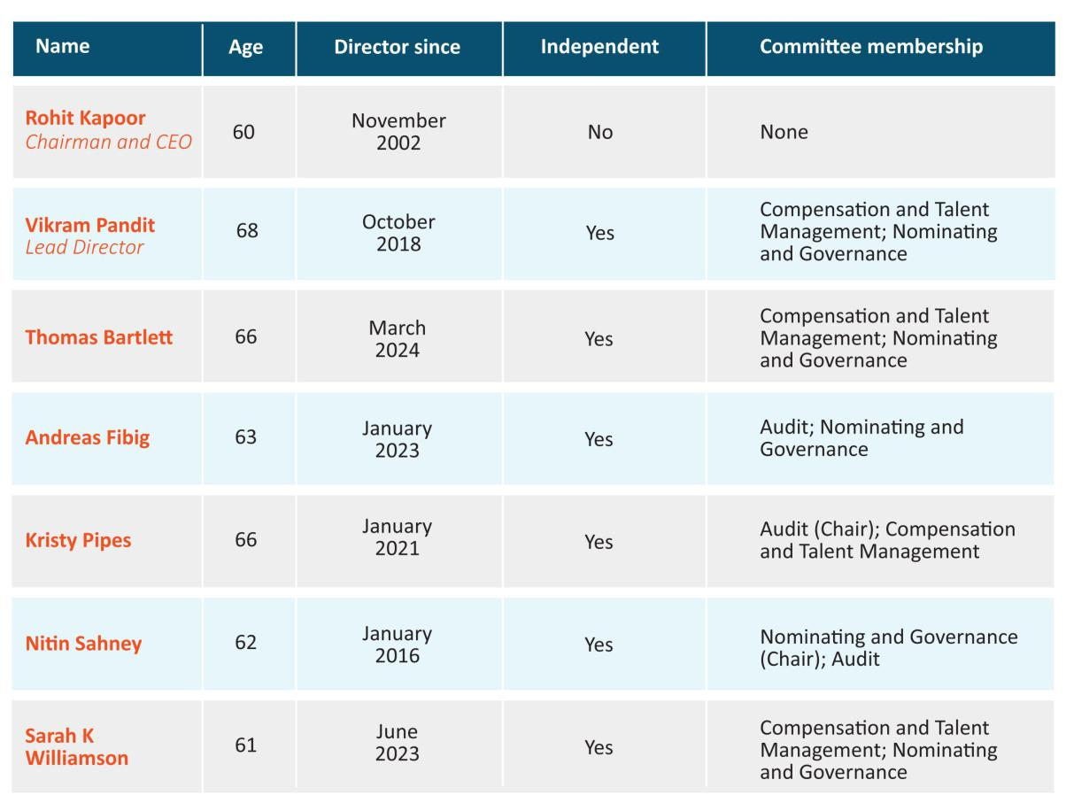

Required vote

The afrmatve vote of a majority of votes cast (meaning the number of shares voted “for” a nominee must exceed the number of shares voted “against” such nominee) at the Annual Meetng will elect the seven nominees as directors for a term of one year. If any nominee for director receives a greater number of votes “against” his or her electon than votes “for” such electon, our By-laws provide that such person will tender to the board of directors his or her resignaton as a director. Unless marked to the contrary, proxies received will be voted “FOR” the nominees.

 | Our board recommends that you vote
 | FOR | the electon of Mr. Kapoor, Mr. Pandit, Mr. Bartlet, Mr. Fibig, Ms. Pipes, Mr. Sahney and
 | FOR | Ms. Williamson as directors of the Company
 |  |  |  | / 105
 |  | EXL 2025 Proxy Statement |  | / 105

Table of Contents

Proposal 2 — Ratfcaton of the appointment of independent registered public accountng frm

Proposal 2 — Ratfcaton of the appointment of independent registered public accountng frm

Our Audit Commitee has appointed Deloite & Touche LLP (“Deloite”) as the independent registered public accountng frm to audit the Company’s and its subsidiaries’ books, records and accounts for fscal year 2025. Our board of directors has endorsed this appointment. Ratfcaton of the appointment of Deloite by our stockholders is not required by law. However, as a mater of good corporate practce, such appointment is being submited to our stockholders for ratfcaton at the Annual Meetng. If our stockholders do not ratfy the appointment, our board of directors and our Audit Commitee will reconsider whether or not to retain Deloite, but may nonetheless retain Deloite. Even if the appointment is ratfed, the Audit Commitee in its discreton may change such appointment at any tme during the year if it determines that such change would be in the best interests of the Company and our stockholders.

In retaining Deloite as the Company’s independent registered public accountng frm, the Audit Commitee considered whether the provision of non-audit services by Deloite was compatble with maintaining Deloite’s independence and concluded that it was. Representatves of Deloite are expected to be present at the Annual Meetng. They will have an opportunity to make a statement, if they desire to do so, and will be available to respond to appropriate questons. Deloite has served as our independent registered public accountng frm since February 28, 2018.

Audit and non-audit fees

The following is a summary of the fees billed or expected to be billed to us by the Company’s independent registered public accountng frm for professional services rendered in each of the last two fscal years:

 | Fiscal | Fiscal
Fee category | 2024 | 2023
 |  | (in thousands)
Audit fees | $1,955 | $1,550
Audit-related fees | — | —
Tax fees | 25 | 37
All other fees | 237 | 30
Total fees | $2,217 | $1,617

Audit fees:

Consist of fees billed or expected to be billed for professional services rendered for the audit of our consolidated fnancial statements, including (i) the audit of efectveness of internal control over fnancial reportng, (ii) review of our consolidated fnancial statements included in our quarterly reports, and

- services that are normally provided by our independent registered public accountants including services in connecton with statutory or regulatory flings or engagements for those fscal years.

106 | / | EXL 2025 Proxy Statement

Table of Contents

Proposal 2 — Ratfcaton of the appointment of independent registered public accountng frm

Audit-related fees:

Consist of fees billed for assurance and related services that are reasonably related to the performance of the audit or review of our consolidated fnancial statements and are not reported under “Audit Fees.”

Tax fees:

Consist primarily of fees billed or expected to be billed for other tax fling and advisory projects.

All other fees:

Consist of fees billed or expected to be billed for other permissible work performed by our independent registered public accountng frm not reported under the categories above and primarily include permissible advisory services related to a project to upgrade our informaton systems.

Our Audit Commitee pre-approves and is responsible for the engagement of all auditng services provided by our independent registered public accountants and all non-auditng services to be provided by such accountants to the extent permited under Secton 10A of the Exchange Act, including all fees and other terms of engagement. Our Audit Commitee may delegate the authority to pre-approve audit and permited non-audit services between meetngs of our Audit Commitee to a designated member of our Audit Commitee, provided that the decisions made by such member are presented to our full Audit Commitee for ratfcaton at its next scheduled meetng.

All of the fees paid to Deloite in fscal year 2024 were pre-approved by the Audit Commitee.

Required vote

The ratfcaton of the appointment of Deloite as our independent registered public accountng frm requires the afrmatve vote of a majority of shares present in person or represented by proxy and enttled to vote at the Annual Meetng. Unless marked to the contrary, proxies received will be voted “FOR” ratfcaton of the appointment.


Our board recommends that you vote:

 |  | FOR | the ratfcaton of the appointment of Deloite as our independent registered public
 |  | FOR | accountng frm
 |  |  | EXL 2025 Proxy Statement / 107

Table of Contents

Proposal 3 — Advisory (non-binding) vote to approve executve compensaton

Proposal 3 — Advisory (non-binding) vote to approve executve compensaton

Proposal 3 is a vote, on a non-binding advisory basis, to approve the compensaton of our executve ofcers as described in this Proxy Statement. Although the vote is advisory and is not binding on the board of directors, our Compensaton and Talent Management Commitee will take into account the outcome of the vote when considering future executve compensaton decisions. We refer to this vote as the “say-on-pay” vote.

At the 2023 Annual Meetng of Stockholders, our stockholders voted on a proposal relatng to the frequency of the “say-on-pay” vote. We recommended, and our stockholders approved on a non-binding advisory basis, an annual say-on-pay vote. Accordingly, we include the say-on-pay vote each year as a regular part of each Annual Meetng of Stockholders. The next vote on the frequency of the “say-on-pay” vote will be held at the 2029 Annual Meetng of Stockholders.

- Our board of directors is commited to corporate governance best practces and recognizes the signifcant interest of stockholders in executve compensaton maters.

- Our board of directors believes that our current executve compensaton program directly links executve compensaton to our performance and aligns the interests of our executve ofcers with those of our stockholders. For example, the bulk of our annual incentve awards is earned based on achievement of two core fnancial metrics: revenue and AOPM. As we discuss in greater detail in our Compensaton Discussion and Analysis, these fnancial metrics focus our named executve ofcers on top-line revenues and botom-line earnings that are likely to make meaningful contributons to our future fnancial performance. We believe rewarding our executves with incentve pay based on achievement of these fnancial metrics closely aligns management with the interests of our stockholders.

In additon, our philosophy places more emphasis on variable elements of compensaton (such as annual incentves and equity-based compensaton) than fxed remuneraton.

Our stockholders have the opportunity to vote for, against or abstain from votng on the following resoluton:

“Resolved, that the stockholders approve on an advisory basis the compensaton of our named executve ofcers, as disclosed pursuant to the compensaton disclosure rules of the SEC (which disclosure shall include the Compensaton Discussion and Analysis, the compensaton tables and any related material disclosed in this Proxy Statement).”

The above-referenced disclosures related to the compensaton of our named executve ofcers appear beginning at page 54 of this Proxy Statement.

108 | / | EXL 2025 Proxy Statement

Table of Contents

Proposal 3 — Advisory (non-binding) vote to approve executve compensaton

Required vote

The approval, on an advisory (non-binding) basis, of the compensaton of our named executve ofcers requires the afrmatve vote of a majority of shares present in person or represented by proxy and enttled to vote at the Annual Meetng. Unless marked to the contrary, proxies received will be voted “FOR” the approval of the compensaton of our named executve ofcers.


Our board recommends that you vote:

the approval, on an advisory (non-binding) basis, of the compensaton of our named _{FOR} executve ofcers as disclosed pursuant to the compensaton disclosure rules of the SEC

(including the Compensaton Discussion and Analysis, the compensaton tables and any related material disclosed in this Proxy Statement)

 | EXL 2025 Proxy Statement | / 109

Table of Contents

Proposal 4 — Approval of the ExlService Holdings, Inc. 2025 Omnibus Incentve Plan

Proposal 4 — Approval of the ExlService Holdings, Inc. 2025 Omnibus Incentve Plan

The board of directors has unanimously approved and declared advisable, and recommends that our stockholders approve, the 2025 Omnibus Incentve Plan (the “Plan”), which reserves 6,800,000 shares of our common stock for grants of awards under the Plan, minus one share for every share subject to an award granted afer March 1, 2025 under the 2018 Omnibus Incentve Plan (the “Prior Plan”) and prior to June 17, 2025 (the “Efectve Date” of the Plan). In additon, if and to the extent that an award under the Plan or, afer March 1, 2025, an award under the Prior Plan, terminates, expires, is cancelled, or is forfeited for any reason (including upon cancellaton or setlement of the award in exchange for cash or property other than shares), the shares associated with that award will be added to the shares available for awards under the Plan.

The last tme that the Company requested that its stockholders approve shares of stock for its equity plan reserve was in 2018, under the Prior Plan. As of March 1, 2025, there were 545,654 shares of stock remaining in the Prior Plan reserve, assuming all outstanding PRSU awards are achieved at the Target (100%) level (which is the assumpton used for the Prior Plan data presented throughout this Proposal). If the Plan is not approved by our stockholders at the Annual Meetng, the Company’s ability to make grants to its employees, directors and consultants will be limited. If the Company is unable to grant equity awards, the Company’s ability to retain, incentvize and hire critcal talent could be severely limited. The Company may also need to rely more heavily on cash compensaton, which could impact the amount of the Company’s cash on hand to pay other expenses. Therefore, we are requestng that our stockholders vote to approve the Plan.

If our stockholders approve the Plan at the Annual Meetng, it will become immediately efectve. As soon as administratvely practcable following the Plan approval, the Company intends to register shares issuable under the Plan on a Form S-8 Registraton Statement fling with the SEC. Upon the Plan becoming efectve, no new awards will be made under the Prior Plan, although outstanding awards previously made under the Prior Plan will contnue to be governed by the terms of that plan. The Plan will have a term of ten years from the date it is approved by our stockholders and no further awards may be granted afer that date (though it will remain in efect with respect to any awards then-outstanding under the Plan).

110 | / | EXL 2025 Proxy Statement

Table of Contents

Proposal 4 — Approval of the ExlService Holdings, Inc. 2025 Omnibus Incentve Plan

The closing price of our stock as reported by Nasdaq on April 24, 2025, was $44.82 per share.
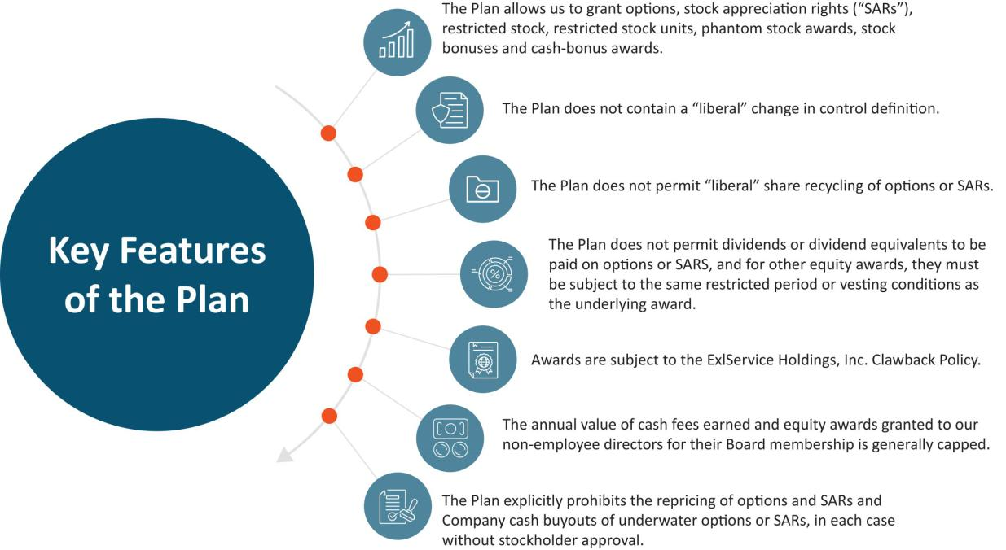

Grant Practces

The majority of the Company’s current equity issuances are in the form of restricted stock units (“RSUs”). In our view, RSUs, as full-value awards, are less dilutve to stockholders as the Company may grant fewer of such awards to achieve the intended economic efect. We currently grant both tme-vested RSUs that generally vest over a four-year period and performance-vested RSUs that are earned based on a three-year performance period.

Our gross average share usage rate, sometmes referred to as burn rate, over the three years ended December 31, 2024 (calculated as the value of equity-based awards granted under our equity compensaton plan for the relevant year, divided by the value of average basic common shares outstanding for that year) is approximately 1.74%.

Overhang as of March 1, 2025

The potental diluton resultng from issuing all of the 6,800,000 shares authorized under the Plan, which, when combined with shares subject to outstanding awards under the Prior Plan which may be rolled into the Plan’s share reserve (if an award under the Prior Plan terminates, expires, is cancelled, or is forfeited afer March 1, 2025), would be approximately 8% on a fully-diluted basis, as of March 1, 2025. No additonal awards will be made under the Prior Plan following the efectveness of the Plan.

 | EXL 2025 Proxy Statement | / 111

Table of Contents

Proposal 4 — Approval of the ExlService Holdings, Inc. 2025 Omnibus Incentve Plan

The following table sets forth certain informaton as of March 1, 2025, unless otherwise noted, with respect to the Company’s existng equity compensaton plans (other than the Company’s employee stock purchase plan, which is not included in the data provided in this Proposal except for in the “Equity Compensaton Plan Informaton” table on page 120 below):

Stock Optons Outstanding | 1,768,305 shares
Weighted-Average Exercise Price of Outstanding Stock Optons/SARS | $30.14
Weighted-Average Remaining Term of Outstanding Stock Optons/SARs | 8.31 years
Total Stock-Setled Full-Value Awards Outstanding | 4,833,733 shares
(i.e., restricted shares, restricted stock units, deferred stock units, etc.)
Basic common shares outstanding as of March 1, 2025 | 162,683,323 shares

Summary of the Plan

General. At the recommendaton of our Compensaton and Talent Management Commitee, our board adopted the Plan on February 20, 2025, subject to and efectve upon the approval of our stockholders. The following is a summary of the material aspects of the Plan. This summary is subject to the more complete descripton of the terms and conditons of the Plan contained in the full text of the Plan, which is atached to this Proxy Statement as Annex A.

Purpose. The purpose of the Plan is to provide a means through which we and our afliates may atract capable persons to enter and remain in our employ or service and to provide a means whereby our employees, directors and consultants can acquire and maintain ownership of our common stock, or be paid incentve compensaton measured by reference to the value of our common stock, thereby strengthening their commitment to the welfare of the Company and its afliates and promotng an identty of interest between them and our stockholders. The Plan is an omnibus document authorizing the establishment of sub-plans which enables us to ofer awards to our employees or other service providers in non-U.S. jurisdictons, subject to compliance with local laws.

Administraton. The Plan will be administered by a commitee, which will be our Compensaton and Talent Management Commitee (or if the board is actng as the commitee, the independent members of our board). Subject to the terms of the Plan and applicable law, the Compensaton and Talent Management Commitee will have, among other things, the authority to grant awards of all types described in the Plan, determine the terms and conditons of awards, determine whether setlement of awards may be deferred, and extend the period of tme during which an award may be exercised (but no longer than the expiraton of the original award term). Notwithstanding anything in the Plan to the contrary, the Compensaton and Talent Management Commitee will also have the power to accelerate the vestng or exercisability of an award and to waive or remove any restricton on an award. The Compensaton and Talent Management Commitee also will have the power to interpret the Plan and any award agreement and to establish, amend, suspend or waive rules in connecton with the administraton of the Plan. The determinaton of the Compensaton and Talent Management Commitee on maters relatng to the Plan or any award agreement will be conclusive. Subject to applicable law and the Company’s governing documents, the Compensaton and Talent Management Commitee may delegate its authority under the Plan to any ofcer or ofcers of the Company, provided that such delegate may not issue awards

112 | / | EXL 2025 Proxy Statement

Table of Contents

Proposal 4 — Approval of the ExlService Holdings, Inc. 2025 Omnibus Incentve Plan

to persons subject to Secton 16 of the Exchange Act; accordingly, references in this proposal to the “Compensaton and Talent Management Commitee” refer to the Compensaton and Talent Management Commitee or the independent members of the board, if actng as the Commitee, or its delegate, as applicable.

Eligibility. Partcipaton in the Plan will be limited to eligible individuals who have entered into an award agreement or who have received writen notfcaton from the Compensaton and Talent Management Commitee (or from a person designated by the commitee), that they have been selected to partcipate in the Plan. The Compensaton and Talent Management Commitee may designate eligible individuals to partcipate in the Plan in its discreton. Eligible individuals are: (x) individuals regularly employed by the Company or an afliate, other than employees covered by a collectve bargaining agreement (unless the collectve bargaining agreement or a related agreement provides otherwise), (y) directors of the Company or an afliate, or

- consultants or advisors to the Company or an afliate who may be ofered securites pursuant to Form S-8. As of March 1, 2025, there were a total of approximately 7,825 individuals, including approximately: 7,818 employees, 7 independent directors (6 afer the Annual Meetng) and 0 consultants and advisors at the Company and our afliates, eligible to be designated as partcipants under the Plan.

Shares Authorized. The Plan reserves 6,800,000 shares of our common stock for grants of awards under the Plan, minus one share for every share subject to an award granted afer March 1, 2025 under the Prior Plan and prior to the Plan’s Efectve Date. In additon, if and to the extent that an award under the Plan or, afer March 1, 2025, an award under the Prior Plan, terminates, expires, is cancelled, or is forfeited for any reason (including upon cancellaton or setlement of the award in exchange for cash or property other than shares), the shares associated with that award will be added to the shares available for awards under the Plan. Common stock delivered by the Company in setlement of awards under the Plan may be authorized and unissued common stock, common stock held in the treasury of the Company, common stock purchased on the open market or by private purchase, or a combinaton of the foregoing.

Share Recycling. Shares of stock withheld in setlement of a tax withholding obligaton associated with an award (other than a stock opton or SAR) made under the Plan or afer March 1, 2025, under the Prior Plan, will be added to the Plan share reserve. The Plan explicitly provides that the following shares will not be available for future issuance under the Plan, regardless of whether the shares are associated with awards granted under the Plan or the Prior Plan: (1) the full number of shares subject to the exercise of an opton, even if the opton exercise price is satsfed through net-setlement or the delivery of shares to the Company, (2) the full number of shares subject to the exercise of a stock-setled SAR, even though only a net number of shares are delivered upon exercise, (3) shares withheld in setlement of a tax withholding obligaton associated with an opton or SAR, and (4) shares repurchased on the open market using proceeds from the exercise of optons.

Acquisitons and Combinatons. Subject to Nasdaq requirements, any shares issued under the Plan in respect of awards granted in substtuton of equity-based awards of an entty acquired by the Company or an afliate, or with which the Company or an afliate combines, will not count against the number of shares issuable under the Plan. Also, subject to Nasdaq requirements, if the Company or an afliate acquires or combines with a company that has shares available under its preexistng equity plan, those shares will become available for future grants under the Plan, and will not count against the number of shares issuable under the Plan.

Substtute Awards. Subject to Secton 409A of the Internal Revenue Code (the “Code”), the Compensaton and Talent Management Commitee may agree to cancel an award under the Plan and grant a substtute award in its stead, so long as the award holder consents.

 | EXL 2025 Proxy Statement | / 113

Table of Contents

Proposal 4 — Approval of the ExlService Holdings, Inc. 2025 Omnibus Incentve Plan

Director Limits. The grant date fair value of awards granted during a single calendar year to any non-employee director, taken together with any cash fees earned during the calendar year by the non-employee director in respect of the director’s service as a member of the board during such year (including service as a member or chair of any commitees of the board), may not exceed $750,000. The independent members of the board may make exceptons to this limit for a non-executve chair of the board, provided that the non-employee director receiving such additonal compensaton may not partcipate in the decision to award such compensaton.

Terms and Conditons of Awards. Under the Plan, the Compensaton and Talent Management Commitee may grant awards of nonqualifed stock optons (or “NSOs”), incentve stock optons (or “ISOs”), SARs, restricted stock, restricted stock units, phantom stock awards, stock bonus awards, or cash bonus awards. Awards may be subject to tme-based vestng conditons and/or performance-based vestng conditons. The Compensaton and Talent Management Commitee has discreton to select appropriate performance criteria upon which to base any performance goals and make adjustments to such criteria in the event of extraordinary, non-recurring or other events.

Optons. The Compensaton and Talent Management Commitee is authorized to grant optons to purchase shares of common stock that are either “qualifed,” meaning they are intended to satsfy the requirements of Secton 422 of the Code for incentve stock optons, or “nonqualifed,” meaning they are not intended to satsfy the requirements of Secton 422 of the Code. The maximum aggregate number of shares that may be issued under the Plan in respect of ISOs is 6,800,000.

An opton provides a partcipant with the right to purchase, within a specifed period of tme, a stated number of shares of our common stock at the price specifed in the award agreement. Optons granted under the Plan will be subject to the terms, including the exercise price and the conditons and tming of exercise, determined by the Compensaton and Talent Management Commitee and specifed in the applicable award agreement. The maximum term of an opton granted under the Plan will be ten years from the date of grant (or fve years in the case of an ISO granted to a 10.0% stockholder).

The exercise price per share paid by a partcipant will be determined by the Compensaton and Talent Management Commitee at the tme of grant but will not be less than 100.0% of the fair market value of one share on the date the opton is granted (or no less than 110.0% of such fair market value in the case of an ISO granted to an employee who is a 10.0% stockholder), with the excepton of optons granted in substtuton of outstanding awards in connecton with an acquisiton or combinaton. While our common stock is listed on Nasdaq, the fair market value will generally mean the closing price on the trading date prior to the grant date.

Payment in respect of the exercise of an opton may be made by cash, check, cash equivalent or transfer or atestaton of shares of our common stock (at their fair market on the date of exercise). The Compensaton and Talent Management Commitee may, in its discreton and subject to applicable law, generally allow such payment to be made in other methods, such as through the delivery of other property having a fair market value on the date of exercise equal to the exercise price, or a broker-assisted cashless exercise. Unless otherwise provided in the award agreement, if, on the expiraton date set forth in the award agreement, the opton remains outstanding and has not yet been exercised and the fair market value exceeds the exercise price, the opton will be deemed to have been automatcally exercised on such date. A stock opton award agreement issued under the Plan may include a provision whereby the partcipant may elect, at any tme before such partcipant’s terminaton of service with the Company, to fully or partally exercise an opton prior to the date on which such opton fully vests. Any unvested shares of stock purchased by means of this exercise may be subject to restrictons as determined by the Compensaton and Talent Management Commitee, including a share repurchase opton in favor of the Company.

114 | / | EXL 2025 Proxy Statement

Table of Contents

Proposal 4 — Approval of the ExlService Holdings, Inc. 2025 Omnibus Incentve Plan

SARs. The Compensaton and Talent Management Commitee will be authorized to award SARs under the Plan. SARs will be subject to the terms and conditons established by the Compensaton and Talent Management Commitee. A SAR is a contractual right that allows a partcipant to receive, either in the form of cash, shares of our common stock or a combinaton of the foregoing, the appreciaton, if any, in the value of one share of our common stock over a certain period of tme. An opton granted under the Plan may include SARs, either on the date of grant or, except in the case of an ISO, by subsequent amendment. The Compensaton and Talent Management Commitee may also award SARs to a partcipant independent of the grant of an opton. SARs granted in connecton with an opton will become exercisable, be transferable and will expire according to the same vestng schedule, transferability rules and expiraton provisions as the corresponding opton. If SARs are granted independent of an opton, the SARs will become exercisable, be transferable and will expire in accordance with the vestng schedule, transferability rules and the expiraton provisions established by the Compensaton and Talent Management Commitee and refected in the award agreement for such SAR. Unless otherwise provided in the award agreement, if, immediately prior to the expiraton of an SAR, the SAR has not yet been exercised and the fair market value exceeds the exercise price, the SAR will be deemed to have been automatcally exercised on such date and payment in respect of the SAR will be made. The maximum term of a SAR will be ten years from the date of grant.

Restricted Stock. The Compensaton and Talent Management Commitee will be authorized to award restricted stock under the Plan. An award of restricted stock is a grant of shares subject to conditons and restrictons set by the Compensaton and Talent Management Commitee. During a restricted period, a partcipant will not be permited to sell, transfer, pledge, assign or otherwise encumber restricted stock. The grant or the vestng of an award of restricted stock may be conditoned upon service to us or our afliates or upon the atainment of performance goals or other factors, as determined in the discreton of the Compensaton and Talent Management Commitee. Holders of an award of restricted stock will have the right to vote the shares.

Restricted Stock Units. The Compensaton and Talent Management Commitee is authorized to award restricted stock units to partcipants. The Compensaton and Talent Management Commitee will establish the terms and conditons applicable to each award of restricted stock units, including any applicable tme-based vestng conditons and/or performance-based vestng conditons. The terms and conditons of each restricted stock unit award will be refected in a restricted stock unit agreement. In the discreton of the Compensaton and Talent Management Commitee and as set forth in the applicable restricted stock unit agreement, payment in respect of a restricted stock unit may be made in cash, shares of our common stock or both, in an amount equal to the fair market value of the award at the tme of distributon. The partcipant does not have stockholder rights with respect to the shares underlying a restricted stock unit award untl the award vests and shares are actually issued thereunder.

Stock Bonus Awards. The Compensaton and Talent Management Commitee may, in its discreton, grant an award of unrestricted shares of our common stock, including, without limitaton, fully-vested deferred stock units, either alone or in tandem with other awards, under such terms and conditons as the Compensaton and Talent Management Commitee in its sole discreton may decide. A stock bonus award may be granted as, or in payment of, a bonus, or to provide special incentves or recognize special achievements or contributons.

Cash Bonus Awards and Phantom Stock Awards. The Compensaton and Talent Management Commitee has the authority to award cash bonuses under the Plan, subject to performance goals or such other terms and conditons, as determined by the Compensaton and Talent Management Commitee and provided for in the applicable award agreement. The Compensaton and Talent Management

 | EXL 2025 Proxy Statement | / 115

Table of Contents

Proposal 4 — Approval of the ExlService Holdings, Inc. 2025 Omnibus Incentve Plan

Commitee also has the authority to make phantom stock awards under the Plan, which are cash awards whose value is determined based on the change in the value of our common stock during a period set forth in an award agreement.

Dividends and Dividend Equivalents. No dividends or dividend equivalent rights will be payable with respect to optons or SARs granted under the Plan. Dividends that become payable with respect to a restricted stock award will be subject to the same restricted period as the restricted stock award. The Compensaton and Talent Management Commitee may also require that the dividends be reinvested in additonal shares of restricted stock, which will be subject to the same restricted period as the underlying restricted stock award. Dividend equivalent rights may be awarded in connecton with an award of restricted stock units, phantom stock, or a stock bonus under the Plan if set forth under the applicable award agreement, and payable in either cash or shares. However, they must be subject to the same vestng conditons as the shares underlying the award to which they relate.

Non-transferability. Generally, each award may be exercised during the partcipant’s lifetme only by the partcipant or, if permissible under applicable law, by the partcipant’s guardian or legal representatve, and such award may not be assigned, alienated, pledged, atached, sold or otherwise transferred or encumbered by a partcipant other than by will or by the laws of descent and distributon.

The Compensaton and Talent Management Commitee may, in its discreton, however, provide that awards granted under the Plan that are not ISOs may be transferred by a partcipant without consideraton to certain “permited transferees” (as defned in the Plan).

Amendment. The Company’s board of directors may amend, alter, suspend, discontnue, or terminate the Plan or any porton thereof at any tme. No such acton may be taken, however, without stockholder approval if such approval is necessary to comply with any tax or regulatory requirement and no such acton that would impair any rights under any previous award will be efectve without the consent of the person to whom such award was made. In additon, the Compensaton and Talent Management Commitee is authorized to amend the terms of any award granted under the Plan if the amendment would not impair the rights of any partcipant without such partcipant’s consent.

No Repricing. Other than in connecton with equitable adjustments for certain corporate events or in connecton with a change in control event, the Plan prohibits the repricing of stock optons or SARs awarded without stockholder approval. The Plan also prohibits the cash buyout of underwater stock optons or SARs without stockholder approval.

Changes in Capital Structure. In the event of changes in the outstanding stock or capital structure of the Company (such as by reason of a stock split, recapitalizaton or other transacton or event described in the Plan) or other changes in law or circumstance which would result in a substantal diluton or enlargement of partcipants’ rights under the Plan or interfere with the intended operaton of the Plan, (1) the maximum number and kind of shares of our common stock which may be delivered pursuant to (i) all awards and (ii) ISOs, (2) the number and kind of shares subject to outstanding awards, (3) the opton price or strike price applicable to outstanding optons or SARs, and/or (4) any other afected terms and conditons of the Plan or outstanding awards, shall be subject to adjustment or substtuton, as determined by the Compensaton and Talent Management Commitee in its sole discreton and in such a manner as determined by the Compensaton and Talent Management Commitee to be equitable.

116 | / | EXL 2025 Proxy Statement

Table of Contents

Proposal 4 — Approval of the ExlService Holdings, Inc. 2025 Omnibus Incentve Plan

Efect of Change in Control. Awards will not automatcally vest upon a change in control, unless otherwise provided in the applicable award agreement, in an employment agreement or by the Compensaton and Talent Management Commitee in its discreton. The Compensaton and Talent Management Commitee may, but is not required to, provide in an award agreement that in the event of a change in control, awards will become vested, restrictons on awards will lapse, and awards will become immediately exercisable. In additon, the Compensaton and Talent Management Commitee may, but is not required to, provide in an award agreement that in the event of a change in control, all incomplete performance periods will end and the Compensaton and Talent Management Commitee will determine the extent to which performance goals have been met and awards should be paid out.

In the event of a change in control, the Compensaton and Talent Management Commitee may also in its discreton cancel and pay out outstanding awards. In the case of an opton or SAR, the value to be paid out will be based upon the spread between the change in control price and the exercise price, and underwater optons or SARs may be cancelled for no consideraton. The Compensaton and Talent Management Commitee need not treat each award in a uniform manner.

The obligatons of the Company under the Plan will be binding on the successor company following the change in control, and the Company will make appropriate provisions for the preservaton of partcipants’ rights under the transacton agreement.

Clawback and Other Policies. Awards under the Plan are subject to the ExlService Holdings, Inc. Clawback Policy and any other current or future clawback policy of the Company that may be in efect from tme to tme and covers the partcipant. In additon, the Compensaton and Talent Management Commitee may specify in an award agreement that rights under such award will be subject to reducton, cancellaton, forfeiture or recoupment upon the occurrence of specifed events, which may include without limitaton misconduct or breach of dutes to the Company. Additonally, awards under the Plan and the related shares will be subject to the Company’s minimum stock holding period requirements, stock ownership policies, insider trading policies, and hedging and pledging policies, as in efect from tme to tme.

US Federal Income Tax Consequences

The following is a general summary of the material U.S. federal income tax consequences related to awards under the Plan. This summary is not intended to be a complete statement of applicable law, and it does not address the efects of other federal taxes (including possible “golden parachute” excise taxes) or taxes imposed under state, local or foreign tax laws. Moreover, the U.S. federal income tax consequences to any partcular partcipant may difer from those described here by reason of, among other things, the partcular circumstances of such partcipant. Tax laws are subject to change.

Generally, all amounts taxable as ordinary income to partcipants in respect of awards granted under the Plan are expected to be deductble by us as compensaton at the same tme the partcipant recognizes the ordinary income, subject to the limitatons of the Code (including the limitatons of Sectons 162(m), which provides that we cannot deduct compensaton paid to certain covered employees in excess of $1 million per year).

Awards under the Plan will be subject to withholding for applicable taxes. Unless otherwise determined by the Compensaton and Talent Management Commitee, required tax withholding for ofcers subject to Secton 16 of the Exchange Act will be satsfed through the withholding of shares subject to their awards.

 | EXL 2025 Proxy Statement | / 117

Table of Contents

Proposal 4 — Approval of the ExlService Holdings, Inc. 2025 Omnibus Incentve Plan

Stock Optons

Non-Qualifed Stock Optons. A partcipant does not recognize any taxable income when a nonqualifed stock opton is granted to them.

Upon the exercise of a nonqualifed stock opton, a partcipant recognizes ordinary income on an amount equal to the fair market value of the shares received minus the exercise price paid. A partcipant’s tax basis in shares received upon the exercise of a nonqualifed stock opton is generally equal to the fair market value of those shares on the exercise date, and the partcipant’s holding period for such shares begins at that tme.

Upon the sale of shares received pursuant to the exercise of a nonqualifed stock opton, the partcipant realizes either short-term or long-term capital gain or loss, depending on the length of tme that the shares are held. The amount of such capital gain or loss is equal to the diference between the amount realized in connecton with the sale of the shares and the partcipant’s tax basis in such shares.

Incentve Stock Optons. A partcipant does not recognize any taxable income when an ISO is granted to or exercised by them (except for a partcipant who is subject to the Alternatve Minimum Tax, who may recognize taxable income upon the exercise of an ISO).

Further, as long as a partcipant meets the applicable holding period requirements for shares received pursuant to the exercise of an ISO (two years from the grant date and one year from the exercise date), any gain or loss realized by the partcipant upon the sale of such shares is long-term capital gain or loss, and we are not enttled to take any deducton.

If, however, a partcipant sells or otherwise disposes of shares received pursuant to the exercise of an ISO before satsfying the applicable holding period requirements, the partcipant recognizes ordinary income. The amount of ordinary income recognized by the partcipant is limited to the lesser of (i) the gain atributable to such sale or dispositon and (ii) the diference between the fair market value of the shares on the exercise date and the exercise price paid. Any gain realized above this amount is treated as either short-term or long-term capital gain, depending on the length of tme that the shares are held. If the exercise price paid is greater than the amount realized upon such a dispositon, then the diference is treated as either short-term or long-term capital loss, depending on the length of tme that the shares are held.

Stock Appreciaton Rights. A partcipant does not recognize any taxable income when a SAR is granted to them or vests.

Upon the exercise of a SAR, a partcipant recognizes ordinary income in an amount equal to the fair market value of each share received minus the base price. A partcipant’s tax basis in shares received pursuant to the exercise of a SAR is generally equal to the fair market value of those shares on the exercise date, and the partcipant’s holding period for such shares begins at that tme.

Upon the sale of shares received pursuant to the exercise of a SAR, the partcipant realizes either short-term or long-term capital gain or loss, depending on the length of tme that the Shares are held. The amount of such capital gain or loss is equal to the diference between the amount realized in connecton with the sale of the shares and the partcipant’s tax basis in such shares.

118 | / | EXL 2025 Proxy Statement

Table of Contents

Proposal 4 — Approval of the ExlService Holdings, Inc. 2025 Omnibus Incentve Plan

Restricted Stock. The federal income tax treatment of restricted stock varies according to whether or not a partcipant chooses to make an electon under Secton 83(b) of the Code (an “83(b) Electon”). Accordingly, we have provided a descripton of both scenarios.

General Treatment: A partcipant does not generally recognize taxable income at the tme restricted stock that is subject to forfeiture conditons is granted. When forfeiture conditons applicable to the restricted stock lapse, the partcipant recognizes ordinary income in an amount equal to the fair market value of the shares which become unencumbered upon such lapse minus any price paid for the shares. A partcipant’s tax basis in unencumbered shares is generally equal to the fair market value of the shares upon becoming unencumbered, and the partcipant’s holding period for the shares begins at that tme.

Upon sale of the shares, the partcipant realizes either short-term or long-term capital gain or loss, depending on the length of tme that the shares are held afer the forfeiture conditons have lapsed. The amount of such capital gain or loss is equal to the diference between the amount realized upon the sale of the shares and the partcipant’s tax basis in such shares.

83(b) Electon Treatment: A partcipant may choose to accelerate the recogniton of taxable income for a restricted stock award by fling an 83(b) Electon with the Internal Revenue Service and with us, in each case within 30 days following the grant. The partcipant will recognize ordinary income at that tme in an amount equal to the fair market value of the shares underlying the award of restricted stock (without considering any forfeiture conditons and transfer restrictons applicable thereto) minus any price paid for the restricted stock award. When forfeiture conditons applicable to the restricted stock lapse, the partcipant will not recognize any additonal ordinary income. However, if any shares of restricted stock are forfeited by the partcipant at any tme (because, for example, specifed vestng conditons are not met), the partcipant will not be enttled to claim a deducton for ordinary income recognized upon making the 83(b) Electon.

A partcipant’s tax basis in the shares is generally equal to the amount of ordinary income recognized by the partcipant pursuant to the 83(b) Electon, and the partcipant’s holding period for such shares begins at that tme.

Upon sale of the shares, the partcipant realizes either short-term or long-term capital gain or loss, depending on the length of tme that the shares are held. The amount of such capital gain or loss is equal to the diference between the amount realized upon the sale of the shares and the partcipant’s tax basis in such shares.

Restricted Stock Units, Cash Bonus Awards and Phantom Stock Awards. A Partcipant does not generally recognize any taxable income when an RSU, cash bonus award or phantom stock award is granted to them.

Upon the setlement of such award, the partcipant recognizes ordinary income in an amount equal to the fair market value of the cash and/or shares paid to them. If shares are paid, a partcipant’s tax basis in any such shares is generally equal to the fair market value of the shares upon the date the shares are issued, and the partcipant’s holding period for such shares begins at that tme.

Upon sale of the shares paid pursuant to such award, the partcipant realizes either short-term or long-term capital gain or loss, depending on the length of tme that the shares are held. The amount of such capital gain or loss is equal to the diference between the amount realized upon the sale of the shares and the partcipant’s tax basis in such shares.

Stock Bonus Awards. The federal income tax treatment of stock bonus awards will depend upon the design of such awards.

 | EXL 2025 Proxy Statement | / 119

Table of Contents

Proposal 4 — Approval of the ExlService Holdings, Inc. 2025 Omnibus Incentve Plan

Equity Compensaton Plan Informaton

The following table provides informaton as of December 31, 2024 with respect to the shares of our common stock that may be issued under our existng equity compensaton plans, the Prior Plan and the ExlService Holdings, Inc. 2022 Employee Stock Purchase Plan (the “ESPP”). For a descripton of our equity compensaton plans, see Note 23—Stock-Based Compensaton to our consolidated fnancial statements under Part II, Item 8, “Financial Statements and Supplementary Data” included in our Form 10-K for the fscal year ended December 31, 2024.

 |  |  | Number of Securites
 | Number of Securites | Weighted | Remaining Available
 | to be Issued Upon | Average Exercise | for Future
 | Exercise/Vestng of | Price of | Issuance Under Equity
 | Outstanding | Outstanding | Compensaton Plans
 | Optons, Warrants | Optons, Warrants and | (Excluding Securites
Plan Category | and Rights(1)* | Rights | Refected in Column 1)(2)
Equity compensaton plans
approved by security holders | 7,926,565 | $30.14 | 5,486,336
Equity compensaton plans not
approved by security holders | — | —
Total | 7,926,565 | $30.14 | 5,486,336

- This includes outstanding optons and unvested restricted stock units, which include tme-based restricted stock units and performance-based restricted stock units. This also includes vested tme-based restricted stock units and performance-based restricted stock units for which the underlying common stock was not issued as of December 31, 2024.

- Includes 1,813,592 shares available under the Prior Plan and 3,672,744 shares under the ESPP.

As of March 1, 2025, 545,654 shares were stll available for grant under the Prior Plan. As of March 1, 2025, optons to purchase 1,768,305 shares of our common stock were issued and outstanding with a weighted average exercise price of $30.14 and an average term of optons of 8.31 years, and we had outstanding 4,833,733 full value awards (i.e., restricted shares, restricted stock units, deferred stock units, etc.) of common stock under our Prior Plan.

New Plan Benefts

On February 20, 2025, the Compensaton and Talent Management Commitee approved normal course 2025 annual equity awards to our Executve Commitee members. These awards were granted under the Plan, contngent upon approval of the Plan by our stockholders (the “Contngent Awards”); the Executve Commitee members did not receive any porton of their 2025 annual equity awards under the 2018 Plan. If the Plan is not approved by stockholders at the Annual Meetng, the Contngent Awards will be forfeited by the applicable Executve Commitee members. The design of the 2025 annual equity awards is generally consistent with the 2024 annual equity awards that were granted to Executve Commitee members under the 2018 Plan. Specifcally, the tme-based porton of these awards, which makes up 40% of the total grant, will vest in equal installments on the frst four anniversaries of the grant date. The performance-based porton of these awards, which makes up 60% of the total grant, will vest at the conclusion of a three-year performance period, commencing on January 1, 2025 and concluding on December 31, 2027, subject to the achievement of pre-determined performance targets related to the Company’s revenue and relatve total stockholder return.

120 | / | EXL 2025 Proxy Statement

Table of Contents

Proposal 4 — Approval of the ExlService Holdings, Inc. 2025 Omnibus Incentve Plan

We currently grant annual equity awards to our | 2025 Omnibus Incentve Plan
non-employee directors following the Annual |  |  |  | Number of
Meetng. If the Plan is approved at the Annual |  | Name and Positon | Dollar Value ($)(1) | Units(2)
Meetng, the board intends to approve tme- |  | Rohit Kapoor
Meetng, the board intends to approve tme- |  | Chairman and Chief Executve Ofcer | 11,500,000 | 242,360
vested restricted stock unit grants with a value |  | Chairman and Chief Executve Ofcer | 11,500,000 | 242,360
of $230,000 to each non-employee director |  | Maurizio Nicolelli
($330,000 for the Lead Director). In additon, |  | Executve Vice President and CFO | 2,000,000 | 42,150
two of our directors, Nitn Sahney and Sarah
two of our directors, Nitn Sahney and Sarah |  | Vikas Bhalla
Williamson, elected to receive their 2025 cash |  | President and Business Head, Insurance | 3,250,000 | 68,490
retainer in tme-based restricted stock units in
retainer in tme-based restricted stock units in |  | Vivek Jetley
lieu of cash, and will therefore receive tme- |  | Vivek Jetley
lieu of cash, and will therefore receive tme- |  | President and Business Head, Analytcs | 3,250,000 | 68,490
vested restricted stock unit grants, together
vested restricted stock unit grants, together |  | Vishal Chhibbar
yielding an aggregate value of $203,750. |  | Vishal Chhibbar
yielding an aggregate value of $203,750. |  | Chief Growth and Strategy Ofcer | 1,900,000 | 40,040
The table to the right refects the new plan |  | Executve Group(3) | 26,750,000 | 563,740
benefts that are determinable under the Plan |  | Non-Executve Director Group | 1,683,750 | —
as of the date of this proxy statement.
as of the date of this proxy statement. |  | Non-Executve Employee Group | 2,850,000 | 60,060
Future equity awards and their size are in the |  | (1) For executves, represents the target dollar value for the Contngent Awards made on February 20, 2025 of tme-based
Future equity awards and their size are in the |  | restricted stock units, and performance-based restricted stock units at the target (100%) level, which can be earned between
discreton of the Compensaton and Talent |  | 0-200% based on performance. For directors, represents the dollar value of annual equity awards that the board expects to
discreton of the Compensaton and Talent |  | grant as soon as administratvely practcable afer the Annual Meetng to non-employee directors and the awards granted in
Management Commitee or board, as |  | lieu of cash retainers described above.
applicable, and are therefore not determinable |  | (2) For executves, represents the number of units for the Contngent Awards made on February 20, 2025 underlying the tme-
applicable, and are therefore not determinable |  | based restricted stock units and performance-based restricted stock units at the target (100%) level which can be earned
at this tme. However, Mr. Kapoor’s |  | between 0-200%. The number of units were determined by dividing the target dollar value by the average stock closing price
at this tme. However, Mr. Kapoor’s |  | for the preceding month. For directors, the number of units underlying the grants will not be determinable untl the grant date.
employment agreement provides that in |  | (3) Represents all executve ofcers, including our named executve ofcers, as a group.

determining his annual equity award, the

Compensaton and Talent Management Commitee will consider, among other factors, an aggregate “baseline” value equal to $4,925,000, Company and individual performance, shareholder input on executve compensaton, and market data. Additonally, if the Plan is approved, we antcipate grantng equity awards under the Plan at an aggregate value of up to approximately $310,000 before the end of 2025 in connecton with our recent acquisiton of ITI Data. Award recipients and the size of the awards will be determined at the tme of grant.

 | EXL 2025 Proxy Statement | / 121

Table of Contents

Proposal 4 — Approval of the ExlService Holdings, Inc. 2025 Omnibus Incentve Plan

Required Vote

The approval of the 2025 Omnibus Incentve Plan requires the afrmatve vote of a majority of shares present in person or represented by proxy and enttled to vote at the Annual Meetng. Unless marked to the contrary, proxies received will be voted “FOR” the proposal.


Our board recommends that you vote:

 |  | FOR | the approval of the ExlService Holdings, Inc. 2025 Omnibus Incentve Plan
122 / EXL 2025 Proxy Statement

Table of Contents

Miscellaneous

Miscellaneous

Stockholder proposals and director nominatons for the 2026 Annual Meetng

Stockholder proposals intended to be included in our proxy materials for the 2026 Annual Meetng of Stockholders (“2026 Annual Meetng”) must be received by the deadline calculated in accordance with SEC Rule 14a-8, which is 120 days before the anniversary of the date of this year’s Proxy Statement. This year’s deadline is December 30, 2025. Such proposals must include the informaton required by SEC rules and should be sent in writng by courier or certfed mail to the Corporate Secretary of the Company at 320 Park Avenue, 29th Floor, New York, New York 10022. Stockholder proposals that are sent to any other person or locaton or by any other means may not be received in a tmely manner and thus may be ineligible for inclusion.

Stockholders who intend to submit proposals at the 2026 Annual Meetng but whose proposals are not included in the proxy materials for the meetng, and stockholders who intend to submit nominatons for directors at the 2026 Annual Meetng, are required to notfy the Corporate Secretary of the Company (at the address above) of their proposal or nominatons not less than 90 days, nor more than 120 days, before the anniversary of this year’s Annual Meetng of Stockholders, in accordance with our By-laws. Such notces of proposals for the 2026 Annual Meetng must be delivered between February 17, 2026 and March 19, 2026. Special notce provisions apply under the By-laws if the date of the 2026 Annual Meetng is more than 30 days before or 70 days afer the anniversary date of this year’s Annual Meetng of Stockholders.

Any notce of proposed business or nominaton, whether or not included in our Proxy Statement, must include the informaton required under our By-laws, including Secton 2.11.4, in order for the mater to be eligible for consideraton at the 2026 Annual Meetng. In additon, to comply with the universal proxy rules, stockholders who intend to solicit proxies in support of director nominees other than the Company’s nominees must provide notce that sets forth the informaton required by Rule 14a-19 under the Exchange Act no later than 60 days before the anniversary of this year’s Annual Meetng of Stockholders, or April 20, 2026 (the frst business day afer such deadline). Special deadlines apply if the date of the 2026 Annual Meetng is more than 30 days from the anniversary date of this year’s Annual Meetng of Stockholders.

The presiding ofcer of the 2026 Annual Meetng may refuse to acknowledge any mater or nominaton not made in compliance with the procedures in our By-laws. Our By-laws can be found on our website and the current SEC rules for submitng stockholder proposals can be obtained from the SEC at: Division of Corporaton Finance, 100 F. Street, N.E., Washington, DC 20549, or through the SEC’s Internet website at www.sec.gov.

Delivery of documents to stockholders sharing an address

If you are the benefcial owner, but not the record holder, of shares of our common stock, your broker, bank, trust or other nominee may only deliver one copy of this Proxy Statement and the 2024 Form 10-K, which serves as our Annual Report to Stockholders under Regulaton 14A (the “2024 Annual Report”), to multple stockholders who share an address unless that nominee has received contrary instructons from one or more of the stockholders. We will deliver promptly, upon writen or oral request, a separate copy of this Proxy Statement and the 2024 Annual Report to a stockholder at a shared address to which a single copy of the documents was delivered. A stockholder who wishes to receive a separate copy of the Proxy Statement and annual

 | EXL 2025 Proxy Statement | / 123

Table of Contents

Miscellaneous

report, now or in the future, should submit this request to our investor relatons department through the Investor Relatons page of our website at htps://ir.exlservice.com/. Benefcial owners sharing an address who are receiving multple copies of proxy materials and annual reports and who wish to receive a single copy of such materials in the future will need to contact their broker, bank, trust or other nominee to request that only a single copy of each document be mailed to all stockholders at the shared address in the future.

Electronic access to Proxy Statement and Annual Report

This proxy statement and our 2024 Annual Report may be viewed on our website at www.exlservice.com and at www.proxyvote.com by following the instructons provided in the Internet Notce. If you are a stockholder of record, you can elect to access future annual reports and proxy statements electronically by marking the appropriate box on your proxy form. If you choose this opton, you will receive a proxy form in mid-May listng the website locatons and your choice will remain in efect untl you notfy us by mail that you wish to resume mail delivery of these documents. If you hold your common stock through a bank, broker or another holder of record, refer to the informaton provided by that entty for instructons on how to elect this opton.

Delinquent Secton 16(a) reports

Secton 16(a) of the Exchange Act requires our directors, executve ofcers and holders of more than 10% of the Company’s common stock to fle reports with the SEC regarding their ownership and changes in ownership of our securites. Based upon our examinaton of the copies of Forms 3, 4, and 5, and amendments thereto fled electronically with the SEC and the writen representatons of our reportng persons, we believe that all reports were fled on a tmely basis during fscal 2024.

Forward-looking statements

This Proxy Statement contains forward-looking statements within the meaning of the United States Private Securites Litgaton Reform Act of 1995. You should not place undue reliance on these statements because they are subject to numerous uncertaintes and factors relatng to our operatons and business environment, all of which are difcult to predict and many of which are beyond our control. These statements ofen include words such as “may,” “will,” “should,” “believe,” “expect,” “antcipate,” “intend,” “plan,” “estmate” or similar expressions. These statements are based on assumptons that we have made in light of our experience in the industry as well as our perceptons of historical trends, current conditons, expected future developments and other factors we believe are appropriate under the circumstances. As you read and consider this Proxy Statement, you should understand that these statements are not guarantees of performance or results. They involve known and unknown risks, uncertaintes and assumptons. Although we believe that these forward-looking statements are based on reasonable assumptons, you should be aware that many factors could afect our actual fnancial results or results of operatons and could cause actual results to difer materially from those in the forward-looking statements. For a more detailed discussion of these factors, see the informaton under “Risk Factors” and “Management’s Discussion and Analysis of Financial Conditon and Results of Operatons” in the 2024 Form 10-K.

124 | / | EXL 2025 Proxy Statement

Table of Contents

Non-GAAP Reconciliaton

Non-GAAP Reconciliaton

The Company reports its fnancial results in accordance with U.S. generally accepted accountng principles (“GAAP”). However, certain non-GAAP measures have been provided in this Proxy Statement.

These non-GAAP fnancial measures are not based on any comprehensive set of accountng rules or principles, should not be considered a substtute for, or superior to, fnancial measures calculated in accordance with GAAP, and may be diferent from non-GAAP fnancial measures used by other companies. Accordingly, the fnancial results calculated in accordance with GAAP and reconciliatons from those fnancial statements should be carefully evaluated.

The Company believes that non-GAAP fnancial measures – present additonal useful comparisons between current results and results in prior operatng periods, providing investors with a supplemental view of the underlying trends of the Company’s business. The Company also uses

these non-GAAP fnancial measures in making fnancial, operatng, planning and compensaton decisions and in evaluatng the Company’s performance.

Non-GAAP measures/ inputs for Proxy Statement 2025

Descripton of Adjusted Financial Measures to GAAP Measures

Our adjusted net income and adjusted diluted EPS refers to net income as per GAAP, adjusted for non-cash expenses like stock-based compensaton expense and amortzaton of acquisiton-related intangible assets and certain non-recurring expenses/(benefts) that the management believe can provide useful supplemental informaton for investors analyzing period-to-period comparisons of the Company’s results and comparisons of the Company’s results with the results of other companies. Our adjusted net income and adjusted diluted EPS also excludes the efects of income tax on such adjustments, as applicable.

 | EXL 2025 Proxy Statement | / 125

Table of Contents

Non-GAAP Reconciliaton

The following table shows the reconciliaton of non-GAAP fnancial measures for the year ended December 31, 2024 and 2023:

Reconciliaton of Adjusted Net Income and Adjusted Diluted Earnings Per Share (Amounts in thousands, except per share data)

 |  |  | Year ended
 |  |  | December 31,
 |  |  | 2024 |  |  | 2023
Net income (GAAP) | $ |  | 198,297 | $ |  | 184,558
add: Stock-based compensaton expense |  |  | 72,658 |  |  | 58,437
add: Amortzaton of acquisiton-related intangibles |  |  | 13,630 |  |  | 14,678
add: Restructuring and litgaton setlement costs (a) |  |  | 6,174 |  |  | 613
add/(subtract): Changes in fair value of contngent consideraton |  |  | (589) |  |  | 1,900
add: Other tax expenses |  |  | 3,817 |  |  | 223
add: Allowance for expected credit losses (b) |  |  | — |  |  | 1,436
add: Other expenses (c) |  |  | — |  |  | 489
subtract: Tax impact on stock-based compensaton expense |  |  | (17,576) |  |  | (17,333)
subtract: Tax impact on amortzaton of acquisiton-related intangibles |  |  | (3,318) |  |  | (3,622)
subtract: Tax impact on restructuring and litgaton setlement costs |  |  | (1,540) |  |  | —
subtract: Tax impact on allowance for expected credit losses |  |  | — |  |  | (364)
add: Tax impact on changes in fair value of contngent consideraton |  |  | 146 |  |  | 152
subtract: Tax impact on other expenses |  |  | — |  |  | (280)
Adjusted net income (Non-GAAP) | $ |  | 271,699 | $ |  | 240,887
Adjusted diluted earnings per share (Non-GAAP) | $ |  | 1.65 | $ |  | 1.43

- To exclude efects of employee severance costs and outplacement support costs of $4,762 and $nil and litgaton setlement costs and associated legal fees of $1,412 and $613 for the year ended December 31, 2024 and 2023, respectvely.

- To exclude the efects of material allowance for expected credit losses on accounts receivables related to a customer bankruptcy event.

- To exclude efects of lease terminaton of $nil and $489 and other items, individually insignifcant of $nil and $282 for the year ended December 31, 2024 and 2023, respectvely.

126 | / | EXL 2025 Proxy Statement

Table of Contents

Annual Meetng Q&A

Annual Meetng Q&A

Who is providing this Proxy Statement?

This Proxy Statement is being furnished to you in connecton with the solicitaton by the board of directors of ExlService Holdings, Inc., a Delaware corporaton (“us,” “we,” “our” or the “Company”), of proxies to be used at our 2025 Annual Meetng of Stockholders (the “Annual Meetng”) to be held in virtual format only via live audio webcast at the website www.virtualshareholdermeetng.com/EXLS2025 on June 17, 2025 at 8:30 AM, Eastern Time, and any adjournments or postponements thereof.

How are the proxy materials being made available?

In accordance with rules and regulatons adopted by the Securites and Exchange Commission (the “SEC”), instead of mailing a printed copy of our proxy materials to each stockholder of record, the Company furnishes proxy materials via the Internet. If you received a Notce of Internet Availability of Proxy Materials (the “Internet Notce”) by mail, you will not receive a printed copy of our proxy materials other than as described herein. Instead, the Internet Notce will instruct you as to how you may access and review all of the important informaton contained in the proxy materials. The Internet Notce also instructs you as to how you may submit your proxy over the Internet or by phone. If you received an Internet Notce by mail and would like to receive a printed copy of our proxy materials, you should follow the instructons for requestng proxy materials included in the Internet Notce.

Our Notce of Annual Meetng, Proxy Statement and form of proxy card are each available at www.proxyvote.com. You may access these materials and provide your proxy by following the instructons provided in the Internet Notce.

When will the internet notce be sent?

We antcipate the Internet Notce will be sent to stockholders on or about April 29, 2025. This Proxy Statement and the form of proxy relatng to the Annual Meetng will be made available via the Internet to stockholders on or prior to the date that the Internet Notce is frst sent.

Who can vote?

Only stockholders who own shares of our common stock at the close of business on April 24, 2025, the record date for the Annual Meetng, can vote at the Annual Meetng. As of the close of business on April 24, 2025, the record date, we had 162,694,355 shares of common stock outstanding and enttled to vote. Each holder of common stock is enttled to one vote for each share held as of the record date for the Annual Meetng.

Is cumulatve votng applicable in the electon of directors?

There is no cumulatve votng in the electon of directors.

 | EXL 2025 Proxy Statement | / 127

Table of Contents

Annual Meetng Q&A

How do I vote my shares?

If your shares are registered directly in your name with Computershare Trust Company, N.A., our transfer agent (which means you are a “stockholder of record”), you can vote your proxy by (i) Internet, (ii) by phone or (iii) by requestng that proxy materials be sent to you by mail that will include a proxy card that you can use to vote by completng, signing, datng and returning the proxy card in the prepaid postage envelope provided. Please refer to the specifc instructons set forth in the Internet Notce.

If you are the benefcial owner of shares held in the name of a brokerage, bank, trust or other nominee as a custodian (also referred to as shares held in “street name”), your broker, bank, trustee or nominee will provide you with materials and instructons for votng your shares. In additon to votng by mail, a number of banks and brokerage frms partcipate in a program provided through Broadridge Financial Solutons, Inc. (“Broadridge”) that ofers telephone and Internet votng optons. Votes submited by telephone or by using the Internet through Broadridge’s program must be received by 11:59 p.m. Eastern Time, on June 16, 2025.

You also have the right to vote electronically at the Annual Meetng if you decide to atend. Our board of directors recommends that you vote by Internet, phone or mail even if you choose to atend the Annual Meetng. If you are a “stockholder of record,” you may vote your shares electronically at the Annual Meetng. If you hold your shares in “street name,” you must obtain a proxy from your broker, bank, trustee or nominee giving you the right to vote the shares electronically at the Annual Meetng or your vote at the Annual Meetng will not be counted.

You will not be able to vote your shares unless you use one of the methods described above to designate a proxy or you vote electronically at the Annual Meetng.

Can I revoke my proxy?

You can revoke your proxy at any tme before it is exercised in any of the following ways:

- by votng at the Annual Meetng;
- by submitng writen notce of revocaton to the inspector of electons prior to the Annual Meetng; or
- by submitng another properly executed proxy of a later date to the inspector of electons prior to the Annual Meetng.

How is a quorum established at the Annual Meetng?

A quorum, which is a majority of the issued and outstanding shares of our common stock as of the record date of April 24, 2025, must be present, in person or by proxy, to conduct business at the Annual Meetng. A quorum is calculated based on the number of shares represented by the stockholders atending the Annual Meetng in person and by their proxy holders. If you indicate an abstenton as your votng preference for all maters to be acted upon at the Annual Meetng, your shares will be counted toward a quorum but they will not be voted on any mater. Virtual atendance at our Annual Meetng consttutes presence in person for purposes of quorum at the Annual Meetng.

128 | / | EXL 2025 Proxy Statement

Table of Contents

Annual Meetng Q&A

What is a “broker non-vote”?

If you are the benefcial owner of shares held in “street name” by a broker, then your broker, as the record holder of the shares, must vote those shares in accordance with your instructons. If you fail to provide instructons to your broker, under the New York Stock Exchange rules (which apply to brokers even though our shares are listed on the Nasdaq Stock Market), your broker will not be authorized to vote your shares on “non-routne” proposals as described below. As a result, a “broker non-vote” occurs. However, without your instructons, your broker has discretonary authority to vote your shares with respect to “routne” proposals only.

How many votes are needed to approve each proposal and what is the efect of abstentons and/or broker non-votes?

If you submit your proxy, but do not mark your votng preference, the proxy holders will vote your shares (i) FOR the electon of all seven nominees for director (or any substtute designated by the Board as described above), (ii) FOR the ratfcaton of the appointment of our independent registered public accountng frm, (iii) FOR the approval on an advisory (non-binding) basis of the compensaton of our named executve ofcers, (iv) FOR the approval of the ExlService Holdings, Inc. 2025 Omnibus Incentve Plan; and (vii) as described below, in the judgment of the proxy holder on any other maters properly presented at the Annual Meetng.

The chart below summarizes, for each proposal described in this Proxy Statement, the board’s votng recommendaton, the votng approval standard, and the efect of abstentons and broker non-votes. Virtual atendance at our Annual Meetng will consttute presence “in person” for purposes of votng at the Annual Meetng.

 |  | Votng approval |  |  | Efect of
 | Board votng | Votng approval | Efect of | Routne or | broker non-
Proposal | recommendaton | standard | abstentons⁽¹⁾ | non-routne | vote⁽²⁾
1: Electon of directors | FOR the electon | Afrmatve vote of | No | Non-routne | No
 | of each nominee | a majority of votes | efect |  | efect
 |  | cast(3)
2: The ratfcaton of the appointment of our independent | FOR | Majority of shares | Vote | Routne | N/A
registered public accountng frm |  | present and enttled | against(4)
 |  | to vote
3: The advisory (non-binding) approval of the compensaton of our | FOR | Majority of shares | Vote | Non-routne | No
named executve ofcers |  | present and | against(4) |  | efect
 |  | enttled to vote
4: The approval of the ExlService Holdings, Inc. 2025 Omnibus | FOR | Majority of shares | Vote | Non-routne | No
Incentve Plan |  | present and | against(4) |  | efect
 |  | enttled to vote

- If you wish to abstain from votng on a proposal, you must indicate, or mark ABSTAIN, while votng. If a proxy is submited with no directon given, the proxies given to the proxy holders will be voted in accordance with the board recommendatons.

- As discussed above under “What is a broker non-vote?,” brokers will not be enttled to vote on “non-routne” proposals unless benefcial owners provide votng instructons.

 | EXL 2025 Proxy Statement | / 129

Table of Contents

Annual Meetng Q&A

- Under our By-Laws, directors who are standing for electon at the Annual Meetng will be elected by the afrmatve vote of a majority of votes cast (meaning the number of shares voted “for” a nominee must exceed the number of shares voted “against” such nominee) by stockholders in person or represented by proxy and enttled to vote at the Annual Meetng. If any incumbent nominee for director receives a greater number of votes “against” his or her electon than votes “for” such electon, our By-laws provide that such person will tender to the board of directors his or her resignaton as a director. You may cast your vote in favor of electng all of the nominees as directors, against one or more nominees, or abstain from votng your shares.

- Under the General Corporaton Law of the State of Delaware, shares that abstain consttute shares that are present and enttled to vote and, accordingly, have the practcal efect of being voted “against” these proposals requiring a majority of shares present and enttled to vote or those based on total shares outstanding.

Are there other maters to be acted upon at the meetng?

Our board of directors presently is not aware of any maters, other than those specifcally stated in the Notce of Annual Meetng, which are to be presented for acton at the Annual Meetng. If any mater other than those described in this Proxy Statement is presented at the Annual Meetng on which a vote may properly be taken, the shares represented by proxies will be voted in accordance with the judgment of the person or persons votng those shares.

What about adjournments and postponements?

Any acton on the items of business described above may be considered at the Annual Meetng at the tme and on the date specifed above or at any tme and date to which the Annual Meetng is properly adjourned or postponed.

Who pays for solicitaton of proxies?

We will pay the cost of printng and mailing proxy materials and postng them on the Internet. Upon request, we will reimburse brokers, dealers, banks and trustees, or their nominees, for reasonable expenses incurred by them in forwarding proxy materials to benefcial owners of shares of our common stock.

How can I atend the Annual Meetng and why is the Company holding the Annual Meetng in a virtual only format?

As we have done in recent years, we will hold a virtual Annual Meetng rather than a meetng at any physical locaton. We believe that holding a meetng in a virtual format provides an opportunity for broader stockholder partcipaton.

To atend and partcipate in the Virtual Annual Meetng, stockholders will need to access the live audio webcast of the meetng. To do so, stockholders of record will need to visit www.virtualshareholdermeetng.com/EXLS2025 and use their 16-digit Control Numbers provided in the Internet Notce to log in to this website, and benefcial owners of shares held in street name will need to follow the instructons provided by the broker, bank or other nominee that holds their shares. We encourage stockholders to log in to this website and access the webcast before the Annual Meetng’s start tme. Further instructons on how to atend, partcipate in and vote at the Annual Meetng, including how to demonstrate your ownership of our stock as of the record date, are available at www.virtualshareholdermeetng.com/EXLS2025. Please note you will only be able to atend, partcipate and vote in the meetng using this website. All references to atending the Annual Meetng “in person” in this Proxy Statement shall mean atending the live webcast at the Annual Meetng.

130 | / | EXL 2025 Proxy Statement

Table of Contents

Annual Meetng Q&A

How do I submit questons at the Annual Meetng?

We are commited to ensuring that our stockholders will be aforded the same rights and opportunites to partcipate in a virtual Annual Meetng as they would at a meetng held at a physical locaton. You will be able to submit questons during our Annual Meetng by visitng www.virtualshareholdermeetng.com/EXLS2025. We will try to answer as many stockholder-submited questons as tme permits that comply with the meetng rules of conduct as determined by the chair of the meetng. However, we reserve the right to edit profanity or other inappropriate language, or to exclude questons that are not pertnent to meetng maters or that are otherwise inappropriate. If we receive substantally similar questons, we will group such questons together and provide a single response to avoid repetton.

Will the Annual Meetng be recorded?

A recording of the Annual Meetng will be available online at www.virtualshareholdermeetng.com/EXLS2025 for approximately 12 months following the meetng date.

What if I have technical difcultes or trouble accessing the virtual Annual Meetng?

We will have technicians ready to assist you with any technical difcultes you may have while accessing the live webcast of the Annual Meetng. A technical support phone number will be posted on www.virtualshareholdermeetng.com/EXLS2025 that you may call if you experience technical difcultes during the check-in process or during the Annual Meetng.

What if I have further questons?

If you have any further questons about votng your shares or atending the Annual Meetng, please call our Investor Relatons Department at (212) 277-7100 or email at ir@exlservice.com.

Important

Please promptly vote and submit your proxy before the Annual Meetng by (i) Internet (by following the instructons provided in the Internet Notce), (ii) by phone (by following the instructons provided in the Internet Notce) or (iii) by requestng that proxy materials be sent to you by mail that will include a proxy card that you can use to vote by completng, signing, datng and returning the proxy card in the prepaid postage envelope provided. This will not limit your right to atend or vote at the Annual Meetng.

 | EXL 2025 Proxy Statement | / 131

Table of Contents

Other maters

Other maters

Our board of directors does not know of any other business that will be presented at the Annual Meetng. If any other business is properly brought before the Annual Meetng, your proxy holders will vote on it as they think best unless you direct them otherwise in your proxy instructons.

Whether or not you intend to be present at the Annual Meetng, we urge you to submit your signed proxy promptly.

By Order of the Board of Directors,

Ajay Ayyappan

Executve Vice President, General Counsel and Corporate Secretary

New York, New York

April 29, 2025

We will furnish without charge to each person whose proxy is being solicited, upon the writen request of any such person, a copy of the 2024 Form 10-K, as fled with the SEC, as well as copies of exhibits to the 2024 Form 10-K, but for copies of exhibits will charge a reasonable fee per page to any requestng stockholder. Stockholders may make such request in writng to ExlService Holdings, Inc., 320 Park Avenue, 29th Floor, New York, New York 10022, Atenton: Investor Relatons. The request must include a representaton by the stockholder that as of April 24, 2025, the stockholder was enttled to vote at the Annual Meetng.

132 | / | EXL 2025 Proxy Statement

Table of Contents

Annex A

ExlService Holdings, Inc.

2025 OMNIBUS INCENTIVE PLAN

1. Purpose

The purpose of the Plan is to provide a means through which the Company and its Afliates may atract able persons to enter and remain in the employ or service of the Company and its Afliates and to provide a means whereby employees, directors and consultants of the Company and its Afliates can acquire and maintain Common Stock ownership, or be paid incentve compensaton measured by reference to the value of Common Stock, thereby strengthening their commitment to the welfare of the Company and its Afliates and promotng an identty of interest between stockholders and these persons.

This Plan document is an omnibus document which may include, in additon to the Plan, separate sub-plans (“Sub Plans”) that permit oferings of grants to employees or other service providers of certain Designated Foreign Subsidiaries. Oferings under the Sub Plans may be made in partcular locatons outside the United States of America and shall comply with local laws applicable to oferings in such foreign jurisdictons. The Plan shall be a separate and independent plan from the Sub Plans, but the total number of shares of Stock authorized to be issued under the Plan applies in the aggregate to both the Plan and the Sub Plans.

So that the appropriate incentve can be provided, the Plan provides for grantng Incentve Stock Optons, Nonqualifed Stock Optons, Stock Appreciaton Rights, Restricted Stock, Restricted Stock Units, Phantom Stock Awards, Stock Bonuses and Cash Bonus Awards, or any combinaton or variaton of the foregoing.

The Plan replaces and supersedes the ExlService Holdings, Inc. 2018 Omnibus Incentve Plan (the “Prior Plan”) and is efectve upon the date approved by the Company’s stockholders. Upon approval of the Plan by the Company’s stockholders, no new awards shall be made under the Prior Plan, although outstanding awards previously made under the Prior Plan shall contnue to be governed by the terms of the Prior Plan. Shares of Stock that are subject to outstanding awards under the Prior Plan that terminate, expire, are cancelled or are forfeited may be subjected to new Awards under the Plan, to the extent provided in Secton 5.

2. Defnitons

The following defnitons shall be applicable throughout the Plan.

- “Afliate” means (i) any entty that directly or indirectly is controlled by, controls or is under common control with the Company and (ii) to the extent provided by the Commitee, any entty in which the Company has a signifcant equity interest.

- “Award” means, individually or collectvely, any Incentve Stock Opton, Nonqualifed Stock Opton, Stock Appreciaton Right, Restricted Stock, Restricted Stock Unit, Phantom Stock Award, Stock Bonus or Cash Bonus Award granted under the Plan.

 | EXL 2025 Proxy Statement | / A-1

Table of Contents

Annex A

- “Award Agreement” means an agreement pursuant to which an Award is granted.

- “Board” means the Board of Directors of the Company.

- “Cash Bonus Award” means an Award of a cash bonus pursuant to Secton 12 of the Plan.

- “Cause” shall mean, unless in the case of a partcular Award the applicable Award Agreement states otherwise, the Company or an Afliate having “cause” to terminate a Partcipant’s employment or service, as defned in any existng employment, consultng or any other agreement between the Partcipant and the Company or an Afliate in efect at the tme of such terminaton or, in the absence of such an employment, consultng or other agreement, upon: (i) the Partcipant’s refusal or willful failure to perform the Partcipant’s dutes to the Company or an Afliate (other than as a result of the Partcipant’s incapacity due to physical or mental illness or injury), (ii) the Partcipant’s willful or wanton misconduct in connecton with the performance of the Partcipant’s dutes including, without limitaton, breach of fduciary dutes, (iii) the Partcipant’s refusal or willful failure to follow the lawful instructons of the Board or the Partcipant’s superiors, (iv) the Partcipant’s violaton of the Company’s writen policies or codes of conduct (including those relatng to discriminaton, harassment, performance of illegal or unethical actvites and ethical misconduct), (v) the Company’s good faith determinaton that the Partcipant has engaged or is about to engage in conduct that is likely to be materially injurious to the Company or an Afliate or bring the Company or an Afliate negatve publicity or into public disgrace, embarrassment or disrepute, (vi) the Partcipant’s convicton of, guilty, no contest or nolo contendere plea to, or admission or confession to any felony or any act of fraud, misappropriaton, embezzlement or any misdemeanor involving moral turpitude, (vi) the Partcipant’s embezzlement, misappropriaton or fraud, whether or not related to the Partcipant’s employment or service to the Company or its Afliates, or (vii) in the case of a Partcipant who is a non-employee director, the Partcipant ceasing to be a member of the Board in connecton with the Partcipant engaging in any of the actvites described in this “Cause” defniton.

- “Change in Control” shall, unless in the case of a partcular Award the applicable Award Agreement states otherwise or contains a diferent defniton of “Change in Control,” be deemed to occur upon:

  - the acquisiton by any individual, entty or group (within the meaning of Secton 13(d)(3) or 14(d)(2) of the Exchange Act (a “Person”)) of benefcial ownership (within the meaning of Rule 13d-3 promulgated under the Exchange Act) of more than 50% (on a fully diluted basis) of either (A) the then outstanding shares of Common Stock of the Company, taking into account as outstanding for this purpose such Common Stock issuable upon the exercise of optons or warrants, the conversion of convertble stock or debt, and the exercise of any similar right to acquire such Common Stock (the “Outstanding Company Common Stock”) or (B) the combined votng power of the then outstanding votng securites of the Company enttled to vote generally in the electon of directors (the “Outstanding Company Votng Securites”); provided, however, that for purposes of this Plan, the following acquisitons shall not consttute a Change in Control:

(I) any acquisiton by the Company or any Afliate, (II) any acquisiton by any employee beneft plan sponsored or maintained by the Company or any Afliate, (III) any acquisiton which complies

A-2 | / | EXL 2025 Proxy Statement

Table of Contents

Annex A

with clauses (A), (B) and (C) of subsecton (v) of this Secton 2(g) or (IV) in respect of an Award held by a partcular Partcipant, any acquisiton by the Partcipant or any group of persons including the Partcipant (or any entty controlled by the Partcipant or any group of persons including the Partcipant);

- individuals who, on the date hereof, consttute the Board (the “Incumbent Directors”) cease for any reason to consttute at least a majority of the Board, provided that any person becoming a director subsequent to the date hereof, whose electon or nominaton for electon was approved by a vote of at least two-thirds of the Incumbent Directors then on the Board (either by a specifc vote or by approval of a registraton statement of the Company describing such person’s inclusion on the Board, or a proxy statement of the Company in which such person is named as a nominee for director, without writen objecton to such nominaton) shall be an Incumbent Director; provided, however, that no individual initally elected or nominated as a director of the Company as a result of an actual or threatened electon contest with respect to directors or as a result of any other actual or threatened solicitaton of proxies or consents by or on behalf of any person other than the Board shall be deemed to be an Incumbent Director;

- the dissoluton or liquidaton of the Company;

- the sale, transfer or other dispositon of all or substantally all of the business or assets of the Company; or

- the consummaton of a reorganizaton, recapitalizaton, merger, consolidaton, statutory share exchange or similar form of corporate transacton involving the Company that requires the approval of the Company’s stockholders, whether for such transacton or the issuance of securites in the transacton (a “Business Combinaton”), unless immediately following such Business Combinaton: (A) more than 50% of the total votng power of (x) the entty resultng from such Business Combinaton (the “Surviving Company”), or (y) if applicable, the ultmate parent entty that directly or indirectly has benefcial ownership of sufcient votng securites eligible to elect a majority of the members of the board of directors (or the analogous governing body) of the Surviving Company (the “Parent Company”), is represented by the Outstanding Company Votng Securites that were outstanding immediately prior to such Business Combinaton (or, if applicable, is represented by shares into which the Outstanding Company Votng Securites were converted pursuant to such Business Combinaton), and such votng power among the holders thereof is in substantally the same proporton as the votng power of the Outstanding Company Votng Securites among the holders thereof immediately prior to the Business Combinaton, (B) no Person (other than any employee beneft plan sponsored or maintained by the Surviving Company or the Parent Company, or one or more Designated Holders), is or becomes the benefcial owner, directly or indirectly, of more than 50% of the total votng power of the outstanding votng securites eligible to elect members of the board of directors of the Parent Company (or the analogous governing body) (or, if there is no Parent Company, the Surviving Company) and (C) at least a majority of the members of the board of directors (or the analogous governing body) of the Parent Company (or, if there is no Parent Company, the Surviving Company) following the consummaton of the Business Combinaton were Board members at the tme of the Board’s approval of the executon of the inital agreement providing for such Business Combinaton.

 | EXL 2025 Proxy Statement | / A-3

Table of Contents

Annex A

Notwithstanding anything in the Plan or an Award Agreement to the contrary, to the extent necessary to comply with Secton 409A of the Code, no event that, but for the applicaton of this paragraph, would be a Change in Control as defned in the Plan or the Award Agreement, as applicable, shall be a Change in Control unless such event is also a “change in control event” as defned in Secton 409A of the Code.

- “Code” means the Internal Revenue Code of 1986, as amended. Reference in the Plan to any secton of the Code shall be deemed to include any amendments or successor provisions to such secton and any regulatons under such secton.

- “Commitee” means the Compensaton Commitee of the Board, or if the Board is actng as the Commitee, the individuals consttutng Eligible Directors of the Board.

- “Common Stock” means the common stock, par value $0.001 per share, of the Company and any stock into which such common stock may be converted or into which it may be exchanged.

- “Company” means ExlService Holdings, Inc. and any successor thereto.

- “Date of Grant” means the date on which the grantng of an Award is authorized, or such other date as may be specifed in such authorizaton or, if there is no such date, the date indicated on the applicable Award Agreement.

- “Designated Foreign Subsidiaries” means all Afliates organized under the laws of any jurisdicton or country other than the United States of America that may be designated by the Board or the Commitee from tme to tme.

- “Disability” means, unless in the case of a partcular Award the applicable Award Agreement states otherwise, “disability,” as defned in any

existng employment, consultng or other similar agreement between the Partcipant and the Company or an Afliate or, in the absence of such an employment, consultng or other agreement, a conditon enttling the Partcipant to receive benefts under a long-term disability plan of the Company or an Afliate, or, in the absence of such a plan, the complete and permanent inability by reason of illness or accident to perform the dutes of the occupaton at which a Partcipant was employed or served when such disability commenced, as determined by the Commitee based upon medical evidence acceptable to it. Notwithstanding anything in the Plan or an Award Agreement to the contrary, to the extent necessary to comply with Secton 409A of the Code, a Partcipant will not be considered to have experienced a “Disability” unless it would consttute a “Disability” within the meaning of Secton 409A of the Code.

- “Efectve Date” means the date on which this Plan is approved by the Company’s stockholders.

- “Eligible Director” means a person who is (i) a “non-employee director” within the meaning of Rule 16b-3 under the Exchange Act, or a person meetng any similar requirement under any successor rule or regulaton, and (ii) an “independent director” under the rules of the stock exchange on which the Stock is listed or the Natonal Associaton of Securites Dealers Automated Quotaton System (the “Nasdaq”), as applicable.

A-4 | / | EXL 2025 Proxy Statement

Table of Contents

Annex A

- “Eligible Person” means any (i) individual regularly employed by the Company or Afliate who satsfes all of the requirements of Secton 6; provided, however, that no such employee covered by a collectve bargaining agreement shall be an Eligible Person unless and to the extent that such eligibility is set forth in such collectve bargaining agreement or in an agreement or instrument relatng thereto; (ii) director of the Company or an Afliate or (iii) consultant or advisor to the Company or an Afliate who may be ofered securites pursuant to Form S-8.

- “Exchange Act” means the Securites Exchange Act of 1934, as amended.

- “Fair Market Value” on a given date, means (i) if the Stock is listed on a natonal securites exchange, the closing price reported as having occurred on the primary exchange with which the Stock is listed and traded on the date prior to such date, or, if there is no such sale on that date, then on the last preceding date on which such a sale was reported; (ii) if the Stock is not listed on any natonal securites exchange but is quoted in the Nasdaq Natonal Market on a last sale basis, the last sale price on such date, or, if there is no such sale on that date, then on the last preceding date on which a sale was reported; or (iii) if the Stock is not listed on a natonal securites exchange nor quoted in the Nasdaq on a last sale basis, the amount determined by the Commitee to be the fair market value based upon a good faith atempt to value the Stock accurately and computed in accordance with applicable regulatons of the Internal Revenue Service.

- “Incentve Stock Opton” means an Opton granted by the Commitee to a Partcipant under the Plan which is designated by the Commitee as an incentve stock opton as described in Secton 422 of the Code and otherwise meets the requirements set forth herein.

- “Nonqualifed Stock Opton” means an Opton granted by the Commitee to a Partcipant under the Plan which is not designated by the Commitee as an Incentve Stock Opton.

- “Opton” means an Award granted under Secton 7 of the Plan.

- “Opton Period” means the period described in Secton 7(c) of the Plan.

- “Opton Price” means the exercise price for an Opton as described in Secton 7(a) of the Plan.

- “Parent” means any parent of the Company, as defned in Secton 424(e) of the Code.

- “Partcipant” means an Eligible Person who has been selected by the Commitee to partcipate in the Plan and to receive an Award pursuant to Secton 6 of the Plan.

- “Performance Criteria” shall mean the criterion or criteria that the Commitee shall select for purposes of establishing the Performance Goal(s) for a Performance Period with respect to any Award under the Plan. The Performance Criteria that may

 | EXL 2025 Proxy Statement | / A-5

Table of Contents

Annex A

be used to establish the Performance Goal(s) may be based on the achievement of specifc levels of performance of the Company (or Afliate, division or operatonal unit of the Company). Performance Criteria, may include, without limitaton, any of the following: (i) net earnings or net income (before or afer taxes); (ii) basic or diluted earnings per share (before or afer taxes); (iii) net revenue or net revenue growth; (iv) gross revenue; (v) new client revenue; (vi) gross proft or gross proft growth; (vii) net operatng proft (before or afer taxes); (viii) return measures (including, but not limited to, return on assets, capital, invested capital, equity or sales); (ix) cash fow (including, but not limited to, operatng cash fow, free cash fow, and cash fow return on capital); (x) earnings before or afer taxes, interest, depreciaton and/or amortzaton; (xi) share price (included, but not limited to, growth measures and total stockholder return); and (xii) any other objectve or subjectve criterion or criteria that the Commitee may select from tme to tme.

Without limitng the Commitee’s authority to select any Performance Criteria as it determines appropriate, any Performance Criteria may be used on an absolute or relatve basis to measure the performance of the Company and/or an Afliate as a whole or any business unit of the Company and/or an Afliate or any combinaton thereof, as the Commitee may deem appropriate, or any Performance Criteria as compared to the performance of a group of comparable companies, or published or special index that the Commitee, in its sole discreton, deems appropriate, or the Company may select Performance Criterion as compared to a selected peer group or published index. Performance goals may also be based on individual performance goals. The Commitee also has the authority to provide for accelerated vestng of any Award based on the achievement of Performance Goals pursuant to the Performance Criteria.

- “Performance Goals” shall mean, for a Performance Period, the one or more goals established by the Commitee for the Performance Period based upon the Performance Criteria. The Commitee is authorized at any tme during a Performance Period, in its sole and absolute discreton, to adjust or modify the calculaton of a Performance Goal for such Performance Period based on the occurrence of any of following events: (i) asset write downs; (ii) litgaton or claim judgments or setlements; (iii) the efect of changes in tax laws, accountng principles, or other laws or regulatory rules afectng reported result; (iv) any reorganizaton or restructuring programs; (v) extraordinary nonrecurring items as described in Accountng Principles Board Opinion No. 30 (or any successor pronouncement thereto) or unusual or infrequently occurring items pursuant to Accountng Standards Update 2015-01 (or any successor pronouncement thereto) and/or in management’s discussion and analysis of fnancial conditons and results of operatons appearing in the Company’s annual report to stockholders for the applicable year; (vi) acquisitons or divesttures; (vii) any other specifc unusual or nonrecurring events, or objectvely determinable category thereof; (viii) foreign exchange gains or losses; (ix) a change in the Company’s fscal year; or (x) any other event or circumstance the Commitee deems appropriate.

- “Performance Period” shall mean the one or more periods of tme, as the Commitee may select, over which the atainment of one or more Performance Goals will be measured for the purpose of determining a Partcipant’s right to and the payment of an Award.

- “Phantom Stock Award” shall mean a cash award whose value is determined based on the change in the value of the Company Common Stock during the period set forth in the Award Agreement pursuant to Secton 12 of the Plan.

A-6 | / | EXL 2025 Proxy Statement

Table of Contents

Annex A

- “Plan” means this ExlService Holdings, Inc. 2025 Omnibus Incentve Plan, as may be amended from tme to tme.

- “Prior Plan” has the meaning given to it in Secton 1 of this Plan.

- “Restricted Period” means, with respect to any Award of Restricted Stock, the period of tme determined by the Commitee during which such Award is subject to forfeiture.

- “Restricted Stock” means shares of Stock issued or transferred to a Partcipant subject to forfeiture and the other restrictons set forth in Secton 9 of the Plan.

- “Restricted Stock Unit” means a right granted under and subject to restrictons set forth under Secton 10.

- “Securites Act” means the Securites Act of 1933, as amended.

- “Senior Partcipant” means each of the Chief Executve Ofcer and the President of the Company and an employee of the Company or an Afliate that is designated as a member of the Executve Commitee.

- “Stock” means the Common Stock.

- “Stock Appreciaton Right” or “SAR” means an Award granted under Secton 8 of the Plan.

- “Stock Bonus” means an Award granted under Secton 11 of the Plan.

- “Stock Opton Agreement” means any agreement between the Company and a Partcipant who has been granted an Opton pursuant to Secton 7 which defnes the rights and obligatons of the partes thereto.

- “Strike Price” means, (i) in the case of a SAR granted in tandem with an Opton, the Opton Price of the related Opton, or (ii) in the case of a SAR granted independent of an Opton, the Fair Market Value on the Date of Grant.

- “Subsidiary” means any subsidiary of the Company, as defned in Secton 424(f) of the Code.

- “Vestng Conditons” may include the contnued employment or service of the Partcipant, the atainment of specifed Performance Goals, or such other factors as the Commitee may determine in its discreton.

- “Vice President Partcipant” means an employee of the Company or an Afliate holding the ofce of vice president or any ofce senior or the ofce of vice president.

 | EXL 2025 Proxy Statement | / A-7

Table of Contents

Annex A

3. Efectve Date, Duraton and Stockholder Approval

The Plan is efectve as of the Efectve Date. No Opton shall be treated as an Incentve Stock Opton unless the Plan has been approved by the stockholders of the Company in a manner intended to comply with the stockholder approval requirements of Secton 422(b)(i) of the Code; provided, that any Opton intended to be an Incentve Stock Opton shall not fail to be efectve solely on account of a failure to obtain such approval, but rather such Opton shall be treated as a Nonqualifed Stock Opton unless and untl such approval is obtained.

The expiraton date of the Plan, on and afer which no Awards may be granted hereunder, shall be the tenth anniversary of the Efectve Date; provided, however, that the administraton of the Plan shall contnue in efect untl all maters relatng to Awards previously granted have been setled.

- Administraton

  - The Commitee shall administer the Plan. The majority of the members of the Commitee shall consttute a quorum. The acts of a majority of the members present at any meetng at which a quorum is present or acts approved in writng by a majority of the Commitee shall be deemed the acts of the Commitee.

  - Subject to the provisions of the Plan and applicable law, the Commitee shall have the power, and in additon to other express powers and authorizatons conferred on the Commitee by the Plan, to: (i) designate Partcipants; (ii) determine the type or types of Awards to be granted to a Partcipant; (iii) determine the number of shares of Stock to be covered by, or with respect to which payments, rights, or other maters are to be calculated in connecton with, Awards; (iv) determine the terms and conditons of any Award; (v) determine whether, to what extent, and under what circumstances Awards may be setled or exercised in cash, shares of Stock, other securites, other Awards or other property, or canceled, forfeited, or suspended and the method or methods by which Awards may be setled, exercised, canceled, forfeited, or suspended; (vi) determine whether, to what extent, and under what circumstances the delivery of cash, Stock, other securites, other Optons, other property and other amounts payable with respect to an Award shall be deferred either automatcally or at the electon of the holder thereof or of the Commitee; (vii) notwithstanding anything in the Plan to the contrary, accelerate the vestng or exercisability of any Award and waive or remove any conditon or restricton on any Award; (viii) extend the period of tme during which an opton or SAR may be exercised (but in no event beyond the expiraton of the original Award term); (ix) interpret, administer, reconcile any inconsistency, correct any defect and/or supply any omission in the Plan and any instrument or agreement relatng to, or Award granted under, the Plan; (x) establish, amend, suspend, or waive such rules and regulatons;

(xi) appoint such agents as it shall deem appropriate for the proper administraton of the Plan; and (xii) make any other determinaton and take any other acton that the Commitee deems necessary or desirable for the administraton of the Plan.

  - Notwithstanding the foregoing, the Commitee may delegate to any ofcer or ofcers of the Company or any Afliate the authority to act on behalf of the Commitee with respect to any mater, right, obligaton, or electon which is the responsibility

A-8 | / | EXL 2025 Proxy Statement

Table of Contents

Annex A

of or which is allocated to the Commitee herein, and which may be so delegated as a mater of law and pursuant to the Company’s governing documents, except for grants of Awards to persons subject to Secton 16 of the Exchange Act. For purposes of the Plan, reference to the Commitee will be deemed to refer to any such delegate to the extent of their authority as a result of the delegaton. Notwithstanding the foregoing, the Commitee will retain broad authority to administer the Plan, including the authority to make determinatons with respect to awards previously granted by a delegate. The Commitee may revoke any delegaton it previously efectuated hereunder at any tme, for any reason, with or without prior notce. Furthermore, the Board will retain broad authority to take any and all actons that the Commitee or its delegate may take under the Plan, unless applicable law requires that such acton be taken by an independent commitee of the Board.

  - Unless otherwise expressly provided in the Plan, all designatons, determinatons, interpretatons, and other decisions under or with respect to the Plan or any Award or any documents evidencing Awards granted pursuant to the Plan shall be within the sole discreton of the Commitee, may be made at any tme and shall be fnal, conclusive and binding upon all partes, including, without limitaton, the Company, any Afliate, any Partcipant, any holder or benefciary of any Award, and any stockholder.

  - No member of the Board, Commitee or any ofcer or employee to whom authority has been delegated shall be liable for any acton or determinaton made in good faith with respect to the Plan or any Award hereunder.

- Grant of Awards; Shares Subject to the Plan

The Commitee may, from tme to tme, grant Awards of Optons, Stock Appreciaton Rights, Restricted Stock, Restricted Stock Units, Phantom Stock Awards, Stock Bonuses and/or Cash Bonus Awards to one or more Eligible Persons; provided, however, that:

- Share Pool. Subject to adjustment as provided in Secton 14, the aggregate number of shares of Stock in respect of which Awards may be granted under the Plan as of the Efectve Date is (i) 6,800,000 shares of Stock, minus (ii) one (1) share of Stock for every one (1) share of Stock subject to an award granted under the Prior Plan afer March 1, 2025 (the “Modeling Date”) and prior to the Plan’s Efectve Date. In additon, if and to the extent that an Award under the Plan, or afer the Modeling Date, an award under the Prior Plan, terminates, expires, is cancelled, or is forfeited for any reason (including upon cancellaton or setlement of such award in exchange for cash or property other than shares), the shares of Common Stock associated with that award will be added to the shares of Common Stock available for grant under the Plan. Stock delivered by the Company in setlement of Awards may be authorized and unissued Stock, Stock held in the treasury of the Company, Stock purchased on the open market or by private purchase, or a combinaton of the foregoing.

- Share Recycling.

  - Shares of Common Stock withheld in setlement of a tax withholding obligaton associated with an Award under the Plan or afer the Modeling Date, an award under the Prior Plan (in each case other than a stock opton or stock appreciaton right), will be added to the shares of Common Stock available for grant under the Plan.

 | EXL 2025 Proxy Statement | / A-9

Table of Contents

Annex A

    - Notwithstanding anything to the contrary contained herein, the following restrictons against liberal recycling of shares of Common Stock shall apply:

      - The full number of shares of Common Stock subject to the exercise of a stock opton (whether granted under this Plan or the Prior Plan) shall be unavailable for future issuance under the Plan, even if the opton exercise price is satsfed through net-setlement or the delivery of shares of Common Stock to the Company (either by actual delivery or atestaton).

      - The full number of shares of Common Stock subject to the exercise of a stock-setled stock appreciaton right (whether granted under this Plan or the Prior Plan) shall be unavailable for future issuance under the Plan, even though only a net number of shares of Common Stock are delivered upon exercise.

      - Shares withheld in setlement of a tax withholding obligaton associated with an opton or stock appreciaton right (whether granted under this Plan or the Prior Plan) shall be unavailable for future issuance under the Plan.

      - Shares repurchased on the open market with the proceeds from the exercise of a stock opton (whether granted under this Plan or the Prior Plan) shall be unavailable for future issuance under the Plan.

  - Acquisitons and Combinatons. Subject to applicable listng exchange requirements: (i) any shares of Common Stock issued in respect of Awards granted in substtuton for equity-based awards of an entty acquired by the Company or an Afliate, or with which the Company or an Afliate combines, will not be counted against the number of shares of Common Stock available for issuance hereunder, and (ii) in the event the Company or any Afliate acquires or combines with a company that has shares available under such company’s preexistng plan, such shares shall be available for grant of Awards under this Plan, and will not be counted against the number of shares of Common Stock available for issuance hereunder.

  - Substtute Awards. Without limitng the generality of the preceding provisions of this Secton 5 and subject to Secton 409A of the Code, the Commitee may, but solely with the Partcipant’s consent, agree to cancel any Award under the Plan and issue a new Award in substtuton therefor upon such terms as the Commitee may in its sole discreton determine, provided that the substtuted Award satsfes all applicable Plan requirements as of the date such new Award is granted.

  - Director Limits. Notwithstanding any other provision in the Plan to the contrary, Awards granted during a single calendar year to any Eligible Director, taken together with any cash fees earned during the calendar year by the Eligible Director in respect of the Eligible Director’s service as a member of the Board during such year (including service as a member or chair of any commitees of the Board), shall not exceed $750,000. For this purpose, equity Awards will be valued based upon their grant date fair value (computed as of the Date of Grant in accordance with applicable fnancial accountng rules and as reported pursuant to Item 402 of Regulaton S-K under the Securites Act, or a successor provision). The independent members of the Board may make exceptons to this limit for a non-executve chair of the Board, provided that the Eligible Director receiving such additonal compensaton may not partcipate in the decision to award such compensaton.

- Eligibility

Partcipaton shall be limited to Eligible Persons who have entered into an Award Agreement or who have received writen notfcaton from the Commitee, or from a person designated by the Commitee, that they have been selected to partcipate in the Plan.

A-10 | / | EXL 2025 Proxy Statement

Table of Contents

Annex A

7. Optons

The Commitee is authorized to grant one or more Incentve Stock Optons or Nonqualifed Stock Optons to any Eligible Person; provided, however, that no Incentve Stock Opton shall be granted to any Eligible Person who is not an employee of the Company or a Parent or Subsidiary. Each Opton so granted shall be subject to the conditons set forth in this Secton 7, or to such other conditons as may be refected in the applicable Stock Opton Agreement.

- Opton Price. Except with respect to an Opton that is granted pursuant to clause (i) of Secton 5(c), the exercise price (“Opton Price”) per share of Stock for each Opton shall be set by the Commitee at the tme of grant but shall not be less than the Fair Market Value of a share of Stock on the Date of Grant.

- Manner of Exercise and Form of Payment. No shares of Stock shall be delivered pursuant to any exercise of an Opton untl payment in full of the Opton Price therefor is received by the Company. Optons which have become exercisable may be exercised by delivery of writen notce of exercise to the Commitee accompanied by payment of the Opton Price. The Opton Price shall be payable (i) in cash, check, cash equivalent and/or shares of Stock valued at the Fair Market Value at the tme the Opton is exercised (including by means of atestaton of ownership of a sufcient number of shares of Stock in lieu of actual delivery of such shares to the Company), (ii) in the discreton of the Commitee, either (A) in other property having a fair market value on the date of exercise equal to the Opton Price or (B) by delivering to the Commitee a copy of irrevocable instructons to a stockbroker to deliver promptly to the Company an amount of loan proceeds, or proceeds from the sale of the Stock subject to the Opton, sufcient to pay the Opton Price or (iii) by such other method as the Commitee may allow. Notwithstanding the foregoing, in no event shall a Partcipant be permited to exercise an Opton in the manner described in clause (ii) or (iii) of the preceding sentence if the Commitee determines that exercising an Opton in such manner would violate the Sarbanes-Oxley Act of 2002, any other applicable law or the applicable rules and regulatons of the Securites and Exchange Commission or the applicable rules and regulatons of any securites exchange or inter dealer quotaton system on which the securites of the Company or any Afliates are listed or traded.

- Vestng, Opton Period and Expiraton. Optons shall be subject to such Vestng Conditons and become exercisable in such manner and on such date or dates determined by the Commitee and shall expire afer such period, not to exceed ten years, as may be determined by the Commitee (the “Opton Period”); provided, however, that notwithstanding any vestng dates set by the Commitee, the Commitee may, in its sole discreton, accelerate the exercisability of any Opton, which acceleraton shall not afect the terms and conditons of such Opton other than with respect to exercisability. If an Opton is exercisable in installments, such installments or portons thereof which become exercisable shall remain exercisable untl the Opton expires.

- Automatc Exercise. Unless otherwise provided in the Award Agreement, if on the last day of the Opton Period, the Fair Market Value exceeds the Opton Price, the Partcipant has not exercised the Opton, and the Opton has not expired, such Opton shall be deemed to have been exercised by the Partcipant on such last day and the Company shall make the appropriate payment therefor.

 | EXL 2025 Proxy Statement | / A-11

Table of Contents

Annex A

- Stock Opton Agreement - Other Terms and Conditons. Each Opton granted under the Plan shall be evidenced by a Stock Opton Agreement. Except as specifcally provided otherwise in such Stock Opton Agreement, each Opton granted under the Plan shall be subject to the following terms and conditons:

  - Each Opton or porton thereof that is exercisable shall be exercisable for the full amount or for any part thereof.

  - Each share of Stock purchased through the exercise of an Opton shall be paid for in full at the tme of the exercise. Each Opton shall cease to be exercisable, as to any share of Stock, when the Partcipant purchases the share or exercises a related SAR or when the Opton expires.

  - Subject to Secton 13(l), Optons shall not be transferable by the Partcipant except by will or the laws of descent and distributon and shall be exercisable during the Partcipant’s lifetme only by him.

  - Each Opton shall vest and become exercisable by the Partcipant in accordance with the vestng schedule established by the Commitee and set forth in the Stock Opton Agreement.

  - At the tme of any exercise of an Opton, the Commitee may, in its sole discreton, require a Partcipant to deliver to the Commitee a writen representaton that the shares of Stock to be acquired upon such exercise are to be acquired for investment and not for resale or with a view to the distributon thereof and any other representaton deemed necessary by the Commitee to ensure compliance with all applicable federal and state securites laws. Upon such a request by the Commitee, delivery of such representaton prior to the delivery of any shares issued upon exercise of an Opton shall be a conditon precedent to the right of the Partcipant or such other person to purchase any shares. In the event certfcates for Stock are delivered under the Plan with respect to which such investment representaton has been obtained, the Commitee may cause a legend or legends to be placed on such certfcates to make appropriate reference to such representaton and to restrict transfer in the absence of compliance with applicable federal or state securites laws.

  - Each Partcipant awarded an Incentve Stock Opton under the Plan shall notfy the Company in writng immediately afer the date the Partcipant makes a disqualifying dispositon of any Stock acquired pursuant to the exercise of such Incentve Stock Opton. A disqualifying dispositon is any dispositon (including any sale) of such Stock before the later of (A) two years afer the Date of Grant of the Incentve Stock Opton or (B) one year afer the date the Partcipant acquired the Stock by exercising the Incentve Stock Opton. The Company may, if determined by the Commitee and in accordance with procedures established by it, retain possession of any Stock acquired pursuant to the exercise of an Incentve Stock Opton as agent for the applicable Partcipant untl the end of the period described in the preceding sentence, subject to complying with any instructons from such Partcipant as to the sale of such Stock.

  - A Stock Opton Agreement may, but need not, include a provision whereby a Partcipant may elect, at any tme before the terminaton of the Partcipant’s employment with the Company, to exercise the Opton as to any part or all

A-12 | / | EXL 2025 Proxy Statement

Table of Contents

Annex A

of the shares of Stock subject to the Opton prior to the full vestng of the Opton. Any unvested shares of Stock so purchased may be subject to a share repurchase opton in favor of the Company or to any other restricton the Commitee determines to be appropriate. The Company shall not exercise its repurchase opton untl at least six (6) months (or such longer or shorter period of tme required to avoid a charge to earnings for fnancial accountng purposes) have elapsed following the exercise of the Opton unless the Commitee otherwise specifcally provides in a Stock Opton Agreement.

  - Incentve Stock Opton Grants to 10% Stockholders. Notwithstanding anything to the contrary in this Secton 7, if an Incentve Stock Opton is granted to a Partcipant who owns stock representng more than ten percent of the votng power of all classes of stock of the Company or of a Subsidiary or Parent, the Opton Period shall not exceed fve years from the Date of Grant of such Opton and the Opton Price shall be at least 110 percent of the Fair Market Value (on the Date of Grant) of the Stock subject to the Opton.

  - $100,000 Per Year Limitaton for Incentve Stock Optons. To the extent the aggregate Fair Market Value (determined as of the Date of Grant) of Stock for which Incentve Stock Optons are exercisable for the frst tme by any Partcipant during any calendar year (under all plans of the Company) exceeds $100,000, such excess Incentve Stock Optons shall be treated as Nonqualifed Stock Optons.

  - Incentve Stock Opton Limit. Subject to adjustment as provided in Secton 14 of the Plan, the maximum aggregate number of shares of Stock that may be issued under the Plan in respect of Incentve Stock Optons is 6,800,000 shares of Stock.

- Stock Appreciaton Rights

Any Opton granted under the Plan may include SARs, either at the Date of Grant or, except in the case of an Incentve Stock Opton, by subsequent amendment. The Commitee also may award SARs to Eligible Persons independent of any Opton. A SAR shall be subject to such terms and conditons not inconsistent with the Plan as the Commitee shall impose, including, but not limited to, the following:

- Vestng, Transferability and Expiraton. A SAR granted in connecton with an Opton shall become exercisable, be transferable and shall expire according to the same vestng schedule, transferability rules and expiraton provisions as the corresponding Opton. A SAR granted independent of an Opton shall become exercisable, be transferable and shall expire in accordance with a vestng schedule, transferability rules and expiraton provisions as established by the Commitee and refected in an Award Agreement.

- Automatc Exercise. Unless otherwise provided in the Award Agreement, if on the last day of the Opton Period (or in the case of a SAR independent of an opton, the period established by the Commitee afer which the SAR shall expire), the Fair Market Value exceeds the Strike Price, the Partcipant has not exercised the SAR or the corresponding Opton, and neither the SAR nor the corresponding Opton has expired, such SAR shall be deemed to have been exercised by the Partcipant on such last day and the Company shall make the appropriate payment therefor.

 | EXL 2025 Proxy Statement | / A-13

Table of Contents

Annex A

  - Payment. Upon the exercise of a SAR, the Company shall pay to the Partcipant an amount equal to the number of shares subject to the SAR multplied by the excess, if any, of the Fair Market Value of one share of Stock on the exercise date over the Strike Price. The Company shall pay such excess in cash, in shares of Stock valued at Fair Market Value, or any combinaton thereof, as determined by the Commitee. Fractonal shares shall be setled in cash.

  - Method of Exercise. A Partcipant may exercise a SAR at such tme or tmes as may be determined by the Commitee at the tme of grant by fling an irrevocable writen notce with the Commitee or its designee, specifying the number of SARs to be exercised, and the date on which such SARs were awarded.

  - Expiraton. A SAR shall expire on a date designated by the Commitee which is not later than ten years afer the Date of Grant of the SAR.

  - Tax Consideratons. The Commitee shall take into account Secton 409A of the Code and applicable regulatory guidance thereunder before grantng a SAR.

- Restricted Stock

  - Award of Restricted Stock.

    - The Commitee shall have the authority to grant Restricted Stock to Eligible Persons and to establish the terms, conditons and restrictons applicable to such Restricted Stock, including establishing the Restricted Period. During the Restricted Period, the Partcipant will not be permited to sell, transfer, pledge, assign or otherwise encumber Restricted Stock. The Commitee may conditon the lapse of restrictons on Restricted Stock upon one or more Vestng Conditons.

    - Each Partcipant granted Restricted Stock shall execute and deliver to the Company an Award Agreement with respect to the Restricted Stock setng forth the restrictons and other terms and conditons applicable to such Restricted Stock. If the Commitee determines that the Restricted Stock shall be held by the Company or in escrow rather than delivered to the Partcipant pending the release of the applicable restrictons, the Commitee may require the Partcipant to additonally execute and deliver to the Company

(A) an escrow agreement satsfactory to the Commitee, if applicable, and (B) the appropriate blank stock power with respect to the Restricted Stock covered by such agreement. If a Partcipant shall fail to execute an agreement evidencing an Award of Restricted Stock and, if applicable, an escrow agreement and stock power, the Award shall be null and void. Subject to the restrictons set forth in Secton 9(b) and to Secton 13(b), the Partcipant generally shall have the rights and privileges of a stockholder as to such Restricted Stock, including the right to vote such Restricted Stock.

    - Upon the grant of Restricted Stock, the Commitee shall cause a stock certfcate registered in the name of the Partcipant to be issued and, if it so determines, deposited together with the stock powers with an escrow agent

A-14 | / | EXL 2025 Proxy Statement

Table of Contents

Annex A

designated by the Commitee. If an escrow arrangement is used, the Commitee may cause the escrow agent to issue to the Partcipant a receipt evidencing any stock certfcate held by it, registered in the name of the Partcipant.

- Restrictons.

  - Restricted Stock awarded to a Partcipant shall be subject to the following restrictons untl the expiraton of the Restricted Period, and to such other terms and conditons, including and without limitaton, the satsfacton of any applicable Performance Goals during such period, as may be set forth in the applicable Award Agreement: (A) if an escrow arrangement is used, the Partcipant shall not be enttled to delivery of the stock certfcate; (B) the shares shall be subject to the restrictons on transferability set forth in the Award Agreement; (C) the shares shall be subject to forfeiture to the extent provided in the applicable Award Agreement; and (D) to the extent such shares are forfeited, the stock certfcates shall be returned to the Company, and all rights of the Partcipant to such shares and as a stockholder with respect to such shares shall terminate without further obligaton on the part of the Company.

  - Each certfcate representng Restricted Stock awarded under the Plan shall bear a legend substantally in the form of the following untl the lapse of all restrictons with respect to such Stock as well as any other informaton the Company deems appropriate: Transfer of this certfcate and the shares represented hereby is restricted pursuant to the terms of the ExlService Holdings, Inc. 2025 Omnibus

Incentve Plan and a Restricted Stock Award Agreement, dated as of , between ExlService Holdings, Inc. and . A copy of such Plan and Agreement is on fle at the ofces of ExlService Holdings, Inc. Stop transfer orders shall be entered with the Company’s transfer agent and registrar against the transfer of legended securites.

(iii) Upon the expiraton of the Restricted Period with respect to any shares of Restricted Stock, the restrictons set forth in this

Secton 9(b) and the Award Agreement shall be of no further force or efect with respect to such shares, except as set forth in the Award Agreement. If an escrow arrangement is used, upon such expiraton, the Company shall deliver to the Partcipant, or the Partcipant’s benefciary, without charge, the stock certfcate evidencing the shares of Restricted Stock which have not then been forfeited and with respect to which the Restricted Period has expired (to the nearest full share).

10. Restricted Stock Units

The Commitee may grant Restricted Stock Units to Eligible Persons and may impose one or more Vestng Conditons on such units. Each Restricted Stock Unit will represent a right to receive from the Company, upon fulfllment of any applicable conditons, an amount equal to the Fair Market Value (at the tme of the distributon). Payment in respect of a Restricted Stock Unit Award may be made in cash, shares of Common Stock or both, at the discreton of the Commitee. The Award Agreement evidencing a grant of Restricted Stock Units shall set forth the Vestng Conditons, and tme and form of payment with respect to such Award. The Partcipant shall not have any stockholder rights with respect to the shares subject to a Restricted Stock Unit Award untl that Award vests and the shares of Common Stock are actually issued thereunder.

 | EXL 2025 Proxy Statement | / A-15

Table of Contents

Annex A

11. Stock Bonus Awards

The Commitee may issue unrestricted Stock, or other Awards denominated in Stock, including and without limitaton, fully-vested deferred stock units, under the Plan to Eligible Persons, alone or in tandem with other Awards, in such amounts and subject to such terms and conditons as the Commitee shall from tme to tme in its sole discreton determine. A Stock Bonus Award under the Plan may be granted as, or in payment of, a bonus, or to provide incentves or recognize special achievements or contributons.

12. Cash Bonus Awards and Phantom Stock Awards

The Commitee shall have the authority to make an Award of a cash bonus to any Partcipant. Any such Award may be subject to a Performance Period, Performance Goals or such other terms and conditons as the Commitee may designate in the applicable Award Agreement. The Commitee shall also have the authority to make a Phantom Stock Award to any Partcipant, which is a cash award whose value is determined based on the change in the value of the Company Common Stock during the period set forth in an Award Agreement.

- General

  - Additonal Provisions of an Award. Awards to a Partcipant under the Plan also may be subject to such other provisions (whether or not applicable to Awards granted to any other Partcipant) as the Commitee determines appropriate, including, without limitaton, provisions to assist the Partcipant in fnancing the purchase of Stock upon the exercise of Optons (provided, that the Commitee determines that providing such fnancing does not violate the Sarbanes-Oxley Act of 2002), provisions for the forfeiture of or restrictons on resale or other dispositon of shares of Stock acquired under any Award, provisions giving the Company the right to repurchase shares of Stock acquired under any Award in the event the Partcipant elects to dispose of such shares, provisions allowing the Partcipant to elect to defer the receipt of payment in respect of Awards for a specifed period or untl a specifed event (subject to Secton 409A of the Code), and provisions to comply with Federal and state securites laws and Federal and state tax withholding requirements. Any such provisions shall be refected in the applicable Award Agreement.

  - Dividends and Dividend Equivalent Rights.

    - No cash distributon or dividend equivalent rights will be payable with respect to Optons or Stock Appreciaton Rights.

    - Cash distributons or dividends that become payable with respect to a share of Restricted Stock while it remains subject to restricton will be subjected to the same Restricted Period as is applicable to the Restricted Stock with respect to which such amounts are paid, or, if the Commitee so determines, reinvested in additonal Restricted Stock to the extent shares of Common Stock are available under Secton 5(a) of the Plan, which additonal Restricted Stock shall also be subjected to the same Restricted Period.

A-16 | / | EXL 2025 Proxy Statement

Table of Contents

Annex A

  - An Award Agreement for Restricted Stock Units, Phantom Stock, or a Stock Bonus under the Plan may provide for the inclusion of dividend equivalent rights enttling a Partcipant to payments or credits equal to the cash dividends that would otherwise have been paid with respect to the shares of Common Stock subject to an Award, had such shares of Common Stock been outstanding. The Commitee may provide that such dividend equivalent rights will be paid or credited in cash or paid or credited in shares of Common Stock (based on the Fair Market Value on the dividend payment date). Any such dividend equivalent payments or credits shall be subject to the same Vestng Conditons as the underlying Award (or porton thereof) to which they relate.

- Privileges of Stock Ownership. Except as otherwise specifcally provided in the Plan, no person shall be enttled to the privileges of ownership in respect of shares of Stock which are subject to Awards hereunder untl such shares have been issued to that person.

- Government and Other Regulatons. The obligaton of the Company to setle Awards in Stock shall be subject to all applicable laws, rules, and regulatons, and to such approvals by governmental agencies as may be required. Notwithstanding any terms or conditons of any Award to the contrary, the Company shall be under no obligaton to ofer to sell or to sell, and shall be prohibited from ofering to sell or selling, any shares of Stock pursuant to an Award unless such shares have been properly registered for sale pursuant to the Securites Act with the Securites and Exchange Commission or unless the Company has received an opinion of counsel, satsfactory to the Company, that such shares may be ofered or sold without such registraton pursuant to an available exempton therefrom and the terms and conditons of such exempton have been fully complied with. The Company shall be under no obligaton to register for sale under the Securites Act any of the shares of Stock to be ofered or sold under the Plan. If the shares of Stock ofered for sale or sold under the Plan are ofered or sold pursuant to an exempton from registraton under the Securites Act, the Company may restrict the transfer of such shares and may legend the Stock certfcates representng such shares in such manner as it deems advisable to ensure the availability of any such exempton.

- Tax Withholding.

  - Whenever a taxable or tax withholding event occurs with respect to an Award, a Partcipant will be required to pay to the Company or any Afliate, or make arrangements satsfactory to the Company or any Afliate regarding the payment of, any federal, foreign, state or local taxes of any kind required by law to be withheld with respect to such amount. The Company or any Afliate shall have the right and is hereby authorized to withhold from any shares of Stock or other property deliverable under any Award or from any compensaton or other amounts owing to a Partcipant, the amount (in cash, Stock or other property) of any such taxes, and to take such other acton as may be necessary in the opinion of the Company to satsfy all obligatons for the payment of such withholding and taxes.

- With respect to persons subject to Secton 16 of the Exchange Act, unless otherwise determined by the Compensaton and Talent Management Commitee of the Board, the required tax withholding shall be satsfed by the withholding of shares of Stock subject to the Award based on the fair market value of those shares, as determined

 | EXL 2025 Proxy Statement | / A-17

Table of Contents

Annex A

by the Company, but in any case, not in excess of the amount determined based on the maximum statutory tax rate in the applicable jurisdicton.

- Claim to Awards and Employment Rights. No employee of the Company or an Afliate, or other person, shall have any claim or right to be granted an Award under the Plan or, having been selected for the grant of an Award, to be selected for a grant of any other Award. Neither the Plan nor any acton taken hereunder shall be construed as giving any Partcipant any right to be retained in the employ or service of the Company or an Afliate.

- Designaton and Change of Benefciary. Each Partcipant may fle with the Commitee a writen designaton of one or more persons as the benefciary who shall be enttled to receive the amounts payable with respect to an Award, if any, due under the Plan upon the Partcipant’s death. A Partcipant may, from tme to tme, revoke or change the Partcipant’s benefciary designaton without the consent of any prior benefciary by fling a new designaton with the Commitee. The last such designaton received by the Commitee shall be controlling; provided, however, that no designaton, or change or revocaton thereof, shall be efectve unless received by the Commitee prior to the Partcipant’s death, and in no event shall it be efectve as of a date prior to such receipt. If no benefciary designaton is fled by a Partcipant, the benefciary shall be deemed to be the Partcipant’s spouse or, if the Partcipant is unmarried at the tme of death, the Partcipant’s estate.

- Payments to Persons Other Than Partcipants. If the Commitee shall fnd that any person to whom any amount is payable under the Plan is unable to care for such person’s afairs because of illness or accident, or is a minor, or has died, then any payment due to such person or such person’s estate (unless a prior claim therefor has been made by a duly appointed legal representatve) may, if the Commitee so directs the Company, be paid to such person’s spouse, child, relatve, an insttuton maintaining or having custody of such person, or any other person deemed by the Commitee to be a proper recipient on behalf of such person otherwise enttled to payment. Any such payment shall be a complete discharge of the liability of the Commitee and the Company therefor.

- No Liability of Commitee Members. No member of the Commitee shall be personally liable by reason of any contract or other instrument executed by such member or on such member’s behalf in such member’s capacity as a member of the Commitee nor for any mistake of judgment made in good faith, and the Company shall indemnify and hold harmless each member of the Commitee and each other employee, ofcer or director of the Company to whom any duty or power relatng to the administraton or interpretaton of the Plan may be allocated or delegated, against any cost or expense (including counsel fees) or liability (including any sum paid in setlement of a claim) arising out of any act or omission to act in connecton with the Plan unless arising out of such person’s own fraud or willful bad faith; provided, however, that approval of the Board shall be required for the payment of any amount in setlement of a claim against any such person. The foregoing right of indemnifcaton shall not be exclusive of any other rights of indemnifcaton to which such persons may be enttled under the Company’s Artcles of Incorporaton or By-Laws, as a mater of law, or otherwise, or any power that the Company may have to indemnify them or hold them harmless.

- Governing Law. The Plan shall be governed by and construed in accordance with the internal laws of the State of Delaware applicable to contracts made and performed wholly within the State of Delaware.

A-18 | / | EXL 2025 Proxy Statement

Table of Contents

Annex A

- Funding. No provision of the Plan shall require the Company, for the purpose of satsfying any obligatons under the Plan, to purchase assets or place any assets in a trust or other entty to which contributons are made or otherwise to segregate any assets, nor shall the Company maintain separate bank accounts, books, records or other evidence of the existence of a segregated or separately maintained or administered fund for such purposes. Partcipants shall have no rights under the Plan other than as unsecured general creditors of the Company, except that insofar as they may have become enttled to payment of additonal compensaton by performance of services, they shall have the same rights as other employees under general law.

- Nontransferability.

  - Each Award shall be exercisable only by a Partcipant during the Partcipant’s lifetme, or, if permissible under applicable law, by the Partcipant’s legal guardian or representatve. No Award may be assigned, alienated, pledged, atached, sold or otherwise transferred or encumbered by a Partcipant other than by will or by the laws of descent and distributon and any such purported assignment, alienaton, pledge, atachment, sale, transfer or encumbrance shall be void and unenforceable against the Company or an Afliate; provided that the designaton of a benefciary shall not consttute an assignment, alienaton, pledge, atachment, sale, transfer or encumbrance.

  - Notwithstanding the foregoing, the Commitee may, in its sole discreton, permit Awards other than Incentve Stock Optons to be transferred by a Partcipant, without consideraton, subject to such rules as the Commitee may adopt consistent with any applicable Award Agreement to preserve the purposes of the Plan, to:

    - any person who is a “family member” of the Partcipant, as such term is used in the instructons to Form S-8 (collectvely, the “Immediate Family Members”);

    - a trust solely for the beneft of the Partcipant and the Partcipant’s Immediate Family Members;

    - a partnership or limited liability company whose only partners or stockholders are the Partcipant and the Partcipant’s Immediate Family Members; or

    - other transferee as may be approved either (a) by the Board or the Commitee in its sole discreton, or (b) as provided in the applicable Award Agreement;

(each transferee described in clauses (A), (B), (C) and (D) above is hereinafer referred to as a “Permited Transferee”); provided that the Partcipant gives the Commitee advance writen notce describing the terms and conditons of the proposed transfer and the Commitee notfes the Partcipant in writng that such a transfer would comply with the requirements of the Plan.

- The terms of any Award transferred in accordance with the immediately preceding sentence shall apply to the Permited Transferee and any reference in the Plan, or in any applicable Award Agreement, to a Partcipant shall be

 | EXL 2025 Proxy Statement | / A-19

Table of Contents

Annex A

deemed to refer to the Permited Transferee, except that (A) Permited Transferees shall not be enttled to transfer any Award, other than by will or the laws of descent and distributon; (B) Permited Transferees shall not be enttled to exercise any transferred Opton unless there shall be in efect a registraton statement on an appropriate form covering the shares of Stock to be acquired pursuant to the exercise of such Opton if the Commitee determines, consistent with any applicable Award Agreement, that such a registraton statement is necessary or appropriate, (C) the Commitee or the Company shall not be required to provide any notce to a Permited Transferee, whether or not such notce is or would otherwise have been required to be given to the Partcipant under the Plan or otherwise, and (D) the consequences of the terminaton of the Partcipant’s employment by, or services to, the Company or an Afliate under the terms of the Plan and the applicable Award Agreement shall contnue to be applied with respect to the Partcipant, including, without limitaton, that an Opton shall be exercisable by the Permited Transferee only to the extent, and for the periods, specifed in the Plan and the applicable Award Agreement.

- Reliance on Reports. Each member of the Commitee and each member of the Board shall be fully justfed in actng or failing to act, as the case may be, and shall not be liable for having so acted or failed to act in good faith, in reliance upon any report made by the independent public accountant of the Company and its Afliates and/or any other informaton furnished in connecton with the Plan by any other person or persons.

- Relatonship to Other Benefts. No payment under the Plan shall be taken into account in determining any benefts under any pension, retrement, proft sharing, group insurance or other beneft plan of the Company except as otherwise specifcally provided in such other plan.

- Expenses. The expenses of administering the Plan shall be borne by the Company and Afliates.

- Titles and Headings. The ttles and headings of the sectons in the Plan are for convenience of reference only, and in the event of any confict, the text of the Plan, rather than such ttles or headings shall control.

- Terminaton of Employment. Unless an applicable Award Agreement provides otherwise, for purposes of the Plan, a person who transfers from employment or service with the Company to employment or service with an Afliate or vice versa shall not be deemed to have terminated employment or service with the Company or an Afliate.

- Severability. If any provision of the Plan or any Award Agreement is or becomes or is deemed to be invalid, illegal, or unenforceable in any jurisdicton or as to any person or Award, or would disqualify the Plan or any Award under any law deemed applicable by the Commitee, such provision shall be construed or deemed amended to conform to the applicable laws, or if it cannot be construed or deemed amended without, in the determinaton of the Commitee, materially altering the intent of the Plan or the Award, such provision shall be stricken as to such jurisdicton, person or Award and the remainder of the Plan and any such Award shall remain in full force and efect.

- Compliance with Applicable Law. Notwithstanding any provision in the Plan to the contrary, the Commitee reserves the right to add any additonal terms or provisions to any Award granted under the Plan that it in its sole discreton deems

A-20 | / | EXL 2025 Proxy Statement

Table of Contents

Annex A

necessary or advisable in order that such Award complies with the legal requirements of any governmental entty to whose jurisdicton the Award is subject.

14. Changes in Capital Structure

The maximum number and kind of shares subject to all Awards stated in Secton 5(a), the maximum number and kind of shares subject to Incentve Stock Opton Awards stated in Secton 7(h), the number and kind of shares subject to outstanding awards, the Opton Price or Strike Price applicable to outstanding Optons or Stock Appreciaton Rights, and/or any other afected terms and conditons of this Plan or outstanding Awards shall be substtuted or adjusted, as determined by the Commitee in its sole discreton, in such manner as is determined by the Commitee to be equitable (i) in the event of changes in the outstanding Stock or in the capital structure of the Company by reason of stock or extraordinary cash dividends, stock splits, reverse stock splits, spin-ofs, recapitalizaton, reorganizatons, mergers, consolidatons, combinatons, exchanges, or other relevant changes in capitalizaton occurring afer the Date of Grant of any such Award or (ii) in the event of any change in applicable laws or any change in circumstances which results in or would result in any substantal diluton or enlargement of the rights granted to, or available for, Partcipants, or which otherwise warrants equitable adjustment because it interferes with the intended operaton of the Plan. Any adjustment in Incentve Stock Optons under this Secton 14 shall be made only to the extent not consttutng a “modifcaton” within the meaning of Secton 424(h)(3) of the Code, and any adjustments under this Secton 14 shall be made in a manner which does not adversely afect the exempton provided pursuant to Rule 16b-3 under the Exchange Act. The Company shall give each Partcipant notce of an adjustment hereunder and, upon notce, such adjustment shall be conclusive and binding for all purposes.

- Efect of Change in Control

  - Awards shall not automatcally vest upon a Change in Control, except as otherwise provided in the applicable Award Agreement, in an employment agreement, or by the Commitee in its discreton.

  - The Commitee may, but is not required to, provide in any partcular Award Agreement:

    - In the event of a Change in Control, notwithstanding any provision of the Plan or any applicable Award Agreement to the contrary, and either in or not in combinaton with another event such as a terminaton of the applicable Partcipant by the Company without Cause, all Optons and SARs subject to such Award shall become immediately exercisable with respect to 100 percent of the shares subject to such Opton or SAR, and/or that the Restricted Period or Vestng Conditons shall expire immediately with respect to

100 percent of such shares of Restricted Stock or Restricted Stock Units subject to such Award (including a waiver of any applicable Performance Goals) and, to the extent practcable, such acceleraton of exercisability, vestng and expiraton of the Restricted Period (as applicable) shall occur in a manner and at a tme which allows afected Partcipants the ability to partcipate in the Change in Control transacton with respect to the Stock subject to their Awards.

 | EXL 2025 Proxy Statement | / A-21

Table of Contents

Annex A

    - In the event of a Change in Control, all incomplete Performance Periods in respect of such Award in efect on the date the Change in Control occurs shall end on the date of such change, and the Commitee shall (A) determine the extent to which Performance Goals with respect to each such Award Period have been met based upon such audited or unaudited fnancial informaton then available as it deems relevant, (B) cause to be paid to the applicable Partcipant partal or full Awards with respect to Performance Goals for each such Award Period based upon the Commitee’s determinaton of the degree of atainment of Performance Goals, and (C) cause the Award, if previously deferred, to be setled in full as soon as possible.

  - In additon, in the event of a Change in Control, the Commitee may in its discreton cancel any outstanding Awards and pay to the holders thereof, in cash or stock, or any combinaton thereof, the value of such Awards based upon the price per share of Stock received or to be received by other stockholders of the Company in the event of the Change in Control (the value of any non-cash consideraton to be determined by the Commitee in its sole discreton). If in the Commitee’s discreton, outstanding Optons or Stock Appreciaton Rights are cancelled pursuant to the prior sentence upon consummaton of a Change in Control, the holders of the afected Optons and Stock Appreciaton Rights shall be paid (in cash or stock, or any combinaton thereof, in the Commitee’s discreton) in respect of each share of stock covered by the Opton or Stock Appreciaton Right being canceled an amount equal to the excess, if any, of the per share price paid or distributed to stockholders in the Change in Control (the value of any non-cash consideraton to be determined by the Commitee in its sole discreton) over the Opton Price or Stock Price, as applicable. For avoidance of doubt, the cancellaton of Optons and Stock Appreciaton Rights pursuant to this Secton 15(c) may be efected notwithstanding anything to the contrary contained in this Plan or any Award Agreement, and if the amount determined pursuant to the preceding sentence is zero or less, the afected Opton or Stock Appreciaton Right may be cancelled without any payment therefore. The Commitee need not treat each Award in a uniform manner under this Secton 15(c).

  - The obligatons of the Company under the Plan shall be binding upon any successor corporaton or organizaton resultng from the merger, consolidaton or other reorganizaton of the Company, or upon any successor corporaton or organizaton succeeding to substantally all of the assets and business of the Company. The Company agrees that it will make appropriate provisions for the preservaton of Partcipants’ rights under the Plan in any agreement or plan which it may enter into or adopt to efect any such merger, consolidaton, reorganizaton or transfer of assets.

- Nonexclusivity of the Plan

Neither the adopton of this Plan by the Board nor the submission of this Plan to the stockholders of the Company for approval shall be construed as creatng any limitatons on the power of the Board to adopt such other incentve arrangements as it may deem desirable, including, without limitaton, the grantng of stock optons otherwise than under this Plan, and such arrangements may be either applicable generally or only in specifc cases.

A-22 | / | EXL 2025 Proxy Statement

Table of Contents

Annex A

- Amendments and Terminaton

  - Amendment and Terminaton of the Plan. The Board may amend, alter, suspend, discontnue, or terminate the Plan or any porton thereof at any tme; provided, that no such amendment, alteraton, suspension, discontnuaton or terminaton shall be made without stockholder approval if such approval is necessary to comply with any tax or regulatory requirement applicable to the Plan (including as necessary to comply with any applicable stock exchange listng requirement); and provided, further that any such amendment, alteraton, suspension, discontnuance or terminaton that would impair the rights of any Partcipant or any holder or benefciary of any Award theretofore granted shall not to that extent be efectve without the consent of the afected Partcipant, holder or benefciary. The terminaton date of the Plan, following which no Awards may be granted hereunder, the tenth anniversary of the Efectve Date; provided, that such terminaton shall not afect Awards then outstanding, and the terms and conditons of the Plan shall contnue to apply to such Awards.

  - Amendment of Award Agreements. The Commitee may, to the extent consistent with the terms of any applicable Award Agreement, waive any conditons or rights under, amend any terms of, or alter, suspend, discontnue, cancel or terminate, any Award theretofore granted or the associated Award Agreement, prospectvely or retroactvely; provided that any such waiver, amendment, alteraton, suspension, discontnuance, cancellaton or terminaton that would impair the rights of any Partcipant or any holder or benefciary of any Award theretofore granted shall not to that extent be efectve without the consent of the afected Partcipant, holder or benefciary; and provided further that, other than in connecton with an equitable adjustment under Secton 14 or a Change in Control, without stockholder approval, (i) no amendment or modifcaton may reduce the Opton Price of any Opton or the Strike Price of any SAR, (ii) the Commitee may not cancel any outstanding Opton or SAR and replace it with a new Opton or SAR (with a lower Opton Price or Strike Price, as the case may be) in a manner which would either (A) (if the Company is subject to the reportng requirement of the Exchange Act) be reportable on the Company’s proxy statement as Optons which have been “repriced” (as such term is used in Item 402 of Regulaton S-K promulgated under the Exchange Act), or (B) result in any Opton being accounted for under the “variable” method for fnancial statement reportng purposes and (iii) the Commitee may not take any other acton which is considered a “repricing” for purposes of the stockholder approval rules of the applicable stock exchange on which the Stock is listed, if any. In no event may the Company buyout for cash any Opton or SAR whose Opton Price or Strike Price (as applicable) on the date of purchase exceeds the Fair Market Value of the Company’s Stock, without stockholder approval.

- Compliance with Secton 409A.

  - It is intended that any amounts payable under this Plan shall either be exempt from or comply with Secton 409A of the Code (including the Treasury regulatons and other published guidance relatng thereto) so as not to subject a Partcipant to payment of any interest or additonal tax imposed under Secton 409A of the Code. To the extent that any amount payable under this Plan would trigger the additonal tax, penalty or interest imposed by Secton 409A of the Code, this Plan shall be modifed to avoid such additonal tax, penalty or interest yet preserve (to the nearest extent reasonably possible) the intended beneft payable to the Partcipant. In no event shall the Company, any member of the Board of Directors, or any employee, agent or other service provider have any liability to any Partcipant for any tax, fne or penalty associated with any failure to comply with the requirements of Secton 409A of the Code.

 | EXL 2025 Proxy Statement | / A-23

Table of Contents

Annex A

  - To the extent a payment or beneft is nonqualifed deferred compensaton subject to Secton 409A of the Code, a terminaton of employment

shall not be deemed to have occurred for purposes of any provision of this Plan or any Award Agreement providing for the payment of any amounts upon or following a terminaton of employment unless such terminaton is also a “separaton from service” within the meaning of Secton 409A of the Code and, for purposes of any such provision of this Plan and any Award Agreement, references to a “terminaton,” “terminaton of employment” or like terms shall mean “separaton from service.” If a Partcipant is deemed on the date of a separaton from service (within the meaning of Secton 409A of the Code) to be a “specifed employee” (within the meaning of that term under Secton 409A(a)(2)(B) of the Code and determined using any identfcaton methodology and procedure selected by the Company from tme to tme, or, if none, the default methodology and procedure specifed under Secton 409A of the Code), then with regard to any payment or the provision of any beneft that is “nonqualifed deferred compensaton” within the meaning of Code Secton 409A and which is paid as a result of the Partcipant’s “separaton from service,” such payment or beneft shall not be made or provided prior to the date which is the earlier of (A) the expiraton of the six-month period measured from the date of such “separaton from service” of the Partcipant, and (B) the date of the Partcipant’s death (the “Delay Period”). Upon the expiraton of the Delay Period, all payments and benefts delayed pursuant to this clause (whether they would have otherwise been payable in a single sum or in installments in the absence of such delay) shall be paid or reimbursed to the Partcipant in a lump sum, and any remaining payments and benefts due under this Agreement shall be paid or provided in accordance with the normal payment dates specifed for them herein.

  - For purposes of Secton 409A of the Code, the Partcipant’s right to receive any installment payments pursuant to this Plan or any Award Agreement shall be treated as a right to receive a series of separate and distnct payments. Whenever a payment under the Plan or any Award Agreement specifes a payment period with reference to a number of days (e.g., “payment shall be made within thirty days following the date of terminaton”), the actual date of payment within the specifed period shall be within the sole discreton of the Company.

    - With regard to any provision herein that provides for reimbursement of costs and expenses or in-kind benefts, except as permited by Secton 409A of the Code, (A) the right to reimbursement or in-kind benefts shall not be subject to liquidaton or exchange for another beneft; (B) the amount of expenses eligible for reimbursement, or in-kind benefts, provided during any taxable year shall not afect the expenses eligible for reimbursement, or in-kind benefts to be provided, in any other taxable year, provided, that the foregoing clause (B) shall not be violated with regard to expenses reimbursed under any arrangement covered by Secton 105(b) of the Code solely because such expenses are subject to a limit related to the period the arrangement is in efect; and (C) such payments shall be made on or before the last day of the Partcipant’s taxable year following the taxable year in which the expense was incurred.

- Forfeiture and Recoupment.

Without limitng in any way the generality of the Commitee’s power to specify any terms and conditons of an Award consistent with law, and for greater clarity, the Commitee may specify in an Award Agreement that the Partcipant’s rights, payments and benefts with respect to an Award, including any payment of Shares received upon exercise or in satsfacton of an Award under the

A-24 | / | EXL 2025 Proxy Statement

Table of Contents

Annex A

Plan shall be subject to reducton, cancellaton, forfeiture or recoupment upon the occurrence of certain specifed events, in additon to any otherwise applicable vestng or performance conditons, without limit as to tme. Such events shall include, but not be limited to, failure to accept the terms of the Award Agreement, terminaton of service under certain or all circumstances, violaton of material Company policies, misstatement of fnancial or other material informaton about the Company, fraud, misconduct, breach of noncompetton, confdentality, nonsolicitaton, noninterference, corporate property protecton, or other agreements that may apply to the Partcipant, or other conduct by the Partcipant that the Commitee determines is detrimental to the business or reputaton of the Company and its Afliates, including facts and circumstances discovered afer terminaton of service. Awards granted under the Plan shall be subject to the ExlService Holdings, Inc. Clawback Policy and any other compensaton recovery policy, as in efect from tme to tme, covering the Partcipant.

20. Other Company Policies.

The Awards and any shares of Common Stock associated therewith shall be subject to the Company’s minimum stock holding period requirements, stock ownership policies, insider trading policies and hedging and pledging policies, as in efect from tme to tme.

21. Whistleblower Provisions.

Nothing contained herein prohibits the Partcipant from: (1) reportng possible violatons of federal law or regulatons, including any possible securites laws violatons, to any governmental agency or entty; (2) making any other disclosures that are protected under the whistleblower provisions of federal law or regulatons; or (3) otherwise fully partcipatng in any federal whistleblower programs, including but not limited to any such programs managed by the U.S. Securites and Exchange Commission.

* * *

As adopted by the Board of Directors of

ExlService Holdings, Inc. as of February 20, 2025.

 | EXL 2025 Proxy Statement | / A-25

Table of Contents


Table of Contents
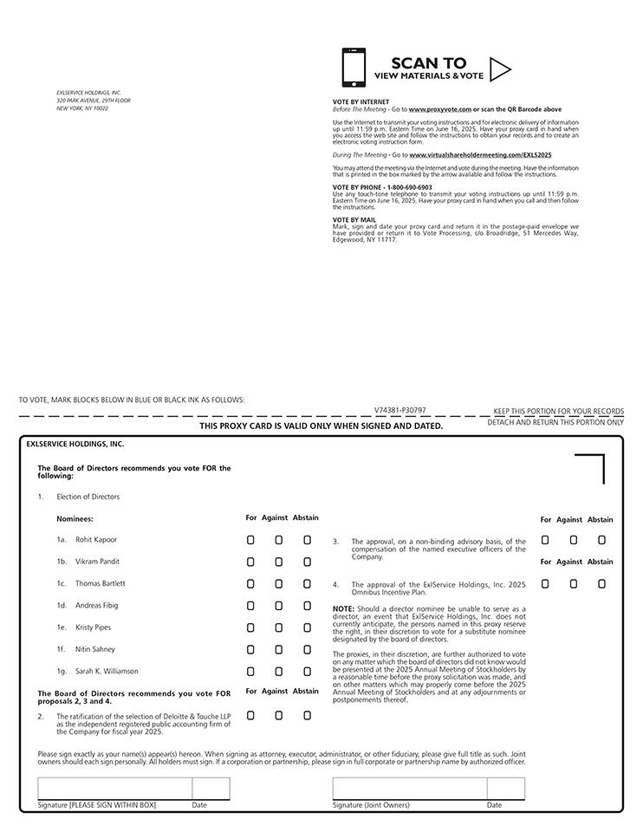

Table of Contents


