UNITED STATES
SECURITIES AND EXCHANGE COMMISSION
Washington, D.C. 20549

SCHEDULE 14A
Proxy Statement Pursuant to Section 14(a) of the
Securities Exchange Act of 1934
(Amendment No.)

Filed by the Registrant ☒
Filed by a Party other than the Registrant [ ]
Check the appropriate box:

☐ | Preliminary Proxy Statement

☐ | Confidential, for Use of the Commission Only (as permitted by Rule 14a-6(e)(2))

☐ | Definitive Proxy Statement

☒ | Definitive Additional Materials

☐ | Soliciting Material under §240.14a-12
ExlService Holdings, Inc.
(Name of Registrant as Specified In Its Charter)
(Name of Person(s) Filing Proxy Statement, if other than the Registrant)
Payment of Filing Fee (Check all boxes that apply):

☒ | No fee required

☐ | Fee paid previously with preliminary materials

☐ | Fee computed on table in exhibit required by Item 25(b) per Exchange Act Rules 14a-6(i)(1) and 0-11


Your Vote Counts! EXLSERVICE HOLDINGS, INC. 2023 Annual Meeting Vote by June 19, 2023 11:59 PM ET EXLSERVICE HOLDINGS, INC. 320 PARK AVENUE, 29TH FLOOR NEW YORK, NY 10022 V08572-P89920 You invested in EXLSERVICE HOLDINGS, INC. and its time to vote! You have the right to vote on proposals being presented at the Annual Meeting. This is an important notice regarding the availability of proxy material for the stockholder meeting to be held on June 20, 2023. Get informed before you vote View the Notice and Proxy Statement and Annual Report online OR you can receive a free paper or email copy of the material(s) by requesting prior to June 6, 2023. If you would like to request a copy of the material(s) for this and/or future stockholder meetings, you may (1) visit www.ProxyVote.com, (2) call 1-800-579-1639 or (3) send an email to sendmaterial@proxyvote.com. If sending an email, please include your control number (indicated below) in the subject line. Unless requested, you will not otherwise receive a paper or email copy. For complete information and to vote, visit www.ProxyVote.com Control # Smartphone users Point your camera here and vote without entering a control number Vote Virtually at the Meeting* June 20, 2023 8:30 AM ET Virtually at: www.virtualshareholdermeeting.com/EXLS2023 *Please check the meeting materials for any special requirements for meeting attendance. V1.2

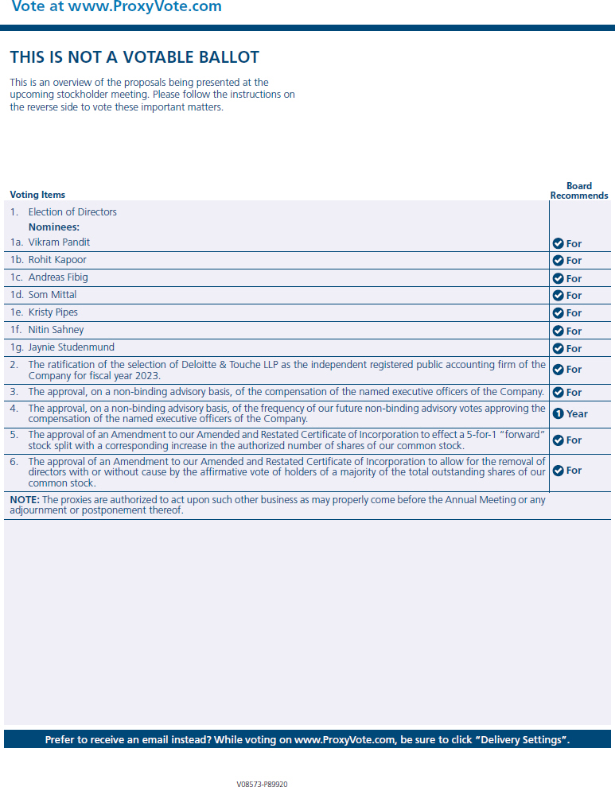
Vote at www.ProxyVote.com THIS IS NOT A VOTABLE BALLOT This is an overview of the proposals being presented at the upcoming stockholder meeting. Please follow the instructions on the reverse side to vote these important matters. Voting Items Board Recommends For For For For For For For For For For 1 Year For 1. Election of Directors Nominees: 1a. Vikram Pandit 1b. Rohit Kapoor 1c. Andreas Fibig 1d. Som Mittal 1e. Kristy Pipes 1f. Nitin Sahney 1g. Jaynie Studenmund 2. The ratification of the selection of Deloitte & Touche LLP as the independent registered public accounting firm of the Company for fiscal year 2023. 3. The approval, on a non-binding advisory basis, of the compensation of the named executive officers of the Company. 4. The approval, on a non-binding advisory basis, of the frequency of our future non-binding advisory votes approving the compensation of the named executive officers of the Company. 5. The approval of an Amendment to our Amended and Restated Certificate of Incorporation to effect a 5-for-1 forward stock split with a corresponding increase in the authorized number of shares of our common stock. 6. The approval of an Amendment to our Amended and Restated Certificate of Incorporation to allow for the removal of directors with or without cause by the affirmative vote of holders of a majority of the total outstanding shares of our common stock. NOTE: The proxies are authorized to act upon such other business as may properly come before the Annual Meeting or any adjournment or postponement thereof. Prefer to receive an email instead? While voting on www.ProxyVote.com, be sure to click Delivery Settings. V08573-P89920

