Table of Contents

UNITED STATES

SECURITIES AND EXCHANGE COMMISSION
Washington, D.C. 20549

SCHEDULE 14A

(Rule 14a-101)

INFORMATION REQUIRED IN PROXY STATEMENT

SCHEDULE 14A INFORMATION

Proxy Statement Pursuant to Section 14(a) of

the Securities Exchange Act of 1934 (Amendment No.

)

Filed by the Registrant ☒

Filed by a Party other than the Registrant o

Check the appropriate box:

- Preliminary Proxy Statement

- Confidential, for Use of the Commission Only (as permitted by Rule 14a-6(e)(2))

- Definitive Proxy Statement

- Definitive Additional Materials

- Soliciting Material under §240.14a-12

ExlService Holdings, Inc.

(Name of Registrant as Specified in its Charter)

N/A

(Name of Person(s) Filing Proxy Statement, if Other Than the Registrant)

PAYMENT OF FILING FEE (Check the appropriate box):

- No fee required.

- Fee computed on table below per Exchange Act Rules 14a-6(i)(1) and 0-11.

  - Title of each class of securities to which transaction applies:

  - Aggregate number of securities to which transaction applies:

  - Per unit price or other underlying value of transaction computed pursuant to Exchange Act Rule 0-11 (set forth the amount on which the filing fee is calculated and state how it was determined):

  - Proposed maximum aggregate value of transaction:

  - Total fee paid:

- Fee paid previously with preliminary materials.

- Check box if any part of the fee is offset as provided by Exchange Act Rule 0-11(a)(2) and identify the filing for which the offsetting fee was paid previously. Identify the previous filing by registration statement number, or the Form or Schedule and the date of its filing.

  - Amount Previously Paid:

  - Form, Schedule or Registration Statement No.:

  - Filing Party:

  - Date Filed:

Table of Contents
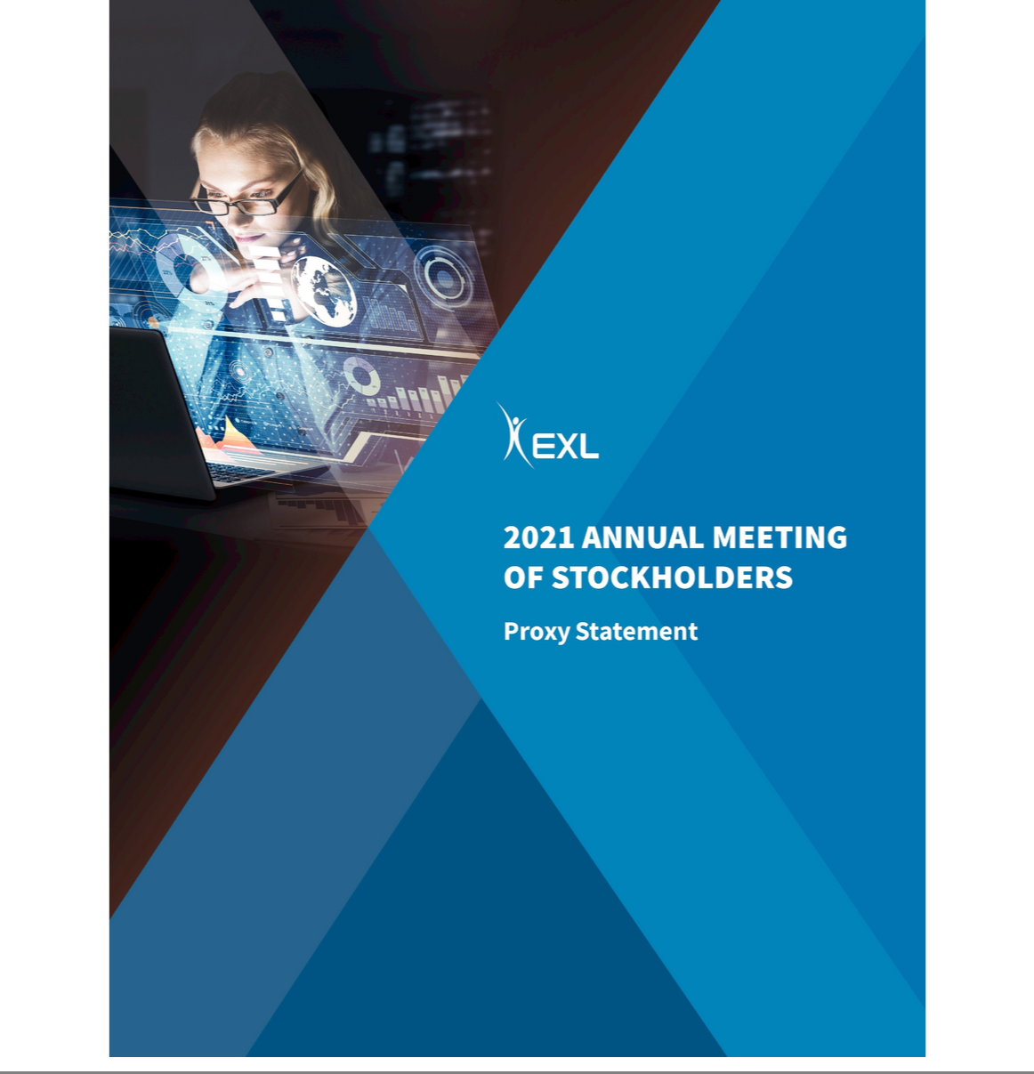

Table of Contents


320 Park Avenue, 29th Floor
New York, NY 10022
(212) 277-7100

April 23, 2021

Dear Stockholder,

As we look back at 2020, we are proud of our performance and perseverance despite the uncertainties that marked this unprecedented year. The efforts EXL put in place early, such as shifting our 30,000+ global workforce to a work from home model, ensuring the health and safety of our employees and safeguarding the business continuity of our clients, helped establish the momentum that we would carry throughout the year. Ultimately, through a combination of ingenuity, hard work and collaboration, we demonstrated agility and resilience in the face of crisis. We ended the year with stronger client relationships, expanded capabilities and a reaffirmation of our mission to work as one team to help our clients transform.

2020 provided a unique opportunity for us to implement our philosophy of looking deeper, finding a better way, and making it happen. Our character and culture stood out more than ever as we exemplified our core values of collaboration, innovation, excellence, integrity and respect.

For the year, we generated revenues of $958.4 million, representing a 3.3% decline from 2019. Like most of the market, the second quarter resulted in the most severe impact on our revenues resulting from COVID-19, representing an 8.6% decline in revenue during that quarter. Owing to the resiliency of our business model and new demand for our services in the second half of the year, we were able to close the year with strong revenue momentum. We also focused on our expense base as a means to mitigate the impacts of COVID-19. EXL achieved record profitability with diluted EPS of $2.59, up from $1.95 in 2019.

There are two key trends that drove our strong performance in 2020 and we believe that these trends will provide momentum for future revenue growth: (1) accelerated demand for our full suite of data and analytics capabilities and (2) leveraging cloud-based solutions to embed intelligence in operations.

First, the massive migration of consumers onto digital channels amid the uneven economic recovery has spurred demand for data-driven insights and powerful analytics. As a result, we are seeing surging interest in our data-led value creation framework, which is being used by clients in every industry we serve to deliver more personalized customer experiences, optimize costs and support resilient operating models. We are well positioned to capitalize on this accelerated market demand.

The second key trend is our cloud solutions offerings through which we are able to embed Artificial Intelligence (AI) in operations, fueling the growth in our operations management business. The Cloud has become central to our clients' resilience strategies and it is the lynchpin to powering advanced data and analytics functions. We are currently investing in a cloud center of excellence and our partnership ecosystem to develop and go-to-market with these cloud-native AI solutions. With several solution pilots underway, we are co-innovating with our clients and partners to solve strategic business problems.


2

Table of Contents

We have entered 2021, our 15th year as a public company, with strong momentum in our large deals pipeline and new logos of leading companies to our client portfolio.

Most importantly, though, the success we have enjoyed in such a difficult year is a testament to the amazing contributions of so many hard-working individuals. We greatly appreciate the contribution of all our colleagues around the world and the support of our stockholders, clients and partners, and we look forward to seeing what we can all accomplish together in 2021.

Our efforts to be good stewards of your capital and to provide industry-leading services to our clients are not our only pledge to our stockholders and other stakeholders. We view our sustainability efforts as integral to our long-term success, durability and resiliency as an organization.

In last year's letter to stockholders, we pledged to improve our disclosure on our sustainability efforts. We have delivered on that pledge. In November 2020, we published our first Sustainability Report according to the UN Sustainability Development Goals and the Global Reporting Initiative standards, which outlines our efforts and goals for improving the environment, human capital management, and corporate social responsibility, among others. More recently, we applied and will soon become a participant in the UN Global Compact. You can read more about our recent accomplishments in sustainability in the "Sustainability" section of this Proxy Statement.

We also continue to improve upon our strong corporate governance practices. At the end of 2020, we launched our formal stockholder engagement program, through which we hold meetings with our stockholders on topics relating to strategy, performance and governance, including board refreshment. These conversations inform our governance practices. Please refer to the "Corporate Governance" section of this Proxy Statement to learn more about governance practices and philosophy.

The success we have enjoyed in such a difficult year is a testament to the amazing contributions of many hard-working individuals. We look forward to seeing what EXL will accomplish in 2021.

Finally, we wish to thank David Kelso and Deborah Kerr, who will be departing from our board of directors following our 2021 Annual Meeting of Stockholders, for their service to EXL.

On behalf of the board of directors of ExlService Holdings, Inc., we are pleased to invite you to the 2021 Annual Meeting of Stockholders, which will be held on June 16, 2021. We look forward to sharing more about our Company at the Annual Meeting. Due to concerns regarding the current public health crisis related to the COVID-19 pandemic and the health and wellbeing of our stockholders, employees and directors, we will hold our Annual Meeting in virtual format only via live audio webcast instead of holding the meeting in New York or at any physical location. We encourage you to read carefully the attached 2021 Annual Meeting of Stockholders and Proxy Statement, which contain important information about the matters to be voted upon and instructions on how you can vote your shares.


3

Table of Contents

Your vote is important to us. Please vote as soon as possible whether or not you plan to participate in the Annual Meeting.

The board of directors and management look forward to seeing you at the Annual Meeting.

Sincerely,
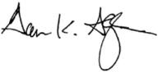
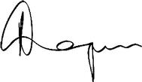

Garen K. Staglin

Chairman

Rohit Kapoor
Vice Chairman and CEO

4

Table of Contents

NOTICE OF 2021 ANNUAL MEETING OF STOCKHOLDERS

Dear Stockholder:

You are cordially invited to the 2021 Annual Meeting of Stockholders of ExlService Holdings, Inc., a Delaware corporation (the "Company"), for the purposes of voting on the following matters:

- the election of nine members of the board of directors of the Company;

- the ratification of the appointment of Deloitte & Touche LLP as the independent registered public accounting firm of the Company for fiscal year 2021;

- the approval, on a non-binding advisory basis, of the compensation of the named executive officers of the Company; and

- the transaction of such other business as may properly come before the Annual Meeting or any adjournment or postponement thereof.

Due to the current state of the public health crisis related to COVID-19, and the health and wellbeing of our stockholders, employees and directors, we will hold our Annual Meeting in virtual format only, via live audio webcast (rather than at any physical location) on June 16, 2021 at 9:30 AM, Eastern Time, instead of holding the meeting in New York or at any physical location. You or your proxyholder may participate, vote, and examine our stockholder list at the Annual Meeting by visiting www.virtualshareholdermeeting.com/EXLS2021 and using your 16-digit control number.

If you are a stockholder of record at the close of business on April 19, 2021, the record date for the Annual Meeting, you are entitled to vote at the Annual Meeting. A list of stockholders as of the record date will be available for examination for any purpose germane to the Annual Meeting, during ordinary business hours, at the Company's

executive offices at 320 Park Avenue, 29th Floor, New York, New York 10022, for a period of 10 days prior to the date of the Annual Meeting and at the Annual Meeting itself. If our corporate headquarters are closed during the 10 days prior to the Annual Meeting, you may send a written request to the Corporate Secretary at our corporate headquarters, and we will arrange a method for you to inspect the list. The list of stockholders will also be available during the Annual Meeting at www.virtualshareholdermeeting.com/EXLS2021.

5

Table of Contents

Please note the technical requirements for virtual attendance at the Annual Meeting, as described in the enclosed Proxy Statement beginning on Page 117 under the heading "Annual Meeting Q&A."

Pursuant to rules promulgated by the Securities and Exchange Commission, we are providing access to our proxy materials over the Internet. On or about April 23, 2021, we will mail a Notice of Internet Availability of Proxy Materials (the "Internet Notice") to each of our stockholders of record and beneficial owners at the close of business on the record date. On the date of mailing of the Internet Notice, all stockholders and beneficial owners will have the ability to access all of the proxy materials on a website referred to in the Internet Notice. These proxy materials will be available free of charge.

Whether or not you expect to attend the Annual Meeting, the Company encourages you to promptly vote and submit your proxy by (i) Internet (by following the instructions provided in the Internet Notice), (ii) by phone (by following the instructions provided in the Internet Notice) or (iii) by requesting that proxy materials be sent to you by mail that will include a proxy card that you can use to vote by completing, signing, dating and returning the proxy card in the prepaid postage envelope provided. Voting by proxy will not deprive you of the right to attend the Annual Meeting or to vote your shares. You can revoke a proxy at any time before it is exercised by voting at the Annual Meeting, by delivering a subsequent proxy or by notifying the inspector of elections in writing of such revocation prior to the Annual Meeting. YOUR SHARES CANNOT BE VOTED UNLESS YOU EITHER (I) VOTE BY USING THE INTERNET, (II) VOTE BY PHONE, (III) REQUEST PROXY MATERIALS BE SENT TO YOU BY MAIL AND THEN USE THE PROXY CARD PROVIDED BY MAIL TO CAST YOUR VOTE BY COMPLETING, SIGNING AND RETURNING THE PROXY CARD BY MAIL OR (IV) ATTEND THE ANNUAL MEETING AND VOTE.

By Order of the Board of Directors
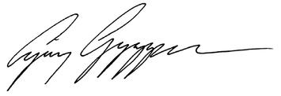

Ajay Ayyappan

Senior Vice President, General Counsel and Corporate Secretary

New York, New York

April 23, 2021

6

2021 PROXY STATEMENT

TABLE OF CONTENTS

2021 PROXY STATEMENT SUMMARY |  |  |  |  |  |  |  |  |  |  |  |  |  |  |  |  |  |  | 8
OUR BOARD OF DIRECTORS |  |  |  |  |  |  |  |  |  |  |  |  |  |  |  |  |  |  | 18
CORPORATE GOVERNANCE |  |  |  |  |  |  |  |  |  |  |  |  |  |  |  |  |  |  |  |  | 30
SUSTAINABILITY |  |  |  |  |  |  |  |  |  |  |  |  |  |  |  |  |  |  |  |  | 47
OUR EXECUTIVE OFFICERS |  |  |  |  |  |  |  |  |  |  |  |  |  |  |  |  |  |  | 59
EXECUTIVE COMPENSATION |  |  |  |  |  |  |  |  |  |  |  |  |  |  |  |  |  |  |  |  | 61
 | Compensation Discussion and Analysis |  |  |  |  |  |  |  |  |  |  |  |  |  |  |  |  |  | 61
 | Compensation Committee Report |  |  |  |  |  |  |  |  |  |  |  |  |  |  |  |  |  |  |  | 85
 | Summary Compensation Table for Fiscal Year 2020 |  |  |  |  |  |  |  |  |  |  |  |  |  |  |  |  |  |  |  | 86
STOCK OWNERSHIP OF DIRECTORS, EXECUTIVE OFFICERS AND CERTAIN BENEFICIAL OWNERS |  |  |  |  |  |  |  |  |  |  |  |  |  |  |  |  |  |  | 106
CERTAIN RELATIONSHIPS AND RELATED PERSON TRANSACTIONS |  |  |  |  |  |  |  |  |  |  |  |  |  |  |  |  |  |  | 108
AUDIT COMMITTEE REPORT |  |  |  |  |  |  |  |  |  |  |  |  |  |  |  |  |  |  | 109
PROPOSAL 1 — ELECTION OF DIRECTORS |  |  |  |  |  |  |  |  |  |  |  |  |  |  |  |  |  |  | 110
PROPOSAL 2 — RATIFICATION OF THE APPOINTMENT OF INDEPENDENT REGISTERED PUBLIC ACCOUNTING FIRM |  |  |  |  |  |  |  |  |  |  |  |  |  |  |  |  |  |  | 112
PROPOSAL 3 — ADVISORY (NON-BINDING) VOTE ON EXECUTIVE COMPENSATION |  |  |  |  |  |  |  |  |  |  |  |  |  |  |  |  |  |  | 114
STOCKHOLDER PROPOSALS AND DIRECTOR NOMINATIONS FOR THE 2022 ANNUAL MEETING |  |  |  |  |  |  |  |  |  |  |  |  |  |  |  |  |  |  | 115
MISCELLANEOUS |  |  |  |  |  |  |  |  |  |  |  |  |  |  |  |  |  |  | 116
ANNUAL MEETING Q&A |  |  |  |  |  |  |  |  |  |  |  |  |  |  |  |  |  |  | 117
OTHER MATTERS |  |  |  |  |  |  |  |  |  |  |  |  |  |  |  |  |  |  | 121
 |  |  |  |  |  |  |  |  |  |  |  |  |  |  |  |  |  |  | 7

Table of Contents

2021 PROXY STATEMENT SUMMARY

2021 PROXY STATEMENT SUMMARY
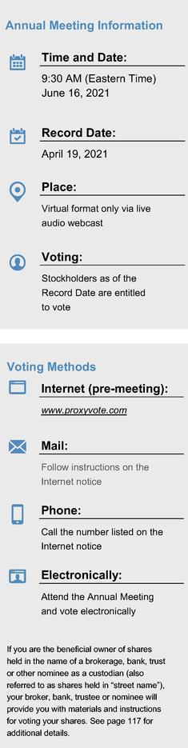

SUMMARY

Below is a summary of select components of this proxy statement, including information regarding this year's stockholder meeting, nominees for our board of directors, summary of our business, performance highlights and selective executive compensation information. This summary does not contain all of the information that you should consider prior to submitting your proxy, and you should review the entire proxy statement and our Annual Report on Form 10-K for the fiscal year ended December 31, 2020 (the "2020 Form 10-K"). We refer to the fiscal year ended December 31, 2020 as "fiscal year 2020," "fiscal 2020," and "2020."

MEETING AGENDA, VOTING MATTERS AND RECOMMENDATIONS

Voting Proposal Item | Board Vote Recommendation
1. Election of directors | FOR the election of each nominee
 | (pg. 110)

Required Vote: Affirmative vote of a majority of shares present in person* or represented by proxy and entitled to vote

2. Ratification of appointment of independent registered public | FOR (pg. 112)
accounting firm | FOR (pg. 112)

Required Vote: Affirmative vote of a majority of shares present in person* or represented by proxy and entitled to vote

3. Advisory (non-binding) vote on executive compensation | FOR (pg. 114)

Required Vote: Affirmative vote of a majority of shares present in person* or represented by proxy and entitled to vote

*Virtual attendance at our Annual Meeting will constitute presence in person for purposes of quorum and voting at the Annual Meeting.

8

Table of Contents

2021 PROXY STATEMENT SUMMARY

OUR BUSINESS

We are a leading operations management and analytics company that helps our clients build and grow sustainable businesses. By orchestrating our domain expertise, data, analytics and digital technology, we look deeper to design and manage agile, client-centric operating models to improve global operations, drive profitability, enhance client satisfaction, increase data-driven insights, and manage risk and compliance. Headquartered in New York, as of March 31, 2021 we had approximately 31,600 professionals in locations throughout the United States, the United Kingdom, Europe, India, the Philippines, Colombia, Canada, Australia and South Africa. We serve clients in multiple industries, including insurance, healthcare, banking and financial services, utilities, travel, transportation and logistics, media and retail, among others.

Company 3 Year Performance |  |  |  | Revenue (Year-over-year growth %)
Revenue and Segment Information ($ in millions) |  | 2018 YOY% |  |  |  | 2019 YOY% |  |  | 2020 YOY%
Insurance Segment | $ | 311.2 | 15.8% |  | $ | 346.4 | 11.3% | $ | 341.8 | –1.3%
Healthcare Segment |  | 89.8 | 5.4% |  |  | 97.5 | 8.5% |  | 101.2 | 4.0%
Emerging Business Segment |  | 196.8 | –0.8% |  |  | 190.1 | –3.4% |  | 152.7 | –19.7%
Analytics Segment |  | 285.3 | 35.90% |  |  | 357.3 | 25.3% |  | 362.7 | 1.5%
Consolidated | $ | 883.1 | 15.8% |  | $ | 991.3 | 12.3% | $ | 958.4 | –3.3%

While our annual revenues decreased from $991.3 million in fiscal year 2019 to $958.4 million in fiscal year 2020, we improved our net income attributable to stockholders by 32% to $89.5 million. During the first fiscal quarter ended March 31, 2020, COVID-19 did not have a significant impact on our business, however, in subsequent quarters, COVID-19 materially impacted us. Among other actions in 2020, we adapted delivery for our clients to a work from home model; took actions in response to the pandemic that focused on helping our employees; and implemented a series of cost reduction measures. For more information regarding these and other business highlights, please see Pages 63 to 65 below and the 2020 Form 10-K.

The graphs below compare our 1-year, 3-year and 5-year cumulative total stockholder return ("TSR") as of December 31, 2020 with the median TSR for companies comprising Nasdaq, S&P 600 and our peer group.
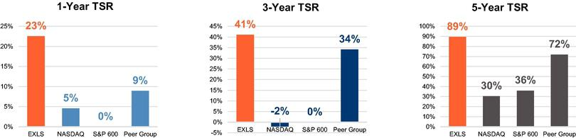

9

Table of Contents

2021 PROXY STATEMENT SUMMARY

OUR PURPOSE AND CORE VALUES
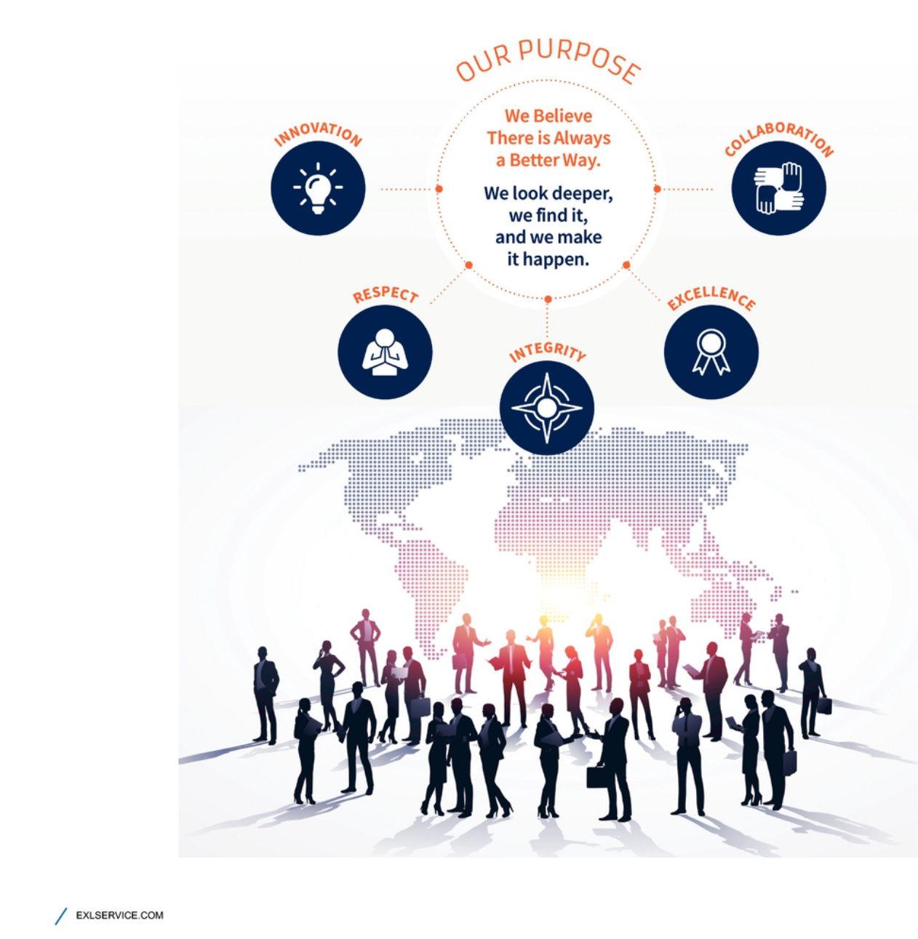

10

Table of Contents

2021 PROXY STATEMENT SUMMARY

Table of Contents
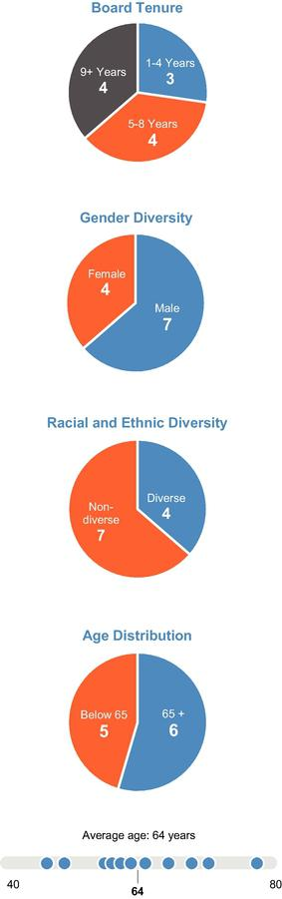

CORPORATE GOVERNANCE HIGHLIGHTS

Based on current board profile and practices (including our nine director nominees, and our two directors who currently serve on our board, but will not be standing for reelection)

Board of Directors Composition

- 11 directors, all of whom are independent, except for our Vice Chairman and CEO

- Independent board chairman

- Seasoned board of directors, with diverse experience, including in human capital management, corporate sustainability, insurance, healthcare, utilities, consulting, banking and financial services, finance/accounting, global business and technology

- Diversity in age, ethnicity, gender and other important characteristics

- Declassified board

Board Accountability

- Majority voting standard for uncontested elections

- Annual board- and committee-level evaluations

- Regularly-held executive session of non-management directors

- Robust executive and director equity ownership guidelines

- Independent board of directors evaluation of CEO performance and compensation

Governance Practices

- Regular executive sessions

- Standing board committees composed solely of independent chairs and members

- Equity ownership guidelines

- Independent compensation consultant

- Board risk oversight and assessment

- Board committee oversight over sustainability efforts

- Director training and education

- Simultaneous service restrictions

- Active stockholder engagement program addressing strategy, performance and governance

11

Table of Contents

2021 PROXY STATEMENT SUMMARY

Director Qualifications
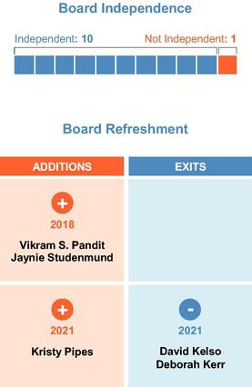

Our board of directors reflects an effective and diverse mix of skills, background and experience appropriate for our Company and industry. Our directors have the following attributes:

- Executive Leadership Experience

- Board Experience

- Finance and Accounting Expertise

- Client and Industry Expertise

- Global Experience

- Risk Oversight/Management Expertise

- Human Capital Management Expertise

- Diverse Backgrounds

- Experience in Environmental, Social and Governance Matters

- Strategic Insight

- Commitment to Accountability, Excellence and Continuous Improvement

- Commitment to Driving our Growth and Success

Skills Matrix










 |  |  |  |  |  |  |  |  |  | Risk
 | Finance |  | Public |  |  | Human |  | Marketing |  | Oversight
 | and | Executive | Company |  |  | Capital | Operations | and | International | and
 | Accounting | Leadership | Governance | Technology | Analytics | Management | Management | Branding | Companies | Management
Garen Staglin | ✓ | ✓ | ✓ | ✓ |  | ✓ | ✓ | ✓ | ✓ | ✓
Rohit Kapoor | ✓ | ✓ | ✓ | ✓ | ✓ | ✓ | ✓ | ✓ | ✓ | ✓
David Kelso | ✓ | ✓ | ✓ |  |  | ✓ |  | ✓ | ✓ | ✓
Deborah Kerr |  | ✓ | ✓ | ✓ | ✓ | ✓ | ✓ | ✓ | ✓ | ✓
Anne Minto |  | ✓ | ✓ |  |  | ✓ | ✓ |  | ✓ | ✓
Som Mittal | ✓ | ✓ | ✓ | ✓ |  | ✓ | ✓ |  | ✓ | ✓
Clyde Ostler | ✓ | ✓ | ✓ |  | ✓ |  | ✓ | ✓ | ✓ | ✓
Vikram Pandit | ✓ | ✓ | ✓ | ✓ | ✓ | ✓ | ✓ | ✓ | ✓ | ✓
Kristy Pipes | ✓ | ✓ | ✓ | ✓ | ✓ | ✓ | ✓ |  | ✓ | ✓
Nitin Sahney | ✓ | ✓ | ✓ |  |  | ✓ | ✓ | ✓ |  | ✓
Jaynie Studenmund | ✓ | ✓ | ✓ | ✓ | ✓ | ✓ | ✓ | ✓ | ✓ | ✓


12

Table of Contents

 |  |  |  | 2021 PROXY STATEMENT SUMMARY
NOMINEES FOR ELECTION AS DIRECTORS
 |  | Director |  | Committee
 | Name | Since | Experience* | Membership
 | Garen Staglin | June | Former Chief Executive Officer of eONE Global LP and Safelite Auto Glass; Chairman of | Compensation Committee; Nominating and
Chairman |  | 2005 | the Company since 2014 | Governance Committee
Rohit Kapoor |  | November | Co-founded the Company in 1999; Vice Chairman and CEO of the Company since 2012 | None
Vice Chairman |  | 2002
Anne Minto |  | March | Former Global Human Reources Durector for Centrica plc, former CHRO for Smiths | Compensation Committee (former Chair
 |  | 2013 | Group plc | through December 2020); Nominating and
 |  |  |  | Governance Committee
 | Som Mittal | December | Former Chairman and President of NASSCOM | Compensation Committee; Nominating and
 |  | 2013 |  | Governance Committee
 | Clyde Ostler | December | Former executive for Wells Fargo, whose roles included Group Executive Vice President, | Audit Committee (Chair); Compensation
 |  | 2007 | Chief Financial Officer and Chief Auditor | Committee
 | Vikram Pandit | October | Chairman and Chief Executive Officer of Orogen Group; former Chairman of TGG Group | Audit Committee; Nominating and
 |  | 2018 | and former Chief Executive Officer of Citigroup Inc. | Governance Committee
 | Kristy Pipes | January | Former Chief Financial Officer of Deloitte Consulting | Audit Committee; Compensation Committee
 |  | 2021
 | Nitin Sahney | January | Founder and Chief Executive Officer of Pharmacord, LLC; former President and CEO of | Nominating and Governance Committee
 |  | 2016 | Omnicare Inc. | (Chair); Audit Committee
 | Jaynie Studenmund | September | Former Chief Operating Officer of Overture Services, Inc.; former President & Chief | Compensation Committee (Chair); Audit
 |  | 2018 | Operating Officer, PayMyBills; former Executive Vice President and Head of Consumer | Committee
 |  |  | and Business Banking for First Interstate of California
*A complete list of each nominee's business experience and directorships is listed below beginning on page 21.
 |  |  |  | 13

Table of Contents

2021 PROXY STATEMENT SUMMARY

SUSTAINABILITY

Our corporate culture is rooted in our five core values. In line with our culture, we are committed to sustainability initiatives that are key to our long-term strategy and benefit our stockholders, clients, employees and communities. See "Sustainability" beginning on page 47 below for more details on our recent accomplishments in sustainability.
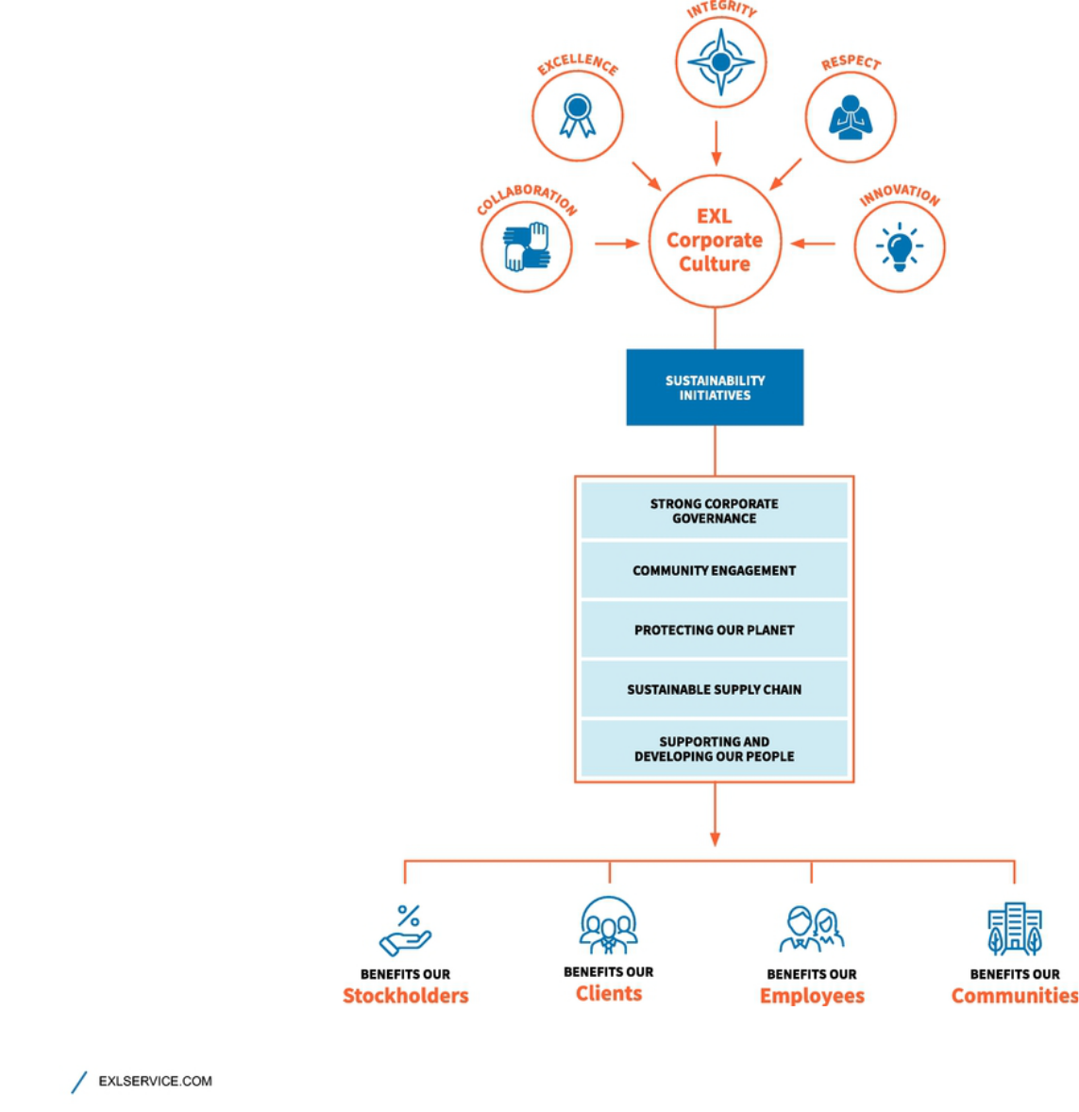

14

Table of Contents

 |  |  |  |  |  | 2021 PROXY STATEMENT SUMMARY
2020 COMPENSATION HIGHLIGHTS
Named Executive Officers
Name | Title
Rohit Kapoor | Vice Chairman and CEO
Maurizio Nicolelli | Executive Vice President and CFO
Pavan Bagai | President and Chief Operating Officer and Former Interim CFO
Nalin Miglani | Executive Vice President and Chief Human Resources Officer
Vikas Bhalla | Executive Vice President and Business Head, Insurance
Samuel Meckey | Executive Vice President and Business Head, Healthcare
2020 Standard Annual Compensation
 |  | Rohit | Maurizio | Pavan | Nalin |  | Vikas | Samuel
Compensation Component |  | Kapoor | Nicolelli | Bagai⁽⁴⁾ | Miglani |  | Bhalla⁽⁴⁾ | Meckey
Salary ⁽¹⁾ |  | $599,016 | $384,283 | $300,977 | $404,631 |  | $229,016 | $382,152
Non-Equity Incentive Plan Compensation |  | 810,000 | 243,097 | 200,164 | 253,125 |  | 169,370 | 239,063
Equity Awards ⁽²⁾ |  | 5,701,209 | 1,166,955 | 1,693,173 | 1,179,065 |  | 1,399,048 | 1,106,585
Other Compensation ⁽³⁾ |  | 31,041 | 133,970 | 20,132 | 9,054 |  | 43,029 | 9,054
Total |  | $7,141,267 | $1,928,305 | $2,214,447 | $1,845,875 |  | $1,840,463 | $1,736,853

- As described in greater detail in the Compensation Discussion and Analysis below beginning on page 61, our named executive officers agreed to a reduction in base salary for four months during fiscal year 2020 in light negative effects of the COVID-19 pandemic.

- Equity award values reflect equity grants in 2020 with time-based and revenue linked performance-based restricted stock units valued based on grant date fair market value and TSR linked performance-based restricted stock units valued using a Monte Carlo fair market valuation.

- For each named executive officer, this category includes, if applicable, his perquisites and personal benefits, hiring bonus, changes in pension value, Company-paid life insurance premiums and Company contributions to our 401(k) plan. A detailed discussion of the compensation components for each named executive officer for fiscal year 2020 is provided in the "Summary Compensation Table for Fiscal Year 2020" beginning on page 86.

- Messrs. Bagai and Bhalla are each based in Delhi, India. Certain of their compensation components, as described herein, are paid in Indian rupees (INR), and are converted for comparison purposes at 73.065 INR to 1 USD, which was the exchange rate on December 31, 2020.

On an annual basis, we submit to our stockholders a vote to approve, on a non-binding advisory basis, the compensation of our named executive officers as described in this proxy statement. We refer to this vote as "say-on-pay". Please refer to our Compensation Discussion and Analysis, beginning on page 61 for a complete description of our 2020 compensation program.

15

Table of Contents

2021 PROXY STATEMENT SUMMARY

Below are a few highlights of our executive compensation:

- Compensation Philosophy: Our executive compensation philosophy is focused on pay-for-performance and is designed to reflect appropriate governance practices aligned with the

needs of our business, and includes, among others, the following features: clawback policy; robust stock ownership guidelines for executives (and non-employee directors); limited perquisites; no tax gross-ups; and an anti-hedging and anti-pledging policy. See "Executive Compensation Program, Practices and Policies" beginning on page 67 below.

- 98% Say-on-Pay Approval of 2019 Compensation: At our 2020 Annual Meeting of Stockholders, our stockholders approved, on a non-binding advisory basis, the compensation paid to our named executive officers for fiscal year 2019. Approximately 98% of the votes present in person or by proxy (excluding broker non-votes) voted in favor of fiscal year 2019 compensation.

- Annual Bonus Program Based Upon Financial Performance Criteria: Our Compensation Committee approved the continued use of our annual bonus program, which was based upon the following performance criteria:

–Company Wide Metrics — Adjusted earnings per share ("EPS"), revenue, and adjusted operating profit margin ("AOPM")

–Business Line Metrics — Revenue, Adjusted EPS, Business Operating Income (BOI), and AOPM

–Individual Metrics — Linked to areas of performance that are specific to each executive

- Long-Term Equity Incentive Program: We also continued our equity incentive program, which includes granting a balanced mix of time-vested restricted stock units and performance-based restricted stock units. The performance-based restricted stock units were comprised of:

–Relative total stockholder return-linked restricted stock units, and

–Revenue-linked restricted stock units.

- 2020 Performance: We delivered the following revenue, Adjusted EPS, and AOPM (as described below) performance:

–Annual Incentive Program: As measured under our annual incentive plan, we delivered 99.20% of our Adjusted EPS target, 89.32% of our revenue performance target, and 95.26% of our AOPM target resulting in annual incentive payout calculations for our named executive officers, ranging from 50.36% of target performance to 94.69% of target performance. As discussed in greater detail in the Compensation Discussion and Analysis below, our Compensation Committee did not make adjustments to the performance targets that had previously been set, but rather reviewed Company, business unit, and individual performance and adjusted the payouts to 75% of target performance for all named executive officers after taking into account the unanticipated impact of the COVID-19 pandemic and the teamwork and extraordinary efforts of the named executive officers.

–Equity Incentive Program: This was the third and final performance year for the 2018 performance-based restricted stock units. We achieved 99.89% of the revenue target for the revenue-linked restricted stock units resulting in 100% of target funding of those grants. The Company's TSR performance was at the 46.51 percentile amongst its peer group, resulting in the executives earning 88.37% of the target funding of those grants. In the aggregate the 2018 performance-based restricted stock units resulted in the vesting of shares at 94.13% of target performance. No adjustments were made to the 2018 performance-based restricted stock units or the associated performance targets — or the outstanding 2019 and 2020

16

Table of Contents

2021 PROXY STATEMENT SUMMARY

performance-based restricted stock units or associated performance targets — to account for the impact of the COVID-19 pandemic in the 2020 fiscal year.

- 2020 COVID-19 Related Temporary Salary Deferrals and Reductions: Although the Compensation Committee approved modest increases to our named executive officers' base salaries to be effective April 1, 2020, the named executive officers agreed to defer these increases due to the uncertainly caused by the COVID-19 pandemic. The increases, therefore, did not come into effect during the 2020 fiscal year. In addition, from May 1, 2020 to August 31, 2020, also due to the uncertainty caused by the COVID-19 pandemic and in order to retain flexibility, the Company's executive management team recommended to the Compensation Committee and the Compensation Committee accepted, salary reductions for the named executive officers. Accordingly, the base salary for the Company's Vice Chairman and Chief Executive Officer, Mr. Rohit Kapoor, was temporarily reduced by 50% and the base salary for the other named executive officers was temporarily reduced by 30%. Finally, as an extension of these cost saving actions, our non-employee directors also agreed to a reduction of 30% in their cash retainers, which was in effect from May 1, 2020 to August 31, 2020.

Compensation Mix
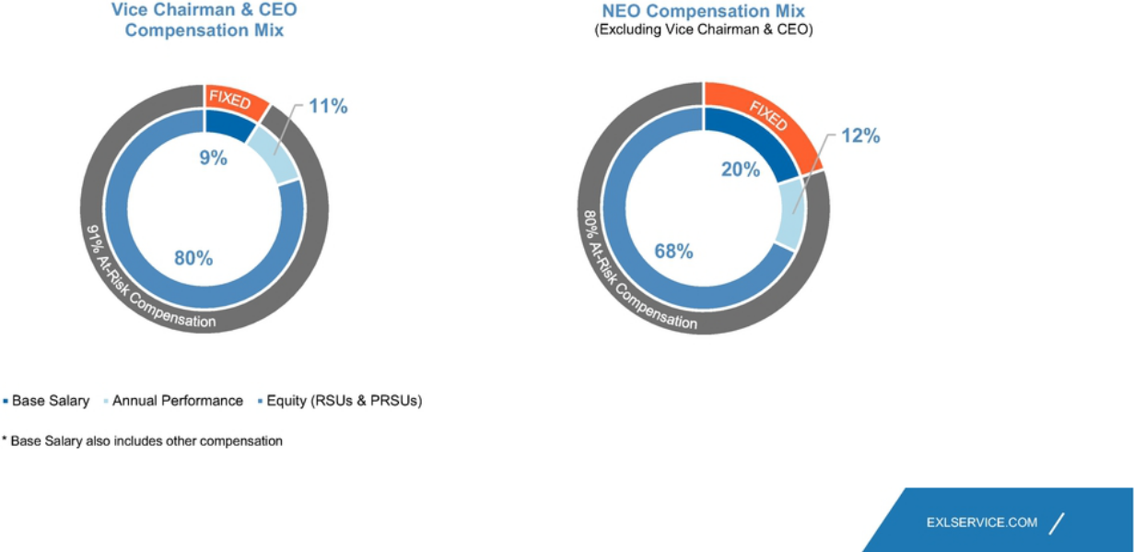

17

Table of Contents

OUR BOARD OF DIRECTORS

OUR BOARD OF DIRECTORS

Our board of directors currently consists of 11 directors (including our nine director nominees, and our two directors who are currently serving on the board, but will not stand for reelection) with diverse experience, including in human capital management, corporate sustainability, insurance, healthcare, utilities, consulting, banking and financial services, finance/accounting, global business and technology. The following tables include a summary of our board composition by age, gender, tenure and independence.
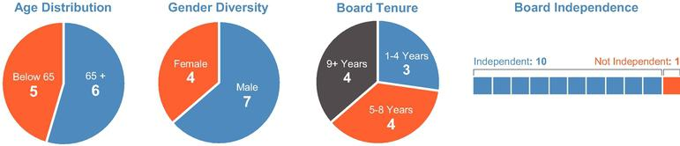

Historically, our board of directors was divided into three classes. Beginning with the Annual Meeting, however, all director nominees elected by our stockholders will be elected to hold office for a term of one year, or until their successors are duly elected and qualified in accordance with our by-laws, and the classification of the Board of Directors will terminate in its entirety.

18

Table of Contents

OUR BOARD OF DIRECTORS

Upon the recommendation of our Nominating and Governance Committee, we are pleased to propose nine of our existing directors as nominees for election as directors at the Annual Meeting. As previously disclosed, two of our current directors, Ms. Kerr and Mr. Kelso, will not be standing for re-election at the Annual Meeting; the remaining nine directors are our director nominees at the Annual Meeting. Our nominees for re-election as directors at the Annual Meeting are as follows:

DIRECTOR NOMINEES

Rohit Kapoor | Vikram Pandit*
Vice Chairman and CEO and Director | Independent Director
Anne Minto | Kristy Pipes
Independent Director and Former Chair | Kristy Pipes
Independent Director and Former Chair | Independent Director
of the Compensation Committee | Independent Director
Som Mittal | Nitin Sahney
Som Mittal | Independent Director and Chair of the
Independent Director | Independent Director and Chair of the
Independent Director | Nominating and Governance Committee
Jaynie Studenmund | Garen Staglin
Independent Director and Chair of the | Independent Director and
Compensation Committee | Chair of the Board
Clyde Ostler
Independent Director and
Chair of the Audit Committee


* Mr. Pandit was appointed to the board as a director under the terms of an Investment Agreement as described on pages 19 to 20 below.

We believe that our director nominees and continuing directors, individually and together as a whole, possess the requisite skills, experience and qualifications necessary to maintain an effective board to serve the best interests of the Company and its stockholders described below under Director Qualifications (see page 12).

In addition to satisfying these general qualifications considered by the Nominating and Governance Committee in connection with a director nomination, Vikram S. Pandit was appointed to the Board on October 4, 2018 as a director pursuant to the terms of an Investment Agreement, dated as of October 1, 2018 (the "Investment Agreement"), between the Company and Orogen Echo LLC (the "Purchaser"), an affiliate of The Orogen Group LLC ("The Orogen Group"). The Investment Agreement was entered into in connection with our issuance to the Purchaser of

19

Table of Contents

OUR BOARD OF DIRECTORS

$150,000,000 in aggregate principal amount of 3.50% Convertible Senior Notes due October 1, 2024 (the "notes"). For so long as the Purchaser has the right to nominate a director to the Board under the Investment Agreement, we have, subject to the terms of the Investment Agreement, agreed to include such person in our list of nominees for election to our board of directors at each of our annual meetings of stockholders at which directors are to be elected, and to use our reasonable best efforts to cause the election of such person to our board of directors. The Purchaser's right to nominate a director will terminate if Purchaser and its affiliates beneficially own less than 50% of the number of shares of our common stock deemed beneficially owned by the Purchaser and its affiliates immediately following the issuance of the notes (which, for purposes of the Investment Agreement, includes shares of our common stock issuable upon conversion of the notes).

20

Table of Contents

OUR BOARD OF DIRECTORS

BOARD OF DIRECTORS

The names, ages and principal occupations (which have continued for at least the past five years unless otherwise indicated) and other information, including the specific experience, qualifications, attributes or skills that led to the conclusion that such person should serve as a director of the Company, with respect to each of the nominees are set forth below. There are no family relationships among any of our directors or executive officers.

Nominees for Election at the Annual Meeting

Rohit Kapoor

Director since November 2002 | Vice Chairman and CEO since April 2012 Non-Independent
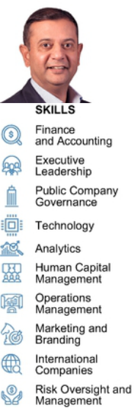

Age: 56 — co-founded EXL in April 1999 and has served as our Vice Chairman and CEO since April 2012 and as a director since November 2002. He previously served as our President and CEO from May 2008 to March 2012. Mr. Kapoor's business experience and directorships are detailed below. The Company has concluded that, in connection with Mr. Kapoor's experience as a founder and current role as CEO of the Company, Mr. Kapoor should serve as a director.

Committees: N/A

Business Experience at the Company

- Vice Chairman and CEO (2012 - present)

- President and CEO (2008 - 2012)

- Various senior leadership roles, including CFO and COO (2000 - 2008)

Other Business Experience

- Business head, Deutsche Bank, a financial services provider (1999 - 2000)

- Various capacities at Bank of America in the United States and Asia, including India (1991 - 1999)

Public Directorships During Past Five Years

- Director and member of the audit committee and former lead independent director,CA Technologies, Inc., a software services company (NASDAQ: CA) (2012 - 2018)

Other Relevant Experience

- Member, Board of Directors, American India Foundation (AIF)

- Member, Board of Directors, Pratham (Tristate Chapter)

21

Table of Contents

OUR BOARD OF DIRECTORS

Anne E. Minto

Director since March 2013 Independent
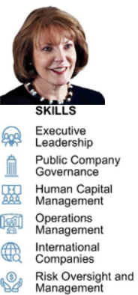

Age: 67 — is a qualified lawyer and member of the Law Society of Scotland. Ms. Minto's business experience and directorships are detailed below. The Company has concluded, based in part on Ms. Minto's extensive experience as a member of international company boards and management in the human resources field and her expertise in human capital management, together with her knowledge and experience of the European business and regulatory environment, that Ms. Minto should serve as a director.

Committees:

- Compensation, Nominating and Governance

Business Experience

- Qualified lawyer and member of Law Society of Scotland

- Group director, human resources and member of the executive committee, Centrica plc, an energy and services company (2002 - 2011)

- Prior senior management roles at Shell UK and Smiths Group plc

Public Directorships During Past Five Years

- Non-executive director, chairman of the remuneration committee, Tate & Lyle plc, a global provider of specialty food products (LSE: TATE) (2012 - present)

- Non-executive director, chairman of the remuneration committee and member of the nomination and governance committee, Shire plc, a global biopharmaceutical company (NASDAQ: SHPG, LSE: SHP) (2010 - 2019)

Other Relevant Experience

- Non-executive director, Court of the University of Aberdeen

- Chairman, University of Aberdeen Development Trust

- Fellow, Chartered Institute of Personnel & Development and the City and Guilds of London Institute

- Fellow, Chartered Institute of Management

- Recipient, Order of the British Empire for services to the U.K. engineering industry (2000)

22

Table of Contents

OUR BOARD OF DIRECTORS

Som Mittal

Director since December 2013 Independent
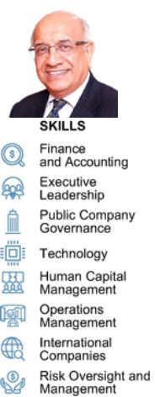

Age: 69 — has held various corporate leadership roles in the IT industry since 1989 and has extensive experience in the engineering and automotive sectors. His business experience and directorships are detailed below. The Company has concluded, based in part on Mr. Mittal's business experience as President of NASSCOM, his knowledge of the global outsourcing industry and his expertise in corporate sustainability and responsibility, that Mr. Mittal should serve as a director.

Committees:

- Compensation, Nominating and Governance

Business Experience

- Chairman and President, NASSCOM, a trade body for the IT and business process management industries in India (2008 - 2014)

- Prior leadership roles at Wipro, Digital, Compaq and HP

- Prior executive roles at Larsen and Tourbo, Escorts and Denso

Public Directorships During Past Five Years

- Director and member of audit and risk management committee, Cyient Ltd., an engineering design services company (NSE:CYIENT) (2014 - present)

- Director and chairman of nomination and remuneration committee, Sheela Foam Ltd., a manufacturing company (NSE: SFL) (2016 - present)

- Director and chairman of customer service committee and IT strategy committee, member of nomination and remuneration committee and other committees, Axis Bank, Ltd., a financial services company (NSE:Axis) (2011 - 2019)

Other Directorships

- Director, Tata SIA Airlines, Ltd., an Indian airline joint venture between TATA and Singapore Airlines with Indian and international operations (2015 - present)

- Non executive Independent Director and Chairman, Vodafone India Services India Pvt Ltd., an Indian shared services company that is wholly owned, operated and controlled by Vodafone Group Plc ("Vodafone") and provides information technology and networks services, among others, to Vodafone (2020 - present)

Other Relevant Experience

- Former member, Board of Governors, Indian Institute of Corporate Affairs

- Former Committee Member, Indian Prime Minister's National e-Governance Program

- Member of the governing body of Axis Bank Foundation, a non-profit organization, and member of board of governors of academic institutions

23

Table of Contents

OUR BOARD OF DIRECTORS

Clyde W. Ostler

Director since December 2007 Independent
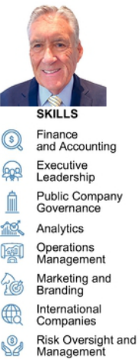

Age: 74 — is a retired executive of Wells Fargo and during his 40-year tenure held numerous senior leadership positions within that organization. The Company has concluded, based in part on Mr. Ostler should serve as a director.

Committees:

- Audit (Chair)*, Compensation

Business Experience

- Leadership positions within Wells Fargo, including: Group Executive Vice President, Wells Fargo & Co., Vice Chairman, Wells Fargo Bank California NA, President, Wells Fargo Family Wealth, Vice Chairman in the Office of the President, Chief Financial Officer, Chief Auditor, Head of Retail Branch Banking, Head of Information Technology, Head of Institutional and Personal Investments and Head of Internet Services

- Served on the Senior Management Committee of Wells Fargo for over 25 years

Public Directorships During Past Five Years

- Director, McClatchy Company, a media company (NYSE: MNI) (2013 - 2020)

Other Directorships

- Advisory Director Emeritus, FTV Capital, a private global investment company

Other Relevant Experience

  - Director's Advisory Council, Scripps Institution of Oceanography

* Audit committee financial expert under applicable SEC rules and regulations.

24

Table of Contents

OUR BOARD OF DIRECTORS

Vikram S. Pandit

Director since October 2018 Independent
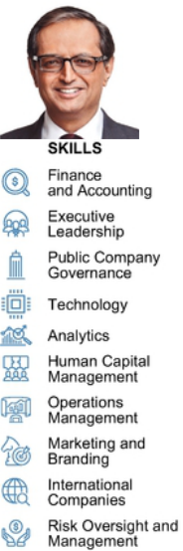

Age: 64 — is Chairman and Chief Executive Officer of The Orogen Group, which makes significant long-term strategic investments in financial services companies and related businesses. Mr. Pandit's business experience and directorships are detailed below. Mr. Pandit was appointed to the Board pursuant to the terms of the Investment Agreement. The Company has concluded, based in part on Mr. Pandit's more than 30 years of experience in the financial services industry, including his experience as Chief Executive Officer and a member of the board of directors of Citigroup Inc. (NYSE: C), that Mr. Pandit should serve as a director.

Committees:

- Audit; Nominating and Governance

Business Experience

- Chairman and Chief Executive Officer, The Orogen Group LLC (July 2016 - present)

- Chairman, TGG Group (February 2014 - June 2016)

- Chief Executive Officer, Citigroup Inc. (December 2007 - October 2012)

Public Directorships During Past Five Years

- Director and member of the nominating and governance and finance committees, Virtusa Corporation (NASDAQ: VRTU) (2017 - 2021)

- Lead Independent Director, chair of the human resources and compensation committee and member of the corporate governance and nominating committee, former member of the audit committee, Bombardier Inc. (TSX: BBD) (2014 - present)

Other Relevant Experience

- Director, Citigroup Inc. (December 2007 - October 2012)

- Chairman, Fair Square Financial Holdings (2017 - present)

- Director, Westcor Land Title Insurance Company (2020 - present)

- Chairman, JM Financial Credit Solutions Ltd. (2014 - present)

- Member of the Board of Overseers of Columbia Business School

- Member of the Board of Visitors of Columbia School of Engineering

- Member of the Board of Trustees of Columbia Business School until 2016

25

Table of Contents

OUR BOARD OF DIRECTORS

Kristy Pipes

Director since January 2021 Independent
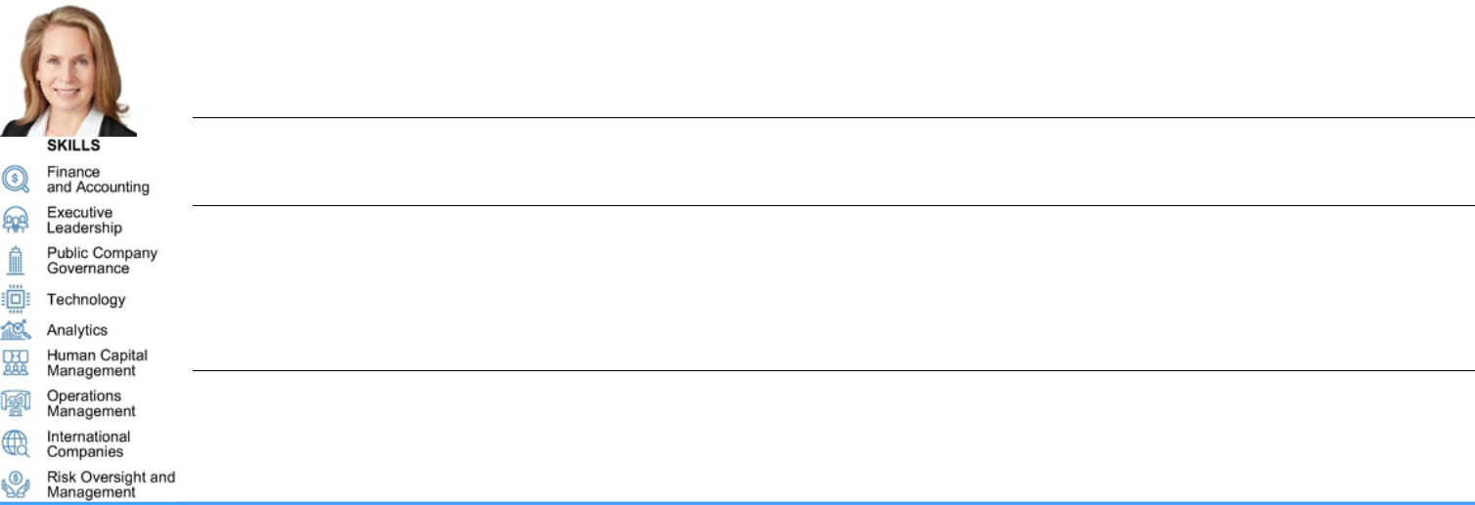

Age: 61 — is a leader in the consulting and financial services industry. Ms. Pipes's business experience and directorships are detailed below. The Company has concluded, based in part on Ms. Pipes's experience as the Chief Financial Officer and as a member of the Management Committee of Deloitte Consulting, LLP and her expertise in the consulting and financial services industry that Ms. Pipes should serve as a director.

Committees:

- Audit; Compensation

Business Experience

- Chief Financial Officer, member of the Management Committee and various leadership positions, Deloitte Consulting LLP, a management consulting firm (1999 - 2019)

- Vice President and Manager, Finance Division, Transamerica Life Companies (1997 - 1999)

- Senior Vice President and Chief of Staff for the President and CEO, among other senior management positions, First Interstate Bank of California (1985 - 1996)

Public Directorships During Past Five Years

  - Director and chair of the audit committee, and member of the nominating/corporate governance committee, PS Business Parks, Inc. (NYSE: PSB), a commercial property real estate investment trust (2019 - present)

  - Director and chair of the audit committee, and member of the nominating/corporate governance committee, Public Storage (NYSE: PSA) an international self storage company (2020 - present)

* Audit committee financial expert under applicable SEC rules and regulations.

26

Table of Contents

OUR BOARD OF DIRECTORS

Nitin Sahney

Director since January 2016 Independent
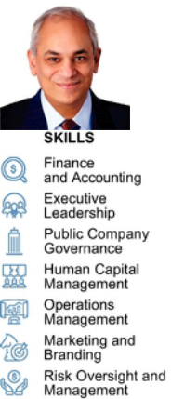

Age: 58 — Is a leader in the healthcare industry with over 25 years of experience across all areas of healthcare. Mr. Sahney's business experience and directorships are detailed below. The Company has concluded, based in part on Mr. Sahney's experience as CEO of Pharmacord and Omnicare, Inc. and his expertise in the healthcare industry garnered from more than two decades of experience, that Mr. Sahney should serve as a director.

Committees:

- Nominating and Governance (Chair), Audit

Business Experience

- Founder, Member-Manager and Chief Executive Officer, Pharmacord, LLC, a company that helps biopharma manufacturers address product access hurdles (2016 - present)

- Operating Advisor, Clayton Dubilier & Rice Funds, a private equity firm (2016 - 2017)

- President and CEO (2014 - 2015) and President and COO (2012 - 2014) of Omnicare Inc., a former New York Stock Exchange-listed Fortune 500 company in the long-term care and specialty care industries

- Manager of a healthcare investment fund (2008 - 2010)

- Founder and CEO of RxCrossroads, a specialty pharmaceutical company (2001 - 2007)

- Prior leadership positions with Cardinal Healthcare, a global healthcare services and products company

Public Directorships During Past Five Years

- Director, Option Care Enterprises, Inc. (NASDAQ: OPCH) (2019 - present)

Other Relevant Experience

- Member of the Board of Trustees, University of Louisville (2017 - 2019)

27

Table of Contents

OUR BOARD OF DIRECTORS

Garen K. Staglin

Director since June 2005 | Chairman of the Board since February 2014 Independent
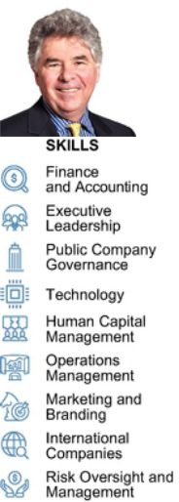

Age: 76 — has over 45 years of experience in the financial services and technology industries. Mr. Staglin's business experience and directorships are detailed below. The Company has concluded, based in part on Mr. Staglin's experience in the financial services and technology industries and his past experience as a member of public company boards of directors, that Mr. Staglin should serve as a director.

Committees:

- Compensation, Nominating and Governance

Business Experience

- Chief Executive Officer of eONE Global LP, an emerging payments company (2001 - 2004)

- Chief Executive Officer of Safelite Auto Glass, a provider of glass claim solutions (1993 - 1999)

Public Directorships During Past Five Years

- Director, chairman of the compensation and member of the governance and risk committees, SVB Financial Group (NASDAQ:SIVB), a financial services provider (2011 - present)

Other Directorships

- Senior Advisor and Advisory Director, FTV Capital, a private global investment company (2004 - present)

- Vice Chairman, Profit Velocity Solutions, a manufacturing analytics firm (2007 - present)

- Chairman, Nvoicepay, Inc. an electronic payment service provider (2010 - 2019)

- Advisory Director, Specialized Bicycle, a manufacturer of cycling equipment (1995 - 2014)

- Other directorships completed prior to 2015 include: Bottomline Technologies, a provider of payment and invoice automation software and services (2007 - 2012); Solera Holdings, a public automotive insurance software service provider (2005 - 2011); First Data Corporation, a payments solutions provider (1992 - 2003); and Global Document Solutions, a private document processing outsourcing company (2005 - 2010).

Other Relevant Experience

- Co-Founder and Co-Chairman, One Mind (1995 - present)

- Founder and Co-Chairman, Healthy Brains Financing Initiative (2019 - present)

- Member of the Stewardship Board, World Economic Forum (2019 - present)

- Co-Chairman, UCLA Centennial Capital Campaign (2014 - 2019)

28

Table of Contents

OUR BOARD OF DIRECTORS

Jaynie M. Studenmund

Director since September 2018 Independent
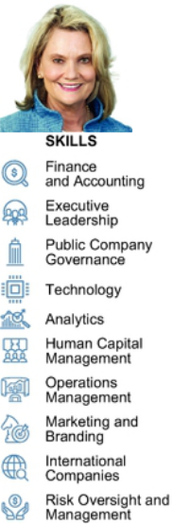

Age: 66 — is a seasoned executive with significant experience as a top line executive leading financial services and digital companies. She also has extensive experience as a public company director. Ms. Studenmund's business experience and directorships are detailed below. The Company has concluded, based in part on Ms. Studenmund's extensive public company board experience, together with her knowledge and experience in the digital, financial services, health care and consumer business sectors, and her expertise in compensation and corporate governance, that Ms. Studenmund should serve as a director.

Committees:

- Compensation (Chair), Audit*

Business Experience

- Chief Operating Officer, Overture Services, a pioneer in paid search and search engine marketing (2001- 2004)

- President & Chief Operating Officer, PayMyBills, the leading consumer bill payment and presentment company (1999 - 2001)

- Previously for over two decades served as Executive Vice President and Head of Consumer and Business Banking for three of the nation's largest banks at the time and primarily for First Interstate of California. Today, these three banks form the backbone of Chase's and Wells Fargo's consumer business in California following the era of bank consolidation.

Other Relevant Experience

- Director and chair of the compensation committee and member of the risk management committee, Pacific Premier Bancorp (Nasdaq: PPBI) (2019 - present)

- Director and chair of the compensation committee and member of the nomination and governance committee, CoreLogic, Inc. (NYSE: CLGX) (2012 - present)

- Director and member of the contracts committee, audit committee and nomination and governance committee, Western Asset Management funds (2004 - present), a major global fixed income fund, and director of affiliated funds for Western Asset Management

- Director, compensation committee chair and member of the compliance committee, Pinnacle Entertainment (Nasdaq: PNK) until its acquisition in 2018 (2012 - 2018)

- Director, compensation committee chair and member of the audit committee, Lifelock (Nasdaq: LOCK) until its acquisition in 2017 (2015 - 2017)

Other Relevant Experience

  - Board Leadership Fellow, National Association of Corporate Directors

  - Life trustee and board chair, Huntington Hospital

  - Founder and board member, Enduring Heroes Foundation

* Audit committee financial expert under applicable SEC rules and regulations.

29

Table of Contents

CORPORATE GOVERNANCE

CORPORATE GOVERNANCE

DIRECTOR INDEPENDENCE

In determining director independence, the board of directors considered the transactions and relationships set forth below under "Certain Relationships and Related Person Transactions — Related Party Transactions" and routine service arrangements between the Company and each of Fair Square Financial ("FSF") and Virtusa Corporation ("Virtusa"). During fiscal year 2020, one of our directors,

Mr. Pandit, served as a non-executive director and, through his ownership in The Orogen Group (see below for information on Mr. Pandit's relationship with The Orogen Group), owned an immaterial indirect equity interest, in each of FSF and Virtusa; Mr. Pandit is not a partner, controlling shareholder or executive officer of either FSF or Virtusa. Based on its review of all applicable relationships, our board of directors has determined that all of the members on our board of directors, other than Mr. Kapoor, meet the independence requirements of the Nasdaq Stock Market and federal securities laws.

MEETING ATTENDANCE

We expect our directors to attend all board of directors meetings and meetings of committees on which they serve. We also expect our directors to spend sufficient time and meet as frequently as necessary to discharge their responsibilities properly. Each director attended at least 75% of the aggregate meetings of our board of directors and the committees on which they served during 2020. It is our policy that all of our directors should attend our Annual Meetings of Stockholders absent exceptional cause, and all of our then-incumbent directors attended the 2020 Annual Meeting of Stockholders.

Board and Committee Meetings in 2020
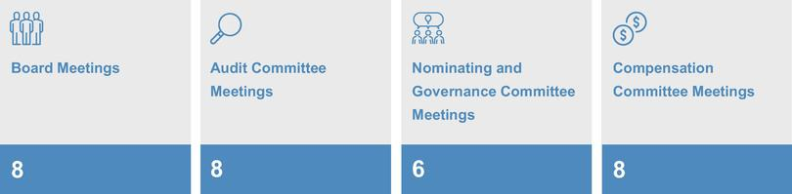

30

Table of Contents

CORPORATE GOVERNANCE

CORPORATE GOVERNANCE FRAMEWORK

The board is responsible for providing governance and oversight over the effectiveness of policy and decision-making with respect to the strategy, operations and management of EXL, in order to enhance our financial performance and stockholder value over the long term.

Our board's commitment to strong corporate governance is informed by the five core values of our corporate culture: innovation, respect, integrity, excellence and collaboration. Our board seeks to maintain best practices in corporate governance by reviewing and updating our governance policies, as appropriate, at least annually, and provides oversight over our risk management and strategic planning, as relates to our growth, human capital management, and environmental, social and governance matters, each as discussed further below.
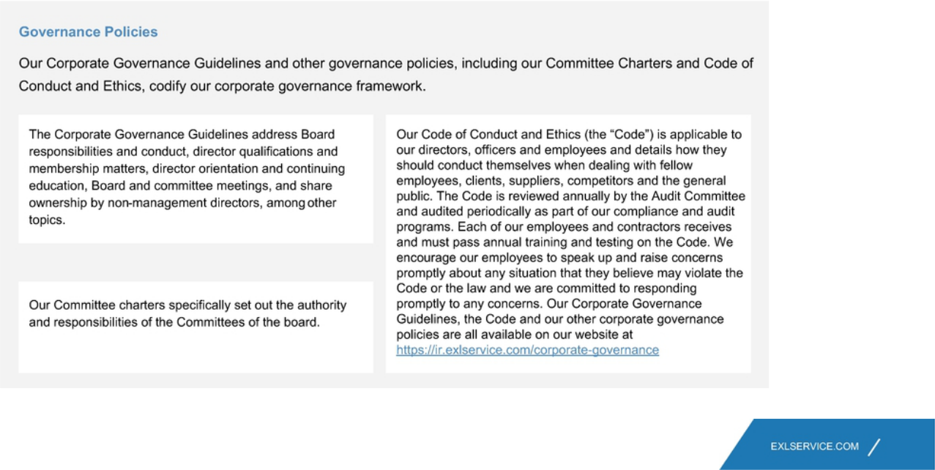

31

Table of Contents

CORPORATE GOVERNANCE

BEYOND THE BOARD ROOM
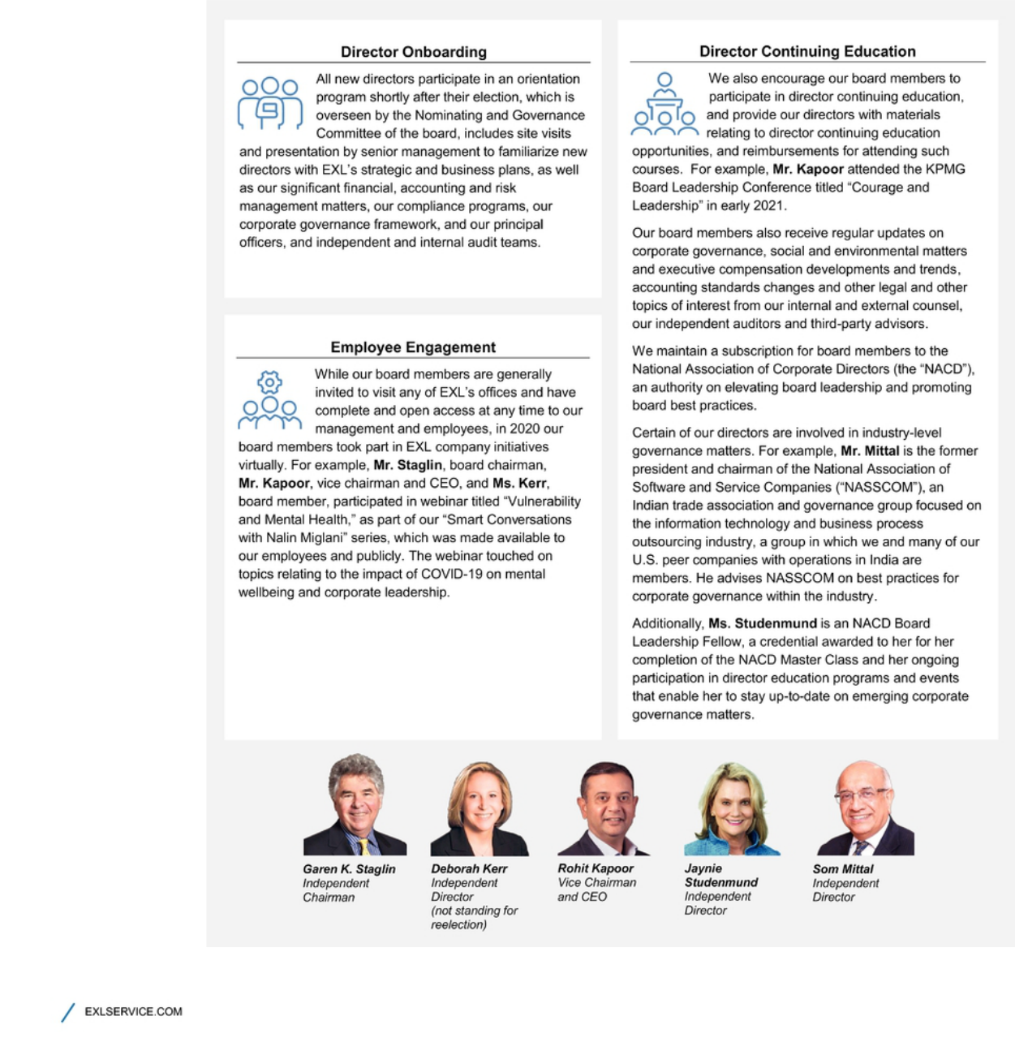

32

Table of Contents

CORPORATE GOVERNANCE

BOARD LEADERSHIP STRUCTURE

Our board of directors is currently led by Garen K. Staglin, our Chairman, and Rohit Kapoor, our Vice Chairman and CEO.

Our by-laws provide that our Chairman or, in the absence of our Chairman, our Lead Director (if there is a Lead Director serving at such time), or in the absence of both our Chairman and Lead Director, our CEO, calls meetings of our board of directors to order and acts as the chairman for those board meetings. In the absence of our Chairman, our Lead Director (if there is a Lead Director serving at such time), and our CEO, a majority of our directors present may elect as chairman of the meeting any director present. Independent directors meet at least quarterly in executive session without any management directors or members of the Company's management present. Our Corporate Governance Guidlines provide that in the absence of our Chairman, our Lead Director (if there is a Lead Director serving at such time) or, in the absence of the Lead Director, a director chosen by the directors meeting in executive session, presides at all executive sessions.

Consolidating the Vice Chairman and CEO positions allows our CEO to contribute his experience and perspective regarding management and leadership of the Company towards the goals of improved corporate governance and greater management accountability. In addition, the presence of our Chairman ensures that the board can retain sufficient delineation of responsibilities, such that our Chairman and our Vice Chairman and CEO may each successfully and effectively perform and discharge their respective duties and, as a corollary, enhance our prospects for success. As a result, the Company will benefit from the ability to integrate the collective leadership and corporate governance experience of our Chairman and our Vice Chairman and CEO, while retaining the ability to facilitate the functioning of the board of directors independently of our management and to focus on our commitment to corporate governance.

For the foregoing reasons, our board of directors has determined that its leadership structure is appropriate and in the best interests of our stockholders at this time.

33

Table of Contents

CORPORATE GOVERNANCE

DIRECTOR QUALIFICATIONS, REFRESHMENT AND EVALUATIONS

Director Qualifications
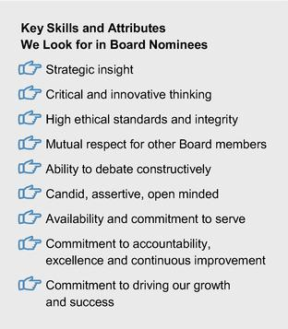

The board of directors considers it paramount to achieving excellence in corporate governance to assemble a board of directors that, taken together, has the breadth of skills, qualifications, experience and attributes appropriate for functioning as the board of directors of our Company and working productively with management. The Nominating and Governance Committee of the board is responsible for recommending nominees who are qualified and bring a diverse set of skills and qualifications to oversee the Company effectively.

The Nominating and Governance Committee has not formally established any minimum qualifications for director candidates, but pursuant to our Corporate Governance Guidelines, our board of directors seeks members from diverse professional and personal backgrounds who combine a broad spectrum of experience and expertise with a reputation for integrity. The Nominating and Governance Committee assesses each director candidate's independence, diversity (including age, ethnicity, race and gender, among others), skills and experience in the context of the needs of the board of directors. The Nominating and Governance Committee considers a number of factors in selecting director candidates, including, among others: ethical standards and integrity; independence; diversity of professional and personal backgrounds; skills and experience; other public company directorships; and financial literacy and expertise; communication skills; and ability and willingness to comply with Company policies and procedures.

34

Table of Contents

CORPORATE GOVERNANCE

In light of our business, the primary areas of experience, qualifications and attributes typically sought and put forward by the Nominating and Governance Committee in director candidates include, but are not limited to, the following:
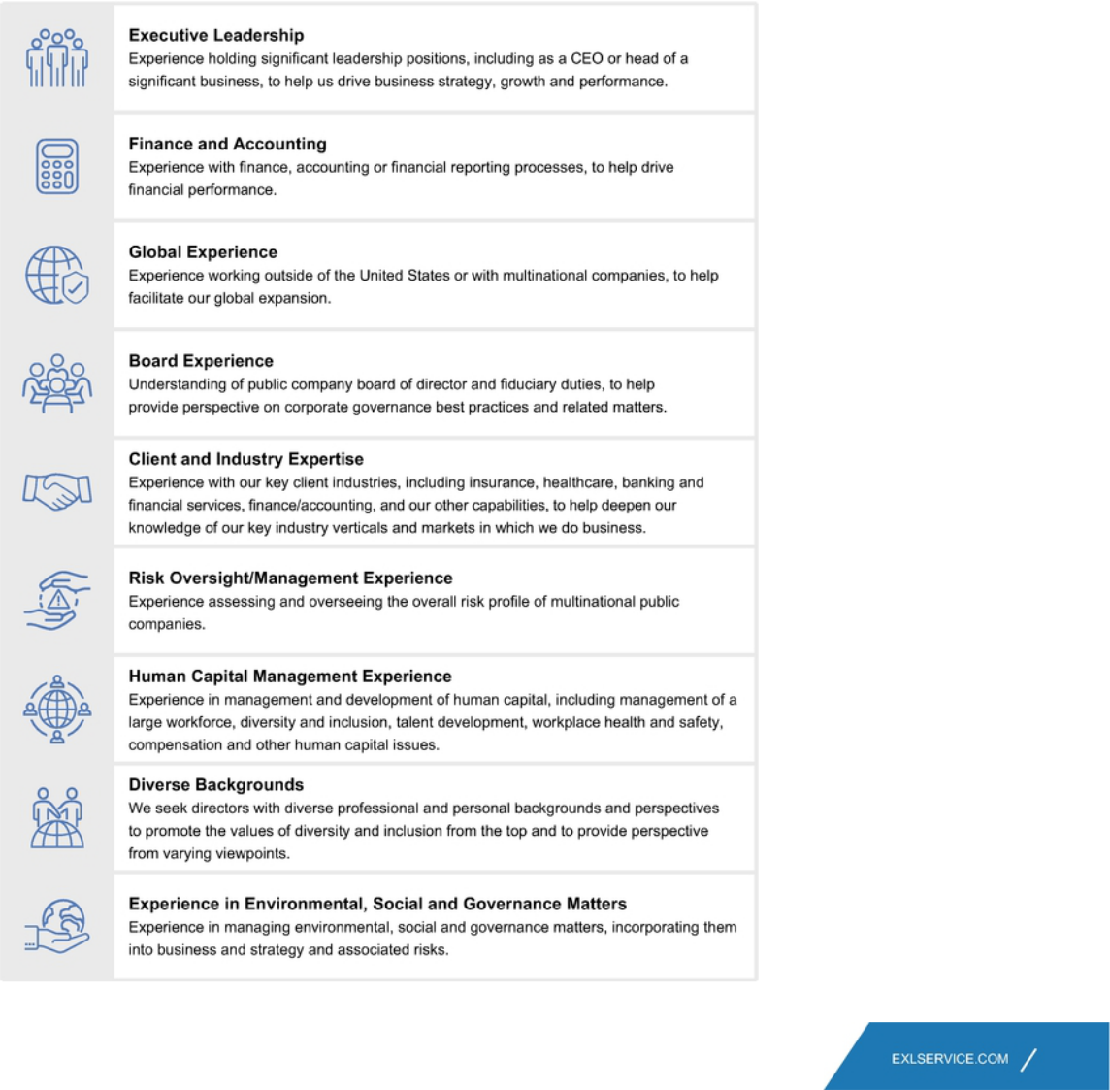

35

Table of Contents

CORPORATE GOVERNANCE

REFRESHMENT
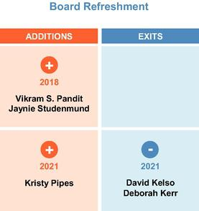

Our Nominating and Governance Committee regularly considers the size and composition of our board on a continual basis with an aim toward creating a balanced board with extensive experience and institutional knowledge, and fresh perspective and insight.

Considerations include whether the composition of the board of directors includes sufficient diversity and independent skill sets and background as appropriate for our immediate and long-term strategic needs. These considerations are also informed by discussions with our investors through stockholder engagement. In terms of diversity, our board is 57% diverse in terms of gender and 57% diverse in terms of ethnic/racial diversity.

In considering board composition, our Nominating and Governance Committee also considers the length of tenure of the directors as a whole. Over the past four years, we have added three new directors, and following the Annual Meeting, will have the following balance of tenures:
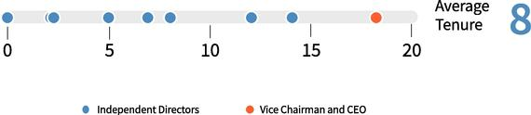

While the Company does not maintain term limits, our Corporate Governance Guidelines provide that the expectations for new directors is a maximum term of ten years. The board actively manages board refreshment and succession planning. The board expects that over the next few years, three to four longer tenured directors may retire. The Nominating and Governance Committee will identify successors based on the goal of maintaining the board's overall balance of experience and perspective. A recommendation regarding board composition is shared with the full board of directors on an annual basis.

36

Table of Contents

CORPORATE GOVERNANCE

Board Refreshment Process:
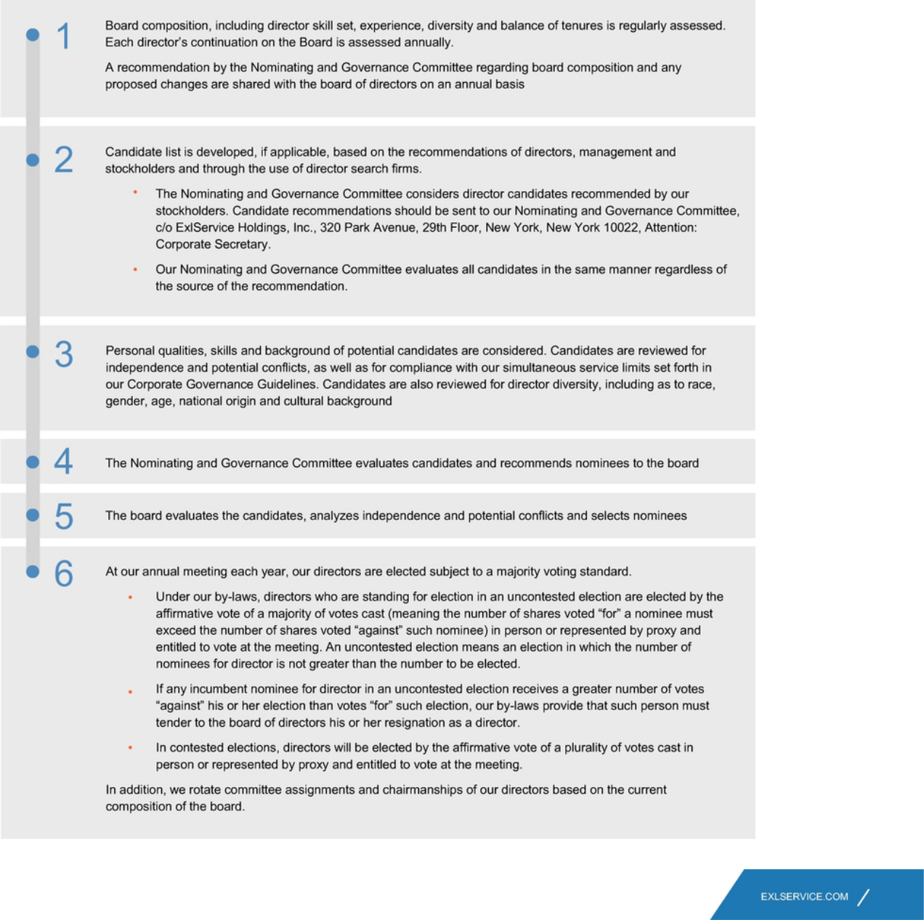

37

Table of Contents

CORPORATE GOVERNANCE

Board Evaluations

We consider the continued effectiveness of the board and its committees as critical to our long-term success and stockholder value. The board evaluates its performance and the performance of it committees and each director on an annual basis through the following process:
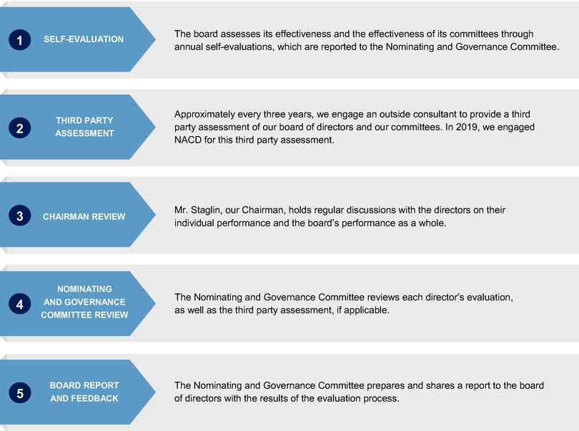

COMMITTEES

Our board of directors currently has three standing committees: the Audit Committee, the Nominating and Governance Committee and the Compensation Committee. As discussed above, our board of directors has determined that each member of the Audit, Nominating and Governance and Compensation Committees meets the independence and experience requirements of the Nasdaq Stock Market and federal securities laws. Copies of our committee charters can be found on the Investor Relations page of our website at: https://ir.exlservice.com/corporate-governance. Information on our website referred to in this proxy statement does not constitute a part of this proxy statement.

38

Table of Contents

CORPORATE GOVERNANCE

The following table sets forth the current chairs and members of each standing committee of the board of directors.
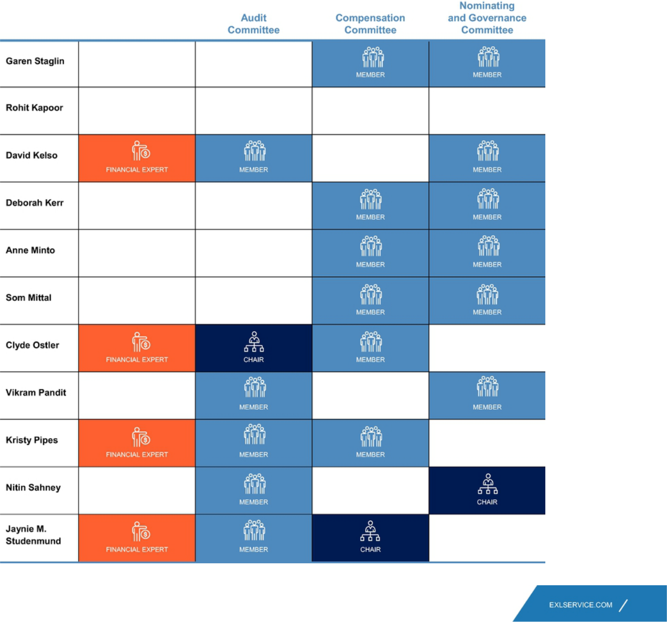

39

Table of Contents

CORPORATE GOVERNANCE

Audit Committee

Our Audit Committee oversees and assists our board of directors in fulfilling its oversight responsibilities with respect to our accounting and financial reporting processes, including the integrity of the financial statements and other financial information provided by us to our stockholders, the public, stock exchanges and others; our compliance with legal and regulatory requirements; our independent registered public accounting firm's qualifications and independence; the audit of our financial statements; the performance of our internal audit function and independent registered public accounting firm; and the Company's cyber security program and cyber strategy-related risks. Our Audit Committee's risk oversight is discussed below beginning on page 43. Our Audit Committee charter permits the committee to form and delegate authority to subcommittees when appropriate, provided that the subcommittees are composed entirely of directors who satisfy the applicable requirement of federal securities laws as well as independence requirements of the Nasdaq Stock Market.
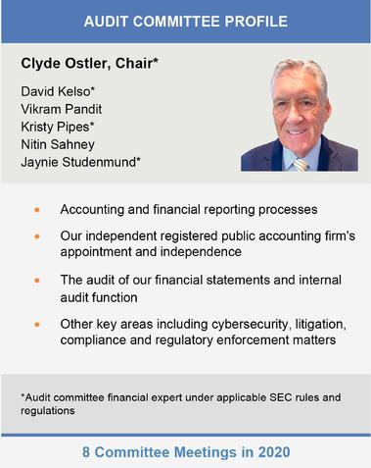

Our Audit Committee has direct responsibility for the appointment, compensation, retention (including termination) and oversight of our independent registered public accounting firm, and our independent registered public accounting firm reports directly to our Audit Committee. Our Audit Committee also reviews and approves specified related-party transactions as required by the rules of the Nasdaq Stock Market, and oversees the Company's cyber security program and cyber strategy-related risks. The Audit Committee was established in accordance with Section 3(a)(58)(A) of the Securities Exchange Act of 1934 (the "Exchange Act"). Our Audit Committee annually reviews and assesses the adequacy of the Audit Committee charter and its own performance.

The members of our Audit Committee are appointed by our board of directors. All members of our Audit Committee must also be recommended by our Nominating and Governance Committee.

40

Table of Contents

CORPORATE GOVERNANCE

Nominating and Governance Committee

Our Nominating and Governance Committee is responsible for: (i) identifying and recommending candidates for election to our board of directors using selection criteria approved by our board of directors and overseeing board refreshment, and committee membership, (ii) developing and recommending to our board of directors Corporate Governance Guidelines and other board procedures that are applicable to us, (iii) overseeing our board of director and management evaluations and our director education program, and (iv) overseeing our ESG goals, policies and practices. Our Nominating and Governance Committee Charter permits the committee to form and delegate authority to subcommittees when appropriate, provided that the subcommittees are composed entirely of directors who satisfy the applicable independence requirements of the Nasdaq Stock Market. Until December 31, 2020, Mr. Kelso was the chair of the Nominating and Governance Committee. Mr. Sahney became the chair of the Nominating and Governance Committee on January 1, 2021.
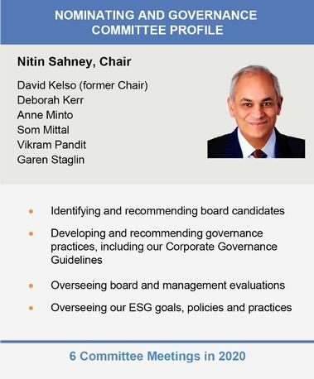

Our Nominating and Governance Committee reviews written and oral information provided by and about candidates and considers any additional criteria it feels is appropriate to ensure that all director nominees possess appropriate skills and experience to serve as a member of our board of directors.

Aside from its role in assessing the board, its committees and individual director effectiveness described above, our Nominating and Governance Committee, together with the Compensation Committee, provides annual reports on our CEO's performance in respect of certain goals and objectives set by the Nominating and Governance Committee and the board. Pursuant to its charter, the Nominating and Governance Committee is responsible for developing, annually reassessing and making recommendations to the board with respect to succession plans for our CEO and other key executive officers of the Company, and preparing contingency plans for interim CEO succession in the event of an unexpected occurrence for board review.

The Nominating and Governance Committee also oversees our director onboarding and training program, which provides new directors with training regarding the Company's policies and procedures and specific requirements that may be needed based on the director's committee memberships.

In addition, the Nominating and Governance Committee oversees and reviews the Company's ESG goals, policies and programs and the Company's corporate governance policies and practices regularly. Our Nominating and Governance Committee annually reviews and assesses the adequacy of the Nominating and Governance Committee charter and its own performance. The members of our Nominating and Governance Committee are appointed by our board of directors.

41

Table of Contents

CORPORATE GOVERNANCE

Compensation Committee

Our Compensation Committee reviews and recommends policies relating to compensation and benefits of our directors, officers and employees and is responsible for approving the compensation of our Vice Chairman and CEO and other executive officers. Our Compensation Committee also reviews, evaluates and makes recommendations to our board of directors with respect to our incentive compensation plans and equity-based plans and administers the issuance of awards under our equity incentive plans. Our Compensation Committee charter permits the committee to form and delegate authority to subcommittees when appropriate, provided that the subcommittees are composed entirely of directors who satisfy the applicable independence requirements of the Nasdaq Stock Market. Until December 31, 2020, Ms. Minto was the chair of the Compensation Committee. Ms. Studenmund became the chair of the Compensation Committee on January 1, 2021.
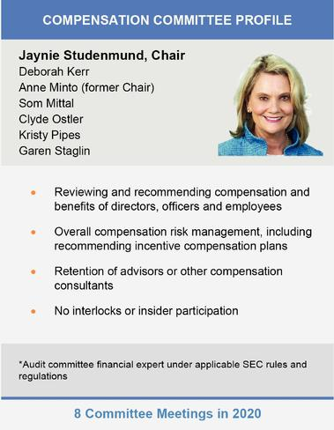

Our Compensation Committee charter also permits the committee to retain advisors, consultants or other professionals to assist the Compensation Committee to evaluate director, Vice Chairman and CEO or other senior executive compensation and to carry out its duties. For 2020, our Compensation Committee retained the services of Frederick W. Cook & Co., Inc. ("FW Cook"), a qualified and independent compensation consultant, to aid the Compensation Committee in performing its review of executive compensation including executive compensation benchmarking and peer group analysis. Our Compensation Committee also provides oversight with respect to diversity and equity matters as relate to compensation, including pay equity. Our Compensation Committee annually reviews and assesses the adequacy of the Compensation processes and procedures for considering executive compensation are addressed in the Compensation Discussion and Analysis below.

The members of our Compensation Committee are appointed by our board of directors. All new members of our Compensation Committee must be recommended by our Nominating and Governance Committee.

During 2020, none of our executive officers served as a member of the board of directors or compensation committee of any entity that has one or more executive officers who serve on our board of directors or Compensation Committee.

42

Table of Contents

CORPORATE GOVERNANCE

BOARD AND COMMITTEE OVERSIGHT OF RISK MANAGEMENT
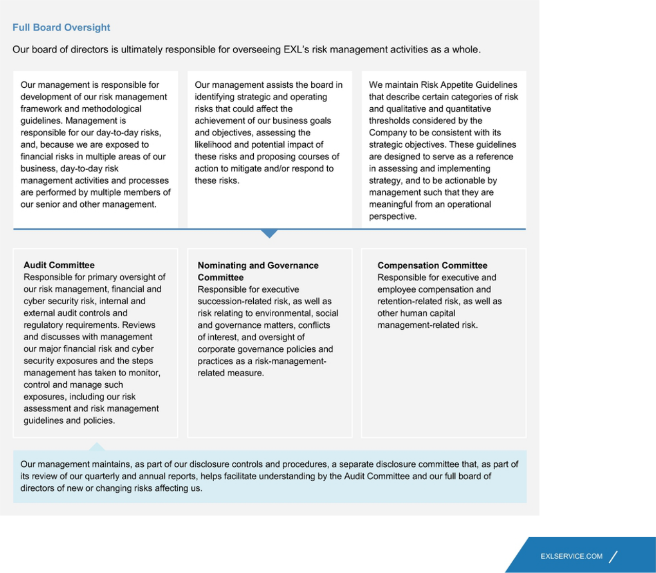

43

Table of Contents

CORPORATE GOVERNANCE

Cybersecurity Risk Management

We maintain a comprehensive program that focuses on information security, cybersecurity, data privacy and the protection of our clients' and their customers' confidential personal and sensitive information. Our Audit Committee has primary oversight and receives presentations throughout the year on cybersecurity-related risks and vulnerabilities and strategic policies and practices from management. At least once a year, the full board receives a report from management on the Company's readiness and capability to prevent, detect and respond to a cyber-attack.

We have invested in our information security and cyber security posture and protocols to support compliance with our contractual obligations and the laws and regulations governing our activities. These investments include people, processes and technology intended to protect information throughout its life cycle. Each of our employees receives and must pass annual, mandatory knowledge and awareness training and testing on risk mitigation and management and controls and procedures relating to information security, cybersecurity and data privacy.

EXL focuses on implementing and maintaining cybersecurity capabilities to identify, protect, detect, respond and recover from cyber threats, incidents and attacks; reduce vulnerabilities and minimize the impact of cyber incidents. We emphasize compliance and institutional governance built upon and supported by policies and processes, tools and technologies, and knowledge and awareness training. EXL takes into account guidance from relevant regulatory and governance bodies. For more details on our cybersecurity program, see "Sustainability — Cybersecurity at EXL" on page 56.

Environmental, Social and Governance ("ESG") Risk Management

Our board reviews and receives regular reports on ESG and sustainability risks, including those relating to employee safety, environmental-related efforts, human capital management matters, and corporate governance trends and best practices.

While the Nominating and Governance Committee is responsible for overseeing our risk management related to ESG matters generally, the other board Committees share in the responsibility with respect to certain matters within their purview. The Compensation Committee deals with certain human capital management matters relating to employee compensation and benefits, and the Audit Committee is involved in regulatory risks touching on ESG matters.

In 2021, we established a new management-level ESG steering committee, which is responsible for setting our sustainability/ESG strategy and risk management, keeping our management and board up-to-date on ESG-related developments, overseeing our internal and external disclosure on ESG matters, and providing implementation support across our Company. The ESG steering committee works in close coordination with the board, and provides the board with advice and assistance in its oversight of ESG risks and other matters. For more details on our ESG and sustainability-related efforts, see "Sustainability" on page 47.

44

Table of Contents

CORPORATE GOVERNANCE

Stockholder Engagement
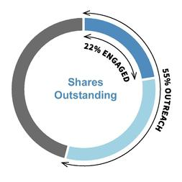

Our formal governance-focused stockholder outreach program commenced in late 2020, which we plan to take forward and expand in future years.

As of the date hereof, we offered to meet with stockholders representing approximately 55% of shares outstanding for discussions focusing on governance topics, and engaged with all stockholders that accepted our invitation, representing nearly 22% of shares outstanding. EXL was represented by our management, members of our legal and investor relationships teams, and board members at these meetings. One of our independent directors, Mr. Pandit, attended meetings with stockholders representing nearly 19% of shares outstanding.

Topics discussed included:

- Board composition and structure

- Executive compensation

- Effects of COVID-19

- Risk oversight

- Diversity, equity and inclusion efforts

- Environmental, social and governance efforts

EXL also regularly interacts and shares information with our stockholders through our quarterly earnings calls, investor meetings, SEC filings and publications on our website, among others.

The feedback received from our stockholders is shared with and reviewed by our board, which is used to inform and focus our decisions relating to our governance and sustainability practices and to improve our disclosure.

Communications with the Board

Stockholders interested in contacting our board of directors, our Chairman or any individual director are invited to do so by writing to:

Board of Directors of ExlService Holdings, Inc.

c/o Corporate Secretary
ExlService Holdings, Inc.
320 Park Avenue, 29th Floor
New York, New York 10022

45

Table of Contents

CORPORATE GOVERNANCE

All other stockholder communications addressed to our board of directors will be referred to our Chairman and tracked by our Corporate Secretary. Stockholder communications specifically addressed to a particular director will be referred to that director.

Complaints and concerns relating to our accounting, internal accounting controls or auditing matters should be communicated to our Audit Committee, which consists solely of non-employee directors.

Any such communication may be anonymous and may be reported to our Audit Committee through our General Counsel by writing to:

Audit Committee of the Board of Directors

ExlService Holdings, Inc.
320 Park Avenue, 29th Floor
New York, New York 10022
Attn: General Counsel

All such concerns will be reviewed under Audit Committee direction and oversight by our General Counsel, our Head of Internal Audit or such other persons as our Audit Committee determines to be appropriate. Confidentiality will be maintained to the fullest extent possible, consistent with the need to conduct an adequate review. Prompt and appropriate corrective action will be taken when and as warranted in the judgment of our Audit Committee. We prepare periodic summary reports of all such communications for our Audit Committee.

46

Table of Contents

SUSTAINABILITY

SUSTAINABILITY

In line with our mission of digging deeper to find a better way for our clients, at EXL we are committed to doing our part as a global citizen to build a better future for us all by operating in a responsible and sustainable manner. We believe that by integrating sustainable practices into our business model, working toward positive social change, and providing transparent reporting on those practices and our progress, we will best able to deliver long-term value to our stockholders while promoting and developing our business, people, communities and the world around us.

Recent Activities

In 2020 and continuing into 2021, we have taken a number of steps to continue improving and formalizing our sustainability program. These recent activities include:
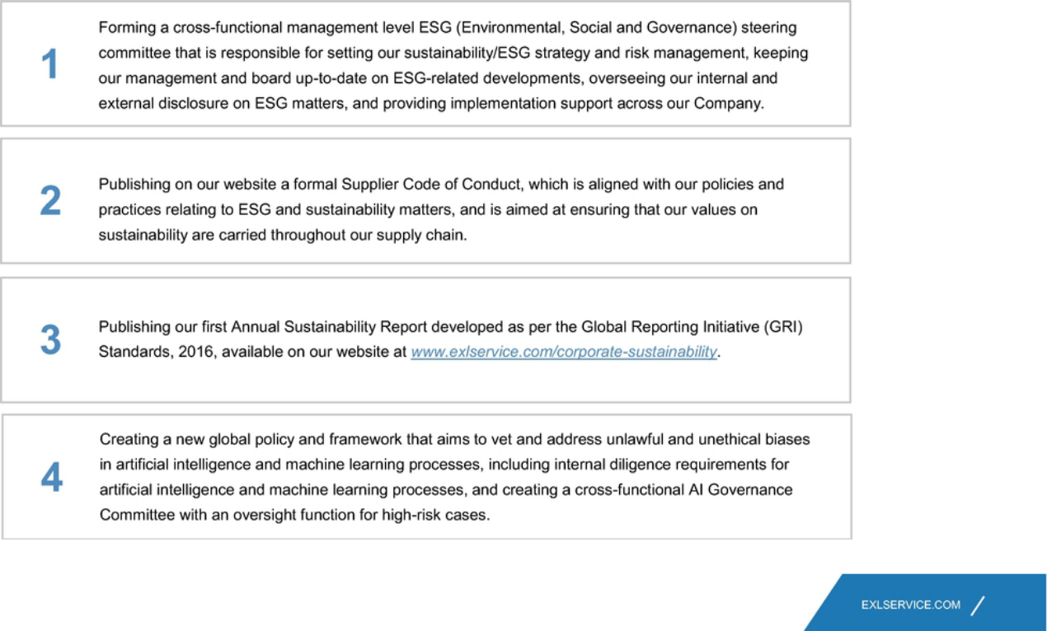

47

Table of Contents

SUSTAINABILITY
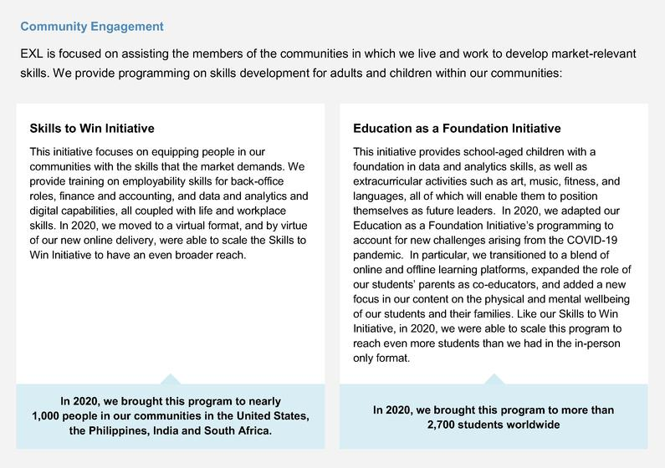

We support our employees' charitable efforts by enabling payroll giving, recognizing social impact through individual, geography and business unit awards, organizing social responsibility events in each region in which we operate and creating "volunteer weeks" that our employees can use for volunteer efforts.

We partner with non-profits and our clients to support corporate social responsibility initiatives, in education and skills, global health and disaster relief.

In 2020, we additionally focused on COVID-19 relief-related contributions through a global network of partners across seven of the countries in which we operate, reaching approximately 78,000 beneficifiaries.

48

Table of Contents

SUSTAINABILITY

Protecting our Planet

At EXL, we endeavor to keep the environmental impact of our operations to a minimum. We strive to continuously improve in our environmental stewardship, with a focus on energy conservation, minimizing waste, and developing green infrastructure and operations, all in order to reduce our carbon footprint across our global operations.

We have committed ourselves to year-on-year targets for reducing our environmental footprint our baseline numbers. We began this process in 2017, with respect to our India and Philipplines operations only, and began recording data and applying our year-on-year targets to our global operations using 2019 as a baseline. The targets, and our progress through 2019 with respect to our India and Philippines operations are as stated in the following table. We expect to report our global progress in our 2020 Annual Sustainability Report to be published during 2021.
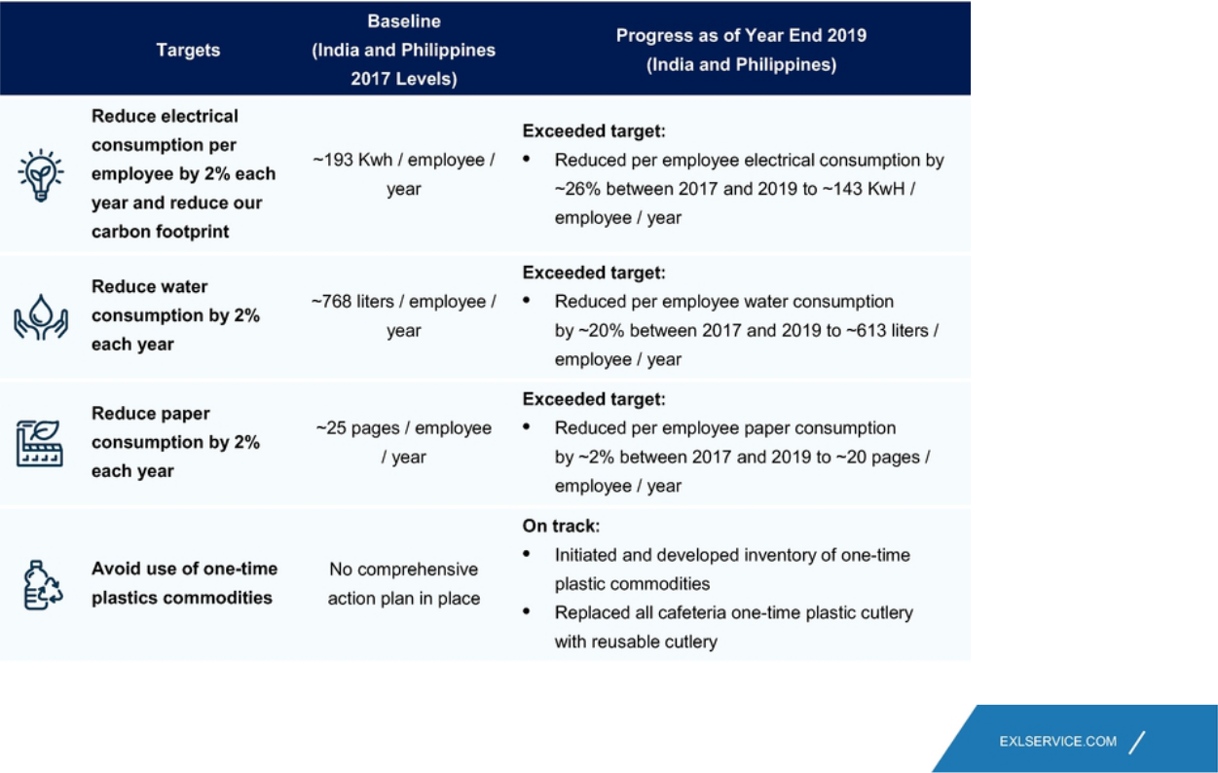

49

Table of Contents

SUSTAINABILITY
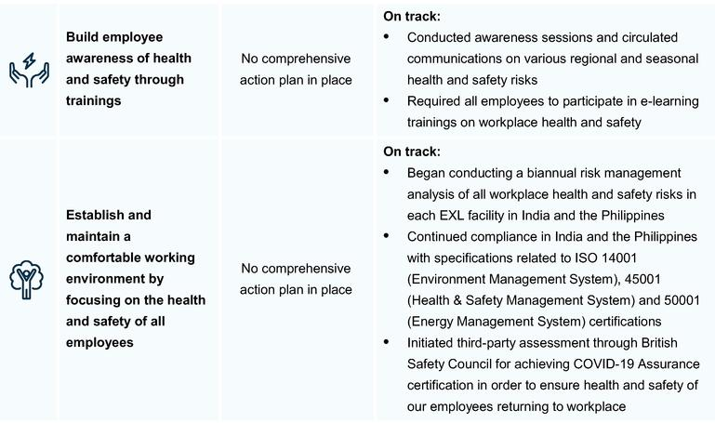

These goals are assessed by our Environment, Health and Safety team periodically, as well as third-party experts, and our progress is reported to our ESG steering committee, management and board for review. We report our progress toward these goals annually in our Annual Sustainability Report.

Sustainable Supply Chain

We conduct background investigations of all of our new suppliers to collect information on their policies and performance relating to economic and environmental matters, as well as human rights, data privacy, product safety and working conditions. Through our Supplier Standards of Conduct, we maintain the right to review our suppliers' practices in the future.

We seek to procure our materials from local suppliers, to the extent feasible.

Our supplier diversity programs ensure that suppliers of diverse backgrounds can participate in our procurement sourcing process and encourages engagement with suppliers owned by people belonging to minority groups, women, the gay, lesbian, bisexual and transgender community, and veterans, specially-abled people, and small business enterprises.

50

Table of Contents

SUSTAINABILITY

Supporting and Developing our People

Our people are our primary assets. The world we work and live in is full of diversity and powered by innovation. We believe success in such a world will come through an environment that embraces diversity of thought. In line with our core values, one of our principal priorities is promoting the talent of our employees while creating an inclusive work environment to permit us to leverage our employees' diversity and to deliver exceptional results for our clients. We have an active employee relations function to ensure that we regularly communicate with and understand our employees, and are able to swiftly respond to specific needs and concerns as they arise. We periodically conduct employee surveys to monitor our employee satisfaction and engagement, and take actions to address the results of such surveys.

EXL is made up of approximately 31,600 professionals (as of March 31, 2021) in locations throughout the United States, the United Kingdom, Europe, India, the Philippines, Colombia, Canada, Australia and South Africa.

EXL Locations
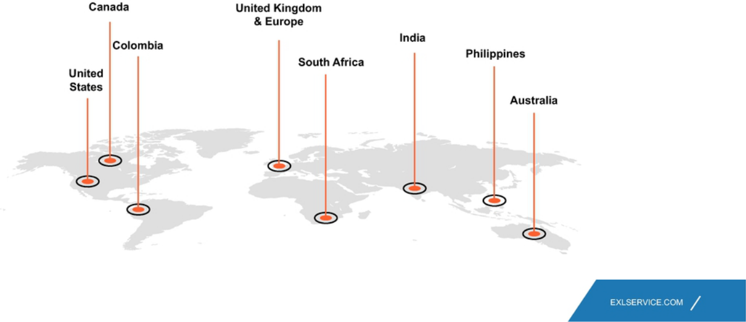

51

Table of Contents

SUSTAINABILITY

Diversity, Equity and Inclusion

Our Diversity and Inclusion Council consists of a global, diverse mix of leaders, provides inputs to the design of our diversity and inclusion program to bring in diverse perspectives, collaborates with external partners for customization inputs, conducts periodic reviews of the progress of our program and provides execution leadership for specific diversity initiatives.
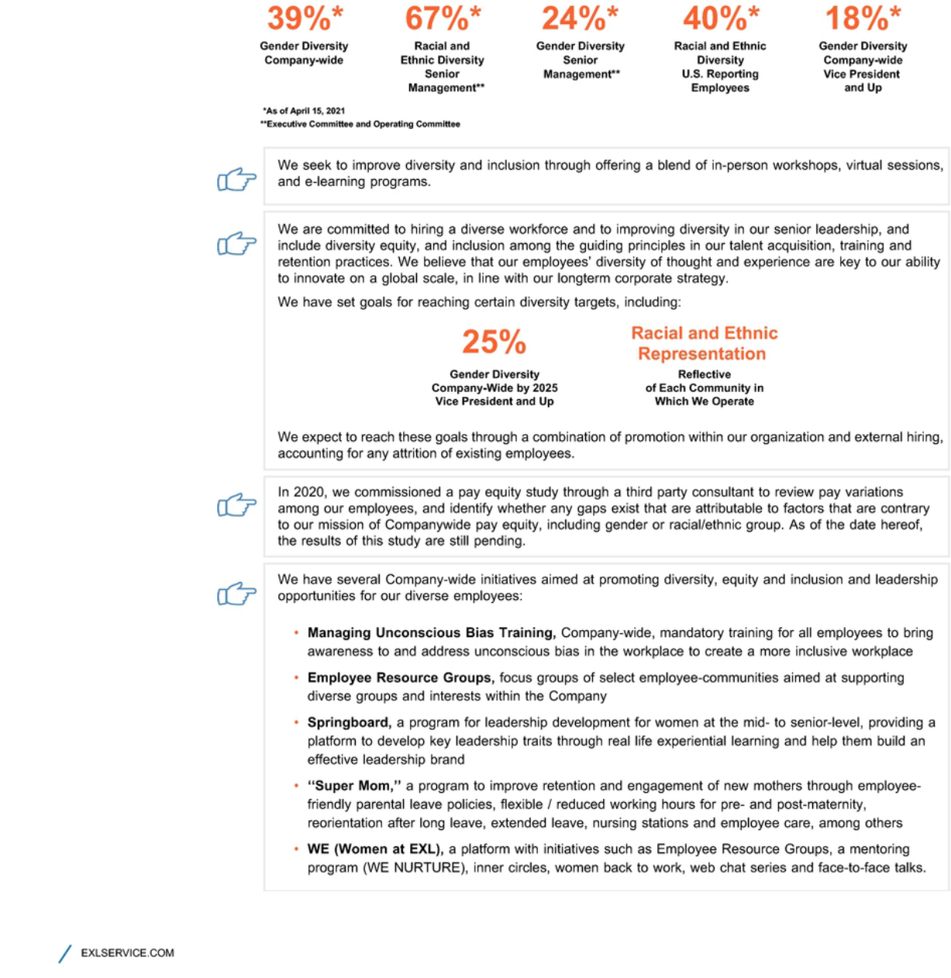

52

Table of Contents

SUSTAINABILITY
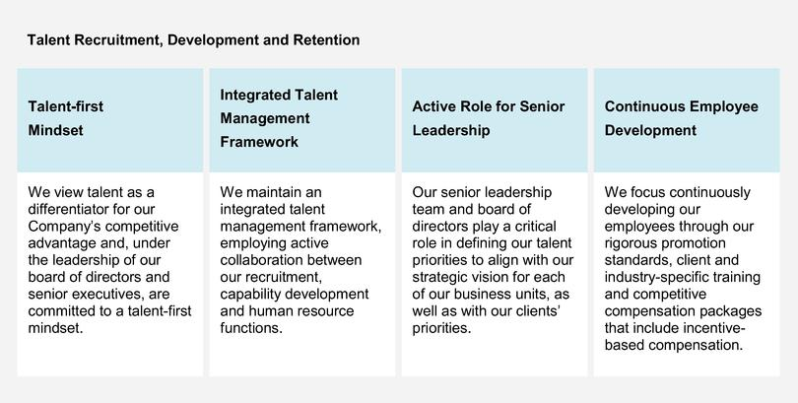

We have institutionalized a comprehensive set of practices, processes and programs to create an active learning culture and to build market-relevant talent within our Company in four stages:

- Prejoining: Assessments, development on online learning platforms

- Onboarding: Company orientation, trainings and informal team meetings

- Job Readiness: Education on client processes, tools and technologies, communication effectiveness and cultural sensitivity

- Ongoing Development: Continue formal learning activities, on the job, supervisor feedback and coaching, regular talent reviews and talent inventory succession, leadership training to identify and develop new leaders

Our capability development framework is focused on developing our employees' digital and domain expertise and leadership as a means to develop our talent internally. We do this through our learning academies, and through partnerships with industry organizations, institutes, business schools and consulting firms. In 2020, in light of COVID-19, we introduced a new capability ecosystem to deliver learning virtually from any location, at any time.

53

Table of Contents

SUSTAINABILITY

Academies
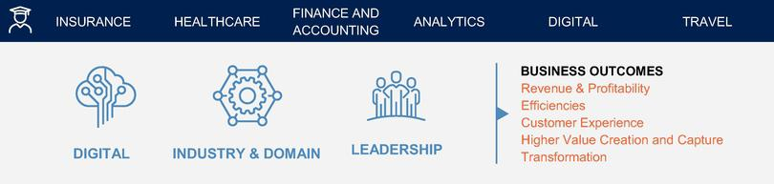

2020 Training

- 22,800 employees trained in digital methodologies and domain information

- 1.2 million hours spent by our employees on trainings

- 390,000 courses and certifications completed by our employees

- 260 employees trained and certified in "Leading in a Virtual Environment"

- 3,080 employees trained in analytics, artificial intelligence, cloud tools and technologies and data management

- 1,600 employees trained on agile and design thinking

- 42 trained on virtual selling capabilities

- 4,500 employees engaged in learning, research and internal projects when not enabled to work from home from April to August 2020

54

Table of Contents

SUSTAINABILITY

Benefits

Enhanced leave for employees impacted by COVID-19 and for employees receiving COVID-19 vaccines

Paid leave for U.S. new parents

Excused days of absence

Generous vacation policy

Paid holidays

Employee Assistance Program providing confidential counseling services

Our employees also participate in our success:

Annual bonuses or incentives: 100% of our employees are eligible to receive

401K plans with Company match: 100% of our U.S. employees are eligible to enroll within three months of their employment at EXL

Employee Health and Safety

In 2020, given COVID-19, approximately 92% of our employees worked from home. We took actions that focused on helping our employees, including:

- disseminating guidance and information to our employees regarding COVID-19-related health protocols

- facilitating work from home, including specific trainings on work from home best practices

- regular virtual town hall meetings, periodic CEO messaging, and virtual team building exercises

- various programs aimed at employee wellness, including a global wellness program

- broad travel restrictions and virtual-only events

- COVID-19-specific protocols for our essential employees whose jobs require them to be on-site or with our customers by implementing additional safety measures at all of our facilities, including increased frequency in cleaning and disinfecting, and enhanced hygiene and social distancing practices

55

Table of Contents

SUSTAINABILITY

Cybersecurity at EXL

We are committed to protecting the confidentiality, integrity, availability and privacy of the information assets of our clients and their customers, as well as our employees, vendors and any other third parties, that are provided to us and for which we are responsible and have developed robust information security and cybersecurity and data privacy controls, safeguards and enabling measures in accordance with applicable laws and regulations and information security standards.

We have implemented and maintain, and regularly improve upon, tools and capabilities to identify, protect, detect, respond and recover from cyber threats, incidents and attacks; reduce vulnerabilities; and minimize the impact from cyber incidents. We have an established culture of compliance around cybersecurity matters, and have a strong governance program built upon and supported by policies and processes, tools and technologies, and periodic knowledge and awareness training. Each of our employees receives and must pass annual, mandatory periodic knowledge and awareness training and testing on risk mitigation and management and controls and procedures relating to information security, cybersecurity and data privacy.

We comply with and/or are certified in the following standards:

SO 27001:2013 | PCI DSS 3.2.1 | SOX 404 / SSAE 16, |  | Hitrust Certification — | ISO22301
Global Information | Credit Card and | SOC 1 and SOC 2 | — | healthcare operations | Business Resiliency
Security Standard — | Payment Industry | Company-wide |  |  | Certification — India,
Company-wide | Certification — India, |  |  |  | Philippines and South
 | Philippines and South |  |  |  | Africa operations
 | Africa operations

For more information on our cybersecurity risk management, please see "Cybersecurity Risk Management" on page 44. For more information on our information security and data privacy procedures, please refer to our Sustainability Report, which is available on our website at www.exlservice.com/corporate-sustainability.

56

Table of Contents

SUSTAINABILITY
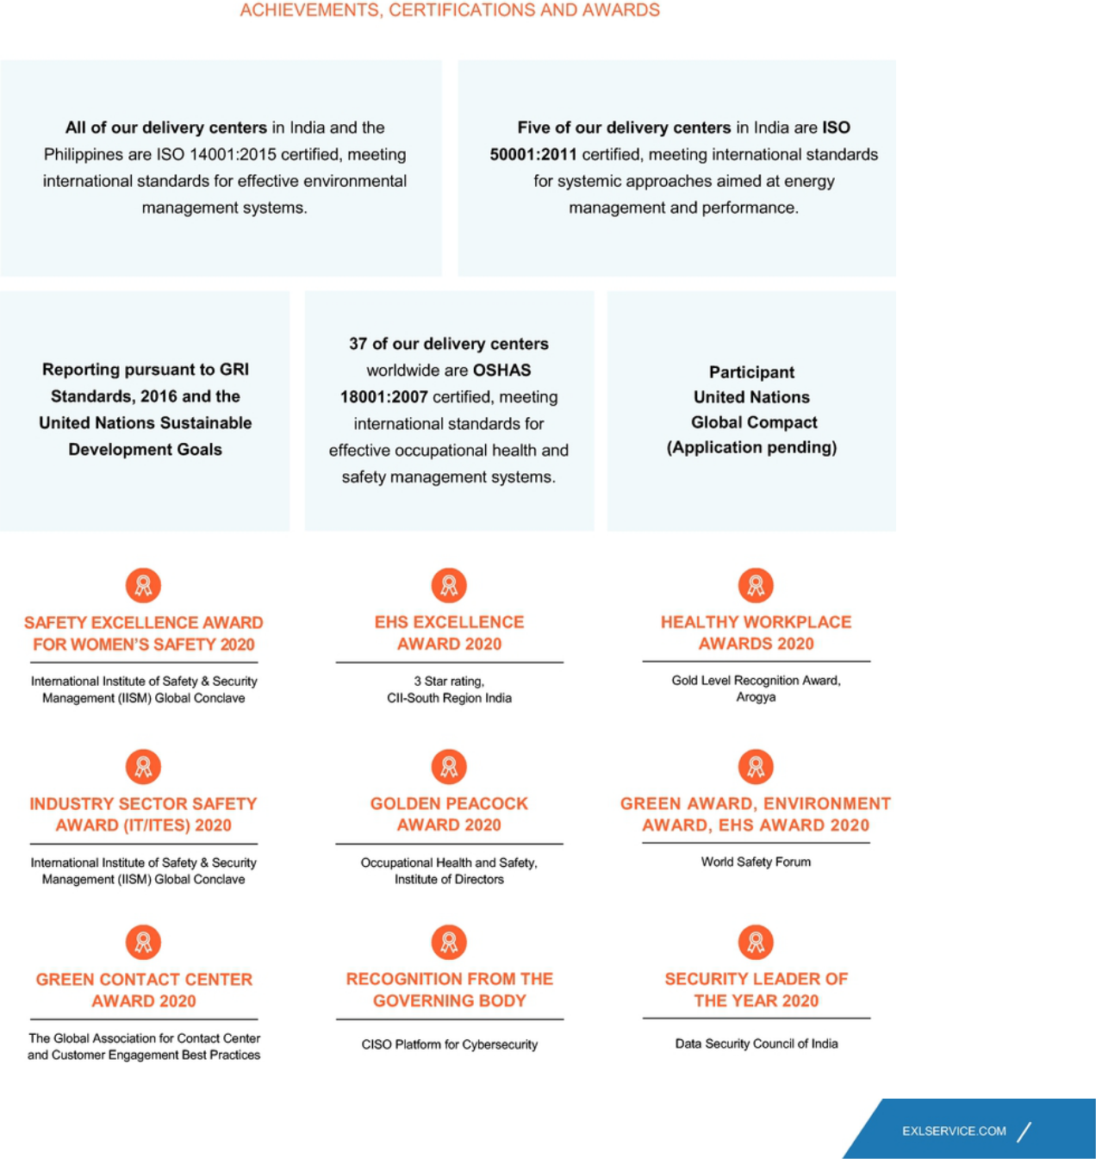

57

Table of Contents

SUSTAINABILITY

Environmental, Social and Governance Matters and Pay-for-Performance at EXL

A portion of our CEO's total compensation is tied to the achievement of specific performance goals relating to ESG matters. For more information, see "Detailed Review of Compensation Components — Incentive Bonus — Determination of Individual Performance Measure Achievement" on page 78.

Sustainability Oversight

For more information on our oversight of sustainability and ESG-related matters and risks, see "Environmental, Social and Governance Risk Management" on page 44.

Learn More about Sustainability and Environmental, Social and Governance Matters at EXL

Please visit www.exlservice.com/corporate-sustainability to learn more about our efforts toward sustainability and the impacts we are making on our communities and the environment. Information on our website referred to in this proxy statement does not constitute a part of this proxy statement.

58

Table of Contents

OUR EXECUTIVE OFFICERS

OUR EXECUTIVE OFFICERS

Rohit Kapoor (age 56) | Vice Chairman and CEO

See section entitled "Our Board of Directors" above.

Ajay Ayyappan (age 43) | Senior Vice President, General Counsel and Corporate Secretary

Mr. Ayyappan has served as our Senior Vice President, General Counsel and Corporate Secretary since December 2018 and our Vice President, Acting General Counsel and Corporate Secretary since August 2018. He previously served as Vice President, Deputy General Counsel and Assistant Secretary from April 2014 to August 2018 and Vice President and Assistant General Counsel from March 2007 to March 2014. Prior to joining us, Mr. Ayyappan was a corporate associate at the law firm of Morgan, Lewis & Bockius LLP.

Pavan Bagai (age 59) | President and Chief Operating Officer

Mr. Bagai has served as our President and Chief Operating Officer since April 2012, as our Chief Operating Officer from May 2008 to March 2012 and as Vice President, Head of Outsourcing Services of EXL India from June 2006 until April 2008. In addition, he served as our interim Chief Financial Officer from December 2019 through February 2020. He previously served as Vice President, Research and Analytics of EXL India from December 2004 to May 2006, as Vice President, Operations of EXL India from November 2003 to November 2004 and as Vice President, Strategic Businesses of EXL India from July 2002 to November 2003. Prior to joining us, Mr. Bagai served in various capacities in several business areas across markets in Europe and Asia, including India, at Bank of America beginning in 1985. Mr. Bagai is based in Delhi, India. On April 16, 2021, Mr. Bagai notified the Company that he will be retiring effective October 1, 2021.

Vikas Bhalla (age 49) | Executive Vice President and Business Head, Insurance

Mr. Bhalla has served as our Executive Vice President and Business Head, Insurance since January 2014 and as our Head of Outsourcing since November 2009. He previously served as Vice President, Operations of EXL India from June 2006 to October 2009 and as Vice President, Migrations, Quality and Process Excellence of EXL India from April 2002 to June 2006 and as Director, Quality Initiatives of EXL India from May 2001 to March 2002. From May 1998 to May 2001, Mr. Bhalla served in various capacities at General Electric, including as the Quality Leader and E-Business Leader for GE Plastics India. Mr. Bhalla is based in Delhi, India.

59

Table of Contents

OUR EXECUTIVE OFFICERS

Vivek Jetley (age 46) | Executive Vice President and Business Head, Analytics

Mr. Jetley has served as our Executive Vice President and Business Head, Analytics since January 2020. He previously served in various leadership roles with us, including heading enterprise strategy and setting up a strategic deal team. Mr. Jetley has been with EXL since 2006. Prior to joining us, Mr. Jetley was a Partner at Inductis.

Anita Mahon (age 52) | Executive Vice President and Chief Growth Officer

Ms. Mahon has served as our Executive Vice President and Chief Growth Officer since March 2020. Prior to joining us, Ms. Mahon served as Vice President, Data, Strategy & Portfolio Officer at IBM Watson Health, a business unit focused on developing cognitive and data-driven technologies to advance health. Ms. Mahon joined IBM in 2016 through its acquisition of Truven Health Analytics, a healthcare information and analytics business, where she served as Chief Strategy Officer. Prior to Truven, she held other leadership roles that placed her at the intersection of strategy, technology and analytics.

Samuel Meckey (age 50) | Executive Vice President and Business Head, Healthcare

Mr. Meckey has served as an Executive Vice President since November 2018 and as Business Head, Healthcare beginning in 2019. Prior to joining us, Mr. Meckey served as President of UnitedHealth Group's Optum Global Solutions and before that has held various executive roles at UnitedHealth Group, where he was employed from May 2004 to June 2018. Prior to joining UnitedHealth Group, Mr. Meckey was an officer and naval aviator in the United States Navy from May 1992 to August 2002.

Nalin Miglani (age 60) | Executive Vice President and Chief Human Resource Officer

Mr. Miglani has served as our Executive Vice President, Chief Human Resource Officer since December 2014. Mr. Miglani is responsible for the global human resources function at the Company. Prior to joining the Company, he was the Chief HR and Corporate Development Officer for Nutreco, based in Amsterdam, Netherlands, from March 2013 to November 2014. Mr. Miglani also served as the Chief HR and Communications Officer for Tata Global Beverages Company, London, UK, from June 2008 to February 2013. In addition, Mr. Miglani held various global and regional HR leadership roles around the world during his career at The Coca-Cola Company and British American Tobacco.

Maurizio Nicolelli (age 52) | Executive Vice President and Chief Financial Officer

Mr. Nicolelli has served as our Executive Vice President and Chief Financial Officer since February 2020. Prior to joining the Company, Mr. Nicolelli served as Senior Vice President and Chief Financial Officer of Casa Systems beginning in 2019. He previously served 23 years at FactSet Research Systems, where he was Senior Vice President, Principal and Chief Financial Officer from 2009 to 2018.

60

Table of Contents

 |  |  |  |  |  |  |  |  |  |  |  |  |  |  |  |  |  |  |  |  |  |  |  |  |  |  |  |  |  |  | EXECUTIVE COMPENSATION
EXECUTIVE COMPENSATION
COMPENSATION DISCUSSION AND ANALYSIS
Table of Contents
NAMED EXECUTIVE OFFICERS |  |  |  |  |  |  |  |  |  |  |  |  |  |  |  |  |  |  |  |  |  |  |  |  |  |  |  |  |  |  | 63
EXECUTIVE SUMMARY |  |  |  |  |  |  |  |  |  |  |  |  |  |  |  |  |  |  |  |  |  |  |  |  |  |  |  |  |  |  |  | 63
 | Select 2020 Financial and Business Highlights |  |  |  |  |  |  |  |  |  |  |  |  |  |  |  |  |  |  |  |  |  |  |  |  |  |  |  |  |  | 63
 | Total Stockholder Return |  |  |  |  |  |  |  |  |  |  |  |  |  |  |  |  |  |  |  |  |  |  |  |  |  |  |  |  |  |  | 64
 | Awards and Industry Recognition |  |  |  |  |  |  |  |  |  |  |  |  |  |  |  |  |  |  |  |  |  |  |  |  |  |  |  |  |  | 64
 | Clients and Operations |  |  |  |  |  |  |  |  |  |  |  |  |  |  |  |  |  |  |  |  |  |  |  |  |  |  |  |  |  |  | 64
 | Summary of Key Compensation Considerations & Decisions in 2020 |  |  |  |  |  |  |  |  |  |  |  |  |  |  |  |  |  |  |  |  |  |  |  |  |  |  |  |  |  | 65
 | Pay-for-Performance |  |  |  |  |  |  |  |  |  |  |  |  |  |  |  |  |  |  |  |  |  |  |  |  |  |  |  |  |  |  | 66
EXECUTIVE COMPENSATION PROGRAM, PRACTICES AND POLICIES |  |  |  |  |  |  |  |  |  |  |  |  |  |  |  |  |  |  |  |  |  |  |  |  |  |  |  |  |  |  | 67
OVERVIEW OF COMPENSATION POLICIES AND PHILOSOPHIES |  |  |  |  |  |  |  |  |  |  |  |  |  |  |  |  |  |  |  |  |  |  |  |  |  |  |  |  |  |  |  | 69
COMPENSATION PROCESS: ROLES AND RESPONSIBILITIES |  |  |  |  |  |  |  |  |  |  |  |  |  |  |  |  |  |  |  |  |  |  |  |  |  |  |  |  |  |  |  | 70
COMPONENTS OF EXECUTIVE COMPENSATION FOR 2020 |  |  |  |  |  |  |  |  |  |  |  |  |  |  |  |  |  |  |  |  |  |  |  |  |  |  |  |  |  |  |  | 72
DETAILED REVIEW OF COMPENSATION COMPONENTS |  |  |  |  |  |  |  |  |  |  |  |  |  |  |  |  |  |  |  |  |  |  |  |  |  |  |  |  |  |  |  | 73
 | Base Salary |  |  |  |  |  |  |  |  |  |  |  |  |  |  |  |  |  |  |  |  |  |  |  |  |  |  |  |  |  |  | 73
 | Incentive Bonus |  |  |  |  |  |  |  |  |  |  |  |  |  |  |  |  |  |  |  |  |  |  |  |  |  |  |  |  |  | 75
 | Long-Term Equity Incentives |  |  |  |  |  |  |  |  |  |  |  |  |  |  |  |  |  |  |  |  |  |  |  |  |  |  |  |  |  | 80
FISCAL YEAR 2020 AWARDS |  |  |  |  |  |  |  |  |  |  |  |  |  |  |  |  |  |  |  |  |  |  |  |  |  |  |  |  |  |  | 81
PAYOUT OF AWARDS GRANTED IN PRIOR FISCAL YEARS |  |  |  |  |  |  |  |  |  |  |  |  |  |  |  |  |  |  |  |  |  |  |  |  |  |  |  |  |  |  | 82
NEW HIRE AWARDS FOR MR. NICOLELLI |  |  |  |  |  |  |  |  |  |  |  |  |  |  |  |  |  |  |  |  |  |  |  |  |  |  |  |  |  |  |  | 83
BENEFITS AND PERQUISITES |  |  |  |  |  |  |  |  |  |  |  |  |  |  |  |  |  |  |  |  |  |  |  |  |  |  |  |  |  |  |  | 83
RISK AND COMPENSATION POLICIES |  |  |  |  |  |  |  |  |  |  |  |  |  |  |  |  |  |  |  |  |  |  |  |  |  |  |  |  |  |  |  | 83
SEVERANCE AND CHANGE-IN-CONTROL BENEFITS |  |  |  |  |  |  |  |  |  |  |  |  |  |  |  |  |  |  |  |  |  |  |  |  |  |  |  |  |  |  |  | 83
REVISED EMPLOYMENT AGREEMENT FOR MR. KAPOOR |  |  |  |  |  |  |  |  |  |  |  |  |  |  |  |  |  |  |  |  |  |  |  |  |  |  |  |  |  |  | 84
2021 COMPENSATION |  |  |  |  |  |  |  |  |  |  |  |  |  |  |  |  |  |  |  |  |  |  |  |  |  |  |  |  |  |  |  | 84
DEDUCTIBILITY CAP ON EXECUTIVE COMPENSATION |  |  |  |  |  |  |  |  |  |  |  |  |  |  |  |  |  |  |  |  |  |  |  |  |  |  |  |  |  |  |  | 84
GRANTS OF PLAN-BASED AWARDS TABLE FOR FISCAL YEAR 2020 |  |  |  |  |  |  |  |  |  |  |  |  |  |  |  |  |  |  |  |  |  |  |  |  |  |  |  |  |  |  | 88
EMPLOYMENT AGREEMENTS |  |  |  |  |  |  |  |  |  |  |  |  |  |  |  |  |  |  |  |  |  |  |  |  |  |  |  |  |  |  |  | 89
OUTSTANDING EQUITY AWARDS AT FISCAL 2020 YEAR-END |  |  |  |  |  |  |  |  |  |  |  |  |  |  |  |  |  |  |  |  |  |  |  |  |  |  |  |  |  |  | 92
OPTION EXERCISES AND STOCK VESTED DURING FISCAL YEAR 2020 |  |  |  |  |  |  |  |  |  |  |  |  |  |  |  |  |  |  |  |  |  |  |  |  |  |  |  |  |  |  |  | 93
PENSION BENEFITS FOR FISCAL YEAR 2020 |  |  |  |  |  |  |  |  |  |  |  |  |  |  |  |  |  |  |  |  |  |  |  |  |  |  |  |  |  |  | 93
POTENTIAL PAYMENTS UPON TERMINATION OR CHANGE IN CONTROL AT FISCAL 2020 YEAR-END |  |  |  |  |  |  |  |  |  |  |  |  |  |  |  |  |  |  |  |  |  |  |  |  |  |  |  |  |  |  | 93
INDICATIVE PAYOUTS FOR ROHIT KAPOOR |  |  |  |  |  |  |  |  |  |  |  |  |  |  |  |  |  |  |  |  |  |  |  |  |  |  |  |  |  |  |  | 96
 |  |  |  |  |  |  |  |  |  |  |  |  |  |  |  |  |  |  |  |  |  |  |  |  |  |  |  |  |  |  | 61

Table of Contents

EXECUTIVE COMPENSATION
INDICATIVE PAYOUTS FOR MAURIZIO NICOLELLI |  |  |  |  |  |  |  | 98
INDICATIVE PAYOUTS FOR PAVAN BAGAI |  |  |  |  |  |  | 98
INDICATIVE PAYOUTS FOR NALIN MIGLANI |  |  |  |  |  |  | 99
INDICATIVE PAYOUTS FOR VIKAS BHALLA |  |  |  |  |  |  | 100
INDICATIVE PAYOUTS FOR SAMUEL MECKEY |  |  |  |  |  |  | 101
CERTAIN DEFINED TERMS |  |  |  |  |  |  | 101
CEO PAY RATIO |  |  |  |  |  |  | 103
DIRECTOR COMPENSATION FOR FISCAL YEAR 2020 |  |  |  |  |  |  | 104

62

Table of Contents

EXECUTIVE COMPENSATION

Named Executive Officers

As determined in accordance with SEC rules, our named executive officers ("NEOs") for 2020 are:


Rohit Kapoor, our Vice Chairman and CEO


Maurizio Nicolelli, our Executive Vice President and CFO


Pavan Bagai, our President, Chief Operating Officer and Former Interim CFO


Nalin Miglani, our Executive Vice President and Chief Human Resources Officer


Vikas Bhalla, our Executive Vice President and Business Head, Insurance


Samuel Meckey, our Executive Vice President and Business Head, Healthcare

Executive Summary

Select 2020 Financial and Business Highlights

- Achieved annual revenues of $958.4 million in fiscal year 2020 on a reported currency basis, a decrease of 3.3% from fiscal year 2019, despite the challenging circumstances of COVID-19

- Improved net income attributable to stockholders by 32% to $89.5 million

- Generated a record $203 million cash flow from operations

- Won 45 new clients and received numerous awards and industry recognitions

63

Table of Contents

EXECUTIVE COMPENSATION

Total Stockholder Return

The following graphs compare our 1-year, 3-year and 5-year cumulative total stockholder return ("TSR") as of December 31, 2020 with the median TSR of companies comprising Nasdaq, S&P 600 and our peer group. As shown in the table, our 1-Year, 3-Year and 5-Year TSR outperformed all of our market benchmarks.

Awards and Industry Recognition

- Our people are our primary assets, and they continue to be recognized across the industry.

- As in prior years, we continued to receive numerous industry recognitions and awards, including being recognized as a Leader and Star Performer in Everest Group Property & Casualty (P&C) Insurance BPO Services PEAK Matrix® Assessment 2020 and recognized as a Leader in The Forrester Wave™: Insights-Driven Business Process Outsourcing, Q4 2020.

Clients and Operations

- In 2020 we won 45 new clients adding to the 28 new clients we won in 2019.

- In the past year, revenue from our top 20 clients grew by 5.3%, with 15 of those clients contracting for our solutions in both analytics and operations management.

64

Table of Contents

 | EXECUTIVE COMPENSATION
Summary of Key Compensation Considerations & Decisions in 2020
The following highlights the Compensation Committee's key considerations and compensation decisions in 2020 and with respect to performance for 2020 for our NEOs.
Items | Considerations and Decisions
Say on Pay Approval | Approximately 98% of our stockholders approved, on a non-binding basis (excluding broker non-votes), of our compensation of our NEOs, consistent with average
 | approval of 97.6% over the past five years.
Base Salaries | Although the Compensation Committee approved modest increases to our named executive officers' base salaries to be effective April 1, 2020, the named executive
 | officers agreed to defer these increases due to the uncertainly caused by the COVID-19 pandemic. The increases, therefore, did not come into effect during the 2020
 | fiscal year.
 | In addition, from May 1, 2020 to August 31, 2020, also due to the uncertainty caused by the COVID-19 pandemic and in order to retain flexibility, the Company's
 | executive management team recommended to the Compensation Committee and the Compensation Committee accepted, salary reductions for the Company's named
 | executive officers. Accordingly, the base salary for Mr. Kapoor, was temporarily reduced by 50% and the base salary for the Company's other named executive officers
 | was temporarily reduced by 30%.
Annual Bonuses | We based our annual bonuses on achievement of company goals (Adjusted EPS, revenue, & AOPM), business unit goals (total revenues, business operating income,
 | and AOPM) and personal performance goals. In 2020, we delivered 99.20% of our Adjusted EPS target, 89.32% of our revenue performance target, and 95.26% of our
 | AOPM target, resulting in annual incentive payout calculations for our NEOs, ranging from 50.36% of target performance to 94.69% of target performance.
 | As discussed in greater detail under Incentive Bonus on page 75, our Compensation Committee did not make adjustments to the performance targets that had previously
 | been set, but rather reviewed Company, business unit, and individual performance and adjusted the payouts to 75% of target performance for all named executive
 | officers taking into account the unanticipated impact of the COVID-19 pandemic and the teamwork and extraordinary efforts of the named executive officers.
Equity Incentives | This was the third and final performance year for the 2018 performance-based restricted stock units. We achieved 99.89% of the revenue target for the revenue-linked
 | restricted stock units resulting in 100% of target funding of those grants. The Company's TSR performance was at the 46.51 percentile amongst its peer group, resulting
 | in the executives earning 88.37% of the 2018 relative TSR-linked restricted stock units pursuant to the terms of the original grant resulting in vesting of shares at 94.13%
 | of target performance. No adjustments were made to the 2018 performance-based restricted stock units or the associated performance targets — or the outstanding
 | 2019 and 2020 performance-based restricted stock units or associated performance targets — to account for the impact of the COVID-19 pandemic in the 2020 fiscal
 | year.
 | 65

Table of Contents

EXECUTIVE COMPENSATION

Pay-for-Performance

Our executive compensation philosophy is focused on pay-for-performance. In this regard, we link a significant portion of each NEO's total compensation to the achievement of specified performance goals. This variable compensation is "at-risk" and rewards performance and contributions to both short- and long-term financial performance

As illustrated by the following charts, the majority of compensation that may be earned by our named executive officers is tied to the achievement of financial performance metrics (annual performance bonuses and PRSUs) or fluctuates with the underlying value of our common stock (RSUs).
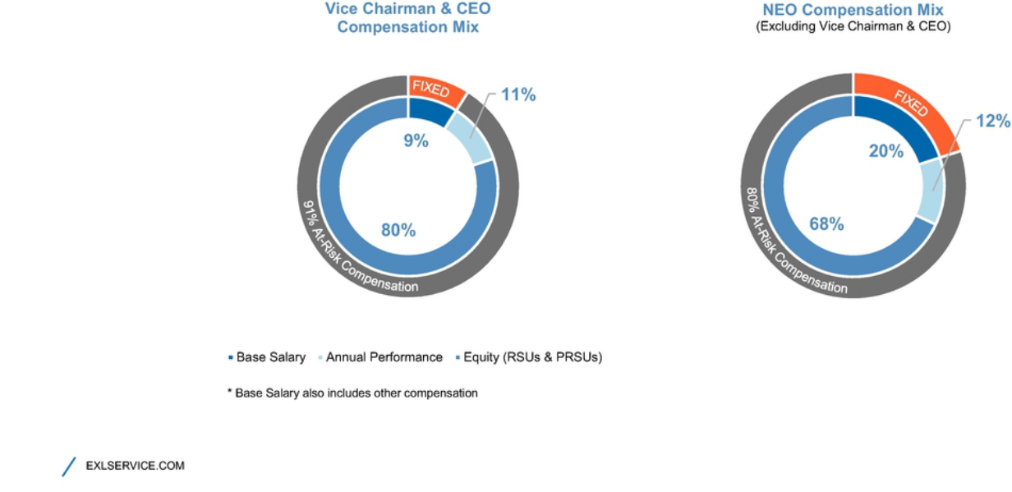

66

Table of Contents

EXECUTIVE COMPENSATION

Executive Compensation Program, Practices and Policies

Our compensation programs, practices and policies are reviewed and re-evaluated regularly and are subject to change from time to time in line with market best practices, including alignment of pay with performance. Our executive compensation philosophy is aligned with our core values, focused on pay-for-performance and designed to reflect appropriate governance practices aligned with the needs of our business. Listed below are some of the Company's more significant practices and policies that were in effect during fiscal year 2020, which were adopted to drive performance and to align our executives' interests with those of our stockholders.

What We Do |  | What We Don't Do
 | Align our Executive Pay with Performance: We link a significant portion of each |  | No Option Repricing: We prohibit option repricing without stockholder approval.
 | NEO's total compensation to the achievement of specific performance goals.
 | Variable compensation is "at-risk" and rewards performance and contributions to both
 | short- and long-term financial performance.
 | Use Appropriate Peer Groups When Establishing Compensation: We established |  | No Option Backdating or Discounting: We prohibit option backdating and
 | a peer group to help us review market practices and design a competitive |  | discounting.
 | compensation program. The criteria for peer group selection include similar market
 | capitalization, annual revenues, scope of operations, potential mobility of talent and
 | industry alignment.
 | We set compensation of our executive officers at levels that we believe are appropriate
 | relative to the compensation paid to similarly situated officers of our peers, giving
 | consideration to market and other factors.
 | Ensure Equity Compensation Best Practices: We design equity incentives to |  | No Excessive Overhang or Dilution: We do not have excessive overhang or dilution
 | encourage our executives to maintain a long-term view of stockholder value creation, |  | from equity grants
 | to encourage retention and to ensure a significant portion of the award is performance-
 | based. Equity awards are granted on the basis of the executive's prior year's
 | performance and are subject to time or performance-based vesting conditions. A
 | significant portion of such awards only pay out according to the achievement of
 | Company performance goals covering a 3-year period.
 | We hold dividends accrued under our equity awards, if any, until the recipient vests in
 | the underlying shares or units.
 | Maintain an Independent Compensation Committee: Compensation decisions for |  | Limited Perquisites: We provide our named executive officers with only limited
 | our NEOs are approved by a Compensation Committee composed of non-employee |  | perquisites and personal benefits that serve an important business purpose in addition
 | independent directors. alignment. |  | to the regular benefits offered to all employees.
 | Our Compensation Committee is advised by an independent consultant who reports |  | We consider the perquisites and personal benefits that we offer to our executives in
 | directly to the Compensation Committee and provides no other services to the |  | India to be customary benefits which allow us to remain competitive for top talent.
 | Company or management.
 |  | 67


Table of Contents

EXECUTIVE COMPENSATION

 | Mitigate Risks: The mix and design of our compensation programs serves to mitigate |  | No Tax Gross-Ups: We do not provide "gross-ups" to any of our named executive
 | operational, financial, legal, regulatory, strategic and reputational risks. |  | officers, including gross-ups for any excise taxes imposed with respect to
 |  |  | Section 280G (change-in-control payments) or Section 409A (nonqualified deferred
 |  |  | compensation) of the U.S. Internal Revenue Code of 1986, as amended (which we
 |  |  | refer to as the "Code").
 | Maintain a Clawback Policy: We maintain a compensation recovery policy that |  | No Hedging: We maintain a policy in which the following persons are prohibited from
 | allows the Company to recover compensation (including cash and/or equity awards) |  | engaging in hedging transactions involving our shares and other securities: our
 | previously paid to one or more officers in the event of a financial restatement caused |  | directors and their secretaries and other assistants; our executive officers and their
 | by noncompliance with reporting requirements that impacts the applicable |  | secretaries and other assistants; our employees in the accounting, finance and legal
 | performance metric if, in the opinion of our board of directors or Compensation |  | departments; the members and permanent invitees of our operating and executive
 | Committee, the identified executive's misconduct was a material factor causing the |  | committees; and all of our vice president level 2 and 3 officers (whom we refer to
 | restatement. |  | collectively as "Reporting Persons"). For this purpose, "hedging" refers to any strategy
 |  |  | to offset or reduce the risk of price fluctuations in our shares or other securities or to
 |  |  | protect, in whole or in part, against declines in the value of our shares or other
 |  |  | securities. This prohibition thus applies to all transactions in derivative securities based
 |  |  | on our stock such as other securities, including puts, calls, swaps and collar
 |  |  | arrangements.
 | Maintain a Robust Stock Ownership Policy: We maintain a stock ownership policy |  | No Pledging: Under our policy mentioned above, Reporting Persons (as defined
 | that requires our CEO to maintain aggregate stock ownership equal to at least six |  | above) are only permitted to pledge shares of our stock that exceed those required to
 | times his base salary and vested stock ownership equal to at least three times his |  | be owned under our Stock Ownership Policy described above.
 | base salary, and that requires the other members of our executive committee to
 | maintain aggregate stock ownership of at least two times their respective base
 | salaries, and vested stock ownership at least equal their respective base salaries.
 | Covered executives have five years from their hire date to attain the required stock
 | ownership levels and three years to attain the vested stock ownership requirements.
 | We maintain a similar stock ownership policy for our non-employee directors that
 | requires directors to maintain stock ownership of at least five times their respective
 | annual retainers. Directors have five years from their appointment date to attain the
 | required stock ownership levels.
 | As of December 31, 2020, all covered executives and directors were in compliance
 | with the stock ownership policy.

68

Table of Contents

EXECUTIVE COMPENSATION

Overview of Compensation Policies and Philosophies

We believe that our long-term success is linked to our ability to recruit, train, motivate and retain employees at every level. There is significant competitive pressure in our industry for qualified managers with a track record of achievement. It is critical that we recruit, train, motivate and retain highly talented individuals at all levels of the organization who are committed to our core values of innovation, collaboration, excellence, integrity and mutual respect. We believe that our executive compensation programs are integral to achieving this end.

Our Compensation Committee bases its executive compensation programs on the following objectives, which guide us in establishing all of our compensation programs:
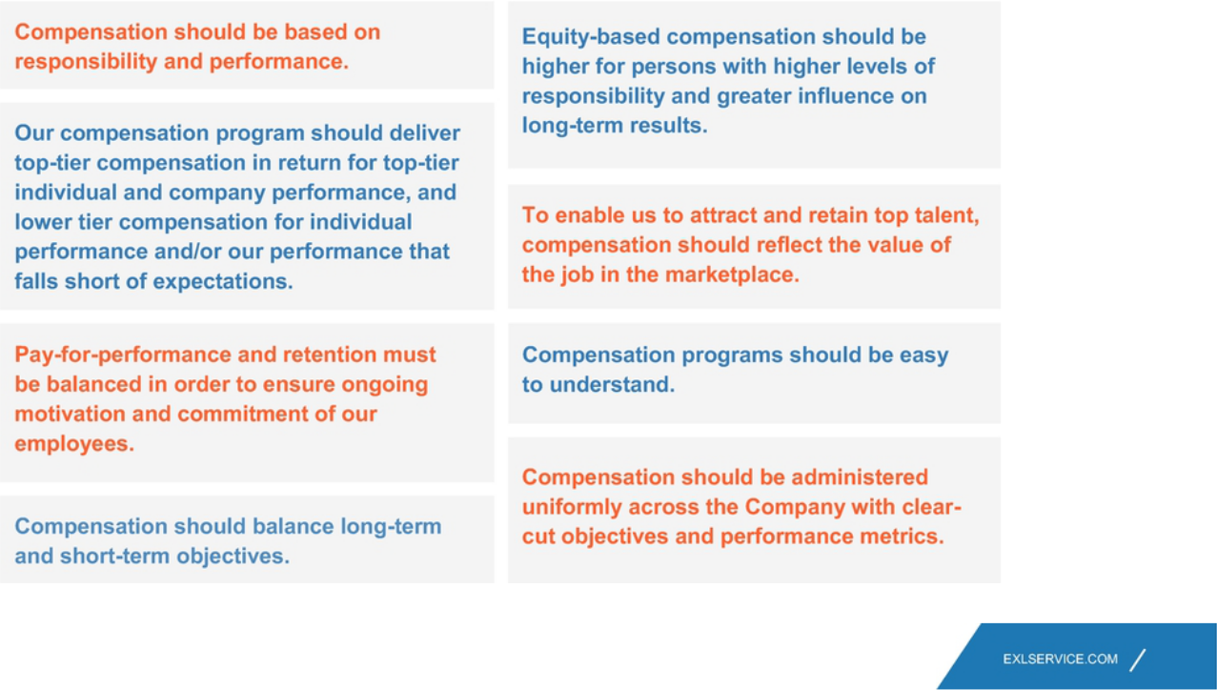

69

Table of Contents

EXECUTIVE COMPENSATION

Compensation Process: Roles and Responsibilities

Our Compensation Committee has established a number of processes to assist it in ensuring that our executive compensation programs are achieving their objectives. Our Compensation Committee, our management and our independent compensation consultant are each engaged in these processes, as described in greater detail below.

Company Performance — |  | Establishment of Performance Measures
Compensation Committee |  | At the beginning of each year, or the end of the prior year, our Compensation Committee establishes the Company-wide and relevant business line performance
 |  | measures on which our named executive officers' annual incentive bonuses and equity incentive awards are largely based. These measures reflect targets that
 |  | are intended to encourage stretch performance.
 |  | Assessment of Company Performance
 |  | At the end of the performance period, the Compensation Committee reviews and certifies our performance achievement in relation to the pre-established
 |  | targets, and considers the appropriateness of adjustments to the performance criteria and calculations of performance achievement.
 | Individual Performance — | The evaluation of an individual's performance determines a portion of the payouts under our incentive bonus program and also influences any changes in base
Board of Directors, |  | salary for each of our named executive officers.
Compensation and Nominating
and Governance Committees, |  | Assessment of Vice Chairman and CEO Performance
and Vice Chairman and CEO
 |  | For Mr. Kapoor, our board of directors reviews and provides feedback on a self-evaluation prepared by Mr. Kapoor. Our Chairman then discusses the
 |  | consolidated feedback from the board of directors with our Compensation and Nominating and Governance Committees. Once all directors have given feedback
 |  | on Mr. Kapoor's performance, we conduct a comprehensive discussion of the full board of directors on Mr. Kapoor's performance, leadership accomplishments
 |  | and overall competence to evaluate the achievement of established objectives.
 |  | Assessment of Performance for All Other NEOs and Executive Officers
 |  | For all other NEOs and executive officers, Mr. Kapoor makes a performance assessment and compensation recommendation to our Compensation and
 |  | Nominating and Governance Committees. He bases the performance assessments on our named executive officers' self-evaluations and his performance
 |  | appraisals of each of them.
 |  | Our Compensation and Nominating and Governance Committees reviews the performance assessments with Mr. Kapoor, and evaluates the achievement of
 |  | established objectives by each named executive officer and his business line, if applicable, and his contribution to our performance, leadership accomplishments
 |  | and overall competence. The Compensation and Nominating and Governance Committees may exercise their judgment based on the named executive officer's
 |  | interactions with the board of directors.
 | Other Matters Relevant to | Our Compensation Committee periodically reviews related matters such as succession planning and management, evaluation of management performance,
Compensation Decisions — |  | changes in the scope of managerial responsibilities, and consideration of the business environment, and considers such matters in making compensation
Compensation Committee |  | decisions. The Compensation Committee also takes into account an executive officer's job responsibilities, performance, qualifications and skills in determining
 |  | individual compensation levels.

70

Table of Contents

 |  | EXECUTIVE COMPENSATION
 | Independent Compensation | For 2020, the Compensation Committee retained the services of FW Cook, a qualified and independent compensation consultant, to aid the Compensation
Consultant |  | Committee in performing its duties. The Compensation Committee's compensation consultant assists in:
- collecting and evaluating external market data regarding executive compensation and performance,

- selecting peer group companies,

- reviewing the proxy statement, and

- advising the Compensation Committee on developing trends and best practices in executive and director compensation and equity and incentive plan design.

 |  | Other than performing these consulting services, FW Cook does not provide other services to us or our executive officers. We have affirmatively determined that
 |  | no conflict of interest has arisen in connection with the work of FW Cook as compensation consultant for the Compensation Committee.
 | Peer Market Data | We review peer compensation data at the beginning of the year (or the end of the prior year) in order to set compensation for each year. At the time
Compensation Committee and |  | compensation decisions were made for our U.S.-based and other senior executive officers in 2020, our Compensation Committee reviewed publicly available
 |  | compensation data for companies that are engaged in business and technology services like us taking into account whether the companies had market
Independent Compensation |  | capitalizations, geographic locations, or annual revenues similar to ours. The companies that comprised our peer group for 2020 were as follows: Blackbaud,
Consultants |  | CoreLogic, CSG Systems International, EPAM Systems, Genpact, Guidewire, Sykes Enterprises, Virtusa, and WNS Holdings.
 |  | Management also separately engaged Aon Consulting in 2019 for the purpose of providing a survey of compensation data (the parameters of which were not
 |  | prepared by Aon Consulting) for individuals in our global industry holding analogous positions to our executive officers. While the Compensation Committee
 |  | reviewed and considered the data provided by these surveys, it did not consider or review the compensation paid to executives at the component companies
 |  | included within such surveys and did not use this information or any other data as a definitive benchmark to set executive compensation for fiscal year 2020.
 |  | Our Compensation Committee reviews compensation information provided by FW Cook and other third party data in order to evaluate each executive's base
 |  | pay, incentive bonus and equity incentives when changes in compensation are considered. Compensation decisions are designed to promote our fundamental
 |  | business objectives and strategy.
 |  | Our Compensation Committee uses the compensation data to obtain a general understanding of current market practices, so it can design our executive
 |  | compensation program to be competitive. Market data is not used exclusively, but rather as a point of reference to draw comparisons and distinctions.
 |  | 71

Table of Contents

EXECUTIVE COMPENSATION

Components of Executive Compensation for 2020

For 2020, the compensation of executive officers consisted of the following five primary components:

Compensation Component |  | Description | Objectives
Base Salary |  | Fixed compensation that is reviewed annually and is based on | Provide a base level of compensation that corresponds to the job
 |  | performance, experience, responsibilities, skill set and market value. | function performed.
 |  |  | Attract, retain, reward and motivate qualified and experienced
 |  |  | executives.
 | Annual Incentives | "At-risk" compensation earned based on performance measured against | Incentivize executives to achieve annual goals that ultimately contribute
 |  | pre-established annual goals. | to long-term company growth and stockholder return.
 |  | Goals are tailored to each executive's position.
 | Long-Term Incentives | "At-risk" compensation in the form of restricted stock unit awards whose | Align executive interests with those of stockholders.
 |  | value fluctuates according to stockholder value.
 |  | 50% of the award vests based on continued service. | Reward continuous service with the company.
 |  |  | Incentivize executives to achieve goals that drive company performance
 |  | 50% vests based on achievement of revenue and total stockholder | over the long-term.
 |  | return goals.
 | Other Benefits | Broad-based benefits provided to company employees (e.g., health and | Provide a total compensation package that is competitive with the
 |  | group insurance), a retirement savings plan and other personal benefits | marketplace and addresses unique needs, especially for overseas
 |  | where appropriate. | executives.
 | Severance and Change in Control | Protect executives during potentially tumultuous corporate transaction. | Allow executives to focus on generating stockholder value during a
Protections |  |  | change in control transaction.
 |  | Provide reduced post-employment compensation upon other involuntary
 |  | terminations. | Provide market-competitive post-employment compensation recognizing
 |  |  | executives likely require more time to find subsequent employment.

72

Table of Contents

EXECUTIVE COMPENSATION

Detailed Review of Compensation Components

Base Salary

As discussed above, we provide our executive officers fixed compensation commensurate with their performance, experience, responsibilities, skill set and market value. This attracts and retains an appropriate caliber of talent for the position and provides a base wage that is not subject to our performance risk. In setting base salaries for 2020, our Compensation Committee considered:

Individual Performance | The degree to which the executive met and exceeded expectations.
Market Data | Geographical and market data to test reasonableness of compensation.
Overall Compensation Mix | Senior employees should have a greater portion of their compensation tied to increasing stockholder value.

Although the Compensation Committee approved modest increases to our named executive officers' base salaries to be effective April 1, 2020, the named executive officers agreed to defer these increases due to the uncertainly caused by the COVID-19 pandemic. The increases, therefore, did not come into effect during the 2020 fiscal year. Further, the fixed compensation amounts for each of Messrs. Bagai and Bhalla cover not only base salary, but also amounts available as a travel allowance, an automobile allowance, a housing allowance, a medical allowance and a cash supplementary allowance, consistent with compensation practices in India.

In May 2020, the Company announced that, due to the uncertainty caused by the COVID-19 pandemic and in order to retain flexibility, the Company's executive management team recommended to the Compensation Committee and the Compensation Committee accepted, salary reductions of 30% or 50% for each of the Company's named executive officers. As a result, the base salary for Mr. Kapoor, was temporarily reduced by 50% and the base salary for the Company's other named executive officers was temporarily reduced by 30% from May 1, 2020 through August 31, 2020.

Each named executive officer agreed that their base salary reduction would not constitute a termination for "good reason" within the meaning of such named executive officer's employment agreement.

73

Table of Contents

EXECUTIVE COMPENSATION

The following table shows the 2019 and 2020 fixed compensation, the approved fixed compensation of our named executive officers for 2020, including the increases that would have taken effect on April 1, 2020 and without adjusting for the salary reductions mentioned above, the actual earned fixed compensation of our named executive officers in 2020, and the overall difference between our named executive officers' actual earned fixed compensation and what they would have earned in 2020 but for the base salary increase deferrals and temporary base salary reductions.

 |  | 2020 Base Salary / | 2020 Approved Base | 2020 Actual Earned | 2020 Overall Base
 | 2019 Base Salary / | 2020 Base Salary / | 2020 Approved Base | 2020 Actual Earned | Salary / Fixed
 | Annual Fixed | Annual Fixed | Salary / Fixed | Base Salary / Fixed | Compensation
Name | Compensation ($) | Compensation ($)⁽⁷⁾ | Compensation ($)⁽⁸⁾ | Compensation ($)⁽⁹⁾ | Reduction ($)
Rohit Kapoor | 720,000 | 720,000 | 742,541 | 599,016 | 143,525
Maurizio Nicolelli⁽¹⁾ | — | 450,000 | 432,172 | 384,283 | 47,889
Pavan Bagai⁽⁶⁾ | INR26,000,000⁽²⁾ | INR26,000,000⁽³⁾ | INR27,502,732⁽¹⁰⁾ | INR23,400,000⁽¹¹⁾ | INR4,102,732⁽¹²⁾
Nalin Miglani | 450,000 | 450,000 | 463,525 | 404,631 | 58,893
Vikas Bhalla⁽⁶⁾ | INR22,000,000⁽⁴⁾ | INR22,000,000⁽⁵⁾ | INR23,878,415⁽¹³⁾ | INR19,800,002⁽¹⁴⁾ | INR4,078,413⁽¹⁵⁾
Samuel Meckey | 425,000 | 425,000 | 437,773 | 382,152 | 55,622

- Mr. Nicolelli joined us on February 3, 2020. As such, he was not eligible for a base salary increase in 2020 and this table shows his approved and actual earned base salary prorated from his start date.

- Equivalent to $364,248, converted at 71.38 INR to 1 USD, which was the exchange rate on December 31, 2019.

- Equivalent to $355,848, converted at 73.065 INR to 1 USD, which was the exchange rate on December 31, 2020.

- Equivalent to $308,210, converted at 71.38 INR to 1 USD, which was the exchange rate on December 31, 2019.

- Equivalent to $301,102, converted at 73.065 INR to 1 USD, which was the exchange rate on December 31, 2020.

- The annual fixed compensation paid to Messrs. Bagai and Bhalla is in Indian rupees (INR).

- The Compensation Committee approved base salary increases in February 2020; however, as noted above these increases were deferred and did not come into effect during the 2020 fiscal year. The following base salary or annual fixed compensation amounts were approved, but not implemented: $750,000 for Mr. Kapoor; INR 28,000,000 for Mr. Bagai; $468,000 for Mr. Miglani; INR 24,500,000 for Mr. Bhalla; and $442,000 for Mr. Meckey.

- Base salary increases were to be effective on April 1, 2020.

- Includes the deferral of the approved 2020 base salaries, as well as the reduction of Mr. Kapoor's base salary by 50%, and our other named executive officers' base salaries by 30% from May 1, 2020 through August 31, 2020.

- Equivalent to $376,415, converted at 73.065 INR to 1 USD, which was the exchange rate on December 31, 2020.

- Equivalent to $320,263, converted at 73.065 INR to 1 USD, which was the exchange rate on December 31, 2020.

- Equivalent to $56,152 converted at 73.065 INR to 1 USD, which was the exchange rate on December 31, 2020.

- Equivalent to $326,811, converted at 73.065 INR to 1 USD, which was the exchange rate on December 31, 2020.

- Equivalent to $270,992, converted at 73.065 INR to 1 USD, which was the exchange rate on December 31, 2020.

- Equivalent to $55,819, converted at 73.065 INR to 1 USD, which was the exchange rate on December 31, 2020.

74

Table of Contents

EXECUTIVE COMPENSATION

Incentive Bonus

We have established an annual incentive bonus program in order to align our executive officers' goals with our performance targets for the current year and to encourage meaningful contributions to our future financial performance. Our Compensation Committee approved the framework of our incentive bonus program in late 2019 for the year 2020 for bonuses payable in respect of 2020 performance. Under the program, bonus target amounts, expressed as a percentage of base salary or annual fixed compensation, are established for participants at the beginning of each year unless their employment agreements contain different terms. Funding of potential bonus payouts for the year are determined by our financial results for the year relative to predetermined performance measures and our assessment of each named executive officer's performance relative to his predetermined individual performance goals. If our performance falls short of target, our aggregate funding of the annual cash bonus incentive pool declines. If we do not achieve a minimum threshold for the established financial performance objectives, then the bonus pool is not funded for that particular objective. Although the Compensation Committee has not historically done so, it has the discretion under the 2018 Plan to adjust an award payout from the amount yielded by the formula at the end of the performance period for reasons such as the effect of changes in laws or regulatory rules, acquisitions or divestitures, extraordinary accounting items, foreign exchange gains or losses, and/or any specific unusual or non-recurring events. As discussed in greater detail below, the Compensation Committee utilized this discretion for the year 2020 in light of the unanticipated impact of the COVID-19 global pandemic.

Our Compensation Committee considered the following when establishing the awards for 2020:

Bonus Targets. Bonus targets were established based on job responsibilities and comparable market data. Our objective was to set bonus targets such that total annual cash compensation was within the broad middle range of market data and a substantial portion of that compensation was linked to our performance. Consistent with our executive compensation policy, individuals with greater job responsibilities had a greater proportion of their total compensation tied to our performance. During 2020, our Compensation Committee established the following bonus targets (expressed as a percentage of base salary or annual fixed compensation) as well as maximum bonus targets for each named executive officer.

Name | Bonus Target | Bonus Maximum
Rohit Kapoor | 150% of base salary | 310% of base salary
Maurizio Nicolelli | 75% of base salary | 155% of base salary
Pavan Bagai | 75% of annual fixed compensation | 155% of annual fixed compensation
Nalin Miglani | 75% of base salary | 155% of base salary
Vikas Bhalla | 75% of annual fixed compensation | 154% of annual fixed compensation
Samuel Meckey | 75% of base salary | 154% of base salary

75

Table of Contents

EXECUTIVE COMPENSATION

Performance Measures. Our executives were eligible to earn annual bonuses based on their achievement of company-wide performance metrics, business line or other company performance metrics and individual performance, as described in the tables below

 | Company-Wide | Individual | Business Line or Other
Name | Performance⁽¹⁾ | Performance | Company Performance⁽²⁾
Rohit Kapoor | 65% | 15% | 20%
Maurizio Nicolelli | 60% | 20% | 20%
Pavan Bagai | 65% | 15% | 20%
Nalin Miglani | 60% | 20% | 20%
Vikas Bhalla | 50% | 20% | 30%
Samuel Meckey | 50% | 20% | 30%

- Based 30% on the Company's Adjusted EPS goal, 40% on the Company's revenue goal, and 30% on the Company's adjusted operating profit margin (AOPM) for all employees whose incentive bonus is linked to Company-wide financial performance, including our named executive officers.

- For Messrs. Kapoor, Bagai, Nicolelli and Miglani, based on aggregate Revenue, Adjusted EPS, and AOPM for specific business units. For Messrs. Bhalla and Meckey, based on aggregate revenue and business operating income for specific business units. Business operating income is a component for measuring business unit performance that is computed as the business unit's gross margin less direct operating expenses.

In 2020, the Compensation Committee continued to set the business line and other Company performance goals as well as the individual performance goals described above for all named executive officers to ensure the executives were properly focused on both the Company's Adjusted EPS, revenue, and AOPM goals, aggregate of business units' performance on revenue and other areas of performance that are unique to their positions within the organization. The Compensation Committee believes achievement of these performance metrics will drive our business and, in turn, lead to increased stockholder value.

76

Table of Contents

EXECUTIVE COMPENSATION

Determination of Financial Performance Achievement:

For 2020, our Compensation Committee established an Adjusted EPS target of $3.65 (18.12% higher than our actual Adjusted EPS for the prior year and 14.96% higher than the prior year's target
performance), a revenue target of $1.075 billion (8.44% higher than our actual revenue for the prior year and 8.70% higher than the prior year's target performance), and an AOPM target of
$165.40 million or 15.4%. 2020 was the first year that the AOPM metric was used. As shown below, the portion of incentive bonus payments that were subject to these financial performance measures

could have ranged from zero to 210% of target depending on the achievement of the performance goals:

Performance Targets: Adjusted EPS ($3.65); Revenue ($1.075 billion); and AOPM ($165.40 million)

% of Performance Achieved Compared to Target Goal | % of Target Portion Funded
Less than 90% | 0%
At 90% | 10%
90% to 100% | Linear interpolation from 10% to 100%
At 100% | 100%
100% to 105% | Linear interpolation from 100% to 160%
105% to 110% | Linear interpolation from 160% to 210%
Above 110% | 210%

Based on our performance during the 2020 fiscal year, we achieved 99.20% of our Adjusted EPS target (resulting in funding of 92.80%), 89.32% of our revenue target (resulting in funding of 0%), and 95.26% of our AOPM target (resulting in funding of 57.37%) for a weighted funding of 45.1%. Notwithstanding these funding percentages, as described below, the Compensation Committee awarded incentive bonus payments in light of our executives' individual and collective extraordinary contributions during the unique circumstances of 2020.

The bonus pool funding for employees whose bonuses are tied to the performance of specific business lines is determined by targets established for such businesses by our Compensation Committee.

77

Table of Contents

EXECUTIVE COMPENSATION

Determination of Individual Performance Measure Achievement:

Our named executive officers earn a portion of their respective annual incentive bonuses based on the achievement of individual performance measures that are designed to balance the attention of the officer between the achievement of near-term objectives that improve specific processes or performance metrics and long-term objectives for us. For more information on the process, roles and responsibilities for determining individual performance measure achievement, please see "Compensation Process: Roles and Responsibilities" on page 70. Below is a summary of each named executive officer's individual performance measures, and a summary of the achievements and accomplishments toward meeting those performance measures:

Named Executive Officer |  |  | Individual Performance Measure |  | Individual Performance Achievement
Rohit Kapoor |  | • | Drive profitable growth agenda | • | Led organization to achieve solid financial results despite a very challenging global environment due to the COVID-19 pandemic
 |  | • | Build digital strategy and organization | • | Acceleration of digital efforts
 |  | • | Improve return on invested capital | • | Excellent focus on ROIC and active pursuit of investment opportunities
 |  | • | Strengthen succession planning | • | Strong progress on development of executive team
 |  | • | Enhance ESG focus | • | Substantial improvement in ESG focus and reporting
 | Maurizio Nicolelli | • | Improve reporting processes | • | Led finance team through tumultuous year with frequent changes to operating plan due to the COVID-19 pandemic
 |  | • | Improve return on capital | • | Significantly enhanced our stock buy back program to effectively deploy capital
 |  | • | Develop long-term M&A stratgey | • | Drove the focus on clearly articulating strategic priorities for M&A assets
 |  | • | Drive profitable growth agenda
 | Pavan Bagai | • | Drive revenue growth and increase profitability | • | Drove cost reductions in technology, facilities, and logistics and improved productivity
 |  | • | Build digital strategy and organization | • | Led business recovery and stabilization during COVID-19 pandemic
 |  | • | Continue focus on risk and compliance culture | • | Developed digital strategy
 |  |  |  | • | Effectively managed information security and related processes
 | Nalin Miglani | • | Focus on company culture | • | Strong pivot and leadership to address COVID-19 challenges, including remote working and employee safety
 |  | • | Expand and drive digitial HR transformation | • | Increased self-learning by employees through digital tools
 |  | • | Drive effective recruitment of key employees | • | Enabled digital hiring, onboarding and training and increased social media visibility
 |  |  |  | • Significantly increased communication with employees on digital platforms
 | Vikas Bhalla | • | Raise insurance business profitability | • | Strong momentum and significant growth in life and annuities business including development of innovative solutions
 |  | • | Create and implement innovative data and analytics | • | Led the design and formulation of a new enterprise operating model to provide greater resiliency and flexibility in the face of the COVID-19
 |  |  | solutions |  | pandemic and beyond
 |  | • | Improve return on invested capital through higher | • | Improved profitability and return on invested capital for insurance business
 |  |  | productivity
 | Samuel Meckey | • | Develop strong sales pipeline and grow strategic | • | Notwithstanding the material affects of the COVID-19 pandemic, grew healthcare significantly over a one-year period with impressive pipeline
 |  |  | accounts |  | growth
 |  | • | Improve return on invested capital for healthcare | • | Improved margin profile of healthcare business
 |  |  | business
 |  | • Drive tighter integration of healthcare into EXL |  | • | Successfully developed and launched the EXL Health Brand

78

Table of Contents

EXECUTIVE COMPENSATION

Actual Bonus Payments:

- Throughout and following the conclusion of the 2020 fiscal year, our Compensation Committee reviewed our 2020 annual incentive bonus program metrics and performance in light of the unanticipated impact of the COVID-19 pandemic. Our Compensation Committee discussed how pre-pandemic performance metrics do not accurately reflect the pay-for-performance compensation approach because of the specific challenges that were encountered during the pandemic. Specifically, our Compensation Committee noted: the tremendous logistical efforts and costs associated with the transition from secure office environments to allow for remote access, addressing the contractual and regulatory restrictions on performing such work remotely, the effort and time spent ensuring the health and safety of our global workforce, and responding to reductions in client budgets on current work and business development strategies.

- Our Compensation Committee also considered calculation adjustments, contemplated under our 2018 Plan to account for extraordinary, unusual or nonrecurring items, had been made to account for identifiable COVID-19 effects. For example, the Compensation Committee considered how the annual bonus payouts would be affected if the direct revenue impact of COVID-19 was accounted for (e.g., known loss of revenue related to the pandemic arising from travel clients, clients that prohibited remote working arrangements, and clients that could not be serviced during the transition to remote working arrangements). Notably, the funding in this scenario was in excess of both the unadjusted formulaic payout as well as the payout finally agreed by the Compensation Committee. Please see the table below for further details.

- The Compensation Committee, after thoughtful consideration, determined not to adjust the performance metrics; however, to recognize the extraordinary efforts of our teams during the 2020 fiscal year and after consideration of the alternative funding scenarios discussed above, our Compensation Committee, after consultation with FW Cook, (1) decided to pay out all named executive officer annual incentive bonuses at 75% of target based on such officer's base salary as in effect prior to the COVID-related salary reductions, and (2) agreed with management's proposal to pay, with certain performance related exceptions, at 75% of target for all employee annual incentive bonuses. The Compensation Committee believes a 75% payout to all named executive officers appropriately balances the goals of rewarding named executive officers for their extraordinary collaborative and collective efforts to meet, address and overcome the challenges of the COVID-19 pandemic and contributions to the Company's performance with the financial and accounting for the business impacts on the Company of the COVID-19 pandemic.

- A comparison of this 75% payout to both the formulaic payout result without any adjustments, as well as the alternative COVID-19-related adjustment scenario is included in the table below. Our Compensation Committee believes this approach and the resulting payouts are appropriate based on the actual Company, business unit, and individual performance achieved despite the additional challenges and financial and operational impact resulting from the COVID-19 pandemic.

79

Table of Contents

EXECUTIVE COMPENSATION

- The table below sets out the 2020 incentive bonuses for our named executive officers (paid in March 2021), as well as the incentive bonuses that would have been paid without adjustment, and the incentive bonuses that would have been paid but for the identifiable COVID-19 effects under the alternative scenario described above.

 |  |  | Alternative Scenario Incentive
 | Actual Incentive Bonus | Incentive Bonus Without | Bonus Without
Name | Awarded ($)(1) | Adjustment ($)(1) | COVID-19 Effects ($)(1)(2)
Rohit Kapoor | 810,000 | 610,318 | 927,456
Maurizio Nicolelli | 243,097 | 187,212 | 276,678
Pavan Bagai | 200,164 | 162,830 | 241,200
Nalin Miglani | 253,125 | 205,059 | 298,216
Vikas Bhalla | 169,370 | 138,203 | 179,814
Samuel Meckey | 239,063 | 322,414 | 401,042

- The exchange rate used for the bonus conversion from Indian rupees to U.S. dollars for Messrs. Bagai and Bhalla was 73.065 INR to 1 USD, which was the exchange rate on December 31, 2020.

- Uses the midpoint of the individual performance funding range.

Long-Term Equity Incentives

The Committee continues to believe that long-term equity awards provide employees with the incentive to stay with us for longer periods of time, which in turn, provides us with greater stability as we grow. These incentives foster the long-term perspective necessary for continued success in our business because the value of the awards is directly linked to long-term stock price performance, and they ensure that our executive officers are properly focused on stockholder value.

Moreover, the Committee favors restricted stock unit awards as these awards offer executives the opportunity to receive shares of our common stock on or shortly following the date that the restrictions lapse. Such awards serve both to reward and retain executives because value is linked to the price of our stock on the date that the restriction lapses, and the executive must generally remain in employment through the date that the restrictions lapse. Restricted stock unit awards provide a significant degree of alignment of interests between our executives and stockholders.

The Committee also believes that the mix between Time-Vested RSUs and Performance-Vested RSUs provides an appropriate balance between incentivizing our executives to continue their employment with the Company and to ensure they are focused on long-term financial performance and generating stockholder value, which will enable them to realize additional compensation.

Finally, restricted stock units are potentially less dilutive to stockholders' equity than stock options because restricted stock awards are full value awards, and our Compensation Committee can award fewer shares than an equivalent value of stock options.

80

Table of Contents

EXECUTIVE COMPENSATION

Fiscal Year 2020 Awards

Under our equity compensation program, our executive officers received restricted stock units under the 2018 Omnibus Incentive Plan approved by the Company's stockholders at the annual meeting of stockholders held in June 2018 (the "2018 Plan"). We awarded restricted stock units to nearly all of our named executive officers in the proportions shown below.

50% + | 25% | + | 25% | = TOTAL
Time-Vested | Revenue-Linked |  | Relative TSR-Linked | LTI
RSUs | RSUs |  | PRSUs | Award

The table below shows the amount of Time-Vested and Performance-Vested RSUs our Compensation Committee awarded our named executive officers in 2020. In general, the Compensation Committee believes that the size of the award granted to an executive officer should increase based on the executive officer's level of responsibility within the Company.

Name | Time-Vested RSUs | Revenue-Linked PRSUs | Relative TSR-Linked PRSUs
Rohit Kapoor⁽¹⁾ | 23,520 | 21,330 | 21,330
Maurizio Nicolelli | 10,263⁽²⁾ | 2,183 | 2,182
Pavan Bagai | 10,045 | 5,023 | 5,022
Nalin Miglani | 6,995 | 3,498 | 3,497
Vikas Bhalla | 8,300 | 4,150 | 4,150
Samuel Meckey | 6,565 | 3,283 | 3,282

- In 2020, Mr. Kapoor was awarded restricted stock units of which approximately 65% were Performance-Vested RSUs, and the remainder were Time-Vested RSUs.

- This amount includes 5,898 Time-Vested RSUs that were granted to Mr. Nicolelli in connection with his February 2020 hire. Accordingly, Mr. Nicolelli's Time-Vested RSUs accounted for more than 50% of this total LTI award in 2020.

  - The Time-Vested RSUs will vest in increments of 25% on each of the first four anniversaries of the grant date, subject to continuous service with the Company through the applicable vesting date.

–The Committee believes these Time-Vested RSUs provide an important role in promoting retention of our executive officers.

  - The "Performance-Vested" portion of the 2020 RSUs ("PRSUs") are split into two types that each vest based on separate performance measures as follows:

–Revenue-Linked PRSUs: 50% of these performance-based restricted stock unit awards will cliff-vest on December 31 of the third fiscal year in the performance period, subject to achievement of threshold Company revenues against an aggregate revenue target over the grant's three-year performance period of January 1, 2020 to December 31, 2022 and continuous employment through December 31, 2022 — we call these awards "Revenue-Linked PRSUs." The ultimate amount of Revenue-Linked PRSUs that a recipient earns may be up to 200% of the target award of Revenue-Linked RSUs. To the extent the Company's revenue falls in between the outlined target achievements, the percentage of Revenue-Based RSUs earned

81

Table of Contents

EXECUTIVE COMPENSATION

will be determined based on straight line interpolation. The chart below sets forth the revenue target achievement thresholds and corresponding funding percentage:

Revenue Target Achievement | Funding Percentage
110% or more | 200%
98% to 102% | 100%
90% or less | 0%

–Relative TSR-Linked PRSUs: The remaining 50% of the performance-based restricted stock unit awards cliff-vest on December 31 of the third fiscal year in the performance period, based on the achievement of relative total stockholder return performance of the Company against a peer group over the grant's three-year performance period of January 1, 2020 to December 31, 2022 and continuous employment through December 31, 2022 — we call these awards "Relative TSR-Linked PRSUs." The Company's TSR for the TSR performance period will be computed and then compared to the TSR of the companies in the TSR peer group, which is comprised of the public companies traded on either the NYSE or NASDAQ stock markets in our 8-digit Global Industry Classification Standard sub-industry group. This comparator set is more appropriate than the compensation peer group for this purpose as it provides a more robust comparison of our performance to the marketplace by the inclusion of more companies and eliminating size as a selection criteria, which is more relevant for compensation than performance comparison. For the Relative TSR-Linked PRSUs granted in 2020, the Company included a negative TSR cap. Under the negative TSR cap, if the total stockholder return is negative over the course of the three year performance period, no named executive officer may receive greater than 100% funding of the TSR-Linked PRSUs.

The percentage of Relative TSR-Linked PRSUs earned will be determined based on straight-line interpolation to the extent the Company's TSR falls in between the 20th and 80th percentiles, as per the chart below:

TSR Peer Group Percentile | Percentage of Relative TSR-Linked PRSUs Earned
80.0 or more | 200%
65.0 | 150%
50.0 | 100%
35.0 | 50%
20.0 or less | 0%

–The Committee believes the PRSUs focus our executives on key drivers of our Company's business that will ultimately lead to creation of additional stockholder value.

Payout of Awards Granted in Prior Fiscal Years

This was the third and final performance year for the 2018 performance-based restricted stock units. We achieved 99.89% of the revenue target for the revenue-linked restricted stock units resulting in 100% of target funding of those grants. The Company's TSR performance was at the 46.51 percentile amongst its peer group, resulting in the executives earning 88.37% of the 2018 relative TSR-linked restricted stock units pursuant to the terms of the original

82

Table of Contents

EXECUTIVE COMPENSATION

grant. No adjustments were made to the 2018 performance-based restricted stock units — or the outstanding 2019 and 2020 performance-based restricted stock units — to account for the impact of the COVID-19 pandemic in the 2020 fiscal year.

New Hire Awards for Mr. Nicolelli

In connection with his appointment, Mr. Nicolelli and the Company entered into an employment agreement, under which Mr. Nicolelli received a joining bonus of $225,000, payable in two installments, and an initial grant of restricted stock units of the Company's common stock with a fair market value of $425,000, which will vest in four equal, annual installments beginning on the first anniversary of the grant date. The bonuses and grants were in part to address lost compensation Mr. Nicolelli would realize as a result of leaving his prior employment.

Benefits and Perquisites

We offer employee benefits coverage in order to:

- provide our global workforce with a reasonable level of financial support in the event of illness or injury; and

- provide market-competitive benefits that enhance productivity and job satisfaction through programs that focus on work/life balance.

The benefits available for all U.S. employees include customary medical and dental coverage, disability insurance and life insurance. In addition, our 401(k) plan provides a reasonable level of retirement income reflecting employees' careers with us. A number of our U.S. employees, including our U.S.-based named executive officers, participate in these plans. The cost of employee benefits is partially borne by our employees, including our named executive officers. Our named executive officers in India, Messrs. Bagai and Bhalla, are eligible to participate in the Company's pension benefit, health and welfare and fringe benefit plans otherwise available to executive employees in India.

We generally do not provide significant perquisites or personal benefits to executive officers other than our Vice Chairman and CEO and our executive officers in India. Our Vice Chairman and CEO is provided a limited number of perquisites which we believe are reasonable and consistent with market trends, which are intended to be part of a competitive overall compensation program. A discussion of the benefits provided to our Vice Chairman and CEO is provided under "Employment Agreements" beginning on page 89.

Risk and Compensation Policies

Our Compensation Committee has taken into account its discussions with management and FW Cook regarding our compensation practices and has concluded that any risks arising from our compensation policies and practices are not reasonably likely to have a material adverse effect on the Company. This conclusion was based on the features of our compensation programs, practices and policies set forth under "Executive Compensation Program, Practices and Policies" on page 67.

Severance and Change-in-Control Benefits

Each named executive officer is party to an employment agreement or letter that sets forth the terms of his or her employment, including compensation, which was negotiated through arms'-length contract negotiations. Under these employment agreements or letters, we are obligated to pay severance or other enhanced benefits upon termination of their employment. A discussion of the severance and other enhanced benefits provided to our named executive officers is provided under "Potential Payments upon Termination or Change in Control at Fiscal 2020 Year-End" beginning on page 93.

We have provided change-in-control severance protection for some of our executive officers, including our named executive officers. Our Compensation Committee believes that such protection is intended to preserve employee

83

Table of Contents

EXECUTIVE COMPENSATION

morale and productivity and encourage retention in the face of the disruptive impact of an actual or rumored change in control. In addition, for executive officers, the program is intended to align executive officers' and stockholders' interests by enabling executive officers to consider corporate transactions that are in the best interests of our stockholders and other constituents without undue concern over whether the transactions may jeopardize the executive officers' own employment.

Senior executive officers, including our named executive officers, have enhanced levels of benefits based on their job level, seniority and probable loss of employment after a change in control. We also consider it likely that it will take more time for senior executive officers to find new employment.

Revised Employment Agreement for Mr. Kapoor

In August 2020, we revised the terms of our Vice Chairman and CEO's employment with our Company by entering into a second amended and restated employment agreement that became effective August 3, 2020. Except as stated herein, these terms are substantially similar to those in effect during the beginning of our 2020 fiscal year and are discussed in greater detail on page 89. The agreement provides for (1) an employment term that extends until Mr. Kapoor's termination or resignation (previously a three year term subject to renewal, unless terminated earlier), (2) updates, to reflect levels currently in effect, to Mr. Kapoor's base salary ($750,000, subject to his 50% base salary reduction and deferment of 2020 increments due to the COVID-19 pandemic), bonus (target of 150% and maximum payout of 310% of base salary) and equity ($4,925,000 baseline), and (3) associated changes to reflect the removal of the employment term and the addition of certain retirement benefits upon Mr. Kapoor's termination of his employment after the age of 60, including 27 months of continued equity vesting for outstanding awards.

2021 Compensation

For fiscal year 2021, we amended the annual bonus program by removing the business unit component to further encourage a focus on enterprise initiatives and performance. For each named executive officer, the 2021 annual bonus program will be weighted 75% on Company performance and 25% on individual performance. Going forward, any relevant business unit performance may still be considered as a part of a named executive officer's individual component assessment.

In response to the continuing COVID-19 pandemic, for fiscal year 2020, we also revised our long-term equity incentive program to remove the revenue performance metric because the current uncertainty and market volatility makes it difficult to predict a three-year revenue target. As a result, the PRSUs are based solely on TSR performance as compared to a pre-determined set of peer companies. Our Compensation Committee believes TSR continues to provide an effective metric as all companies are impacted by the current unprecedented environment. This decision was only made with respect to the 2021 grants and is not, at this time, intended to reflect a permanent change to the long-term equity incentive program.

Deductibility Cap on Executive Compensation

As in the past, our Compensation Committee expects to continue to take into consideration the tax deductibility of compensation, but reserves the right to authorize payments that may not be deductible if it believes that the payments are appropriate and consistent with our compensation philosophy.

Despite the limited availability of Code Section 162(m) performance-based compensation exceptions following the Tax Cuts and Jobs Act of 2017, our Compensation Committee does not anticipate a shift away from variable or performance-based compensation payable to our named executive officers. Similarly, we do not expect to apply less rigor in the process by which we establish performance goals or evaluate performance against pre-established goals with respect to compensation paid to our named executive officers.

84

Table of Contents

EXECUTIVE COMPENSATION

COMPENSATION COMMITTEE REPORT

The Compensation Committee of the board of directors of ExlService Holdings, Inc. has reviewed and discussed the Compensation Discussion and Analysis with our management and, based on such review and discussion, has recommended to the board of directors of ExlService Holdings, Inc. that the Compensation Discussion and Analysis be included in our Annual Report on Form 10-K for the fiscal year ended December 31, 2020, and our proxy statement relating to the Annual Meeting.

Compensation Committee

Ms. Jaynie M. Studenmund (Chair)
Ms. Deborah Kerr
Ms. Anne Minto (Chair until December 31, 2020)
Mr. Som Mittal
Mr. Clyde W. Ostler

Mr. Garen K. Staglin

85

Table of Contents

EXECUTIVE COMPENSATION

SUMMARY COMPENSATION TABLE FOR FISCAL YEAR 2020

The following table sets forth information for compensation earned in fiscal years 2018, 2019 and 2020 by our named executive officers:

 |  |  |  |  |  | Change in
 |  |  |  |  |  | Pension Value
 |  |  |  |  |  | and
 |  |  |  |  | Non-Equity | Nonqualified
 |  |  |  |  | Incentive | Deferred
 |  |  |  | Stock | Plan | Compensation | All Other
Name and |  | Salary | Bonus | Awards | Compensation | Earnings | Compensation | Total
Principal Position | Year | ($) | _{($)}(13) | ($)⁽⁴⁾ | ($)⁽⁵⁾ | ($)⁽⁶⁾ | ($) | ($)
Rohit Kapoor | 2020 | 599,016 | — | 5,701,209 | 810,000 | — | 31,041⁽⁷⁾ | 7,141,267
Vice Chairman & CEO | 2019 | 720,000 | — | 4,121,410 | 1,304,453 | — | 49,354 | 6,195,217
 | 2018 | 720,000 | — | 3,791,277 | 532,748 | — | 61,484 | 5,105,509
Maurizio Nicolelli | 2020 | 384,283 | 125,000 | 1,166,955 | 243,097 | — | 8,970⁽⁸⁾ | 1,928,305
Executive Vice President and CFO | 2019 | — | — | — | — | — | — | —
 | 2018 | — | — | — | — | — | — | —
Pavan Bagai | 2020 | 300,977⁽²⁾ | — | 1,693,173 | 200,164 | 5,988 | 14,145⁽⁹⁾ | 2,214,447
President & Chief Operating Officer and | 2019 | 311,554 | — | 1,557,454 | 323,814 | 6,129 | 47,893 | 2,246,845
Interim CFO⁽¹⁾ | 2018 | 301,448 | — | 1,339,363 | 133,946 | 17,124 | 57,284 | 1,849,164
Nalin Miglani | 2020 | 404,631 | — | 1,179,065 | 253,125 | — | 9,054⁽¹⁰⁾ | 1,845,875
Executive Vice President and Chief Human | 2019 | 450,000 | — | 880,294 | 411,735 | — | 9,444 | 1,751,473
Resources Officer | 2018 | 440,137 | — | 809,936 | 164,579 | — | 8,640 | 1,423,292
Vikas Bhalla | 2020 | 229,016⁽³⁾ | — | 1,399,048 | 169,370 | 5,067 | 37,962⁽¹¹⁾ | 1,840,463
Executive Vice President and Business Head, | 2019 | 263,809 | — | 973,685 | 285,636 | 5,186 | 40,367 | 1,568,683
Insurance | 2018 | — | — | — | — | — | — | —
Samuel Meckey | 2020 | 382,152 | — | 1,106,585 | 239,063 | — | 9,054⁽¹²⁾ | 1,736,853
Executive Vice President and Business Head, | 2019 | 425,000 | — | 765,547 | 364,320 | — | 9,444 | 1,564,311
Healthcare | 2018 | — | — | — | — | — | — | —

- In addition to his other roles, Mr. Bagai served as our interim Chief Financial Officer in January 2020.

- The amount set forth in the "Salary" column for Mr. Bagai includes $112,092 of base salary, $113,237 of a cash supplementary allowance, $56,046 of housing allowance (which Mr. Bagai elected to receive instead in cash), $9,337 of travel allowance (which Mr. Bagai elected to receive instead in cash), and $10,265 of a special car allowance (which Mr. Bagai elected to receive instead in cash).

- The amount set forth in the "Salary" column for Mr. Bhalla includes $94,847 of base salary, $78,845 of a cash supplementary allowance, $47,423 of housing allowance (which Mr. Bhalla elected to receive instead in cash), $7,901 of travel allowance (which Mr. Bhalla elected to receive instead in cash).

- Amounts reflect the total grant date fair value of awards (RSUs and revenue based PRSUs) and Monte Carlo value of awards (TSR based PRSUs) (recognized for financial statement reporting purposes for the fiscal years ended December 31, 2018, 2019 and 2020, in accordance with FASB ASC Topic 718 (disregarding any forfeiture assumptions). Assumptions used in the calculation of these amounts are included (i) for 2020, in footnotes 2 and 23 to the audited financial statements for the fiscal year ended December 31, 2020, included in the 2020 Form 10-K; (ii) for 2019, in footnotes 2 and 23 to the audited financial statements for the fiscal year ended December 31, 2019, included in our Annual Report on Form 10-K filed with the Securities and Exchange Commission on February 27, 2020; and (iii) for 2018, in footnotes 2 and 24 to the audited financial statements for the fiscal year ended December 31, 2018, included in our Annual Report on Form 10-K filed with the Securities and Exchange Commission on February 28, 2019. With respect to stock awards granted in 2020, the table below sets forth the value attributable to performance restricted stock

86

Table of Contents

EXECUTIVE COMPENSATION

units valued at target achievement. Performance restricted stock units granted in 2020 may pay out up to 200% of the target award, which would have amounted to the grant date fair values listed as the maximum total grant date fair value for each named executive officer in the table below.

Name | Total Grant Date Fair Value ($) | Maximum Total Grant Date Fair Value ($)
Rohit Kapoor | 3,853,478 | 7,706,956
Maurizio Nicolelli | 393,798 | 787,596
Pavan Bagai | 906,248 | 1,812,496
Nalin Miglani | 631,077 | 1,262,154
Vikas Bhalla | 748,826 | 1,497,652
Samuel Meckey | 592,282 | 1,184,564

- Reflects the cash incentive bonuses earned in respect of 2020 and paid in 2021. For details on our annual incentive bonus program, see "Compensation Discussion and Analysis — Incentive Bonus" beginning on page 75.

- Reflects the present value of accruals under the Gratuity Plan for Indian employees. Information regarding our Gratuity Plan (including the assumptions used to calculate these amounts) may be found under "Pension Benefits for Fiscal Year 2020" beginning on page 93.

- Amount for Mr. Kapoor includes the travel allowance ($13,927) provided for under his employment agreement, to be used for once-a-year business class airfare for himself and his family between the United States and India, costs associated with use of an automobile and driver ($2,688), car lease rental ($5,372), contribution to our 401(k) plan ($8,550), and Company-paid Life Insurance ($504).

- Amount for Mr. Nicolelli includes contribution to our 401(k) plan ($8,550), Company-paid Life Insurance ($420).

- Amount for Mr. Bagai includes contributions to the Employees' Provident Fund Scheme (a statutorily required defined contribution program for Indian employees) ($13,451), costs associated with use of an automobile and driver in India

($443.40), home internet and telephone charges ($250.20).

- Amount for Mr. Miglani includes contributions to 401(k) plan ($8,550) and Company paid Life Insurance premiums ($504).

- Amount for Mr. Bhalla includes car allowance ($20,530), contributions to the Employees' Provident Fund Scheme (a statutorily required defined contribution program for Indian employees) ($11,381), costs associated with use of an automobile and driver in India ($5,502), home internet and telephone charges ($549).

- Amount for Mr. Samuel Meckey includes contributions to 401(k) plan ($8,550) and Company paid Life Insurance premiums ($504).

- Mr. Nicolelli received $125,000 as his joining bonus.

Unless otherwise specified, U.S. dollar figures in this proxy statement have been converted from Indian rupees at a rate of 73.065 Indian rupees to $1.00, the Indian rupee to U.S. dollar exchange rate in effect as of December 31, 2020. Some of the information in the Summary Compensation Tables for fiscal years 2019 and 2018 was converted using the exchange rates in effect as set forth below:

Fiscal Year | Rate | Exchange Rate of INR per US$1
2019 | December 31, 2019 | 71.38
2018 | December 31, 2018 | 69.77

87

Table of Contents

EXECUTIVE COMPENSATION

Grants of Plan-Based Awards Table for Fiscal Year 2020

The following table sets forth information concerning grants of stock and option awards and non-equity incentive plan awards granted to our named executive officers during fiscal year 2020:

 |  |  |  | Estimated Future Payouts |  |  |  | Estimated Future Payouts |  |  |  | All Other | Grant
 |  |  |  |  |  |  |  |  |  |  |  | Stock Awards: | Date Fair
 |  |  |  | Under Non-Equity |  |  |  |  | Under Equity |  |  | Stock Awards: | Date Fair
 |  |  |  |  |  |  |  |  | Under Equity |  |  | Number of | Value of Stock
 |  |  |  | Incentive Plan Awards⁽¹⁾ |  |  |  | Incentive Plan Awards |  |  |  | Number of | Value of Stock
 |  |  |  |  |  |  |  |  |  |  |  | Number of | and Option
 |  |  |  |  |  |  |  |  |  |  |  | Shares of | and Option
 |  | Grant |  | Threshold | Target | Maximum |  | Threshold | Target | Maximum |  | Stock or Units | Awards⁽⁶⁾
Name |  | Date |  | ($) | ($) | ($) |  | (#) | (#) | (#) |  | (#) | ($)
Rohit Kapoor |  |  |  |  | 1,080,000 | 2,234,520
 | 2/20/20 |  |  |  |  |  |  |  |  |  |  | 23,520⁽⁴⁾ | 1,847,731
 | 2/20/20 |  |  |  |  |  |  |  | 21,330⁽²⁾ | 42,660 |  |  | 1,675,685
 | 2/20/20 |  |  |  |  |  |  |  | 21,330⁽³⁾ | 42,660 |  |  | 2,177,793
Maurizio Nicolelli |  | 2/3/20 |  |  | 324,129 | 735,300 |  |  |  |  |  | 5,898⁽⁵⁾ | 431,203
 |  | 2/19/20 |  |  |  |  |  |  | 2,183⁽²⁾ |  |  | 4,365⁽⁴⁾ | 341,954
 |  | 2/19/20 |  |  |  |  |  |  | 2,183⁽²⁾ | 4,366 |  |  | 171,016
 |  | 2/19/20 |  |  |  |  |  |  | 2,182⁽³⁾ | 4,364 |  |  | 222,782
Pavan Bagai |  |  |  |  | 266,886 | 552,186
 | 2/19/20 |  |  |  |  |  |  |  |  |  |  | 10,045⁽⁴⁾ | 786,925
 | 2/19/20 |  |  |  |  |  |  |  | 5,023⁽²⁾ | 10,046 |  |  | 393,502
 | 2/19/20 |  |  |  |  |  |  |  | 5,022⁽³⁾ | 10,044 |  |  | 512,746
Nalin Miglani |  |  |  |  | 337,500 | 696,600 |  |  |  |  |  | 6,995⁽⁴⁾ | 547,988
 |  | 2/19/20 |  |  |  |  |  |  | 3,498⁽²⁾ |  |  | 6,995⁽⁴⁾ | 547,988
 |  | 2/19/20 |  |  |  |  |  |  | 3,498⁽²⁾ | 6,996 |  |  | 274,033
 |  | 2/19/20 |  |  |  |  |  |  | 3,497⁽³⁾ | 6,994 |  |  | 357,044
Vikas Bhalla |  |  |  |  | 225,826 | 464,299
 | 2/19/20 |  |  |  |  |  |  |  |  |  |  | 8,300⁽⁴⁾ | 650,222
 | 2/19/20 |  |  |  |  |  |  |  | 4,150⁽²⁾ | 8,300 |  |  | 325,111
 | 2/19/20 |  |  |  |  |  |  |  | 4,150⁽³⁾ | 8,300 |  |  | 423,715
Samuel Meckey |  |  |  |  | 318,750 | 655,350 |  |  |  |  |  | 6,565⁽⁴⁾ | 514,302
 |  | 2/19/20 |  |  |  |  |  |  | 3,283⁽²⁾ |  |  | 6,565⁽⁴⁾ | 514,302
 |  | 2/19/20 |  |  |  |  |  |  | 3,283⁽²⁾ | 6,566 |  |  | 257,190
 |  | 2/19/20 |  |  |  |  |  |  | 3,282⁽³⁾ | 6,564 |  |  | 335,092

- These amounts reflect the target and maximum cash incentive bonuses set for 2020. For details of our annual incentive bonus program, see "Compensation Discussion and Analysis — Incentive Bonus" beginning on page 75.

- Represents annual awards of Revenue-Linked PRSUs granted under the 2018 Plan, subject to the vesting set forth in footnote 7.

- Represents annual awards of Relative TSR-Linked PRSUs granted under the 2018 Plan, subject to the vesting set forth in footnote 7.

- Represents annual awards of restricted stock units granted under the 2018 Plan, subject to the vesting set forth in footnote 7.

- Represents one time joining award of restricted stock units granted under the 2018 Plan, subject to the vesting set forth in footnote 7.

- The grant date fair value of the estimated future payouts for the Relative TSR-Linked PRSUs are based on the Monte Carlo value.

- The vesting schedules of the stock grants mentioned in the table are as follows for each named executive officer (subject to continued employment through each applicable vesting date).

Grant Date | Vesting Start Date | Vesting Schedule
2/19/2020 | 2/19/2020 | Revenue Linked PRSUs:
 |  | 100% vesting on 12/31/2022
2/19/2020 | 2/19/2020 | Relative TSR-Linked PRSUs:
 |  | 100% vesting on 12/31/2022
2/19/2020⁽¹⁾⁽²⁾ | 2/19/2020 | Restricted Stock Units:
Vesting over 4 years — 25% each year

- The grant date and vesting start date for Mr. Kapoor's annual equity award was February 20, 2020.

- The grant date and vesting start date for Mr. Nicolelli's one-time joining awards was February 3, 2020.

88

Table of Contents

EXECUTIVE COMPENSATION

Employment Agreements

In addition to the terms described below, the employment and severance agreements for each of our named executive officers include severance, termination and/or noncompetition provisions, which are described below under "Potential Payments upon Termination or Change in Control at Fiscal 2020 Year-End" beginning on page 93.

Rohit Kapoor

Mr. Kapoor serves as our Vice Chairman and CEO, and is based at our executive offices in New York, New York. Our engagement of Mr. Kapoor has been under the terms of employment agreements for over 15 years. On September 19, 2017, we entered into an amended and restated employment agreement with Mr. Kapoor that became effective on January 1, 2018 (the "Prior Kapoor Agreement"). The Prior Kapoor Agreement provided for an initial term from January 1, 2018 until December 31, 2020, and automatically renewed for successive one-year periods unless terminated with 120 days' prior notice. In light of the impending expiration of the initial term of the Prior Kapoor Agreement, the Company entered into a second amended and restated employment agreement with Mr. Kapoor dated and effective as of August 3, 2020 (the "Amended Kapoor Agreement"). The Amended Kapoor Agreement provides for an employment term that extends until Mr. Kapoor's termination or resignation. Unless otherwise noted, the summary below describes the terms of both the Prior Kapoor Agreement and the Amended Kapoor Agreement.

- Salary, Bonus and Equity:

In 2020, Mr. Kapoor's base salary was increased from $720,000 to $750,000, subject to his 50% base salary reduction and deferment of 2020 increments due to the COVID-19 pandemic, as documented in the Amended Kapoor Agreement.

Mr. Kapoor's base salary can be increased at our sole discretion and cannot be decreased unless a Company-wide decrease in pay is implemented. Mr. Kapoor can earn an annual cash bonus, with a target of 150% of base salary and a maximum payout of 310% of base salary (326% under the Prior Kapoor Agreement), based upon the attainment of performance criteria determined by our Compensation Committee. Mr. Kapoor remains eligible to receive equity-based awards annually during the term, in amounts and forms determined by the Compensation Committee but with terms no less favorable than his direct reports. Under the Prior Kapoor Agreement, Mr. Kapoor was entitled to vesting terms no less favorable than ratable vesting over four years from the date of grant.

- Personal Benefits:

We provide Mr. Kapoor with certain personal benefits, including certain club memberships, home office supplies, term life insurance policy (with a face value of $500,000), once-a-year business class airfare between the United States and India for the executive and his family, up to $12,000 for personal tax and estate planning expenses, up to $1,400 per month car allowance, up to $12,000 per year for expenses associated with maintaining an automobile in India (including cost of a driver), personal security for the executive and his family while in India, reimbursement for first-class business travel, and a per diem allowance for certain trips. In addition, his employment agreement entitles him to certain other benefits in the event he is relocated to India, but which are not applicable currently as he maintains a U.S. residency.

Mr. Kapoor's employment agreement also includes severance, termination and noncompetition provisions which are described below under "Potential Payments upon Termination or Change in Control at Fiscal 2020 Year-End" beginning on page 93.

Maurizio Nicolelli

Mr. Nicolelli serves as our Executive Vice President and CFO and is based at our executive offices in New York, New York. We entered into an employment agreement with him, effective February 3, 2020, which will continue throughout

89

Table of Contents

EXECUTIVE COMPENSATION

Mr. Nicolelli's employment with the Company. In connection with his appointment, Mr. Nicolelli received a joining bonus of $225,000, payable in two installments, and an initial grant of restricted stock units of the Company's common stock with a fair market value of $425,000, which will vest in four equal, annual installments beginning on the first anniversary of the grant date.

- Salary, Bonus and Equity:

Mr. Nicolelli's base salary was set at $475,000 upon his hire in 2020. In addition, Mr. Nicolelli can earn an annual cash bonus, with a target of 75% of base salary, based upon the attainment of performance criteria determined by our Compensation Committee. Mr. Nicolelli is also eligible, subject to performance and other conditions, to receive annual equity awards at the discretion of the Compensation Committee.

Mr. Nicolelli's agreements also includes severance, termination and noncompetition provisions which are described below under "Potential Payments upon Termination or Change in Control at Fiscal 2020 Year-End" beginning on page 93.

Pavan Bagai

Mr. Bagai serves as our President and Chief Operating Officer, and is based in Delhi, India. During January 2020, he also served as our interim CFO. We entered into two employment agreements with him, effective July 31, 2002 and August 1, 2002, respectively and a severance letter, effective March 15, 2011, each of which will continue throughout Mr. Bagai's employment with the Company.

- Salary, Bonus and Equity:

Mr. Bagai's annual fixed compensation, measured in U.S. dollars rather than his home currency of Indian rupees (using an exchange rate of 71.38 INR to 1 USD, which was the exchange rate on December 31, 2020), was decreased to $364,248 effective April 1, 2019. Mr. Bagai's annual fixed compensation includes base salary, as well as amounts available as a leave travel allowance, a housing allowance, an automobile allowance, a medical allowance and a cash supplementary allowance. In addition, Mr. Bagai can earn an annual cash bonus, with a target of 75% of annual fixed compensation and a maximum of 163% of annual fixed compensation, based upon the attainment of performance criteria determined by our Compensation Committee. Mr. Bagai is also eligible, subject to performance and other conditions, to receive annual equity awards at the discretion of the Compensation Committee.

Mr. Bagai's agreements also includes severance, termination and noncompetition provisions which are described below under "Potential Payments upon Termination or Change in Control at Fiscal 2020 Year-End" beginning on page 93.

Nalin Miglani

Mr. Miglani serves as our Executive Vice President and Chief Human Resources Officer, and is based at our executive offices in New York, New York. We entered into an employment agreement with him, effective December 1, 2014, which will continue throughout Mr. Miglani's employment with the Company.

- Salary, Bonus and Equity:

Mr. Miglani's base salary was held constant at $450,000 in 2020 but may be increased from time to time by our board of directors. While employed, Mr. Miglani can earn an annual cash bonus, with a target of 75% of base salary and a maximum of 162% of base salary, based upon attainment of performance criteria determined by our Compensation Committee. Mr. Miglani is also eligible, subject to performance and other conditions, to receive annual equity awards at the discretion of the Compensation Committee. Mr. Miglani's employment agreement provided for: (i) an initial equity award of 20,000 restricted stock units that will vest according to the schedule described below under "Outstanding Equity Awards at Fiscal 2020 Year-End" beginning on page 92 and (ii) a one-time joining bonus of $200,000 half of which was paid on the commencement of his employment

90

Table of Contents

EXECUTIVE COMPENSATION

and the other half paid in March 2015, based on his continued service with the Company. Mr. Miglani received $100,000 in connection with his relocation from Amsterdam to New York in 2014.

Mr. Miglani's employment agreement also includes severance, termination and noncompetition provisions which are described below under "Potential Payments upon Termination or Change in Control at Fiscal 2020 Year-End" beginning on page 93.

Vikas Bhalla

Mr. Bhalla serves as our Executive Vice President and Business Head, Insurance, and is based in Delhi, India. We entered into an employment agreement with him, effective April 28, 2001 and a severance letter, effective March 15, 2011, each of which will continue throughout Mr. Bhalla's employment with the Company.

- Salary, Bonus and Equity:

Mr. Bhalla's annual fixed compensation, measured in U.S. dollars rather than his home currency of Indian rupees (using an exchange rate of 71.38 INR to 1 USD, which was the exchange rate on December 31, 2019), was decreased from $344,450 to $308,210 effective April 1, 2019. Mr. Bhalla's annual fixed compensation includes base salary, as well as amounts available as a leave travel allowance, a housing allowance, an automobile allowance, a medical allowance and a cash supplementary allowance. In addition, Mr. Bhalla can earn an annual cash bonus, with a target of 75% of annual fixed compensation and a maximum of 162% of annual fixed compensation, based upon the attainment of performance criteria determined by our Compensation Committee. Mr. Bhalla is also eligible, subject to performance and other conditions, to receive annual equity awards at the discretion of the Compensation Committee.

Mr. Bhalla's agreements also includes severance, termination and noncompetition provisions which are described below under "Potential Payments upon Termination or Change in Control at Fiscal 2020 Year-End" beginning on page 93.

Samuel Meckey

Mr. Meckey serves as our Executive Vice President and Business Head, Healthcare, and is based at our executive offices in New York, New York. We entered into an employment agreement with him, effective November 5, 2018, which will continue throughout Mr. Meckey's employment with the Company.

- Salary, Bonus and Equity:

Mr. Meckey's annual fixed compensation was held constant at $425,000 in 2019. In addition, Mr. Meckey can earn an annual cash bonus, with a target of 75% of annual fixed compensation and a maximum of 162% of annual fixed compensation, based upon the attainment of performance criteria determined by our Compensation Committee. Mr. Meckey is also eligible, subject to performance and other conditions, to receive annual equity awards at the discretion of the Compensation Committee.

Mr. Meckey's agreements also includes severance, termination and noncompetition provisions which are described below under "Potential Payments upon Termination or Change in Control at Fiscal 2020 Year-End" beginning on page 93.

91

Table of Contents

EXECUTIVE COMPENSATION

Outstanding Equity Awards at Fiscal 2020 Year-End

 |  |  |  |  |  | Equity Incentive Plan
 |  |  |  |  | Equity Incentive Plan | Awards: Market or
 |  |  |  |  | Awards: Number of | Payout Value of
 |  |  |  | Market Value of | Unearned Shares, | Unearned Shares,
 |  |  | Number of Shares or | Shares or Units | Units or Other | Units or Other
 |  | Stock Award | Units of Stock That | of Stock That | Rights That Have | Rights That Have
Name |  | Grant Date | Have Not Vested (#)⁽¹⁾ | Have Not Vested ($)⁽³⁾ | Not Vested (#)⁽²⁾ | Not Vested ($)⁽³⁾
Rohit Kapoor |  | 2/22/2017 | 7,973 | 678,741
 |  | 2/20/2018 | 15,003 | 1,277,205
 |  | 2/20/2019 | 21,683 | 1,845,874
 |  | 2/20/2019 |  |  | 28,910^{(a)} | 2,461,108
 |  | 2/20/2019 |  |  | 28,910^{(b)} | 2,461,108
 |  | 2/20/2020 | 23,520 | 2,002,258
 |  | 2/20/2020 |  |  | 21,330^{(c)} | 1,815,823
 |  | 2/20/2020 |  |  | 21,330^{(d)} | 1,815,823
 | Maurizio Nicolelli | 2/3/2020 | 5,898 | 502,097
 |  | 2/19/2020 | 4,365 | 371,592
 |  | 2/19/2020 |  |  | 2,183^{(c)} | 185,839
 |  | 2/19/2020 |  |  | 2,182^{(d)} | 185,754
 | Pavan Bagai | 2/23/2017 | 2,875 | 244,749
 |  | 2/22/2018 | 5,300 | 451,189
 |  | 2/20/2019 | 8,194 | 697,555
 |  | 2/20/2019 |  |  | 10,926^{(a)} | 930,130
 |  | 2/20/2019 |  |  | 10,924^{(b)} | 929,960
 |  | 2/19/2020 | 10,045 | 855,131
 |  | 2/19/2020 |  |  | 5,023^{(c)} | 427,608
 |  | 2/19/2020 |  |  | 5,022^{(d)} | 427,523
 | Nalin Miglani | 2/23/2017 | 1,788 | 152,212
 |  | 2/22/2018 | 3,205 | 272,842
 |  | 2/20/2019 | 4,632 | 394,322
 |  | 2/20/2019 |  |  | 6,176^{(a)} | 525,763
 |  | 2/20/2019 |  |  | 6,174^{(b)} | 525,593
 |  | 2/19/2020 | 6,995 | 595,484
 |  | 2/19/2020 |  |  | 3.498^{(c)} | 297,785
 |  | 2/19/2020 |  |  | 3,497^{(d)} | 297,700
 | Vikas Bhalla | 2/23/2017 | 1,362 | 115,947
 |  | 2/22/2018 | 3,328 | 283,313
 |  | 2/20/2019 | 5,123 | 436,121
 |  | 2/20/2019 |  |  | 6,830^{(a)} | 581,438
 |  | 2/20/2019 |  |  | 6.830^{(b)} | 581,438
 |  | 2/19/2020 | 8,300 | 706,579
 |  | 2/19/2020 |  |  | 4.150^{(c)} | 353,290
 |  | 2/19/2020 |  |  | 4,150^{(d)} | 353,290
 | Samuel Meckey | 11/8/2018 | 4,253 | 362,058
 |  | 2/20/2019 | 4,028 | 342,904
 |  | 2/20/2019 |  |  | 5,370^{(a)} | 457,148
 |  | 2/20/2019 |  |  | 5370^{(b)} | 457,148
 |  | 2/19/2020 | 6,565 | 558,878
 |  | 2/19/2020 |  |  | 3,283^{(c)} | 279,482
 |  | 2/19/2020 |  |  | 3,282^{(d)} | 279,397

- The restricted stock unit awards in this table vest and convert to shares in accordance with the following schedule (generally subject to continued employment through each applicable vesting date): 25% of the restricted stock units vest on each of the first, second, third and fourth anniversaries of the grant date.

- The performance restricted stock unit awards in this table vest and convert to shares in accordance with the following schedules (generally subject to continued employment through the applicable vesting date and achievement of applicable performance goals):

  - 100% of the restricted stock units vest on December 31, 2021. This amount represents the 2019 Revenue-Linked PRSUs and reflects maximum performance.

  - 100% of the restricted stock units vest on December 31, 2021. This amount represents the 2019 Relative TSR-Linked PRSUs and reflects maximum performance.

  - 100% of the restricted stock units vest on December 31, 2022. This amount represents 2020 Revenue-Linked PRSUs and reflects target performance.

  - 100% of the restricted stock units vest on December 31, 2022. This amount represents 2020 Relative TSR-Linked PRSUs and reflects target performance.

- The price used in determining the market values set forth in this table is $85.13, which was the closing price of our stock on December 31, 2020.

92

Table of Contents

EXECUTIVE COMPENSATION

Option Exercises and Stock Vested During Fiscal Year 2020

The following table provides additional information about the value realized by our named executive officers on option award exercises and stock award vesting during fiscal year 2020:

 |  | Option Awards |  |  |  |  |  | Stock Awards
 |  | Number of Shares |  |  | Value Realized on |  | Number of Shares |  |  | Value Realized on
 |  | Acquired on |  |  | Exercise |  | Acquired on |  |  | Vesting
Name |  | Exercise |  |  | ($) |  | Vesting | ($)
Rohit Kapoor |  | 29,259 |  |  | 1,390,750 |  | 60,335 |  |  | 4,654,983
Maurizio Nicolelli |  | — |  |  | — |  | — |  |  | —
Pavan Bagai |  | — |  |  | — |  | 21,365 |  |  | 1,648,592
Nalin Miglani |  | — |  |  | — |  | 12,470 |  |  | 962,034
Vikas Bhalla |  | — |  |  | — |  | 12,625 |  |  | 974,084
Samuel Meckey |  | — |  |  | — |  | 3,469 |  |  | 276,247
Pension Benefits for Fiscal Year 2020
The following table discloses the present value of accumulated benefits payable to each of the named executive officers and the years of
 |  |  |  |  | Number of |  | Present Value |  |  | Payments During
 |  |  |  |  | Years Credited |  | of Accumulated |  |  | Last Fiscal Year
Name |  | Plan Name |  |  | Service (#)⁽¹⁾ |  | Benefit ($) | ($)
Pavan Bagai |  | Gratuity Plan for Indian Employees⁽²⁾ |  |  | 18 |  | 107,781 |  |  | —
Vikas Bhalla |  | Gratuity Plan for Indian Employees⁽²⁾ |  |  | 20 |  | 101,332 |  |  | —

- Consists of the number of years of service credited as of December 31, 2020 for the purpose of determining benefit service under the Gratuity Plan. Credited service is determined based on the completed years of continuous employment (rounded to the nearest whole number of years) with the Company since the executive's date of hire.

- Liabilities with regard to the Gratuity Plans are determined by actuarial valuation using the projected unit credit method. Under this method, we determine our liability based upon the discounted value of salary increases until the date of separation arising from retirement, death, resignation or other termination of services. Critical assumptions used in measuring the plan expense and projected liability under the projected unit credit method include the discount rate, expected return on assets and the expected increase in the compensation rates. Details regarding the assumptions used in the calculation of these amounts are included in footnote 20 to the audited financial statements for the fiscal year ended December 31, 2020 included in the 2020 Form 10-K.

We are required to provide all Indian employees with benefits under the Gratuity Plan, a defined benefit pension plan in India. Distributions from the Gratuity Plan are made in a single lump sum following retirement from the Company. An executive's benefit under the Gratuity Plan is determined at any time as the executive's annual base salary (determined based on the executive's most recent monthly base salary) divided by 26, multiplied by 15, and the product multiplied by the executive's completed years of continuous service with the Company. An executive has a vested and nonforfeitable right to payment of his accrued Gratuity Plan benefit only after five years of service. The present value of Messrs. Bagai and Bhalla's accumulated benefits has been determined based on their monthly basic salary rates in effect on December 31, 2020, which are approximately $10,379 and $8,782, respectively.

Potential Payments upon Termination or Change in Control at Fiscal 2020 Year-End

The following tables summarize the amounts payable to each named executive officer upon a change in control or termination of his employment with us on December 31, 2020. In calculating potential payments for purposes of this disclosure, we have quantified our equity-based payments using the closing stock price on December 31, 2020, which was $85.13. Some of the capitalized terms used in the employment agreements for our named executive officers are defined in the section entitled "Certain Defined Terms" on page 101.

93

Table of Contents

EXECUTIVE COMPENSATION

Rohit Kapoor

Unless otherwise noted, the below summary describes the terms of the Amended Kapoor Agreement in place as of December 31, 2020 in order to align with the quantitative disclosures provided in the accompanying tables.

Cash Severance: If Mr. Kapoor's employment were terminated by us without "cause" or by the executive for "good reason" or by "retirement" (in each case, as described below) on December 31, 2020, he would have been entitled to cash severance consisting of:

- except in the case of retirement, continuation of his base salary for 24 months;

- except in the case of retirement, his actual bonus, if any, earned for the year of termination, determined as if he had been employed for the full year of termination, paid ratably over the remaining period of base salary payments;

- any unpaid bonus amounts from prior periods;

- any accrued but unpaid base salary and vacation days or unreimbursed expenses;

- costs of continued COBRA coverage under the Company's group health plan on behalf of the executive and his eligible dependents (described in more detail below), until the earlier of

(x) the 18-month anniversary of termination and (y) the date the executive becomes eligible to receive comparable benefits from a subsequent employer; and

- except in the case of retirement, continuation of life insurance coverage until the earlier of (x) the 18-month anniversary of termination and (y) the date the executive commences employment with a subsequent employer.

Under the Prior Kapoor Agreement, Mr. Kapoor was also entitled to the above severance amount in the event of the Company's non-renewal of his employment agreement but not in the event of his "retirement."

Change-in-Control Cash Severance: If Mr. Kapoor's employment is terminated by us without "cause" or by the executive for "good reason" (in each case, as described above) within 12 months following a "change in control" or in specific contemplation of a change in control, the executive will receive, in lieu of the cash severance described above, (1) a lump sum payment equal to 24 months of base salary and (2) his actual bonus, if any, earned for the year of termination, determined as if he had been employed for the full year of termination, paid ratably over the remaining period of base salary payments.

Death or Disability: If Mr. Kapoor's employment terminates due to his death or is terminated by either the executive or us due to his disability, he (or his estate) will be entitled to a prorated portion of his projected bonus amount for the year of termination.

Noncompetition and Non-solicitation Provisions: Mr. Kapoor is subject to confidentiality and non-disparagement restrictions at all times, as well as noncompetition and non-solicitation restrictions during his employment and for one year thereafter.

Annual Equity Awards: If Mr. Kapoor's employment is terminated by us without cause or by Mr. Kapoor for good reason, Mr. Kapoor will be treated as if he was still employed by the Company for a period of twenty-seven months (two years under the Prior Kapoor Agreement) following the termination date. On a "change in control" (as defined in the 2006 Plan, 2015 Plan, or 2018 Plan, as applicable), retirement (as defined below), or on death, Mr. Kapoor's outstanding annual equity awards will vest as described below:

Time-Vested RSUs: If a change in control occurs prior to the end of the four-year vesting period, Mr. Kapoor's Time-Vested RSUs will be advanced by one year. In addition, all of Mr. Kapoor's outstanding Time-Vested RSUs will

94

Table of Contents

EXECUTIVE COMPENSATION

become fully vested if he is terminated without cause in specific contemplation of or within 12 months following a change in control, or he voluntarily terminates his employment for good reason within 12 months following a change in control. If Mr. Kapoor dies before the end of the four-year vesting period, all of Mr. Kapoor's outstanding Time-Vested RSUs will become fully vested. For awards granted in 2020, if Mr. Kapoor retires and the applicable award has been outstanding for at least 6 months, Mr. Kapoor will become fully vested in any unvested RSUs that would have vested within the next 12 months absent his retirement.

Revenue-Linked PRSUs: If a change in control occurs prior to the end of the performance period, 100% of target of Mr. Kapoor's Revenue-Linked PRSUs will be deemed earned, will be subject to a three-year installment vesting schedule and will be advanced by one year under such schedule. In addition, all of Mr. Kapoor's outstanding Revenue-Linked PRSUs will become fully vested if, (i) he is terminated without cause in specific contemplation of or within 12 months following a change in control; (ii) he voluntarily terminates his employment for good reason within 12 months following a change in control; or (iii) he dies following a change in control. If Mr. Kapoor dies prior to the end of the performance period and no change in control has occurred, Mr. Kapoor will become vested in a portion of the outstanding Revenue-Linked PRSUs equal to (x) the number of completed full months during the three-year performance period up to the date of Mr. Kapoor's death divided by (y) 36 multiplied by

- 100% of Mr. Kapoor's Revenue-Linked PRSUs. For awards granted in 2020, if Mr. Kapoor retires and the award has been outstanding for at least 6 months, Mr. Kapoor will become vested in a portion of the outstanding Revenue-Linked PRSUs equal to (x) the number of years of service completed by Mr. Kapoor from the grant date (rounding up to the closest whole number) divided by (y) 3 multiplied by (z) the number of Revenue-Linked PRSUs earned based on actual performance.

Relative TSR-Linked PRSUs: If a change in control occurs on or prior to the first anniversary of the grant date, 100% of target of Mr. Kapoor's Relative TSR-Linked PRSUs will be deemed earned. If a change in control occurs after the first anniversary of the grant date, the performance period will be deemed to end on the date of the change in control and the Compensation Committee will determine the number of earned Relative TSR-Linked PRSUs based on the TSR of the Company and the peer group as of such date. In either scenario, the Relative TSR-Linked PRSUs that are deemed earned will be subject to a three year installment vesting schedule and will be advanced by one year under such schedule. In addition, all of Mr. Kapoor's outstanding Relative TSR-Linked PRSUs will become fully vested if, following or in specific contemplation of a change in control, he is terminated without cause or, following a change in control, he (i) voluntarily terminates his employment for good reason or

- dies. If Mr. Kapoor dies prior to the end of the performance period and no change in control has occurred, Mr. Kapoor will become vested in a portion of the outstanding Relative TSR-Linked PRSUs equal to (x) the number of completed full months during the 3 year performance period up to the date of Mr. Kapoor's death divided by (y) 36 multiplied by (z) 100% of Mr. Kapoor's Relative TSR-Linked PRSUs. For awards granted in 2020, if Mr. Kapoor retires and the award has been outstanding for at least 6 months, Mr. Kapoor will become vested in a portion of the outstanding Revenue-Linked PRSUs equal to (x) the number of years of service completed by Mr. Kapoor from the grant date (rounding up to the closest whole number) divided by (y) 3 multiplied by (z) the number of Revenue-Linked PRSUs earned based on actual performance.

Release of Claims: Mr. Kapoor's severance payments and termination-related equity acceleration are subject to his execution of a release of claims against us, his not having committed a material breach of the restrictive covenants that has remained uncured for 15 days after we have given him notice of such breach and his resignation from the board of directors and all committees thereof, if requested by the Company.

Code Section 280G: Mr. Kapoor's employment agreement also contains a "modified cut-back" provision such that any payments that constitute "excess parachute payments" under Section 280G of the Code will be reduced to an amount that does not trigger the applicable excise taxes, to the extent such reduced amount is larger than the amount Mr. Kapoor would have received on a present-value net-after-tax basis (including excise taxes) absent such a reduction.

95

Table of Contents

EXECUTIVE COMPENSATION
Indicative Payouts for Rohit Kapoor
 |  |  |  |  |  | Termination
 |  |  |  |  |  | Without Cause or
 |  |  |  |  |  | for Good Reason
 |  |  |  |  |  | Following Change
 |  |  |  |  |  | in Control or
 |  |  |  |  |  | Termination
 |  |  |  |  |  | Without Cause
 | Death Prior to | Death After |  | Termination for |  | in Specific
 | a Change | a Change |  | Good Reason or | Change | Contemplation of
 | in Control | in Control | Disability | Without Cause | in Control | Change in Control
Payments upon Termination | ($) | ($) | ($) | ($) | ($) | ($)
Base salary payout | — | — | — | 1,440,000 | — | 1,440,000
Bonus payout | 810,000 | 810,000 | 810,000 | 810,000 | — | 810,000
Life insurance | — | — | — | 4,239 | — | 4,239
Health insurance | — | — | — | 35,229 | — | 35,229
Restricted stock units | 5,804,078 | 5,804,078 | — | 5,303,429 | 2,433,164 | 5,804,078
Performance restricted stock units | 2,851,248 | 6,843,392 | — | 6,092,754⁽¹⁾ | 5,632,965 | 6,843,392

- As described above, upon his termination for good reason or without cause, Mr. Kapoor is treated as having continued his employment for two additional years for purposes of his annual equity awards. The information in this table was calculated assuming target performance over the additional two year-period, however, the actual payment would depend upon the Company's actual performance following Mr. Kapoor's termination.

Maurizio Nicolelli

Either Mr. Nicolelli or we may terminate Mr. Nicolelli's employment at any time with 30 days' notice (or 90 days' notice if termination is by Mr. Nicolelli). If Mr. Nicolelli is terminated by us without "cause" (other than due to death or disability), or if Mr. Nicolelli resigns for "good reason", Mr. Nicolelli will receive a cash severance payment equal to twelve months' of his then-current base salary, with 25% payable on the first payroll date at least 10 days following termination and the remainder payable in nine equal monthly installments.

On a "change in control" (as defined in the 2018 Plan) or death, Mr. Nicolelli's outstanding equity awards will vest as described below:

Time-Vested RSUs: If a change in control occurs prior to the end of the four-year vesting period, Mr. Nicolelli's Time-Vested RSUs will be advanced by one year. In addition, all of Mr. Nicolelli's outstanding Time-Vested RSUs will become fully vested if, following or in specific contemplation of a change in control, he is terminated without cause or, following a change in control, he terminates his employment for good reason. If Mr. Nicolelli dies before the end of the four-year vesting period, all of Mr. Nicolelli's outstanding Time-Vested RSUs will become fully vested. For awards granted in 2020, if Mr. Nicolelli retires with at least 10 years of service and the applicable award has been outstanding for at least 6 months, Mr. Nicolelli will become vested in all unvested RSUs that would have vested within the next 12 months absent his retirement. If Mr. Nicolelli retires with at least 5 years of service but less than 10, the number of vested Time-Vested PRSUs will be calculated as described in the preceding sentence and then reduced by 50%.

Revenue-Linked PRSUs: If a change in control occurs prior to the end of the performance period, 100% of Mr. Nicolelli's Revenue-Linked PRSUs will be deemed earned, will be subject to a new three year installment vesting schedule and will be advanced by one year under such schedule. In addition, all of Mr. Nicolelli's outstanding Revenue-Linked PRSUs will become fully vested if, following or in specific contemplation of a change in control, he is

96

Table of Contents

EXECUTIVE COMPENSATION

terminated without cause or, following a change in control, he (i) terminates his employment for good reason or, (ii) dies. If Mr. Nicolelli dies prior to the end of the performance period and no change in control has occurred, Mr. Nicolelli will become vested in a portion of the outstanding Revenue-Linked PRSUs equal to (x) the number of completed full months during the 3 year performance period up to the date of Mr. Nicolelli's death divided by (y) 36 multiplied by (z) 100% of Mr. Nicolelli's Revenue-Linked PRSUs. For awards granted in 2020, if Mr. Nicolelli retires with at least 10 years of service and the award has been outstanding for at least 6 months, Mr. Nicolelli will become vested in a portion of the outstanding Revenue-Linked PRSUs equal to (x) the number of years of service completed by Mr. Nicolelli from the grant date (rounding up to the closest whole number) divided by (y) 3 multiplied by (z) the number of Revenue-Linked PRSUs earned based on actual performance. If Mr. Nicolelli retires with at least 5 years of service but less than 10, the number of vested Revenue-Linked PRSUs will be calculated as described in the preceding sentence and then reduced by 50%.

Relative TSR-Linked PRSUs: If a change in control occurs on or prior to the first anniversary of the grant date, 100% of Mr. Nicolelli's Relative TSR-Linked PRSUs will be deemed earned. If a change in control occurs after the first anniversary of the grant date, the performance period will be deemed to end on the date of the change in control and the Compensation Committee will determine the number of earned Relative TSR-Linked PRSUs based on the TSR of the Company and the peer group as of such date. In either scenario, the Relative TSR-Linked PRSUs that are deemed earned will be subject to a new three year installment vesting schedule and will be advanced by one year under such schedule. In addition, all of Mr. Nicolelli's outstanding, earned TSR-Linked PRSUs will become fully vested if, following or in specific contemplation of a change in control, he is terminated without cause or, following a change in control, he (i) voluntarily terminates his employment for good reason or,

- dies. If Mr. Nicolelli dies prior to the end of the performance period and no change in control has occurred, Mr. Nicolelli will become vested in a portion of the outstanding Relative TSR-Linked PRSUs equal to (x) the number of completed full months during the 3 year performance period up to the date of Mr. Nicolelli's death divided by (y) 36 multiplied by (z) 100% of Mr. Nicolelli's Relative TSR-Linked PRSUs. For awards granted in 2020, if Mr. Nicolelli retires with at least 10 years of service and the award has been outstanding for at least 6 months, Mr. Nicolelli will become vested in a portion of the outstanding Relative TSR-Linked PRSUs equal to (x) the number of years of service completed by Mr. Nicolelli from the grant date (rounding up to the closest whole number) divided by (y) 3 multiplied by (z) the number of Relative TSR-Linked PRSUs earned based on actual performance. If Mr. Nicolelli retires with at least 5 years of service but less than 10, the number of vested Relative TSR-Linked PRSUs will be calculated as described in the preceding sentence and then reduced by 50%.

Mr. Nicolelli's severance payments and termination-related equity acceleration are subject to his execution of a waiver and release of claims against us. Mr. Nicolelli is subject to confidentiality restrictions at all times, as well as noncompetition and nonsolicitation restrictions for two years following termination of his employment.

97

Table of Contents

EXECUTIVE COMPENSATION
Indicative Payouts for Maurizio Nicolelli
 |  |  |  |  | Termination
 |  |  |  |  | Without Cause or
 |  |  |  |  | for Good Reason
 |  |  |  |  | Following Change
 |  |  |  |  | in Control or
 |  |  |  |  | Termination
 |  |  |  |  | Without Cause
 | Death Prior to | Death After | Termination for |  | in Specific
 | a Change | a Change | Good Reason or | Change | Contemplation of
 | in Control | in Control | Without Cause | in Control | Change in Control
Payments upon Termination | ($) | ($) | ($) | ($) | ($)
Base salary payout | — | — | 475,000 | — | 475,000
Restricted stock units | 873,689 | 873,689 | — | 218,422 | 873,689
Performance restricted stock units | 123,852 | 371,592 | — | 247,741 | 371,592
Pavan Bagai

Either Mr. Bagai or we may terminate Mr. Bagai's employment at any time with three months' notice (or pay three months' salary in lieu of notice). If Mr. Bagai is terminated by us without "cause" (other than due to disability) at any time following a change in control or in specific contemplation of a change in control, or if Mr. Bagai resigns for "good reason" following a "change in control" (as defined in the 2015 Plan), Mr. Bagai will receive a cash severance payment equal to twelve months' of his then-current annual fixed compensation, payable in twelve equal monthly installments.

On a "change in control" (as defined in the 2018 Plan) or death, Mr. Bagai's outstanding equity awards will vest in the same manner as described for Mr. Nicolelli's outstanding equity awards beginning on Page 96.

Mr. Bagai's severance payments and termination-related equity acceleration are subject to his execution of a waiver and release of claims against us. Mr. Bagai is subject to confidentiality restrictions at all times, as well as noncompetition and nonsolicitation restrictions for two years following termination of his employment.

Indicative Payouts for Pavan Bagai
 |  |  |  |  |  | Termination
 |  |  |  |  |  | Without Cause or
 |  |  |  |  |  | for Good Reason
 |  |  |  |  |  | Following Change
 |  |  |  |  |  | in Control or
 |  |  |  |  |  | Termination
 |  |  |  |  |  | Without Cause
 | Death Prior to | Death After |  | Termination for |  | in Specific
 | a Change | a Change |  | Good Reason or | Change | Contemplation of
 | in Control | in Control | Disability | Without Cause | in Control | Change in Control
Payments upon Termination | ($) | ($) | ($) | ($) | ($) | ($)
Base salary payout | — | — | — | 355,848 | — | 355,848
Restricted stock units | 2,248,624 | 2,248,624 | — | — | 916,637 | 2,248,624
Performance restricted stock units | 905,076 | 2,068,814 | — | — | 1,783,799 | 2,068,814
Government-required payouts⁽¹⁾ | 107,781 | 107,781 | — | 107,781 | — | 107,781

(1) Represents distributions under the Gratuity Plan, which is due to Mr. Bagai because he has earned over five years of credited service.

98

Table of Contents

EXECUTIVE COMPENSATION

Nalin Miglani

Either Mr. Miglani or we may terminate Mr. Miglani's employment at any time (though we must give Mr. Miglani 30 days' notice if the termination is without "cause" and Mr. Miglani must give us 90 days' advance notice upon any resignation). If Mr. Miglani's employment with the Company is terminated by the Company without "cause" (other than due to death or disability) or by Mr. Miglani for "good reason" (both "cause" and "good reason" as defined above), Mr. Miglani will receive a cash severance payment equal to 12 months base salary, with 25% payable as a lump sum payment and the remaining 75% payable in accordance with the Company's regular payroll practices.

On a "change in control" (as defined in the 2018 Plan) or death, Mr. Miglani's outstanding equity awards will vest in the same manner as described for Mr. Nicolelli's outstanding equity awards beginning on Page 96.

Mr. Miglani's severance payments and termination-related equity acceleration are subject to his execution of a release of claims against us. Mr. Miglani is subject to confidentiality restrictions at all times, as well as noncompetition, nondisparagement and nonsolicitation restrictions during his employment and for one year thereafter.

Indicative Payouts for Nalin Miglani
 |  |  |  |  |  | Termination
 |  |  |  |  |  | Without Cause or
 |  |  |  |  |  | for Good Reason
 |  |  |  |  |  | Following Change
 |  |  |  |  |  | in Control or
 |  |  |  |  |  | Termination
 |  |  |  |  |  | Without Cause
 | Death Prior to | Death After | Termination for |  |  | in Specific
 | a Change | a Change | Good Reason or | Change |  | Contemplation of
 | in Control | in Control | Without Cause | in Control | Retirement | Change in Control
Payments upon Termination | ($) | ($) | ($) | ($) | ($) | ($)
Base salary payout | — | — | 450,000 | — |  | 450,000
Restricted stock units | 1,414,861 | 1,414,861 | — | 568,924 | 74,436 | 1,414,861
Performance restricted stock units | 548,944 | 1,281,468 | — | 1,082,993 | 99,247 | 1,281,468
Vikas Bhalla

Either Mr. Bhalla or we may terminate Mr. Bhalla's employment at any time with three months' notice (or pay three months' salary in lieu of notice). If Mr. Bhalla is terminated by us without "cause" (other than due to disability) at any time following a change in control or in specific contemplation of a change in control, or if Mr. Bhalla resigns for "good reason" after at least six months following a "change in control" (as defined in the 2015 Plan), Mr. Bhalla will receive a cash severance payment equal to twelve months' of his then-current annual fixed compensation, payable in twelve equal monthly installments.

On a "change in control" (as defined in the 2018 Plan) or death, Mr. Bhalla's outstanding equity awards will vest in the same manner as described for Mr. Nicolelli's outstanding equity awards beginning on Page 96.

Mr. Bhalla's severance payments and termination-related equity acceleration are subject to his execution of a waiver and release of claims against us. Mr. Bhalla is subject to confidentiality restrictions at all times, as well as noncompetition and nonsolicitation restrictions for two years following termination of his employment.

99

Table of Contents

EXECUTIVE COMPENSATION
Indicative Payouts for Vikas Bhalla
 |  |  |  |  | Termination
 |  |  |  |  | Without Cause or
 |  |  |  |  | for Good Reason
 |  |  |  |  | Following Change
 |  |  |  |  | in Control or
 |  |  |  |  | Termination
 |  |  |  |  | Without Cause
 | Death Prior to | Death After | Termination for |  | in Specific
 | a Change | a Change | Good Reason or | Change | Contemplation of
 | in Control | in Control | Without Cause | in Control | Change in Control
Payments upon Termination | ($) | ($) | ($) | ($) | ($)
Base salary payout | — | — | 301,102 | — | 301,102
Restricted stock units | 1,541,960 | 1,541,960 | — | 579,586 | 1,541,960
Performance restricted stock units | 623,147 | 1,465,355 | — | 1,229,853 | 1,465,355
Government-required payouts⁽¹⁾ | 101,332 | 101,332 | 101,332 | — | 101,332

(1) Represents distributions under the Gratuity Plan, which is due to Mr. Bhalla because he has earned over five years of credited service.

Samuel Meckey

Either Mr. Meckey or we may terminate Mr. Meckey's employment at any time (though we must give Mr. Meckey 30 days' notice if the termination is without "cause" and Mr. Meckey must give us
60 days' advance notice upon any resignation). If Mr. Meckey's employment with the Company is terminated by the Company without "cause" (other than due to death or disability) or by Mr. Meckey for "good reason" (both "cause" and "good reason" as defined above), Mr. Meckey will receive a cash severance payment equal to 12 months base salary, with 25% payable as a lump sum payment and the remaining 75% payable in accordance with the Company's regular payroll practices.

On a "change in control" (as defined in the 2018 Plan) or death, Mr. Meckey's outstanding equity awards will vest in the same manner as described for Mr. Nicolelli's outstanding equity awards on Page 96.

Mr. Meckey's severance payments and termination-related equity acceleration are subject to his execution of a release of claims against us. Mr. Meckey is subject to confidentiality restrictions at all times, as well as noncompetition, nondisparagement and nonsolicitation restrictions during his employment and for one year thereafter.

100

Table of Contents

 |  |  |  |  | EXECUTIVE COMPENSATION
Indicative Payouts for Samuel Meckey
 |  |  |  |  |  | Termination
 |  |  |  |  |  | Without Cause or
 |  |  |  |  |  | for Good Reason
 |  |  |  |  |  | Following Change
 |  |  |  |  |  | in Control or
 |  |  |  |  |  | Termination
 |  |  |  |  |  | Without Cause
 | Death Prior to | Death After | Termination for |  |  | in Specific
 | a Change | a Change | Good Reason or | Change |  | Contemplation of
 | in Control | in Control | Without Cause | in Control |  | Change in Control
Payments upon Termination | ($) | ($) | ($) | ($) | ($)
Base salary payout | — | — | 425,000 | — |  | 425,000
Restricted stock units | 1,263,840 | 1,263,840 | — | 435,036 |  | 1,263,840
Performance restricted stock units | 491,055 | 1,155,457 | — | 969,183 |  | 1,155,457
Certain Defined Terms
Definition of Cause

The following definition of "cause" applies to Messrs. Kapoor, Nicolelli, Bagai, Miglani, Bhalla and Meckey unless stated otherwise. "Cause" will occur if: (i) there is a final nonappealable conviction of, or pleading of no contest to, (1) a crime of moral turpitude which causes serious economic injury or serious injury to our reputation or (2) a felony; (ii) the executive engages in fraud, embezzlement, gross negligence, self-dealing, dishonesty or other gross and willful misconduct which causes serious and demonstrable injury to us; (iii) the executive materially violates any of our material policies (for

Mr. Kapoor, which is not remedied within 15 days of receipt of notice from the Company specifying the breach in reasonable detail); (iv) the executive willfully and continually fails to substantially perform his duties (other than for reason of physical or mental incapacity) which continues beyond 15 days after we notify him in writing of his need to substantially improve his performance; provided that a failure to achieve performance objectives will not by itself constitute cause and no act or failure to act shall be considered "willful" unless done or failed to be done by the executive in bad faith and without a reasonable belief that his actions or omission was in our best interest; (v) the executive fails to reasonably cooperate in a governmental investigation involving us; (vi) the executive materially, knowingly and intentionally fails to comply with applicable laws with respect to the execution of the Company's business operations (subject to a presumption of good faith if the executive is following advice of counsel); (vii) the executive fails to follow his supervisor's (or, for Messrs. Kapoor and Bagai our board of directors') lawful instructions and does not remedy the failure for 15 days after we give him written notice; (viii) the executive's use of alcohol or drugs materially interferes with the performance of his duties; (ix) for Mr. Kapoor only, he fails to take reasonable steps to end certain affiliations specified in his employment agreement within six months after a request by our board of directors; or (x) for Mr. Kapoor only, he materially breaches any material term of his employment agreement which is not remedied within 15 days of receipt of notice from the Company specifying the breach in reasonable detail.

Definition of Good Reason

For Mr. Kapoor, "good reason" generally means: (i) his duties or responsibilities are substantially reduced, he is required to report to anyone other than our board of directors, or his title as our officer is adversely changed; however, if following a change in control, his new title and authority are similar to his old title and authority, then any change in the executive's title will not constitute a significant reduction in his duties and authorities, it being understood that "good reason" shall be deemed to exist if Mr. Kapoor is no longer the chief executive officer of the Company or any entity

101

Table of Contents

EXECUTIVE COMPENSATION

that acquires the Company; (ii) his base salary is reduced, or his target annual bonus opportunity is reduced below 100% of his base salary; (iii) the office or location where he is based in the metropolitan New York City area is moved more than 30 miles, and the new location is more than 30 miles from his primary residence in the metropolitan New York City area; or (iv) we breach any material term of his employment agreement. If Mr. Kapoor plans to terminate his employment for good reason, he must notify us within 45 days following the date the executive first becomes aware of the circumstances giving rise to good reason and must allow us 30 days to remedy the problem.

The following definition of "good reason" applies to Messrs. Nicolelli, Bagai, Miglani, Bhalla and Meckey unless stated otherwise. "Good reason" means, without the executive's prior written consent:

- the executive's duties or responsibilities are substantially reduced, or he is required to report to anyone other than our board of directors, or our CEO; (ii) the executive's title as our officer is adversely changed; however, if following a change in control (as defined in the 2018 Plan), his new title and authority are similar to his old title and authority, then any change in the executive's title will not constitute a significant reduction in his duties and authorities; (iii) for Mr. Bagai only, the executive's base salary or annual cash bonus opportunity is reduced, other than in connection with a proportionate reduction impacting all members of our executive committee; (iv) for Messrs. Nicolelli, Miglani and Meckey only, there is a change in the office or location where the executive is based of more than 50 miles and such new office or location is more than 50 miles from the executive's primary residence; or (v) we breach any material term of the executive's employment agreement or severance agreement. If the executive plans to terminate his employment for good reason, he must notify us within 30 days following the date the executive first becomes aware of the circumstances giving rise to good reason and must allow us 30 days to remedy the problem.

Definition of Change in Control

A "change in control" (as generally defined in Mr. Kapoor's employment agreement and the 2018 Plan, as applicable) generally means any of the following events: (i) any person or group becomes a beneficial owner (within the meaning of Rule 13d-3 under the Exchange Act) of more than 50% of either (1) the combined voting power of our then-outstanding voting securities entitled to vote in the election of directors or (2) our outstanding shares of common stock, assuming all rights to acquire common stock through options, warrants, conversion of convertible stock or debt, and the like are exercised; (ii) a majority of the members of our board of directors changes from those in office as of the date of Mr. Kapoor's employment agreement or the effective date of the 2018 Plan (as applicable), except that the election of any new director whose election or nomination was approved by at least two-thirds of our incumbent directors will not be regarded towards a change in the majority for these purposes; (iii) our dissolution or liquidation; (iv) the sale, transfer or other disposition of all or substantially all of our business or our assets; or (v) consummation of a reorganization, recapitalization, merger, consolidation or similar transaction with another entity which requires the approval of our stockholders; however, any such transaction will not be a change in control if after the transaction

- more than 50% of the total voting power of the resulting entity or its ultimate parent is represented by what were our outstanding voting securities before the transaction in substantially the same proportion among holders; (2) no person or group is or becomes the beneficial owner of more than 50% of the total voting power of the outstanding voting securities eligible to elect members of our board of directors of the parent or surviving company; and (3) at least a majority of the members of our board of directors of the parent or surviving company following the transaction were our board members when our board first approved the transaction.

Definition of Retirement

A "retirement" generally means a named executive officer's voluntary termination of employment that is effective after he reaches age 60.

102

Table of Contents

EXECUTIVE COMPENSATION

CEO Pay Ratio

In accordance with SEC rules and the Dodd-Frank Wall Street Reform and Consumer Protection Act, presented below is an estimate of the ratio of our CEO's annual total compensation to our median employee's annual total compensation (our "Pay Ratio"). Due to the size and complexity of our organization, which as of March 31, 2021 was made up of approximately 31,600 professionals throughout the world, with delivery centers in over 10 countries, our Pay Ratio is based on reasonable assumptions and estimates described below.

We calculated our Pay Ratio by looking at our entire employee population (excluding our CEO) as of December 31, 2020, but excluding leased employees and independent contractors. We then calculated each employee's "total pay" using the sum of his or her fixed pay / base salary and variable pay (including any performance bonus, sales commission, and retention or signing bonus). We also annualized total pay for all full-time and part-time employees that were employed for less than the full fiscal year 2020.

For all employees located in jurisdictions other than the United States, a cost-of-living adjustment was made to align their compensation with the cost-of-living standards in the United States, the jurisdiction in which our CEO resides. Finally, we identified the median employee and calculated his or her annual total compensation and the CEO's annual total compensation in the manner required by Item 402(u) of Regulation S-K, to determine the pay ratio shown in the table below.

Pay Ratio — All Employees (with COLA)⁽¹⁾
Chief Executive Officer's Annual Total Compensation | $7,141,267
Median Employee's Annual Total Compensation | $10,682
Ratio of Chief Executive Officer's Annual Total Compensation to Median Employee's Annual Total Compensation | 669:1

(1) 2020 Mercer Combined Index. Our median employee, identified without performing a cost-of-living adjustment, is based in India and had an annual total compensation of $6,870, resulting in a pay ratio of 1,039:1.

Approximately 93% of our employees are located outside of the United States, primarily in India and the Philippines. As is common with many global companies, our compensation programs are market based, and as such they may differ for employees based on the country where an employee works. Accordingly, we believe that it is important to show our pay-ratio calculated in a similar manner as described above using the median U.S.-based employee to provide a commensurable view of our pay practices.

Pay Ratio — United States Employees

Chief Executive Officer's Annual Total Compensation | $7,141,267
Median Employee's Annual Total Compensation | $114,037
Ratio of Chief Executive Officer's Annual Total Compensation to Median Employee's Annual Total Compensation | 63:1
 | 103

Table of Contents

EXECUTIVE COMPENSATION

Director Compensation for Fiscal Year 2020

The following table sets forth information for compensation earned in fiscal year 2020 by our non-executive directors who served during fiscal year 2020:

 | Fees Earned or |  | All Other
 | Paid in Cash | Stock Awards | Compensation | Total
Name⁽¹⁾ | ($)⁽⁴⁾ | _{($)}(5)(6) | ($)⁽²⁾ | ($)
David Kelso | 83,250 | 140,000 | — | 193,250
Deborah Kerr | 72,000 | 140,000 | — | 182,000
Anne Minto | 81,000 | 140,000 | 12,123 | 203,123
Som Mittal | 72,000 | 140,000 | 7,501 | 189,501
Clyde Ostler | 85,500 | 140,000 | — | 195,500
Vikram Pandit⁽³⁾ | 65,250 | 140,000 | — | 175,250
Nitin Sahney | 74,250 | 140,000 | — | 184,250
Garen Staglin | 162,000 | 240,000 | 52,345 | 424,345
Jaynie Studenmund | 74,250 | 140,000 | — | 184,250

- Mr. Kapoor's compensation during 2020 was based solely on his role as CEO, as disclosed in the "Summary Compensation Table for Fiscal Year 2020" beginning on page 86 and discussed in "Compensation Discussion and Analysis" beginning on page 61. He does not receive any additional compensation for his services as a director. Mr. Pipes, a current non-executive director, was not a director during fiscal year 2020.

- For Ms. Minto and Mr. Mittal, amount reflects our reimbursement to the director for fees associated with tax preparer services. For Mr. Staglin, amount reflects our reimbursement for costs associated with secretarial services.

- Pursuant to the Investment Agreement, Mr. Pandit's 2020 compensation was paid to The Orogen Group.

- Fees earned or paid in cash were temporarily reduced due to COVID-19, as described on page 105.

- Amounts reflect the aggregate grant date fair value of stock awards and option awards recognized for financial statement reporting purposes for the fiscal year ended December 31, 2020, in accordance with FASB ASC Topic 718 (disregarding any forfeiture assumptions). Assumptions used in the calculation of these amounts are included in footnotes 2 and 23 to our audited financial statements for the fiscal year ended December 31, 2020 included in the 2020 Form 10-K.

104

Table of Contents

 |  |  | EXECUTIVE COMPENSATION
(6) The outstanding equity awards held by our non-employee directors on December 31, 2020 is set forth on the table below:
 | No. of Securities Underlying | No. of Securities Underlying | No. of Shares or
Name⁽¹⁾ | Unexercised Options (#) | Unexercised Options (#) | Units of Stock That Have
Name⁽¹⁾ | Exercisable | Unexercisable | Not Vested
David Kelso | 21,156 | 0 | 2,363
Deborah Kerr | 0 | 0 | 2,363
Anne Minto | 3,093 | 0 | 2,363
Som Mittal | 0 | 0 | 2,363
Clyde Ostler | 0 | 0 | 2,363
Vikram Pandit | 0 | 0 | 2,363
Nitin Sahney | 0 | 0 | 2,363
Garen Staglin | 0 | 0 | 3,711
Jaynie Studenmund | 0 | 0 | 2,363

For 2020, non-employee directors (other than the non-executive Chairman) were eligible to receive an annual retainer fee in the amount of $60,000 in cash and $140,000 in equity valued at the time of grant. The non-executive Chairman of our board of directors was eligible to receive an annual retainer fee in the amount of $160,000 in cash and $240,000 in equity valued at the time of grant. New non-employee directors who join our board of directors during a calendar quarter are eligible to receive the full cash fee for such calendar quarter and a pro-rated equity grant. The chairperson of our Audit Committee was eligible to receive an additional annual fee of $25,000 in cash, and other members of our Audit Committee were eligible to receive an additional annual fee of $12,500 in cash. The Chairpersons of committees other than our Audit Committee were eligible to receive an additional annual fee of $20,000 in cash, and members of committees other than our Audit Committee were eligible to receive an additional annual fee of $10,000.

2020 COVID-19 Related Temporary Salary Deferrals and Reductions

From May 1, 2020 to August 31, 2020, due to the uncertainty caused by the COVID-19 pandemic and in order to retain flexibility, as an extension of the cost savings actions taken by the Company as described above (including related to salary increment deferrals and salary reductions), the Company's non-employee directors agreed to a reduction of 30% in their respective cash retainers.

There are no additional fees payable for attendance at our board or committee meetings (whether in person, telephonic or otherwise). We make quarterly cash payments in respect of the director fees to our directors.

Holders of restricted stock units do not receive the underlying shares of common stock until the units have vested and are settled. The restricted stock units issued to each of our non-employee directors will settle on the earliest of:

- such director's death;

- 180 days following the end of such director's term on our board of directors, or if the director has satisfied our stock ownership guidelines and made an election prior to the grant, the vesting date of the award; and

- the occurrence of a "change in control," as defined in the 2006 Plan, 2015 Plan or 2018 Plan, as applicable, that satisfies the requirements of Section 409A of the Code.

105

Table of Contents

STOCK OWNERSHIP OF DIRECTORS, EXECUTIVE OFFICERS AND CERTAIN BENEFICIAL OWNERS

STOCK OWNERSHIP OF DIRECTORS, EXECUTIVE OFFICERS AND CERTAIN BENEFICIAL OWNERS

Unless otherwise indicated, the table below sets forth information with respect to the beneficial ownership of our common stock by:

- each of our directors and each of our named executive officers individually;

- each person who is known to be the beneficial owner of more than 5% of our common stock; and

- all of our current directors and current executive officers (i.e., not just named executive officers) as a group.

The amounts and percentages of common stock beneficially owned below are as of March 31, 2021 (the "Determination Date") and are reported on the basis of the regulations of the SEC governing the determination of beneficial ownership of securities. Under these rules, a person is deemed to be a beneficial owner of a security if that person has or shares voting power, which includes the power to vote or to direct the voting of such security, or investment power, which includes the power to dispose of or to direct the disposition of such security. A person is also deemed to be a beneficial owner of any securities of which that person has a right to acquire beneficial ownership within 60 days of the Determination Date. Under these rules, more than one person may be deemed to be a beneficial owner of the same securities. Except as otherwise indicated below, each of the persons named in the table has sole voting and investment power with respect to the securities beneficially owned by such person as set forth opposite such person's name.

 | Beneficial Ownership
 |  |  | Vested but
Name and Address⁽¹⁾ | Shares | %(2) | Unsettled RSUs⁽³⁾ | Total
5% Beneficial Owners
Blackrock Inc.⁽⁴⁾ | 5,022,856 | 14.98 | —
Vanguard Group, Inc.⁽⁵⁾ | 3,490,051 | 10.41 | —
FMR LLC⁽⁶⁾ | 2,736,294 | 8.16 | —
Wellington Management Group LLP⁽⁷⁾ | 1,873,175 | 5.59 | —
Named Executive Officers
Rohit Kapoor | 729,618⁽⁸⁾ | 2.18 | — | 729,618
Maurizio Nicolelli | 3,210 | * | — | 3,210
Pavan Bagai | 55,938 | * | — | 55,938
Nalin Miglani | 3,879 | * | — | 3,879
Vikas Bhalla | 13,630 | * | — | 13,630
Samuel Meckey | 4,366 | * | — | 4,366

106

Table of Contents

 | STOCK OWNERSHIP OF DIRECTORS, EXECUTIVE OFFICERS AND CERTAIN BENEFICIAL OWNERS
 |  |  | Vested but
Name and Address⁽¹⁾ | Shares | %(2) | Unsettled RSUs⁽³⁾ | Total
Directors
David Kelso | 26,663⁽⁹⁾ | * | 38,061 | 64,724
Deborah Kerr | — | * | 11,923 | 11,923
Anne E. Minto | 3,093⁽¹⁰⁾ | * | 19,074 | 22,167
Som Mittal | 5,657 | * | 10,670 | 16,327
Clyde W. Ostler | 22,261 | * | 36,241 | 58,502
Vikram S. Pandit | — | * | 2,995 | 2,995
Kristy Pipes | — | * | 0 | 0
Nitin Sahney | — | * | 8,499 | 8,499
Garen K. Staglin | 23,753⁽¹¹⁾ | * | 51,139 | 74,892
Jaynie M. Studenmund | 2,220 | * | 3,036 | 5,256
All current directors and executive officers as a group (18 people)⁽¹²⁾ | 942,020⁽¹³⁾ | 2.81

* Less than 1%.

- Unless otherwise noted, the business address of each beneficial owner is c/o ExlService Holdings, Inc., 320 Park Avenue, 29th Floor, New York, New York 10022.

- Based on 33,526,889 shares outstanding as of the Determination Date.

- For non-management directors, this column includes restricted stock units (previously granted for service on the Board) that have vested but are unsettled. Because vested restricted stock units generally settle 180 days following the director's term of service (see "Director Compensation for Fiscal Year 2020" for additional details on settlement), the units are not treated as beneficially owned under SEC rules because the holder does not have the right to acquire the underlying stock within 60 days of the Determination Date. However, restricted stock units that are vested but unsettled provide a meaningful alignment with the Company's stockholders, and they count towards our stock ownership policy for non-employee directors, which requires directors to maintain stock ownership of at least five times their respective annual retainers.

- Based on the Schedule 13G/A filed on February 26, 2021, BlackRock, Inc. had sole voting power with respect to 4,981,727 shares and sole dispositive power with respect to 5,022,856 shares. The business address of Blackrock, Inc. is 55 East 52nd Street, New York, New York 10022.

- Based on the Schedule 13G/A filed on February 10, 2021, Vanguard Group, Inc. had shared voting power with respect to 76,177 shares, sole dispositive power with respect to 3,386,871 shares and shared dispositive power with respect to 103,180 shares. The business address of Vanguard Group, Inc. is 100 Vanguard Boulevard, Malvern, PA 19355.

- Based on the Schedule 13G/A filed on February 8, 2021, FMR LLC had sole voting power with respect to 551,810 shares and sole dispositive power with respect to 2,736,294 shares. The business address of FMR LLC is 245 Summer Street, Boston, Massachusetts 02210.

- Based on the Schedule 13G/A filed on February 4, 2021, Wellington Management Group LLP had shared voting power with respect to 1,590,523 shares and shared dispositive power with respect to 1,873,175 shares. The business address of Wellington Management Group LLP is c/o Wellington Management Company LLP, 280 Congress Street, Boston, MA 02210.

- The amount includes: (a) 177,134 shares of our common stock owned indirectly by Mr. Kapoor through a family trust created in 2016 under a 2005 grantor-retained annuity trust, for which Mr. Kapoor's spouse and Mr. Kapoor's brother are the co-trustees and share dispositive and voting control over the shares in the trust, (b) 40,219 shares of our common stock owned indirectly by Mr. Kapoor through a family trust created in 2016 under a 2013 grantor retained annuity trust, for which Mr. Kapoor's spouse and Mr. Kapoor's brother are the co-trustees and share dispositive and voting control over the shares in the trust, (c) 84,000 shares of our common stock owned indirectly by Mr. Kapoor through a spousal lifetime access trust, for which Mr. Kapoor's spouse and Mr. Kapoor's brother are the co-trustees and share dispositive and voting control over the shares in the trust, (d) 84,000 shares of our common stock owned indirectly by Mr. Kapoor through a spousal lifetime access trust for Mr. Kapoor's spouse, for which Mr. Kapoor and Mr. Kapoor's brother are the co-trustees and share dispositive and voting control over the shares in the trust, and (e) 158,185 shares of our common stock owned indirectly by

Mr. Kapoor through a family trust created in 2016 for which Mr. Kapoor is the investment advisor to Commonwealth Trust Company, the trustee.

- This amount consists of 21,156 shares of our common stock of which Mr. Kelso has the right to acquire beneficial ownership within 60 days of the Determination Date pursuant to currently vested and exercisable stock options.

- This amount consists of 3,093 shares of our common stock of which Ms. Minto has the right to acquire beneficial ownership within 60 days of the Determination Date pursuant to currently vested and exercisable stock options.

- This amount includes 1,854 shares of our common stock owned indirectly by Mr. Staglin through an irrevocable family trust created in 2018, for which Mr. Staglin's spouse is the sole beneficiary and trustee with sole dispositive and voting control over the shares in the trust.

- Includes all 10 current non-employee directors and our eight current executive officers.

- This amount includes an aggregate of 28,249 shares of our common stock of which our current directors and current executive officers have the right to acquire beneficial ownership within 60 days of the Determination Date pursuant to currently vested and exercisable stock options.

107

Table of Contents

CERTAIN RELATIONSHIPS AND RELATED PERSON TRANSACTIONS

CERTAIN RELATIONSHIPS AND RELATED PERSON TRANSACTIONS

Review and Approval of Related Party Transactions
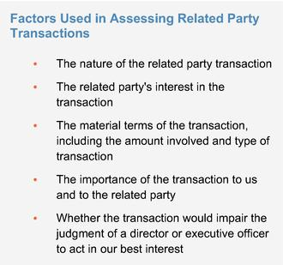

We review all relationships and transactions in which we, our directors and executive officers or their immediate family members and our 5%
stockholders are participants to determine whether such persons have a direct or indirect material interest in such transactions. Our Code of
Conduct and Ethics instructs our directors, officers and employees to report the facts and circumstances of any such transaction or potential
transaction to our General Counsel or our Audit Committee. Our board of directors has adopted a policy regarding the review of potential
related party transactions. Under this policy, our General Counsel will review the facts and circumstances of any covered transaction. If our
General Counsel determines that the transaction involves a related party transaction and if the amount involved does not equal or exceed
$120,000, our General Counsel will approve or disapprove the transaction. If our General Counsel determines that the transaction involves a
related party transaction and if the amount involved equals or exceeds $120,000, our General Counsel will refer the transaction to our Audit
Committee for consideration. In the course of reviewing, approving or ratifying a disclosable related party transaction, our General Counsel
and Audit Committee considers all factors it considers appropriate, including but not limited to the factors in the box to the right.

Related Party Transactions

As required under SEC rules, transactions that are determined to be directly or indirectly material to us or a related person and which involve amounts exceeding $120,000 in the previous fiscal year are disclosed in our proxy statement.

On October 1, 2018, the Company entered into the Investment Agreement with the Purchaser, an affiliate of The Orogen Group. One of the Company's directors, Vikram Pandit, is the Chairman and Chief Executive Officer of The Orogen Group. Under the terms of the Investment Agreement, the Company issued to the Purchaser $150,000,000 in aggregate principal amount of 3.50% Convertible Senior Notes due October 1, 2024. In addition, we appointed Mr. Pandit, a nominee of the Purchaser, to our board of directors pursuant to the Investment

Agreement. After considering the facts and circumstances regarding the relationship, our board of directors has determined that the Investment Agreement does not impair Mr. Pandit's independence under applicable Nasdaq standards and federal securities laws.

108

Table of Contents

AUDIT COMMITTEE REPORT

AUDIT COMMITTEE REPORT

The Audit Committee of the board of directors of ExlService Holdings, Inc. assists our board of directors in fulfilling its oversight responsibilities with respect to the following:

- our accounting and financial reporting processes, including the integrity of the financial statements and other financial information provided by us to our stockholders, the public, stock exchanges and others;

- our compliance with legal and regulatory requirements;

- our registered independent public accounting firm's qualifications and independence;

- the audit of our financial statements; and

- the performance of our internal audit function and independent registered public accounting firm.

In connection with these responsibilities, the Audit Committee met with management and Deloitte & Touche LLP to review and discuss the December 31, 2020 audited consolidated financial statements. The Audit Committee also discussed with Deloitte & Touche LLP the matters required to be discussed by the applicable requirements of the Public Company Accounting Oversight Board and the SEC. The Audit Committee also received written disclosures and the letter from Deloitte & Touche LLP required by Rule 3526 of the Public Company Accounting Oversight Board (Communications with Audit Committees Concerning Independence), and the Audit Committee discussed with Deloitte & Touche LLP the firm's independence.

Based on the review and discussions referred to above, the Audit Committee approved the inclusion of the audited financial statements in the Company's Annual Report on Form 10-K for the fiscal year ended December 31, 2020.

Audit Committee

Mr. Clyde W. Ostler (Chairman)
Mr. David B. Kelso
Mr. Vikram Pandit
Ms. Kristy Pipes
Mr. Nitin Sahney

Ms. Jaynie Studenmund

109

Table of Contents

PROPOSAL 1 — ELECTION OF DIRECTORS

PROPOSAL 1 — ELECTION OF DIRECTORS

The Nominees

Our Nominating and Governance Committee has nominated, and our board of directors has designated, Mses. Minto, Pipes and Studenmund and Messrs. Kapoor, Mittal, Ostler, Pandit, Sahney and Staglin to stand for election as directors at the Annual Meeting. Two of our current directors, Ms. Kerr and Mr. Kelso, will not be standing for re-election at the Annual Meeting.

Term of Office

If elected, each of the director nominees will serve a term of one year on our board of directors, until our 2022 Annual Meeting of Stockholders or until their successors are duly elected and qualified in accordance with our by-laws.

Voting Instructions and Substitutes

The proxies given to the proxy holders will be voted or not voted as directed and, if no direction is given, will be voted FOR these six nominees. Our board of directors knows of no reason why any of these nominees should be unable or unwilling to serve. However, if for any reason any nominee should be unable or unwilling to stand for election, the shares represented by proxies will be voted for the election of any substitute nominee designated by our board of directors to fill the vacancy.

General Information about Nominees

The age, tenure on our board of directors and committee membership, if any, of each nominee appears below. Information regarding the business experience during at least the last five years and directorships of other publicly owned corporations of each nominee can be found above under "Our Board of Directors." Other information required

110

Table of Contents

PROPOSAL 1 — ELECTION OF DIRECTORS

with respect to any solicitation of proxies in connection with the election of directors is found elsewhere in this proxy statement.

 |  |  | Director
Name |  | Age | Since | Independent | Committee Membership
Garen Staglin |  | 76 | June | Yes | Compensation; Nominating and Governance
Chairman |  |  | 2005
Rohit Kapoor |  | 56 | November | No | None
Vice Chairman and CEO |  |  | 2002
Anne Minto |  | 67 | March | Yes | Compensation; Nominating and Governance
 |  |  | 2013
 | Som Mittal | 69 | December | Yes | Compensation; Nominating and Governance
 |  |  | 2013
 | Clyde Ostler | 74 | December | Yes | Audit (Chair); Compensation
 |  |  | 2007
 | Vikram Pandit | 64 | October | Yes | Audit; Nominating and Governance
 |  |  | 2018
 | Kristy Pipes | 61 | January | Yes | Audit; Compensation
 |  |  | 2021
 | Nitin Sahney | 58 | January | Yes | Nominating and Governance (Chair); Audit
 |  |  | 2016
 | Jaynie Studenmund | 66 | September | Yes | Compensation (Chair); Audit
 |  |  | 2018
Required Vote

The affirmative vote of a majority of votes (meaning the number of shares voted "for" a nominee must exceed the number of shares voted "against" such nominee) cast in person or represented by proxy and entitled to vote at the Annual Meeting will elect the nine nominees as directors for a term of one year. If any nominee for director receives a greater number of votes "against" his or her election than votes "for" such election, our by-laws provide that such person will tender to the board of directors his or her resignation as a director. Unless marked to the contrary, proxies received will be voted "FOR" the nominees.
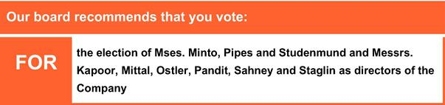

111

Table of Contents

PROPOSAL 2 — RATIFICATION OF THE APPOINTMENT OF INDEPENDENT REGISTERED PUBLIC ACCOUNTING FIRM

PROPOSAL 2 — RATIFICATION OF THE APPOINTMENT OF INDEPENDENT REGISTERED PUBLIC ACCOUNTING FIRM

Our Audit Committee has appointed Deloitte & Touche LLP ("Deloitte") as the independent registered public accounting firm to audit the Company's and its subsidiaries' books, records and accounts for the fiscal year 2021. Our board of directors has endorsed this appointment. Ratification of the appointment of Deloitte by our stockholders is not required by law. However, as a matter of good corporate practice, such appointment is being submitted to our stockholders for ratification at the Annual Meeting. If our stockholders do not ratify the appointment, our board of directors and our Audit Committee will reconsider whether or not to retain Deloitte, but may nonetheless retain Deloitte. Even if the appointment is ratified, the Audit Committee in its discretion may change such appointment at any time during the year if it determines that such change would be in the best interests of the Company and our stockholders.

In retaining Deloitte as the Company's independent registered public accounting firm, the Audit Committee considered whether the provision of non-audit services by Deloitte was compatible with maintaining Deloitte's independence and concluded that it was. Representatives of Deloitte are expected to be present at the Annual Meeting. They will have an opportunity to make a statement, if they desire to do so, and will be available to respond to appropriate questions. Deloitte has served as our independent registered public accounting firm since February 28, 2018.

Audit and Non-Audit Fees

The following is a summary of the fees billed or expected to be billed to us by the Company's independent registered public accounting firm for professional services rendered in each of the last two fiscal years:

 | Fiscal | Fiscal
Fee Category | 2020 | 2019
 |  | (in thousands)
Audit Fees | $ 1,451 | $ 1,391
Audit-Related Fees | — | 114
Tax Fees | 758 | 696
All Other Fees | — | —
Total Fees | $ 2,209 | $ 2,201

112

Table of Contents

PROPOSAL 2 — RATIFICATION OF THE APPOINTMENT OF INDEPENDENT REGISTERED PUBLIC ACCOUNTING FIRM

Audit Fees: Consist of fees billed or expected to be billed for professional services rendered for the audit of our consolidated financial statements, including (i) the audit of effectiveness of internal control over financial reporting, (ii) review of our consolidated financial statements included in our quarterly reports, and (iii) services that are normally provided by our registered independent public accountants including services in connection with statutory or regulatory filings or engagements for those fiscal years.

Audit-Related Fees: Consist of fees billed for assurance and related services that are reasonably related to the performance of the audit or review of our consolidated financial statements and are not reported under "Audit Fees." These services include SSAE 18 service organization audits and due diligence in connection with acquisition activity.

Tax Fees: Consist primarily of fees billed or expected to be billed for other tax filing and advisory projects.

All Other Fees: Consist of fees billed or expected to be billed for other permissible work performed by the Company's independent public registered accounting firm that does not meet the above category descriptions.

Our Audit Committee pre-approves and is responsible for the engagement of all auditing services provided by our independent registered public accountants and all non-auditing services to be provided by such accountants to the extent permitted under Section 10A of the Exchange Act, including all fees and other terms of engagement. Our Audit Committee may delegate the authority to pre-approve audit and permitted non-audit services between meetings of our Audit Committee to a designated member of our Audit Committee, provided that the decisions made by such member are presented to our full Audit Committee for ratification at its next scheduled meeting.

All of the fees paid to Deloitte in fiscal year 2020 were pre-approved by the Audit Committee.

Required Vote

The ratification of the appointment of Deloitte as our independent registered public accounting firm requires the affirmative vote of a majority of shares present in person or represented by proxy and entitled to vote at the Annual Meeting. Unless marked to the contrary, proxies received will be voted "FOR" ratification of the appointment.


113

Table of Contents

PROPOSAL 3 — ADVISORY (NON-BINDING) VOTE ON EXECUTIVE COMPENSATION

PROPOSAL 3 — ADVISORY (NON-BINDING) VOTE ON EXECUTIVE COMPENSATION

Proposal 3 is a vote, on a non-binding advisory basis, to approve the compensation of our executive officers as described in this proxy statement. Although the vote is advisory and is not binding on the board of directors, our Compensation Committee will take into account the outcome of the vote when considering future executive compensation decisions. We refer to this vote as the "say-on-pay" vote.

At the 2018 Annual Meeting of Stockholders, our stockholders voted on a proposal relating to the frequency of the "say-on-pay" vote. We recommended, and our stockholders approved on a non-binding advisory basis, an annual say-on-pay vote. Accordingly, we include the say-on-pay vote each year as a regular part of each Annual Meeting of Stockholders, and the next such say-on-pay vote will occur at next year's Annual Meeting of Stockholders. The next vote on the frequency of the "say-on-pay" vote will be held at the Annual Meeting to be held in 2023.

- Our board of directors is committed to corporate governance best practices and recognizes the significant interest of stockholders in executive compensation matters.

- Our board of directors believes that our current executive compensation program directly links executive compensation to our performance and aligns the interests of our executive officers with those of our stockholders. For example, the bulk of our annual incentive bonuses are earned based on achievement of three core financial metrics: Adjusted EPS, revenues and AOPM. As we discuss in greater detail in our Compensation Discussion and Analysis, these financial metrics focus our named executive officers on top-line revenues and bottom-line earnings that are likely to make meaningful contributions to our future financial performance. We believe rewarding our executives with incentive pay based on achievement of these three financial metrics closely aligns management with the interests of our stockholders.

In addition, our philosophy places more emphasis on variable elements of compensation (such as incentive bonuses and equity-based compensation) than fixed remuneration.

Our stockholders have the opportunity to vote for, against or abstain from voting on the following resolution:

"Resolved, that the stockholders approve on an advisory basis the compensation of our named executive officers, as disclosed pursuant to the compensation disclosure rules of the SEC (which disclosure shall include the Compensation Discussion and Analysis, the compensation tables and any related material disclosed in this proxy statement)."

The above-referenced disclosures related to the compensation of our named executive officers appear beginning at page 61 of this proxy statement.

Required Vote

The approval, on an advisory (non-binding) basis, of the compensation of our named executive officers requires the affirmative vote of a majority of shares present in person or represented by proxy and entitled to vote at the Annual Meeting. Unless marked to the contrary, proxies received will be voted "FOR" the approval of the compensation of our named executive officers.
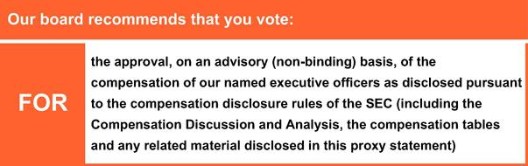

114

Table of Contents

STOCKHOLDER PROPOSALS AND DIRECTOR NOMINATIONS FOR THE 2022 ANNUAL MEETING

STOCKHOLDER PROPOSALS AND DIRECTOR NOMINATIONS FOR THE 2022 ANNUAL MEETING

Stockholder proposals intended to be included in our proxy materials for the 2022 Annual Meeting of Stockholders ("2022 Annual Meeting") must be received by the deadline calculated in accordance with SEC Rule 14a-8, which is 120 days before the anniversary of the date of this year's proxy statement. This year's deadline is Friday, December 24, 2021. Such proposals must include the information required by SEC rules, and should be sent in writing by courier or certified mail to the Corporate Secretary of the Company at 320 Park Avenue, 29th Floor, New York, New York 10022. Stockholder proposals that are sent to any other person or location or by any other means may not be received in a timely manner and thus may be ineligible for inclusion.

Stockholders who intend to submit proposals at the 2022 Annual Meeting but whose proposals are not included in the proxy materials for the meeting, and stockholders who intend to submit nominations for directors at the 2022 Annual Meeting, are required to notify the Corporate Secretary of the Company (at the address above) of their proposal or nominations not less than 90 days, nor more than 120 days, before the anniversary of this year's Annual Meeting of Stockholders, in accordance with our by-laws. Such notices of proposals for the 2022 Annual Meeting must be delivered between February 16, 2022 and March 18, 2022. Special notice provisions apply under the by-laws if the date of the 2022 Annual Meeting is more than 30 days before or 70 days after the anniversary date of this year's Annual Meeting of Stockholders.

Any notice of proposed business or nomination, whether or not included in our proxy statement, must include the information required under our by-laws, including Section 2.11.4, in order for the matter to be eligible for consideration at the 2022 Annual Meeting. The presiding officer of the 2022 Annual Meeting may refuse to acknowledge any matter or nomination not made in compliance with the procedures in our by-laws. Our by-laws can be found on our website and the current SEC rules for submitting stockholder proposals can be obtained from the SEC at: Division of Corporation Finance, 100 F. Street, N.E., Washington, DC 20549, or through the SEC's Internet website at www.sec.gov.

115

Table of Contents

MISCELLANEOUS

MISCELLANEOUS

Delivery of Documents to Stockholders Sharing an Address

If you are the beneficial owner, but not the record holder, of shares of our common stock, your broker, bank, trust or other nominee may only deliver one copy of this proxy statement and the 2020 Form 10-K, which serves as our Annual Report to Stockholders under Regulation 14A (the "2020 Annual Report"), to multiple stockholders who share an address unless that nominee has received contrary instructions from one or more of the stockholders. We will deliver promptly, upon written or oral request, a separate copy of this proxy statement and the 2020 Annual Report to a stockholder at a shared address to which a single copy of the documents was delivered. A stockholder who wishes to receive a separate copy of the proxy statement and annual report, now or in the future, should submit this request to our investor relations department through the Investor Relations page of our website at https://ir.exlservice.com/. Beneficial owners sharing an address who are receiving multiple copies of proxy materials and annual reports and who wish to receive a single copy of such materials in the future will need to contact their broker, bank, trust or other nominee to request that only a single copy of each document be mailed to all stockholders at the shared address in the future.

Electronic Access to Proxy Statement and Annual Report

This proxy statement and our 2020 Annual Report may be viewed on our website at www.exlservice.com and at www.proxyvote.com by following the instructions provided in the Internet Notice. If you are a stockholder of record, you can elect to access future annual reports and proxy statements electronically by marking the appropriate box on your proxy form. If you choose this option, you will receive a proxy form in mid-May listing the website locations and your choice will remain in effect until you notify us by mail that you wish to resume mail delivery of these documents. If you hold your common stock through a bank, broker or another holder of record, refer to the information provided by that entity for instructions on how to elect this option.

116

Table of Contents

ANNUAL MEETING Q&A

ANNUAL MEETING Q&A

WHO IS PROVIDING THIS PROXY STATEMENT?

This Proxy Statement is being furnished to you in connection with the solicitation by the board of directors of ExlService Holdings, Inc., a Delaware corporation ("us," "we," "our" or the "Company"), of proxies to be used at our 2021 Annual Meeting of Stockholders (the "Annual Meeting") to be held in virtual format only via live audio webcast at the website www.virtualshareholdermeeting.com/EXLS2021 on June 16, 2021 at 9:30 AM, Eastern Time, and any adjournments or postponements thereof.

HOW ARE THE PROXY MATERIALS BEING MADE AVAILABLE?

In accordance with rules and regulations adopted by the Securities and Exchange Commission (the "SEC"), instead of mailing a printed copy of our proxy materials to each stockholder of record, the Company furnishes proxy materials via the Internet. If you received a Notice of Internet Availability of Proxy Materials (the "Internet Notice") by mail, you will not receive a printed copy of our proxy materials other than as described herein. Instead, the Internet Notice will instruct you as to how you may access and review all of the important information contained in the proxy materials. The Internet Notice also instructs you as to how you may submit your proxy over the Internet or by phone. If you received an Internet Notice by mail and would like to receive a printed copy of our proxy materials, you should follow the instructions for requesting proxy materials included in the Internet Notice.

Our Notice of Annual Meeting, proxy statement and form of proxy card are each available at www.proxyvote.com. You may access these materials and provide your proxy by following the instructions provided in the Internet Notice.

WHEN WILL THE INTERNET NOTICE BE SENT?

We anticipate the Internet Notice will be sent to stockholders on or about April 23, 2021. This proxy statement and the form of proxy relating to the Annual Meeting will be made available via the Internet to stockholders on or prior to the date that the Internet Notice is first sent.

WHO CAN VOTE?

Only stockholders who own shares of our common stock at the close of business on April 19, 2021, the record date for the Annual Meeting, can vote at the Annual Meeting. As of the close of business on April 19, 2021, the record date, we had 33,479,956 shares of common stock outstanding and entitled to vote. Each holder of common stock is entitled to one vote for each share held as of the record date for the Annual Meeting.

IS CUMULATIVE VOTING APPLICABLE IN THE ELECTION OF DIRECTORS?

There is no cumulative voting in the election of directors.

HOW DO I VOTE MY SHARES?

If your shares are registered directly in your name with Computershare Trust Company, N.A., our transfer agent (which means you are a "stockholder of record"), you can vote your proxy by (i) Internet,

- by phone or (iii) by requesting that proxy materials be sent to you by mail that will include a proxy card that you can use to vote by completing, signing, dating and returning the proxy card in the prepaid postage envelope provided. Please refer to the specific instructions set forth in the Internet Notice.

If you are the beneficial owner of shares held in the name of a brokerage, bank, trust or other nominee as a custodian (also referred to as shares held in "street name"), your broker, bank, trustee or nominee will provide you with materials

117

Table of Contents

ANNUAL MEETING Q&A

and instructions for voting your shares. In addition to voting by mail, a number of banks and brokerage firms participate in a program provided through Broadridge Financial Solutions, Inc. ("Broadridge") that offers telephone and Internet voting options. Votes submitted by telephone or by using the Internet through Broadridge's program must be received by 11:59 p.m. Eastern Time, on June 15, 2021.

You also have the right to vote electronically at the Annual Meeting if you decide to attend. Our board of directors recommends that you vote by Internet, phone or mail even if you choose to attend the Annual Meeting. If you are a "stockholder of record," you may vote your shares electronically at the Annual Meeting. If you hold your shares in "street name," you must obtain a proxy from your broker, bank, trustee or nominee giving you the right to vote the shares electronically at the Annual Meeting or your vote at the Annual Meeting will not be counted.

You will not be able to vote your shares unless you use one of the methods described above to designate a proxy or you vote electronically at the Annual Meeting.

CAN I REVOKE MY PROXY?

You can revoke your proxy at any time before it is exercised in any of the following ways:

- by voting at the Annual Meeting;

- by submitting written notice of revocation to the inspector of elections prior to the Annual Meeting; or

- by submitting another properly executed proxy of a later date to the inspector of elections prior to the Annual Meeting.

HOW IS A QUORUM ESTABLISHED AT THE ANNUAL MEETING?

A quorum, which is a majority of the issued and outstanding shares of our common stock as of the record date of April 19, 2021, must be present, in person or by proxy, to conduct business at the Annual Meeting. A quorum is calculated based on the number of shares represented by the stockholders attending the Annual Meeting in person and by their proxy holders.

If you indicate an abstention as your voting preference for all matters to be acted upon at the Annual Meeting, your shares will be counted toward a quorum but they will not be voted on any matter.
Virtual attendance at our Annual Meeting constitutes presence in person for purposes of quorum at the Annual Meeting.

WHAT IS A "BROKER NON-VOTE"

If you are the beneficial owner of shares held in "street name" by a broker, then your broker, as the record holder of the shares, must vote those shares in accordance with your instructions. If you fail to provide instructions to your broker, under the New York Stock Exchange rules (which apply to brokers even though our shares are listed on the NASDAQ Stock Market), your broker will not be authorized to vote your shares on "non-routine" proposals, which include, at the Annual Meeting, the election of directors and approval on an advisory (non-binding) basis of the compensation of our named executive officers. As a result, a "broker non-vote" occurs. However, without your instructions, your broker has discretionary authority to vote your shares with respect to "routine" proposals only, which include, at the Annual Meeting, the ratification of the appointment of our independent registered public accounting firm.

HOW MANY VOTES ARE NEEDED TO APPROVE EACH PROPOSAL AND WHAT IS THE EFFECT OF ABSTENTIONS AND/OR BROKER NON-VOTES?

Proposal 1: Election of Directors

Under our Fifth Amended and Restated By-Laws (our "by-laws"), directors who are standing for election at the Annual Meeting will be elected by the affirmative vote of a majority of votes cast (meaning the number of shares voted "for" a

118

Table of Contents

ANNUAL MEETING Q&A

nominee must exceed the number of shares voted "against" such nominee) by stockholders in person or represented by proxy and entitled to vote at the Annual Meeting. If any incumbent nominee for director receives a greater number of votes "against" his or her election than votes "for" such election, our by-laws provide that such person will tender to the board of directors his or her resignation as a director. You may cast your vote in favor of electing all of the nominees as directors, against one or more nominees, or abstain from voting your shares. For purposes of the vote on Proposal 1, abstentions and broker non-votes will have no effect on the results of the vote. Virtual attendance at our Annual Meeting will constitute presence in person for purposes of voting at the Annual Meeting.

Other Proposals

The ratification of the appointment of our independent registered public accounting firm, the advisory (non-binding) approval of the compensation of our named executive officers and each other item to be acted upon at the Annual Meeting will require the affirmative vote of a majority of shares present in person or represented by proxy and entitled to vote at the Annual Meeting. You may cast your vote in favor of or against these proposals or you may abstain from voting your shares. For purposes of the vote on Proposal 2 (ratification of the appointment of our independent registered public accounting firm), Proposal 3 (advisory (non-binding) vote on executive compensation), and such other items properly presented and to be acted upon at the Annual Meeting, abstentions will have the effect of a vote against these proposals. Broker non-votes will have the effect of a vote against Proposal 3, but because Proposal 2 is a "routine" proposal where brokers have discretionary authority to vote in the absence of instruction, there will be no broker non-votes.

If you submit your proxy, but do not mark your voting preference, the proxy holders will vote your shares (i) FOR the election of all six nominees for director, (ii) FOR the ratification of the appointment of our independent registered public accounting firm, (iii) FOR the approval on an advisory (non-binding) basis of the compensation of our named executive officers, and (iv) as described below, in the judgment of the proxy holder on any other matters properly presented at the Annual Meeting.

ARE THERE OTHER MATTERS TO BE ACTED UPON AT THE MEETING?

Our board of directors presently is not aware of any matters, other than those specifically stated in the Notice of Annual Meeting, which are to be presented for action at the Annual Meeting. If any matter other than those described in this proxy statement is presented at the Annual Meeting on which a vote may properly be taken, the shares represented by proxies will be voted in accordance with the judgment of the person or persons voting those shares.

WHAT ABOUT ADJOURNMENTS AND POSTPONEMENTS?

Any action on the items of business described above may be considered at the Annual Meeting at the time and on the date specified above or at any time and date to which the Annual Meeting is properly adjourned or postponed.

WHO PAYS FOR SOLICITATION OF PROXIES?

We will pay the cost of printing and mailing proxy materials and posting them on the Internet. Upon request, we will reimburse brokers, dealers, banks and trustees, or their nominees, for reasonable expenses incurred by them in forwarding proxy materials to beneficial owners of shares of our common stock.

HOW CAN I ATTEND THE ANNUAL MEETING AND WHY IS THE COMPANY HOLDING THE ANNUAL MEETING IN A VIRTUAL ONLY FORMAT?

We have monitored the pandemic closely and have determined that holding an in-person annual meeting could pose a risk to the health and safety of our stockholders, employees, and directors, and therefore we will instead hold a virtual Annual Meeting rather than a meeting in New York or at any physical location.

119

Table of Contents

ANNUAL MEETING Q&A

To attend and participate in the Virtual Annual Meeting, stockholders will need to access the live audio webcast of the meeting. To do so, stockholders of record will need to visit www.virtualshareholdermeeting.com/EXLS2021 and use their 16-digit Control Number provided in the Internet Notice to log in to this website, and beneficial owners of shares held in street name will need to follow the instructions provided by the broker, bank or other nominee that holds their shares. We encourage stockholders to log in to this website and access the webcast before the Annual Meeting's start time. Further instructions on how to attend, participate in and vote at the Annual Meeting, including how to demonstrate your ownership of our stock as of the record date, are available at www.virtualshareholdermeeting.com/EXLS2021. Please note you will only be able to attend, participate and vote in the meeting using this website. All references to attending the Annual Meeting "in person" in this Proxy Statement shall mean attending the live webcast at the Annual Meeting.

HOW DO I SUBMIT QUESTIONS AT THE ANNUAL MEETING?

We are committed to ensuring that our stockholders will be afforded the same rights and opportunities to participate in a virtual Annual Meeting as they would at a meeting held at a physical location. You will be able to submit questions during our Annual Meeting by visiting www.virtualshareholdermeeting.com/EXLS2021. We will try to answer as many stockholder-submitted questions as time permits that comply with the meeting rules of conduct as determined by the chairman of the meeting. However, we reserve the right to edit profanity or other inappropriate language, or to exclude questions that are not pertinent to meeting matters or that are otherwise inappropriate. If we receive substantially similar questions, we will group such questions together and provide a single response to avoid repetition.

WILL THE ANNUAL MEETING BE RECORDED?

A recording of the Annual Meeting will be available online at http://ir.exlservice.com for approximately 12 months following the meeting date.

WHAT IF I HAVE TECHNICAL DIFFICULTIES OR TROUBLE ACCESSING THE VIRTUAL ANNUAL MEETING?

We will have technicians ready to assist you with any technical difficulties you may have accessing the live webcast of the Annual Meeting. A technical support phone number will be posted on www.virtualshareholdermeeting.com/EXLS2021 that you may call if you experience technical difficulties during the check-in process or during the Annual Meeting.

WHAT IF I HAVE FURTHER QUESTIONS?

If you have any further questions about voting your shares or attending the Annual Meeting, please call our Investor Relations Department at (212) 624-5913.

IMPORTANT

Please promptly vote and submit your proxy before the Annual Meeting by (i) Internet (by following the instructions provided in the Internet Notice), (ii) by phone (by following the instructions provided in the Internet Notice) or (iii) by requesting that proxy materials be sent to you by mail that will include a proxy card that you can use to vote by completing, signing, dating and returning the proxy card in the prepaid postage envelope provided. This will not limit your right to attend or vote at the Annual Meeting.

120

Table of Contents

OTHER MATTERS

OTHER MATTERS

Our board of directors does not know of any other business that will be presented at the Annual Meeting. If any other business is properly brought before the Annual Meeting, your proxy holders will vote on it as they think best unless you direct them otherwise in your proxy instructions.

Whether or not you intend to be present at the Annual Meeting, we urge you to submit your signed proxy promptly.

By Order of the Board of Directors,

Ajay Ayyappan

Senior Vice President, General Counsel and Corporate Secretary

New York, New York
April 23, 2021

We will furnish without charge to each person whose proxy is being solicited, upon the written request of any such person, a copy of the 2020 Form 10-K, as filed with the SEC, as well as copies of exhibits to the 2020 Form 10-K, but for copies of exhibits will charge a reasonable fee per page to any requesting stockholder. Stockholders may make such request in writing to ExlService Holdings, Inc., 320 Park Avenue, 29th Floor, New York, New York 10022, Attention: Investor Relations. The request must include a representation by the stockholder that as of April 19, 2021, the stockholder was entitled to vote at the Annual Meeting.

121

Table of Contents




